CtModel vs CtElement:

Source:

<https://spoon.gforge.inria.fr/mvnsites/spoon-core/apidocs/>

**CtModel:**

represents a Java program, modeled by a set of compile-time (Ct) objects where each object is a program element (for instance, a CtClass represents a class).

Package spoon.reflect Description

This package defines the Spoon's compile-time meta-model of Java programs.

The meta-model defines a read/write compile-time meta-representation of Java 5 programs. The programmers should instantiate or resolve the meta-elements by using Factory's sub-factories because it ensures the model consistency. The CoreFactory is the raw factory for program elements and is the only factory to be implemented when wanting to provide an alternative implementation of the Spoon meta-model.

Ein CtModel besteht aus CtElementen. Beginnend bei einem CtPackage wo alle Klassen (Klasse, Interface, Packages) enthalten sind, danach wird baumartig abstrahiert. Bis hin zu einzelnen Klammern.

**Beispiel:**

unnamed module 🡪 beginnend bei root Knoten AST

unnamed package 🡪in Package alles von MavenProjekt

public interface Calculator { 🡪erstes Kind Klasse (=Interface)

public abstract int add(int a, int b);

public abstract int sub(int a, int b);

// Change name of vars

public abstract int div(int x, int y);

public abstract void printMsg(java.lang.String msg);

}

public abstract int add(int a, int b);

int

int a

int

int b

int

public abstract int sub(int a, int b);

int

int a

int

int b

int

// Change name of vars

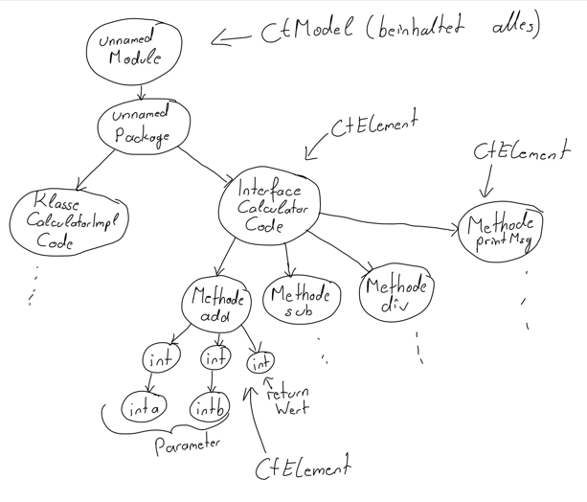

**CtElement (Interface)**

This interface is the root interface for the metamodel elements (any program element).

Rest sieht javadoc 🡪 Methode usw.

**Spoon MavenLauncher**

Source:

<https://spoon.gforge.inria.fr/mvnsites/spoon-core/apidocs/spoon/MavenLauncher.html>

Parameters:

mavenProject - the path to the root of the project

sourceType - the source type (App, test, or all)

**buildModel()**

public CtModel buildModel()

Description copied from interface: SpoonAPI

Builds the model

Specified by:

buildModel in interface SpoonAPI