C# 2 Team "Thunderbird"

# **Team members:**

|  |  |  |  |
| --- | --- | --- | --- |
| radenkovn  Николай Раденков | Curiosity  Яне Йосифов | bai.gundi  Светлин Кръстанов | evgeni.tasev.7  Евгени Тасев |
| Alex_H  Александрина Хаджиге | maryakach  Мария Качарава | Ascension  Асен Кимов | nikoladimoff  Никола Димов |

# **Game description:**

The main character of the game **“Silly Spider”** is an amazing, extraordinary red spider who is extremely horrified of getting wet. The symptoms of his disorder are commonly associated with an immense fear of the rain, behavior also known by the great minds of our century as **“Ombrophobia”**.

The only things that can increase his courage and calm him down are **the yellow flies (>:<)** enchanted by the great magician **Ombre**.

The Silly Spider has to struggle for catching the flies in an unfriendly terrific environment of awful storms with heavy rain, dark clouds and scary noises. **Uuuuh, Gooose Bumps!**

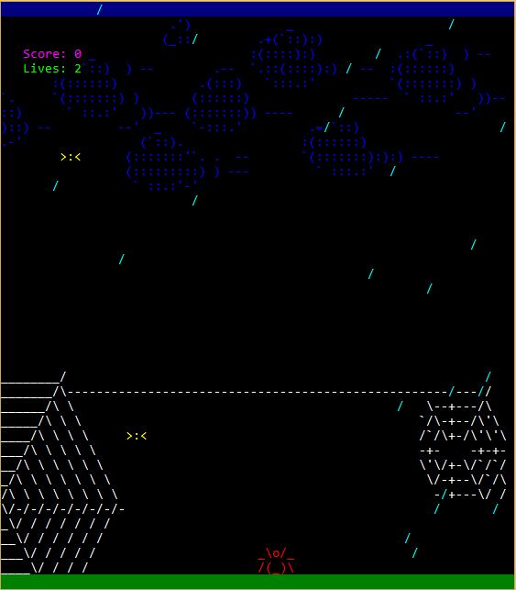The red spider has **only two lives** for eating **as many flies (>:<) as possible** before dying due to a **raindrop touch**.

Deadly Raindrops

Silly Spiders’ Comfort Zone

Yellow flies

Total Lives

Total Eaten Flies

Use arrow keys to move

# **Technical description:**

The playfield of the game consists of printed console graphic elements – clouds, decorative webs, green grass and blue sky.

The spider is controlled by arrow keys of the keyboard taking indexes of x and y depending on the console’s width and height.

There are raindrops printed on the console which can take a life from the spider if they hit him.

There are yellow flies which spider must eat and increase the total score of eaten flies.

The raindrops and flies both are moving in the environment so as the spider.

The game includes audio effects. There is a rain sound as background and a sound effect when a raindrop hits the spider, also when the game finishes.

The program uses a twelve methods:

RandomChanceFliesAndDrops

PrintOnPosition

PrintStaticElementsPlayfield

GameCycle

DefiningSpider

MAIN

PrintASCIIBackground

PlaySound

MovingAndPrintingSpider

MovingFlies

PrintingDrops

MovingDrops

PrintingFlies

# Git repository:

https://github.com/ThunderBirdTeam/ThunderBird