Sleep Quality Monitor
Deven Patel
EECS 1011 Section F
Sonya Allin
York University
December 2, 2025

Introduction
Most of us never consider what happens once we close our eyes, even though we spend nearly a third of our lives asleep. Sleep provides many benefits both physically and mentally. Physically, it supports tissue repair, muscle growth, and immune function, while mentally it improves memory, learning, problem-solving, and mood control (National Sleep Foundation, 2023). Sleep also makes you more focused, alert, and energetic, which helps new engineers be more productive. This idea makes me curious about how important sleep is and whether it is possible to measure the quality of our sleep and improve it.
Later in the course, I was introduced to the United Nations Sustainable Development Goals, which set global targets for improving 17 different issues in today's world. My project focuses on Goals 3 and 4: Good Health and Well-Being, and Quality Education (United Nations, 2015). Goal 3 relates to the project as it focuses on improving sleep quality, an important to overall health. Goal 4 connects to sleep quality in relation to education, as research shows that adequate quality sleep can improve learning (Sleep Foundation, 2024).
The Sleep Quality Monitor uses a Beginner Grove Kit with temperature, light, and sound sensors to continuously evaluate sleep conditions. Using the sensors every 2 seconds, the system calculates a sleep quality score (0-100) with respective recommendations. When conditions drop below acceptable levels, an LED and a buzzer activate letting the user know. The system provides environmental trends through 3 color-coded plots displaying temperature, light, and sound levels over time. Users have a button that safely stops monitoring and shuts down all actuators.
System Overview
- Grove Beginner Kit for Arduino (System)
- Analogue Inputs: Temperature, Light and Sound Sensors
- Digital Outputs: LED, Buzzer and Button (Kill Switch)
System Connection:
The system has three analogue sensors and two digital outputs that are integrated that keep track of sleep: temperature (A0), light (A2), sound (A6), LED (D4) and buzzer (D5). Also, button (D6) is used to let the user manually turn off the system.
System Image:
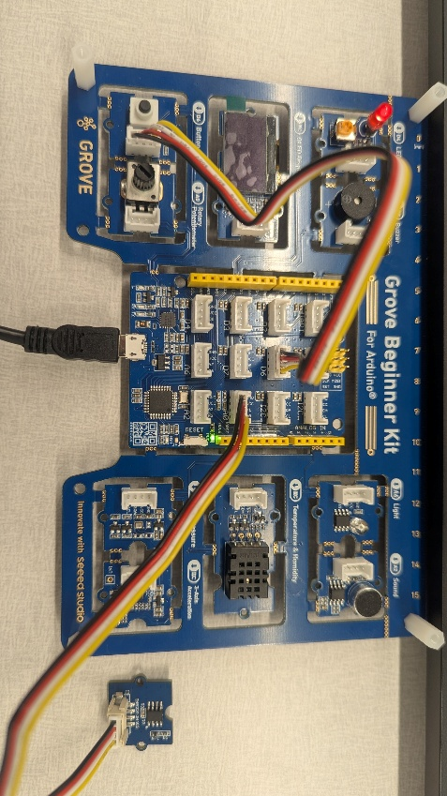
System Design
The system reads the temperature, light, and sound sensors, converting raw voltages into Celsius, lux, and decibels. The sensors were calibrated (Info in results). Each measurement is scored in a range: 15-19°C temperature, light >800 (darker), and sound <400. Each sensor score is combined by weighting averages (temperature is 35%, light is 30%, and sound is 35%), by the calculateSleepScore function. The score is passed to classifySleepCondition function, which categorizes the score into four levels: Excellent (85-100), Good (70-84), Fair (50-69), or Poor (below 50). The system displays sensor data, score, condition and recommendations in a table alongside color-coded graphs showing temperature (red), light (blue), and sound (green). In addition, an LED warns when scores drop below 70, while a buzzer alerts when scores fall below 50. A button is used for a kill switch.
The system uses three separate functions for easy testing and organization. Direct sensor reading without filtering maintains real-time responsiveness since bedroom conditions change slowly. The two-level alert system (LED at score 70, buzzer at score 50) prevents alert fatigue. The code uses only standard MATLAB and Arduino libraries, with threshold values stored as constants for easy adjustment.

Flowcharts (For more information or more clear idea, view the video):
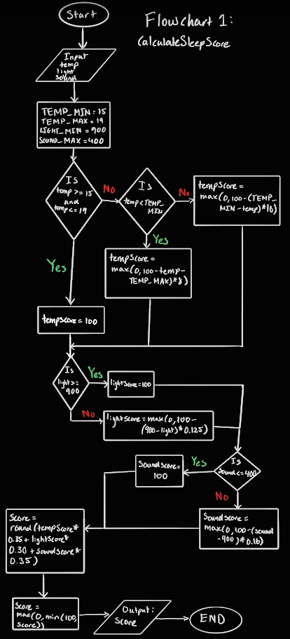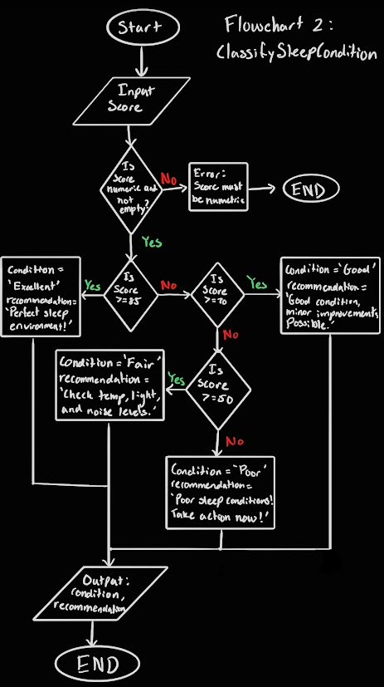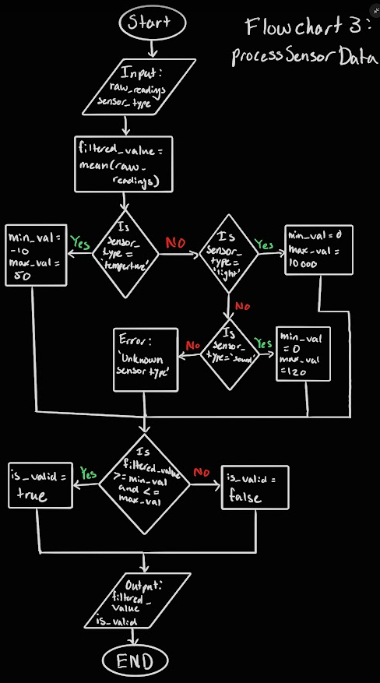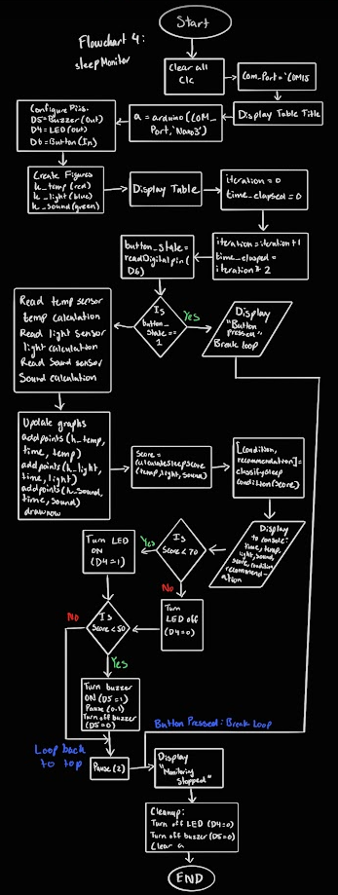
Results
The sensors are calibrated using different sets of equation converting volages to aproperiate units. The temperature sensor uses the Steinhart-Hart thermistor equation, the light sensor was inverted (light = 1023 - analog value) so higher values represent darkness and the sound sensor uses 32-sample averaging to reduce noise, outputting relative analog values (0-1023). All equations were derived from Seed Studio Wiki.
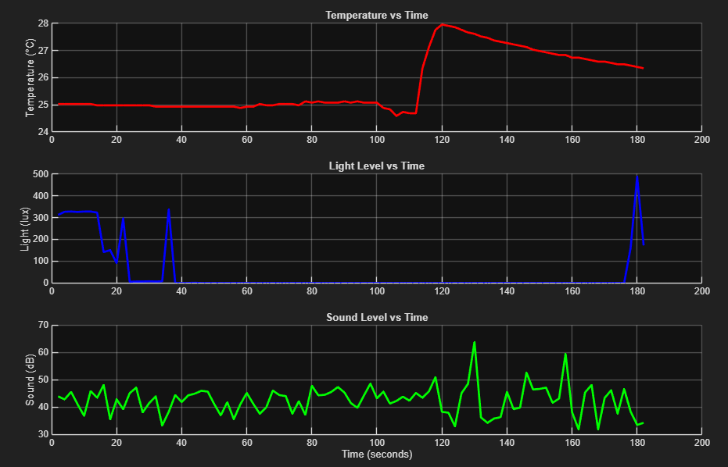
Temperature: Started at 26°C, spiked to 35°C when warmed, then stabilized back to 26-27°C. Shows good responsiveness and minimal drift.
Light: Spiked to 650 when covered (dark), settled at 300-400 for room lighting, and dropped to 250 with bright light. Responds within 1-2 seconds.
Sound: Stable baseline around 180 units with ±10 variations. Spikes above 190 indicate ambient noise. Averaging effectively reduces noise.
The weighted scoring (35% for temperature, 30% for light, and 35% for sound) worked well. The best conditions (temp 15–19°C, light >800, sound <400) would get a score of about 95–100. Good conditions would get a score of 70–85, fair conditions would get a score of 50–70 (LED alert), and poor conditions would get a score of less than 50 (buzzer alert). Every two seconds, the system checks for changes in the environment for all sensors. It sends feedback through the console, graphs, and digital alerts. The two-system warning worked to let people know about problems without having to look at the console. There were problems with needing to change the thresholds (LIGHT_MIN=900, SOUND_MAX=400), making small changes to the sound baseline with the sound sensor, and getting light and sound values that show relative measurements instead of absolute lux or decibels.
Challenges:
During development, a number of problems came up. At first, the light sensor gave strange results: covering it gave low scores. This was fixed by flipping the output so that higher values mean darkness. Determining optimal thresholds required empirical testing since sensors output relative values rather than absolute units, resulting in LIGHT_MIN=900 and SOUND_MAX=400 through trial and error. I learned how to use the sound sensor, how to calibrate the sensors, and how to make unit tests to check that the functions work. Calibrating the sensors provided more precise results, while the unit tests made sure that the functions were working correctly. If I had more time, I would have added more sensors, like humidity and air quality, and ways to use the sensors wireless around a room.
Use of AI
Chat GPT was used during the creation of this project. AI was used as a tool to debug and proofread the code to make sure that it functions correctly. Also, in some places, Chat GPT was just to comment on small important things, for instance, % Calculate light score (higher light value = darker = better). For debugging, the error was given to Chat GPT to find out what the issue is, as coding errors are very vague. I believe that the use of AI helped save time; for example, when debugging, instead of looking through the entire project myself, which is 3 functions and the main code, AI was able to find the code in seconds, so I could focus more on the important things, such as the logic and process. AI might have impacted my way of learning how to debug; however, with a project this large, it was the best option.

References
Grove - Light Sensor | Seeed Studio Wiki. (2023, January 5). Seeedstudio.com.
https://wiki.seeedstudio.com/Grove-Light_Sensor/#features
Grove - Sound Sensor - Seeed Wiki. (n.d.). Wiki.seeedstudio.com.
https://wiki.seeedstudio.com/Grove-Sound_Sensor/
Grove - Temperature Sensor V1.2 | Seeed Studio Wiki. (2023, January 3). Seeedstudio.com.
https://wiki.seeedstudio.com/Grove-Temperature_Sensor_V1.2/?utm_source
MATLAB Documentation. (n.d.). Www.mathworks.com. https://www.mathworks.com/help/matlab/index.html
Newsom, R., & Wright, H. (2022, April 19). Sleep & Job Performance: Can Sleep Deprivation
Hurt Your Work? Sleep Foundation; Sleep Foundation. https://www.sleepfoundation.org/sleep-hygiene/good-sleep-and-job-performance
OpenAI. (2025). ChatGPT. ChatGPT; OpenAI. https://chatgpt.com/
Summer, J. (2024, February 9). Physical Health and Sleep: How Are They Connected? Sleep
Foundation. https://www.sleepfoundation.org/physical-health
United Nations. (2025a). Goal 3: Ensure healthy lives and promote well-being for all at all ages.
United Nations. https://sdgs.un.org/goals/goal3
United Nations. (2025b). Goal 4 | Ensure Inclusive and Equitable Quality Education and
Promote Lifelong Learning Opportunities for All. United Nations. https://sdgs.un.org/goals/goal4

