COURSE NAME : **BIC 10204: COMPUTER AND PROGRAMMING**

ACTIVITY : **LAB ACTIVITY 1**

1. Identify what are the input, process, and output.

a. Find and display the mean of 4 numbers, P, Q, R and S.

|  |  |
| --- | --- |
| **INPUT** | P, Q, R, S |
| **PROCESS** | MEAN: (P + Q + R + S)/4 |
| **OUTPUT** | VALUE OF MEAN |

b. Convert the length of an object from millimeters to centimeters and display the result.

|  |  |
| --- | --- |
| **INPUT** | LENGTH OF AN OBJECT IN MILLIMETERS |
| **PROCESS** | CENTIMETERS OF AN OBJECT: MILLIMETERS OF AN OBJECT/10 |
| **OUTPUT** | DISPLAY MILLIMETERS OF AN OBJECT 🡪 CENTIMETERS OF AN OBJECT |

c. Calculate the volume of a cone, if the volume is below 12cm3, print “Accepted” but if the

volume is equal to or more than 12cm3, print “Not Accepted”.

|  |  |
| --- | --- |
| **INPUT** | RADIUS OF CONE, r , HEIGHT OF CONE, h |
| **PROCESS** | VOLUME OF A CONE: π /3*r2*h  IF VOLUME OF A CONE < 12cm3,  DISPLAY “Accepted”  ELSE IF Volume of a cone >= 12cm3,  DISPLAY “Not Accepted” |
| **OUTPUT** | DISPLAY “Accepted” or “Not Accepted” |

2. Draw the flowchart for the given questions.

a. A company selling sports goods would like to give discounts to customers by organizing an annual sales. If customers buy goods of more than RM 100 then customers will get a discount of 10%. However, if they buy RM 500 and above then 50% discount will be given.

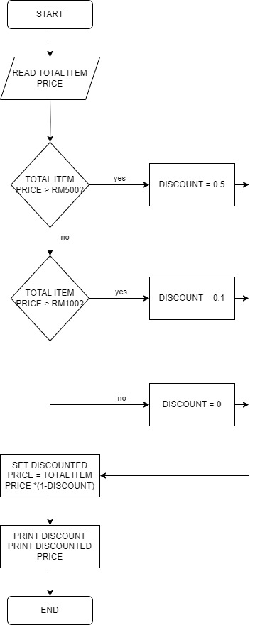

b. A student marking system receives input of student’s total mark from lecturer. If a student gets total mark of 75 or above, the system will print ‘A’. If a student’s mark is between 65 to 74, the system will print out ‘B’. While ‘C’ will be printed out if the mark is between 50 to 64. Whichever the total mark is below 50, ‘F’ will be printed.

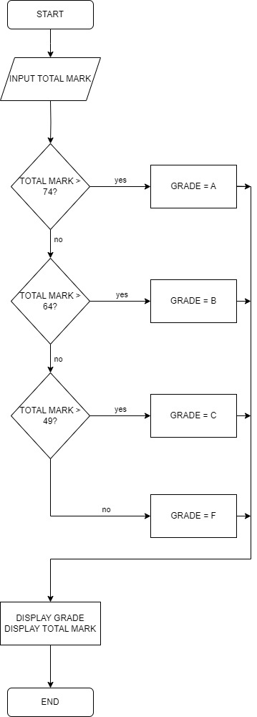

3. Write the pseudocodes/algorithm for the given questions.

a. ABC bank offers 5% discount if payment is made within 10 days after notice. No discount if the payment is made after 10 days.

START

READ AMOUNT OF PAYMENT

READ NUMBER OF DAYS OF PAYMENT IS MADE

IF NUMBER OF DAYS OF PAYMENT IS MADE > 10

DISCOUNT = 0.05

ELSE

DISCOUNT = 0

COMPUTE NETT PAYMENT AS AMOUNT OF PAYMENT TIMES BY ( ONE MINUS DISCOUNT)

DISPLAY DISCOUNT, NETT PAYMENT

END

b. A program receives input of an integer number. This number is then to be multiplied by numbers from 1 to 12. The result for each multiplication is printed

START

DECLARE n, intnum

READ intnum

FOR (n=1, n<=12, n++)

Totalnum= intnum * n

DISPLAY Totalnum

END