BharatFlix OTT Streaming Experience
A streaming-platform demonstration that connects content discovery, viewing, personal libraries and editorial management.

Problem Statement
1. Discovery is often fragmented. Viewers need a clear way to find films and series across language, genre and format.
2. A poster alone is not enough. People want a synopsis, runtime, genres and, for series, seasons and episodes before pressing Play.
3. Returning viewers need continuity. Without a watchlist and remembered progress, resuming a title requires extra effort.
4. Playback needs honest expectations. A prototype must distinguish full open-license films from short technical demo clips.
5. Editorial teams need control. Operators need to review metadata, manage drafts and curate homepage placement without editing source code.
6. Roles and publishing are different concerns. Viewers must not access the CMS; administrators need scoped tools, and super-admins need wider oversight.

What does the idea mean?
BharatFlix brings two connected experiences into one OTT concept. The viewer side presents a cinematic catalogue, title pages, a playable media experience and a personal list. The operator side provides content-management and editorial workflows for staff, with a super-admin layer for broader oversight.
The current implementation is designed for a client walkthrough, not a commercial streaming launch. Film footage, plan prices and editorial data are intentionally limited to demonstration-safe material.

Who uses the platform?
• Viewer: discovers, watches available media and manages their own watchlist and progress.
• Admin: manages content and homepage curation in the operator experience.
• Super-admin: has operator access plus account, settings and audit oversight.

Feature A Watch movies and series
A viewer opens BharatFlix, searches the catalogue, inspects a movie or series, then starts a credited open-film stream or a clearly labeled sample clip. Signed-in users can save titles and continue watching later.
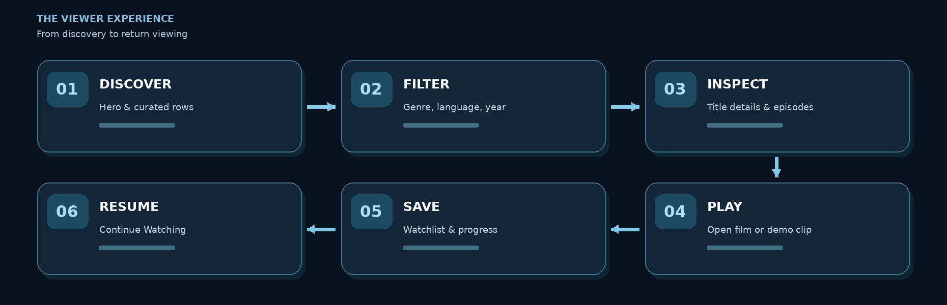

Viewer journey
1. The viewer lands on a featured hero and browses curated catalogue rows.
2. They open Explore and filter by title, genre, language, year or media type.
3. They inspect a title page, including available series seasons and episodes.
4. They press Play and watch an available open film or labeled sample video.
5. They add a title to My List and retain demo playback progress.
6. They return to My Space to resume from Continue Watching.

Possible viewer features
• Cinematic featured titles, curated shelves and instant catalogue search.
• Movie and series detail pages with synopsis, genres and episode lists.
• Responsive Video.js playback controls and clear source/credit information.
• My List, Continue Watching and per-viewer progress in the demo environment.
• Three illustrative plans: Mobile, Standard and Premium, with monthly and annual views.
• Visible demo sign-in options for Viewer, Admin and Super-admin on the account page.

Media and subscription scope
Some open films use attributed MP4 sources; fictional titles use sample footage labeled as such. Pricing is illustrative only. There is no live billing, commercial media library, DRM or production streaming entitlement service.

Feature B Operate and curate the OTT catalogue
A staff member signs in with an Admin or Super-admin demo account. The Operator Studio provides a presentation-ready content workflow; additional CMS pages demonstrate catalogue records, homepage rows, settings and auditing. These surfaces have separate prototype storage paths and are not a unified production publishing system.
ROLE | WHAT THEY CAN SEE | RESTRICTION
Viewer | Storefront, playback, My Space | No CMS or administration routes
Admin | Operator Studio, content editing, rows and assigned editorial tools | No user-role management; restricted oversight tools
Super-admin | All admin tools, account oversight, settings and audit views | Demo scope only, not production identity

Illustrative operator journey
1. Staff signs in and opens the role-protected Operator Studio.
2. They search a title, inspect metadata and update its draft or publication state.
3. They curate featured titles and homepage shelves for a storefront preview.
4. They review source attribution, asset intake notes and rights holds.
5. They check release plans, catalogue counts and editorial activity.
6. A super-admin can additionally review demo accounts and restricted oversight pages.

Admin and super-admin capabilities
• Operator Studio: overview, content library, homepage curation, media operations, release planner, rights checklist and catalogue insights.
• Catalogue editor: create/edit titles, update genres, episodes and stream metadata, manage draft/publish states; separate rows and settings screens.
• Super-admin only: demo account and role management, with broader settings/audit visibility.

How the two features fit together
 | VIEWER EXPERIENCE | OPERATOR EXPERIENCE
Who uses it? | Guests and signed-in viewers | Admins and super-admins
Main goal | Find and enjoy available media | Organize and manage catalogue content
Typical action | Browse → Details → Play → Resume | Review → Edit → Curate → Preview
Access | Storefront and personal library | Server-gated CMS and staff pages

Demonstration boundary: Operator Studio edits reflect in the same browser through local storage. The separate SQLite catalogue editor is staging-oriented and does not automatically update the storefront. Vercel serverless storage is not a durable production database. Audience analytics, payments, licensed commercial distribution and end-to-end publication remain future work.

