# Ex1 RL Circuit

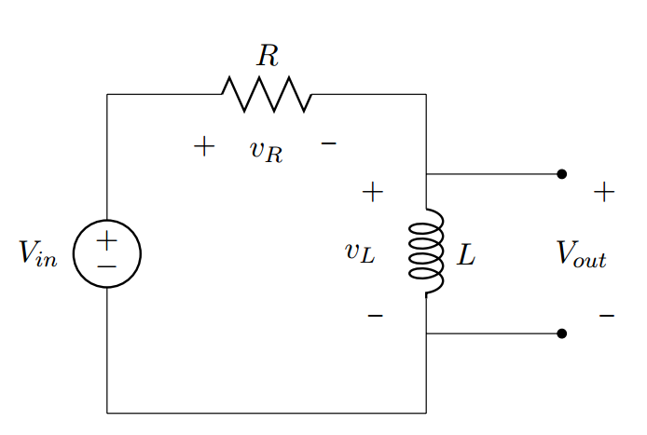

## Ex1.1 step signal

In this exercise, we have RL circuit in series. The following plots are for the step signal with amplitude 5.5V.

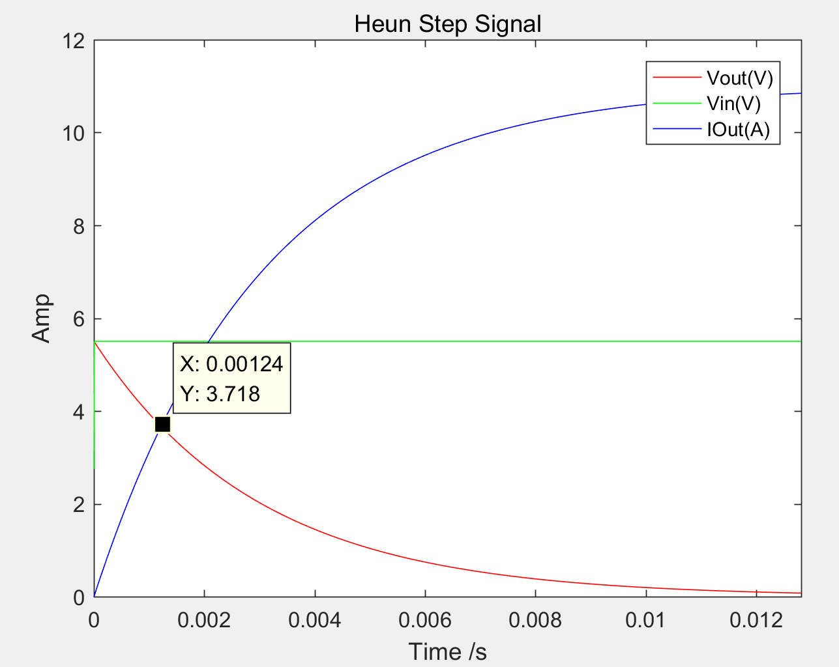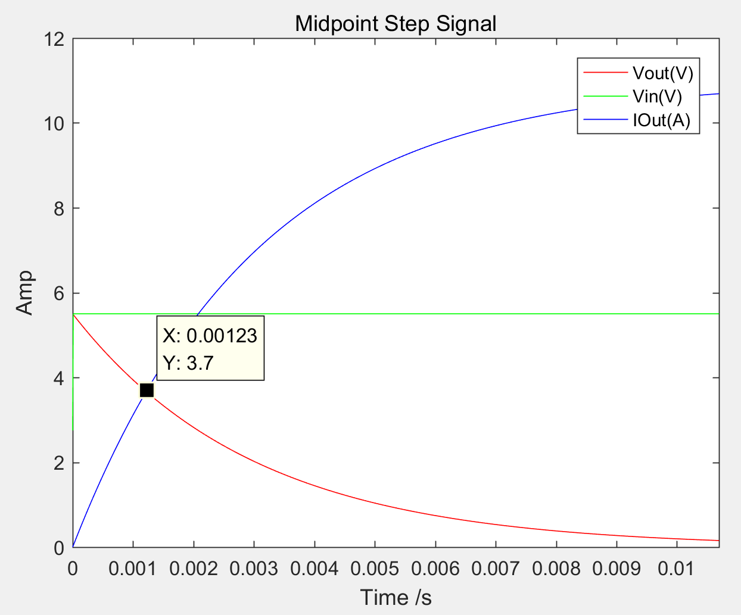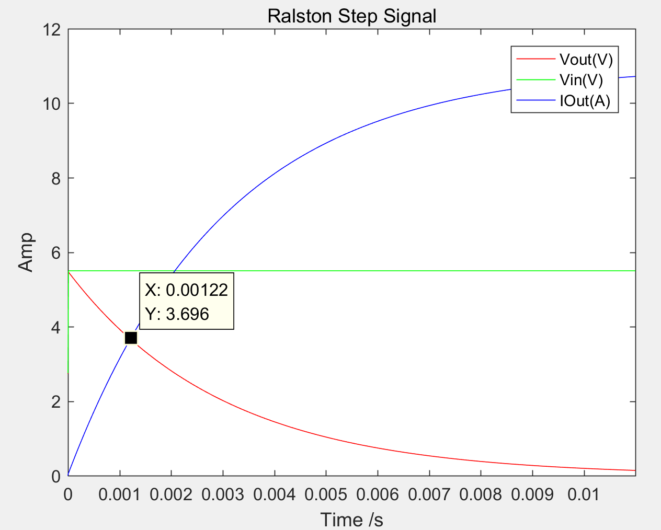

Compare to the plots from Heun, Midpoint and Ralston method, we can see that the output is similar. Theoretically, at first, the voltage difference across the inductor is very high, so the current can barely pass through and $≈$. From the plot, we can see is 0 when t = 0. Then, the due to the characteristic of the inductor, the voltage across the inductor decrease, so the current can pass through increasingly. Hence C:\Users\浦\AppData\Local\Microsoft\Windows\INetCacheContent.Word\Vout.png decrease and C:\Users\浦\AppData\Local\Microsoft\Windows\INetCacheContent.Word\Iout.png increase. By keeping constant and equals to 5.5V.



Mathematically, and C:\Users\浦\AppData\Local\Microsoft\Windows\INetCacheContent.Word\heun_step_I.PNG, so when t increase, decrease and increase. is constant here.



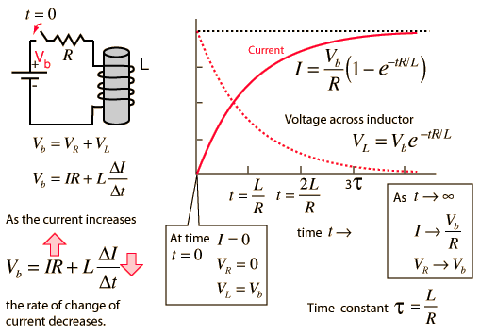

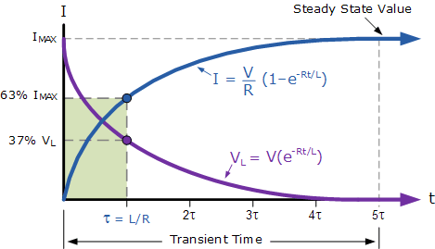

From the graph above, we can see the maximum value of http://hyperphysics.phy-astr.gsu.edu/hbase/electric/imgele/imaxl.gif, the value is 5.5/0.5 = 11A.

In conclusion, these three plot are similar and compare to the plot of the RL circuit transient, we can prove that the simulation is correct.

## Ex 1.2 Impulsive signal and decay

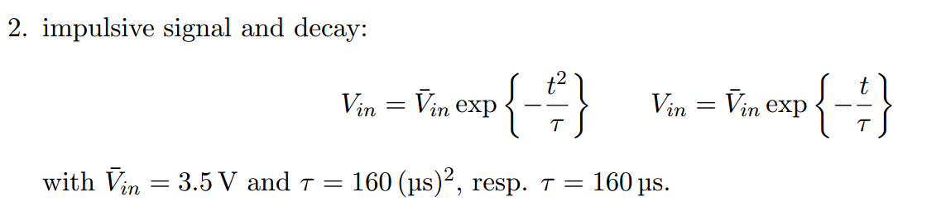

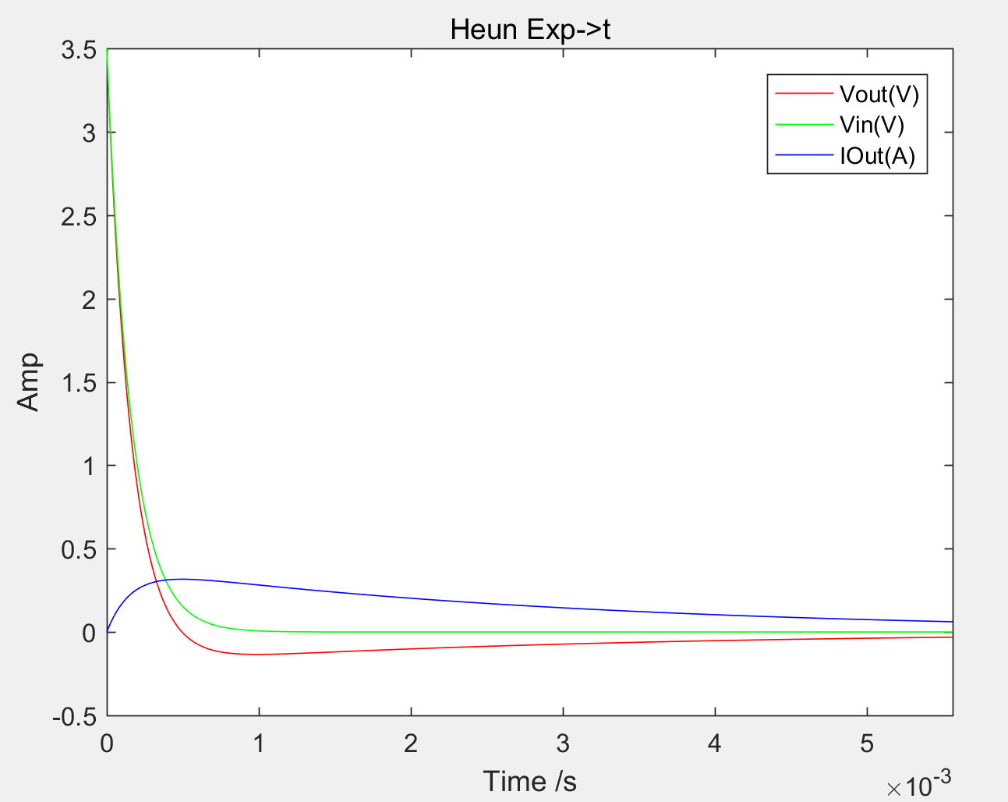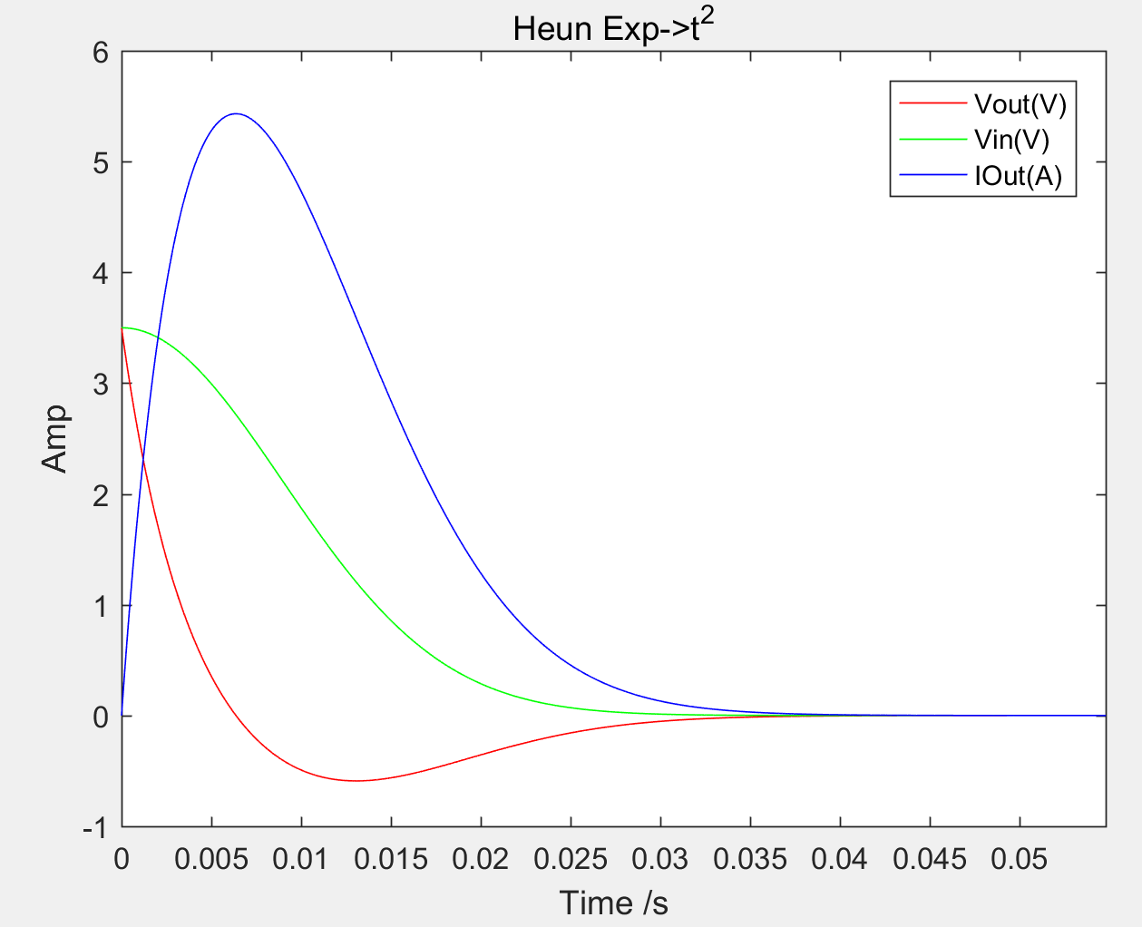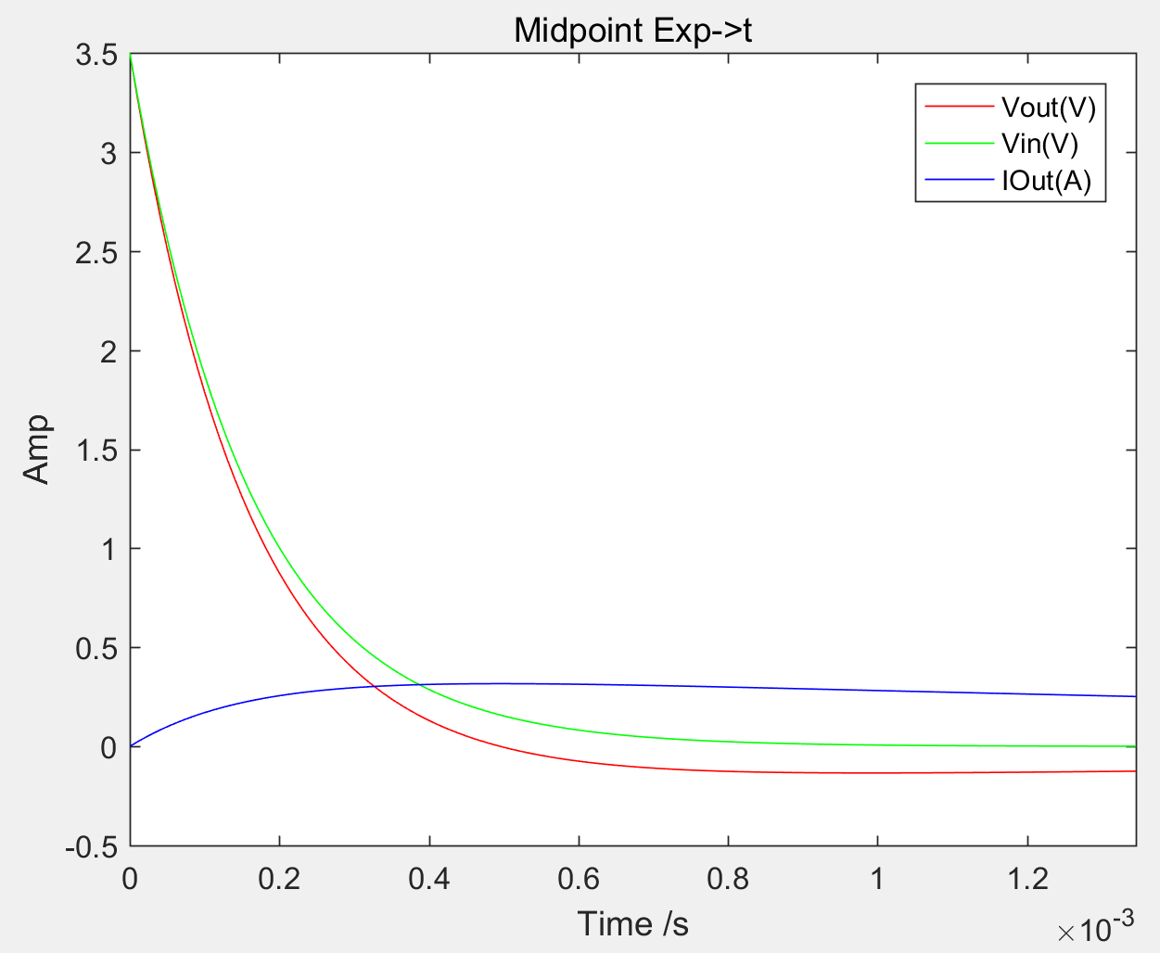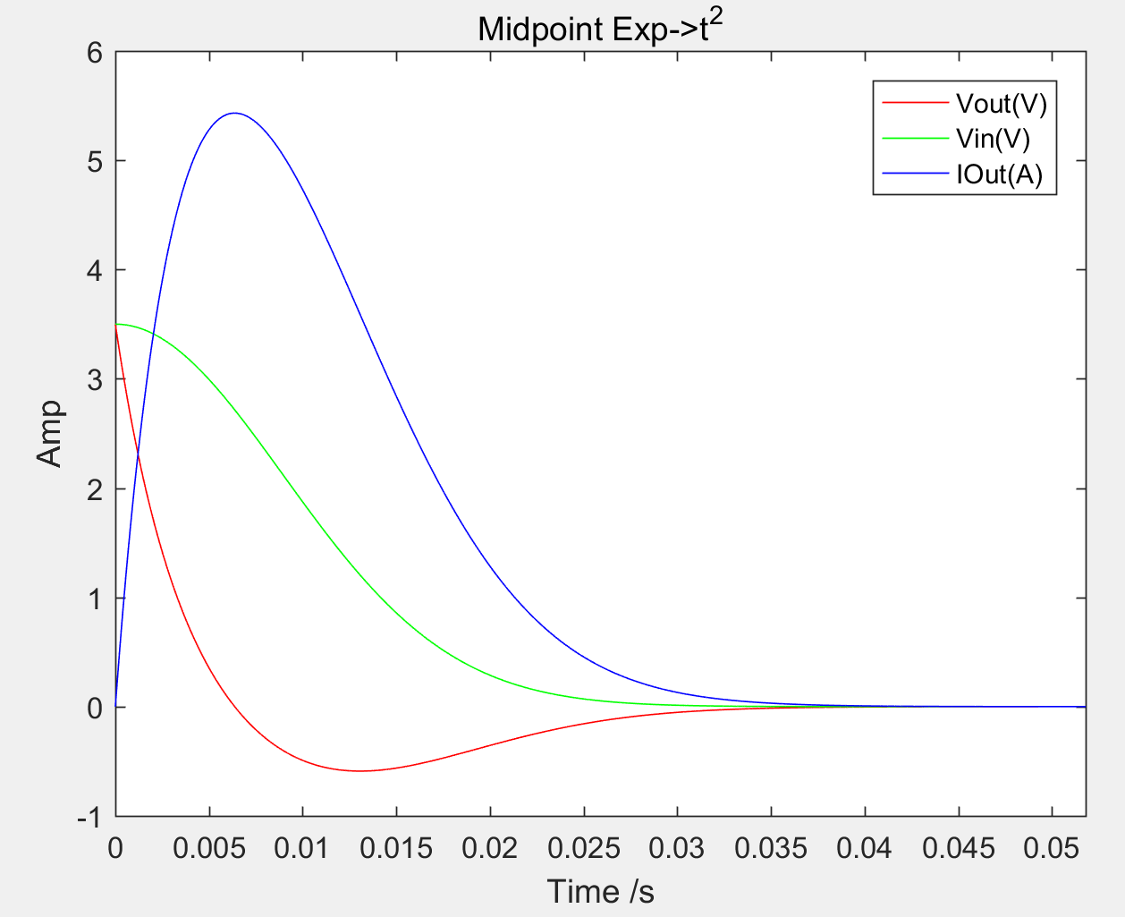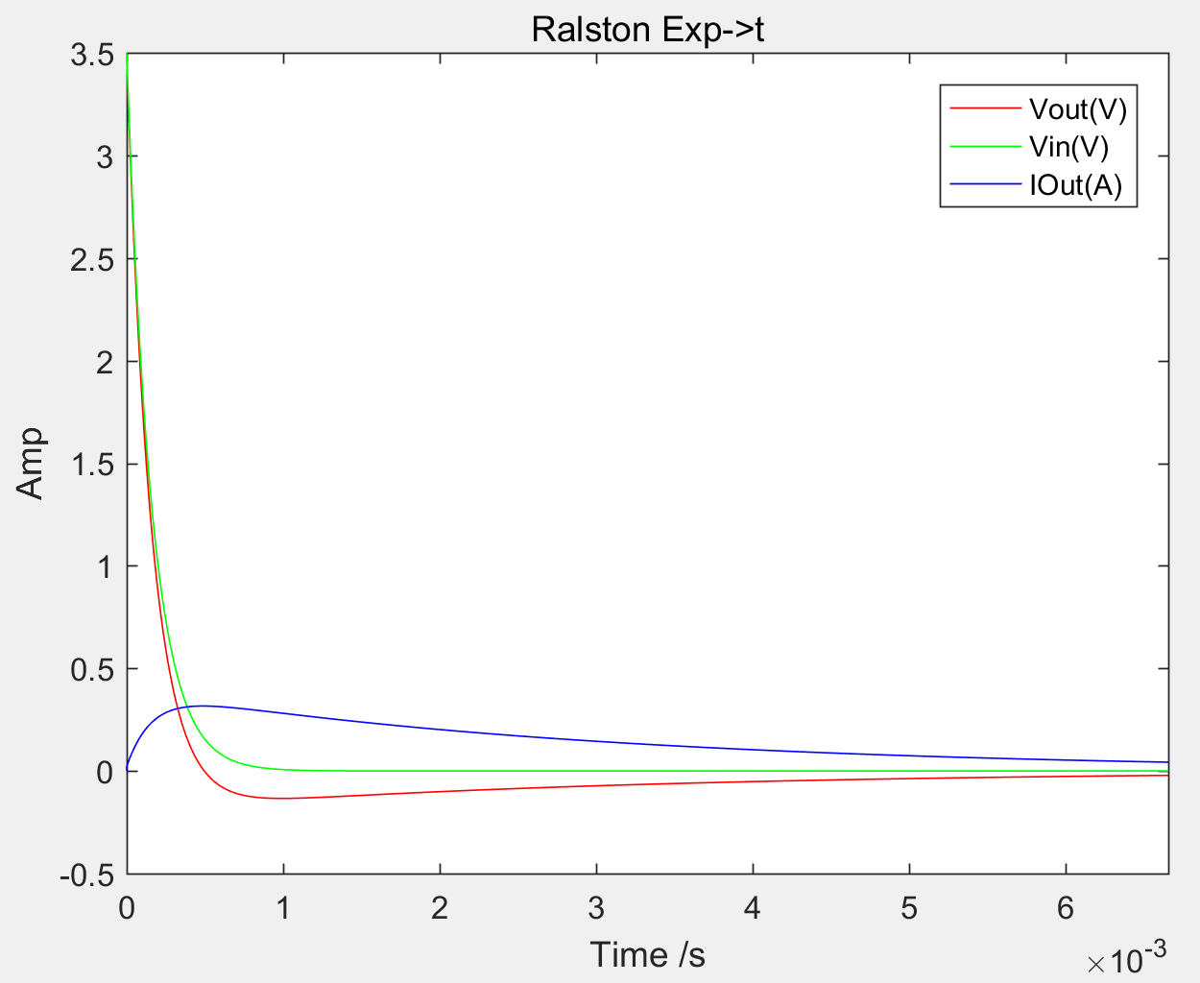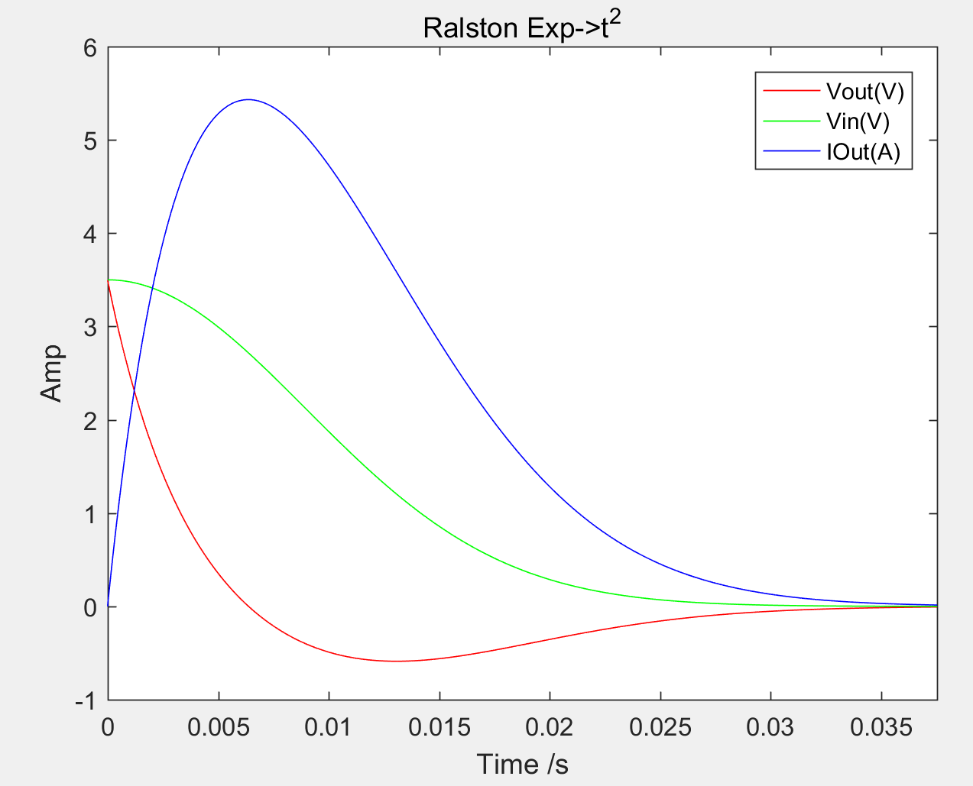

## Ex 1.3 sine, square, and saw-tooth waves

