How to use Google Colab

1.1 Create a Colab notebook on Google Drive
1.Login in Google Drive.
https://drive.google.com
2.First associate Colab with Google Drive
Click New -> More -> Connect more apps, find Google Colaboratory, and connect.
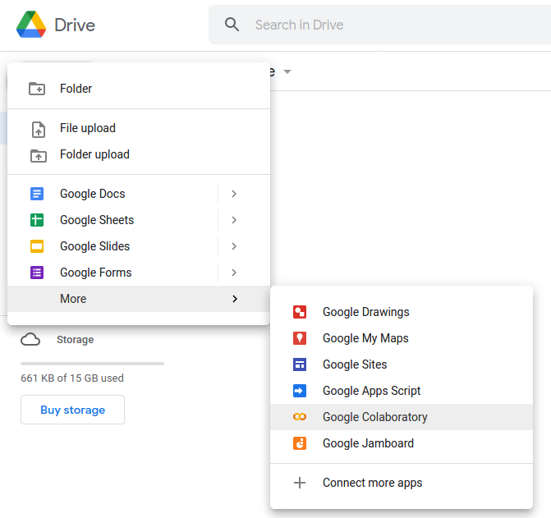
Appears following page after creation
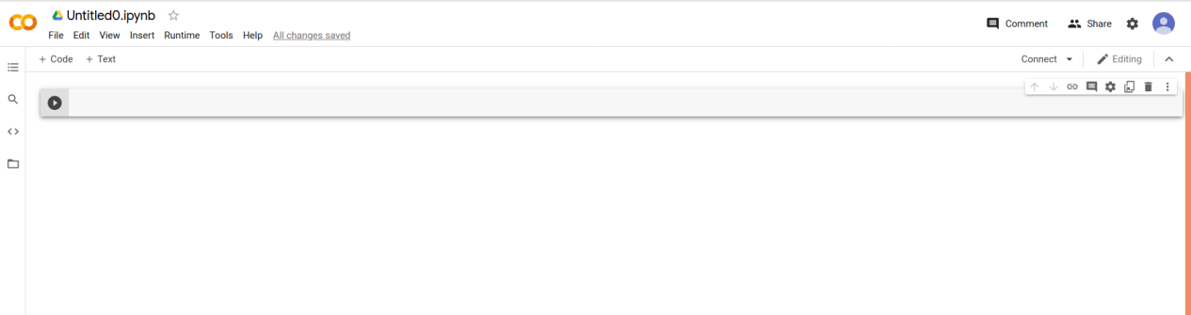
3.Use free GPU
Runtime-> Change Runtime type, select GPU as Hardware accelerator-> Save
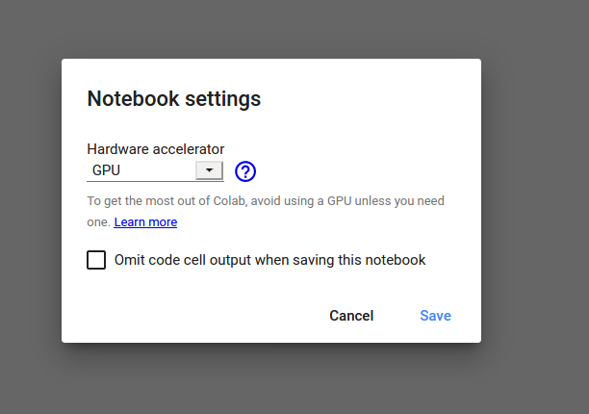

1.2 Run command at Colab notebook
This notebook can also execute some commands under linux, because this is actually a linux virtual machine, but when you execute linux commands, you must add”!” In front of it, for example: !ls, !pwd.

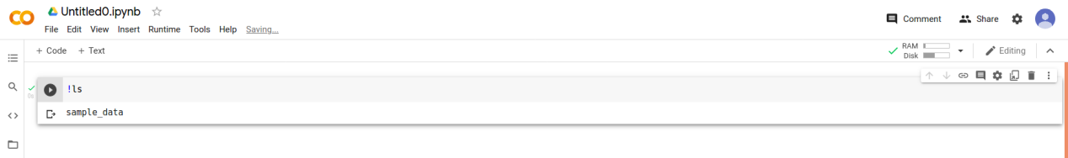

colab is equivalent to jupyter notebook, you can run python code directly, such as:
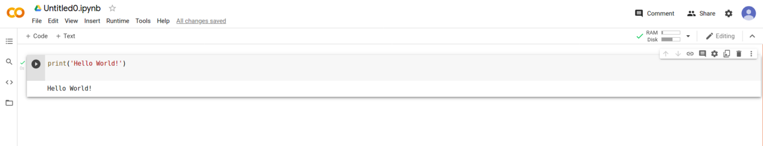

1.3 Basic information check
1.Check if the GPU is running:
Because TensorFlow itself is installed, there is no need to install it, just use it directly, how to determine whether you are already in the GPU environment, you only need to enter this code:
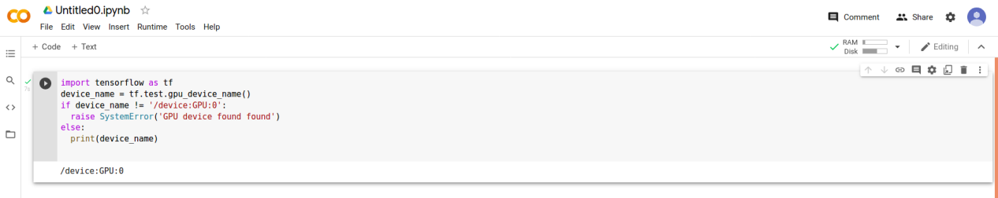
2.Check GPU memory information:
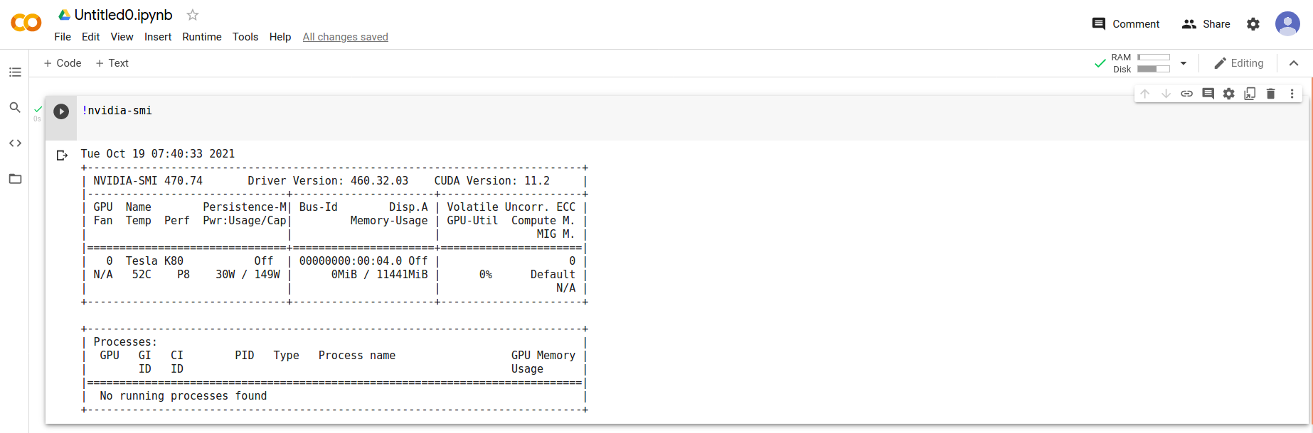
3.Check memory information:

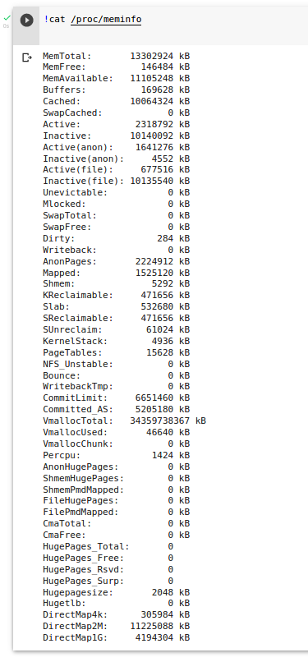
4.Check cpu information:
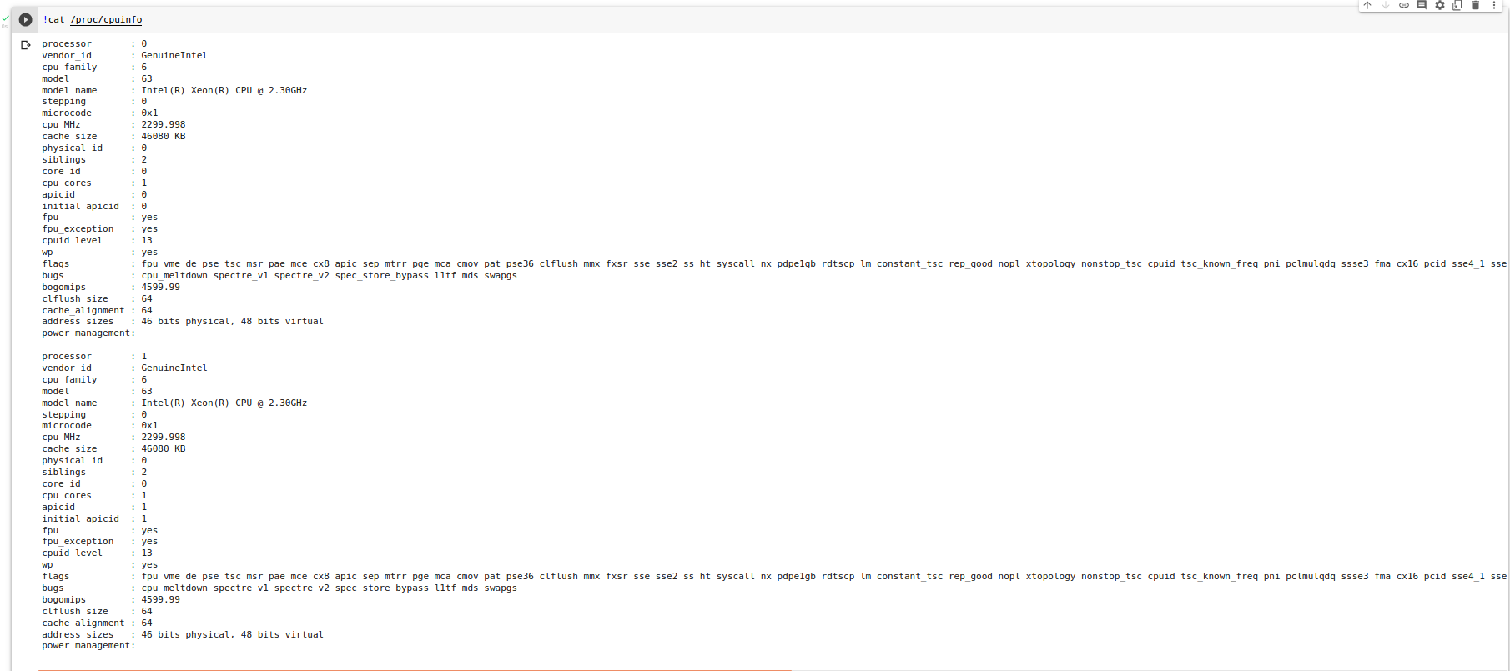
5.Check network speed:
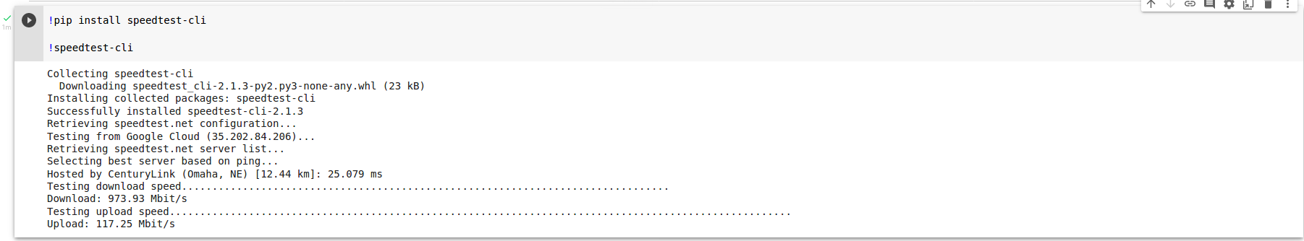

Setup pytorch CPU-only AIMET environment
- Install Dependency packages
1)Install common debian packages
import os
os.environ['SRC_URL'] = 'https://raw.githubusercontent.com/quic/aimet/develop/packaging/google_colab/'
!curl ${SRC_URL}reqs_deb_common.txt | xargs apt-get --assume-yes install

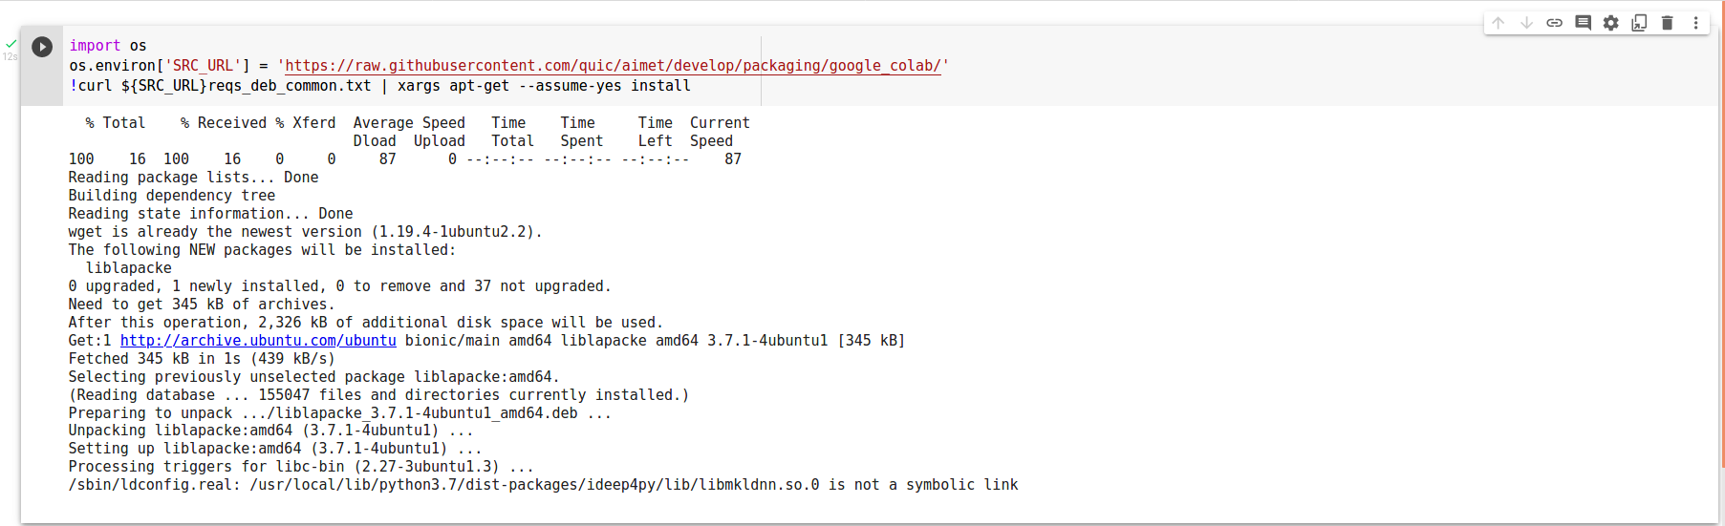
2)Install pytorch CPU python packages
!wget ${SRC_URL}reqs_pip_torch_cpu.txt
!pip3 install -r reqs_pip_torch_cpu.txt -f https://download.pytorch.org/whl/torch_stable.html

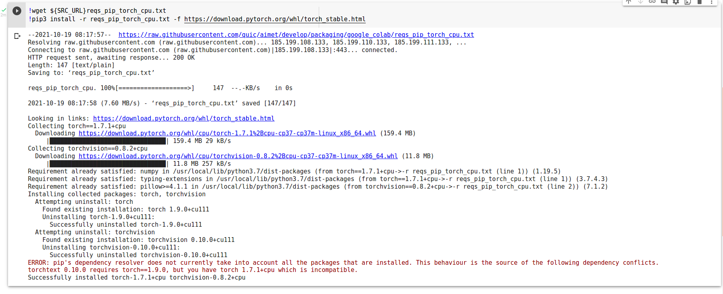
- Install AIMET packages
Go to https://github.com/quic/aimet/releases and check which is for Google Colab (python3.7) . Then run the below commands to install the AIMET packages:
import os
os.environ['release_tag']="1.16.2.py37"
!pip3 install https://github.com/quic/aimet/releases/download/${release_tag}/AimetCommon-torch_cpu_${release_tag}-cp37-cp37m-linux_x86_64.whl
!pip3 install https://github.com/quic/aimet/releases/download/${release_tag}/AimetTorch-torch_cpu_${release_tag}-cp37-cp37m-linux_x86_64.whl

!wget ${SRC_URL}reqs_pip_torch_cpu.txt
!pip3 install -r reqs_pip_torch_cpu.txt -f https://download.pytorch.org/whl/torch_stable.html

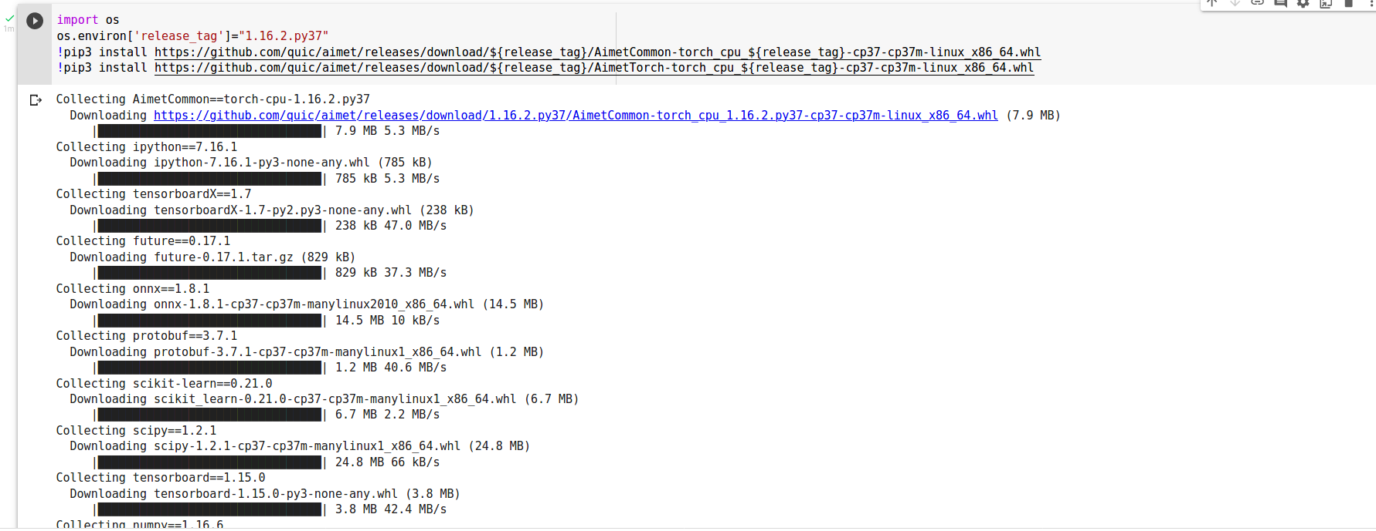
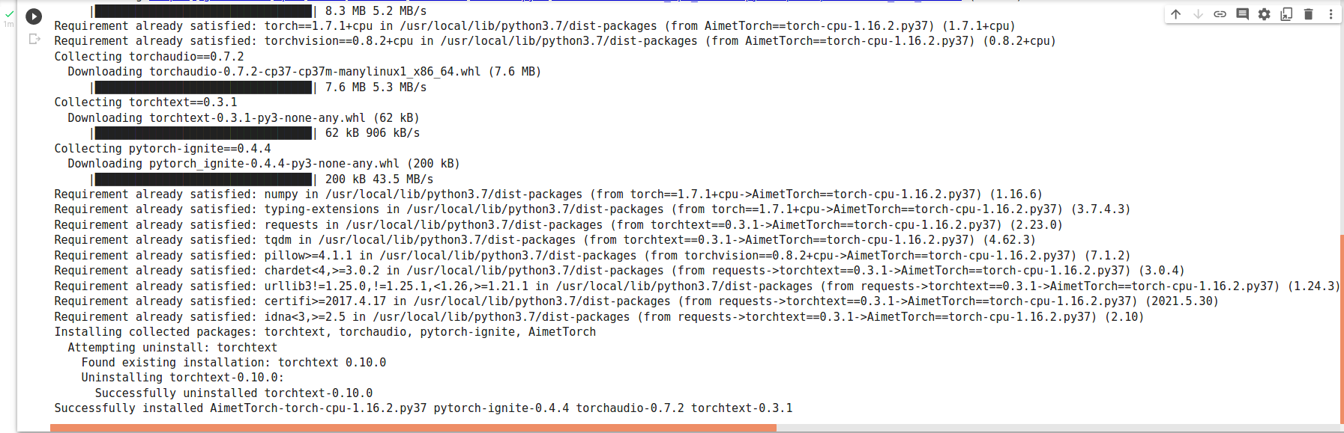
Check AIMET packages:

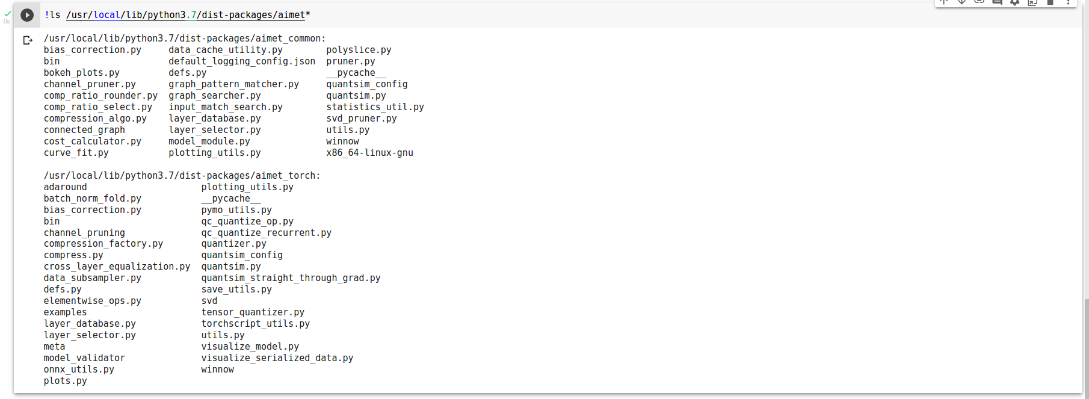
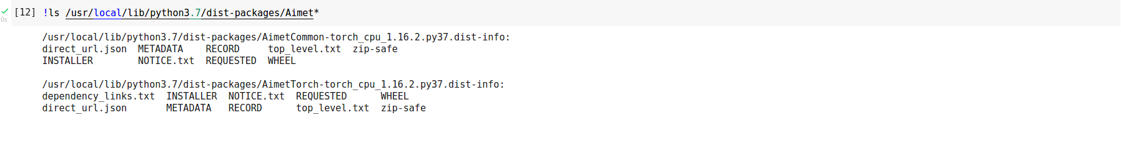
- Environment setup
import sys
sys.path.append('/usr/local/lib/python3.7/dist-packages/aimet_common/x86_64-linux-gnu')
sys.path.append('/usr/local/lib/python3.7/dist-packages/aimet_common/x86_64-linux-gnu/aimet_tensor_quantizer-0.0.0-py3.7-linux-x86_64.egg/')
import os
os.environ['LD_LIBRARY_PATH'] +=':/usr/local/lib/python3.6/dist-packages/aimet_common/x86_64-linux-gnu'

- Environment Validation
The install could be validated by executing a snippet of code that instantiates a AIMET quantization simulator
import torch
from torchvision import models
from aimet_torch.quantsim import QuantizationSimModel
m = models.resnet18()
sim = QuantizationSimModel(m, dummy_input=torch.rand(1, 3, 224, 224))
print(sim)

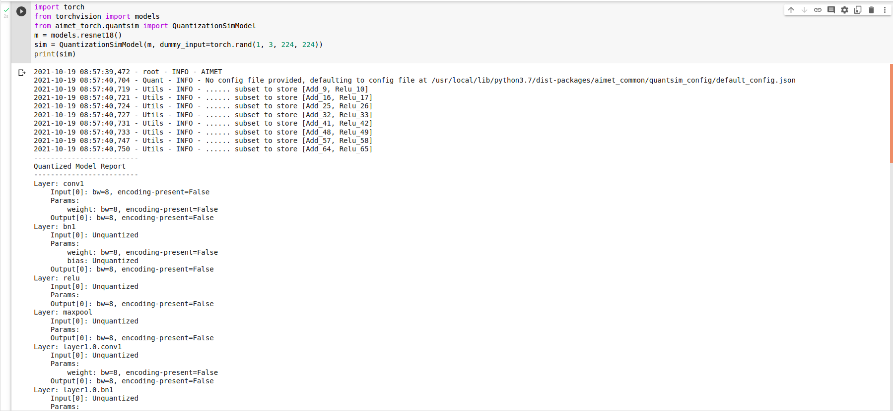

Setup pytorch GPU AIMET environment
- Install Dependency packages
- Install common and pytorch GPU debian packages
import os
os.environ['SRC_URL'] = 'https://raw.githubusercontent.com/quic/aimet/develop/packaging/google_colab/'
!curl ${SRC_URL}reqs_deb_common.txt | xargs apt-get --assume-yes install
!curl ${SRC_URL}reqs_deb_torch_gpu.txt | xargs apt-get --assume-yes --allow-change-held-packages install

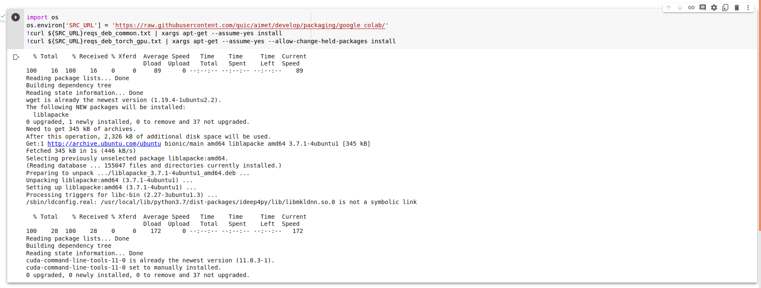
- Install pytorch GPU python packages
!wget ${SRC_URL}reqs_pip_torch_gpu.txt
!pip3 install -r reqs_pip_torch_gpu.txt -f https://download.pytorch.org/whl/torch_stable.html

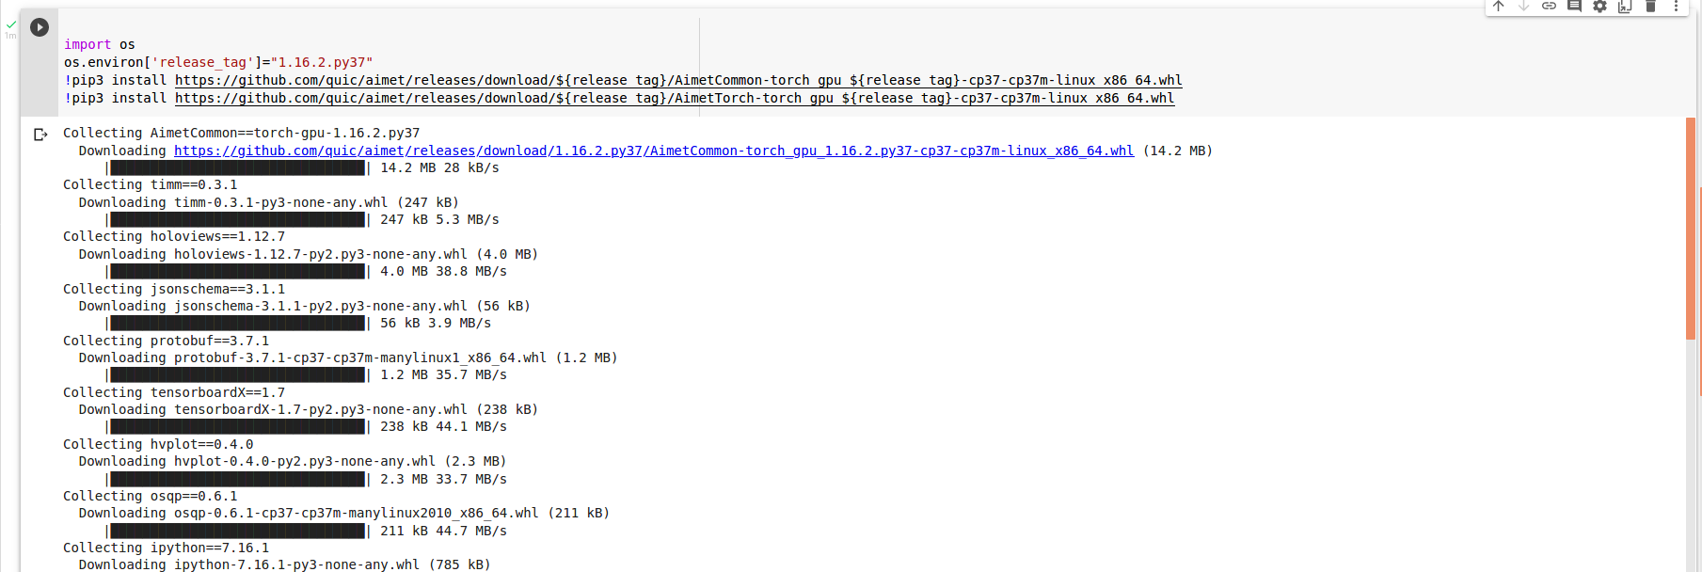
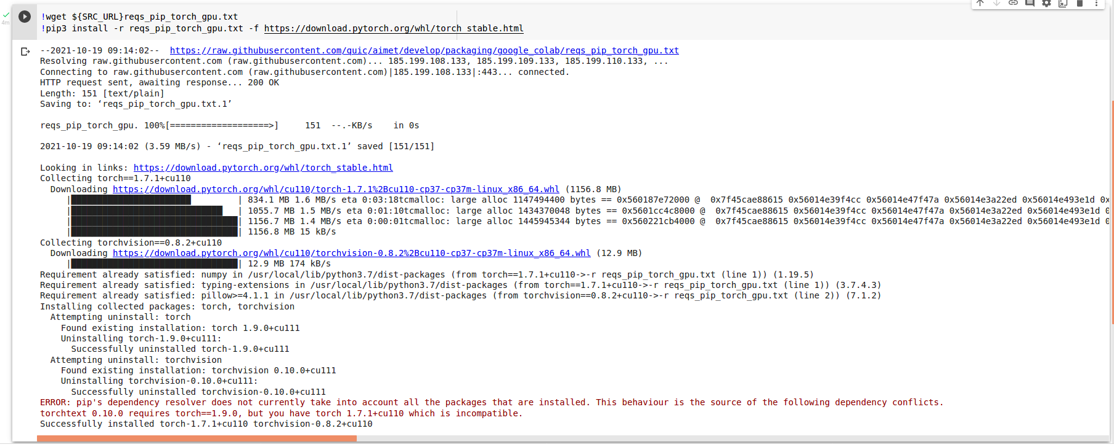

- Install AIMET packages
Go to https://github.com/quic/aimet/releases and check which is for Google Colab (python3.7) . Then run the below commands to install the AIMET packages:
import os
os.environ['release_tag']="1.16.2.py37"
!pip3 install https://github.com/quic/aimet/releases/download/${release_tag}/AimetCommon-torch_gpu_${release_tag}-cp37-cp37m-linux_x86_64.whl
!pip3 install https://github.com/quic/aimet/releases/download/${release_tag}/AimetTorch-torch_gpu_${release_tag}-cp37-cp37m-linux_x86_64.whl

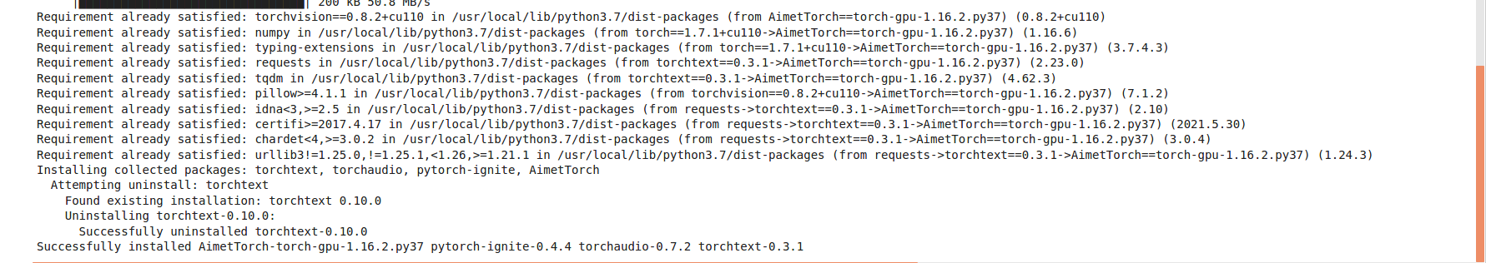
Check AIMET packages:
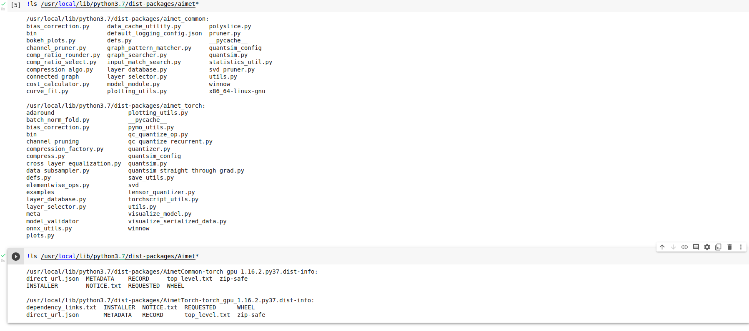
- Environment setup
import sys
sys.path.append('/usr/local/lib/python3.7/dist-packages/aimet_common/x86_64-linux-gnu')
sys.path.append('/usr/local/lib/python3.7/dist-packages/aimet_common/x86_64-linux-gnu/aimet_tensor_quantizer-0.0.0-py3.7-linux-x86_64.egg/')
import os
os.environ['LD_LIBRARY_PATH'] +=':/usr/local/lib/python3.6/dist-packages/aimet_common/x86_64-linux-gnu'

- Environment Validation
The install could be validated by executing a snippet of code that instantiates a AIMET quantization simulator
import torch
from torchvision import models
from aimet_torch.quantsim import QuantizationSimModel
m = models.resnet18().cuda()
sim = QuantizationSimModel(m, dummy_input=torch.rand(1, 3, 224, 224).cuda())
print(sim)

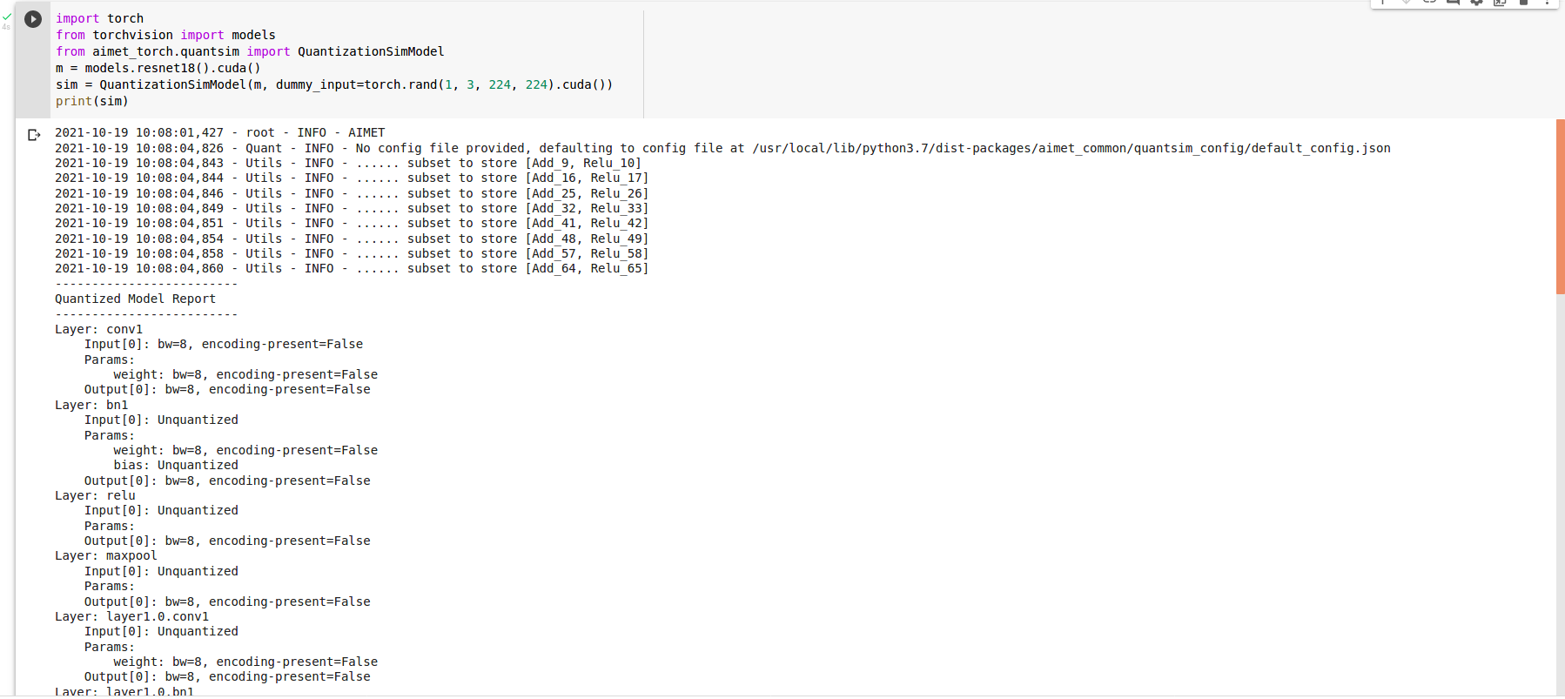

Summary
This document introduces the following points for new developers to use AIMET:
1. How to Setup a Google Colab environment, check Google Colab resources, check network speed, etc.
2. How to install the debian package that pytorch AIMET depends on Google colab, install
pytorch AIMET CPU and GPU version packages, verify whether the environment is built successfully.

Developers can use AIMET based on this environment to quantize and compress pytorch models.

