Thundercomm TurboX™

C610 OpenKit UserManual

# Hardware introduce

**TurboXTM C610 Open Kit front**

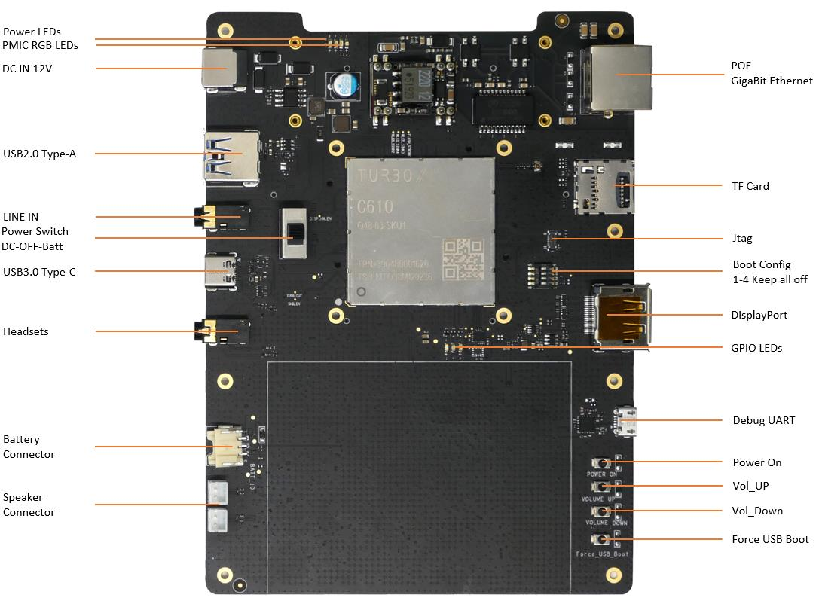

**TurboXTM C610 Open Kit back**

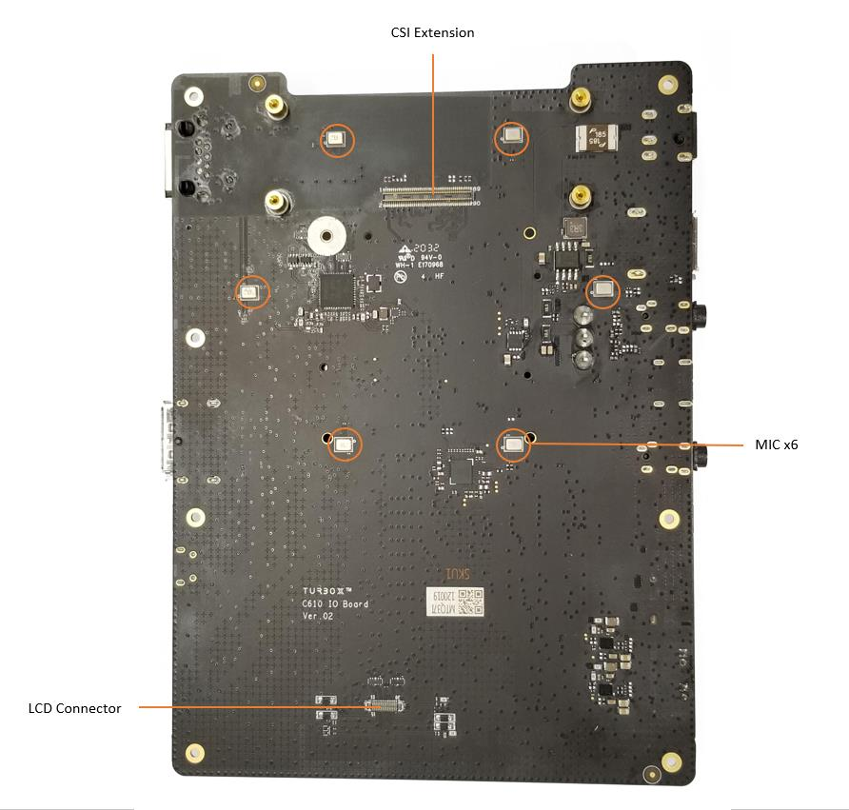

TurboXTM C610 Open Kit Block Diagram

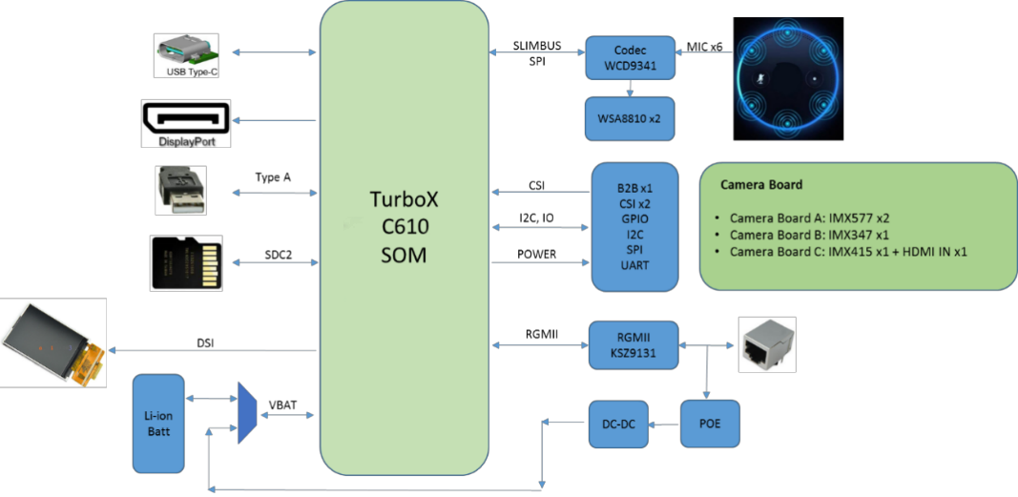

## Extension hardware 415 camera module

This 415 module is TurboX C610 board camera module.Maximum pixel support 1080p.

**C610 Camera IMX415**

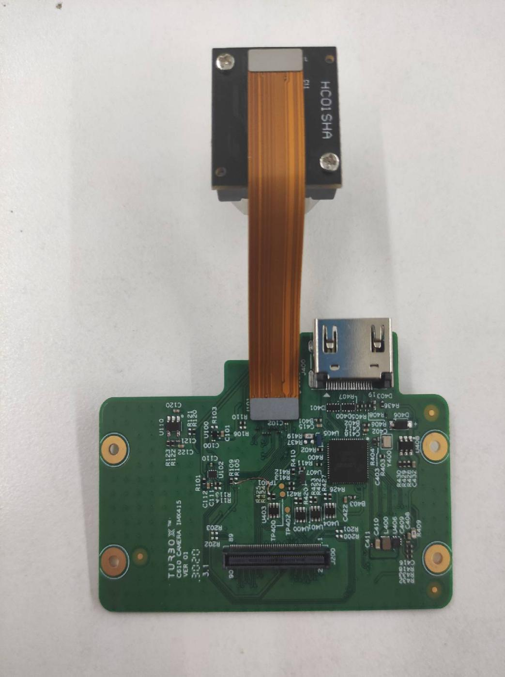

**C610 Camera IMX415 jumper detatil**

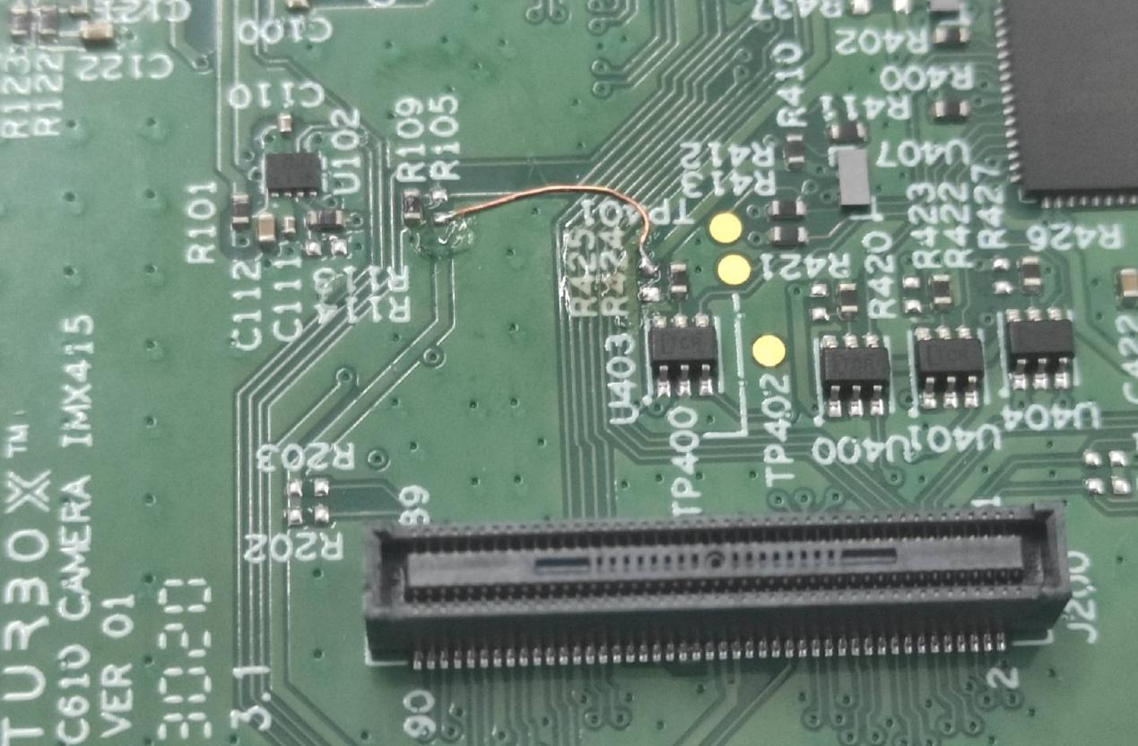

**Correct jumper connection method :left side R109 connect with right side R424.**

# Flash system

## Getting the ROM package

FastbootBuild_Turbox-C610_le1.0.R.debug.Pre-FC2.xxxxx.zip

FlatBuild_Turbox-C610_le1.0.R.debug.Pre-FC2.xxxxx.zip

1. xxxxx corresponds to different system versions.The system version have to >= 20201228 if you need use 415 module.

## Flash Images to Board

1. Please flash the FLatBuild Image to the Open Kit firstly if the current Image is not this release on your Open Kit.

### Flash FastbootBuild image

Fastboot tool flash image, the device must be placed in the Fastboot mode. Use the following methods:

When the device is in the ADB mode, enter the following command:

$ adb root

$ adb reboot bootloader

To determine if the device has entered the Fastboot mode, run the following command:

$ fastboot devices

If successful, an output like the following displays on the shell:

7050372c fastboot

Enter image directory and execute the below commands to flash an image to the board:

$ cd FastbootBuild_Turbox-C610_le1.0.r.perf.fc1.r001003

$bash ./turbox_flash.sh -r -v perf

1. ./turbox_flash -h will show detailed usage!

### Flash FaltBuild Image

If the Open kit can’t bootup to fastboot mode, you can flash the FlatBuild image using [QDL](https://www.96boards.org/documentation/consumer/guides/qdl.md.html).The detailed compilation process is provided on the OFFICIAL QDL web site.Follow its instructions to get to an executable QDL file that you need to put into the ROM package.

1. Enter 9008 mode

Press and hold the Force_USB_Boot key , then insert the usb and power cable, and you can see the 9008 port, and release the Force USB Boot key:

$ lsusb

……

Bus 001 Device 042: ID 05c6:9008 Qualcomm, Inc. Gobi Wireless Modem (QDL mode)

…….

1. Start to flash the flatbuild image

Enter image directory and download command is as below:

$ cd FlatBuild_Turbox-C610_le1.0.r.perf.fc1.r001003

$ chmod +x qdl

$ sudo ./qdl --storage emmc prog_firehose_ddr.elf rawprogram*.xml patch*.xml

# SmartCashier Demo Usage

## Start a adb shell environment

$ adb root

$ adb remount

$ adb shell mount -o remount rw /

$ adb shell

$ adb push xxx/SmartCashier /data

## Start SmartCashier demo

### Start SmartCashier

Execute below commands to start multi-decoder:

$ chmod u+x SmartCashier/Install.sh

$ ./Install.sh

$ ./smartcashier