## Summary

This guide shows how to get TensorFlowJS Model and go about converting the model trained with TensorFlowJS to TensorFlow Lite FlatBuffers.

## How to get TensorFlowJS Model

**1.Download gesture_classification web project from github.**

URL:https://github.com/tensorflow/examples/tree/master/lite/examples/gesture_classification/web

**2.Run gesture_classification web project.**

Insert an USB camera and use a browser to open ../gesture_classification/web/index.html

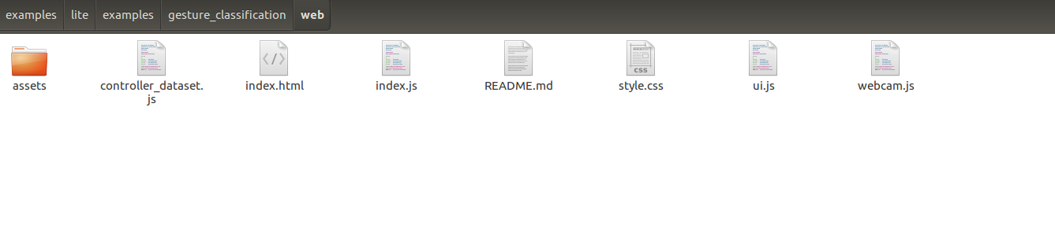

Enter Model Training page, set some parameters if needed

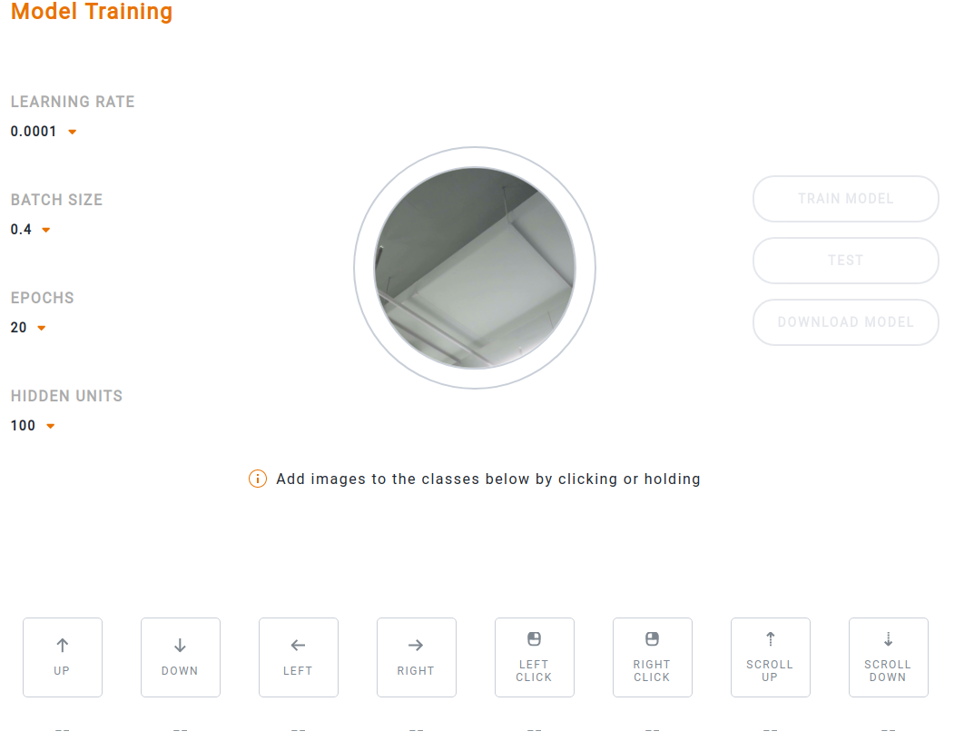

**3.Train and get TensorFlowJS Model.**

Add the corresponding data set (i.e. take a few corresponding pictures), and then click the “**TRAIN”** button.

We should add data sets with "up", "down", "left" and "right" directions

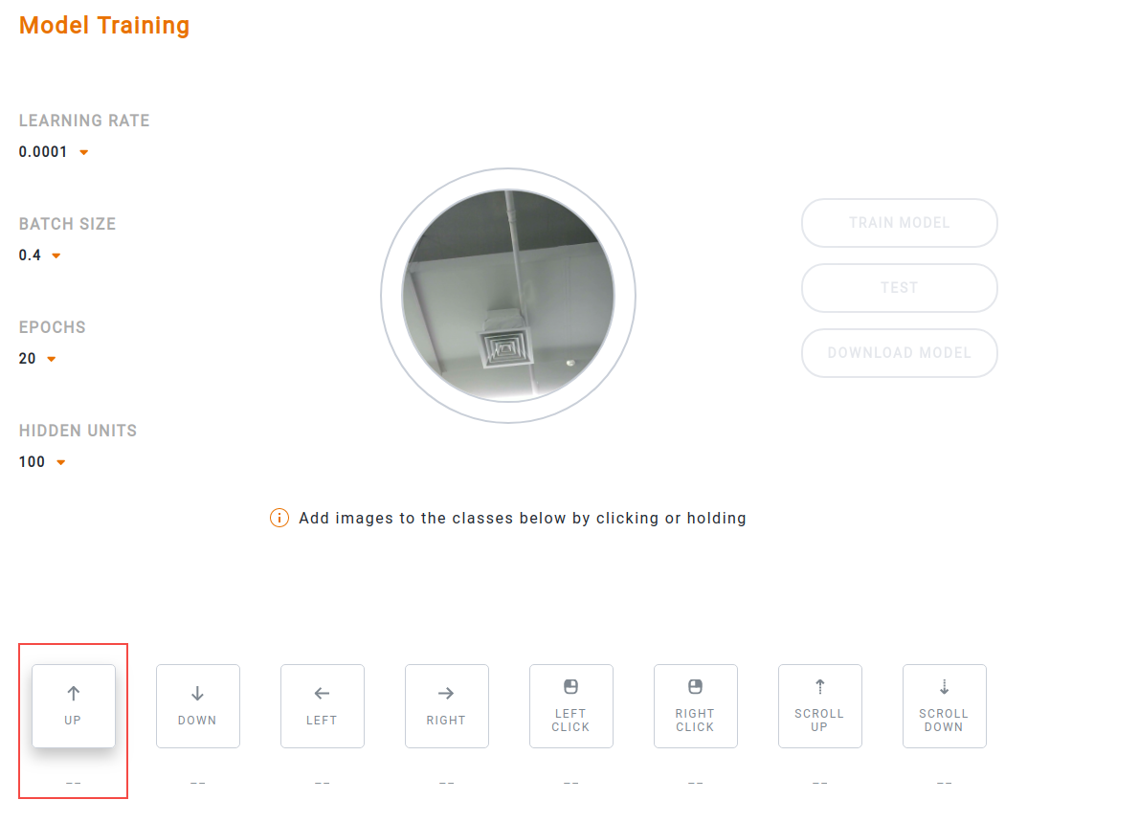

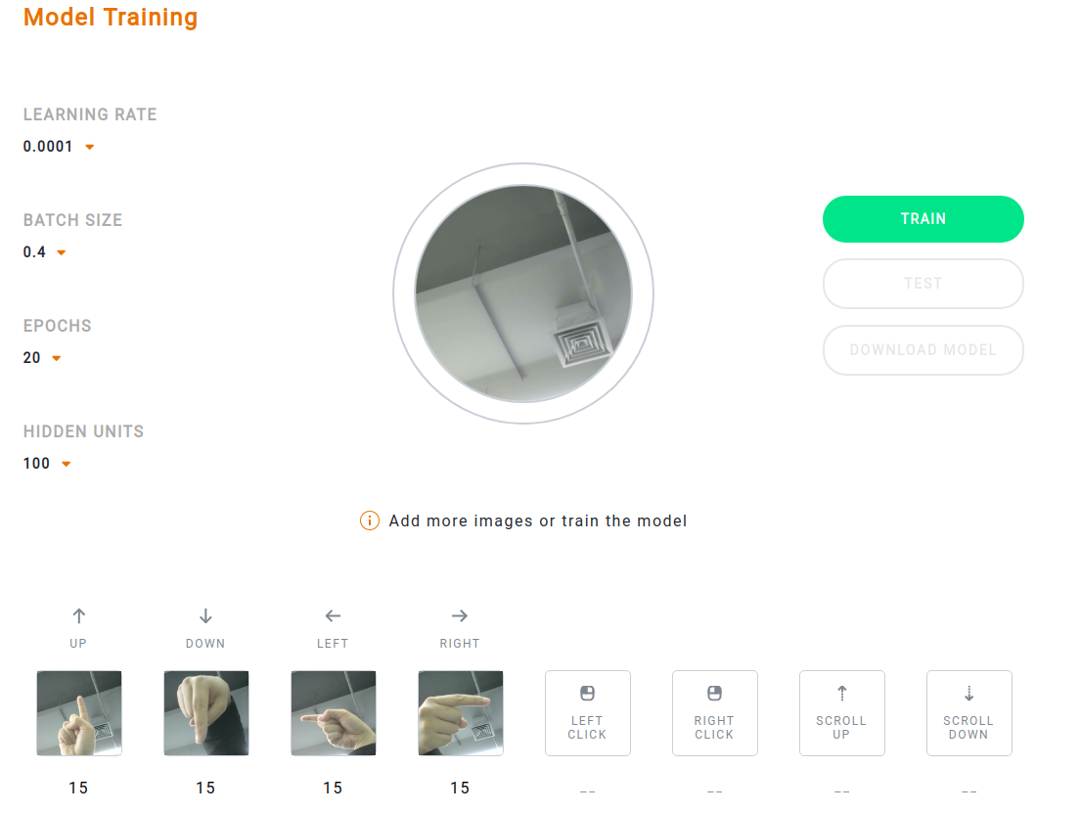

Train the model

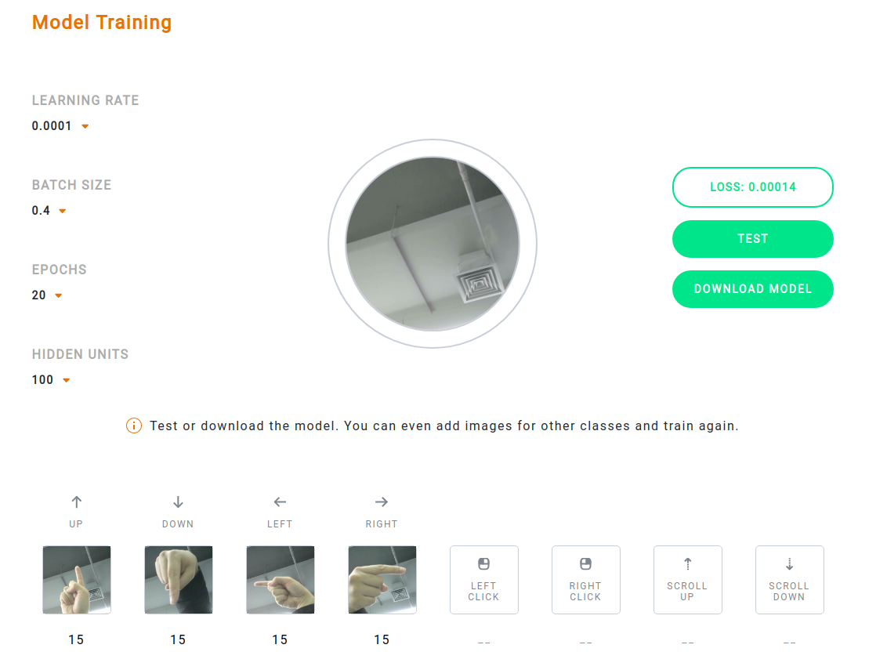

Test the model

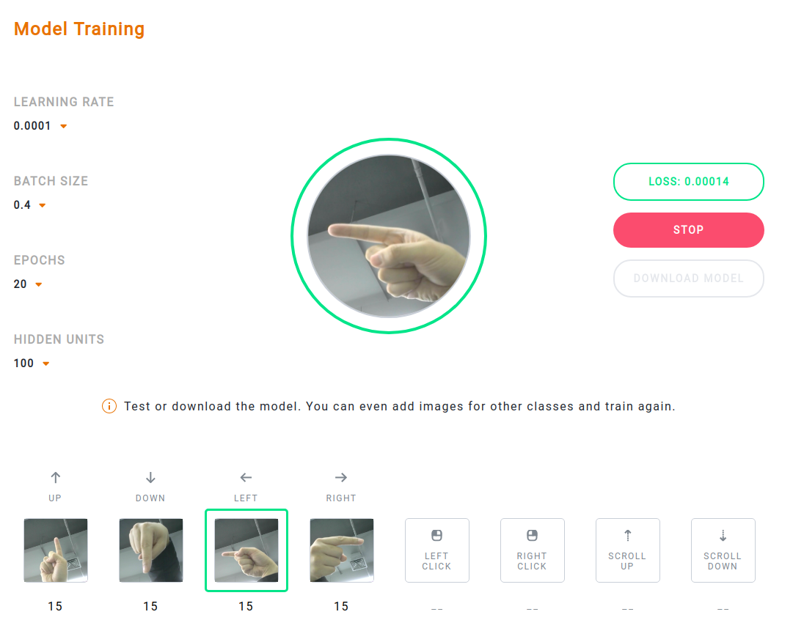

Download the model

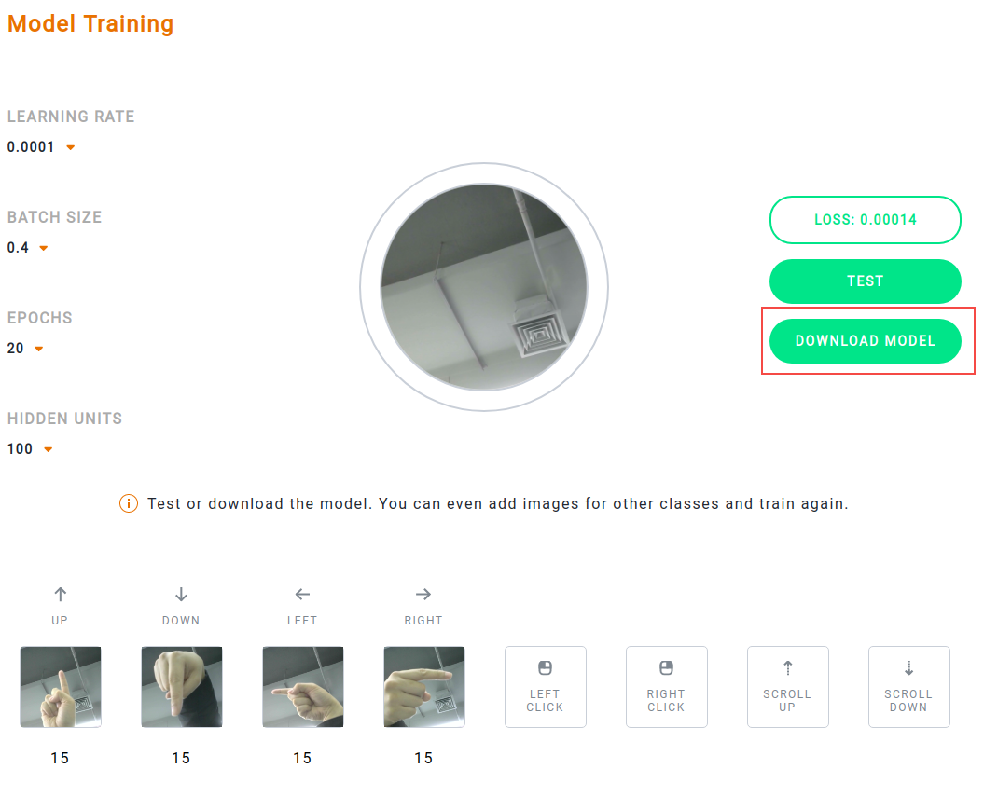

## How to use Google Colab to convert

#### 2.1 Create a Colab notebook on Google Drive

**1.Login in Google Drive.**

https://drive.google.com

**2.First associate Colab with Google Drive**

Click New -> More -> Connect more apps, find Google Colaboratory, and connect.

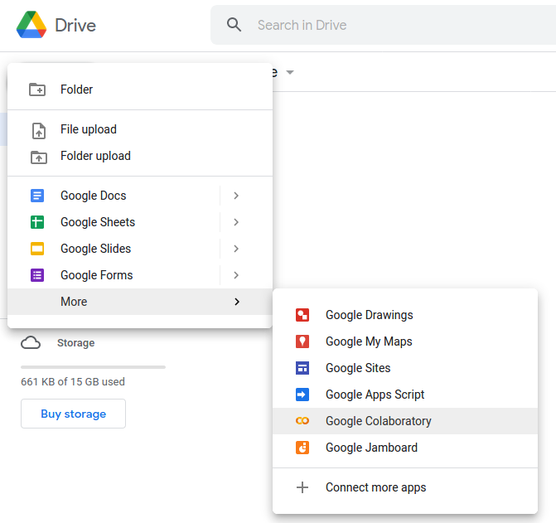

Appears following page after creation

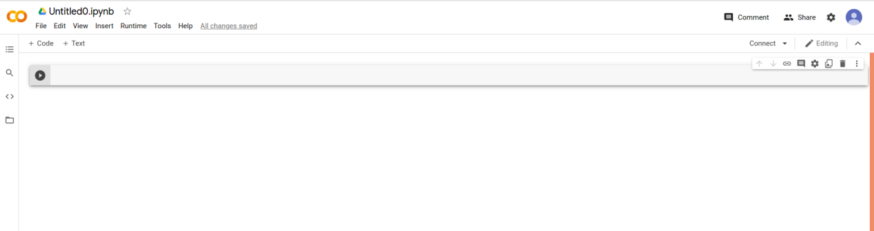

#### 2.2 Run command at Colab notebook

**1.Install Dependencies**



!pip install -q tensorflowjs

## 

import traceback

import logging

import tensorflow as tf

import os

from google.colab import files

from tensorflow import keras

from tensorflowjs.converters import load_keras_model

logging.basicConfig(level=logging.INFO)

logger = logging.getLogger(__name__)

**2.Upload your Tensorflow.js Artifacts Here**

i.e., The weights manifest **model.json** and the binary weights file **model-weights.bin**

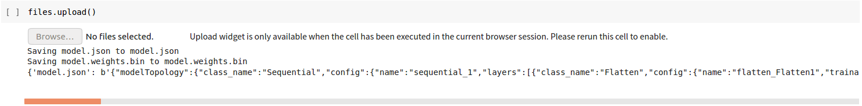

files.upload()

**3.Export Configuration**

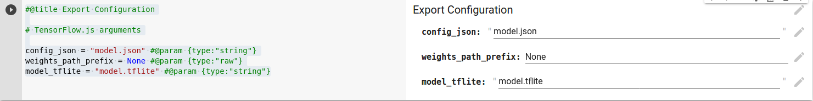

#@title Export Configuration

# TensorFlow.js arguments

config_json = "model.json" #@param {type:"string"}

weights_path_prefix = None #@param {type:"raw"}

model_tflite = "model.tflite" #@param {type:"string"}

**4.Model Converter**

The following class converts a TensorFlow.js model to a TFLite FlatBuffer

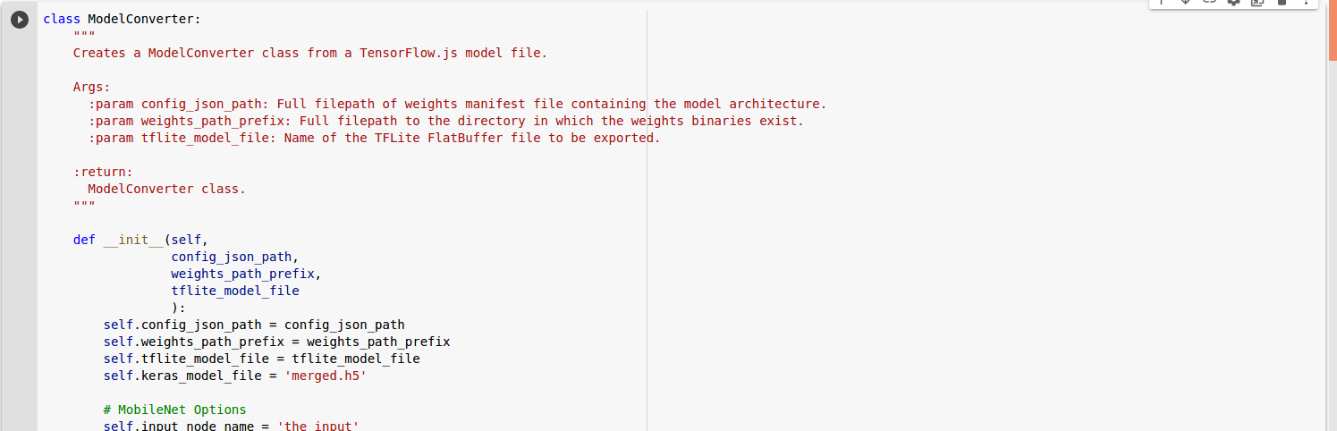

class ModelConverter:

"""

Creates a ModelConverter class from a TensorFlow.js model file.

Args:

:param config_json_path: Full filepath of weights manifest file containing the model architecture.

:param weights_path_prefix: Full filepath to the directory in which the weights binaries exist.

:param tflite_model_file: Name of the TFLite FlatBuffer file to be exported.

:return:

ModelConverter class.

"""

def __init__(self,

config_json_path,

weights_path_prefix,

tflite_model_file

):

self.config_json_path = config_json_path

self.weights_path_prefix = weights_path_prefix

self.tflite_model_file = tflite_model_file

self.keras_model_file = 'merged.h5'

# MobileNet Options

self.input_node_name = 'the_input'

self.image_size = 224

self.alpha = 0.25

self.depth_multiplier = 1

self._input_shape = (1, self.image_size, self.image_size, 3)

self.depthwise_conv_layer = 'conv_pw_13_relu'

def convert(self):

self.save_keras_model()

self._deserialize_tflite_from_keras()

logger.info('The TFLite model has been generated')

def save_keras_model(self):

top_model = load_keras_model(self.config_json_path, self.weights_path_prefix,

weights_data_buffers=None,

load_weights=True,

)

base_model = self.get_base_model()

self._merged_model = self.merge(base_model, top_model)

logger.info("The merged Keras has been generated.")

def merge(self, base_model, top_model):

"""

Merges base model with the classification block

:return: Returns the merged Keras model

"""

logger.info("Initializing model...")

layer = base_model.get_layer(self.depthwise_conv_layer)

model = keras.Model(inputs=base_model.input, outputs=top_model(layer.output))

logger.info("Model created.")

return model

def get_base_model(self):

"""

Builds MobileNet with the default parameters

:return: Returns the base MobileNet model

"""

input_tensor = keras.Input(shape=self._input_shape[1:], name=self.input_node_name)

base_model = keras.applications.MobileNet(input_shape=self._input_shape[1:],

alpha=self.alpha,

depth_multiplier=self.depth_multiplier,

input_tensor=input_tensor,

include_top=False)

return base_model

def _deserialize_tflite_from_keras(self):

converter = tf.lite.TFLiteConverter.from_keras_model(self._merged_model)

tflite_model = converter.convert()

with open(self.tflite_model_file, "wb") as file:

file.write(tflite_model)

**5.Getting TFLite model.**

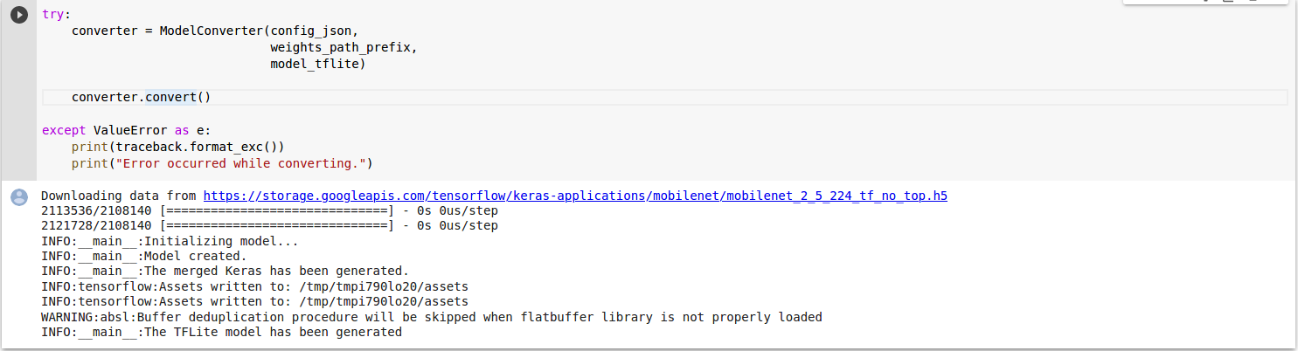

try:

converter = ModelConverter(config_json,

weights_path_prefix,

model_tflite)

converter.convert()

except ValueError as e:

print(traceback.format_exc())

print("Error occurred while converting.")

**6.Download TFLite model**



files.download(model_tflite)

**7.Check TFLite model**

Access <https://netron.app/> and import tflite model file:

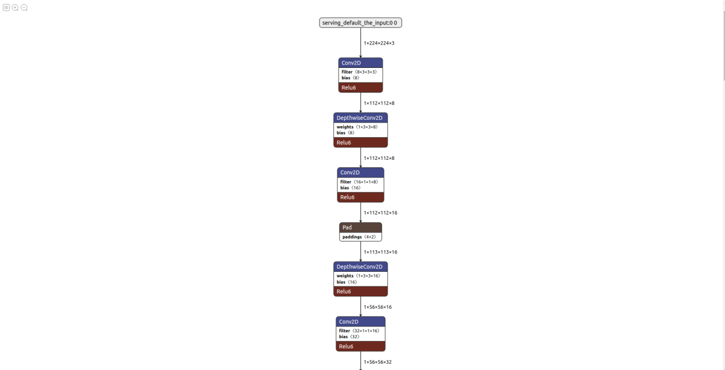

Please check <Project Dir>/C865DK-VisionTest1.0/model.tflite.svg to check full layer structure.