Qualcomm Developer Project FireDetectApp
Attribution:
Email address | sunzhen@thundersoft.com  yangrong0925@thundersoft.com  wangjie0508@thundersoft.com  Kouzw0723@thundersoft.com  yansh0810@thundersoft.com
Project Title* | Fire detector
Description*  High level description of the project (75 words or less) | Using aikit-c845 to collect multiple 1080 camera data through RTSP, send decoded data to fireworks detection algorithm to display fireworks position.使用aikit-C845通过rtsp取流方式采集多路1080摄像头数据，将解码数据送给烟火检测算法再显示烟火位置。
Images  Upload up to 5 images of your project  Please submit/send the original JPEG/PNG files for all images included in the document | Aikit_DEV.png  [alt tag: “MultVideoPlayer using the Aikit-C845 development board.多路视频解码器，使用Aikit-C845开发板”]  Type-C.png  [alt tag: “using the type-c line to develop on Gokit4 development board. 使用type-c线开发。”]  Mini-hdmi.jpg  [alt tag: “use mini-hdmi line to connect display . mini-hdmi线连接显示器。”]  HIKVISION_Camera.png  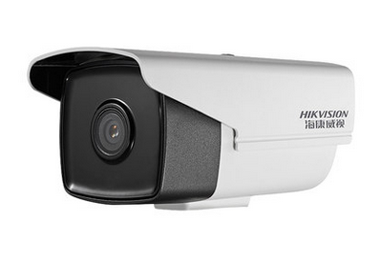
  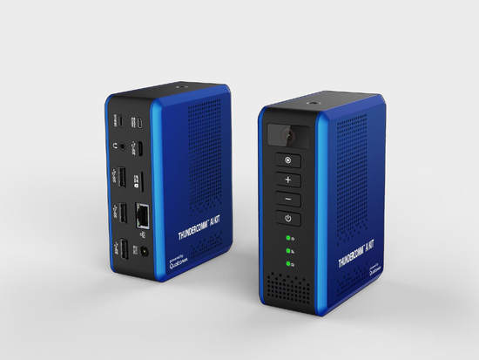
  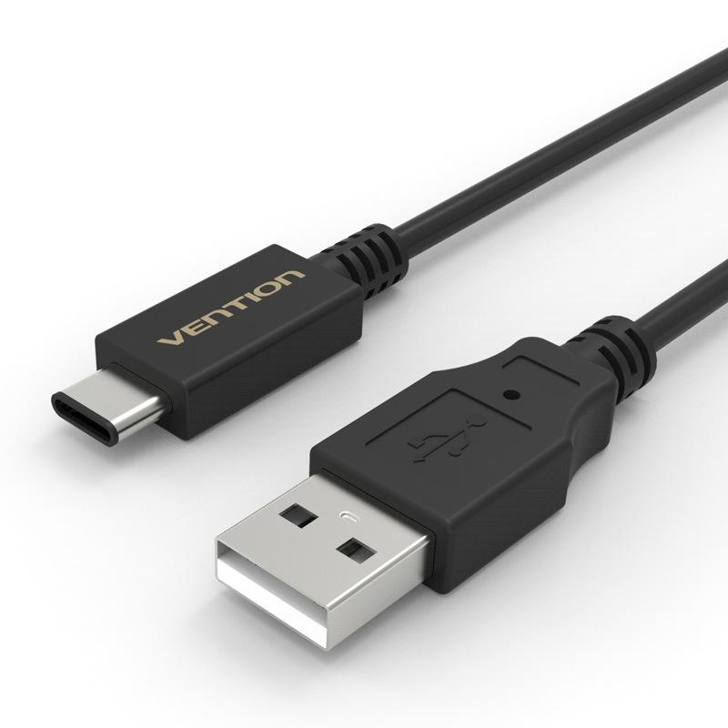
  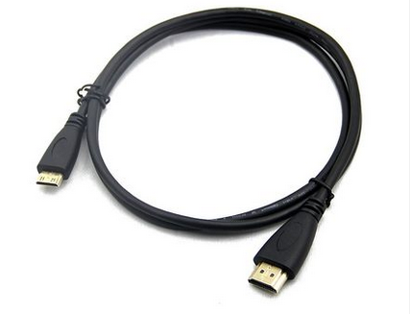
Objective  - What inspired you to create this project?  - What is your desired outcome? | Show the powerful decoding and computing power of aikit-c845 through 4 decoding videos.（通过4路解码视频展示aikit-C845的强大解码能力和算力能力）
Operation System*  (Android, Linux, Windows 10 IoT Core) |  Android  RTOS  Linux | Windows 10 IoT Core  Ubuntu Core
Cloud Services/Platform  AT&T M2X, AWS IoT, IBM Bluemix, IBM Watson IoT, Such as Microsoft Azure IoT) | Amazon AWS IoT  AT&T M2x  IBM Bluemix | IBM Watson IoT  EasyMonitor  Google Cloud Platform
Skill Level Required  (Beginner, Intermediate, Advanced) | Advanced  Beginner | Intermediate
Areas of Focus  (e.g., IoT, smart cities, smart home, robotics, hardware, construction site, factory workshop, catering kitchen, outdoor forest etc.) | 3D Printing & Modeling  Alexa Voice Service  Bluetooth  Computer Vision  Digital Signage  Education  Embedded  Gaming | Healthcare  Robotics  Sensors  SmartCities  Toys  construction site  factory workshop  catering kitchen  outdoor forest
Materials Required / Parts List / Tools | Part Name | Link
Materials Required / Parts List / Tools | Aikit | https://www.thundercomm.com/app_en/store/detail/1536844968290219
Materials Required / Parts List / Tools | Type-c line | https://detail.tmall.com/item.htm?id=44425281296&ali_refid=a3_430582_1006:1103572855:N:8BFxSxK119dzkfQCc2yGI2us815vvcUHETWnj5g1swo=:6399b40850a40201c56536531a885bcf&ali_trackid=1_6399b40850a40201c56536531a885bcf&spm=a230r.1.14.11
Materials Required / Parts List / Tools | Mini-hdmi line | https://detail.tmall.com/item.htm?spm=a230r.1.14.308.721f3c99U7hVi5&id=520813921702&ns=1&abbucket=1
Materials Required / Parts List / Tools | HIKVISION_Camera | https://item.jd.com/100006551428.html
Source Code / Source Examples / Application Executable  Link to open source / shareable code repository | Description | Link
 | Source Code | https://github.com/ThunderSoft-XA/demo-Smart-Motion-detector
Additional Resources  List related links or resources such as websites, videos, presentations, or other materials | Resource Title | Link or File Name (and provide file)
 | Video of "demo-Smart-Heart-rate-detector” | https://pan.baidu.com/s/1ml_8yiqcInbP6VOKYXGDwQ  g95y
Build / Assembly Instructions | Parts used  Below are the items used in this project.（以下是本项目中使用到的部分。）  Aikit.jpg display.jpg  [alt tag: “Parts used for the Gokit4 development kit demo-Smart-Heart-rate-detector”]  - Ubuntu16.04.（windows7台式机）  - Aikit development board.（aikit开发板套件）  - HIKVISION camera is used to collect video data.（海康摄像头用来采集视频数据）  - HDMI display for viewing decoded video results.（HDMI显示器用于查看解码视频结果）  Deploying the project  - According to the demo requirements, combine the onboard resources of the Gokit development board to purchase suitable devices.（根据demo的需求，结合板载资源购买合适的器件。）  - Test if the optional device is available.（检测器件是否可用。）  - Build and debug hardware circuits.（搭建和调试硬件电路。）  - Create a FireDetectApp project locally.（创建本地项目“demo-Smart-Motion-detector”。）  - Transplant relevant source code.（移植相关源代码。）  - Joint debugging.（联合调试。）  - Code uploaded to github.（上传代码到github。）  How does it work?  Below are some usage instructions to test the project.（下面是测试项目的使用说明。）  Now let's introduce the FireDetectApp’s workflow. It （现在我们介绍”FireDetectApp”的工作流程。  FireDetectApp application realizes the video data decoding of 4-way RTSP camera and sends it to the cloud for pyrotechnic detection algorithm detection. The location of the fire is displayed in a rectangular frame（FireDetectApp 应用实现4路rtsp摄像头视频数据解码送云端烟火检测算法检测，降火情位置以矩形框展示）  init_window---->init_camea---->init_decodert---->start_detect_process  FireDetectApp/FireDetectApp.c  void main( void )  {  /*step 1 init window for display*/  init_window ();  /*step 2 init viedeo resource*/  init_camera(INI_FILE_PATH, CAM_CONFIG_MAX);  /*step 3 init decoder resource*/  init_decoder();  /*step 4 start fire/smoke detect process*/  start_detect_process(CLOUDE_DEV_NAME);  while(true) sleep(3);  /*step 5 deinit decoder resource*/  deinit_decoder();  return 0;  }  Config module realizes the management of configuration files camera_conf.ini（config 模块实现对配置文件camera_conf.ini的管理）  /FireDetectApp/config/src/param.c  camera_param_load Load configuration to memory for Application use（加载配置到内存共应用使用）  int camera_param_load(char *fileName, ST_CameraConf* pstCameraConf)  {  sprintf(mfileName,"%s",fileName);  int ret = param_init();  if(ret)  return -1;  sprintf(pstCameraConf->cameraName, "%s",param_get_string(pstCameraConf->camera_dic,"cameraname","camera_zero"));  sprintf(pstCameraConf->decode, "%s",param_get_string(pstCameraConf->camera_dic,"decode","NULL"));  sprintf(pstCameraConf->enable, "%s",param_get_string(pstCameraConf->camera_dic,"enable","off"));  sprintf(pstCameraConf->path, "%s",param_get_string(pstCameraConf->camera_dic,"path","NULL"));  pstCameraConf->cameraID = param_get_int(pstCameraConf->camera_dic,"cameraid",0);  pstCameraConf->height = param_get_int(pstCameraConf->camera_dic,"height",1920);  pstCameraConf->width = param_get_int(pstCameraConf->camera_dic,"width",1080);  pstCameraConf->w_x = param_get_int(pstCameraConf->camera_dic,"w_x",0);  pstCameraConf->w_y = param_get_int(pstCameraConf->camera_dic,"w_y",0);  pstCameraConf->w_w = param_get_int(pstCameraConf->camera_dic,"w_w",320);  pstCameraConf->w_y = param_get_int(pstCameraConf->camera_dic,"w_h",240);  param_deinit();  printf("%s\n",__FUNCTION__);  printf("cameraID: %d\n",pstCameraConf->cameraID);  printf("cameraName: %s\n",pstCameraConf->cameraName);  printf("decode: %s\n",pstCameraConf->decode);  printf("enable: %s\n",pstCameraConf->enable);  printf("path: %s\n",pstCameraConf->path);  printf("height: %d\n",pstCameraConf->height);  printf("widh: %d\n",pstCameraConf->width);  printf("w_x: %d\n",pstCameraConf->w_x);  printf("w_y: %d\n",pstCameraConf->w_y);  printf("w_h: %d\n",pstCameraConf->w_h);  printf("w_w: %d\n",pstCameraConf->w_w);  if(strncmp(pstCameraConf->decode, "NULL",strlen("NULL")) == 0 || strncmp(pstCameraConf->path,"NULL",strlen("NULL")) == 0)  {  printf("%s: error\n",__FUNCTION__);  return -1;  }  return 0;  }  Ai_client module realizes the client work of fireworks detection algorithm，the workflow is as follows: (ai_client 模块实现烟火检测算法客户端工作,工作流程如下)  Get_devidec_token->push_image_data ->get_detect_result  int get_device_token(char *name, char *token)  {  int add_flag = 0, i = 0;  T_DeviceInfo DevInfo[MAX_DEV_NUM];  memset(DevInfo, 0, sizeof(T_DeviceInfo)*MAX_DEV_NUM);  int ret = bdai_query_devices(DevInfo);  if(ret > 0)  {  for(i=0; i<ret; i++)  {  if(strncmp(name, DevInfo[i].name, strlen(name)) == 0)  {  printf("%s name%s token %s \n",__FUNCTION__,DevInfo[i].name,DevInfo[i].device_token);  sprintf(token, "%s",DevInfo[i].device_token);  return 0;  }  }  }  return bdai_add_device(name,token);  }  int bdai_push_image(char *image, int size,long long requestTime, char *device_token)  {  int ret = 0;  char *base64_data = (char *)malloc(size*2);  memset(base64_data, 0, size*2);  base64_encode(image, size, base64_data);  /*create json string*/  cJSON * objson = cJSON_CreateObject();  cJSON_AddStringToObject(objson, "resource",base64_data);  cJSON_AddStringToObject(objson,"resourceType","base64");  cJSON_AddStringToObject(objson, "deviceToken",device_token);  cJSON_AddNumberToObject(objson, "requestTime",requestTime);  /*create connect*/  T_CurlClientOpt stClientOpt;  memset(&stClientOpt,0, sizeof(T_CurlClientOpt));  stClientOpt.response_callback = result_of_request_bdai;  stClientOpt.post_type = TYPE_UPLOAD_IMAGE;  sprintf(stClientOpt.content_type, "%s",CONTENTTYPE_OF_JSON_UTF8);  sprintf(stClientOpt.strUrl,"%s?%s",IMAGE_UPLOAD_IP,ACCESS_TOKEN);  stClientOpt.body = cJSON_Print(objson);  printf("[%s:%d] UIL:%s \nbody: \n",__FUNCTION__,__LINE__,stClientOpt.strUrl/*,stClientOpt.body*/);  ret = client_start_connection(stClientOpt, NULL);  if(base64_data)  free(base64_data);  /*must release json string*/  free(stClientOpt.body);  cJSON_Delete(objson);  return ret;  }  int bdai_get_detect_result(int type, char *device_token, long requestTime_start, long requestTime_end, void *detect_result)  {  int ret = 0;  /*create json string*/  cJSON * objson = cJSON_CreateObject();  cJSON_AddStringToObject(objson, "deviceToken",device_token);  cJSON_AddNumberToObject(objson, "skillId",type);  cJSON_AddNumberToObject(objson, "startTime",requestTime_start);  cJSON_AddNumberToObject(objson, "endTime",requestTime_end);  /*create connect*/  T_CurlClientOpt stClientOpt;  memset(&stClientOpt,0, sizeof(T_CurlClientOpt));  stClientOpt.response_callback = result_of_request_bdai;  if(type == SKILL_FIRE_DETECT)  stClientOpt.post_type = TYPE_QURY_FIRE_EVENT;  else if(type == SKILL_LEAVER_WORK)  stClientOpt.post_type = TYPE_QURY_LEAVE_EVENT;  else if(type == SKILL_STRANGER_DETECT)  stClientOpt.post_type = TYPE_QURY_FACE_EVENT;  sprintf(stClientOpt.content_type, "%s",CONTENTTYPE_OF_JSON_UTF8);  sprintf(stClientOpt.strUrl,"%s?%s",EVENT_QURY_IP,ACCESS_TOKEN);  stClientOpt.body = cJSON_Print(objson);  printf("[%s:%d] UIL:%s \nbody: %s\n",__FUNCTION__,__LINE__,stClientOpt.strUrl,stClientOpt.body);  ret = client_start_connection(stClientOpt, detect_result);  /*must release json string*/  free(stClientOpt.body);  //cJSON_Delete(objson);  return ret;  }
  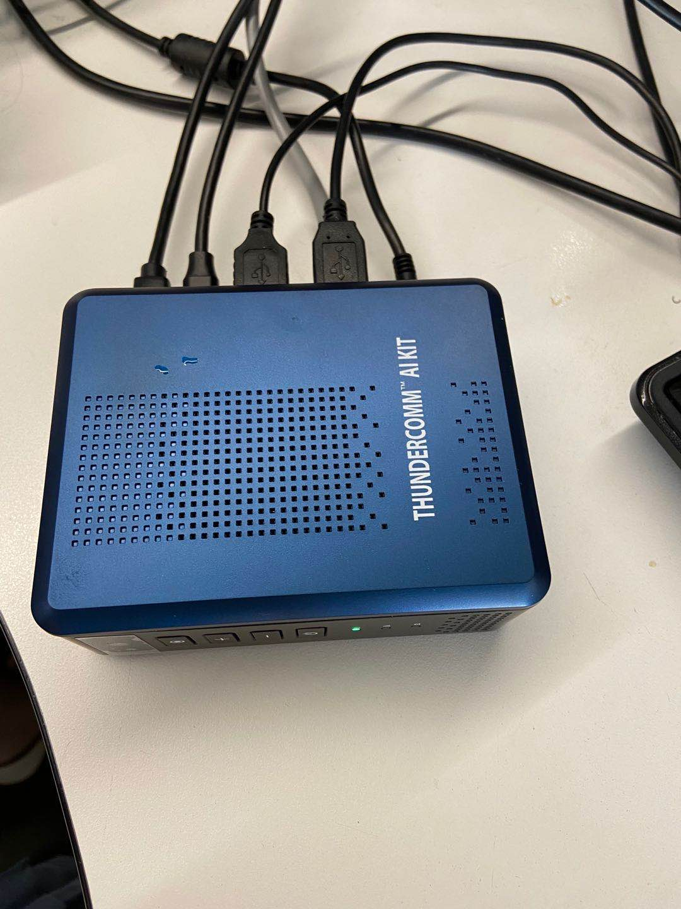 | 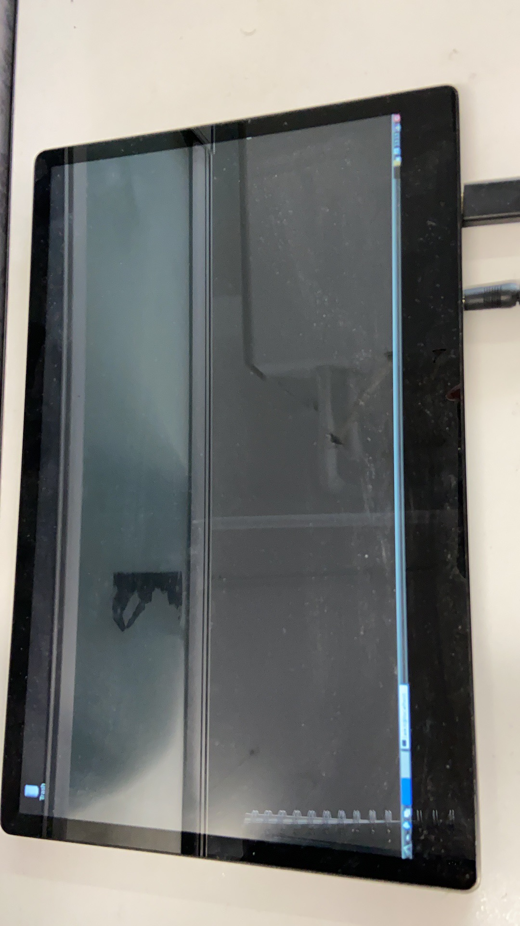
Usage Instructions | - Downloading code from github according to the repository in “https://github.com/ThunderSoft-XA/demo-Smart-Motion-detector” sheet.（从该github链接地址处下载代码。）  - Connect to Aikit by ADB.（adb 连接aikit）  - Refer to the development manual to configure the compile execution environment (参考开发手册配置编译执行环境)  - Push code and compile the code on Aikit development board.（导入并编译代码在开发板。）  - Connecting the display with mini HDMI cable（mini-hdmi 线连接显示器）  - Refer to the development manual to run app to view decoded video（参考开发手册，运行app可查看解码视频）
Fireworks detection algorithm support | Please refer to the user manual for instructions on pyrotechnic detection algorithm.（请参考开发者手册中有关烟火检测算法使用说明。）  The fireworks detection application is the fireworks detection algorithm of Baidu public cloud service. The development refers to the easymonitor video monitoring development platform. There are very detailed use documents in the platform, and developers need to register their own account to obtain cloud services.（烟火检测应用的是百度公有云服务的烟火检测算法，开发参考EasyMonitor 视频监控开发平台，平台内有非常详细的使用文档，需要开发者自行注册账号获取云服务。）
Performance test report
Contributor(s) Info  Feel free to include headshots! | Name | Title  Company
Contributor(s) Info  Feel free to include headshots! | Zhen  sunzhen@thundersoft.com | Thundersoft
Contributor(s) Info  Feel free to include headshots! | Rong  yangrong0925@thundersoft.com | Thundersoft
Contributor(s) Info  Feel free to include headshots! | Jie  wangjie0508@thundersoft.com | Thundersoft
Contributor(s) Info  Feel free to include headshots! | Kou  kouzw0723@thundersoft.com | Thundersoft
Contributor(s) Info  Feel free to include headshots! | Eric  yansh0810@thundersoft.com | Thundersoft

By submitting your content (“Submission”), you are granting Qualcomm a royalty-free, perpetual, non-exclusive, unrestricted, worldwide license to: (a) post, use, copy, sublicense, adapt, transmit, publicly perform or display any such Submission, (b) use, reproduce, modify, adapt, publish, translate, create derivative works from, distribute, perform, play, host, communicate, make available and publish your Submission without restriction and (c) sublicense to third parties the unrestricted right to exercise any of the foregoing rights granted with respect to the Submission. The foregoing grants shall include the right to exploit any ideas, concepts, intellectual property, or proprietary rights in such Submission, including but not limited to rights under copyright, trademark, servicemark or patent laws under any relevant jurisdiction without Qualcomm owing any monies to you whatsoever. You represent and warrant that you own all right, title and interest in and to the Submission, or you have been granted sufficient rights in and to the Submission allowing the foregoing use of such Submission.

