Qualcomm Developer Project
MultDecoderApp
Attribution:
Email address | sunzhen@thundersoft.com  yangrong0925@thundersoft.com  wangjie0508@thundersoft.com  Kouzw0723@thundersoft.com  yansh0810@thundersoft.com
Project Title* | MultDecoder
Description*  High level description of the project (75 words or less) | Using aikit-c845 to collect multiple 1080 camera data through RTSP, decode and output to HDMI display .使用aikit-C845通过rtsp取流方式采集多路1080摄像头数据，解码输出到HDMI显示。
Images  Upload up to 5 images of your project  Please submit/send the original JPEG/PNG files for all images included in the document | Aikit_DEV.png  [alt tag: “MultDecoder using the Aikit-C845 development board.多路视频解码器，使用Aikit-C845开发板”]  Type-C.png  [alt tag: “using the type-c line to develop on Gokit4 development board. 使用type-c线开发。”]  Mini-hdmi.jpg  [alt tag: “use mini-hdmi line to connect display . mini-hdmi线连接显示器。”]  HIKVISION_Camera.png  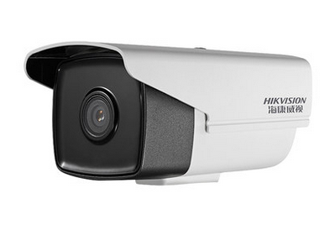
  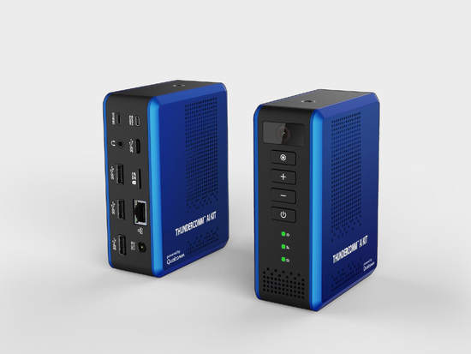
  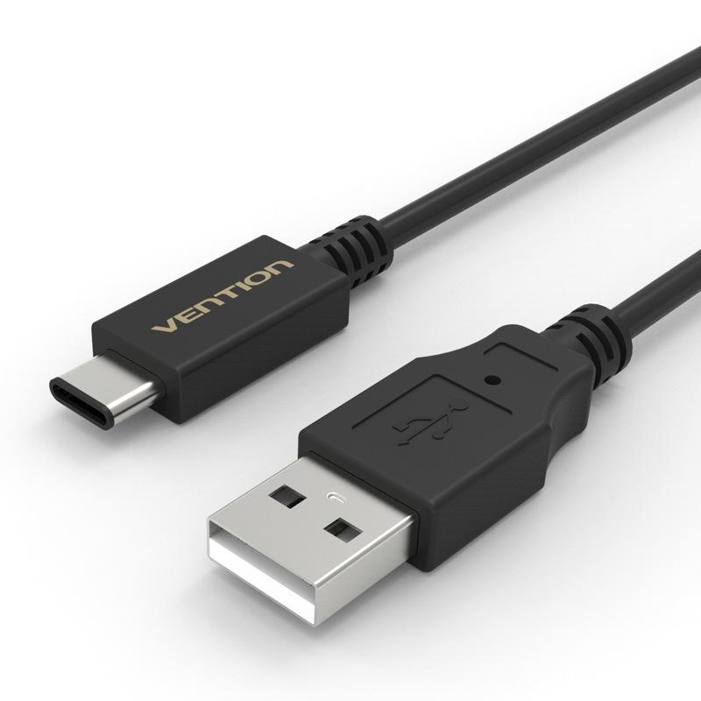
  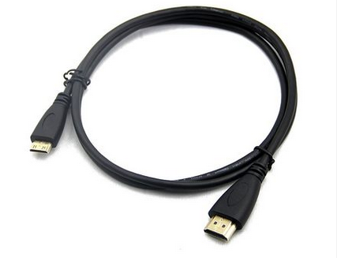
Objective  - What inspired you to create this project?  - What is your desired outcome? | Show the powerful decoding and computing power of aikit-c845 through 8 decoding videos.（通过8路解码视频展示aikit-C845的强大解码能力和算力能力）
Operation System*  (Android, Linux, Windows 10 IoT Core) |  Android  RTOS  Linux | Windows 10 IoT Core  Ubuntu Core
Cloud Services/Platform  AT&T M2X, AWS IoT, IBM Bluemix, IBM Watson IoT, Such as Microsoft Azure IoT) | Amazon AWS IoT  AT&T M2x  IBM Bluemix | IBM Watson IoT  EasyMonitor  Google Cloud Platform
Skill Level Required  (Beginner, Intermediate, Advanced) | Advanced  Beginner | Intermediate
Areas of Focus  (e.g., IoT, smart cities, smart home, robotics, hardware, construction site, factory workshop, catering kitchen, outdoor forest etc.) | 3D Printing & Modeling  Alexa Voice Service  Bluetooth  Computer Vision  Digital Signage  Education  Embedded  Gaming | Healthcare  Robotics  Sensors  SmartCities  Toys  construction site  factory workshop  catering kitchen  outdoor forest
Materials Required / Parts List / Tools | Part Name | Link
Materials Required / Parts List / Tools | Aikit | https://www.thundercomm.com/app_en/store/detail/1536844968290219
Materials Required / Parts List / Tools | Type-c line | https://detail.tmall.com/item.htm?id=44425281296&ali_refid=a3_430582_1006:1103572855:N:8BFxSxK119dzkfQCc2yGI2us815vvcUHETWnj5g1swo=:6399b40850a40201c56536531a885bcf&ali_trackid=1_6399b40850a40201c56536531a885bcf&spm=a230r.1.14.11
Materials Required / Parts List / Tools | Mini-hdmi line | https://detail.tmall.com/item.htm?spm=a230r.1.14.308.721f3c99U7hVi5&id=520813921702&ns=1&abbucket=1
Materials Required / Parts List / Tools | HIKVISION_Camera | https://item.jd.com/100006551428.html
Source Code / Source Examples / Application Executable  Link to open source / shareable code repository | Description | Link
 | Source Code | https://github.com/ThunderSoft-XA/demo-Smart-Motion-detector
Additional Resources  List related links or resources such as websites, videos, presentations, or other materials | Resource Title | Link or File Name (and provide file)
 | Video of "demo-Smart-Heart-rate-detector” | https://pan.baidu.com/s/1ml_8yiqcInbP6VOKYXGDwQ  g95y
Build / Assembly Instructions | Parts used  Below are the items used in this project.（以下是本项目中使用到的部分。）  Aikit.jpg display.jpg  [alt tag: “Parts used for the Aikit MultDecoder”]  - Ubuntu16.04.（PC台式机）  - Aikit development board.（aikit开发板套件）  - HIKVISION camera is used to collect video data.（海康摄像头用来采集视频数据）  - HDMI display for viewing decoded video results.（HDMI显示器用于查看解码视频结果）  Deploying the project  - According to the demo requirements, combine the onboard resources of the Aikit development board to purchase suitable devices.（根据demo的需求，结合板载资源购买合适的器件。）  - Test if the optional device is available.（检测器件是否可用。）  - Build and debug hardware circuits.（搭建和调试硬件电路。）  - Create a MultDecoder project locally.（创建本地项目“MultDecoderApp”。）  - Transplant relevant source code.（移植相关源代码。）  - Joint debugging.（联合调试。）  - Code uploaded to github.（上传代码到github。）  How does it work?  Below are some usage instructions to test the project.（下面是测试项目的使用说明。）  Now let's introduce the MultDecoderApp ’s workflow. It （现在我们介绍”MultDecoderApp ”的工作流程。  MultDecoderApp application realizes the simultaneous decoding and display of video data of 8-way RTSP camera (MultDecoderApp 应用实现8路rtsp摄像头视频数据同时解码和显示)  init_window---->init_camea---->init_decoder---->start_player_process  MultDecoderApp/MultDecoderApp.cpp  void main( void )  {  /*step 1 init window for display*/  init_window ();  /*step 2 init viedeo resource*/  init_camera(INI_FILE_PATH, CAM_CONFIG_MAX);  /*step 3 init decoder resource*/  init_decoder();  /*step 4 start mult decoder process*/  start_player_process();  while(true) sleep(3);  /*step 5 deinit decoder resource*/  deinit_decoder();  return 0;  }  Config module realizes the management of configuration files camera_conf.ini（config 模块实现对配置文件camera_conf.ini的管理）  /MultDecoderApp /config/src/param.c  camera_param_load Load configuration to memory for Application use（加载配置到内存共应用使用）  int camera_param_load(char *fileName, ST_CameraConf* pstCameraConf)  {  sprintf(mfileName,"%s",fileName);  int ret = param_init();  if(ret)  return -1;  sprintf(pstCameraConf->cameraName, "%s",param_get_string(pstCameraConf->camera_dic,"cameraname","camera_zero"));  sprintf(pstCameraConf->decode, "%s",param_get_string(pstCameraConf->camera_dic,"decode","NULL"));  sprintf(pstCameraConf->enable, "%s",param_get_string(pstCameraConf->camera_dic,"enable","off"));  sprintf(pstCameraConf->path, "%s",param_get_string(pstCameraConf->camera_dic,"path","NULL"));  pstCameraConf->cameraID = param_get_int(pstCameraConf->camera_dic,"cameraid",0);  pstCameraConf->height = param_get_int(pstCameraConf->camera_dic,"height",1920);  pstCameraConf->width = param_get_int(pstCameraConf->camera_dic,"width",1080);  pstCameraConf->w_x = param_get_int(pstCameraConf->camera_dic,"w_x",0);  pstCameraConf->w_y = param_get_int(pstCameraConf->camera_dic,"w_y",0);  pstCameraConf->w_w = param_get_int(pstCameraConf->camera_dic,"w_w",320);  pstCameraConf->w_y = param_get_int(pstCameraConf->camera_dic,"w_h",240);  param_deinit();  printf("%s\n",__FUNCTION__);  printf("cameraID: %d\n",pstCameraConf->cameraID);  printf("cameraName: %s\n",pstCameraConf->cameraName);  printf("decode: %s\n",pstCameraConf->decode);  printf("enable: %s\n",pstCameraConf->enable);  printf("path: %s\n",pstCameraConf->path);  printf("height: %d\n",pstCameraConf->height);  printf("widh: %d\n",pstCameraConf->width);  printf("w_x: %d\n",pstCameraConf->w_x);  printf("w_y: %d\n",pstCameraConf->w_y);  printf("w_h: %d\n",pstCameraConf->w_h);  printf("w_w: %d\n",pstCameraConf->w_w);  if(strncmp(pstCameraConf->decode, "NULL",strlen("NULL")) == 0 || strncmp(pstCameraConf->path,"NULL",strlen("NULL")) == 0)  {  printf("%s: error\n",__FUNCTION__);  return -1;  }  return 0;  }
  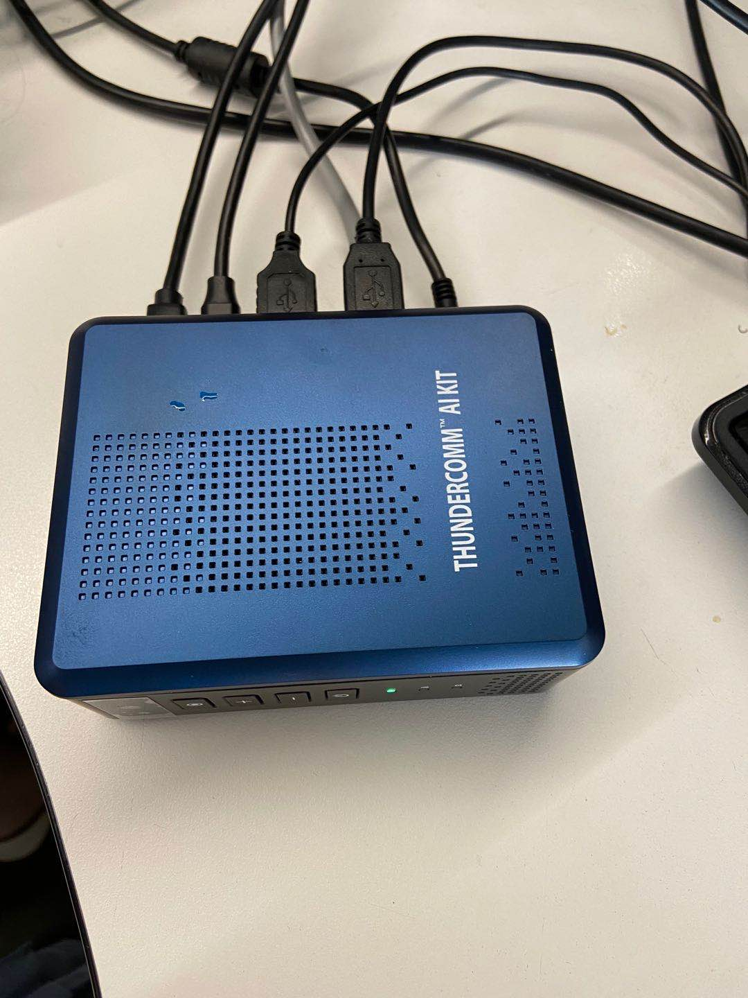 | 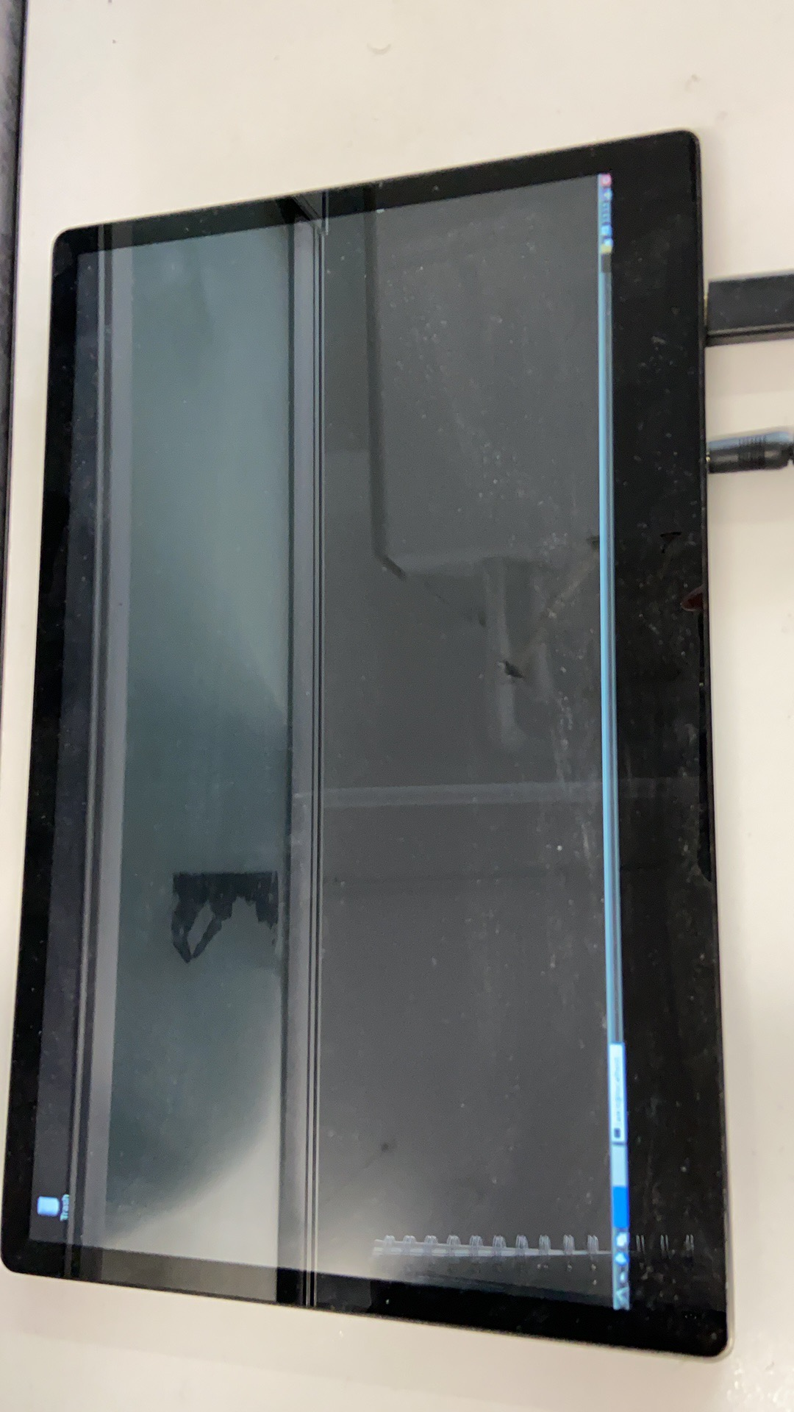
Usage Instructions | - Downloading code from github according to the repository in “https://github.com/ThunderSoft-XA/demo-Smart-Motion-detector” sheet.（从该github链接地址处下载代码。）  - Connect to Aikit by ADB.（adb 连接aikit）  - Refer to the development manual to configure the compile execution environment (参考开发手册配置编译执行环境)  - Push code and compile the code on Aikit development board.（导入并编译代码在开发板。）  - Connecting the display with mini HDMI cable（mini-hdmi 线连接显示器）  - Refer to the development manual to run app to view decoded video（参考开发手册，运行app可查看解码视频）
Performance test report | 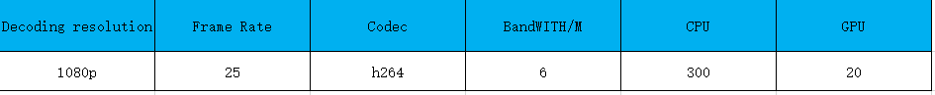
Contributor(s) Info  Feel free to include headshots! | Name | Title  Company
Contributor(s) Info  Feel free to include headshots! | Zhen  sunzhen@thundersoft.com | Thundersoft
Contributor(s) Info  Feel free to include headshots! | Rong  yangrong0925@thundersoft.com | Thundersoft
Contributor(s) Info  Feel free to include headshots! | Jie  wangjie0508@thundersoft.com | Thundersoft
Contributor(s) Info  Feel free to include headshots! | Kou  kouzw0723@thundersoft.com | Thundersoft
Contributor(s) Info  Feel free to include headshots! | Eric  yansh0810@thundersoft.com | Thundersoft

By submitting your content (“Submission”), you are granting Qualcomm a royalty-free, perpetual, non-exclusive, unrestricted, worldwide license to: (a) post, use, copy, sublicense, adapt, transmit, publicly perform or display any such Submission, (b) use, reproduce, modify, adapt, publish, translate, create derivative works from, distribute, perform, play, host, communicate, make available and publish your Submission without restriction and (c) sublicense to third parties the unrestricted right to exercise any of the foregoing rights granted with respect to the Submission. The foregoing grants shall include the right to exploit any ideas, concepts, intellectual property, or proprietary rights in such Submission, including but not limited to rights under copyright, trademark, servicemark or patent laws under any relevant jurisdiction without Qualcomm owing any monies to you whatsoever. You represent and warrant that you own all right, title and interest in and to the Submission, or you have been granted sufficient rights in and to the Submission allowing the foregoing use of such Submission.

