Qualcomm Developer Project
Smart-Motion-detector
Attribution:
Email address | sunzhen@thundersoft.com  yangrong0925@thundersoft.com  wangjie0508@thundersoft.com  Kouzw0723@thundersoft.com  yansh0810@thundersoft.com
Project Title* | Smart-Motion-detector
Description*  High level description of the project (75 words or less) | Use the ADXL345 sensor to detect three axis acceleration values, When axis acceleration values changes beyond the set range,led lights up.
Images  Upload up to 5 images of your project  Please submit/send the original JPEG/PNG files for all images included in the document | Gokit4_board_619x599.png  [alt tag: “Smart-Motion-detector using the Gokit4 development board.”]  Usb_data_line_693x271.png  [alt tag: “using the data line to supply power for Gokit4 development board. ”]  ADXL345_Sensor_200*152.png  [alt tag: “using ADXL345 to detect three axis acceleration values. ”]  DuPont_ line_578x305.png  [alt tag: “used as a cable”]  led_348x225.png  [alt tag: “As a signal light, when axis acceleration values changes beyond the set range, it is lit”]
  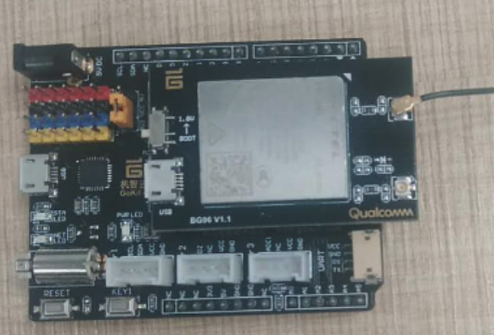
  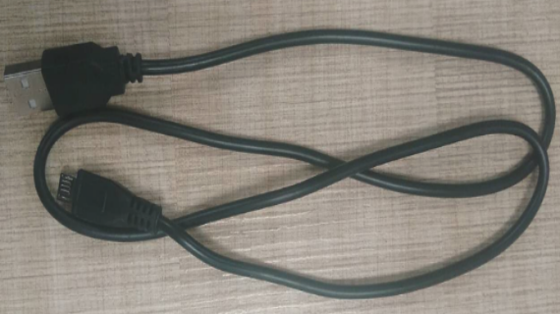
  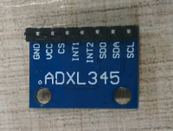 | 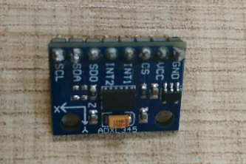
  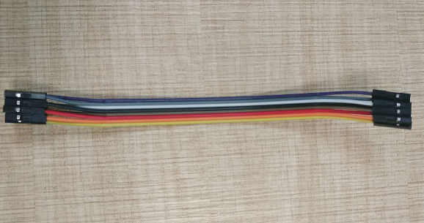
  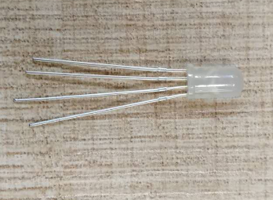
Objective  - What inspired you to create this project?  - What is your desired outcome? | Mainly to connect the ADXL345 sensor to the SPI interface provided by the Gokit development board to collect three axis acceleration values information, When axis acceleration values changes beyond the set range,led lights up.
Operation System*  (Android, Linux, Windows 10 IoT Core) |  Android  Linux  RTOS |  | Windows 10 IoT Core  Ubuntu Core
Cloud Services/Platform  AT&T M2X, AWS IoT, IBM Bluemix, IBM Watson IoT, Such as Microsoft Azure IoT) | Amazon AWS IoT  AT&T M2x  IBM Bluemix |  | IBM Watson IoT  Gizwits Cloud  Google Cloud Platform
Skill Level Required  (Beginner, Intermediate, Advanced) | Advanced  Beginner |  | Intermediate
Areas of Focus  (e.g., IoT, smart cities, smart home, robotics, hardware, gaming, healthcare, automotive, digital signage, etc.) | 3D Printing & Modeling  Alexa Voice Service  Bluetooth  Computer Vision  Digital Signage  Education  Embedded  Gaming |  | Healthcare  Robotics  Sensors  Smart Cities  Toys
Materials Required / Parts List / Tools | Part Name | Link
Materials Required / Parts List / Tools | BG96 | https://www.quectel.com/product/bg96.htm
Materials Required / Parts List / Tools | Gokit4 | https://www.csdn.net/article/a/2018-09-03/15959591
Materials Required / Parts List / Tools | ADXL345 sensor | https://detail.tmall.com/item.htm?spm=a230r.1.14.1.425e45608ZZgqS&id=543181203940&ns=1&abbucket=6
Materials Required / Parts List / Tools | Led | https://detail.tmall.com/item.htm?spm=a230r.1.14.6.492b57c9IZIW9W&id=42895674142&cm_id=140105335569ed55e27b&abbucket=6
Materials Required / Parts List / Tools | Dupoint line | https://detail.tmall.com/item.htm?spm=a220m.1000858.1000725.6.3bb324e7xTOxcA&id=41065178536&skuId=83326522222&areaId=610100&user_id=2155882228&cat_id=2&is_b=1&rn=5dd30edec82ae5abc8d4645ec15c6aee
Source Code / Source Examples / Application Executable  Link to open source / shareable code repository | Description | Link
 | Source Code | https://github.com/ThunderSoft-XA/demo-Smart-Motion-detector
Additional Resources  List related links or resources such as websites, videos, presentations, or other materials | Resource Title | Link or File Name (and provide file)
 | Video of "demo-Smart-Motion-detector” | https://pan.baidu.com/s/1ml_8yiqcInbP6VOKYXGDwQ  g95y
Build / Assembly Instructions | Parts used  Below are the items used in this project.  parts.png  [alt tag: “Parts used for the Gokit4 development kit demo-Smart-Heart-rate-detector”]  - Win7 PC.  - Gokit4 development board.  - ADXL345 Sensor, used to detect axis acceleration values.  - Led,when axis acceleration values changes beyond the set range,led lights up.  - Dupoint line, used to connect other components as wires.  Deploying the project  - According to the demo requirements, combine the onboard resources of the Gokit development board to purchase suitable devices.  - Test if the optional device is available.  - Build and debug hardware circuits.  - Create a demo-Smart-Motion-detector project locally.  - Transplant relevant source code.  - Develop related functions for collecting three axis acceleration values  - Joint debugging.  - Code uploaded to github.  How does it work?  Below are some usage instructions to test the project.  Now let's introduce the demo-Smart-Motion-detector’s workflow.  gagentMain---->sensorInit---->led_init---->motion_init---->tx_timer_create  Register a callback in the interface named “tx_timer_create”,when time is up, call the callback called “userTimerCB”.  demo-Smart-Motion-detector/main/main.c  void gagentMain( void )  {  getFreeHeap();  sensorInit();  gizwitsInit();  }  The function named gagentMain was called by GAgent, the main role of GAgent is data forwarding, which is a data interaction bridge between device data, wit cloud, and application end (APP).in function sensorInit, do some sensor init,  void sensorInit(void)  {  int32 ret = -1;  gizLog(LOG_INFO,"Sensor initialization ...\n");  led_init();  motion_init();  txm_module_object_allocate(&userTimer, sizeof(TX_TIMER));  ret = tx_timer_create(userTimer, "userTimer", userTimerCB, NULL, 1,  200, TX_AUTO_ACTIVATE);  if(ret != TX_SUCCESS)  {  gizLog(LOG_ERROR,"Failed to create UserTimer.\n");  }  }  void led_init()  {  led_gpio_config();  led_on_off(false,led_green); //init status is off  led_on_off(true,GPIO_BLUE); //init status is off  }  void motion_init()  {  adxl345_init();  }  demo-Smart-Motion-detector/driver/adxl345/adxl345.c  /*do some initialization about SPI and ADXL345 sensor.*/  void adxl345_init()  {  static uint8 data;  uint8 *data_addr;  spi_init();  data_addr = spi_reg_read(0x00); //read device id;  qapi_Timer_Sleep(10, QAPI_TIMER_UNIT_TICK, true);  data = *data_addr;  gizLog(LOG_INFO, "Device id is 0x%02x\n", data);  spi_reg_write(0x31, 0x2B);  spi_reg_write(0x2C, 0x08);  spi_reg_write(0x2D, 0x08);  spi_reg_write(0x2E, 0x00);  spi_reg_write(0x2F, 0x00);  spi_reg_write(0x2E, 0x02);  spi_reg_write(0x38, 0x9F);  }  demo-Smart-Motion-detector/driver/spi/spi.c  /*do SPI initialization*/  void spi_init(void)  {  /*Get a handle to an SPI instance.*/  qapi_SPIM_Open(QAPI_SPIM_INSTANCE_6_E, &spi_hdl);  /*Turn on all resources required for a successful SPI transaction.*/  qapi_SPIM_Power_On(spi_hdl);  /*spi interface config*/  /*set the spi mode, determined by slave device*/  spi_config.SPIM_Mode = QAPI_SPIM_MODE_3_E;  /*set CS low as active, determined by slave device*/  spi_config.SPIM_CS_Polarity = QAPI_SPIM_CS_ACTIVE_LOW_E;  spi_config.SPIM_endianness = SPI_LITTLE_ENDIAN;  spi_config.SPIM_Bits_Per_Word = 8;  spi_config.SPIM_Slave_Index = 0;  /*config spi clk about 1Mhz */  spi_config.Clk_Freq_Hz = 1000000;  spi_config.SPIM_CS_Mode = QAPI_SPIM_CS_KEEP_ASSERTED_E;  /*don't care, set 0 is ok.*/  spi_config.CS_Clk_Delay_Cycles = 0;  /*don't care, set 0 is ok.*/  spi_config.Inter_Word_Delay_Cycles = 0;  spi_config.loopback_Mode = 0;  }  /*used to write data to registers*/  qapi_Status_t spi_reg_write(uint8 reg, uint8 data)  {  qapi_Status_t res = QAPI_OK;  qapi_SPIM_Descriptor_t spi_desc;  int num;  tx_buf[0] = reg & 0x3f;  tx_buf[1] = data;  spi_desc.rx_buf = rx_buf;  spi_desc.tx_buf = tx_buf;  spi_desc.len = 2;  spi_status.status = 0;  spi_status.read_addr = NULL;  spi_status.len = 1;  /*used to performs a data transfer over the SPI bus */  res = qapi_SPIM_Full_Duplex(spi_hdl, &spi_config, &spi_desc, 1, qapi_spi_cb_func, &spi_status, false);  if (res != QAPI_OK)  return res;  for(num = 0; num < 100; num++)  {  gizLog(LOG_INFO,"num = %d\n", num);  if (spi_status.status == QAPI_SPI_COMPLETE)  {  gizLog(LOG_INFO,"spi write reg(0x%02x) = 0x%02x\n", reg, data);  return QAPI_OK;  }  else if (spi_status.status != 0)  {  gizLog(LOG_INFO,"spi write err\n");  return QAPI_ERROR;  }  qapi_Timer_Sleep(1, QAPI_TIMER_UNIT_TICK, true);  }  return QAPI_ERR_TIMEOUT;  }  demo-Smart-Motion-detector/main/main.c  /*”userTimerCB” is registered in the inteface named “tx_timer_create”*/  void ICACHE_FLASH_ATTR userTimerCB(void)  {  static uint8_t ctime = 0;  static uint8_t ccount = 0;  GETAXIS_ERROR_t status = 0;  static uint8_t num = 0;  int tmp_x = 0, tmp_y = 0, tmp_z = 0;  int32_t X_axis_Value = 0;  int32_t Y_axis_Value = 0;  int32_t Z_axis_Value = 0;  if (QUERY_INTERVAL < ctime)  {  ctime = 0;  status=getaxis(&X_axis_Value,&Y_axis_Value,&Z_axis_Value);  if( status != GETAXIS_OK)  {  return;  }  if(num == 0)  {  old_axis_val.X = X_axis_Value;  old_axis_val.Y = Y_axis_Value;  old_axis_val.Z = Z_axis_Value;  num += 1;  }  else  {  tmp_x = old_axis_val.X > X_axis_Value ? old_axis_val.X - X_axis_Value:X_axis_Value - old_axis_val.X;  tmp_y = old_axis_val.Y > Y_axis_Value ? old_axis_val.Y - Y_axis_Value:Y_axis_Value - old_axis_val.Y;  tmp_z = old_axis_val.Z > Z_axis_Value ? old_axis_val.Z - Z_axis_Value:Z_axis_Value - old_axis_val.Z;  gizLog(LOG_INFO, "tmp_x= %d, tmp_y = %d , tmp_z = %d\n", tmp_x, tmp_y, tmp_z);  if(tmp_x > X_AXIS_THRESHOLD || tmp_y > Y_AXIS_THRESHOLD || tmp_z > Z_AXIS_THRESHOLD)  {  led_on_off(true,led_green);  gizLog(LOG_INFO, "LED ON\n");  }  else  {  led_on_off(false, led_green);  gizLog(LOG_INFO, "LED OFF\n");  }  old_axis_val.X = X_axis_Value;  old_axis_val.Y = Y_axis_Value;  old_axis_val.Z = Z_axis_Value;  }  currentDataPoint.valueX_axis_Value = X_axis_Value;  currentDataPoint.valueY_axis_Value = Y_axis_Value;  currentDataPoint.valueZ_axis_Value = Z_axis_Value;  }  ctime++;  }  demo-Smart-Motion-detector/driver/adxl345/adxl345.c  /*used to get three axis acceleration values*/  uint8_t getaxis(int32_t *X_axis_Value, int32_t *Y_axis_Value, int32_t *Z_axis_Value)  {  qapi_Status_t res = QAPI_ERROR;  uint8_t data;  uint8_t *data_addr;  SENSOR_DATA_TypeDef axis_converted_avg;  data_addr = spi_reg_read(0x30);  if (data_addr == NULL) {  gizLog(LOG_ERROR, "read 0x30 err\n");  return GETAXIS_ERR;  }  qapi_Timer_Sleep(10, QAPI_TIMER_UNIT_TICK, true);  data = *data_addr;  if (data & 0x02)  {  res = ADXL345_READ_FIFO(&axis_converted_avg);  if (res != QAPI_OK)  return GETAXIS_ERR;  *X_axis_Value = axis_converted_avg.X;  *Y_axis_Value = axis_converted_avg.Y;  *Z_axis_Value = axis_converted_avg.Z;  return GETAXIS_OK;  }  else  {  return GETAXIS_NO_INT;  }  }  demo-Smart-Motion-detector/driver/spi/spi.c  /*used to read data from registers*/  uint8 *spi_reg_read(uint8 reg)  {  qapi_Status_t res = QAPI_OK;  qapi_SPIM_Descriptor_t spi_desc;  int num;  tx_buf[0] = reg | 0x80 & 0xbf;  tx_buf[1] = 0xff;  rx_buf [0] = 0;  rx_buf [1] = 0;  spi_desc.rx_buf = rx_buf;  spi_desc.tx_buf = tx_buf;  spi_desc.len = 2;  spi_status.status = 0;  spi_status.read_addr = NULL;  spi_status.len = 1;  res = qapi_SPIM_Full_Duplex(spi_hdl, &spi_config, &spi_desc, 1, qapi_spi_cb_func, &spi_status, false);  gizLog(LOG_INFO,"read spi end\n");  if (res != QAPI_OK)  return NULL;  return rx_buf + 1;  }  demo-Smart-Motion-detector/driver/adxl345/adxl345.c  /*used to get data from slave device*/  qapi_Status_t ADXL345_READ_FIFO(SENSOR_DATA_TypeDef *axis_converted_avg)  {  uint16_t axis_raw_data[10][3];  static uint8_t data_buf[6];  uint8 *data_addr;  SENSOR_DATA_TypeDef axis_converted[10];  for (uint8_t i = 0; i < 10; i++)  {  for(uint8_t m = 0; m < 6; m++) {  data_addr = spi_reg_read(0x32 + m);  qapi_Timer_Sleep(10, QAPI_TIMER_UNIT_TICK, true);  data_buf[m] = *data_addr;  }  /*x, y, z raw val*/  for(uint8_t n = 0; n < 6; n++){  gizLog(LOG_INFO, "data_buf[%d] = 0x%x\n", n, data_buf[n]);  }  axis_raw_data[i][0] = data_buf[0] | (((uint16_t)data_buf[1]) << 8);  axis_raw_data[i][1] = data_buf[2] | (((uint16_t)data_buf[3]) << 8);  axis_raw_data[i][2] = data_buf[4] | (((uint16_t)data_buf[5]) << 8);  gizLog(LOG_INFO, "dtat[%d].x = 0x%x, dtat[%d].y = 0x%x, dtat[%d].z = 0x%x\n", i, axis_raw_data[i][0], i, axis_raw_data[i][1], i, axis_raw_data[i][2]);  axis_converted[i] = ADXL345_DATA_CONVERT(axis_raw_data[i]);  }  *axis_converted_avg = ADXL345_AVERAGE(axis_converted, 10);  return QAPI_OK;  }  /*used to deal with raw data*/  SENSOR_DATA_TypeDef ADXL345_DATA_CONVERT(uint16_t *data)  {  int8_t sign = 1;  uint16_t temp = 0;  uint8_t i = 0;  uint32_t val = 0;  SENSOR_DATA_TypeDef converted_data;  for (i = 0; i < 3; i++)  {  sign = 1;  temp = data[i];  if ((temp & 0xF000) == 0xF000)  {  sign = -1;  temp = -temp;  }  if (i == 0)  {  /*calibrate out x axis offset*/  converted_data.X = ((temp & 0x0FFF) * 4) * sign;  }  else if (i == 1)  {  /*calibrate out y axis offset*/  converted_data.Y = ((temp & 0x0FFF) * 4) * sign;  }  else if (i == 2)  {  /*calibrate out z axis offset*/  converted_data.Z = ((temp & 0x0FFF) * 4) * sign;  }  }  gizLog(LOG_INFO, "converted_data.X = %d, converted_data.Y = %d, converted_data.Z = %d\n", converted_data.X, converted_data.Y, converted_data.Z);  return converted_data;  }  /*Average 10 sets of raw data*/  SENSOR_DATA_TypeDef ADXL345_AVERAGE(SENSOR_DATA_TypeDef *data, uint8_t len)  {  SENSOR_DATA_TypeDef result = {0};  uint32_t i;  for (i = 0; i < len; i++)  {  result.X += data[i].X;  result.Y += data[i].Y;  result.Z += data[i].Z;  }  result.X /= len;  result.Y /= len;  result.Z /= len;  return result;  }
  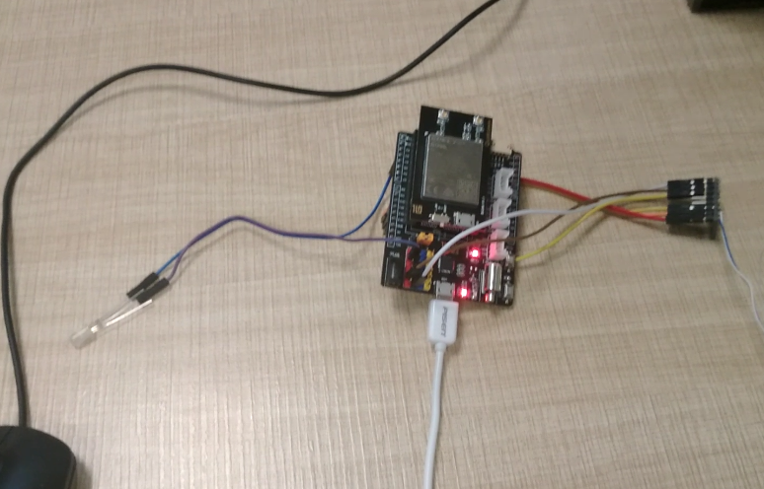 | 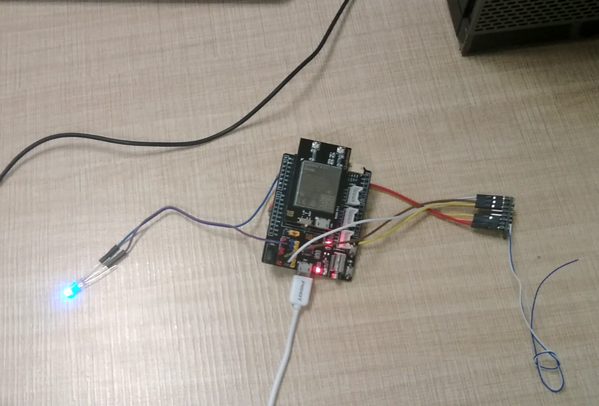
Usage Instructions | - Downloading code from github according to the repository in “https://github.com/ThunderSoft-XA/demo-Smart-Motion-detector” sheet.  - Compile the code and flash the image to Gokit4 development kit.  - Connect the ADXL345 sensor to the SPI interface of the Gokit development board.  - Connect one pin of the led to the D9 pin of the development board, and the other pin is connected to the vcc.  - USB data cable to connect PC and Gokit development board.  - Open the serial debugging assistant.  - Shake the ADXL345 sensor and you can see that the data has changed.  - When axis acceleration values changes beyond the set range,the LED will be lit.
Contributor(s) Info  Feel free to include headshots! | Name | Title  Company
Contributor(s) Info  Feel free to include headshots! | Zhen  sunzhen@thundersoft.com | Thundersoft
Contributor(s) Info  Feel free to include headshots! | Rong  yangrong0925@thundersoft.com | Thundersoft
Contributor(s) Info  Feel free to include headshots! | Jie  wangjie0508@thundersoft.com | Thundersoft
Contributor(s) Info  Feel free to include headshots! | Kou  kouzw0723@thundersoft.com | Thundersoft
Contributor(s) Info  Feel free to include headshots! | Eric  yansh0810@thundersoft.com | Thundersoft

By submitting your content (“Submission”), you are granting Qualcomm a royalty-free, perpetual, non-exclusive, unrestricted, worldwide license to: (a) post, use, copy, sublicense, adapt, transmit, publicly perform or display any such Submission, (b) use, reproduce, modify, adapt, publish, translate, create derivative works from, distribute, perform, play, host, communicate, make available and publish your Submission without restriction and (c) sublicense to third parties the unrestricted right to exercise any of the foregoing rights granted with respect to the Submission. The foregoing grants shall include the right to exploit any ideas, concepts, intellectual property, or proprietary rights in such Submission, including but not limited to rights under copyright, trademark, servicemark or patent laws under any relevant jurisdiction without Qualcomm owing any monies to you whatsoever. You represent and warrant that you own all right, title and interest in and to the Submission, or you have been granted sufficient rights in and to the Submission allowing the foregoing use of such Submission.

