Qualcomm Developer Project
Smart-Pressure-detector
Attribution:
Email address | sunzhen@thundersoft.com  yangrong0925@thundersoft.com  wangjie0508@thundersoft.com  Kouzw0723@thundersoft.com  yansh0810@thundersoft.com
Project Title* | Smart-Pressure-detector
Description*  High level description of the project (75 words or less) | Use the Fsr402 sensor to detect pressure values, When pressure values beyond the set threshold, led lights up.
Images  Upload up to 5 images of your project  Please submit/send the original JPEG/PNG files for all images included in the document | Gokit4_board_619x599.png  [alt tag: “Smart-Pressure-detector using the Gokit4 development board.”]  Usb_data_line_693x271.png  [alt tag: “using the data line to supply power for Gokit4 development board. ”]  Fsr402_Sensor_200*152.png  [alt tag: “using Fsr402 sensor to detect pressure values. ”]  DuPont_ line_578x305.png  [alt tag: “used as a cable”]  led_348x225.png  [alt tag: “As a signal light, when pressure values changes beyond the set threshold, it is lit”]
  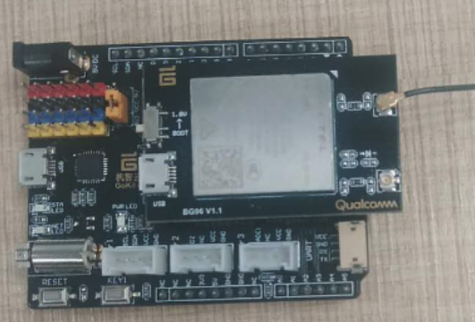
  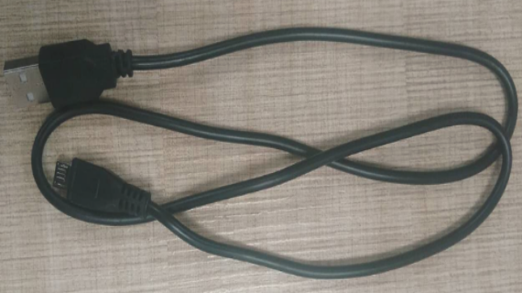
  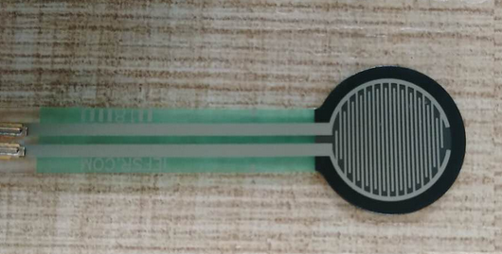 | 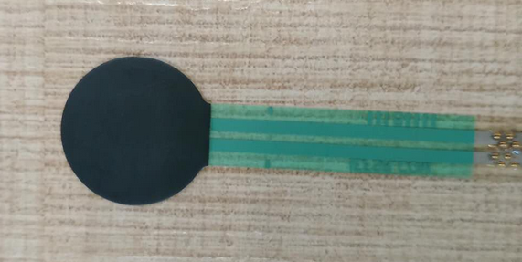
  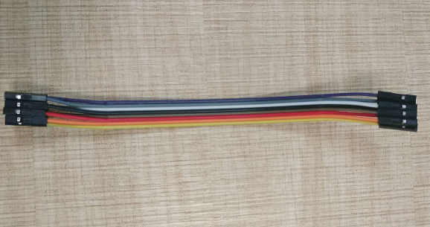
  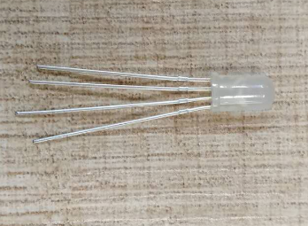
Objective  - What inspired you to create this project?  - What is your desired outcome? | Mainly to connect the Fsr402 sensor to the ADC interface provided by the Gokit development board to collect pressure values information, When pressure values changes beyond the set threshold, led lights up.
Operation System*  (Android, Linux, Windows 10 IoT Core) |  Android  Linux  RTOS |  | Windows 10 IoT Core  Ubuntu Core
Cloud Services/Platform  AT&T M2X, AWS IoT, IBM Bluemix, IBM Watson IoT, Such as Microsoft Azure IoT) | Amazon AWS IoT  AT&T M2x  IBM Bluemix |  | IBM Watson IoT  Gizwits Cloud  Google Cloud Platform
Skill Level Required  (Beginner, Intermediate, Advanced) | Advanced  Beginner |  | Intermediate
Areas of Focus  (e.g., IoT, smart cities, smart home, robotics, hardware, gaming, healthcare, automotive, digital signage, etc.) | 3D Printing & Modeling  Alexa Voice Service  Bluetooth  Computer Vision  Digital Signage  Education  Embedded  Gaming |  | Healthcare  Robotics  Sensors  Smart Cities  Toys
Materials Required / Parts List / Tools | Part Name | Link
Materials Required / Parts List / Tools | BG96 | https://www.quectel.com/product/bg96.htm
Materials Required / Parts List / Tools | Gokit4 | https://www.csdn.net/article/a/2018-09-03/15959591
Materials Required / Parts List / Tools | Fsr402 sensor | https://item.taobao.com/item.htm?spm=a230r.1.14.146.19633327nojc3o&id=16384226473&ns=1&abbucket=6#detail
Materials Required / Parts List / Tools | Led | https://detail.tmall.com/item.htm?spm=a230r.1.14.6.492b57c9IZIW9W&id=42895674142&cm_id=140105335569ed55e27b&abbucket=6
Materials Required / Parts List / Tools | Dupoint line | https://detail.tmall.com/item.htm?spm=a220m.1000858.1000725.6.3bb324e7xTOxcA&id=41065178536&skuId=83326522222&areaId=610100&user_id=2155882228&cat_id=2&is_b=1&rn=5dd30edec82ae5abc8d4645ec15c6aee
Source Code / Source Examples / Application Executable  Link to open source / shareable code repository | Description | Link
 | Source Code | https://github.com/ThunderSoft-XA/demo-Smart-Pressure-detector
Additional Resources  List related links or resources such as websites, videos, presentations, or other materials | Resource Title | Link or File Name (and provide file)
 | Video of "demo-Smart-Pressure-detector” | https://pan.baidu.com/s/1Y7xSvNsvVVldcjnHaVz9Cw  1ajf
Build / Assembly Instructions | Parts used  Below are the items used in this project.  parts.png  [alt tag: “Parts used for the Gokit4 development kit  demo-Smart-Pressure-detector”]  - Win7 PC.  - Gokit4 development board.  - Fsr402 Sensor, used to detect pressure values.  - Led,when pressure values changes beyond the set threshold,led lights up.  - Dupoint line, used to connect other components as wires.  Deploying the project  - According to the demo requirements, combine the onboard resources of the Gokit development board to purchase suitable devices.  - Test if the optional device is available.  - Build and debug hardware circuits.  - Create a demo-Smart-Pressure-detector project locally.  - Transplant relevant source code.  - Develop related functions for collecting pressure values  - Joint debugging.  - Code uploaded to github.  How does it work?  Below are some usage instructions to test the project.  Now let's introduce the demo-Smart-Pressure-detector’s workflow.  gagentMain---->user_init---->led_init---->tx_timer_create---->userTimerCB  Register a callback in the interface named “tx_timer_create”,when time is up, call the callback called “userTimerCB”.  demo-Smart-Pressure-detector/main/main.c  void gagentMain( void )  {  getFreeHeap();  user_init();  }  The function named gagentMain was called by GAgent, the main role of GAgent is data forwarding, which is a data interaction bridge between device data, wit cloud, and application end (APP).in function user_init, do some initialization.  void user_init(void)  {  int32 ret = -1;  gizLog(LOG_INFO,"Sensor initialization ...\n");  led_init(); //led init  txm_module_object_allocate(&userTimer, sizeof(TX_TIMER));  ret = tx_timer_create(userTimer, "userTimer", userTimerCB, NULL, 1,  20, TX_AUTO_ACTIVATE);  if(ret != TX_SUCCESS)  {  gizLog(LOG_WARNING,"Failed to create UserTimer.\n");  }  }  void led_init()  {  gizLog(LOG_INFO,"in led init...\n");  led_gpio_config();  led_on_off(false,led_green); //init status is off  }  demo-Smart-Pressure-detector/driver/gpio.c  void led_on_off(bool on, uint8_t pin_gpio)  {  if (on)  {  qapi_TLMM_Drive_Gpio(gpio_id_tbl[pin_gpio], gpio_map_tbl[pin_gpio].gpio_id, QAPI_GPIO_LOW_VALUE_E);  }  else  {  qapi_TLMM_Drive_Gpio(gpio_id_tbl[pin_gpio], gpio_map_tbl[pin_gpio].gpio_id, QAPI_GPIO_HIGH_VALUE_E);  }  }  void ICACHE_FLASH_ATTR userTimerCB(void)  {  gizLog(LOG_INFO,"in userTimerCB.....\n");  int16_t quality;  quality = fsr402_pressure_adc_read(); //get quality value.  if(quality >= 1000)  {  led_on_off(true,led_green);  qapi_Timer_Sleep(100, QAPI_TIMER_UNIT_MSEC, true);  led_on_off(false, led_green);  }  else if(quality == -1)  {  led_on_off(true,led_red);  qapi_Timer_Sleep(100, QAPI_TIMER_UNIT_MSEC, true);  led_on_off(false, led_red);  }  }  demo-Smart-Pressure-detector/driver/adc/fsr402_pressure_adc.c  //used to get quality value  int fsr402_pressure_adc_read(void)  {  int ret = -1;  int32_t m_voltage = 0;  int16_t quilty = 0;  qapi_ADC_Read_Result_t result;  qapi_Status_t status = QAPI_ERROR;  const char *channel_name_adc0 = ADC_INPUT_ADC0;  qapi_Adc_Input_Properties_Type_t Properties_ADC0;  /*get an adc handle*/  status = adc_open_handle();  if(status != QAPI_OK)  {  gizLog(LOG_ERROR,"Get ADC Handle ERROR!\n");  return status;  }  /*get the adc channel configuration*/  status = adc_get_properties(channel_name_adc0, &Properties_ADC0);  if(status != QAPI_OK)  {  gizLog(LOG_ERROR,"Get ADC channel-%s Configuration ERROR!\n", channel_name_adc0);  return status;  }  /*read channel ADC0*/  memset(&result, 0, sizeof(result));  status = qapi_ADC_Read_Channel(adc_handle, &Properties_ADC0, &result);  if(QAPI_OK == status)  {  if(ADC_RESULT_VALID == result.eStatus)  {  m_voltage = result.nMicrovolts /1000;  quilty = to_quality(m_voltage);  if(quilty > 0)  {  gizLog(LOG_INFO,"Input %s Voltage: %d mV about %d g\n", channel_name_adc0, m_voltage, quilty);  }  else if (quilty == 0)  {  gizLog(LOG_INFO,"no press.\n");  }  else  {  gizLog(LOG_INFO,"Out of range!\n");  }  }  }  status = qapi_ADC_Close(adc_handle, false);  if(QAPI_OK != status)  {  gizLog(LOG_ERROR,"Free ADC Handle ERROR!\n");  }  return quilty;  }  qapi_Status_t adc_open_handle(void)  {  qapi_Status_t status = QAPI_ERROR;  status = qapi_ADC_Open(&adc_handle, 0);  if (QAPI_OK != status)  {  gizLog(LOG_ERROR, "open adc error!\n");  }  return status;  }  qapi_Status_t adc_get_properties(const char *Channel_Name_Ptr,  qapi_Adc_Input_Properties_Type_t *Properties_Ptr)  {  qapi_Status_t status = QAPI_ERROR;  uint32_t Channel_Name_Size = strlen(Channel_Name_Ptr) + 1;  status = qapi_ADC_Get_Input_Properties(adc_handle, Channel_Name_Ptr, Channel_Name_Size, Properties_Ptr);  if (QAPI_OK != status)  {  gizLog(LOG_ERROR, "ADC Get Channel-%s Properties ERROR!\n", Channel_Name_Ptr);  }  return status;  }  //find quality from an arry based on voltage.  int16_t to_quality(int32 m_voltage)  {  uint8_t i =0;  int16_t quilty = 0;  for(i = 0; i < V_TO_Q_SIZE; i++)  {  if(m_voltage <= voltage_to_quality[i].voltage)  {  quilty = voltage_to_quality[i].quality;  return quilty;  }  i++;  }  if(i >= V_TO_Q_SIZE)  return -1;  }  About the arry, you can see more instructions from my blog, and the link is below:  https://blog.csdn.net/weixin_38498942/article/details/86680506
  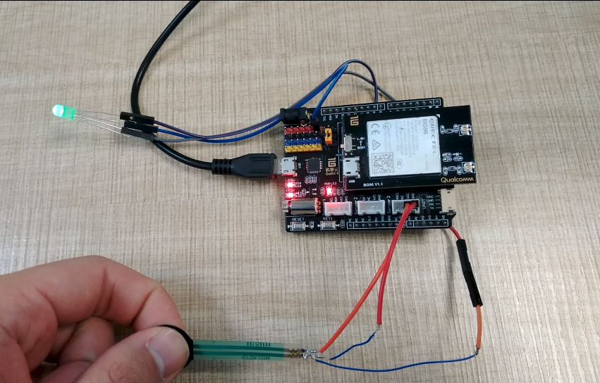
Usage Instructions | - Downloading code from github according to the repository in “https://github.com/ThunderSoft-XA/demo-Smart-Pressure-detector” sheet.  - Compile the code and flash the image to Gokit4 development kit.  - Connect the Fsr402 sensor to the ADC interface of the Gokit development board.  - Connect one pin of the led to the D9 pin of the development board, and the other pin is connected to the vcc.  - USB data cable to connect PC and Gokit development board.  - Open the serial debugging assistant.  - Put your finger on the pressure receiving surface of the sensor, you can see that the data has changed.  - When pressure values change beyond the set threshold,the LED will be lit.
Contributor(s) Info  Feel free to include headshots! | Name | Title  Company
Contributor(s) Info  Feel free to include headshots! | Zhen  sunzhen@thundersoft.com | Thundersoft
Contributor(s) Info  Feel free to include headshots! | Rong  yangrong0925@thundersoft.com | Thundersoft
Contributor(s) Info  Feel free to include headshots! | Jie  wangjie0508@thundersoft.com | Thundersoft
Contributor(s) Info  Feel free to include headshots! | Kou  kouzw0723@thundersoft.com | Thundersoft
Contributor(s) Info  Feel free to include headshots! | Eric  yansh0810@thundersoft.com | Thundersoft

By submitting your content (“Submission”), you are granting Qualcomm a royalty-free, perpetual, non-exclusive, unrestricted, worldwide license to: (a) post, use, copy, sublicense, adapt, transmit, publicly perform or display any such Submission, (b) use, reproduce, modify, adapt, publish, translate, create derivative works from, distribute, perform, play, host, communicate, make available and publish your Submission without restriction and (c) sublicense to third parties the unrestricted right to exercise any of the foregoing rights granted with respect to the Submission. The foregoing grants shall include the right to exploit any ideas, concepts, intellectual property, or proprietary rights in such Submission, including but not limited to rights under copyright, trademark, servicemark or patent laws under any relevant jurisdiction without Qualcomm owing any monies to you whatsoever. You represent and warrant that you own all right, title and interest in and to the Submission, or you have been granted sufficient rights in and to the Submission allowing the foregoing use of such Submission.

