中南大学

Web应用开发技术
实验报告

姓 名： | 孙羽豪,周希,王翰毅
学 号： | 8209200529, 8209200602,8209200528
班 级： | 软件工程2005/06
指导老师： | 宋 铁
完成时间： | 2022/01/13
分 数：
批阅日期：

实验一 基于MVC用JSP/Servlet实现JPetStore

- 实验内容——基本任务。
- 商品展示业务模块，包括大类Category、小类Product和具体商品Item的展示和搜索功能。
- 展示大类Category
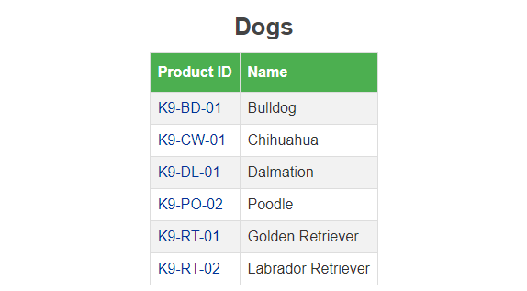
核心代码：
ViewCategoryServlet.java
public class ViewCategoryServlet extends HttpServlet {
private static final String VIEW_CATEGORY = "/WEB-INF/jsp/catalog/Category.jsp";
private String categoryId;
@Override
protected void doGet(HttpServletRequest request, HttpServletResponse response) throws ServletException, IOException {
categoryId = request.getParameter("categoryId");
CatalogService catalogService = new CatalogService();
Category category = catalogService.getCategory(categoryId);
List<Product> productList = catalogService.getProductListByCategory(categoryId);
String username;
if (request.getSession().getAttribute("account") == null)
username = "";
else
username = ((Account) request.getSession().getAttribute("account")).getUsername();
HttpSession session = request.getSession();
session.setAttribute("category", category);
session.setAttribute("productList", productList);

request.getRequestDispatcher(VIEW_CATEGORY).forward(request, response);
}

@Override
protected void doPost(HttpServletRequest request, HttpServletResponse response) throws ServletException, IOException {
doGet(request, response);
}
}

Category.jsp
<table>
<tr>
<th>Product ID</th>
<th>Name</th>
</tr>
<c:forEach var="product" items="${sessionScope.productList}">
<tr>
<td>
<a href="viewProduct?productId=${product.productId}">${product.productId}</a>
</td>
<td>
${product.name}
</td>
</tr>
</c:forEach>
</table>
- 展示小类Product
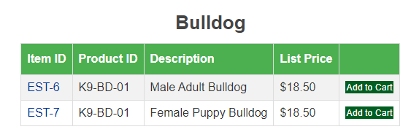

核心代码：
ViewProductServlet.java
private static final String VIEW_PRODUCT = "/WEB-INF/jsp/catalog/Product.jsp";
@Override
protected void doGet(HttpServletRequest request, HttpServletResponse response) throws ServletException, IOException {
productId = request.getParameter("productId");

CatalogService catalogService = new CatalogService();
Product product = catalogService.getProduct(productId);
List<Item> itemList = catalogService.getItemListByProduct(productId);
HttpSession session = request.getSession();
session.setAttribute("product", product);
session.setAttribute("itemList", itemList);

request.getRequestDispatcher(VIEW_PRODUCT).forward(request, response);
}

Product.jsp
<c:forEach var="item" items="${sessionScope.itemList}">
<tr>
<td>
<a href="viewItem?itemId=${item.itemId}">
${item.itemId}
</a>
</td>
<td>${sessionScope.product.productId}</td>
<td>${item.attribute1} ${item.attribute2} ${item.attribute3}
${item.attribute4} ${item.attribute5} ${sessionScope.product.name}</td>
<td><fmt:formatNumber value="${item.listPrice}"
pattern="$#,##0.00"/></td>
<td>
<a class="Button" href="addItemToCart?workingItemId=${item.itemId}">Add to Cart</a>
</td>
</tr>
</c:forEach>
- 展示商品Item
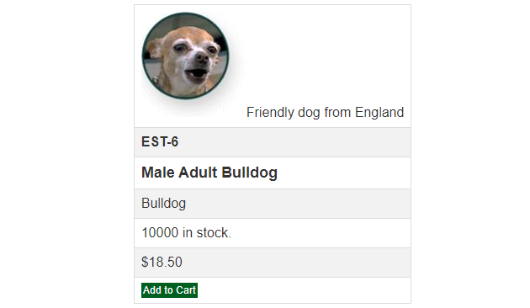
核心代码：
ViewItemServlet.java
public class ViewItemServlet extends HttpServlet {
private String itemId;
private static final String VIEW_ITEM = "/WEB-INF/jsp/catalog/Item.jsp";
@Override
protected void doGet(HttpServletRequest request, HttpServletResponse response) throws ServletException, IOException {
itemId = request.getParameter("itemId");

CatalogService service = new CatalogService();
Item item = service.getItem(itemId);
Product product = item.getProduct();

HttpSession session = request.getSession();
session.setAttribute("product", product);
session.setAttribute("item", item);
request.getRequestDispatcher(VIEW_ITEM).forward(request, response);
}

@Override
protected void doPost(HttpServletRequest request, HttpServletResponse response) throws ServletException, IOException {
doGet(request, response);
}
}
Item.jsp

<table>
<tr>
<td>${sessionScope.product.description}</td>
</tr>
<tr>
<td><b> ${sessionScope.item.itemId} </b></td>
</tr>
<tr>
<td><b><font size="4"> ${sessionScope.item.attribute1}
${sessionScope.item.attribute2} ${sessionScope.item.attribute3}
${sessionScope.item.attribute4} ${sessionScope.item.attribute5}
${sessionScope.product.name} </font></b></td>
</tr>
<tr>
<td>${sessionScope.product.name}</td>
</tr>
<tr>
<td><c:if test="${sessionScope.item.quantity <= 0}">
Back ordered.
</c:if> <c:if test="${sessionScope.item.quantity > 0}">
${sessionScope.item.quantity} in stock.
</c:if></td>
</tr>
<tr>
<td><fmt:formatNumber value="${sessionScope.item.listPrice}"
pattern="$#,##0.00" /></td>
</tr>

<tr>
<td><a class="Button" href="addItemToCart?workingItemId=${sessionScope.item.itemId}">
Add to Cart
</a></td>
</tr>
</table>
- 搜索功能
搜索 “do”
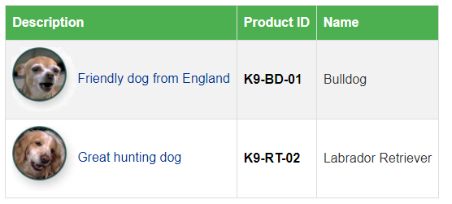

核心代码：
protected void doPost(HttpServletRequest request, HttpServletResponse response) throws ServletException, IOException {
keywords = request.getParameter("keyword");
String requestType = request.getParameter("requestType");
CatalogService service = new CatalogService();
List<Product> productList = service.searchProductList(keywords);

if (!"ajax".equals(requestType)){
HttpSession session = request.getSession();
session.setAttribute("productList", productList);
request.getRequestDispatcher(SEARCH_PRODUCT).forward(request, response);
} else {
response.setContentType("application/json;charset=UTF-8");
PrintWriter out = response.getWriter();
String jsonString = JSON.toJSONString(productList);
out.write(jsonString);
out.flush();
out.close();
}
}

SearchProducts.jsp
<table class="searchResult">
<tr class="head">
<th>Description</th>
<th>Product ID</th>
<th>Name</th>
</tr>
<c:forEach var="product" items="${sessionScope.productList}">
<tr>
<td><a href="viewProduct?productId=${product.productId}">
${product.description}
</a></td>
<td><b> <a href="viewProduct?productId=${product.productId}">
<font color="BLACK"> ${product.productId} </font>
</a> </b></td>
<td>${product.name}</td>
</tr>
</c:forEach>
</table>
- 用户管理业务模块，包括用户注册、登录、修改用户信息、查询用户相关订单等业务功能。
- 用户注册
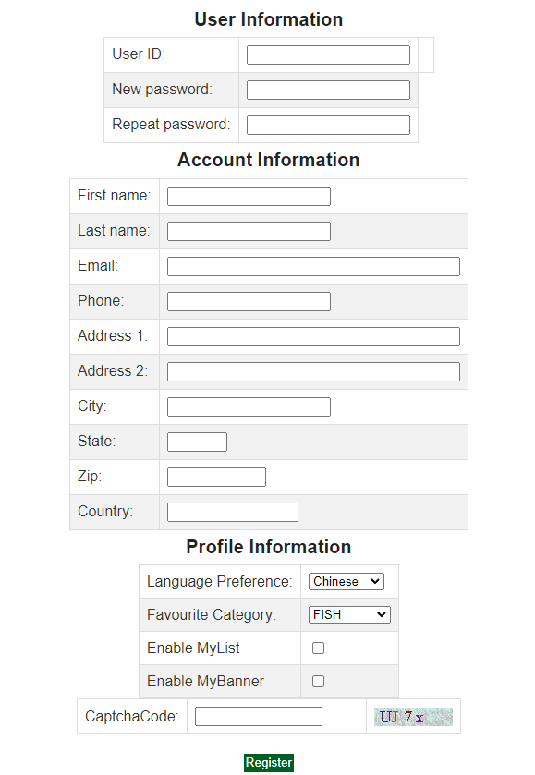
核心代码：RegisterServlet.java
public class RegisterServlet extends HttpServlet {
Account account = new Account();
private static final String REGISTER_PAGE = "/WEB-INF/jsp/account/NewAccountForm.jsp";
@Override
protected void doGet(HttpServletRequest request, HttpServletResponse response) throws ServletException, IOException {
doPost(request, response);
}

@Override
protected void doPost(HttpServletRequest request, HttpServletResponse response) throws ServletException, IOException {
String code = request.getParameter("captchaCode");
String captCode = (String) request.getSession().getAttribute("capCode");
if (!captCode.equalsIgnoreCase(code)) {
request.setAttribute("msg", "incorrect CaptchaCode!");
request.getRequestDispatcher("registerPage").forward(request, response);
return;
}

request.setCharacterEncoding("utf-8");
String username = request.getParameter("username");
account.setUsername(username);
String password = request.getParameter("password");
account.setPassword(password);
String repeatedPassword = request.getParameter("repeatedPassword");
String firstName = request.getParameter("account.firstName");
account.setFirstName(firstName);
String lastName = request.getParameter("account.lastName");
account.setLastName(lastName);
String email = request.getParameter("account.email");
account.setEmail(email);
String phone = request.getParameter("account.phone");
account.setPhone(phone);
String address1 = request.getParameter("account.address1");
account.setAddress1(address1);
String address2 = request.getParameter("account.address2");
account.setAddress2(address2);
String city = request.getParameter("account.city");
account.setCity(city);
String state = request.getParameter("account.state");
account.setState(state);
String zip = request.getParameter("account.zip");
account.setZip(zip);
String country = request.getParameter("account.country");
account.setCountry(country);
account.setLanguagePreference(request.getParameter("account.languagePreference"));
account.setFavouriteCategoryId(request.getParameter("account.favouriteCategoryId"));
account.setListOption("on".equals(request.getParameter("account.listOption")));
account.setBannerOption("on".equals(request.getParameter("account.bannerOption")));

request.getSession().setAttribute("account", account);
request.setAttribute("repeatedPassword", repeatedPassword);
if (username.isEmpty() || password.isEmpty() || repeatedPassword.isEmpty() ||
firstName.isEmpty() || lastName.isEmpty() || email.isEmpty() ||
phone.isEmpty() || address1.isEmpty() || address2.isEmpty() ||
city.isEmpty() || state.isEmpty() || zip.isEmpty() || country.isEmpty()
) {
request.setAttribute("msg", "Please fill all line.");
request.getRequestDispatcher(REGISTER_PAGE).forward(request, response);
} else if (!email.matches("^(\\w+([-.][A-Za-z0-9]+)*){3,18}@\\w+([-.][A-Za-z0-9]+)*\\.\\w+([-.][A-Za-z0-9]+)*$") && false) {
request.setAttribute("msg", "Incorrect email.");
request.getRequestDispatcher(REGISTER_PAGE).forward(request, response);
} else if (!repeatedPassword.equals(password)) {
request.setAttribute("msg", "Two input password must be consistent");
request.getRequestDispatcher(REGISTER_PAGE).forward(request, response);
}else {

AccountService accountService = new AccountService();
accountService.insertAccount(account);
account = accountService.getAccount(account.getUsername());
List<Product> myList = new CatalogService().getProductListByCategory(account.getFavouriteCategoryId());

HttpSession session = request.getSession();
session.setAttribute("account", account);
session.setAttribute("myList", myList);
session.setAttribute("isAuthenticated", true);

request.getRequestDispatcher("main").forward(request, response);
}
}
}
- 用户登录
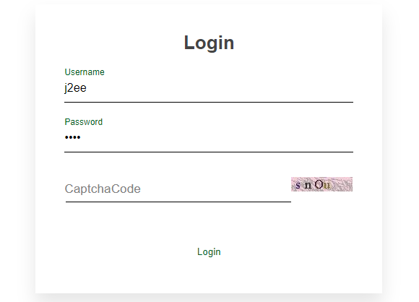
核心代码：LoginServlet.java
public class LoginServlet extends HttpServlet {
private String username;
private String password;
private Account account;
private List<Product> myList;
private boolean authenticated = false;
private final AccountService accountService = new AccountService();
private final CatalogService catalogService = new CatalogService();
@Override
protected void doGet(HttpServletRequest request, HttpServletResponse response) throws ServletException, IOException {
doPost(request, response);
}

@Override
protected void doPost(HttpServletRequest request, HttpServletResponse response) throws ServletException, IOException {
String code = request.getParameter("captchaCode");
String captCode = (String) request.getSession().getAttribute("capCode");
if (!captCode.equalsIgnoreCase(code)) {
request.setAttribute("msg", "incorrect CaptchaCode!");
request.getRequestDispatcher("loginPage").forward(request, response);
return;
}
username = request.getParameter("username");
password = request.getParameter("password");
account = accountService.getAccount(username, password);
if (account == null) {
request.setAttribute("msg", "Invalid username or password. Signon failed.");
account = new Account();
request.getRequestDispatcher("loginPage").forward(request,response);
} else {
account.setPassword(null);
myList = catalogService.getProductListByCategory(account.getFavouriteCategoryId());
authenticated = true;
HttpSession session = request.getSession();
session.setAttribute("account", account);
session.setAttribute("myList", myList);
session.setAttribute("isAuthenticated", authenticated);
Cart cart = null;
try {
CartDAOImpl cartDAO = new CartDAOImpl();
byte[] bytes = cartDAO.getCartString(account.getUsername());
if (bytes == null) {
cart = new Cart();
cartDAO.insertCart(account.getUsername(), SerializeUtil.serialize(cart));
} else {
cart = (Cart) SerializeUtil.serializeToObject(bytes);
}
} catch (ClassNotFoundException e) {
e.printStackTrace();
}
session.setAttribute("cart", cart);
request.getRequestDispatcher("main").forward(request, response);
}
}
}
- 修改用户信息
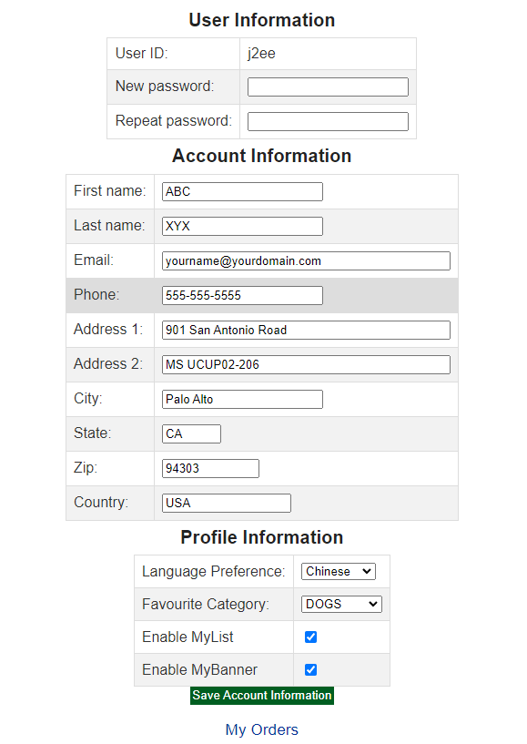

核心代码：
public class EditAccountServlet extends HttpServlet {
@Override
protected void doGet(HttpServletRequest request, HttpServletResponse response) throws ServletException, IOException {
doPost(request, response);
}

@Override
protected void doPost(HttpServletRequest request, HttpServletResponse response) throws ServletException, IOException {
request.setCharacterEncoding("utf-8");
HttpSession session = request.getSession();
Account account = (Account) session.getAttribute("account");

if (account == null) {
request.getRequestDispatcher("loginForm").forward(request, response);
return;
}

String password = request.getParameter("password");
String repeatedPassword = request.getParameter("repeatedPassword");
if (password.equals(repeatedPassword)) {
account.setPassword(password);
}

String firstName = request.getParameter("account.firstName");
account.setFirstName(firstName);
String lastName = request.getParameter("account.lastName");
account.setLastName(lastName);
String email = request.getParameter("account.email");
account.setEmail(email);
String phone = request.getParameter("account.phone");
account.setPhone(phone);
String address1 = request.getParameter("account.address1");
account.setAddress1(address1);
String address2 = request.getParameter("account.address2");
account.setAddress2(address2);
String city = request.getParameter("account.city");
account.setCity(city);
String state = request.getParameter("account.state");
account.setState(state);
String zip = request.getParameter("account.zip");
account.setZip(zip);
String country = request.getParameter("account.country");
account.setCountry(country);
account.setLanguagePreference(request.getParameter("account.languagePreference"));
account.setFavouriteCategoryId(request.getParameter("account.favouriteCategoryId"));
account.setListOption("on".equals(request.getParameter("account.listOption")));
account.setBannerOption("on".equals(request.getParameter("account.bannerOption")));

AccountService accountService = new AccountService();
accountService.updateAccount(account);
account = accountService.getAccount(account.getUsername());
session.setAttribute("account", account);
request.getRequestDispatcher("editAccountForm").forward(request, response);
}
}
- 查询订单
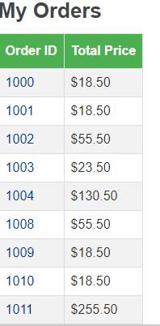
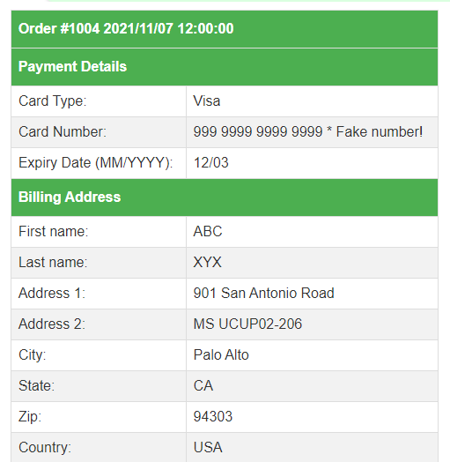
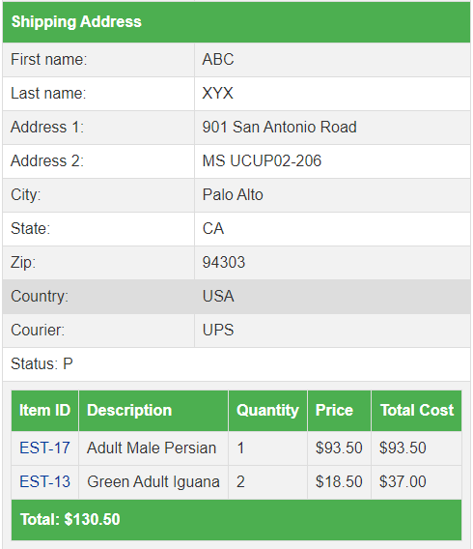
核心代码：ListOrderServlet.java
public class ListOrderServlet extends HttpServlet {
private static final String LIST_ORDER = "/WEB-INF/jsp/order/ListOrders.jsp";
@Override
protected void doGet(HttpServletRequest request, HttpServletResponse response) throws ServletException, IOException {
Account account = (Account) request.getSession().getAttribute("account");
if (account == null) {
request.getRequestDispatcher("main").forward(request, response);
return;
}
List<Order> orderList = new OrderService().getOrderByUsername(account.getUsername());
request.getSession().setAttribute("orderList", orderList);
request.getRequestDispatcher(LIST_ORDER).forward(request, response);
}

@Override
protected void doPost(HttpServletRequest request, HttpServletResponse response) throws ServletException, IOException {
doGet(request, response);
}
}

ViewOrderServlet.java

protected void doGet(HttpServletRequest request, HttpServletResponse response) throws ServletException, IOException {
HttpSession session = request.getSession();
Account account = (Account) session.getAttribute("account");
Order order = new OrderService().getOrder(Integer.parseInt(request.getParameter("orderId")));
session.setAttribute("order", order);

if (account.getUsername().equals(order.getUsername())) {
request.getRequestDispatcher(VIEW_ORDER).forward(request, response);
} else {
request.setAttribute("msg", "You may only view your own orders.");
request.getRequestDispatcher(ERROR_PAGE).forward(request, response);
}
}

- 订单管理模块，包括购物车管理、新增订单、地址信息等业务功能。
- 购物车管理
添加商品代码
protected void doGet(HttpServletRequest request, HttpServletResponse response) throws ServletException, IOException {
workingItemId = request.getParameter("workingItemId");
catalogService = new CatalogService();
Cart cart = (Cart) request.getSession().getAttribute("cart");
Account account = (Account) request.getSession().getAttribute("account");
if (account == null) {
request.setAttribute("msg", "You must sign on before attempting to check out. Please sign on and try checking out again.");
request.getRequestDispatcher("loginPage").forward(request, response);
return;
}
if (cart == null) {
cart = new Cart();
}
if (workingItemId == null) {
request.getSession().setAttribute("cart", cart);
request.getRequestDispatcher(JUMP_TO_CART).forward(request, response);
return;
}
if (cart.containsItemId(workingItemId)) {
cart.incrementQuantityByItemId(workingItemId);
} else {
boolean isInStock = catalogService.isItemInStock(workingItemId);
Item item = catalogService.getItem(workingItemId);
cart.addItem(item, isInStock);
}
request.getSession().setAttribute("cart", cart);
new CartDAOImpl().updateCart(((Account) request.getSession().getAttribute("account")).getUsername(), SerializeUtil.serialize(cart));
request.getRequestDispatcher(JUMP_TO_CART).forward(request, response);
}
更新购物车
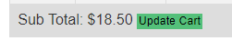
核心代码：UpdateCartServlet.java
HttpSession session = request.getSession();
Cart cart = (Cart) session.getAttribute("cart");
Iterator<CartItem> cartItems = cart.getAllCartItems();
Account account = (Account) session.getAttribute("account");
JSONArray responseData = new JSONArray();
while (cartItems.hasNext()) {
CartItem cartItem = cartItems.next();
String itemId = cartItem.getItem().getItemId();

int quantity = Integer.parseInt(request.getParameter(itemId));
cart.setQuantityByItemId(itemId, quantity);
if (quantity < 1) {
cartItems.remove();
}else if (request.getParameter("requestType").equals("ajax")){
JSONObject jsonObject = new JSONObject();
jsonObject.put("itemId", cartItem.getItem().getItemId());
jsonObject.put("totalPrice", cartItem.getTotal());
responseData.add(jsonObject);
}

}
- 新增订单和地址信息
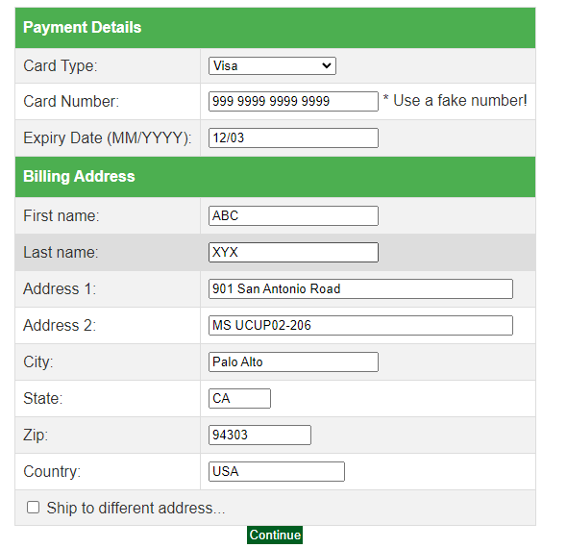
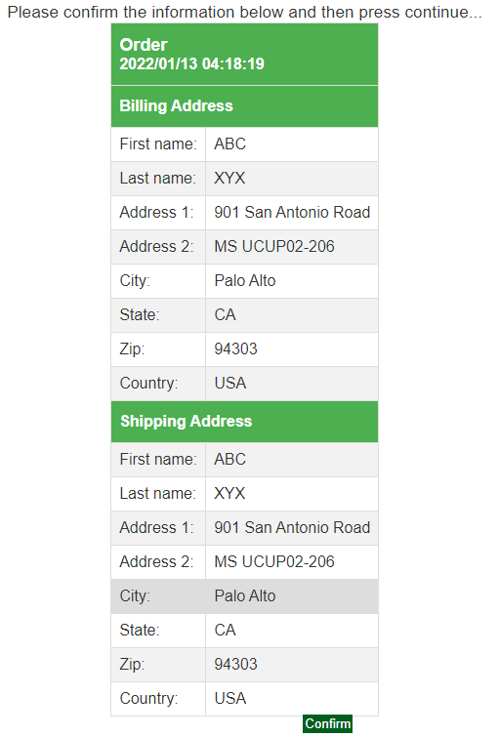
核心代码：NewOrderServlet.java
protected void doPost(HttpServletRequest request, HttpServletResponse response) throws ServletException, IOException {
HttpSession session = request.getSession();
Order order = (Order) session.getAttribute("order");
boolean confirmed = (boolean) session.getAttribute("confirmed");
Account account = (Account) session.getAttribute("account");

if ("true".equals(request.getParameter("inputOrderInfo"))) {
formDataToOrder(request, order, "on".equals(request.getParameter("shippingAddressRequired")));
}
if (!confirmed) {
request.getRequestDispatcher(CONFIRM_ORDER).forward(request, response);
} else if (order != null) {

new OrderService().insertOrder(order);
session.setAttribute("cart", new Cart());
new CartDAOImpl().updateCart(account.getUsername(), SerializeUtil.serialize(new Cart()));
request.setAttribute("msg", "Thank you, your order has been submitted.");
request.getRequestDispatcher(VIEW_ORDER).forward(request, response);
} else {
request.setAttribute("msg", "An error occurred processing your order (order was null).");
request.getRequestDispatcher(ERROR_PAGE).forward(request, response);
}

}
- 实验内容——扩展任务。
- 添加验证码功能：在用户注册和用户登录模块中添加验证码功能。
基本原理和实现方案：
验证码生成方案：在[A-Za-z0-9]中随机选取4个字符创建图像并添加干扰线
核心代码：
private void init() {
// 在内存中创建图象
int width = 85, height = 20;
BufferedImage image = new BufferedImage(width, height, BufferedImage.TYPE_INT_RGB);
// 获取图形上下文
Graphics g = image.getGraphics();
// 生成随机类
Random random = new Random();
// 设定背景色
g.setColor(getRandColor(200, 250));
g.fillRect(0, 0, width, height);
// 设定字体
g.setFont(new Font("Times New Roman", Font.PLAIN, 18));
// 随机产生155条干扰线，使图象中的认证码不易被其它程序探测到
g.setColor(getRandColor(160, 200));
for (int i = 0; i < 155; i++) {
int x = random.nextInt(width);
int y = random.nextInt(height);
int xl = random.nextInt(12);
int yl = random.nextInt(12);
g.drawLine(x, y, x + xl, y + yl);
}
// 取随机产生的认证码(4位数字)
String sRand = "";
for (int i = 0; i < 4; i++) {
String rand = String.valueOf(code[random.nextInt(code.length)]);
sRand += rand;
// 将认证码显示到图象中
g.setColor(new Color(20 + random.nextInt(110), 20 + random.nextInt(110), 20 + random.nextInt(110)));
// 调用函数出来的颜色相同，可能是因为种子太接近，所以只能直接生成
g.drawString(rand, 13 * i + 6, 16);
}
// 赋值验证码
this.str = sRand;

// 图象生效
g.dispose();
this.image = image;/* 赋值图像 */
}

登录验证
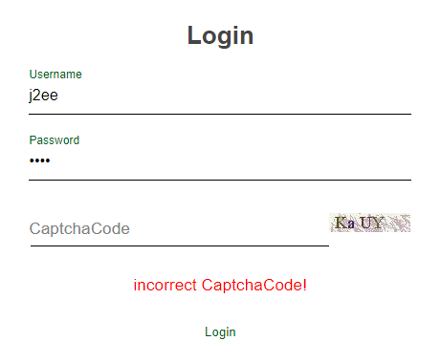
核心代码：
String code = request.getParameter("captchaCode");
String captCode = (String) request.getSession().getAttribute("capCode");
if (!captCode.equalsIgnoreCase(code)) {
request.setAttribute("msg", "incorrect CaptchaCode!");
request.getRequestDispatcher("loginPage").forward(request, response);
return;
}

- 购物车功能：原项目中购物车为内存购物车，即将用户相关的购物车存储在session中；在数据库中添加购物车表，将购物车数据持久化，以便用户下次登录时可查看或修改自己的购物车数据。
实现原理：利用java对象的序列化，每次修改购物车时，将购物车序列化并存进数据库中，下次登录时从数据库中还原购物车对象，从而实现购物车持久化
核心代码：
new CartDAOImpl().updateCart(account.getUsername(), SerializeUtil.serialize(cart));
序列化：
public static byte[] serialize(Object obj) throws IOException {
ByteArrayOutputStream byteArrayOutputStream = new ByteArrayOutputStream();
ObjectOutputStream objectOutputStream;
objectOutputStream = new ObjectOutputStream(byteArrayOutputStream);
objectOutputStream.writeObject(obj);
byte[] string = byteArrayOutputStream.toByteArray();
objectOutputStream.close();
byteArrayOutputStream.close();
return string;
}
public static Object serializeToObject(byte[] str) throws IOException, ClassNotFoundException {
ByteArrayInputStream byteArrayInputStream = new ByteArrayInputStream(str);
ObjectInputStream objectInputStream = new ObjectInputStream(byteArrayInputStream);
Object object = objectInputStream.readObject();
objectInputStream.close();
byteArrayInputStream.close();
return object;
}

- 日志功能：数据库中添加日志信息表，给项目添加日志功能，用户登录后记录用户行为，比如浏览了哪些商品、将商品添加进购物车、生成订单等。
实现原理：利用web Filter，对每一次访问都进行过滤，并保存访问的用户名（如果未登录则为空）和url到数据库
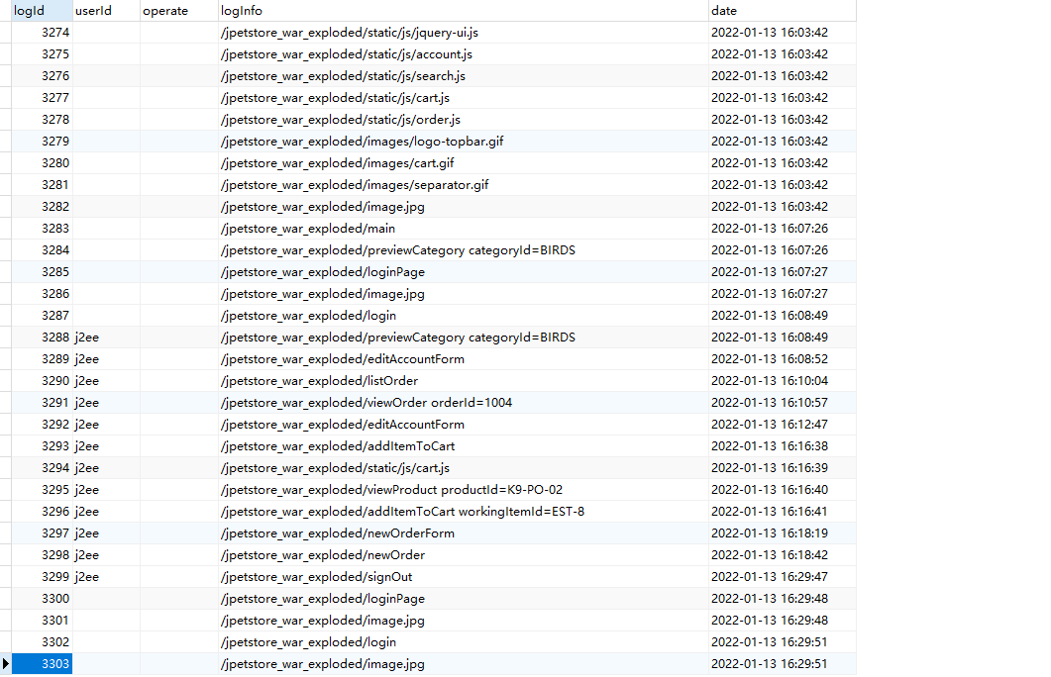

核心代码：LogFilter.java
public class LogFilter implements Filter {
public void init(FilterConfig config) throws ServletException {
}

public void destroy() {
}

@Override
public void doFilter(ServletRequest request, ServletResponse response, FilterChain chain) throws ServletException, IOException {
HttpServletRequest httpServletRequest = (HttpServletRequest) request;
HttpSession session = httpServletRequest.getSession();

Account account = (Account) session.getAttribute("account");

new LogService().addLog(new Log(account != null ? account.getUsername() : "", httpServletRequest.getRequestURI() + " " + (httpServletRequest.getQueryString() == null ? "" : httpServletRequest.getQueryString()), null));

chain.doFilter(request, response);
}
}
- 小组成员分工及实验总结
- 小组分工
孙羽豪为组长负责商品展示模块和附加功能，周希负责用户管理业务模块，王翰毅负责订单管理模块
- 实验总结
在实验一的编写中，一开始配置编写servlet的时候遇到各种问题，比如404错误，jar包丢失，无法转跳等等。但经过几个servlet的编写后，逐渐熟悉了servlet的编写：创建servlet类，配置web.xml文件，获取客户端的值，处理，返回相应的页面或转发给下一个servlet处理。
在写日志功能时，一开始我在每一个servlet中都添加了log信息的获取，造成代码的冗余和不优雅。之后复习时发现ppt中有web filter的介绍，可以对请求过滤，处理再转发。于是我创建了一个LogFilter类来过滤所有url（/*），再filter中进行日志的记录，再发送到相应的servlet处理。
心得体会：这次实验主要是熟悉MVC架构的开发模式。MVC模式中的三层是紧密联系但又是互相独立的，每一层内部的变动都不影响其他层，只要保证接口不变，所以要尽量做到面向接口编程。在这个项目中，persistence层就是先确定接口，再实现接口。MVC架构解决了复杂问题的分工协作，保证项目的可拓展性和可维护性

实验二 使用AJAX和jQuery改善用户体验
- 实验内容——基本任务。
- 账号管理模块。在新建账号和修改账号信息页面上用AJAX技术进行表单验证，如“判断用户名是否已存在”等功能。
核心代码：account.js
$('#registerUsername').blur(() => {
if ($('#registerUsername').val() === '') return;
$.ajax({
type : 'GET',
url: 'usernameExist?username=' + $('#registerUsername').val(),
beforeSend : () => {
$("#usernameTips").removeAttr('class').val('');
},
success : (data) => {
if (data === 'Not Exist') {
$('#usernameTips').attr('class', 'okTips').text('Available');
} else {
$('#usernameTips').attr('class', 'errorTips').text('This name has been used.');
}
}
});
});
- 查询商品模块。在主页面右上角的查询商品功能中添加自动补全功能。
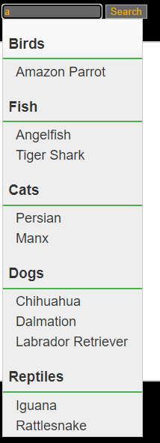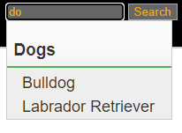
核心代码：
let searchText = $('#searchText');

$.widget('custom.categoryAutoComplete', $.ui.autocomplete, {
_create: function () {
this._super();
this.widget().menu('option', 'items', '> :not(.ui-autocomplete-category)');
},
_renderMenu: function (ul, items) {
let that = this, currentCategory = '';
$.each(items, function (index, item) {
let li;
if (item.category !== currentCategory) {
ul.append(`<li class='ui-autocomplete-category'>${item.category}</li>`);
currentCategory = item.category;
}
li = that._renderItemData(ul, item);
if (item.category) {
li.attr('aria-label', `${item.category} : ${item.label}`)
}
});
}
})

searchText.categoryAutoComplete({
minLength: 1,
delay: 500,
source: (request, response) => {
$.ajax({
type: 'POST',
url: 'search',
data: {requestType: 'ajax', keyword: searchText.val()},
success: (data) => {
response($.map(data, item => {
console.log(item.name + item.categoryId)
return {label: item.name, category: (item.categoryId).slice(0, 1) + item.categoryId.slice(1).toLowerCase(), id: item.productId}
}));

}
});
},
select: (event, ui) => {
window.location.href = 'viewProduct?productId=' + ui.item.id;
}

})
- 购物车模块。在购物车模块中修改购买数量时，通过AJAX修改购物车信息。
修改前：
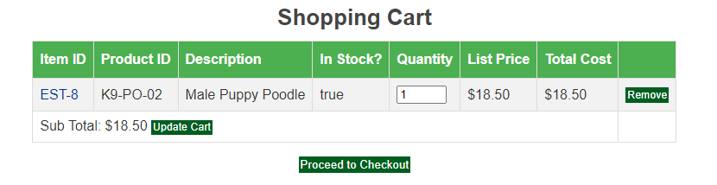
修改后：
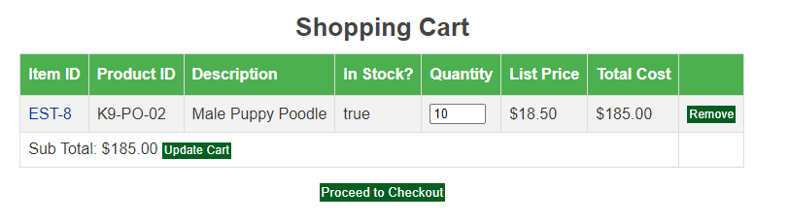
核心代码：
let tr = $('#cart tbody tr')
inputText.on('blur', (e) => {
let valid = true
$.each(inputText, (i, v) => {
console.log($(v).val())
if ($(v).val() < 1 || isNaN($(v).val())) {
$('#dialog').dialog()
valid = false
}
if (valid) {
let ids = $('table td>a:not(.Button)');
let quantities = $('table input[type="text"]');
let requestData = {};
for (let i = 0; i < ids.length; i++) {
requestData[ids[i].text.trim()] = quantities[i].value;
}
requestData.requestType = 'ajax';

$.ajax({
type: 'POST',
url: 'updateCart',
data: requestData,
success: (data) => {
let totalSub = 0;
for (let i = 0; i < data.length; i++) {
quantities[i].parentElement.parentElement.nextElementSibling.nextElementSibling.textContent = "$" + data[i].totalPrice.toFixed(2);
totalSub += data[i].totalPrice;
}
let subTotal = $('#subTotal')
subTotal.html((subTotal.html().replace(/\$\d*.\d{2}/, "$" + totalSub.toFixed(2))));
}
});
}

})
})
- 实验内容——选做任务。
- 商品展示模块。在首页展示商品的图片上添加AJAX效果，即当鼠标移到某个商品图片上时，用悬浮窗展示该类型商品的信息。
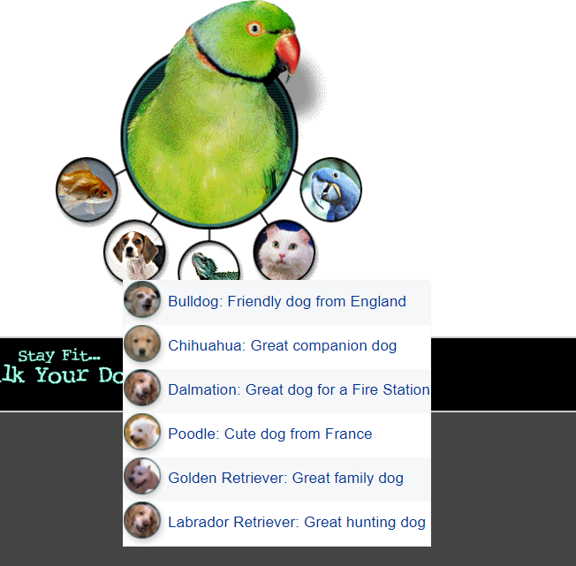
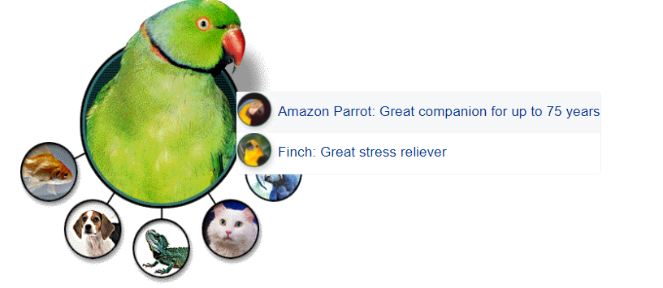
基本原理：鼠标悬浮时触发mouseenter事件，通过ajax向服务器发送请求获取对应类别的数据并展示在页面上
实现方案：mouseenter的回调函数
$('area').mouseenter((e) => {
let area = e.currentTarget;
$.ajax({
type: 'GET',
url: 'previewCategory',
data: {categoryId: area.alt.toUpperCase()},
success: (data) => {
if (area.hasChildNodes()) {
$(area).children().css('top', e.clientY)
$(area).children().css('left', e.clientX)
return;
}
let $previewDiv = $(`<div class="preview" style="top: ${e.clientY}px; left: ${e.clientX}px;"><ul></ul></div>`)
$previewDiv.slideUp(100, 'swing')
let $ul = $previewDiv.children(':nth-child(1)')
for (let datum of data) {
let arr = datum.description.match(/(<.*>)(.*)/)
$ul.append(`<li><a href="viewProduct?productId=${datum.productId}">${arr[1].replaceAll('\\', '')}<span><label class="name">${datum.name}</label>: <label class="des">${arr[2]}</label></span></a></li>`)
}
$(area).append($previewDiv)
$previewDiv.slideDown(100, 'swing')

$(area).mouseleave((e) => {
$('div.preview').slideUp(100, 'swing')
})
$(area).mouseenter((e) => {
$(area).children().slideDown(100, 'swing')
})
}
})
})
- 订单模块。通过选项卡或模版内容实现订单多个信息部分的录入，不需要页面跳转，在一个页面完成订单所有内容的录入。
未选中ship to different address
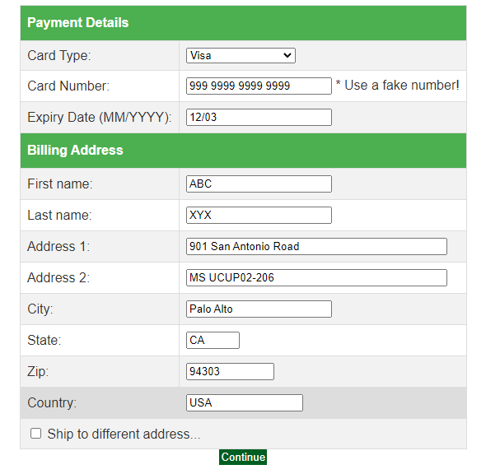
选中ship to different address
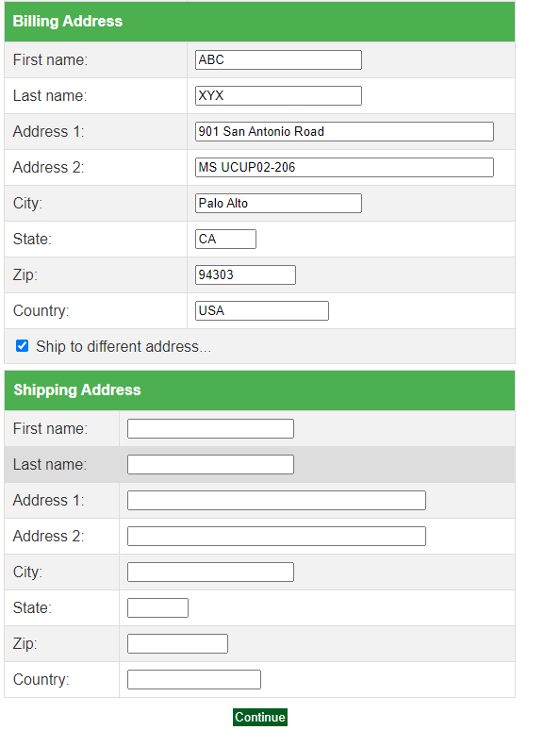
基本原理：利用js绑定复选框的change的回调函数，当复选框选中时，调用slideDown函数下拉Shipping Address的表单域，当复选框未选中时，调用slideUp函数隐藏表单域，提交时根据复选框是否选中判断是否要获取shipping address中的内容
实现方案：
let shippingForm = $('.shippingAddress');
shippingForm.slideUp(0);
$('input[name="shippingAddressRequired"]').change(() => {
if (($('input[name="shippingAddressRequired"]').is(':checked'))) {
shippingForm.slideDown(300, 'swing');
shippingForm.removeAttr("disabled")
} else {
shippingForm.slideUp(300, 'swing')
shippingForm.attr('disabled')
}

})

- 其他效果：可自行选择其他UI模版，或选择其他功能点进行用户体验的优化。
简单的修改了部分UI
导航栏：
css样式：
nav {
text-align: -webkit-center;
position: relative;
width: 575px;
height: 50px;
background-color: #daffe0;
border-radius: 8px;
box-shadow: 0 2px 3px rgba(0, 0, 0, 0.1);
}

nav a {

position: relative;
display: block;
float: left;
font-size: 15px;
line-height: 50px;
width: 100px;
height: 50px;
color: #fff;
text-decoration: none;
text-align: center;
z-index: 10;
}

nav a:nth-child(3) {
width: 175px;
}
nav a:nth-child(5) {
clear: right;
}
nav .animation {
display: none;
position: absolute;
height: 100%;
width: 100px;
background-color: #95ff45;
z-index: 9;
border-radius: 8px;
transition: all 0.3s;
}

nav a:nth-child(1):hover~.animation {
display: block;
width: 100px;
left: 0px;
}
nav a:nth-child(2):hover~.animation {
display: block;
width: 100px;
left: 100px;
}
nav a:nth-child(3):hover~.animation {
display: block;
width: 175px;
left: 200px;
}
nav a:nth-child(4):hover~.animation {
display: block;
width: 100px;
left: 375px;
}
nav a:nth-child(5):hover~.animation {
display: block;
width: 100px;
left: 475px;
}

表格：
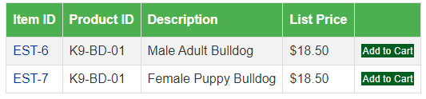
css样式：

table {
font-family: Arial, sans-serif;
border-collapse: collapse;
}

table td, table th {
border: 1px solid #ddd;
height: inherit;
padding: 8px;
vertical-align: middle;
}

table tr:nth-child(even) {
background-color: #f2f2f2;
}
table tr:hover {
background-color: #ddd;
}
table th {
padding-top: 12px;
padding-bottom: 12px;
text-align: left;
background-color: #4caf50;
color: white;
}

登录界面
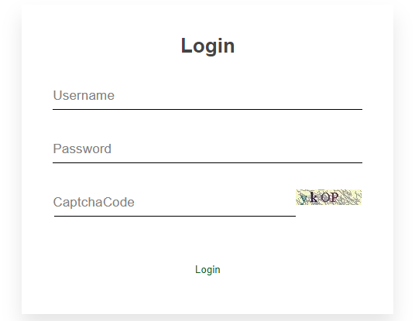

css样式：
div.login *{
padding: 0;
margin: 0;
box-sizing: border-box;
}

div.login {
display: flex;
flex-direction: column;
align-items: center;
width: 400px;
padding: 40px;
margin: auto;
background-color: white;
box-shadow: 0 15px 25px rgba(0,0,0,0.1);
}

div.login h2 {
margin-bottom: 30px;
}

div.login div.loginBox {
position: relative;
width: 100%;
}

div.login div.loginBox input{
outline: none;
border: none;
width: 100%;
padding: 10px 0;
margin-bottom: 30px;
color: black;
font-size: 16px;
border-bottom: 1px solid black;
}

div.login div.loginBox label {
position: absolute;
top: 0;
left: 0;
padding: 10px 0;
pointer-events: none;
transition: all 0.5s;
color: grey;;
}

div.login div.loginBox input:focus + label ,
div.login div.loginBox input:valid + label {
top: -20px;
color: #005e21;
font-size: 12px;

}

div.login input.loginButton {
position: relative;
padding: 10px 20px;
color: #005e21;
border: 0;
background-color: white;
transition: all 0.5s;
}

div.login input.loginButton:hover {
color: white;
border-radius: 5px;
background-color: #079437;
box-shadow: 0 0 5px #079437, 0 0 25px #079437, 0 0 50px #079437, 0 0 100px #079437;
}

input[name='captchaCode'] {
width: 78% !important;
}
- 小组成员分工及实验总结
- 小组分工
孙羽豪为组长负责查询商品模块和附加功能，周希负责购物车模块，王翰毅负责账号查询模块
- 实验总结
实验二主要的难点是js和css的编写，js由于变化灵活易于上手，但是在调试方面有些麻烦，需要在浏览器的开发者工具中加断点或输出到控制台。对于css，由于这个项目使用的是jsp动态页面，所以调试css非常困难，如果直接在css文件中写，每次都需要更新资源再刷新浏览器才能看到变化；如果在浏览器开发者工具中写，难以保存样式。找不到一个好的方法调css
实验总结：这次实验只要是利用ajax技术优化用户体验和css美化界面。ajax可以在不刷新整个页面的情况下，向服务器发送请求，刷新部分页面，这样可以节省带宽，不影响用户浏览，最近B站手机端的评论区也增加了自动刷新评论的功能，在你浏览的评论上方刷新最新的评论，用的应该也是类似的异步请求技术。Css技术的难点在于不知道怎么将脑中想的样式变成代码，归根结底还是写Css的经验不足，需要多加练习

