School AI Chat Platform — Launch Notes & Roadmap Input
A cleaned, structured version of the whiteboard notes (MVP → April 20 launch)
Target launch date: 20 April
Last updated: 2026-02-11

Project goal | Replace/augment ChatGPT for school use: safer, structured, and aligned with The Global College (TGC) learning culture.
Core question | How can we support the TGC community in using appropriate AI for appropriate tasks?
Approach | Student-focused model + teacher-facing tools, built with privacy and school context in mind.

1. Whiteboard Notes — Clean Transcription

1.1 Stakeholders to interview / listen to
- Students — speak
- What is it you need to know?
- How are you going to find out?
- From who?
- By when?
- Teachers — speak
- How many?
- What do you want to know?
- When do you want to know it by?
- Board / Senior leadership
- What is our culture? (what should the tool reinforce?)

Extra prompt from the board:
“Teachers: what do you want from a ‘subject’ agent?”

1.2 Research & validation activities
- Research alternatives
- Behaviours / culture — TGC
- Interview / questionnaire
- Research: features / news / new models
- Test groups — teachers / students (broad sample)
- A/B testing
- Long-form reflections (qualitative feedback)

1.3 Product / delivery notes
- Info for teachers to guide students in use (guardrails + examples).
- Accessible language for all users (students and staff).
- Timetables / schedules + feature deadlines.
- Revise tasks regularly as each feature moves from draft → shipped.
- Financing? (open question)
- Track user… (analytics / adoption tracking, with privacy constraints)

2. ‘Student Model’ Concept (from blue notes)
- Starter: A student model
- Hook: 2-layer persona + agent orchestration
- Research (p/s): unknown / to define (circled “?” on the board)
- Target rollout path:
- DP1 → DP2 (+ DP1) → TOK (and other contexts) → all schools
- Marketing / pitch framing: 2 layers | agent orchestrator | context relevant | PRIVATE
- Date: April 20th

2.1 Central framing question
How can we support the TGC community in using appropriate AI for appropriate tasks?
- Related note: culture / curriculum alignment.

3. Structured Backlog (turn the notes into a working plan)
This section reorganises the whiteboard into a practical backlog you can expand. Use it as a base for a proper roadmap (phases, owners, success metrics).

3.1 Discovery (now → early March)
- Run short interviews with a small set of students + teachers (5–10 each).
- Design a questionnaire that focuses on: most common tasks, acceptable vs unacceptable use, and pain points with existing tools.
- Write an ethical statement + privacy position (what data is collected, why, retention).
- Define what ‘appropriate AI’ means at TGC (examples + boundaries).

3.2 Build (March → early April)
- Teacher guide inside the product (quick rules + examples per subject).
- Accessible language pass (UI copy + system prompts).
- Core ‘subject agent’ capability (what teachers actually want).
- Analytics plan (minimal, privacy-safe) to track adoption and pain points.
- Test groups: set up cohorts for controlled pilots (students + teachers).

3.3 Validate & tune (early April → launch)
- A/B test key UX decisions (prompting UI, tooltips, guardrails, model selection).
- Collect long-form reflections from a few students/teachers (depth over breadth).
- Iterate weekly: revise tasks and reprioritise as features move from draft → shipped.
- Prepare the launch pitch (student value + teacher confidence + leadership culture fit).

3.4 Launch checklist (week of April 20)
- Ethical statement published and visible in-app.
- Privacy defaults configured (no unnecessary logging).
- Teacher guide + ‘how to use’ page ready.
- Pilot group confirmed and feedback channel set up.
- Fallback plan if a feature breaks (graceful degradation).

Appendix A — Original whiteboard photos
These are included for reference so you can add missing details later.

Whiteboard notes (red)
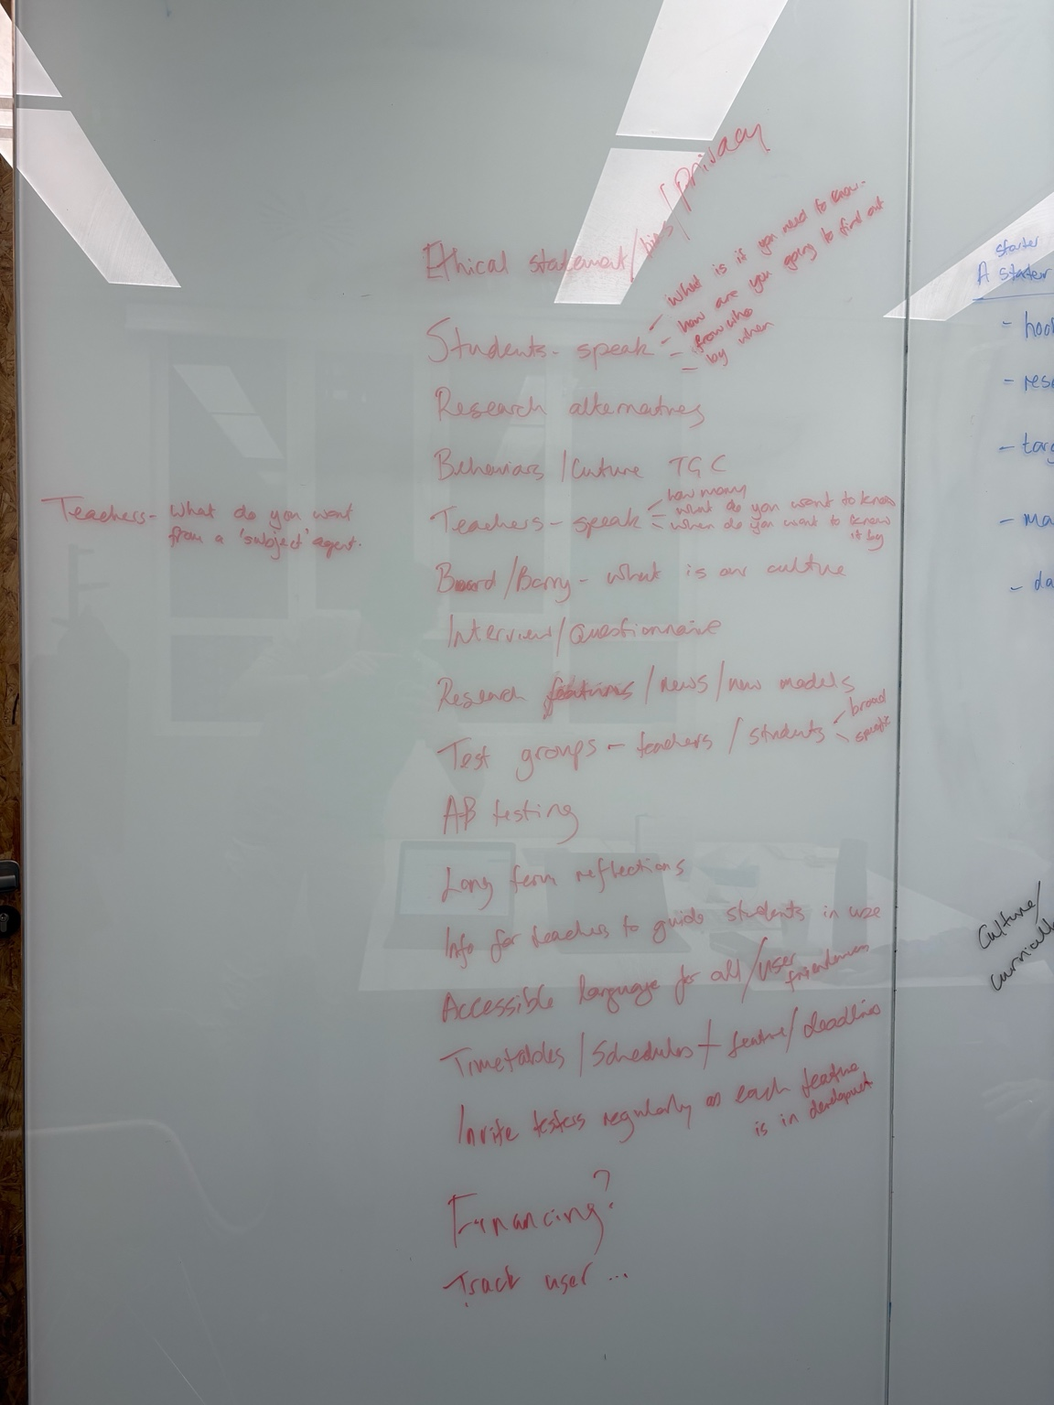

Whiteboard notes (blue)


