VIETNAM GENERAL CONFEDERATION OF LABOUR
TON DUC THANG UNIVERSITY
FACULTY OF INFORMATION TECHNOLOGY


523c0012 – Huynh Nhat Huy
523v0002 – Bui Quang Huy

FINAL PROJECT — PART 2
SAIGONRIDE: DISTRIBUTED VEHICLE RENTAL SYSTEM

System Design Document
Introduction to Software Engineering | HK2, 2025-2026
Instructor: Ky-Trung Pham

Tier 4 — ASP.NET MVC Code-First + Entity Framework + VNPay Sandbox
(Max Score: 10.0)

HO CHI MINH CITY, YEAR 2025 - 2026

1. Source Code, Version Control & Deployment

https://github.com/Thundercok/SaigonRide/invitations
- Detailed Design & Justification (Changes from Part 2)

When transitioning from the UML diagrams in Part 2 to actual C# code, we realized some of our initial designs were too theoretical and hard to implement. We made the following practical changes:

2.1. Database Design (Entity Framework Code-First)

- What we planned: In Part 2, we designed LocalCommuter and ForeignTourist as separate entities extending a base User class.

- What we actually coded: When we implemented ASP.NET Core Identity for authentication, managing multiple user tables became extremely complex. To fix this, we used Table-Per-Hierarchy (TPH). We created a single AspNetUsers table and added custom columns like UserType (Enum: Local/Tourist) and PassportNumber (nullable). This saved us a lot of time and made login logic much simpler.

- Added Transactions table: Our Part 2 design only had a Rentals table holding the payment info. However, when working with VNPay Sandbox, we realized users could cancel midway or the API could fail. We added a new PaymentTransactions table to log the exact vnp_ResponseCode for debugging purposes.

2.2. Architectural Changes

In our Sequence Diagram (Part 2), the RentalController called the PaymentGateway directly. We changed this to follow the Strategy Pattern (as required by the case study). We created an IPaymentService interface. The VNPayService and CashService implement this interface. This way, our Controller doesn't care which payment method is used, strictly following the Dependency Inversion Principle.

3. QA & Testing Report
3.1. Test Design Techniques: 15% Discount Logic (FR-03)
- Business Rule: Apply a 15% discount if a vehicle is returned to a station where the current vehicle count is strictly less than 20% of its max capacity.
Formula: Occupancy ($P$) = (CurrentVehicleCount / MaxCapacity) * 100

- Equivalence Partitioning (EP):
We divided the test cases into valid and invalid partitions.
EP-1 (Valid): Low Inventory ($0 \le P < 20$) -> Expect 15% Discount.
EP-2 (Valid): Normal/High Inventory ($20 \le P \le 100$) -> Expect 0% Discount.
EP-3 (Invalid): Out of bounds ($P < 0$ or $P > 100$) -> Expect System Exception.

- Boundary Value Analysis (BVA):
The most critical point where our if-else statement could fail is exactly at 20%.
Test $P = 19\%$: Just below threshold -> Expect 15% Discount.
Test $P = 20\%$: Exactly on threshold -> Expect 0% Discount.
Test $P = 21\%$: Just above threshold -> Expect 0% Discount.

3.2. Execution Evidence (Unit Tests)
We used xUnit to test our PricingService without needing the database.
Source code for Pricing Unit Tests:
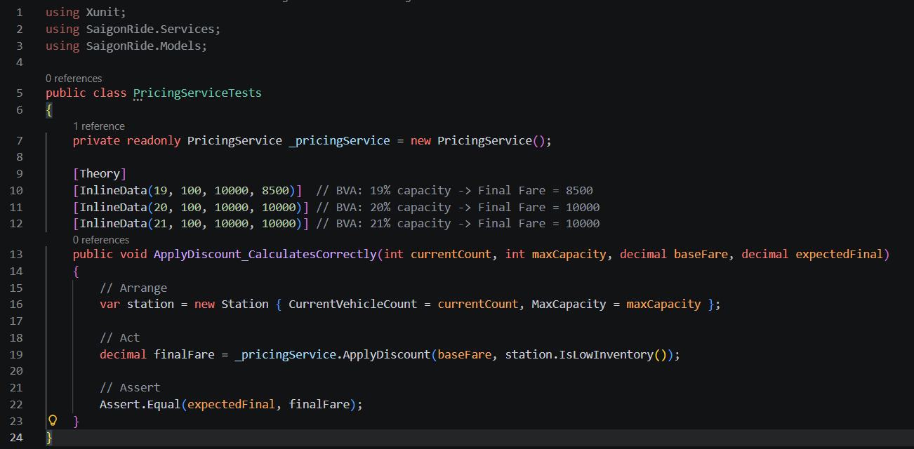

3.3. Tier 4 Automation Tests (Selenium)
To meet Tier 4 requirements, we used Selenium WebDriver in C# to automate the System Admin login and verify the CRUD interface loads correctly.
Selenium Script (AdminUITests.cs):
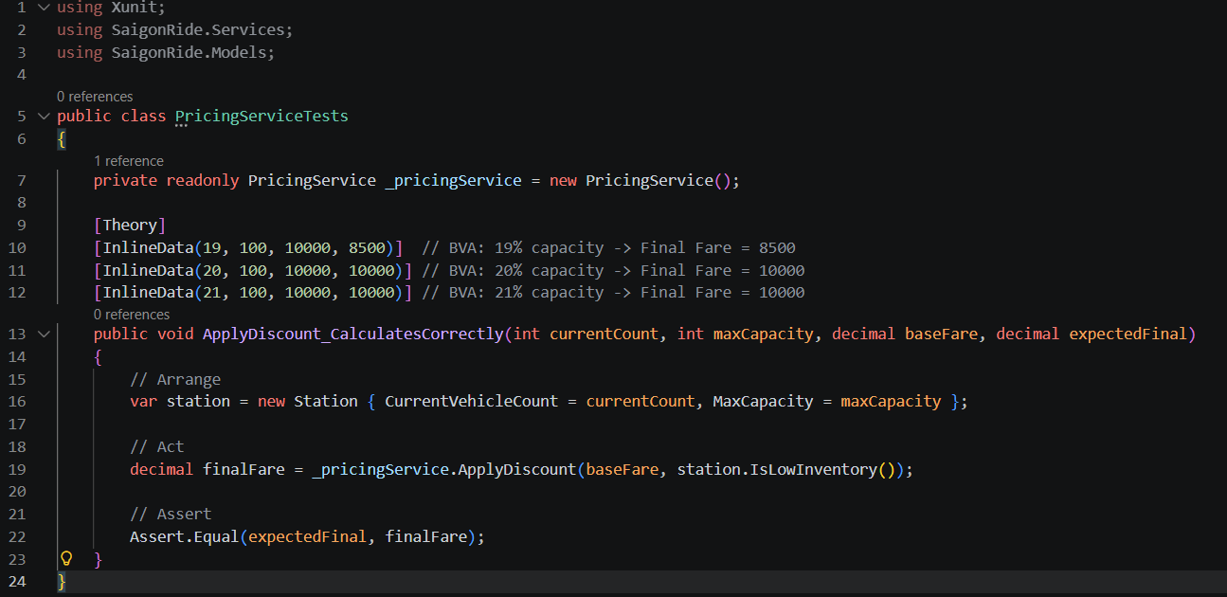

4. Verification of Given Solution (Requirements Traceability Matrix)
This table proves that our final code satisfies the FRs and NFRs we promised in Part 1.

Req ID | Requirement Description | Implementation / Verification Status
FR-01 | Process rentals & update status to "In-Transit" | Done. Implemented in RentalController.Checkout(). Database updates vehicle status immediately.
FR-02 | Calc fare (Bike=500, Scooter=1500) | Done. Implemented inside PricingService.cs.
FR-03 | 15% discount for low-inventory stations | Done. Verified via xUnit BVA testing.
FR-04/05 | Support VNPay/MoMo/Cash by User Type | Done. Used Strategy Pattern for IPaymentService. VNPay Sandbox API is fully functional.
FR-08 | Generate Revenue Report | Done. Used Chart.js in Admin Dashboard to group revenue by vehicle type.
FR-10/14 | Admin CRUD for Vehicles and Stations | Done. Scaffolding used, UI styled with Bootstrap.
NFR-05 | Security (Admin features protected) | Done. Added [Authorize(Roles="Admin")] to all Admin controllers.
NFR-08 | Maintainability (MVC Architecture) | Done. Views only contain HTML/Razor. Controllers handle routing. All DB logic is in EF Core DbContext.

5. Lessons Learnt (Reflection)

Huynh Nhat Huy (523c0012) - Backend/UX:
"Integrating the VNPay Sandbox API (Tier 4) was the most challenging part of this project for me. I spent nearly two days stuck on VNPay's 'Invalid Checksum' error. I eventually realized it was because I wasn't encoding the URL parameters in alphabetical order, as required by the API documentation. Additionally, designing the UI with Bootstrap was quite enjoyable, but I noticed that embedding too much C# logic into the Razor Views made the code extremely messy. As a result, I had to refactor the code and move all the price calculation logic into the PricingService."

Bui Quang Huy (523v0002) - Frontend/QA:
"I was responsible for implementing the CRUD operations and the Report section (UC2). My biggest challenge was handling Foreign Key Constraints in Entity Framework. Initially, when I tried to delete a Station that had currently rented vehicles, the program crashed and displayed a yellow SQL Server error screen. After looking into it, I used a try-catch block to catch the DbUpdateException, preventing the deletion and displaying a user-friendly error message on the UI using a Bootstrap Alert. Writing Test Cases using BVA (Boundary Value Analysis) also gave me a clearer understanding of why developers often let bugs slip through at boundary points (for example, right at the 20% capacity mark)."

