Summary of Exercises 1–10: Fundamentals of WinForms Development
Through the completion of Exercises 1–10, I developed a foundational understanding of building Graphical User Interfaces (GUIs) using Windows Forms (WinForms) in C#. The exercises were structured to progressively build proficiency in UI design, state management, and event-driven programming.
- UI Design & Event-Driven Programming (Exercises 1–3): Gained proficiency in creating WinForms projects and utilizing the Toolbox to design interfaces. This included implementing core controls (Label, Button, TextBox) and applying event-driven programming principles to handle user interactions, such as updating text properties dynamically and triggering message boxes upon button clicks.
- Input Processing & Dynamic UI (Exercises 4–5): Developed a functional calculator by retrieving and parsing input from multiple text boxes, executing basic arithmetic operations, and updating the UI to display the computed results. Additionally, explored programmatic UI manipulation by populating ListBox and ComboBox controls during the form's Load event, as well as retrieving and displaying user-selected items.
- Tabular Data Management (Exercises 6–9): Utilized the DataGridView control to display and manage tabular data effectively. Key implementations included defining custom columns, populating grids using data arrays, and enabling runtime row insertion via user input. Furthermore, configured the grid for row editing and deletion, and successfully integrated a ComboBox column directly within the DataGridView to facilitate flexible, constrained data entry.
- Advanced Controls & Process Simulation (Exercise 10): Incorporated the DateTimePicker for formatted date selection and the ProgressBar control to visualize task execution. Implemented a Timer component to simulate a background process, writing logic to programmatically increment the progress bar's value at set intervals until the simulated task reached completion.

Summary of Exercises 11–20: Fundamentals of WinForms Development
Exercise 11 (TreeView Control), Exercise 12 (ListView Control) & Exercise 13 (TabControl)
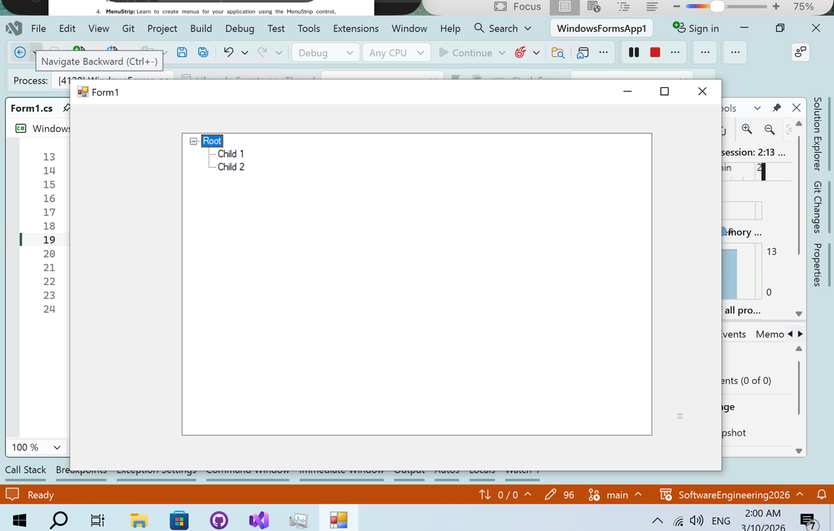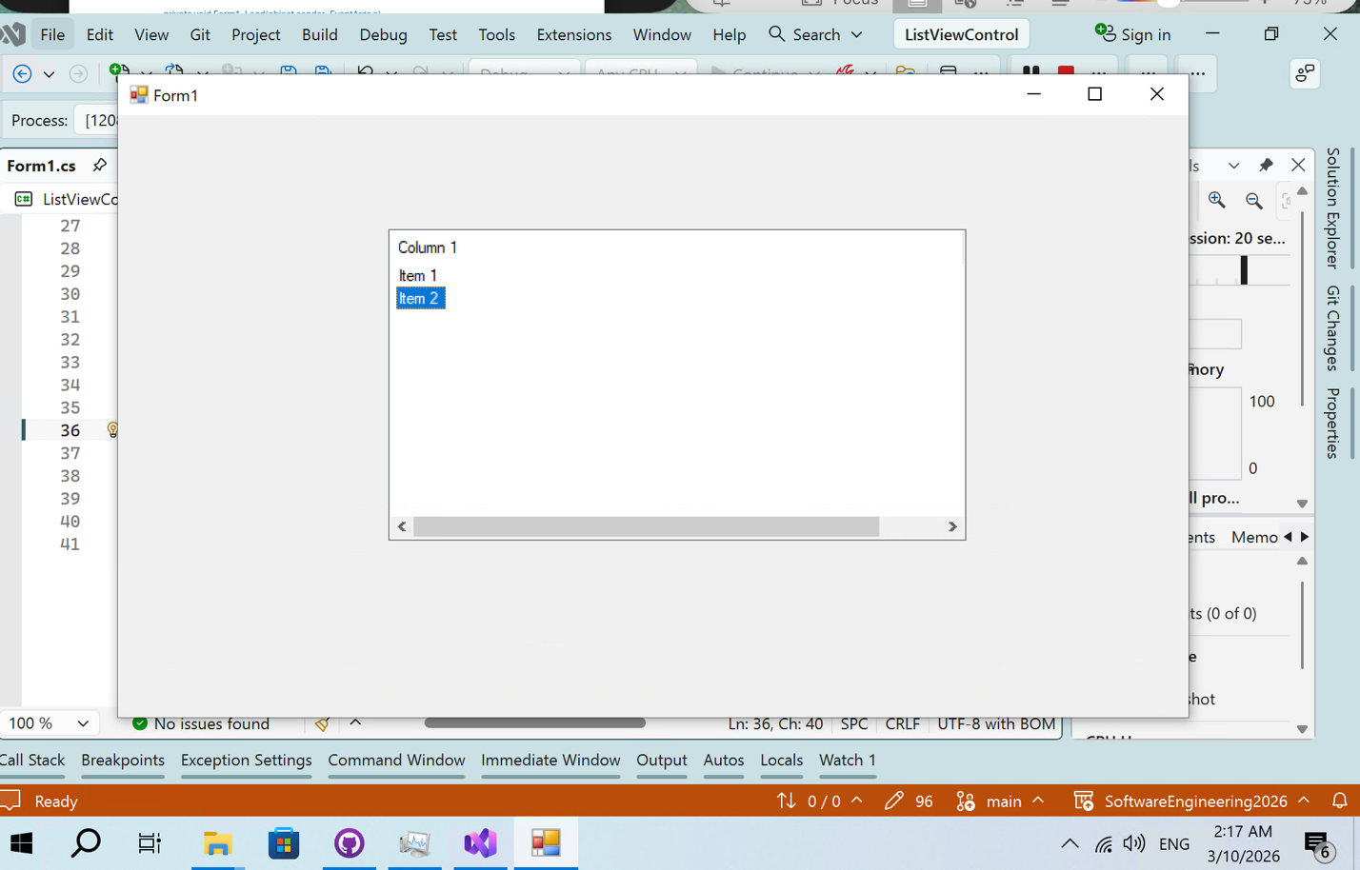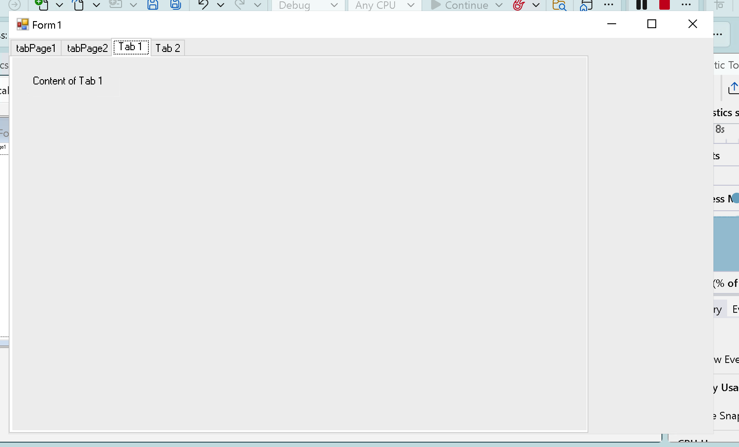
Exercise 14 (MenuStrip), Exercise 15 (ContextMenuStrip), Exercise 16 (ToolStrip), Exercise 17 (StatusStrip) & Exercise 18 (SplitContainer)
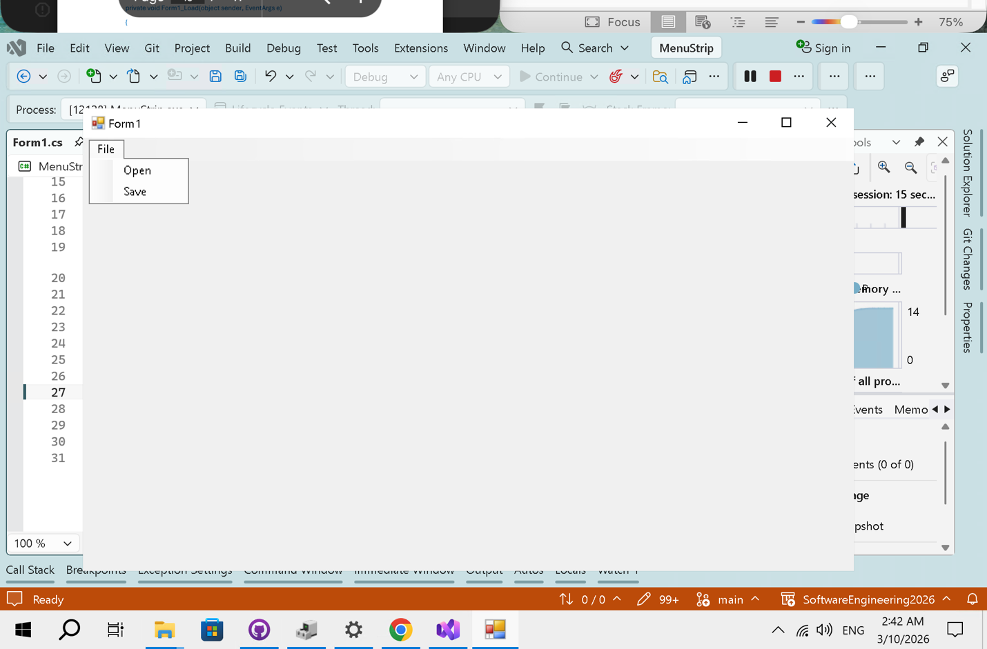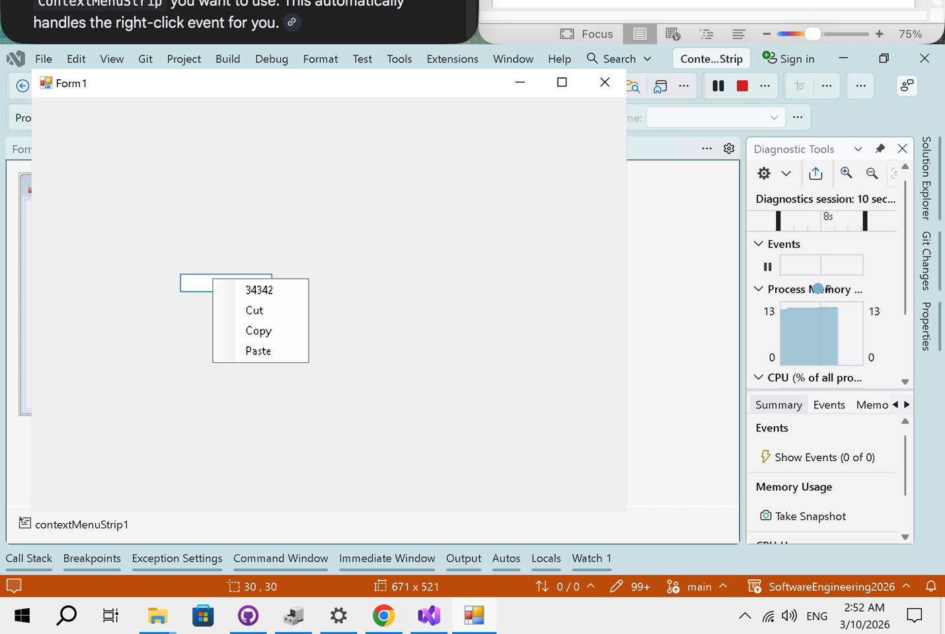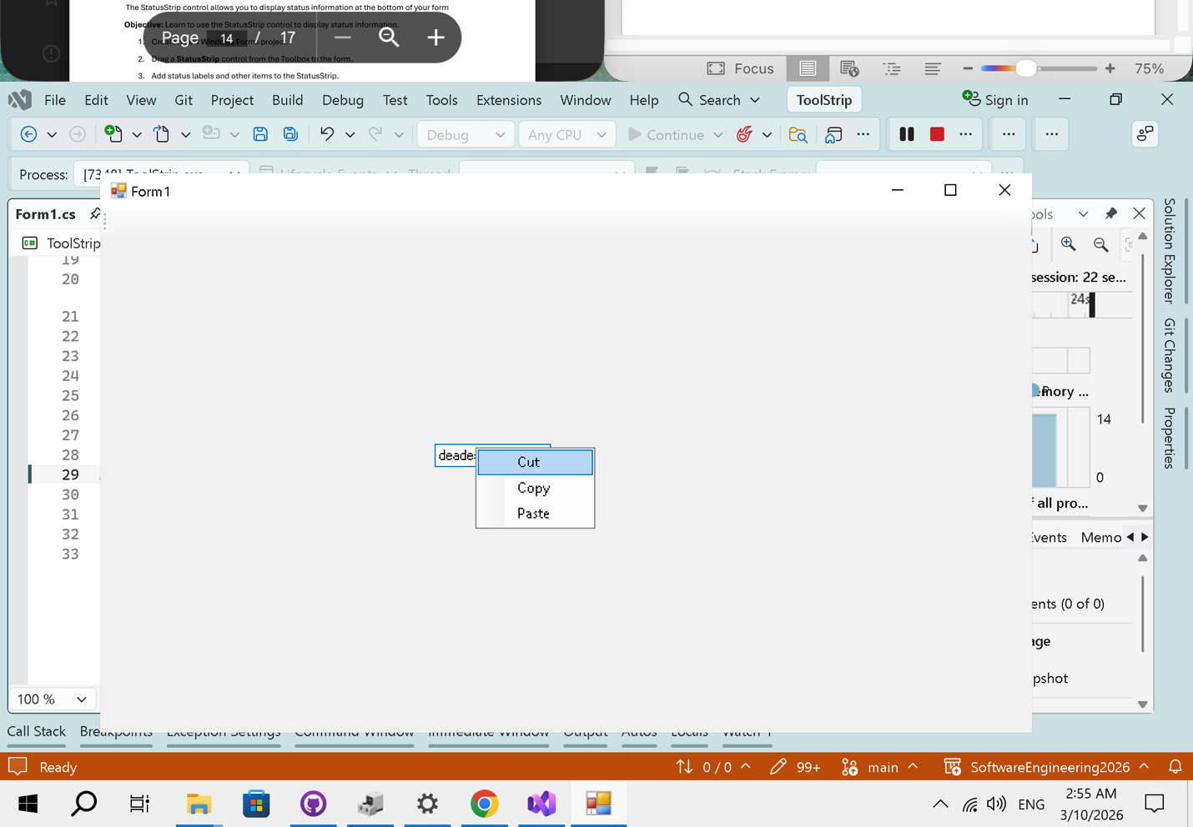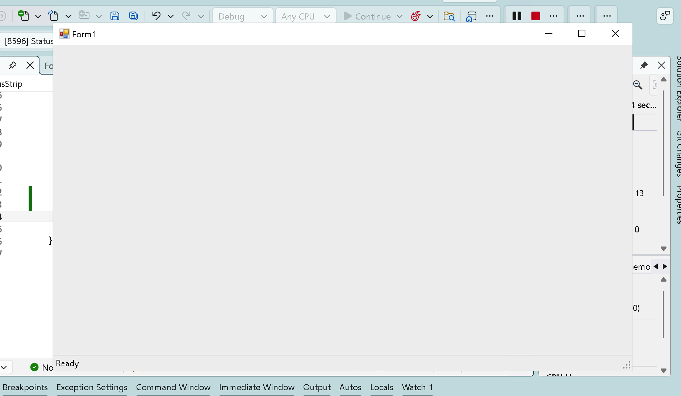
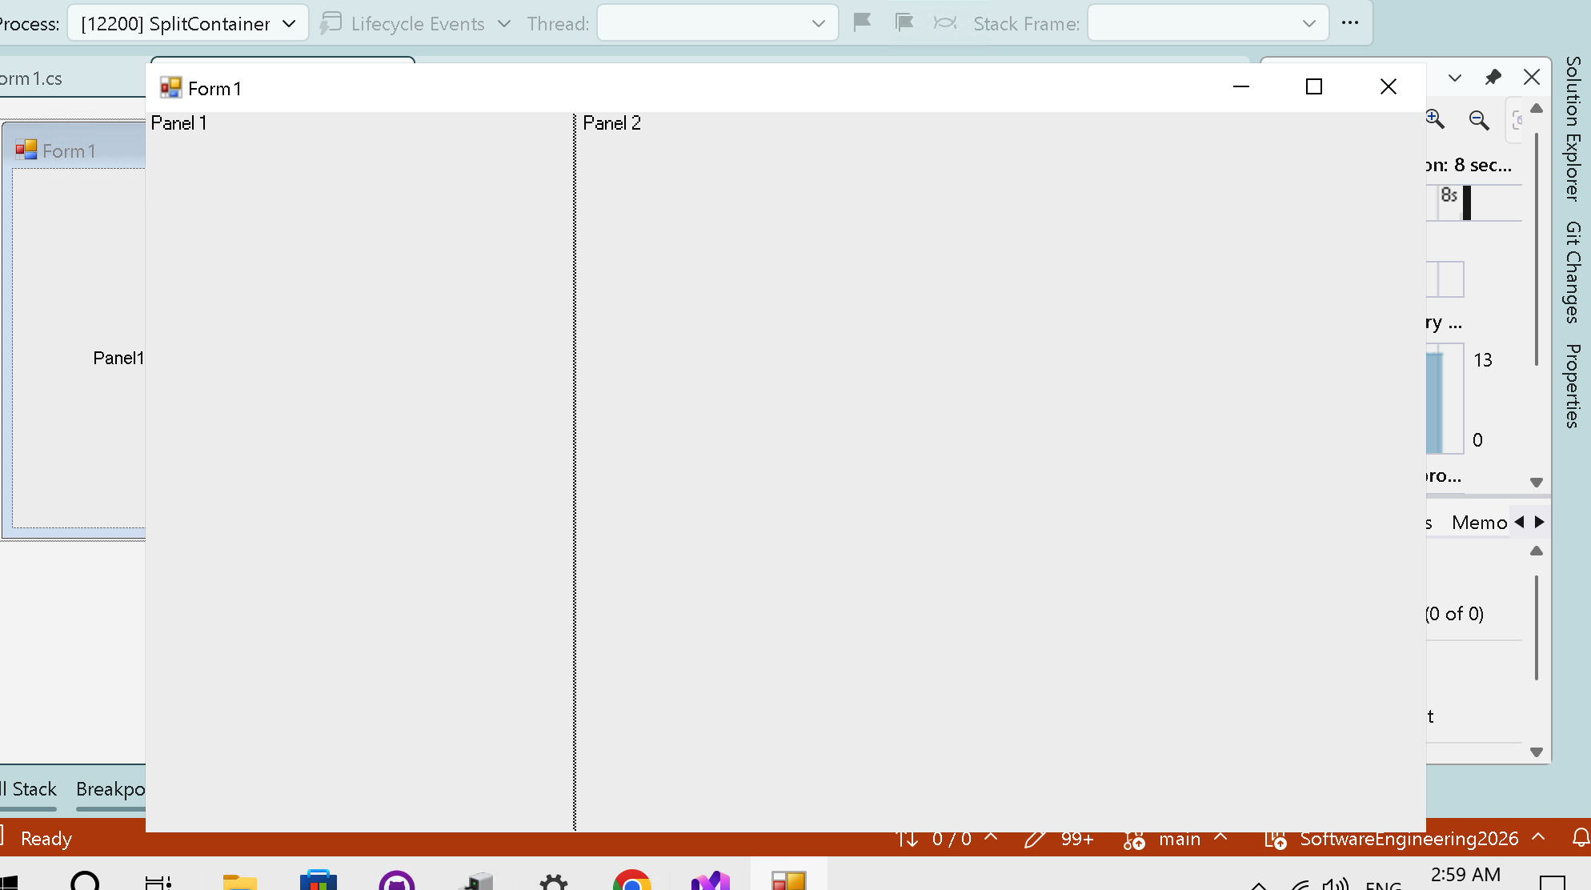
Exercise 19 (FlowLayoutPanel) & Exercise 20 (TableLayoutPanel)
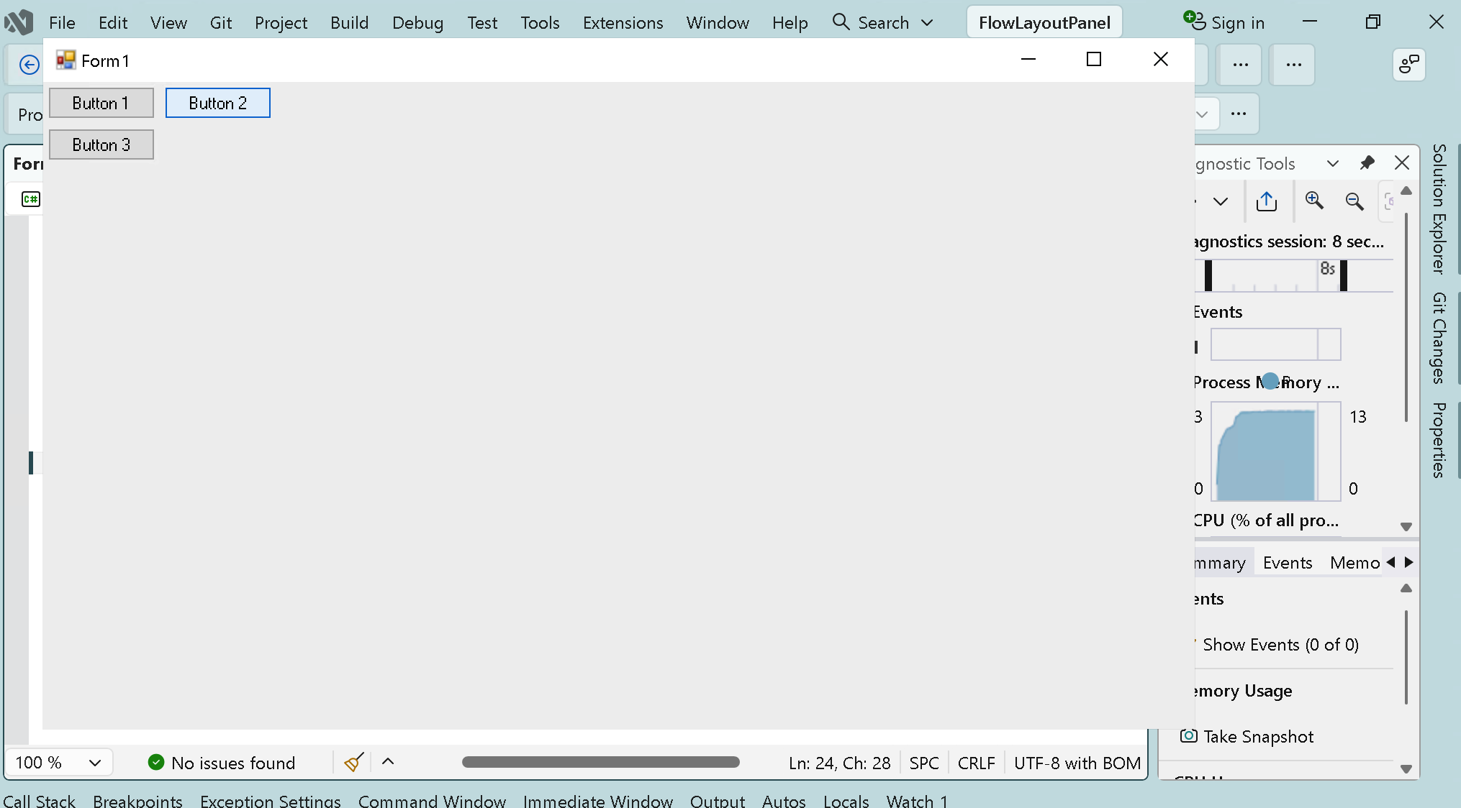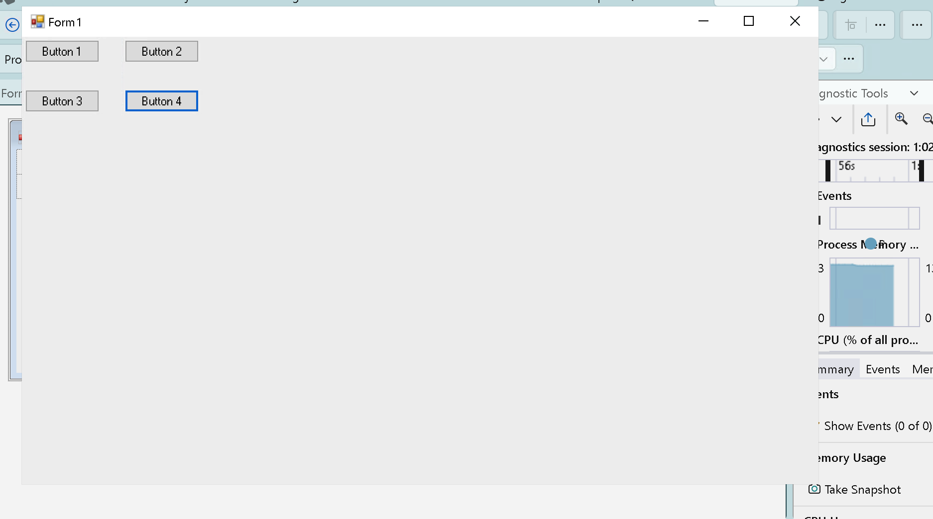
Developed by HuynhNhatHuy

