1. INTRODUCTION

1.1. Objectives
The primary goal of this lab is to understand how to connect a C# application to a database using ADO.NET. Specifically, the lab covers:
- Implementing a secure Login system.
- Performing CRUD (Create, Read, Update, Delete) operations on multiple tables.
- Managing database connection strings.

1.2. Technical Stack & Environment
Due to development on macOS, the project was adapted from the original Windows Forms requirements to a modern web-based architecture:
- Framework: .NET 10 Razor Pages.
- IDE: JetBrains Rider (macOS version).
- Database: SQLite (Used as a portable alternative to MS SQL Server for better compatibility and easier submission).
- Library: Microsoft.Data.Sqlite.

2. DATABASE SCHEMA
The system utilizes a relational database (app.db) consisting of the following tables:
- tblUsers: Stores credentials for authentication.
- tblStudents: Manages student profiles (Name, DOB, City, Age, etc.).
- tblCourses: Stores academic course information.
- tblDepartments & tblInstructors: Manages faculty and staff data.
- tblStudentCourses: A junction table for student-course enrollments.

3. IMPLEMENTATION DETAILS

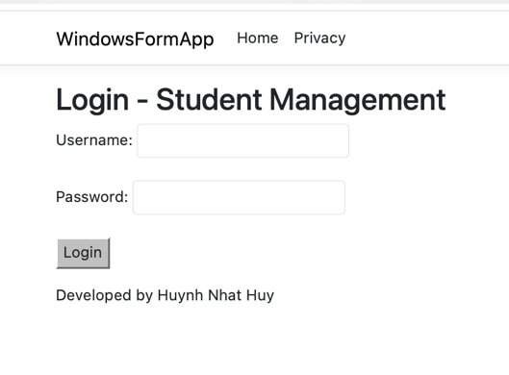
3.1. Exercise 1: Login Authentication
The login system validates users against tblUsers. The logic uses ExecuteScalar to verify if a matching record exists.
- Username: admin
- Password: 123
Figure 1. Login Page

3.2. Exercise 2: Student Management
This section implements a full CRUD interface for students. Data is retrieved using a SqliteCommand and displayed in an HTML table (acting as a replacement for the WinForms DataGridView).
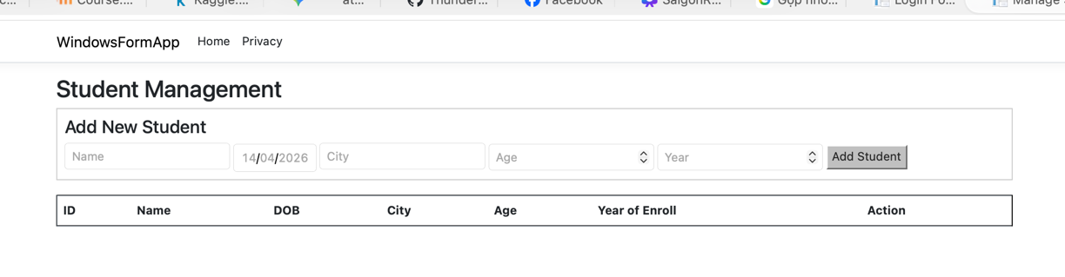 Figure 2. "Add Student" Form

3.3. Homework: Course Faculty Management
I implemented additional management pages for Courses, Instructors, and Departments. Each page supports adding and deleting records.
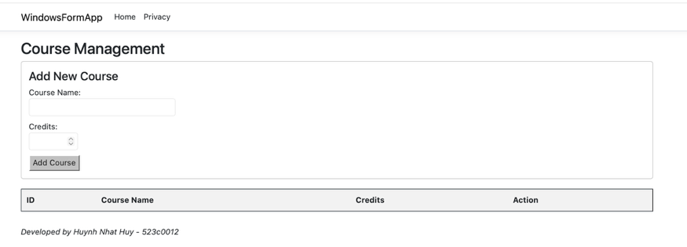 Figure 3. "Add Course" Form

3.4. Homework: Student Enrollment (Filtering)
This page features a Dropdown (Select) menu. When a course is selected, the system dynamically filters and displays only the students enrolled in that specific course.


4. CHALLENGES & SOLUTIONS
- Challenge: Windows Forms (WinForms) is not natively supported for GUI design on macOS.
- Solution: Transitioned the project to ASP.NET Core Razor Pages. While the UI layer changed, the C# ADO.NET logic (Connections, Commands, Readers) remains identical to the lab requirements.
- Challenge: Installing MS SQL Server on Mac requires heavy Docker containers.
- Solution: Switched to SQLite. This makes the project "zero-config" for the grader; the database file is included in the source code and works immediately upon execution.

5. CONCLUSION
This lab successfully demonstrated the core concepts of database integration in C#. By adapting the project for macOS, I gained additional experience in cross-platform .NET development and web-based UI design while maintaining the rigorous logic required by the course syllabus.

