1. Introduction
The objective of Lab 3 is to apply the 3-Tier software architecture, encompassing the Data Access Layer (DAL), Business Logic Layer (BLL), and Presentation Layer (GUI). Furthermore, the practice integrates Entity Framework Core (EF Core) using the Code-First approach to interact with the database.
Due to the development environment being macOS, the Presentation Layer was flexibly adapted from WinForms to ASP.NET Core MVC. The database utilizes Azure SQL Edge deployed via a Docker container to ensure system compatibility and performance.

2. Exercise 1: 3-Tier Architecture and Entity Framework
Task Description:
- Separated the Solution into 3 independent projects: DAL (containing Models, DbContext, and Repositories), BLL(containing business logic Services), and WinformUI (Web MVC acting as the GUI).
- Utilized EF Core to configure the Connection String connecting to the SQL Server database.
- Built the Customer entity, Exer1DbContext, and executed Migration commands (add, update) to initialize the tables and the LabDB database.
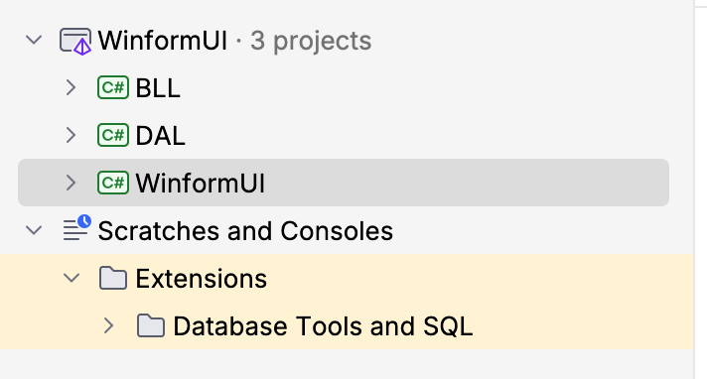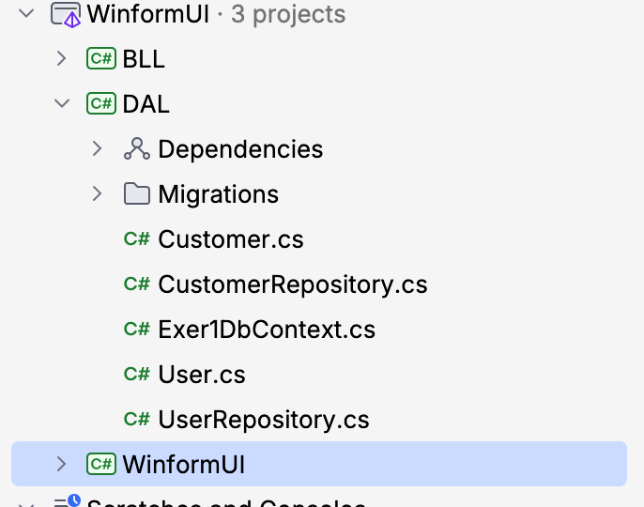
Figure 1: The 3-Tier Architecture structure of the Solution.
& Figure 2: Implementation of DbContext and Repository pattern in the DAL.

3. Exercise 2: Login Functionality (Login Form)
Task Description:
Developed a user authentication workflow strictly adhering to the 3-tier architecture:
- DAL: Added the User entity and UserRepository with a database query method using LINQ to verify account credentials (Username/Password).
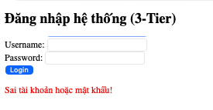
- BLL: Implemented UserService to receive login input from the UI, call the DAL for authentication, and return the logical result.
- GUI: Designed the Login.cshtml view and handled the logic in AccountController. The system verifies the result from the BLL, establishes a secure Session, and redirects the user upon successful login.
Figure 3: The account authentication interface (Login Form).

4. Exercise 3: Main Interface and Navigation Menu (Main Form)
Task Description:
- Upon successful authentication, the system redirects the user to the homepage (Main Form).
- Designed a global navigation Navbar in the _Layout.cshtml file (serving the equivalent function of a MenuStrip in a Desktop application).
- Integrated navigation links pointing to the management modules: Customer Management, Product Form, and Supplier Form.
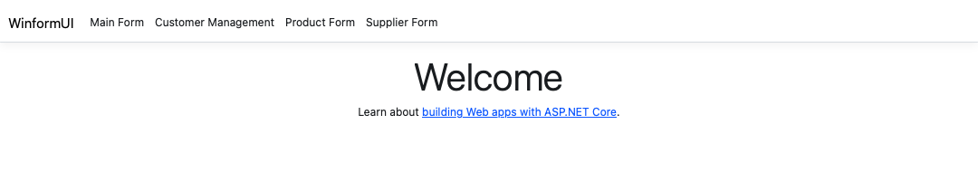
Figure 4: Main Form interface integrating the navigation Navbar.

5. Conclusion
Lab 3 has been successfully completed, meeting all core requirements. The 3-Tier model combined with Entity Framework Core effectively separates the responsibilities of each layer, minimizing source code dependency between the user interface and the database. Successfully deploying this project on macOS using ASP.NET Core MVC and Docker demonstrates the flexibility and adaptability of this architecture in developing modern, cross-platform software systems.

Homework: School Management System (3-Tier Adaptation)
Task Description: Applied the 3-Tier Architecture and Entity Framework Core to the School Management System assigned in the Lab 2 homework.
Implementation:
- DAL: Created the Student and Teacher entities. Implemented SchoolDbContext and individual repository classes (StudentRepository, TeacherRepository) to handle database transactions.
- BLL: Developed StudentService and TeacherService to act as intermediaries, handling data retrieval and enforcing business rules before data reaches the database.
- GUI: Built the StudentController and Razor Views (Index.cshtml, Create.cshtml).
- Database: Successfully ran EF Core Code-First migrations (add InitialSchoolDB and database update) to dynamically generate the schema in the Azure SQL Edge Docker container.
