Exercise 1: Dockerizing the Application
Description: I created a multi-stage Dockerfile using the .NET 10 preview SDK and runtime images. This allows the application to be built inside a standardized container environment, ensuring consistency across different machines. 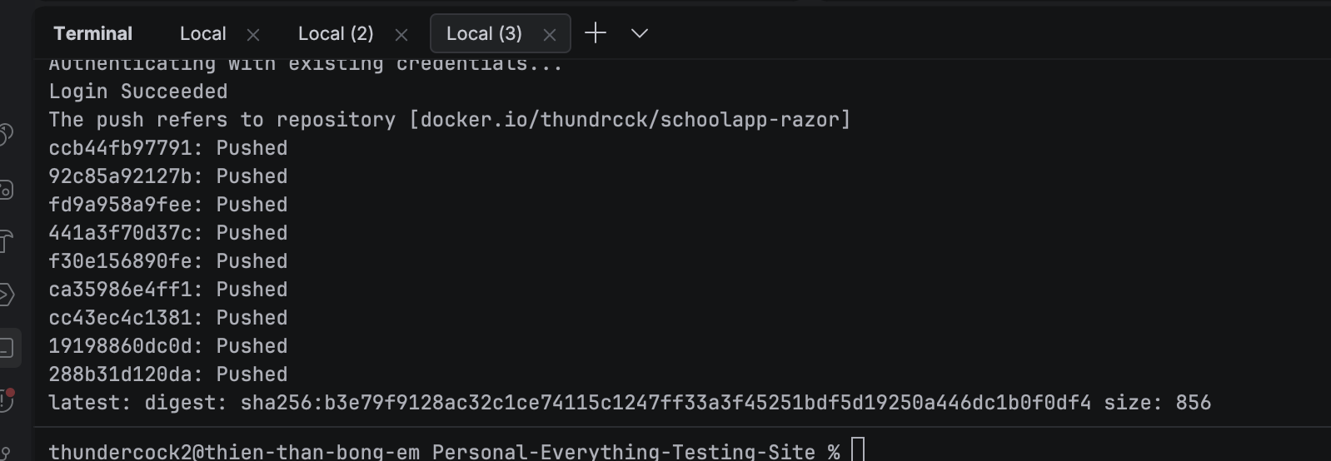
- Screenshot: Terminal showing docker build -t schoolapp-razor . finishing successfully.

Exercise 2: Running Locally & Docker Hub
Description: I verified the container by running it locally on port 8080. I then pushed the image to Docker Hub (thundrcck/schoolapp-razor) to make it available for remote deployment.
- Screenshot 1: Browser showing localhost:8080. 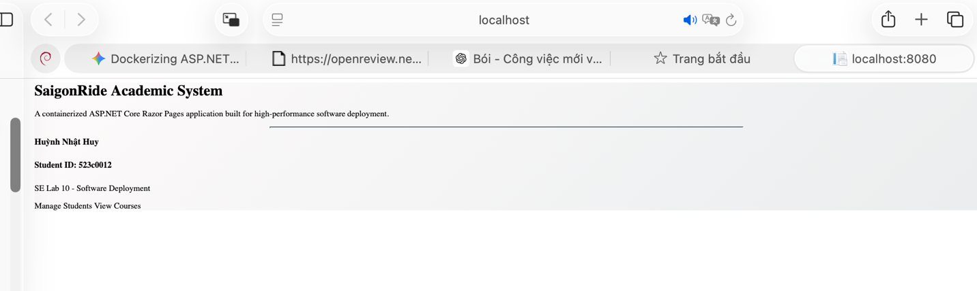
- Screenshot 2: Terminal showing the successful docker push to Docker Hub.

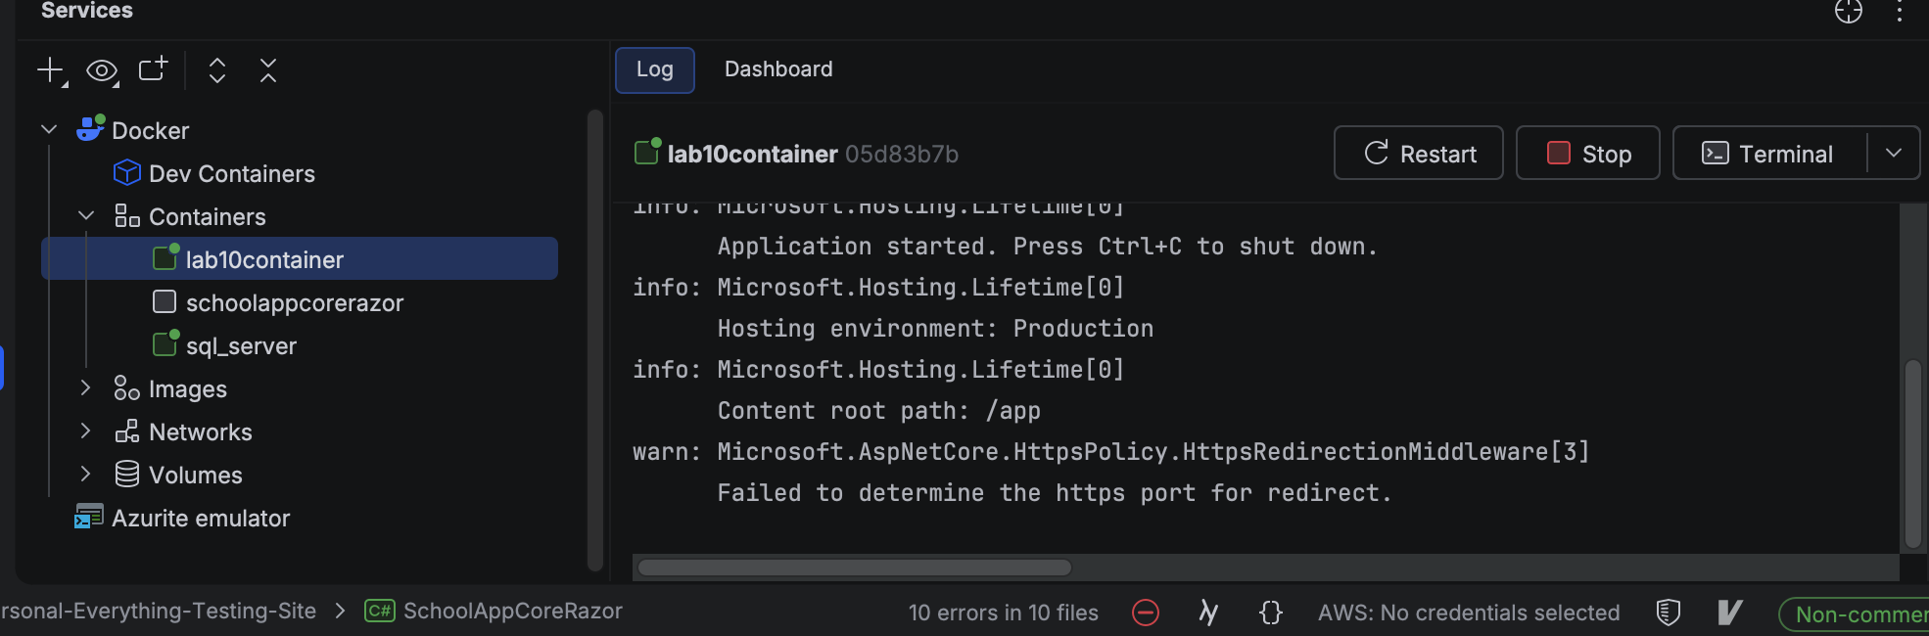Exercise 3: Deployment to Debian Server (NUC)
Description: I deployed the application to a physical home server running Debian. I used docker pull to retrieve the image from Docker Hub and ran it as a background daemon.
- Screenshot: Terminal of the NUC showing the running container (docker ps).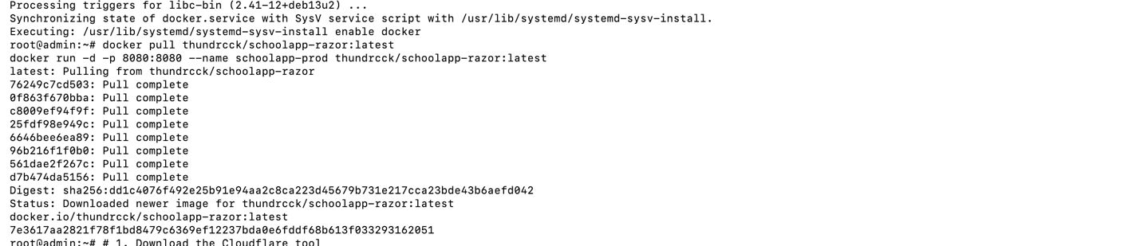

Exercise 4: CI/CD with GitHub Actions
Description: I implemented a GitHub Actions workflow that automatically builds and pushes a new Docker image every time I push code to the main branch.
- Screenshot: The GitHub Actions tab showing the green checkmark for your "Add CI/CD pipeline" run. 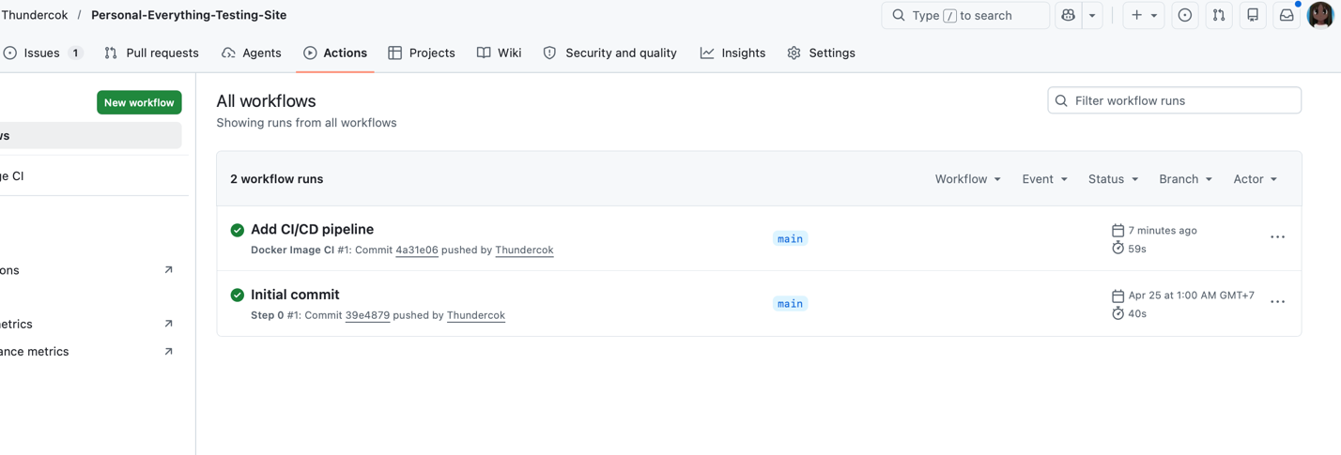

Special Exercise: Public Production Environment
Description: I used a Cloudflare Tunnel to expose the local NUC deployment to the public internet, providing a secure production URL without requiring static IP configuration.
https://humanitarian-mysql-comfort-rooms.trycloudflare.com
- Screenshot: Browser showing the site live on the trycloudflare.com URL.
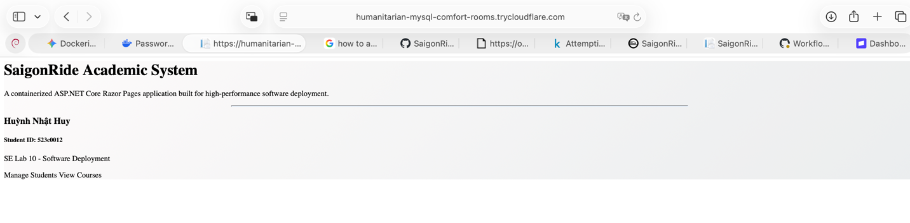

My github link to this repo: https://github.com/Thundercok/Personal-Everything-Testing-Site

