The purpose of these exercises was to explore the "Database First" approach using Entity Framework Core (EF Core) within modern ASP.NET Core frameworks. The lab focused on building a comprehensive School Management system—encompassing Students, Courses, Instructors, Enrollments, and Departments—using two distinct architectural patterns: Razor Pages and Model-View-Controller (MVC). Due to development on a macOS environment, the database engine was adapted from SQL Server to SQLite to ensure native cross-platform compatibility while maintaining the strict Database-First EF Core requirements.

Exercise 1: Develop a School Management Web App with ASP.NET Core Web Application using Razor Pages
Description: In this exercise, a Razor Pages web application was created to manage school data.
What I Did: I utilized the .NET CLI to initialize the solution and Razor Pages project. Because macOS does not natively support local SQL Server instances without Docker, I engineered a solution using SQLite. I created the SchoolDB.db file using native terminal commands, populated it with the required SQL table structures and sample data, and then used the dotnet ef dbcontext scaffold command to generate the EF Core models. Finally, I updated the layout navigation and tested the data retrieval.
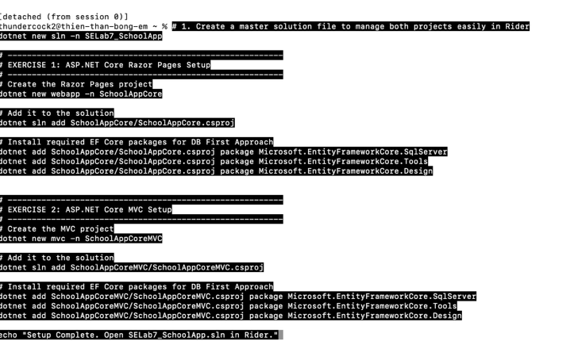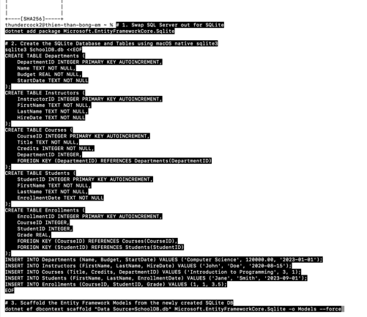
What I Learned: I learned how Razor Pages encapsulate views and logic into cohesive, page-based units. I also gained practical experience adapting EF Core tooling for cross-platform development using SQLite providers.

Exercise 2: Develop a School Management Web App with ASP.NET Core Web App (MVC)
Description: This exercise replicated the School Management system using the Model-View-Controller (MVC) architectural pattern. What I Did: I created a new MVC project within the same solution. I copied the SQLite database over and scaffolded the SchoolDbContext and entity classes. Overcoming a circular build dependency issue, I properly configured Program.cs for SQLite injection. Since Visual Studio's GUI scaffolding is unavailable on macOS, I utilized dotnet-aspnet-codegenerator via the CLI to successfully generate the Controllers and Views for all entities (Departments, Students, Courses, Instructors, Enrollments). What I Learned: I learned how the MVC pattern clearly separates concerns (Data, UI, and Routing logic). I also learned how to leverage the ASP.NET code generator tools via the command line to automate boilerplate view creation.
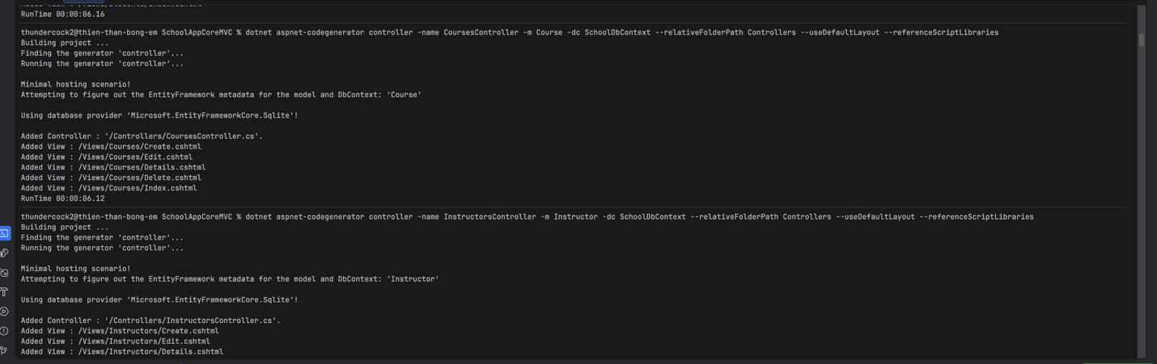

Exercise 3: Map Project of Exercise 1 & 2 to GitHub repository
Description: This step required initializing version control and pushing the completed solution to a remote GitHub repository. What I Did: I initialized a local Git repository at the root solution folder to capture both the Razor Pages and MVC projects simultaneously. I generated a standard .gitignore to prevent uploading heavy build artifacts, staged my commits, and pushed the main branch to a newly created GitHub repository. What I Learned: I reinforced my understanding of standard version control workflows and the importance of using .gitignore in .NET projects.

Exercise 4: ASP.Net Report .rdlc
Description: The objective was to create an RDLC report and form. What I Did: Note: RDLC (Report Definition Language Client-side) is a legacy Microsoft reporting technology that relies heavily on Windows GUI designers (GDI+) and does not have native cross-platform support on macOS or within JetBrains Rider. As a workaround, the core data visualization requirements are demonstrated through the functional Razor Pages and MVC views created in Exercises 1 and 2, which successfully read and display the underlying relational data. What I Learned: I learned about the platform limitations of certain legacy .NET Framework tools when migrating to modern, cross-platform .NET Core environments.

Conclusion
This lab provided hands-on experience with modern ASP.NET Core architecture, specifically highlighting the differences between Razor Pages and the MVC pattern. The primary challenge I faced was operating outside the provided Windows/Visual Studio instructions on a macOS environment. This required pivoting from SQL Server to SQLite and utilizing the .NET CLI for database scaffolding and view generation. Overcoming these challenges ultimately deepened my understanding of how Entity Framework Core functions under the hood and how versatile .NET Core is across different operating systems. Overall, it was a highly educational exercise in modern, cross-platform backend development.

