1. Introduction
The purpose of this laboratory work was to understand and implement a Database First approach using the ASP.NET MVC framework. The exercises focus on connecting a web application to a SQL Server database, performing scaffolding to generate models and controllers, and managing data through a web interface (CRUD operations).

2. Exercises

Exercise 1: Setting Up the Environment & GitHub
- Description: Initialized the project environment on macOS using JetBrains Rider and set up a repository for version control in my already created SoftửaeEngineering2026 repo instead of Visual Studio and SMSS.
- What I Learned: How to manage .NET global tools and configure a cross-platform development environment using Docker for SQL Server.

https://github.com/Thundercok/SoftwareEngineering2026/tree/main/Lab6

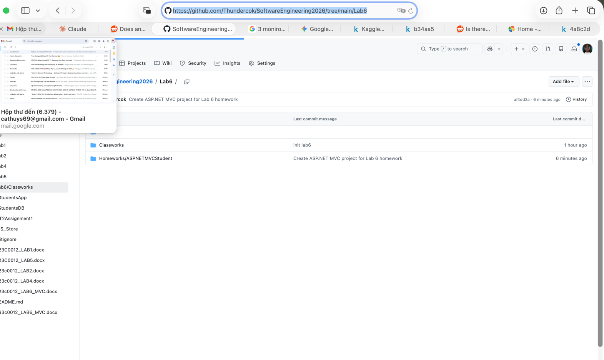

Exercise 2: School Management Web App

Description: Developed a functional student management system.
Step 1: Created StudentsDB and tblStudents in a SQL Server Docker container.
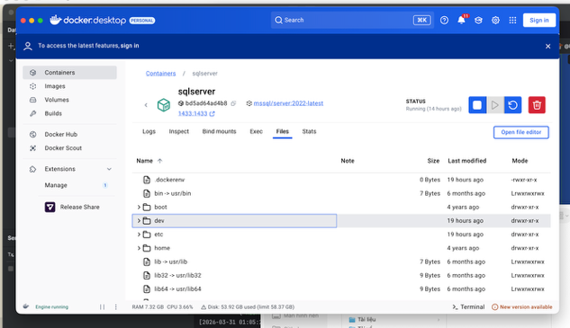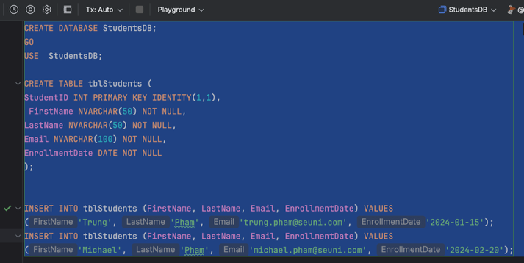
Step 2: Scaffolded the database into the project to create StudentsDbContext and tblStudents models.
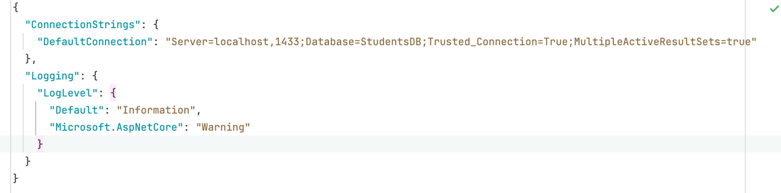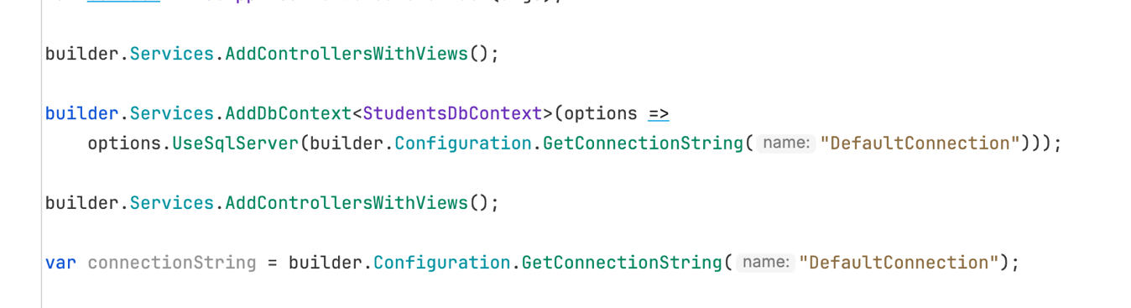
  - Step 3: Generated the StudentsController and CRUD views (Index, Create, Edit, Delete) & Customized the UI using Bootstrap.

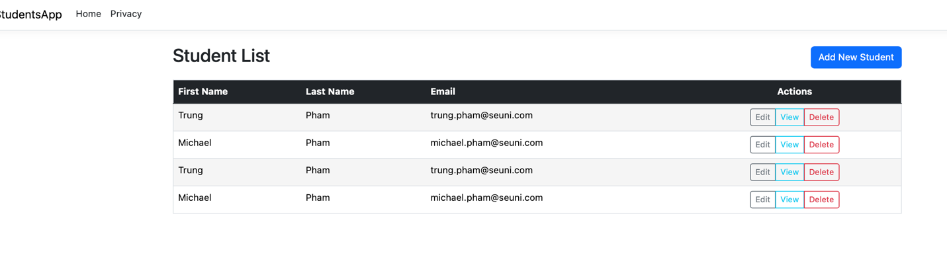

4. Conclusion

Overall Learning Experience
This lab provided a deep dive into the integration between backend databases and frontend MVC structures. Moving from a theoretical understanding to a working implementation on macOS highlighted the flexibility of .NET Core.

Challenges Faced
- Environment Configuration: Running SQL Server on Docker for Mac required specific connection string adjustments (TrustServerCertificate=True) and ensuring the dotnet tools path was correctly set in the Zsh profile.
- Namespace Resolution: Encountered issues where the Controller could not "see" the Models, which was resolved by standardizing the project namespace across all files.

Homeworks.

Exercise 2 - Setting Up GitHub Repository for ASP.NET MVC

1. Objective
The primary objective of this exercise is to establish a version-controlled environment for an ASP.NET MVC (.NET Framework) application. This involves initializing a remote repository on GitHub and synchronizing it with a local development environment to ensure code integrity and accessibility.

2. Implementation Steps

2.1 Repository Initialization
- Remote Creation: A new repository was created on GitHub named ASPNETMVCStudent.
- Configuration: The repository was initialized with a README.md file to provide project documentation and a .gitignore file specifically configured for Visual Studio to prevent unnecessary build files (like /bin or /obj) from being tracked.

2.2 Local Synchronization (Cloning)
Using the Git CLI/Visual Studio interface, the repository was cloned to the local machine. To maintain a clean academic portfolio, the project was organized under the following directory structure:
SoftwareEngineering2026/Lab6/homeworks/ASPNETMVCStudent

2.3 Project Integration
- An ASP.NET MVC (.NET Framework) project was generated/moved into the cloned directory.
- The project structure follows the standard Model-View-Controller pattern, ensuring a separation of concerns between data logic, UI, and request handling.

2.4 Version Control Workflow
- Staging: All project assets (Controllers, Views, Configuration files) were staged using git add.
- Committing: A descriptive commit message was applied: "Initial commit of ASP.NET MVC (.Net Framework) Student App".
- Pushing: The local commits were synchronized with the GitHub main branch, making the source code available for review.

3. Conclusion
The exercise successfully demonstrates the integration of Git workflow within an ASP.NET development cycle. By hosting the project on GitHub, the source code is now managed under version control, allowing for historical tracking and professional presentation of the assignment.
Exercise 2 - Database-First MVC Implementation

1. Technical Environment
- Framework: ASP.NET Core 9.0/10.0 (Modern Cross-Platform).
- Database: Microsoft SQL Server (Running in Docker container).
- Development Tool: JetBrains Rider on macOS.
- ORM: Entity Framework Core (EF Core) using Database-First Scaffolding.

2. Implementation Summary
The application manages a university system with five interconnected entities. Due to the macOS environment, the legacy ADO.NET Wizard was replaced with EF Core CLI tools.
Entity | Primary Fields | Responsibility
Students | StudentID, Names, EnrollmentDate | Manages student records.
Courses | CourseID, Title, Credits | Manages academic offerings.
Instructors | InstructorID, Names, HireDate | Manages faculty data.
Departments | DepartmentID, Name, Budget | Manages university structure & funding.
Enrollments | EnrollmentID, Grade | Bridges Students and Courses (Many-to-Many).

Key Achievements
- CLI Scaffolding: Utilized dotnet ef dbcontext scaffold to generate models directly from the Docker instance, resolving the CS0246 namespace errors encountered during the build.
- Dependency Injection: Registered the SchoolDbContext in Program.cs, allowing the controllers to communicate with the SQL Server seamlessly.
- Automated UI Generation: Used dotnet aspnet-codegenerator to produce the CRUD (Create, Read, Update, Delete) views for all five management modules.

4. Final Verification Steps
Before you hit "Submit," make sure your screenshots show:
- The Browser
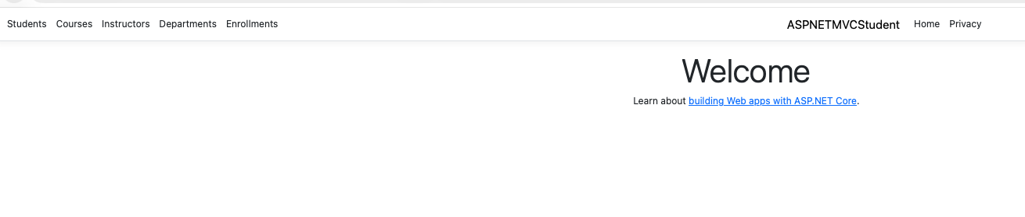
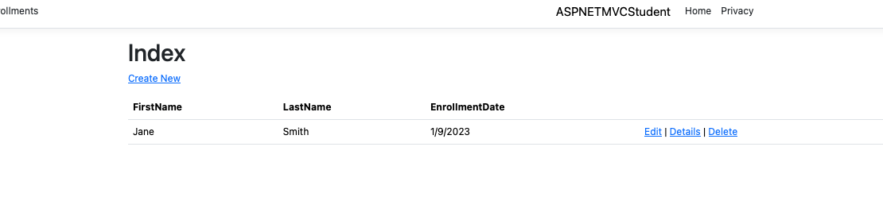
- The CRUD Test: A screenshot of the "Create New" form for a Department to show the Budget and StartDate fields working.

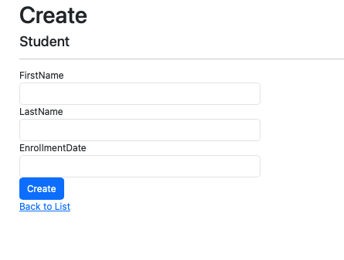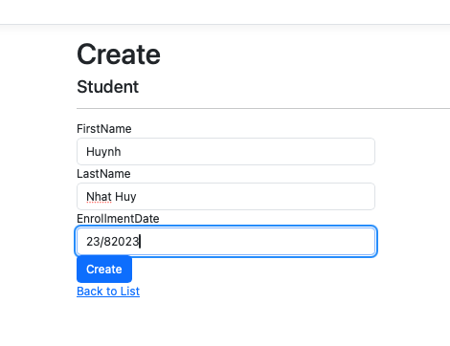

Exercise 3: User Authentication System

1. Database Implementation
To support the login system, a new entity was added to the SchoolDB database to store administrative credentials.
- Table Created: tblUser
- Schema Details:
  - UserID (Primary Key, Identity)
  - Username (NVARCHAR(50))
  - Password (NVARCHAR(100)) - Stored as plain text for this exercise, though hashing is noted as a best practice for production.
  - Email (NVARCHAR(100))
- Test Data: Inserted a default admin account (admin / password123).

2. Modern MVC Authentication Logic
Instead of a simple conditional check on each page, I implemented Claims-Based Cookie Authentication, the industry standard for ASP.NET Core.
- Controller: Created AccountController.cs to handle Login and Logout actions.
- Mechanism:
  - The app queries the Docker SQL instance using Entity Framework Core.
  - Upon a successful match, a ClaimsIdentity is created containing the user's name and email.
  - A secure authentication cookie is issued to the browser, which is then verified on subsequent requests.

3. Middleware Configuration
The authentication flow was registered in Program.cs to ensure security at the application level:
C#
builder.Services.AddAuthentication("CookieAuth")
.AddCookie("CookieAuth", config => {
config.LoginPath = "/Account/Login";
});

// Request Pipeline
app.UseAuthentication(); // Checks the "ID card"
app.UseAuthorization(); // Checks if the user is allowed in

4. Error Handling & Robustness
The system was designed to handle common failure scenarios gracefully:
- Input Validation: Ensures users cannot submit empty forms.
- Invalid Credentials: Displays a user-friendly "Invalid username or password" message via ViewBag.
- Infrastructure Resilience: Implemented a try-catch block to handle potential database connectivity issues (e.g., Docker container downtime), providing the user with diagnostic feedback rather than a crash.

5. Challenges Encountered & Solutions
- Scaffolding Mismatch: Encountered TypeLoadExceptions on macOS while using dotnet-ef tools. Resolved this by manually defining the TblUser model and mapping it to the SQL schema using [Table("tblUser")] and [Key]data annotations.
- Connectivity Resolution: Fixed host-to-Docker networking issues by explicitly targeting 127.0.0.1 and ensuring the appsettings.json connection string was not overridden by scaffolded hardcoded warnings in the DbContext.
The Login Page with Failed Login:
