LABORATORY REPORT 2
SUBJECT: SOFTWARE ENGINEERING
TOPIC: SALES MANAGEMENT SYSTEM (3-TIER ARCHITECTURE & MVC)
Instructor: Mr. Pham Thai Ky Trung Date: November 2025
STUDENT TEAM:
- 523c0012 – Huynh Nhat Huy
- 523v0002 – Bui Quang Huy
TABLE OF CONTENTS
- Introduction
- Database Design
- Exercise 1: Windows Forms Application (3-Tier Architecture)
- Exercise 2: ASP.NET MVC Web Application
- Exercise 5: Unit Testing
- Conclusion & Contribution
1. PROJECT OVERVIEW
1.1 Problem Description
The assignment requires building an order management system following a 3-Tier Architecture and deploying it across multiple platforms. The system allows managing information for products (Items), agents (Agents), and orders (Orders) with a one-to-many relationship between Order and OrderDetail.
1.2 Database
The system uses a SQL Server database with the following tables:
Table Name | Primary Key | Description
Item | ItemID (PK) | Product information: name, size, price
Agent | AgentID (PK) | Agent information: name, address
Order | OrderID (PK) | Order: date, FK AgentID
OrderDetail | ID (PK) | Order details: FK OrderID, FK ItemID, Qty, unit price
Users | UserID (PK) | Login account: username, email, password

1.3 Implemented Exercises
Exercise | Content | Technology | Status
Exer 1 | WinForms 3-Tier Architecture | .NET Framework, WinForms | Completed
Exer 2 | ASP.NET MVC - DB First | .NET Framework, MVC, EF6 | Completed
Exer 3 | ASP.NET Razor Pages | .NET 8, Razor Pages, EF Core | Completed
Exer 4 | ASP.NET Core MVC - Code First | .NET 8, MVC, EF Core | Completed
2. EXERCISE 1 – WINFORMS 3-TIER ARCHITECTURE
2.1 Introduction
Exercise 1 builds a Windows Forms application following a 3-Tier Architecture, completely separating the user interface tier, business logic tier, and data access tier.
2.2 3-Tier Architecture
Tier | Project | Role
Tier 1 - DAL | DataAccess | Connects to SQL Server, executes SQL queries
Tier 2 - BLL | BusinessLogic | Validates data, processes business logic
Tier 3 - UI | UIWinForms | User interface forms
2.3 Solution Structure
File | Description
DataAccess/DbConnection.cs | Reads connection string from App.config, returns SqlConnection
DataAccess/ItemDAO.cs | Product CRUD: GetAll, Insert, Update, Delete
DataAccess/AgentDAO.cs | Agent CRUD: GetAll, Insert, Update, Delete
DataAccess/OrderDAO.cs | Manages orders and OrderDetail (one-many)
DataAccess/FilterDAO.cs | Statistical queries: best items, items by agent
BusinessLogic/ItemBLL.cs | Validate: name not empty, price not negative
UIWinForms/frmLogin.cs | Login form, checks account from DB
UIWinForms/frmMain.cs | Main form, navigates to child forms
UIWinForms/frmItem.cs | Product management: DataGridView + CRUD
UIWinForms/frmAgent.cs | Agent management: DataGridView + CRUD
UIWinForms/frmOrder.cs | Create order and add OrderDetail (one-many)
UIWinForms/frmFilter.cs | Statistics: best-selling products, top buying agents
2.4 Implemented Features
2.4.1 Login Form (frmLogin)
Enter username and password
Check account from Users table in SQL Server
Check IsLocked = 0 to ensure the account is not locked
Display error message if information is incorrect
Press Enter on the password field for quick login
2.4.2 Product Management (frmItem)
Display product list in DataGridView
Click on a row → auto-fill information in the right form
Add new product with validation (name not empty, price not negative)
Edit selected product information
Delete product with confirmation dialog
Refresh button to clear the input form
2.4.3 Agent Management (frmAgent)
Similar functionality to frmItem with AgentName and Address fields
2.4.4 Order Management (frmOrder) - One-Many
Create new order: select agent, select order date
Add multiple products (OrderDetail) into the same order
Display list of orders and details of each order
Delete order: automatically delete all OrderDetails first
Print order using PrintDocument + PrintPreviewDialog
2.4.5 Statistics (frmFilter)
Tab 1: Top 10 best-selling products (by total quantity)
Tab 2: Products by purchasing agent
Tab 3: Top purchasing agents (by total amount)
2.5 Test Results
The application starts at frmLogin. Successful login with admin/admin123 account → opens frmMain. All CRUD functions operate correctly. The print order feature displays PrintPreviewDialog with complete information.

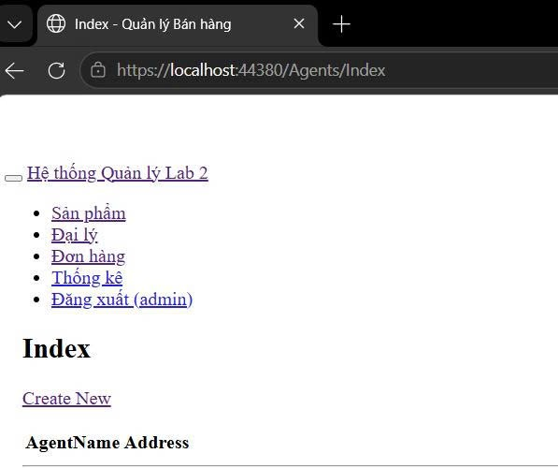

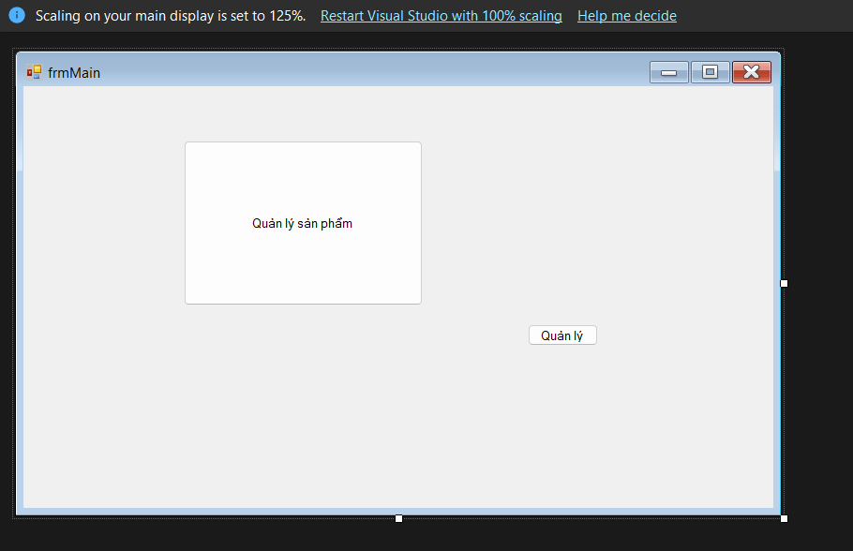
3. EXERCISE 2 – ASP.NET MVC .NET FRAMEWORK (DB FIRST)
3.1 Introduction
Exercise 2 builds a web application using the MVC (Model-View-Controller) pattern with ASP.NET MVC 5 on the .NET Framework. DB First approach: create the database first, then use Entity Framework to automatically generate Models from the existing database.
3.2 Technologies Used
Component | Details
Framework | ASP.NET MVC 5 (.NET Framework 4.7.2)
ORM | Entity Framework 6 - DB First (ADO.NET Entity Data Model)
Database | SQL Server Express - Database LabAssignment2
UI Framework | Bootstrap 5 (CDN)
Authentication | ASP.NET Session
3.3 MVC Structure
Controller / View | Function
AccountController | Login, Logout using Session
ItemController | Product CRUD (auto scaffold)
AgentController | Agent CRUD (auto scaffold)
OrderController | Create order, add OrderDetail, view details, print order
FilterController | Statistics for best-selling products and agents
3.4 Operational Flow
User accesses → automatically redirects to Login page (RouteConfig)
Successful login → Session["UserName"] is saved → redirects to Home
Each action checks Session before execution → if not logged in → redirects to Login
EF Scaffold automatically generates Index/Create/Edit/Delete/Details for Item and Agent
OrderController processes manually to support 1-to-many relationship with OrderDetail
3.5 Highlighted Features
3.5.1 DB First with Entity Framework 6
Use ADO.NET Entity Data Model Wizard to connect directly to SQL Server
EF automatically generates Model classes from existing tables in the database
Connection string is saved in Web.config with EntityClient provider
3.5.2 Automatic Scaffold
ItemController and AgentController are generated using Visual Studio Scaffold
Automatically creates 5 Views: Index, Create, Edit, Details, Delete
Saves time, standard code following MVC conventions
3.5.3 Print Order
Order Details page has a "Print Order" button
Uses browser's window.print()
CSS @media print hides non-printable parts (add product form, buttons)
3.5.4 LINQ Statistics
GroupBy + Sum to calculate total quantity and revenue by product
OrderByDescending to rank best-selling products
Display results using Bootstrap Tab Navigation
3.6 Test Results
The application runs on localhost. The default page is Login. After logging in, the navbar fully displays: Products, Agents, Orders, Statistics, Logout. All CRUD functions work correctly. The print order page displays correctly when pressing Ctrl+P.

4. EXERCISE 3 – ASP.NET CORE RAZOR PAGES

4.1 Introduction
Exercise 3 implements the order management system using ASP.NET Core 8 Razor Pages. Unlike MVC, Razor Pages is page-centric, which co-locates the UI (HTML) and the logic (C#) in a .cshtml and .cshtml.cs file pair.

4.2 Technologies Used
- Framework: .NET 8.0
- ORM: Entity Framework Core (EF Core)
- Approach: DB First (Scaffold-DbContext)
- UI: Bootstrap 5 with Tag Helpers

4.3 Key Features & Implementation
- Handler Methods: Uses OnGetAsync and OnPostAsync instead of Action methods to manage data flow.
- Dependency Injection: The DbContext is registered in Program.cs and injected into the PageModels.
- One-to-Many Order Form: Implemented using a "ViewModel" approach to handle the list of OrderDetail items dynamically within the Order Create page.

5.1 Introduction
This exercise focuses on the Code First approach. We define the system's entities as C# classes first, and Entity Framework Core generates the SQL Server database schema via Migrations.

5.2 Development Workflow
- Define Models: Created Item, Agent, Order, and OrderDetail classes with data annotations (e.g., [Key], [Required]).
- Data Migration:
  - dotnet ef migrations add InitialCreate
  - dotnet ef database update
- Controller Scaffolding: Used the built-in generator to create controllers with views for Items and Agents.

5.3 Database Seeding
To meet the requirement of 15-30 rows per table, we implemented a DbInitializer class to automatically populate the database with sample data upon the first run.

6. EXERCISE 5 – UNIT TESTING

6.1 Introduction
A Unit Test Project was created to ensure the reliability of the business logic across the different sub-projects.

6.2 Testing Frameworks
- Framework: xUnit / MSTest
- Mocking: Moq (to simulate the Database Access Layer)

6.3 Test Cases
Module | Logic Tested | Expected Result
ItemBLL | Validate UnitPrice > 0 | Returns false if price is negative
AgentBLL | Validate AgentName not empty | Throws validation exception if null
OrderLogic | Calculate TotalAmount | Sum of (Qty * UnitPrice) is correct
Xuất sang Trang tính

7. CONCLUSION & CONTRIBUTION

7.1 Conclusion
Through this assignment, we successfully deployed a Sales Management System across four different .NET technologies. We gained a deep understanding of the trade-offs between 3-Tier Architecture in WinForms and MVC/Razor Pages in web environments, as well as the differences between DB First and Code First workflows.

