- Introduction
The purpose of this lab was to implement a 3-Tier Architecture using ASP.Net WebForms. This architectural pattern separates the application into three logical layers:
The Presentation Layer (UI), The Business Logic Layer (BLL/BAL), The Data Access Layer (DAL) .
By doing so, we aim to improve the maintainability, scalability, and organization of web by isolating data handling from it’s UI.
- Exercises (Classwork’s)
- Exercise 1: Setting up a 3-Tier Architecture with WebForms
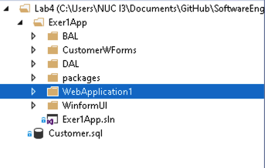
In this exercise, I developed a Customer Management system that performs full CRUD operations by using a layered approach mostly by using Lab3’s foundations and building on it.
Figure 1. Lab4 Exercise1's Folder tree
- Data Access Layer (DAL)
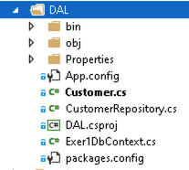
The DAL handles all direct communication with the MSSQL database.

Figure 2. DAL's Folder tree

Model (Customer.cs): A simple class defining the data structure (ID, Name, Email).
DbContext (Exer1DbContext.cs): Acts as the bridge to the database using Entity Framework. Repository (CustomerRepository.cs): Contains the methods to Add, Update, and Delete data.
- Business Logic Layer (BAL)

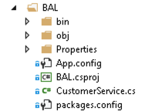
The BAL (specifically CustomerService.cs) acts as a buffer. It receives commands from the web page and passes them to the DAL, ensuring the UI never talks directly to the database.
Figure 3. BAL's Folder tree

- Presentation Layer (CustomerWForm)
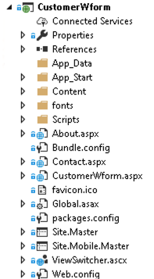
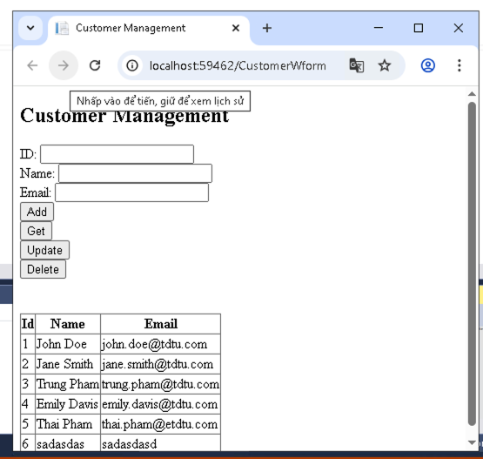
Figure 4. UI’s folder tree
Figure 5. CustomerWForm.aspx’s UI.
Controls: Used an asp: GridView to display the customer list and asp:TextBox controls for data entry.
Configuration: Added the SQL connection string (MyConn) to the web.config file to link the web app to the database.

- Homeworks
Instructor Note regarding Development Environment: Due to hardware limitations (developing the homework on a macOS environment where the legacy Windows-only ASP.NET Web Forms .NET Framework is not supported natively), this homework was implemented using ASP.NET Core Razor Pages. Razor Pages is the direct modern, cross-platform equivalent to Web Forms, utilizing the exact same UI/Code-Behind structural paradigm (.cshtml and .cshtml.cs replacing .aspx and .aspx.cs) to achieve the exact same 3-Tier architectural goals.
Task Description: Applied the strictly layered 3-Tier Architecture to the "School Management System" requirements originally assigned in Lab 2.
- Data Access Layer (DAL): Established the SchoolDbContext using Entity Framework Core (configured with SQLite for cross-platform local database execution). Created the Student entity and StudentRepository class. The repository handles all direct database transactions (Add, Get, Update, Delete) using LINQ, ensuring complete isolation from the UI.
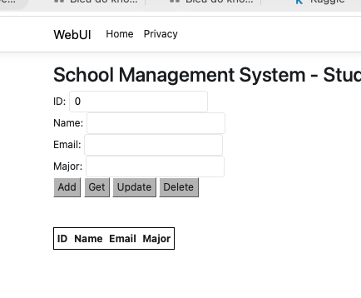
- Business Logic Layer (BLL): Implemented the StudentService class. This class acts as the intermediary bridge, receiving mapped data from the Presentation Layer and passing it down to the DAL's repository methods.
- Presentation Layer (WebUI): Designed the user interface using ASP.NET Core Razor Pages to perfectly mimic the functionality of the requested Web Forms application.
• UI (Index.cshtml): Built a unified CRUD dashboard featuring input textboxes and multiple submit buttons mapping directly to different server-side handlers (mimicking Web Form OnClick events). An HTML table iterating through the Model was implemented to replace the asp:GridView.
• Code-Behind (Index.cshtml.cs): Utilized [BindProperty] attributes to handle form data and mapped OnPostAdd, OnPostUpdate, OnPostGet, and OnPostDelete handlers to safely call the BLL's StudentService.
IV. Conclusion
Overall, Lab 4 successfully demonstrated the critical importance of a 3-Tier Architecture. By separating the application into the Data Access Layer, Business Logic Layer, and Presentation Layer, the source code became highly modular. If the database changes, only the DAL needs updating; if the UI changes, the DAL and BLL remain untouched.
Challenges Faced: The primary challenge was the environment constraint of switching from a Windows machine to a macOS machine for the homework. However, this challenge provided an excellent learning opportunity. By adapting the assignment to ASP.NET Core Razor Pages, I learned that architectural patterns like 3-Tier are language and framework agnostic. The fundamental concepts of data isolation and business logic buffering apply equally to legacy Web Forms and modern cross-platform web development.

