Introduction
The purpose of this lab exercise is to learn how to create an ASP.NET Core Web Application using the Code First approach with Entity Framework Core. Specifically, this lab demonstrates how to define a database schema using C# classes and implement CRUD (Create, Read, Update, Delete) operations using Razor Pages.

Exercises

Exercise 1: Setting Up the ASP.NET Core Web Application with Razor
Description & What I Learned: In this exercise, I set up a new ASP.NET Core Web Application utilizing Razor Pages. I learned how to install necessary Entity Framework Core tools via the NuGet package manager and terminal. I successfully defined the data models (Student, Course, Instructor, Enrollment, Department) and the SchoolContext. By configuring the connection string and running EF Core migrations, I learned how the Code First approach generates SQL Server database tables directly from C# code. Finally, I utilized the ASP.NET code generator to automatically scaffold the CRUD Razor Pages and updated the _Layout.cshtml navigation menu to test the application in the browser.
Screenshots:
- Screenshot 1: Visual Studio/Rider showing the Solution Explorer with the Models and Pages folders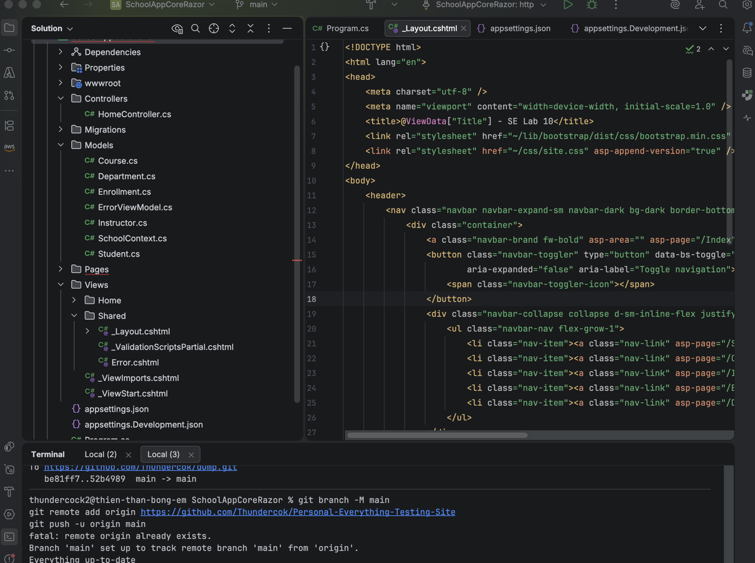

- [Screenshot 2: The Home Page running in the browser]

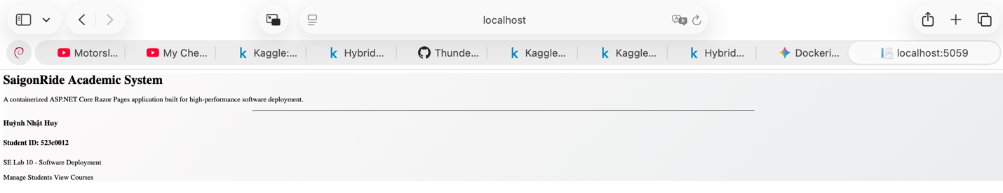

Exercise 3: Upload Projects to GitHub
Description & What I Learned: I learned how to use Git version control to stage, commit, and push my completed Razor Pages project to a remote GitHub repository to organize my code and make it accessible.
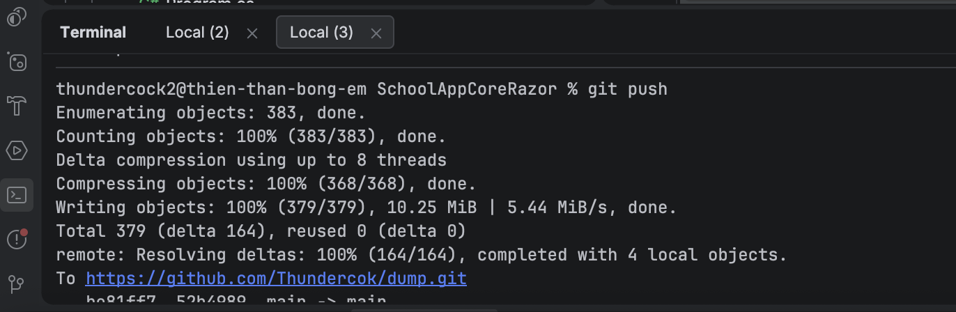
- [Screenshot 3: The terminal showing the successful git push]
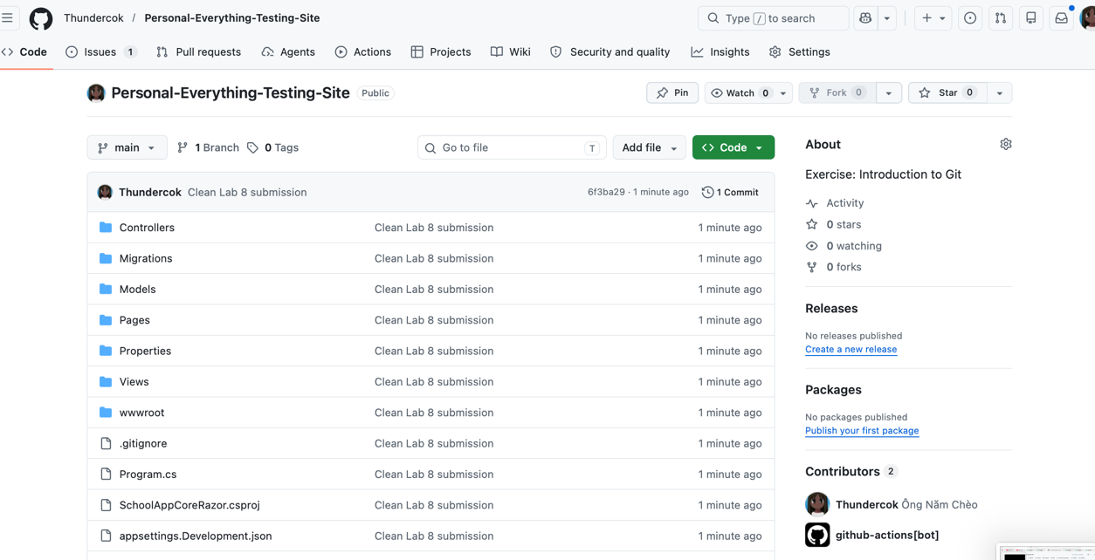
- [Screenshot 4: The GitHub repository page in the browser showing the uploaded project files]

Conclusion
Overall, this lab provided a strong foundational understanding of how Entity Framework Core bridges the gap between object-oriented C# models and relational databases. The biggest challenge was configuring the database connection and managing Entity Framework dependencies on macOS, which required utilizing Docker to host the SQL Server and using terminal-based .NET CLI commands instead of Visual Studio's GUI tools. Overcoming this challenge significantly improved my understanding of how ASP.NET Core applications are structured under the hood.

