Exericse 1. Creating a GitHub repo & manage the source code for an app.
I bypassed the account creation step, as a GitHub account was already established and active from previous years and I opted to name the repository TDTUStudentApp for conveinence sake, as I am building an app with that name.

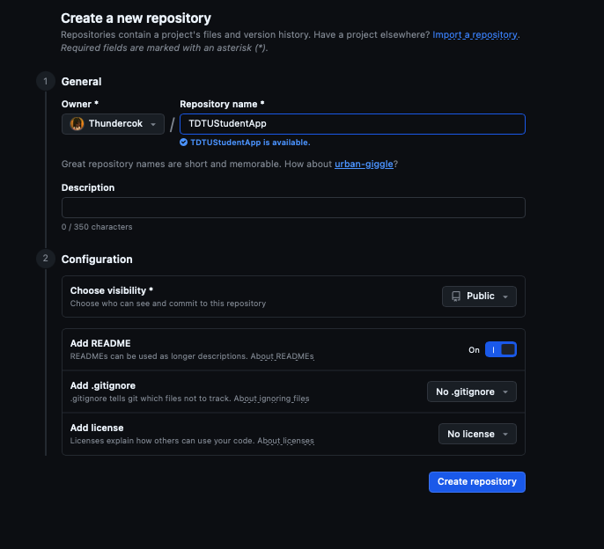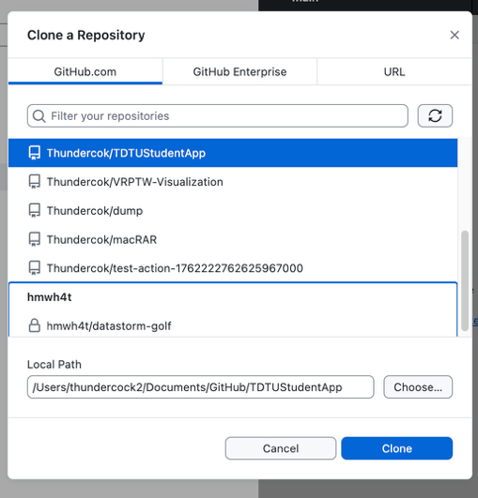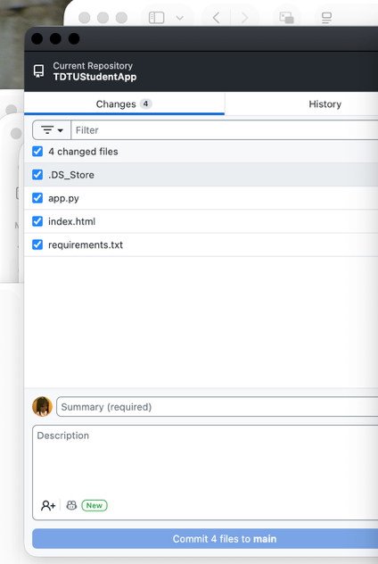
Because my primary development environment is a MacBook, I utilized my preferred, dedicated GitHub Client to handle version control operations. I cloned the remote TDTUStudentApprepository to my local machine using the client.
I moved my existing TDTUStudentApp source code directly into the newly cloned local repository folder via the macOS Finder, ensuring the directory structure was clean and ready for version control.
Using the GitHub Client interface, I staged all the newly added project files. I entered a commit message (e.g., "First steps") and successfully pushed the main branch to the remote repository on GitHub.
Conclusion: The objective of the exercise was successfully met. The source code for TDTUStudentApp is now fully version-controlled and hosted on GitHub, utilizing a macOS-compatible Git workflow instead of the Visual Studio built-in tools.

Exercise 2. Creating a Project Repository Locally and Mapping to GitHub
Objective: Initialize a local Git repository for the application and push it to a newly created remote GitHub repository.Execution & Learnings: Instead of using Visual Studio’s built-in Git tools, I managed the local repository initialization via my GitHub client.
- I created a new, blank repository on GitHub named Spider-The-Web-Crawler (without a README or .gitignore to prevent conflicts).
- Locally, I initialized a new Git repository in my project folder.
- I mapped the local repository to the remote GitHub URL (origin).
- Finally, I staged the initial project files, committed them, and pushed the main branch to GitHub. This exercise reinforced the standard Git workflow of establishing a local codebase before linking and pushing to a remote server.
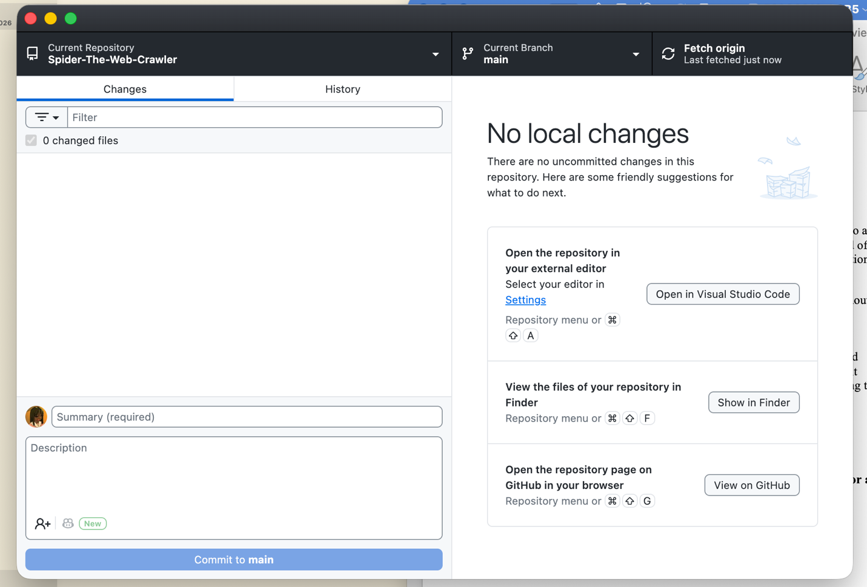

Exericse 3. Collaborating on a Project Using GitHub
For this collaborative exercise, my partner and I split the roles of Student A and Student B.
- 3a & 3b (Setup & Cloning): I hosted the repository and invited my partner via the GitHub repository settings. We both cloned the repository to our local machines.
- 3c (Partner Modifications): My partner added changes, committed the changes, and pushed them to the remote repository.
- 3d (Retrieving & Adding Changes): I pulled my partner's latest commits using my GitHub client to ensure my local codebase was up to date. I then added the "Course Name" Label and TextBox, committed my updates, and pushed them back to GitHub.
This exercise highlighted the importance of communication and frequent pulling/pushing when multiple developers are modifying the same files.

Conclusion

This lab provided practical experience in Source Code Management. While the lab instructions focused on Visual Studio's built-in Git integration, successfully completing the objectives using a dedicated GitHub client on macOS demonstrated that core Git principles—cloning, staging, committing, pulling, and pushing—remain consistent regardless of the IDE or operating system. The most valuable takeaway was navigating the collaboration process and learning how to safely resolve merge conflicts without losing work.

