- Introduction
The purpose of this lab was to implement a 3-Tier Architecture using ASP.Net WebForms. This architectural pattern separates the application into three logical layers:
The Presentation Layer (UI),
The Business Logic Layer (BLL/BAL),
The Data Access Layer (DAL) .
By doing so, we aim to improve the maintainability, scalability, and organization of web by isolating data handling from it’s UI.

- Exercises (Classwork’s)
- Exercise 1: Setting up a 3-Tier Architecture with WebForms
In this exercise, I developed a Customer Management system that performs full CRUD operations by using a layered approach mostly by using Lab3’s foundations and building on it.
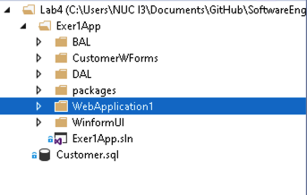
Figure 1. Lab4 Exercise1's Folder tree

- Data Access Layer (DAL)
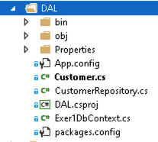
The DAL handles all direct communication with the MSSQL database.

Figure 2. DAL's Folder tree

Model (Customer.cs): A simple class defining the data structure (ID, Name, Email).
DbContext (Exer1DbContext.cs): Acts as the bridge to the database using Entity Framework.
Repository (CustomerRepository.cs): Contains the methods to Add, Update, and Delete data.

All of the files above were made with the example code from the instructor’s lab file

- Business Logic Layer (BAL)

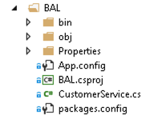
The BAL (specifically CustomerService.cs) acts as a buffer. It receives commands from the web page and passes them to the DAL, ensuring the UI never talks directly to the database.
Figure 3. BAL's Folder tree

All of the files above were also made with the example code from the instructor’s lab file

- Presentation Layer (CustomerWForm)

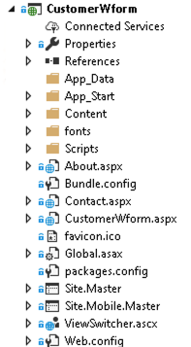
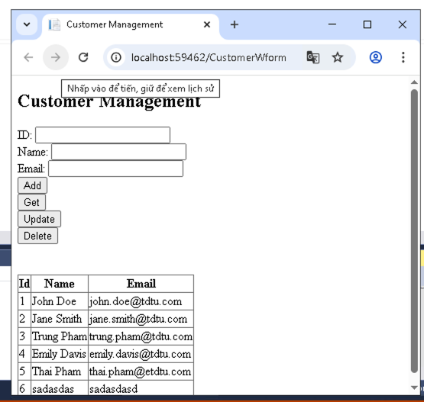
Figure 5. CustomerWForm.aspx’s UI.
Figure 4. UI’s folder tree

Controls: Used an asp: GridView to display the customer list and asp:TextBox controls for data entry.
Configuration: Added the SQL connection string (MyConn) to the web.config file to link the web app to the database.

All of the files above were made with the example code from the instructor’s lab file

- Homeworks
Sorry for the sloppy presentation, I promise I will do better than this for future projects.
By the time you are reading this, my homework is done and currently is in my github repository ./Homeworks.
And it’s more detailed report is currently in 523c0012_Lab4.pdf.
- Github Repo Link:
https://github.com/Thundercok/SoftwareEngineering2026/tree/main/Lab4

