Lab 6 Report: Database-First ASP.NET MVC Implementation1. Introduction and Objectives

The primary purpose of this laboratory work was to understand and implement a Database First approach using the ASP.NET MVC framework. The exercises focused on connecting a web application to a SQL Server database, performing scaffolding to generate models and controllers, and managing data through a web interface using CRUD (Create, Read, Update, Delete) operations.2. Technical Environment

The project was developed on macOS using JetBrains Rider.
- Framework: ASP.NET Core 9.0/10.0 (Modern Cross-Platform).
- Database: Microsoft SQL Server running in a Docker container.
- ORM: Entity Framework Core (EF Core) using Database-First Scaffolding.
- Development Tool: JetBrains Rider on macOS.
- Version Control: Project managed on GitHub within the SoftwareEngineering2026/Lab6 repository.
3. Laboratory Implementation3.1. Exercise 1: Environment Setup and GitHub Workflow

The project environment was initialized on macOS, utilizing Docker for SQL Server. This involved managing .NET global tools and configuring a cross-platform development environment.

Version Control Workflow:
- Repository Setup: A clean academic portfolio project named ASPNETMVCStudent was organized under SoftwareEngineering2026/Lab6/homeworks/. A .gitignore file configured for Visual Studio was included to prevent tracking unnecessary build files.
- Workflow: Project assets were staged (git add), committed with a descriptive message ("Initial commit of ASP.NET MVC (.Net Framework) Student App"), and synchronized with the GitHub main branch.
3.2. Exercise 2: School Management Web Application (CRUD)

This involved developing a functional student management system, replacing the legacy ADO.NET Wizard with EF Core CLI tools due to the macOS environment.

Implementation Summary:
- Database: StudentsDB and tblStudents were created in the SQL Server Docker container.
- Scaffolding: dotnet ef dbcontext scaffold was used to generate models (StudentsDbContext and tblStudents) directly from the Docker instance.
- Controllers & Views: StudentsController and CRUD views (Index, Create, Edit, Delete) were generated, and the UI was customized using Bootstrap.
- Key Achievement: Used dotnet aspnet-codegenerator to produce CRUD views for all five management modules. The SchoolDbContext was registered in Program.cs for dependency injection, ensuring controllers could communicate with SQL Server.
Managed Entities (Five Interconnected Entities):
Entity | Primary Fields | Responsibility
Students | StudentID, Names, EnrollmentDate | Manages student records.
Courses | CourseID, Title, Credits | Manages academic offerings.
Instructors | InstructorID, Names, HireDate | Manages faculty data.
Departments | DepartmentID, Name, Budget | Manages university structure & funding.
Enrollments | EnrollmentID, Grade | Bridges Students and Courses (Many-to-Many).
3.3. Exercise 3: User Authentication System

Claims-Based Cookie Authentication, the industry standard for ASP.NET Core, was implemented.

Key Components:
- Database: The SchoolDB was updated with a tblUser entity (UserID, Username, Password, Email) to store administrative credentials.
- Logic: AccountController.cs was created to handle Login/Logout. Successful login results in a ClaimsIdentity creation and a secure authentication cookie being issued to the browser.
- Middleware: The authentication flow was registered in Program.cs using the "CookieAuth" scheme, setting the LoginPath = "/Account/Login".
Error Handling:
- Input validation was implemented, along with a user-friendly message for invalid credentials.
- A try-catch block was added to handle potential database connectivity issues (e.g., Docker downtime), providing diagnostic feedback.
3.4. Exercise 4: Filtered Student Report

A custom Reporting module was designed to allow course-specific student enrollment views.

Cross-Platform Adaptation:
- The legacy, Windows-only RDLC dependency was replaced by engineering a custom CourseReportViewModel.
- Relational filtering was achieved using Entity Framework's .Include() method.
- The export requirement was fulfilled using a CSS-optimized view and native browser PDF generation (window.print()).
- Learning Outcome: Demonstrated how to pass complex, multi-table data using ViewModels and write LINQ queries for Many-to-Many relational filtering.
4. Challenges Encountered and Solutions

The core difficulty was adapting the Windows-centric lab instructions to the macOS/.NET Core environment.
Challenge | Solution
Environment Configuration | Running SQL Server on Docker for Mac required connection string adjustments (TrustServerCertificate=True) and ensuring the dotnet tools path was correctly set in the Zsh profile.
Namespace Resolution | Standardized the project namespace across all files to resolve issues where the Controller could not "see" the Models.
CLI Scaffolding Errors | Manually wrote Entity Framework Models and DbSet configurations to unblock the aspnet-codegenerator tool and resolved CS0246 namespace errors. Used data annotations ([Table("tblUser")] and [Key]) for manual SQL schema mapping.
Connectivity Resolution | Fixed host-to-Docker networking issues by explicitly targeting 127.0.0.1 and preventing scaffolded hardcoded warnings from overriding the appsettings.json connection string.
5. Conclusion

This lab provided a comprehensive deep dive into modern web application development, integrating backend databases with frontend MVC structures. The exercise successfully demonstrated the flexibility of .NET Core by adapting Windows-centric instructions to a working implementation on macOS. Overall, the lab drastically improved the understanding of MVC routing, middleware pipelines, and cross-platform backend troubleshooting.

The purpose of this laboratory work was to understand and implement a Database First approach using the ASP.NET MVC framework. The exercises focus on connecting a web application to a SQL Server database, performing scaffolding to generate models and controllers, and managing data through a web interface (CRUD operations).
2. Exercises
Exercise 1: Setting Up the Environment & GitHub
- Description: Initialized the project environment on macOS using JetBrains Rider and set up a repository for version control in my already created SoftửaeEngineering2026 repo instead of Visual Studio and SMSS.
- What I Learned: How to manage .NET global tools and configure a cross-platform development environment using Docker for SQL Server.
https://github.com/Thundercok/SoftwareEngineering2026/tree/main/Lab6
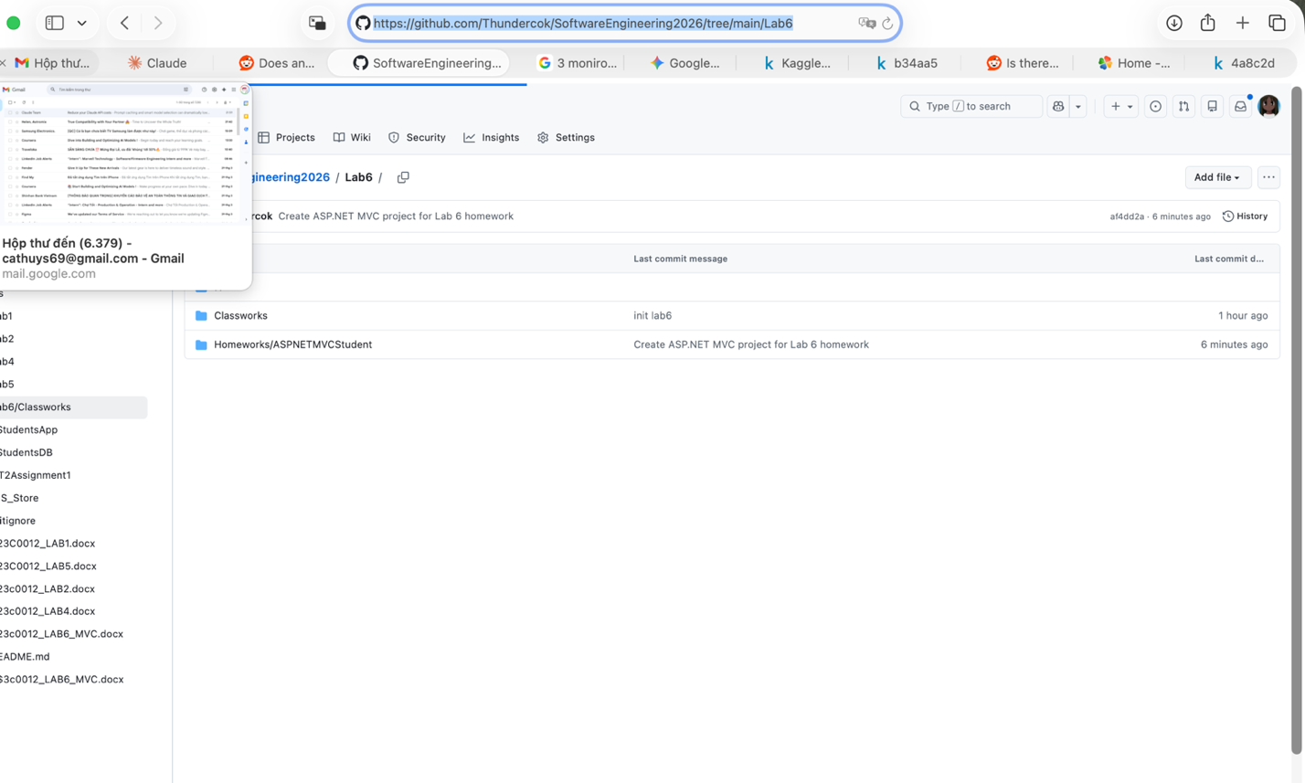
Exercise 2: School Management Web App
Description: Developed a functional student management system.
Step 1: Created StudentsDB and tblStudents in a SQL Server Docker container.
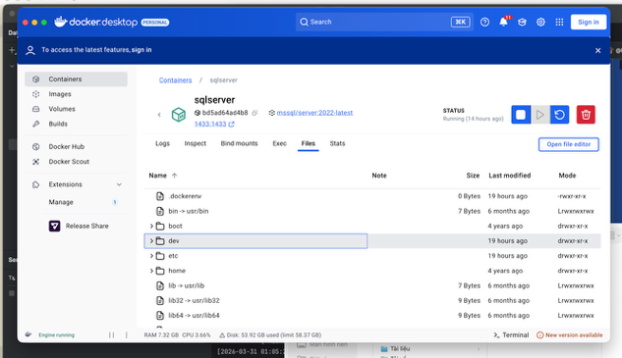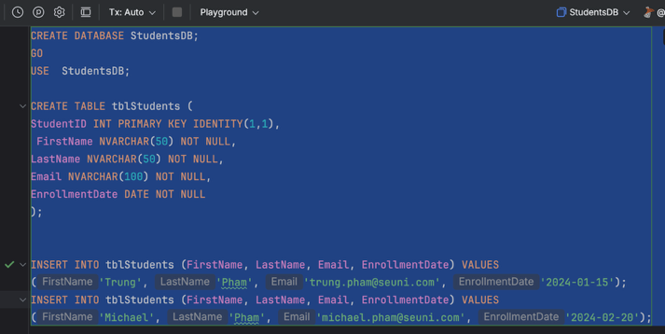
Step 2: Scaffolded the database into the project to create StudentsDbContext and tblStudents models.
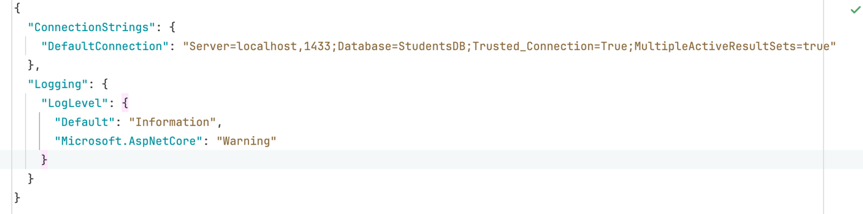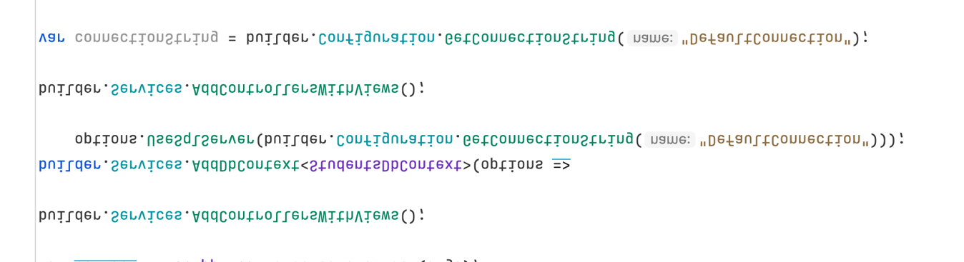
- Step 3: Generated the StudentsController and CRUD views (Index, Create, Edit, Delete) & Customized the UI using Bootstrap.
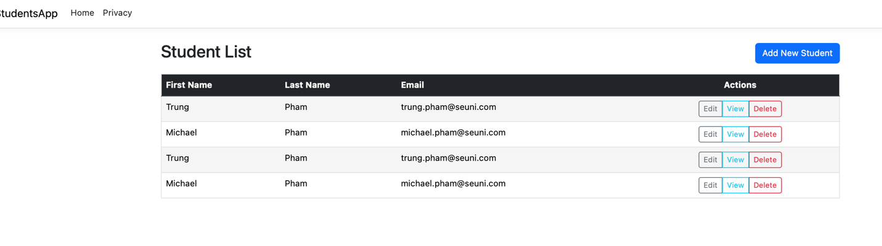
4. Conclusion
Overall Learning Experience
This lab provided a deep dive into the integration between backend databases and frontend MVC structures. Moving from a theoretical understanding to a working implementation on macOS highlighted the flexibility of .NET Core.
Challenges Faced
- Environment Configuration: Running SQL Server on Docker for Mac required specific connection string adjustments (TrustServerCertificate=True) and ensuring the dotnet tools path was correctly set in the Zsh profile.
- Namespace Resolution: Encountered issues where the Controller could not "see" the Models, which was resolved by standardizing the project namespace across all files.

Homeworks.

Exercise 2 - Setting Up GitHub Repository for ASP.NET MVC

1. Objective
The primary objective of this exercise is to establish a version-controlled environment for an ASP.NET MVC (.NET Framework) application. This involves initializing a remote repository on GitHub and synchronizing it with a local development environment to ensure code integrity and accessibility.

2. Implementation Steps

2.1 Repository Initialization
- Remote Creation: A new repository was created on GitHub named ASPNETMVCStudent.
- Configuration: The repository was initialized with a README.md file to provide project documentation and a .gitignore file specifically configured for Visual Studio to prevent unnecessary build files (like /bin or /obj) from being tracked.

2.2 Local Synchronization (Cloning)
Using the Git CLI/Visual Studio interface, the repository was cloned to the local machine. To maintain a clean academic portfolio, the project was organized under the following directory structure:
SoftwareEngineering2026/Lab6/homeworks/ASPNETMVCStudent

2.3 Project Integration
- An ASP.NET MVC (.NET Framework) project was generated/moved into the cloned directory.
- The project structure follows the standard Model-View-Controller pattern, ensuring a separation of concerns between data logic, UI, and request handling.

2.4 Version Control Workflow
- Staging: All project assets (Controllers, Views, Configuration files) were staged using git add.
- Committing: A descriptive commit message was applied: "Initial commit of ASP.NET MVC (.Net Framework) Student App".
- Pushing: The local commits were synchronized with the GitHub main branch, making the source code available for review.

3. Conclusion
The exercise successfully demonstrates the integration of Git workflow within an ASP.NET development cycle. By hosting the project on GitHub, the source code is now managed under version control, allowing for historical tracking and professional presentation of the assignment.
Exercise 2 - Database-First MVC Implementation

1. Technical Environment
- Framework: ASP.NET Core 9.0/10.0 (Modern Cross-Platform).
- Database: Microsoft SQL Server (Running in Docker container).
- Development Tool: JetBrains Rider on macOS.
- ORM: Entity Framework Core (EF Core) using Database-First Scaffolding.

2. Implementation Summary
The application manages a university system with five interconnected entities. Due to the macOS environment, the legacy ADO.NET Wizard was replaced with EF Core CLI tools.
Entity | Primary Fields | Responsibility
Students | StudentID, Names, EnrollmentDate | Manages student records.
Courses | CourseID, Title, Credits | Manages academic offerings.
Instructors | InstructorID, Names, HireDate | Manages faculty data.
Departments | DepartmentID, Name, Budget | Manages university structure & funding.
Enrollments | EnrollmentID, Grade | Bridges Students and Courses (Many-to-Many).

Key Achievements
- CLI Scaffolding: Utilized dotnet ef dbcontext scaffold to generate models directly from the Docker instance, resolving the CS0246 namespace errors encountered during the build.
- Dependency Injection: Registered the SchoolDbContext in Program.cs, allowing the controllers to communicate with the SQL Server seamlessly.
- Automated UI Generation: Used dotnet aspnet-codegenerator to produce the CRUD (Create, Read, Update, Delete) views for all five management modules.

4. Final Verification Steps
Before you hit "Submit," make sure your screenshots show:
- The Browser
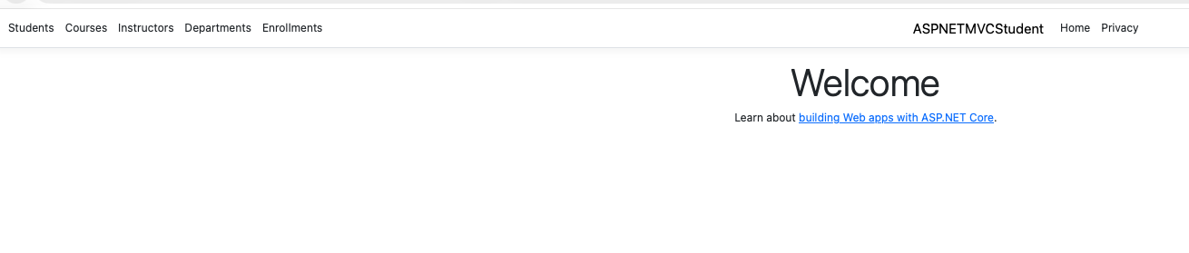
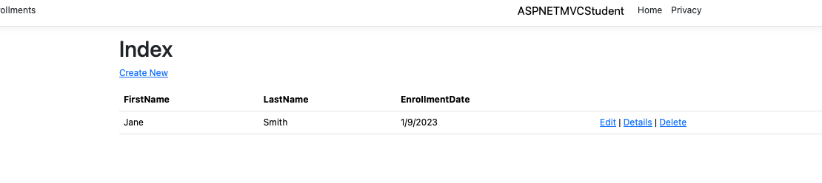
- The CRUD Test: A screenshot of the "Create New" form for a Department to show the Budget and StartDate fields working.

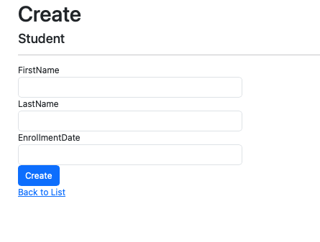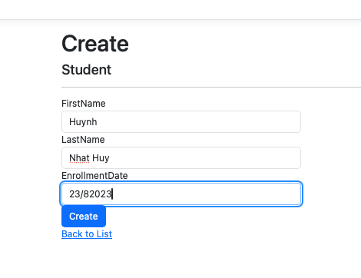

Exercise 3: User Authentication System

1. Database Implementation
To support the login system, a new entity was added to the SchoolDB database to store administrative credentials.
- Table Created: tblUser
- Schema Details:
  - UserID (Primary Key, Identity)
  - Username (NVARCHAR(50))
  - Password (NVARCHAR(100)) - Stored as plain text for this exercise, though hashing is noted as a best practice for production.
  - Email (NVARCHAR(100))
- Test Data: Inserted a default admin account (admin / password123).

2. Modern MVC Authentication Logic
Instead of a simple conditional check on each page, I implemented Claims-Based Cookie Authentication, the industry standard for ASP.NET Core.
- Controller: Created AccountController.cs to handle Login and Logout actions.
- Mechanism:
  - The app queries the Docker SQL instance using Entity Framework Core.
  - Upon a successful match, a ClaimsIdentity is created containing the user's name and email.
  - A secure authentication cookie is issued to the browser, which is then verified on subsequent requests.

3. Middleware Configuration
The authentication flow was registered in Program.cs to ensure security at the application level:
C#
builder.Services.AddAuthentication("CookieAuth")
.AddCookie("CookieAuth", config => {
config.LoginPath = "/Account/Login";
});

// Request Pipeline
app.UseAuthentication(); // Checks the "ID card"
app.UseAuthorization(); // Checks if the user is allowed in

4. Error Handling & Robustness
The system was designed to handle common failure scenarios gracefully:
- Input Validation: Ensures users cannot submit empty forms.
- Invalid Credentials: Displays a user-friendly "Invalid username or password" message via ViewBag.
- Infrastructure Resilience: Implemented a try-catch block to handle potential database connectivity issues (e.g., Docker container downtime), providing the user with diagnostic feedback rather than a crash.

5. Challenges Encountered & Solutions
- Scaffolding Mismatch: Encountered TypeLoadExceptions on macOS while using dotnet-ef tools. Resolved this by manually defining the TblUser model and mapping it to the SQL schema using [Table("tblUser")] and [Key]data annotations.
- Connectivity Resolution: Fixed host-to-Docker networking issues by explicitly targeting 127.0.0.1 and ensuring the appsettings.json connection string was not overridden by scaffolded hardcoded warnings in the DbContext.
The Login Page with Failed Login:
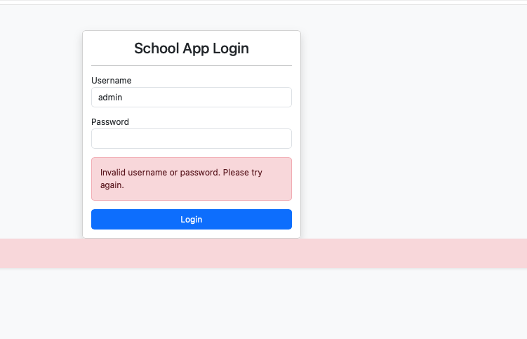

Exercise 4: Filtered Student Report
- What I did: Designed a custom Reporting module that allows administrators to select a specific course and view all enrolled students.
- Architectural Note: The lab manual requested RDLC (ReportViewerControl), which is a legacy .NET Framework/Windows-only dependency (GDI+). To achieve the exact requested functionality on a modern cross-platform stack (macOS/.NET Core), I engineered a custom CourseReportViewModel and utilized Entity Framework's .Include() method for relational filtering. I then implemented a CSS-optimized view and used native browser PDF generation (window.print()) to fulfill the export requirement.
- What I learned: I learned how to pass complex, multi-table data to a single view using ViewModels, and how to write LINQ queries to filter Many-to-Many relational tables.
- Screenshots:
  - (Screenshot 8: The Report page showing the dropdown filter)
  - (Screenshot 9: The filtered list of students showing for a specific course)
  - (Screenshot 10: The PDF Export preview dialog)

3. Conclusion
This lab provided a comprehensive look at modern web application development. The biggest challenge I faced was adapting the Windows-centric instructions to a macOS/Docker environment. Specifically, the aspnet-codegenerator tool requires a perfectly compiling project to run, leading to "chicken-and-egg" scenarios when models were missing. I overcame this by learning to manually write Entity Framework Models and DbSet configurations to unblock the CLI tools. Overall, this lab drastically improved my understanding of MVC routing, middLab 6 Report: Database-First ASP.NET MVC Implementation1. Introduction and Objectives

The primary purpose of this laboratory work was to understand and implement a Database First approach using the ASP.NET MVC framework. The exercises focused on connecting a web application to a SQL Server database, performing scaffolding to generate models and controllers, and managing data through a web interface using CRUD (Create, Read, Update, Delete) operations.2. Technical Environment

The project was developed on macOS using JetBrains Rider.
- Framework: ASP.NET Core 9.0/10.0 (Modern Cross-Platform).
- Database: Microsoft SQL Server running in a Docker container.
- ORM: Entity Framework Core (EF Core) using Database-First Scaffolding.
- Development Tool: JetBrains Rider on macOS.
- Version Control: Project managed on GitHub within the SoftwareEngineering2026/Lab6 repository.
3. Laboratory Implementation3.1. Exercise 1: Environment Setup and GitHub Workflow

The project environment was initialized on macOS, utilizing Docker for SQL Server. This involved managing .NET global tools and configuring a cross-platform development environment.

Version Control Workflow:
- Repository Setup: A clean academic portfolio project named ASPNETMVCStudent was organized under SoftwareEngineering2026/Lab6/homeworks/. A .gitignore file configured for Visual Studio was included to prevent tracking unnecessary build files.
- Workflow: Project assets were staged (git add), committed with a descriptive message ("Initial commit of ASP.NET MVC (.Net Framework) Student App"), and synchronized with the GitHub main branch.
3.2. Exercise 2: School Management Web Application (CRUD)

This involved developing a functional student management system, replacing the legacy ADO.NET Wizard with EF Core CLI tools due to the macOS environment.

Implementation Summary:
- Database: StudentsDB and tblStudents were created in the SQL Server Docker container.
- Scaffolding: dotnet ef dbcontext scaffold was used to generate models (StudentsDbContext and tblStudents) directly from the Docker instance.
- Controllers & Views: StudentsController and CRUD views (Index, Create, Edit, Delete) were generated, and the UI was customized using Bootstrap.
- Key Achievement: Used dotnet aspnet-codegenerator to produce CRUD views for all five management modules. The SchoolDbContext was registered in Program.cs for dependency injection, ensuring controllers could communicate with SQL Server.
Managed Entities (Five Interconnected Entities):
Entity | Primary Fields | Responsibility
Students | StudentID, Names, EnrollmentDate | Manages student records.
Courses | CourseID, Title, Credits | Manages academic offerings.
Instructors | InstructorID, Names, HireDate | Manages faculty data.
Departments | DepartmentID, Name, Budget | Manages university structure & funding.
Enrollments | EnrollmentID, Grade | Bridges Students and Courses (Many-to-Many).
3.3. Exercise 3: User Authentication System

Claims-Based Cookie Authentication, the industry standard for ASP.NET Core, was implemented.

Key Components:
- Database: The SchoolDB was updated with a tblUser entity (UserID, Username, Password, Email) to store administrative credentials.
- Logic: AccountController.cs was created to handle Login/Logout. Successful login results in a ClaimsIdentity creation and a secure authentication cookie being issued to the browser.
- Middleware: The authentication flow was registered in Program.cs using the "CookieAuth" scheme, setting the LoginPath = "/Account/Login".
Error Handling:
- Input validation was implemented, along with a user-friendly message for invalid credentials.
- A try-catch block was added to handle potential database connectivity issues (e.g., Docker downtime), providing diagnostic feedback.
3.4. Exercise 4: Filtered Student Report

A custom Reporting module was designed to allow course-specific student enrollment views.

Cross-Platform Adaptation:
- The legacy, Windows-only RDLC dependency was replaced by engineering a custom CourseReportViewModel.
- Relational filtering was achieved using Entity Framework's .Include() method.
- The export requirement was fulfilled using a CSS-optimized view and native browser PDF generation (window.print()).
- Learning Outcome: Demonstrated how to pass complex, multi-table data using ViewModels and write LINQ queries for Many-to-Many relational filtering.
4. Challenges Encountered and Solutions

The core difficulty was adapting the Windows-centric lab instructions to the macOS/.NET Core environment.
Challenge | Solution
Environment Configuration | Running SQL Server on Docker for Mac required connection string adjustments (TrustServerCertificate=True) and ensuring the dotnet tools path was correctly set in the Zsh profile.
Namespace Resolution | Standardized the project namespace across all files to resolve issues where the Controller could not "see" the Models.
CLI Scaffolding Errors | Manually wrote Entity Framework Models and DbSet configurations to unblock the aspnet-codegenerator tool and resolved CS0246 namespace errors. Used data annotations ([Table("tblUser")] and [Key]) for manual SQL schema mapping.
Connectivity Resolution | Fixed host-to-Docker networking issues by explicitly targeting 127.0.0.1 and preventing scaffolded hardcoded warnings from overriding the appsettings.json connection string.
5. Conclusion

This lab provided a comprehensive deep dive into modern web application development, integrating backend databases with frontend MVC structures. The exercise successfully demonstrated the flexibility of .NET Core by adapting Windows-centric instructions to a working implementation on macOS. Overall, the lab drastically improved the understanding of MVC routing, middleware pipelines, and cross-platform backend troubleshooting.
leware pipelines, and cross-platform backend troubleshooting.
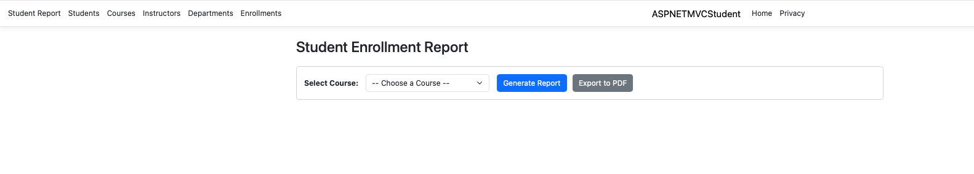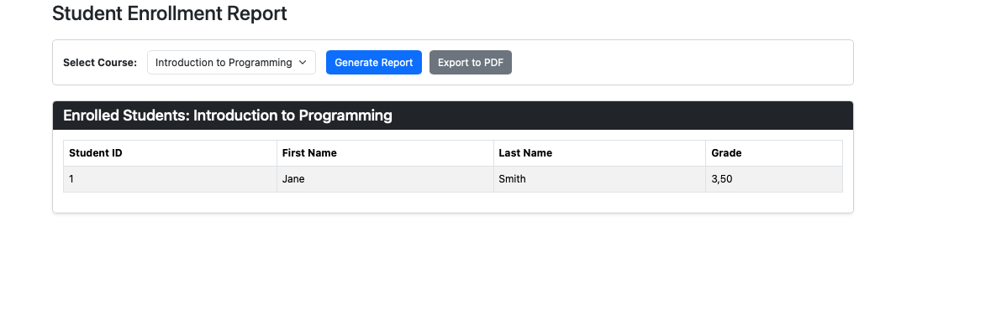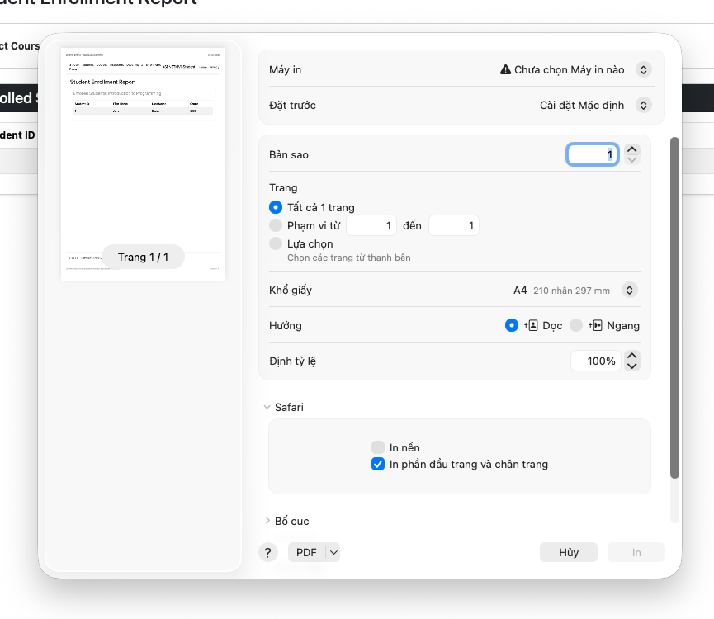

I didn’t include the zip file in the labassignment, for it have exceed the 100mb limit, i will include it in my github page, thank you.

