VIETNAM GENERAL CONFEDERATION OF LABOUR
TON DUC THANG UNIVERSITY
FACULTY OF INFORMATION TECHNOLOGY

HUỲNH NHẬT HUY - 523C0012

FINAL ESSAY
LINEAR ALGEBRA

HO CHI MINH CITY, YEAR 2023 -2024
VIETNAM GENERAL CONFEDERATION OF LABOUR
TON DUC THANG UNIVERSITY
FACULTY OF INFORMATION TECHNOLOGY


HUỲNH NHẬT HUY - 523C0012

MIDTERM ESSAY

LINEAR ALGEBRA

Dr. Truong Thi Kim Tien

HO CHI MINH CITY, YEAR 2023 -2024
ACKNOWLEDGMENTS

I, Huynh Nhat Huy, would like to sincerely thank you, Dr. Truong Thi Kim Tien for your invaluable guidance to the given subject, I’ve learnt a lot and this assignment wouldn’t be possible without her.

INSTRUCTOR RUBRIC
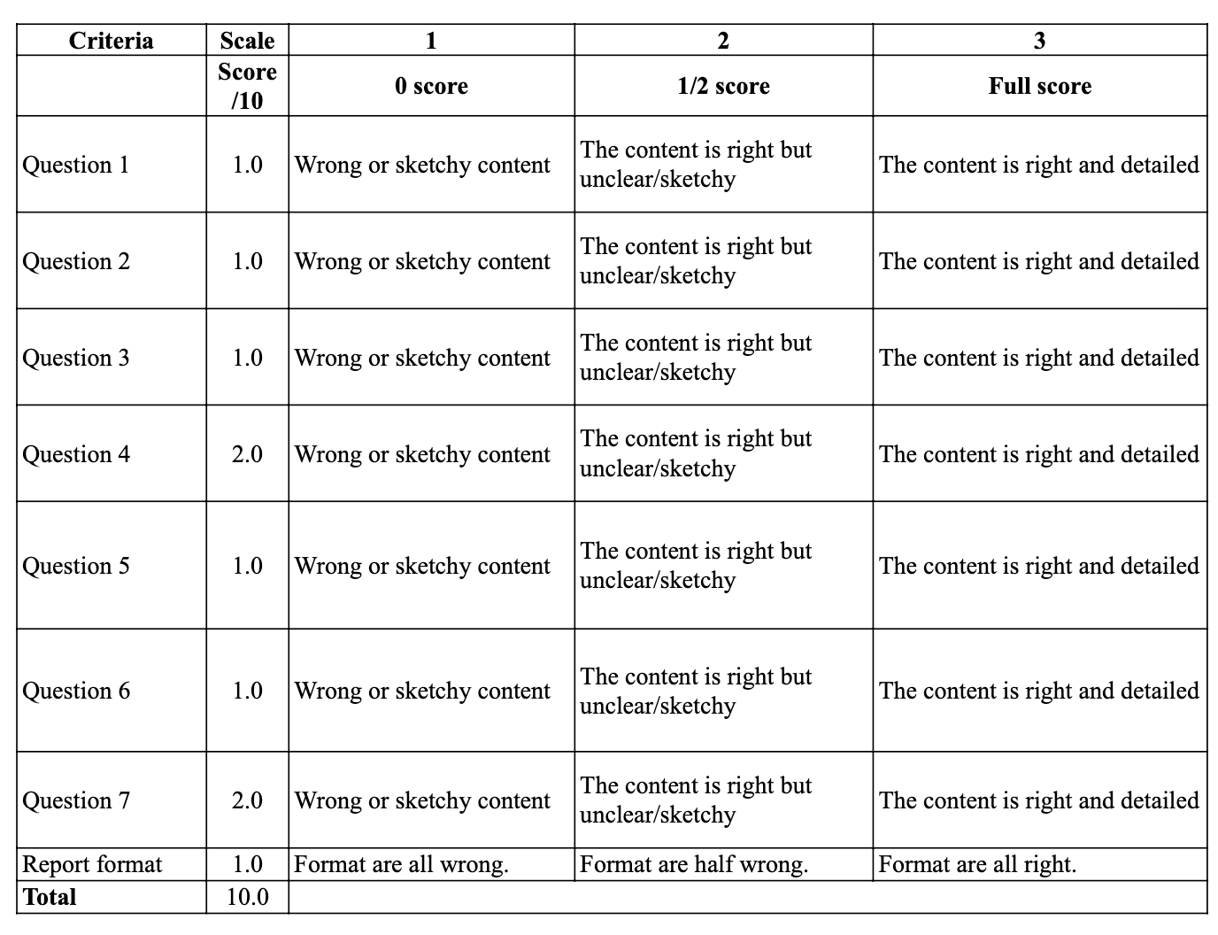
Name of instructor: Dr. Truong Thi Kim Tien

Overall score according to rubrik's rubric:

Ho Chi Minh City, December 2025
Instructors

DISCRETE STRUCTURE
ABBREVIATE

Question | Topic | Value
Q1 | Determinants | 1.0
Q2 | Systems of Equations | 1.0
Q3 | Basis Vectors | 1.0
Q4 | Diagonalization | 2.0
Q5 | Coordinate Vectors | 1.0
Q6 | Orthogonalization | 1.0
Q7 | Change of Basis | 2.0

Question 1: $Given the matrix A = \left(\begin{matrix}1 & 2 & -1 \\ 2 & 2 & 1 \\ 1 & 2 & a\end{matrix}\right)$
$$Find all values of a on which det\left(A\right)=0$$
Solution:
To find the determinant, we apply the Laplace Expansion (Cofactor Expansion) method along the first row. (The determinant of a square matrix is equal to the sum of the products of the elements of any row and their corresponding cofactors.)
The formula for expanding along the first row is:
$$det\left(A\right)=a_{11}C_{11}+a_{12}C_{12}+a_{13}C_{13}$$
$Substituing the values from the first row of matrix A = \left(1 2 -1\right)$:
$$\det\left(A\right)=1\left|\begin{matrix}2 & 1 \\ 2 & a\end{matrix}\right|-2\left|\begin{matrix}2 & 1 \\ 1 & a\end{matrix}\right|-1\left|\begin{matrix}2 & 2 \\ 1 & 2\end{matrix}\right| =1\left(2a-2\right)-2\left(2a-1\right)-1\left(4-2\right)$$
$$=-2a-2$$
$$Solve for a.We are given the condition det\left(A\right)=0.$$
$$-2a - 2 = 0 ⇒ a = -1$$

Question 2: $Solve the following system of linear equations$
$$a) \left\{\begin{matrix}x+3y-z=3 \\ x-2y+2z =4 \\ 2x+y+z=7\end{matrix}\right. b) \left\{\begin{matrix}x +3y - z = 3 \\ x - 2y + 2 z = 4 \\ 2x + y + z = 7\end{matrix}\right.$$
$$using Gaussian Elimination method.$$
$$a)$$
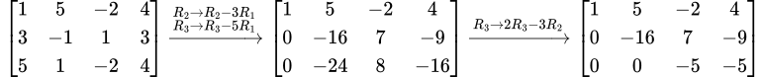
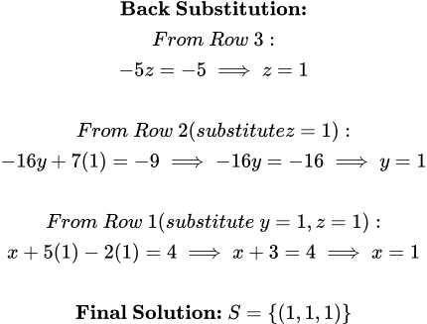
$$b)$$
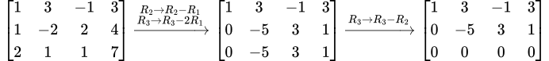

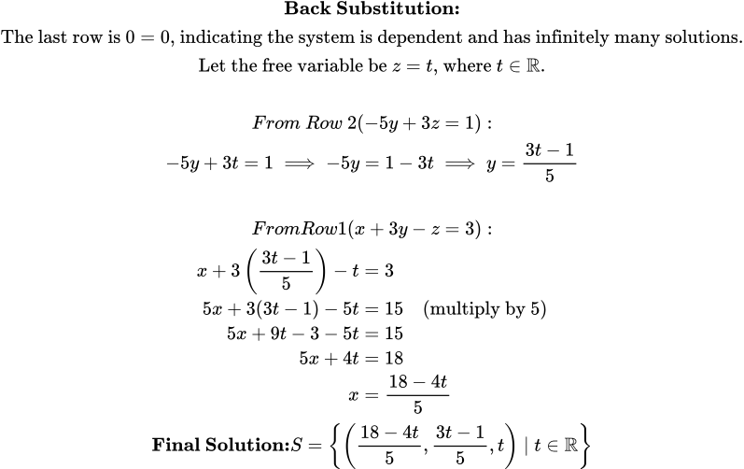

Question 3:
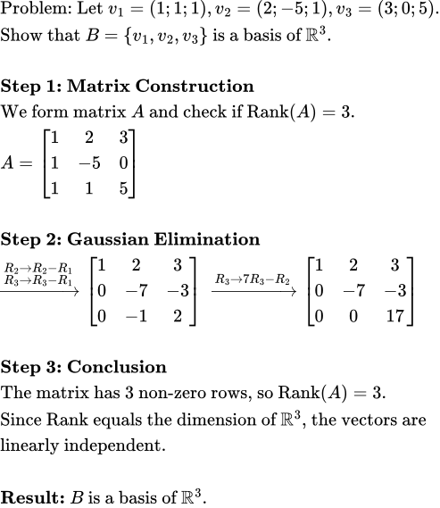

Question 4:
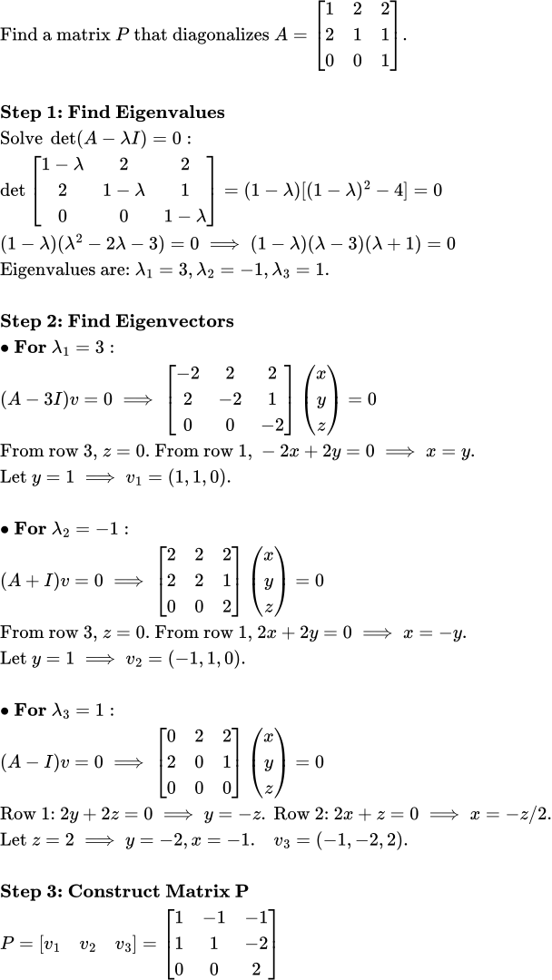
Question 5:
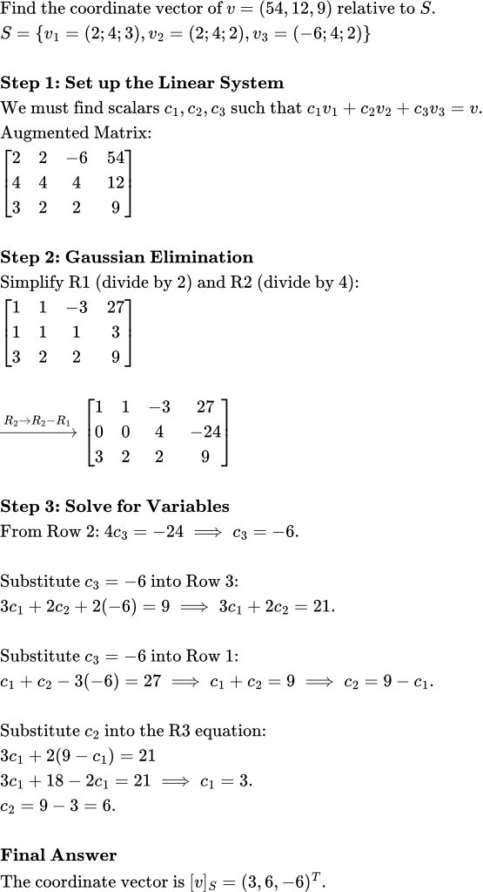

Question 6:
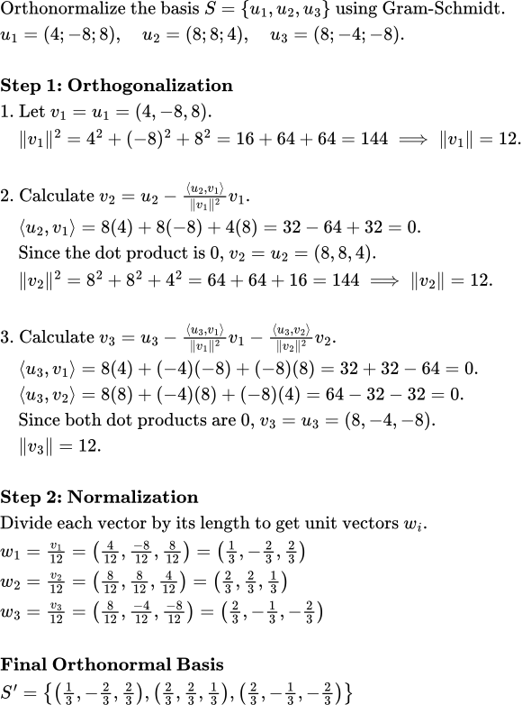

Question 7:
