武汉纺织大学

Web应用开发课程设计

**基于SSM的智能机器人聊天网页**

**学 院： 数学与计算机学院**

**班 级： 软件11802班**

**姓 名： 陈为**

**学 号： 1802220130**

**指导老师： 聂刚**

**成 绩：**

**完成日期： 2020年12月15日**

目 录

1 需求分析 1

1.1用户登陆 1

1.2主菜单 1

1.3各项功能 1

1.3.1 收银 1

1.3.2 查询统计 1

1.3.3 商品维护 2

1.3.4 修改密码 2

1.3.5 数据导出 3

1.3.6 退出 3

1.3.7 **** 3

2 系统设计 3

2.1用户用例图 3

2.2 ER图 4

2.3 UML类图（Class Diagram） 4

2.4 UML时序图（Sequence Diagram） 6

2.4.1 系统登录 6

2.5 UML活动图（Activity Diagram） 6

2.5.1 登陆 6

2.5.2 收银 7

3 系统实现 9

3.1 项目结构 9

3.2 配置文件 9

3.2.1 jdbc.properties文件 9

3.2.2 log4j2.xml文件 9

3.2.3 mybatis.xml文件 10

3.2.4 sprnig-mybatis.xml文件 10

3.2.3 spring-mvc.xml文件 10

3.3 VO类User.java 10

3.4 DAO接口类IUserDAO.java 11

3.5 接口映射文件UserMapper.xml 11

3.6 工具包Util 11

3.6.1 MybatisUtils.java 11

3.6.2 MD5Util.java 12

3.7 服务层UserService.java 13

3.8 用户界面Driver.java 14

3.9 ******.java 14

4 系统测试 14

5 系统总结 14

# 1 需求分析

设计实现一个用户与图灵智能机器人的聊天界面，支持用户发送消息，图灵机器人回复用户，并记录用户与图灵机器人的聊天记录。

## 1.1用户登陆

当程序运行成功时，在浏览器进入程序登录页面，提示用户依次输入用户名及其密码，当用户名及密码不正确时，显示提示信息“用户名或密码不正确，请重新输入”，如若用户没有用户名和密码可以通过点击注册入口进入注册页面，用户输入用户名，昵称，以及两次输入密码后，点击注册按钮即可进行注册，若用户名已存在，或两次输入密码不一致，则提示用户错误信息，完成注册操作后，可以通过点击返回登录按钮返回登录页面进行登录；

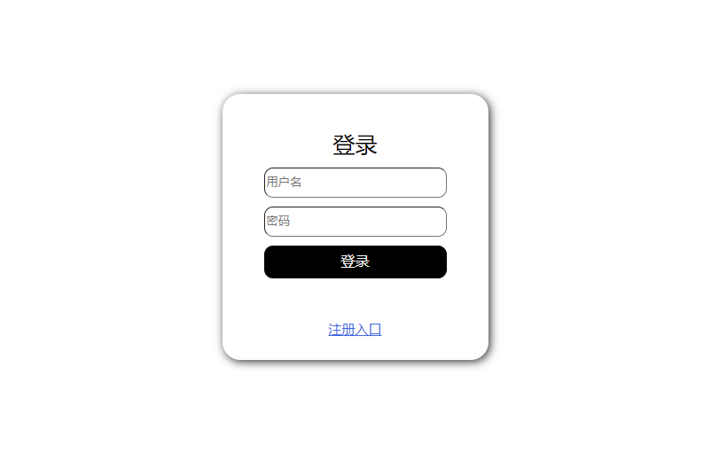

## 1.2主界面

当用户成功进行登录时，跳转至主页面，即用户和图灵机器人的聊天界面，界面顶部可查看当前用户昵称：

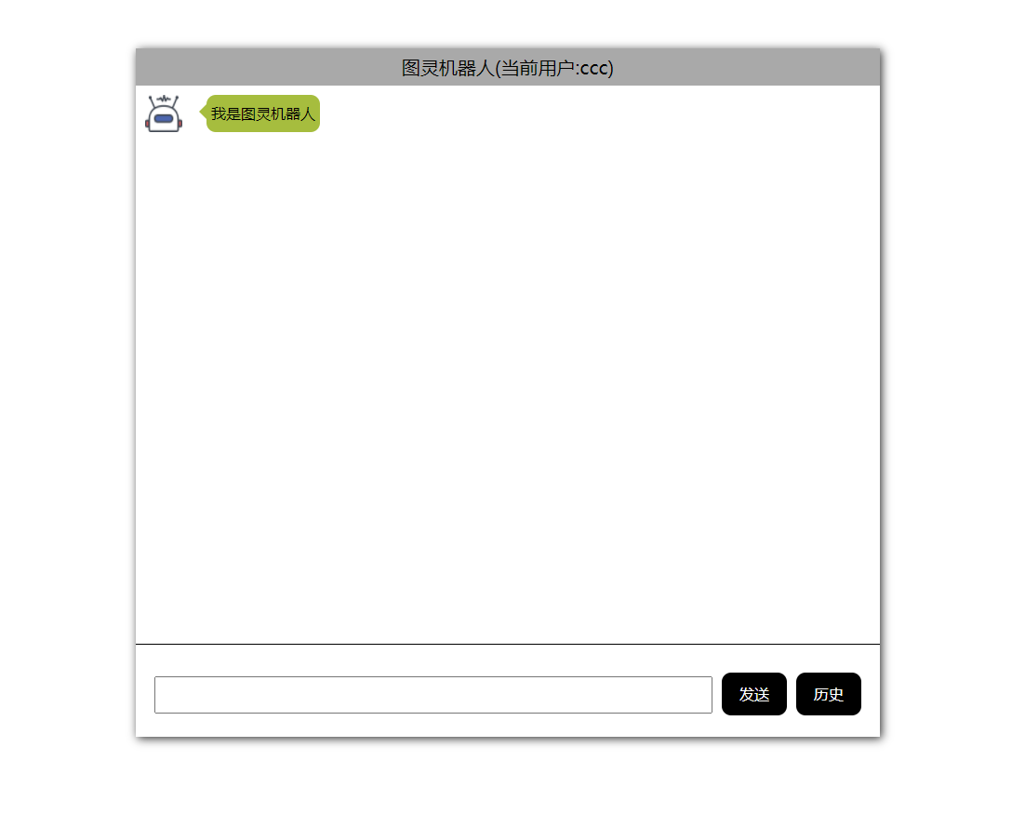

## 1.3各项功能

### 1.3.1 输入并发送信息

在聊天界面（主界面）底部有一个输入框，用户可以在输入框中输入想要发送给图灵机器人的消息，输入完信息后可以点击发送按钮发送信息。

当用户点击发送按钮或者按下键盘回车键，程序会检测输入框中是否存在信息，若不存在信息则会提示用户发送消息不可以为空，若输入框中不为空，则通过Ajax将输入的信息发送至服务器端，服务器将处理后的信息发送至前端，然后前端显示接受到的信息。

若消息长度超过一定的数量，会变换气泡框的大小来适应消息内容。

每次发送消息时聊天界面会自动的跳转至最下方。

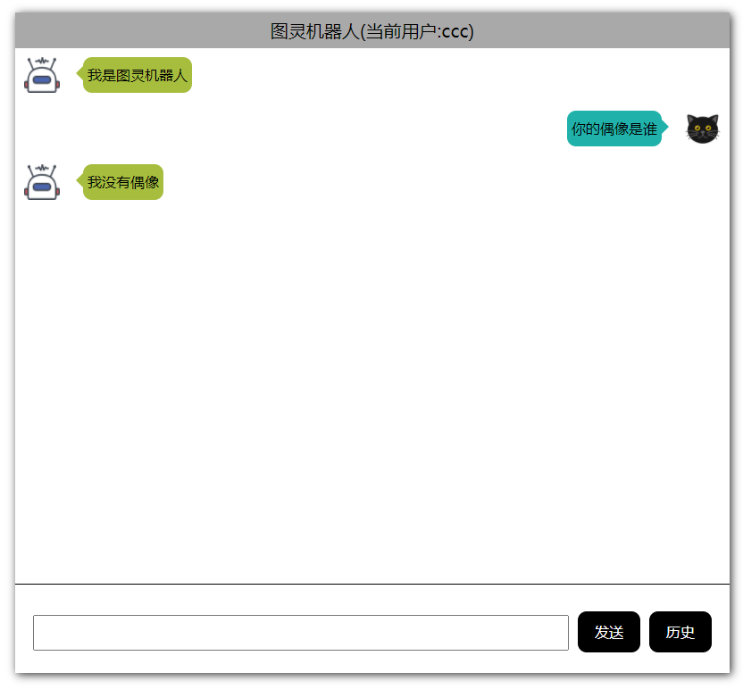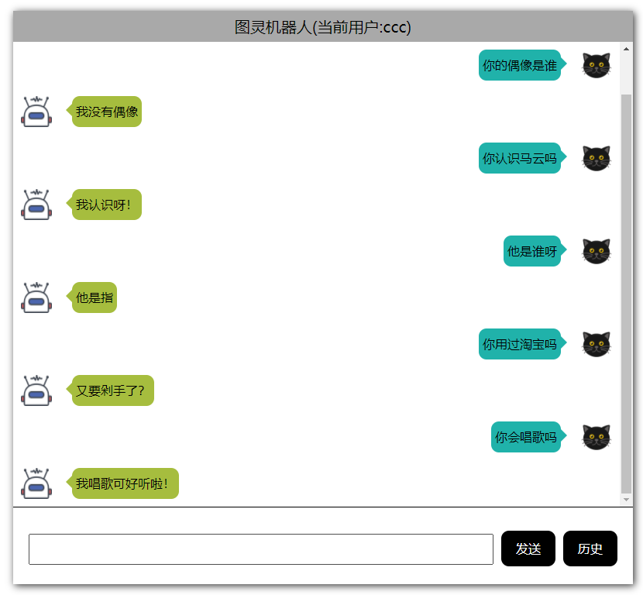

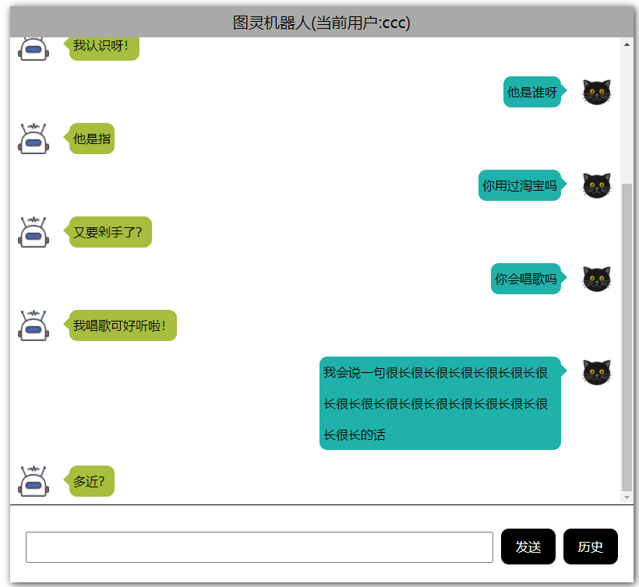

### 1.3.2 查看历史信息

当用户点击历史按钮即可查看当前用户与图灵机器人的聊天记录，聊天记录可以保存用户发送消息的时间，信息以及图灵机器人返回的信息。

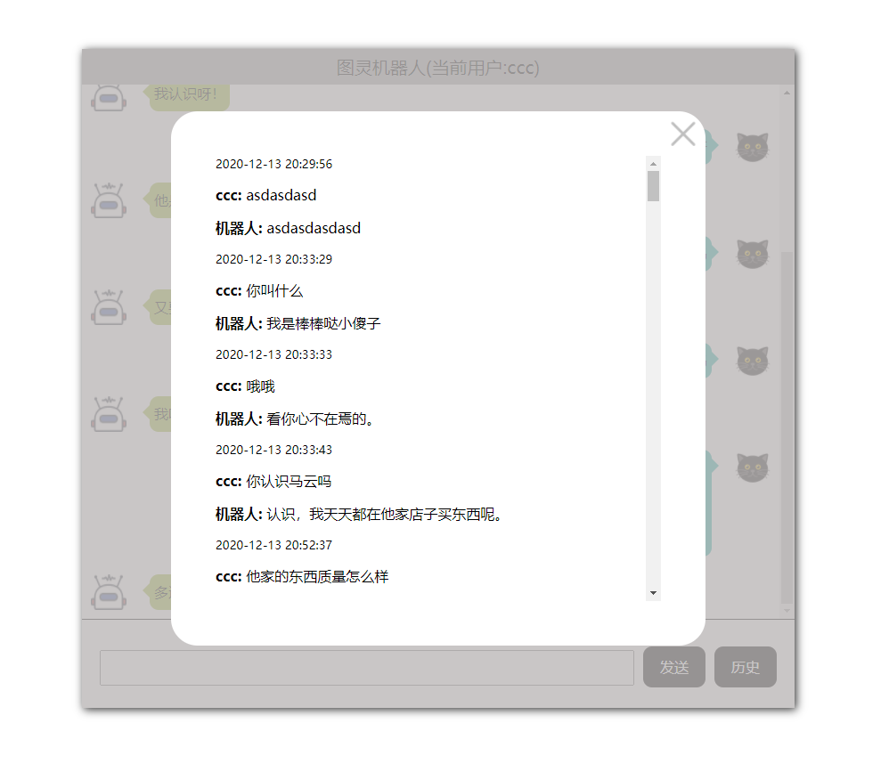

# **2 系统设计**

## 2.1用户用例图

系统只存在用户一个角色，用户用例图如下图所示:

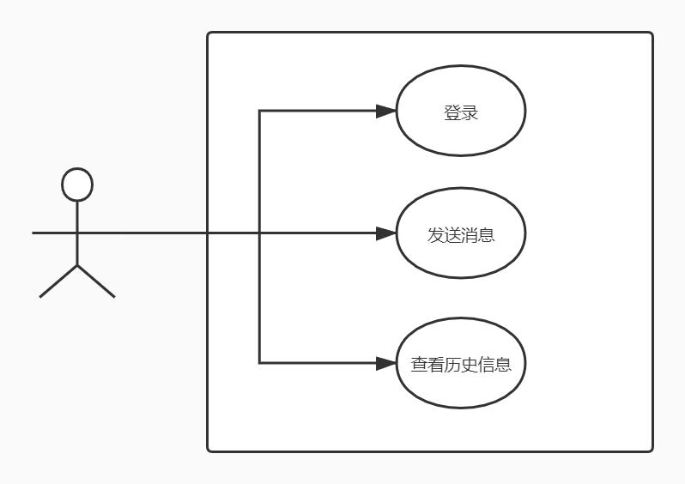

## 2.2 ER图

数据库设计2张表，用户表，用户消息历史表，对应的ER图如图3-1所示。

%3CmxGraphModel%3E%3Croot%3E%3CmxCell%20id%3D%220%22%2F%3E%3CmxCell%20id%3D%221%22%20parent%3D%220%22%2F%3E%3Cmysql.table%20entity.table.tableName%3D%22uses%22%20label%3D%22uses%22%20id%3D%222%22%3E%3CmxCell%20style%3D%22swimlane%3BfontStyle%3D0%3BchildLayout%3DstackLayout%3Bhorizontal%3D1%3Bhtml%3D1%3BstartSize%3D26%3BfillColor%3D%23b0e3e6%3BhorizontalStack%3D0%3BresizeParent%3D1%3BresizeParentMax%3D0%3BresizeLast%3D0%3Bcollapsible%3D1%3BmarginBottom%3D0%3BswimlaneFillColor%3D%23ffffff%3Balign%3Dcenter%3BfontSize%3D13%3BstrokeColor%3D%230e8088%3Brounded%3D0%3Bshadow%3D1%3Bcomic%3D0%3Bglass%3D0%3BgradientDirection%3Dsouth%3BgradientColor%3D%23ffffff%3B%22%20vertex%3D%221%22%20connectable%3D%220%22%20parent%3D%221%22%3E%3CmxGeometry%20x%3D%2260%22%20y%3D%2250%22%20width%3D%22310%22%20height%3D%22130%22%20as%3D%22geometry%22%2F%3E%3C%2FmxCell%3E%3C%2Fmysql.table%3E%3Cmysql.column%20entity.column.tableName%3D%22uses%22%20entity.column.name%3D%22userName%22%20entity.column.dataType%3D%22VARCHAR%22%20entity.column.PK%3D%22true%22%20label%3D%22%26lt%3Bimg%20title%3D%26quot%3BPrimary%20Key%26quot%3B%20src%3D%26quot%3Bimg%2Fdb%2Fkey1.png%26quot%3B%20width%3D%26quot%3B16%26quot%3B%20height%3D%26quot%3B16%26quot%3B%20align%3D%26quot%3Btop%26quot%3B%26gt%3B%26amp%3Bnbsp%3B%26lt%3Bfont%20size%3D%26quot%3B1%26quot%3B%20face%3D%26quot%3BTahoma%26quot%3B%26gt%3B%26lt%3Bspan%20style%3D%26quot%3Bfont-size%3A%2013px%26quot%3B%26gt%3B%26lt%3Bb%26gt%3Bid%20int%20primary%20key%26lt%3B%2Fb%26gt%3B%26lt%3B%2Fspan%26gt%3B%26lt%3B%2Ffont%26gt%3B%22%20entity.column.oldName%3D%22id%22%20entity.column.datalen%3D%2220%22%20entity.column.decimals%3D%22%22%20entity.column.autoIncreament%3D%22%22%20entity.column.unsigned%3D%22%22%20entity.column.bin%3D%22%22%20entity.column.ascii%3D%22%22%20entity.column.unicode%3D%22%22%20entity.column.unique%3D%22%22%20entity.column.isNotNull%3D%22NOT%20NULL%22%20entity.column.defaultValue%3D%22%22%20entity.column.comment%3D%22%22%20entity.column.enum%3D%22%22%20entity.column.set%3D%22%22%20entity.column.enumSetValue%3D%22%22%20id%3D%223%22%3E%3CmxCell%20style%3D%22text%3Bhtml%3D1%3BstrokeColor%3Dnone%3BfillColor%3Dnone%3BspacingLeft%3D4%3BspacingRight%3D4%3Boverflow%3Dhidden%3Brotatable%3D0%3BportConstraint%3Deastwest%3BfontSize%3D12%3BverticalAlign%3Dmiddle%3B%22%20vertex%3D%221%22%20parent%3D%222%22%3E%3CmxGeometry%20y%3D%2226%22%20width%3D%22310%22%20height%3D%2226%22%20as%3D%22geometry%22%2F%3E%3C%2FmxCell%3E%3C%2Fmysql.column%3E%3Cmysql.column%20entity.column.tableName%3D%22uses%22%20entity.column.name%3D%22chrName%22%20entity.column.datalen%3D%2220%22%20entity.column.dataType%3D%22VARCHAR%22%20label%3D%22%26lt%3Bimg%20title%3D%26quot%3BPrimary%20Key%26quot%3B%20src%3D%26quot%3Bimages%2Fspacer.gif%26quot%3B%20width%3D%26quot%3B16%26quot%3B%20height%3D%26quot%3B16%26quot%3B%20align%3D%26quot%3Btop%26quot%3B%26gt%3B%26amp%3Bnbsp%3B%26lt%3Bfont%20size%3D%26quot%3B1%26quot%3B%20face%3D%26quot%3BTahoma%26quot%3B%26gt%3B%26lt%3Bspan%20style%3D%26quot%3Bfont-size%3A%2013px%26quot%3B%26gt%3B%26lt%3Bb%26gt%3Bname%20varchar(10)%26lt%3B%2Fb%26gt%3B%26lt%3B%2Fspan%26gt%3B%26lt%3B%2Ffont%26gt%3B%22%20entity.column.oldName%3D%22name%22%20entity.column.decimals%3D%22%22%20entity.column.autoIncreament%3D%22%22%20entity.column.unsigned%3D%22%22%20entity.column.bin%3D%22%22%20entity.column.ascii%3D%22%22%20entity.column.unicode%3D%22%22%20entity.column.PK%3D%22false%22%20entity.column.unique%3D%22%22%20entity.column.isNotNull%3D%22%22%20entity.column.defaultValue%3D%22%22%20entity.column.comment%3D%22%22%20entity.column.enum%3D%22%22%20entity.column.set%3D%22%22%20entity.column.enumSetValue%3D%22%22%20id%3D%224%22%3E%3CmxCell%20style%3D%22text%3Bhtml%3D1%3BstrokeColor%3Dnone%3BfillColor%3Dnone%3BspacingLeft%3D4%3BspacingRight%3D4%3Boverflow%3Dhidden%3Brotatable%3D0%3BportConstraint%3Deastwest%3BfontSize%3D12%3BverticalAlign%3Dmiddle%3B%22%20vertex%3D%221%22%20parent%3D%222%22%3E%3CmxGeometry%20y%3D%2252%22%20width%3D%22310%22%20height%3D%2226%22%20as%3D%22geometry%22%2F%3E%3C%2FmxCell%3E%3C%2Fmysql.column%3E%3Cmysql.column%20entity.column.tableName%3D%22uses%22%20entity.column.name%3D%22password%22%20entity.column.datalen%3D%2250%22%20entity.column.dataType%3D%22VARCHAR%22%20label%3D%22%26lt%3Bimg%20title%3D%26quot%3BPrimary%20Key%26quot%3B%20src%3D%26quot%3Bimages%2Fspacer.gif%26quot%3B%20width%3D%26quot%3B16%26quot%3B%20height%3D%26quot%3B16%26quot%3B%20align%3D%26quot%3Btop%26quot%3B%26gt%3B%26amp%3Bnbsp%3B%26lt%3Bfont%20size%3D%26quot%3B1%26quot%3B%20face%3D%26quot%3BTahoma%26quot%3B%26gt%3B%26lt%3Bspan%20style%3D%26quot%3Bfont-size%3A%2013px%26quot%3B%26gt%3B%26lt%3Bb%26gt%3Bname%20varchar(10)%26lt%3B%2Fb%26gt%3B%26lt%3B%2Fspan%26gt%3B%26lt%3B%2Ffont%26gt%3B%22%20entity.column.oldName%3D%22chrName%22%20entity.column.decimals%3D%22%22%20entity.column.autoIncreament%3D%22%22%20entity.column.unsigned%3D%22%22%20entity.column.bin%3D%22%22%20entity.column.ascii%3D%22%22%20entity.column.unicode%3D%22%22%20entity.column.PK%3D%22false%22%20entity.column.unique%3D%22%22%20entity.column.isNotNull%3D%22%22%20entity.column.defaultValue%3D%22%22%20entity.column.comment%3D%22%E5%AF%86%E7%A0%81%22%20entity.column.enum%3D%22%22%20entity.column.set%3D%22%22%20entity.column.enumSetValue%3D%22%22%20id%3D%225%22%3E%3CmxCell%20style%3D%22text%3Bhtml%3D1%3BstrokeColor%3Dnone%3BfillColor%3Dnone%3BspacingLeft%3D4%3BspacingRight%3D4%3Boverflow%3Dhidden%3Brotatable%3D0%3BportConstraint%3Deastwest%3BfontSize%3D12%3BverticalAlign%3Dmiddle%3B%22%20vertex%3D%221%22%20parent%3D%222%22%3E%3CmxGeometry%20y%3D%2278%22%20width%3D%22310%22%20height%3D%2226%22%20as%3D%22geometry%22%2F%3E%3C%2FmxCell%3E%3C%2Fmysql.column%3E%3Cmysql.column%20entity.column.tableName%3D%22uses%22%20entity.column.name%3D%22role%22%20entity.column.datalen%3D%2220%22%20entity.column.dataType%3D%22VARCHAR%22%20label%3D%22%26lt%3Bimg%20title%3D%26quot%3BPrimary%20Key%26quot%3B%20src%3D%26quot%3Bimages%2Fspacer.gif%26quot%3B%20width%3D%26quot%3B16%26quot%3B%20height%3D%26quot%3B16%26quot%3B%20align%3D%26quot%3Btop%26quot%3B%26gt%3B%26amp%3Bnbsp%3B%26lt%3Bfont%20size%3D%26quot%3B1%26quot%3B%20face%3D%26quot%3BTahoma%26quot%3B%26gt%3B%26lt%3Bspan%20style%3D%26quot%3Bfont-size%3A%2013px%26quot%3B%26gt%3B%26lt%3Bb%26gt%3Bname%20varchar(10)%26lt%3B%2Fb%26gt%3B%26lt%3B%2Fspan%26gt%3B%26lt%3B%2Ffont%26gt%3B%22%20entity.column.oldName%3D%22chrName%22%20entity.column.decimals%3D%22%22%20entity.column.autoIncreament%3D%22%22%20entity.column.unsigned%3D%22%22%20entity.column.bin%3D%22%22%20entity.column.ascii%3D%22%22%20entity.column.unicode%3D%22%22%20entity.column.PK%3D%22false%22%20entity.column.unique%3D%22%22%20entity.column.isNotNull%3D%22%22%20entity.column.defaultValue%3D%22%22%20entity.column.comment%3D%22%E8%A7%92%E8%89%B2%22%20entity.column.enum%3D%22%22%20entity.column.set%3D%22%22%20entity.column.enumSetValue%3D%22%22%20id%3D%226%22%3E%3CmxCell%20style%3D%22text%3Bhtml%3D1%3BstrokeColor%3Dnone%3BfillColor%3Dnone%3BspacingLeft%3D4%3BspacingRight%3D4%3Boverflow%3Dhidden%3Brotatable%3D0%3BportConstraint%3Deastwest%3BfontSize%3D12%3BverticalAlign%3Dmiddle%3B%22%20vertex%3D%221%22%20parent%3D%222%22%3E%3CmxGeometry%20y%3D%22104%22%20width%3D%22310%22%20height%3D%2226%22%20as%3D%22geometry%22%2F%3E%3C%2FmxCell%3E%3C%2Fmysql.column%3E%3Cmysql.table%20entity.table.tableName%3D%22product%22%20label%3D%22product%22%20id%3D%227%22%3E%3CmxCell%20style%3D%22swimlane%3BfontStyle%3D0%3BchildLayout%3DstackLayout%3Bhorizontal%3D1%3Bhtml%3D1%3BstartSize%3D26%3BfillColor%3D%23b0e3e6%3BhorizontalStack%3D0%3BresizeParent%3D1%3BresizeParentMax%3D0%3BresizeLast%3D0%3Bcollapsible%3D1%3BmarginBottom%3D0%3BswimlaneFillColor%3D%23ffffff%3Balign%3Dcenter%3BfontSize%3D13%3BstrokeColor%3D%230e8088%3Brounded%3D0%3Bshadow%3D1%3Bcomic%3D0%3Bglass%3D0%3BgradientDirection%3Dsouth%3BgradientColor%3D%23ffffff%3B%22%20vertex%3D%221%22%20connectable%3D%220%22%20parent%3D%221%22%3E%3CmxGeometry%20x%3D%2260%22%20y%3D%22210%22%20width%3D%22310%22%20height%3D%22130%22%20as%3D%22geometry%22%2F%3E%3C%2FmxCell%3E%3C%2Fmysql.table%3E%3Cmysql.column%20entity.column.tableName%3D%22product%22%20entity.column.name%3D%22barcode%22%20entity.column.dataType%3D%22VARCHAR%22%20entity.column.PK%3D%22true%22%20label%3D%22%26lt%3Bimg%20title%3D%26quot%3BPrimary%20Key%26quot%3B%20src%3D%26quot%3Bimg%2Fdb%2Fkey1.png%26quot%3B%20width%3D%26quot%3B16%26quot%3B%20height%3D%26quot%3B16%26quot%3B%20align%3D%26quot%3Btop%26quot%3B%26gt%3B%26amp%3Bnbsp%3B%26lt%3Bfont%20size%3D%26quot%3B1%26quot%3B%20face%3D%26quot%3BTahoma%26quot%3B%26gt%3B%26lt%3Bspan%20style%3D%26quot%3Bfont-size%3A%2013px%26quot%3B%26gt%3B%26lt%3Bb%26gt%3Bid%20int%20primary%20key%26lt%3B%2Fb%26gt%3B%26lt%3B%2Fspan%26gt%3B%26lt%3B%2Ffont%26gt%3B%22%20entity.column.oldName%3D%22id%22%20entity.column.datalen%3D%2210%22%20entity.column.decimals%3D%22%22%20entity.column.autoIncreament%3D%22%22%20entity.column.unsigned%3D%22%22%20entity.column.bin%3D%22%22%20entity.column.ascii%3D%22%22%20entity.column.unicode%3D%22%22%20entity.column.unique%3D%22%22%20entity.column.isNotNull%3D%22NOT%20NULL%22%20entity.column.defaultValue%3D%22%22%20entity.column.comment%3D%22%22%20entity.column.enum%3D%22%22%20entity.column.set%3D%22%22%20entity.column.enumSetValue%3D%22%22%20id%3D%228%22%3E%3CmxCell%20style%3D%22text%3Bhtml%3D1%3BstrokeColor%3Dnone%3BfillColor%3Dnone%3BspacingLeft%3D4%3BspacingRight%3D4%3Boverflow%3Dhidden%3Brotatable%3D0%3BportConstraint%3Deastwest%3BfontSize%3D12%3BverticalAlign%3Dmiddle%3B%22%20vertex%3D%221%22%20parent%3D%227%22%3E%3CmxGeometry%20y%3D%2226%22%20width%3D%22310%22%20height%3D%2226%22%20as%3D%22geometry%22%2F%3E%3C%2FmxCell%3E%3C%2Fmysql.column%3E%3Cmysql.column%20entity.column.tableName%3D%22product%22%20entity.column.name%3D%22productName%22%20entity.column.datalen%3D%2250%22%20entity.column.dataType%3D%22VARCHAR%22%20label%3D%22%26lt%3Bimg%20title%3D%26quot%3BPrimary%20Key%26quot%3B%20src%3D%26quot%3Bimages%2Fspacer.gif%26quot%3B%20width%3D%26quot%3B16%26quot%3B%20height%3D%26quot%3B16%26quot%3B%20align%3D%26quot%3Btop%26quot%3B%26gt%3B%26amp%3Bnbsp%3B%26lt%3Bfont%20size%3D%26quot%3B1%26quot%3B%20face%3D%26quot%3BTahoma%26quot%3B%26gt%3B%26lt%3Bspan%20style%3D%26quot%3Bfont-size%3A%2013px%26quot%3B%26gt%3B%26lt%3Bb%26gt%3Bname%20varchar(10)%26lt%3B%2Fb%26gt%3B%26lt%3B%2Fspan%26gt%3B%26lt%3B%2Ffont%26gt%3B%22%20entity.column.oldName%3D%22name%22%20entity.column.decimals%3D%22%22%20entity.column.autoIncreament%3D%22%22%20entity.column.unsigned%3D%22%22%20entity.column.bin%3D%22%22%20entity.column.ascii%3D%22%22%20entity.column.unicode%3D%22%22%20entity.column.PK%3D%22false%22%20entity.column.unique%3D%22%22%20entity.column.isNotNull%3D%22%22%20entity.column.defaultValue%3D%22%22%20entity.column.comment%3D%22%22%20entity.column.enum%3D%22%22%20entity.column.set%3D%22%22%20entity.column.enumSetValue%3D%22%22%20id%3D%229%22%3E%3CmxCell%20style%3D%22text%3Bhtml%3D1%3BstrokeColor%3Dnone%3BfillColor%3Dnone%3BspacingLeft%3D4%3BspacingRight%3D4%3Boverflow%3Dhidden%3Brotatable%3D0%3BportConstraint%3Deastwest%3BfontSize%3D12%3BverticalAlign%3Dmiddle%3B%22%20vertex%3D%221%22%20parent%3D%227%22%3E%3CmxGeometry%20y%3D%2252%22%20width%3D%22310%22%20height%3D%2226%22%20as%3D%22geometry%22%2F%3E%3C%2FmxCell%3E%3C%2Fmysql.column%3E%3Cmysql.column%20entity.column.tableName%3D%22product%22%20entity.column.name%3D%22price%22%20entity.column.datalen%3D%229%22%20entity.column.dataType%3D%22DECIMAL%22%20label%3D%22%26lt%3Bimg%20title%3D%26quot%3BPrimary%20Key%26quot%3B%20src%3D%26quot%3Bimages%2Fspacer.gif%26quot%3B%20width%3D%26quot%3B16%26quot%3B%20height%3D%26quot%3B16%26quot%3B%20align%3D%26quot%3Btop%26quot%3B%26gt%3B%26amp%3Bnbsp%3B%26lt%3Bfont%20size%3D%26quot%3B1%26quot%3B%20face%3D%26quot%3BTahoma%26quot%3B%26gt%3B%26lt%3Bspan%20style%3D%26quot%3Bfont-size%3A%2013px%26quot%3B%26gt%3B%26lt%3Bb%26gt%3Bname%20varchar(10)%26lt%3B%2Fb%26gt%3B%26lt%3B%2Fspan%26gt%3B%26lt%3B%2Ffont%26gt%3B%22%20entity.column.oldName%3D%22price%22%20entity.column.decimals%3D%222%22%20entity.column.autoIncreament%3D%22%22%20entity.column.unsigned%3D%22%22%20entity.column.bin%3D%22%22%20entity.column.ascii%3D%22%22%20entity.column.unicode%3D%22%22%20entity.column.PK%3D%22false%22%20entity.column.unique%3D%22%22%20entity.column.isNotNull%3D%22%22%20entity.column.defaultValue%3D%22%22%20entity.column.comment%3D%22%22%20entity.column.enum%3D%22%22%20entity.column.set%3D%22%22%20entity.column.enumSetValue%3D%22%22%20id%3D%2210%22%3E%3CmxCell%20style%3D%22text%3Bhtml%3D1%3BstrokeColor%3Dnone%3BfillColor%3Dnone%3BspacingLeft%3D4%3BspacingRight%3D4%3Boverflow%3Dhidden%3Brotatable%3D0%3BportConstraint%3Deastwest%3BfontSize%3D12%3BverticalAlign%3Dmiddle%3B%22%20vertex%3D%221%22%20parent%3D%227%22%3E%3CmxGeometry%20y%3D%2278%22%20width%3D%22310%22%20height%3D%2226%22%20as%3D%22geometry%22%2F%3E%3C%2FmxCell%3E%3C%2Fmysql.column%3E%3Cmysql.column%20entity.column.tableName%3D%22product%22%20entity.column.name%3D%22supply%22%20entity.column.datalen%3D%2220%22%20entity.column.dataType%3D%22VARCHAR%22%20label%3D%22%26lt%3Bimg%20title%3D%26quot%3BPrimary%20Key%26quot%3B%20src%3D%26quot%3Bimages%2Fspacer.gif%26quot%3B%20width%3D%26quot%3B16%26quot%3B%20height%3D%26quot%3B16%26quot%3B%20align%3D%26quot%3Btop%26quot%3B%26gt%3B%26amp%3Bnbsp%3B%26lt%3Bfont%20size%3D%26quot%3B1%26quot%3B%20face%3D%26quot%3BTahoma%26quot%3B%26gt%3B%26lt%3Bspan%20style%3D%26quot%3Bfont-size%3A%2013px%26quot%3B%26gt%3B%26lt%3Bb%26gt%3Bname%20varchar(10)%26lt%3B%2Fb%26gt%3B%26lt%3B%2Fspan%26gt%3B%26lt%3B%2Ffont%26gt%3B%22%20entity.column.oldName%3D%22price%22%20entity.column.decimals%3D%22%22%20entity.column.autoIncreament%3D%22%22%20entity.column.unsigned%3D%22%22%20entity.column.bin%3D%22%22%20entity.column.ascii%3D%22%22%20entity.column.unicode%3D%22%22%20entity.column.PK%3D%22false%22%20entity.column.unique%3D%22%22%20entity.column.isNotNull%3D%22%22%20entity.column.defaultValue%3D%22%22%20entity.column.comment%3D%22%22%20entity.column.enum%3D%22%22%20entity.column.set%3D%22%22%20entity.column.enumSetValue%3D%22%22%20id%3D%2211%22%3E%3CmxCell%20style%3D%22text%3Bhtml%3D1%3BstrokeColor%3Dnone%3BfillColor%3Dnone%3BspacingLeft%3D4%3BspacingRight%3D4%3Boverflow%3Dhidden%3Brotatable%3D0%3BportConstraint%3Deastwest%3BfontSize%3D12%3BverticalAlign%3Dmiddle%3B%22%20vertex%3D%221%22%20parent%3D%227%22%3E%3CmxGeometry%20y%3D%22104%22%20width%3D%22310%22%20height%3D%2226%22%20as%3D%22geometry%22%2F%3E%3C%2FmxCell%3E%3C%2Fmysql.column%3E%3Cmysql.table%20entity.table.tableName%3D%22saleDetail%22%20label%3D%22saleDetail%22%20id%3D%2212%22%3E%3CmxCell%20style%3D%22swimlane%3BfontStyle%3D0%3BchildLayout%3DstackLayout%3Bhorizontal%3D1%3Bhtml%3D1%3BstartSize%3D26%3BfillColor%3D%23b0e3e6%3BhorizontalStack%3D0%3BresizeParent%3D1%3BresizeParentMax%3D0%3BresizeLast%3D0%3Bcollapsible%3D1%3BmarginBottom%3D0%3BswimlaneFillColor%3D%23ffffff%3Balign%3Dcenter%3BfontSize%3D13%3BstrokeColor%3D%230e8088%3Brounded%3D0%3Bshadow%3D1%3Bcomic%3D0%3Bglass%3D0%3BgradientDirection%3Dsouth%3BgradientColor%3D%23ffffff%3B%22%20vertex%3D%221%22%20connectable%3D%220%22%20parent%3D%221%22%3E%3CmxGeometry%20x%3D%22480%22%20y%3D%2280%22%20width%3D%22280%22%20height%3D%22208%22%20as%3D%22geometry%22%2F%3E%3C%2FmxCell%3E%3C%2Fmysql.table%3E%3Cmysql.column%20entity.column.tableName%3D%22saleDetail%22%20entity.column.name%3D%22lsh%22%20entity.column.dataType%3D%22VARCHAR%22%20entity.column.PK%3D%22true%22%20label%3D%22%26lt%3Bimg%20title%3D%26quot%3BPrimary%20Key%26quot%3B%20src%3D%26quot%3Bimg%2Fdb%2Fkey1.png%26quot%3B%20width%3D%26quot%3B16%26quot%3B%20height%3D%26quot%3B16%26quot%3B%20align%3D%26quot%3Btop%26quot%3B%26gt%3B%26amp%3Bnbsp%3B%26lt%3Bfont%20size%3D%26quot%3B1%26quot%3B%20face%3D%26quot%3BTahoma%26quot%3B%26gt%3B%26lt%3Bspan%20style%3D%26quot%3Bfont-size%3A%2013px%26quot%3B%26gt%3B%26lt%3Bb%26gt%3Bid%20int%20primary%20key%26lt%3B%2Fb%26gt%3B%26lt%3B%2Fspan%26gt%3B%26lt%3B%2Ffont%26gt%3B%22%20entity.column.oldName%3D%22id%22%20entity.column.datalen%3D%2220%22%20entity.column.decimals%3D%22%22%20entity.column.autoIncreament%3D%22%22%20entity.column.unsigned%3D%22%22%20entity.column.bin%3D%22%22%20entity.column.ascii%3D%22%22%20entity.column.unicode%3D%22%22%20entity.column.unique%3D%22%22%20entity.column.isNotNull%3D%22NOT%20NULL%22%20entity.column.defaultValue%3D%22%22%20entity.column.comment%3D%22%22%20entity.column.enum%3D%22%22%20entity.column.set%3D%22%22%20entity.column.enumSetValue%3D%22%22%20id%3D%2213%22%3E%3CmxCell%20style%3D%22text%3Bhtml%3D1%3BstrokeColor%3Dnone%3BfillColor%3Dnone%3BspacingLeft%3D4%3BspacingRight%3D4%3Boverflow%3Dhidden%3Brotatable%3D0%3BportConstraint%3Deastwest%3BfontSize%3D12%3BverticalAlign%3Dmiddle%3B%22%20vertex%3D%221%22%20parent%3D%2212%22%3E%3CmxGeometry%20y%3D%2226%22%20width%3D%22280%22%20height%3D%2226%22%20as%3D%22geometry%22%2F%3E%3C%2FmxCell%3E%3C%2Fmysql.column%3E%3Cmysql.column%20entity.column.tableName%3D%22saleDetail%22%20entity.column.name%3D%22barcode%22%20entity.column.datalen%3D%2210%22%20entity.column.dataType%3D%22VARCHAR%22%20label%3D%22%26lt%3Bimg%20title%3D%26quot%3BPrimary%20Key%26quot%3B%20src%3D%26quot%3Bimages%2Fspacer.gif%26quot%3B%20width%3D%26quot%3B16%26quot%3B%20height%3D%26quot%3B16%26quot%3B%20align%3D%26quot%3Btop%26quot%3B%26gt%3B%26amp%3Bnbsp%3B%26lt%3Bfont%20size%3D%26quot%3B1%26quot%3B%20face%3D%26quot%3BTahoma%26quot%3B%26gt%3B%26lt%3Bspan%20style%3D%26quot%3Bfont-size%3A%2013px%26quot%3B%26gt%3B%26lt%3Bb%26gt%3Bname%20varchar(10)%26lt%3B%2Fb%26gt%3B%26lt%3B%2Fspan%26gt%3B%26lt%3B%2Ffont%26gt%3B%22%20entity.column.oldName%3D%22barcode%22%20entity.column.decimals%3D%22%22%20entity.column.autoIncreament%3D%22%22%20entity.column.unsigned%3D%22%22%20entity.column.bin%3D%22%22%20entity.column.ascii%3D%22%22%20entity.column.unicode%3D%22%22%20entity.column.PK%3D%22false%22%20entity.column.unique%3D%22%22%20entity.column.isNotNull%3D%22%22%20entity.column.defaultValue%3D%22%22%20entity.column.comment%3D%22%22%20entity.column.enum%3D%22%22%20entity.column.set%3D%22%22%20entity.column.enumSetValue%3D%22%22%20id%3D%2214%22%3E%3CmxCell%20style%3D%22text%3Bhtml%3D1%3BstrokeColor%3Dnone%3BfillColor%3Dnone%3BspacingLeft%3D4%3BspacingRight%3D4%3Boverflow%3Dhidden%3Brotatable%3D0%3BportConstraint%3Deastwest%3BfontSize%3D12%3BverticalAlign%3Dmiddle%3B%22%20vertex%3D%221%22%20parent%3D%2212%22%3E%3CmxGeometry%20y%3D%2252%22%20width%3D%22280%22%20height%3D%2226%22%20as%3D%22geometry%22%2F%3E%3C%2FmxCell%3E%3C%2Fmysql.column%3E%3Cmysql.column%20entity.column.tableName%3D%22saleDetail%22%20entity.column.name%3D%22productName%22%20entity.column.datalen%3D%2250%22%20entity.column.dataType%3D%22VARCHAR%22%20label%3D%22%26lt%3Bimg%20title%3D%26quot%3BPrimary%20Key%26quot%3B%20src%3D%26quot%3Bimages%2Fspacer.gif%26quot%3B%20width%3D%26quot%3B16%26quot%3B%20height%3D%26quot%3B16%26quot%3B%20align%3D%26quot%3Btop%26quot%3B%26gt%3B%26amp%3Bnbsp%3B%26lt%3Bfont%20size%3D%26quot%3B1%26quot%3B%20face%3D%26quot%3BTahoma%26quot%3B%26gt%3B%26lt%3Bspan%20style%3D%26quot%3Bfont-size%3A%2013px%26quot%3B%26gt%3B%26lt%3Bb%26gt%3Bname%20varchar(10)%26lt%3B%2Fb%26gt%3B%26lt%3B%2Fspan%26gt%3B%26lt%3B%2Ffont%26gt%3B%22%20entity.column.oldName%3D%22productName%22%20entity.column.decimals%3D%22%22%20entity.column.autoIncreament%3D%22%22%20entity.column.unsigned%3D%22%22%20entity.column.bin%3D%22%22%20entity.column.ascii%3D%22%22%20entity.column.unicode%3D%22%22%20entity.column.PK%3D%22false%22%20entity.column.unique%3D%22%22%20entity.column.isNotNull%3D%22%22%20entity.column.defaultValue%3D%22%22%20entity.column.comment%3D%22%22%20entity.column.enum%3D%22%22%20entity.column.set%3D%22%22%20entity.column.enumSetValue%3D%22%22%20id%3D%2215%22%3E%3CmxCell%20style%3D%22text%3Bhtml%3D1%3BstrokeColor%3Dnone%3BfillColor%3Dnone%3BspacingLeft%3D4%3BspacingRight%3D4%3Boverflow%3Dhidden%3Brotatable%3D0%3BportConstraint%3Deastwest%3BfontSize%3D12%3BverticalAlign%3Dmiddle%3B%22%20vertex%3D%221%22%20parent%3D%2212%22%3E%3CmxGeometry%20y%3D%2278%22%20width%3D%22280%22%20height%3D%2226%22%20as%3D%22geometry%22%2F%3E%3C%2FmxCell%3E%3C%2Fmysql.column%3E%3Cmysql.column%20entity.column.tableName%3D%22saleDetail%22%20entity.column.name%3D%22price%22%20entity.column.datalen%3D%229%22%20entity.column.dataType%3D%22DECIMAL%22%20label%3D%22%26lt%3Bimg%20title%3D%26quot%3BPrimary%20Key%26quot%3B%20src%3D%26quot%3Bimages%2Fspacer.gif%26quot%3B%20width%3D%26quot%3B16%26quot%3B%20height%3D%26quot%3B16%26quot%3B%20align%3D%26quot%3Btop%26quot%3B%26gt%3B%26amp%3Bnbsp%3B%26lt%3Bfont%20size%3D%26quot%3B1%26quot%3B%20face%3D%26quot%3BTahoma%26quot%3B%26gt%3B%26lt%3Bspan%20style%3D%26quot%3Bfont-size%3A%2013px%26quot%3B%26gt%3B%26lt%3Bb%26gt%3Bname%20varchar(10)%26lt%3B%2Fb%26gt%3B%26lt%3B%2Fspan%26gt%3B%26lt%3B%2Ffont%26gt%3B%22%20entity.column.oldName%3D%22productName%22%20entity.column.decimals%3D%222%22%20entity.column.autoIncreament%3D%22%22%20entity.column.unsigned%3D%22%22%20entity.column.bin%3D%22%22%20entity.column.ascii%3D%22%22%20entity.column.unicode%3D%22%22%20entity.column.PK%3D%22false%22%20entity.column.unique%3D%22%22%20entity.column.isNotNull%3D%22%22%20entity.column.defaultValue%3D%22%22%20entity.column.comment%3D%22%22%20entity.column.enum%3D%22%22%20entity.column.set%3D%22%22%20entity.column.enumSetValue%3D%22%22%20id%3D%2216%22%3E%3CmxCell%20style%3D%22text%3Bhtml%3D1%3BstrokeColor%3Dnone%3BfillColor%3Dnone%3BspacingLeft%3D4%3BspacingRight%3D4%3Boverflow%3Dhidden%3Brotatable%3D0%3BportConstraint%3Deastwest%3BfontSize%3D12%3BverticalAlign%3Dmiddle%3B%22%20vertex%3D%221%22%20parent%3D%2212%22%3E%3CmxGeometry%20y%3D%22104%22%20width%3D%22280%22%20height%3D%2226%22%20as%3D%22geometry%22%2F%3E%3C%2FmxCell%3E%3C%2Fmysql.column%3E%3Cmysql.column%20entity.column.tableName%3D%22saleDetail%22%20entity.column.name%3D%22count%22%20entity.column.datalen%3D%229%22%20entity.column.dataType%3D%22INT%22%20label%3D%22%26lt%3Bimg%20title%3D%26quot%3BPrimary%20Key%26quot%3B%20src%3D%26quot%3Bimages%2Fspacer.gif%26quot%3B%20width%3D%26quot%3B16%26quot%3B%20height%3D%26quot%3B16%26quot%3B%20align%3D%26quot%3Btop%26quot%3B%26gt%3B%26amp%3Bnbsp%3B%26lt%3Bfont%20size%3D%26quot%3B1%26quot%3B%20face%3D%26quot%3BTahoma%26quot%3B%26gt%3B%26lt%3Bspan%20style%3D%26quot%3Bfont-size%3A%2013px%26quot%3B%26gt%3B%26lt%3Bb%26gt%3Bname%20varchar(10)%26lt%3B%2Fb%26gt%3B%26lt%3B%2Fspan%26gt%3B%26lt%3B%2Ffont%26gt%3B%22%20entity.column.oldName%3D%22price%22%20entity.column.decimals%3D%22%22%20entity.column.autoIncreament%3D%22%22%20entity.column.unsigned%3D%22%22%20entity.column.bin%3D%22%22%20entity.column.ascii%3D%22%22%20entity.column.unicode%3D%22%22%20entity.column.PK%3D%22false%22%20entity.column.unique%3D%22%22%20entity.column.isNotNull%3D%22%22%20entity.column.defaultValue%3D%22%22%20entity.column.comment%3D%22%22%20entity.column.enum%3D%22%22%20entity.column.set%3D%22%22%20entity.column.enumSetValue%3D%22%22%20id%3D%2217%22%3E%3CmxCell%20style%3D%22text%3Bhtml%3D1%3BstrokeColor%3Dnone%3BfillColor%3Dnone%3BspacingLeft%3D4%3BspacingRight%3D4%3Boverflow%3Dhidden%3Brotatable%3D0%3BportConstraint%3Deastwest%3BfontSize%3D12%3BverticalAlign%3Dmiddle%3B%22%20vertex%3D%221%22%20parent%3D%2212%22%3E%3CmxGeometry%20y%3D%22130%22%20width%3D%22280%22%20height%3D%2226%22%20as%3D%22geometry%22%2F%3E%3C%2FmxCell%3E%3C%2Fmysql.column%3E%3Cmysql.column%20entity.column.tableName%3D%22saleDetail%22%20entity.column.name%3D%22operator%22%20entity.column.datalen%3D%2220%22%20entity.column.dataType%3D%22VARCHAR%22%20label%3D%22%26lt%3Bimg%20title%3D%26quot%3BPrimary%20Key%26quot%3B%20src%3D%26quot%3Bimages%2Fspacer.gif%26quot%3B%20width%3D%26quot%3B16%26quot%3B%20height%3D%26quot%3B16%26quot%3B%20align%3D%26quot%3Btop%26quot%3B%26gt%3B%26amp%3Bnbsp%3B%26lt%3Bfont%20size%3D%26quot%3B1%26quot%3B%20face%3D%26quot%3BTahoma%26quot%3B%26gt%3B%26lt%3Bspan%20style%3D%26quot%3Bfont-size%3A%2013px%26quot%3B%26gt%3B%26lt%3Bb%26gt%3Bname%20varchar(10)%26lt%3B%2Fb%26gt%3B%26lt%3B%2Fspan%26gt%3B%26lt%3B%2Ffont%26gt%3B%22%20entity.column.oldName%3D%22count%22%20entity.column.decimals%3D%22%22%20entity.column.autoIncreament%3D%22%22%20entity.column.unsigned%3D%22%22%20entity.column.bin%3D%22%22%20entity.column.ascii%3D%22%22%20entity.column.unicode%3D%22%22%20entity.column.PK%3D%22false%22%20entity.column.unique%3D%22%22%20entity.column.isNotNull%3D%22%22%20entity.column.defaultValue%3D%22%22%20entity.column.comment%3D%22%22%20entity.column.enum%3D%22%22%20entity.column.set%3D%22%22%20entity.column.enumSetValue%3D%22%22%20id%3D%2218%22%3E%3CmxCell%20style%3D%22text%3Bhtml%3D1%3BstrokeColor%3Dnone%3BfillColor%3Dnone%3BspacingLeft%3D4%3BspacingRight%3D4%3Boverflow%3Dhidden%3Brotatable%3D0%3BportConstraint%3Deastwest%3BfontSize%3D12%3BverticalAlign%3Dmiddle%3B%22%20vertex%3D%221%22%20parent%3D%2212%22%3E%3CmxGeometry%20y%3D%22156%22%20width%3D%22280%22%20height%3D%2226%22%20as%3D%22geometry%22%2F%3E%3C%2FmxCell%3E%3C%2Fmysql.column%3E%3Cmysql.column%20entity.column.tableName%3D%22saleDetail%22%20entity.column.name%3D%22saleTime%22%20entity.column.datalen%3D%22%22%20entity.column.dataType%3D%22DATETIME%22%20label%3D%22%26lt%3Bimg%20title%3D%26quot%3BPrimary%20Key%26quot%3B%20src%3D%26quot%3Bimages%2Fspacer.gif%26quot%3B%20width%3D%26quot%3B16%26quot%3B%20height%3D%26quot%3B16%26quot%3B%20align%3D%26quot%3Btop%26quot%3B%26gt%3B%26amp%3Bnbsp%3B%26lt%3Bfont%20size%3D%26quot%3B1%26quot%3B%20face%3D%26quot%3BTahoma%26quot%3B%26gt%3B%26lt%3Bspan%20style%3D%26quot%3Bfont-size%3A%2013px%26quot%3B%26gt%3B%26lt%3Bb%26gt%3Bname%20varchar(10)%26lt%3B%2Fb%26gt%3B%26lt%3B%2Fspan%26gt%3B%26lt%3B%2Ffont%26gt%3B%22%20entity.column.oldName%3D%22count%22%20entity.column.decimals%3D%22%22%20entity.column.autoIncreament%3D%22%22%20entity.column.unsigned%3D%22%22%20entity.column.bin%3D%22%22%20entity.column.ascii%3D%22%22%20entity.column.unicode%3D%22%22%20entity.column.PK%3D%22false%22%20entity.column.unique%3D%22%22%20entity.column.isNotNull%3D%22%22%20entity.column.defaultValue%3D%22%22%20entity.column.comment%3D%22%22%20entity.column.enum%3D%22%22%20entity.column.set%3D%22%22%20entity.column.enumSetValue%3D%22%22%20id%3D%2219%22%3E%3CmxCell%20style%3D%22text%3Bhtml%3D1%3BstrokeColor%3Dnone%3BfillColor%3Dnone%3BspacingLeft%3D4%3BspacingRight%3D4%3Boverflow%3Dhidden%3Brotatable%3D0%3BportConstraint%3Deastwest%3BfontSize%3D12%3BverticalAlign%3Dmiddle%3B%22%20vertex%3D%221%22%20parent%3D%2212%22%3E%3CmxGeometry%20y%3D%22182%22%20width%3D%22280%22%20height%3D%2226%22%20as%3D%22geometry%22%2F%3E%3C%2FmxCell%3E%3C%2Fmysql.column%3E%3CmxCell%20id%3D%2220%22%20value%3D%221..n%22%20style%3D%22edgeStyle%3DentityRelationEdgeStyle%3BfontSize%3D12%3Bhtml%3D1%3BendArrow%3DERoneToMany%3BstrokeWidth%3D2%3BstrokeColor%3D%236c8ebf%3BexitX%3D1%3BexitY%3D0.25%3BentryX%3D0%3BentryY%3D0.5%3B%22%20edge%3D%221%22%20source%3D%224%22%20target%3D%2214%22%20parent%3D%221%22%3E%3CmxGeometry%20relative%3D%221%22%20as%3D%22geometry%22%2F%3E%3C%2FmxCell%3E%3CmxCell%20id%3D%2221%22%20value%3D%221..n%22%20style%3D%22edgeStyle%3DentityRelationEdgeStyle%3BfontSize%3D12%3Bhtml%3D1%3BendArrow%3DERoneToMany%3BstrokeWidth%3D2%3BstrokeColor%3D%236c8ebf%3BexitX%3D1%3BexitY%3D0.5%3BentryX%3D0%3BentryY%3D0.5%3B%22%20edge%3D%221%22%20source%3D%228%22%20target%3D%2216%22%20parent%3D%221%22%3E%3CmxGeometry%20relative%3D%221%22%20as%3D%22geometry%22%2F%3E%3C%2FmxCell%3E%3C%2Froot%3E%3C%2FmxGraphModel%3E

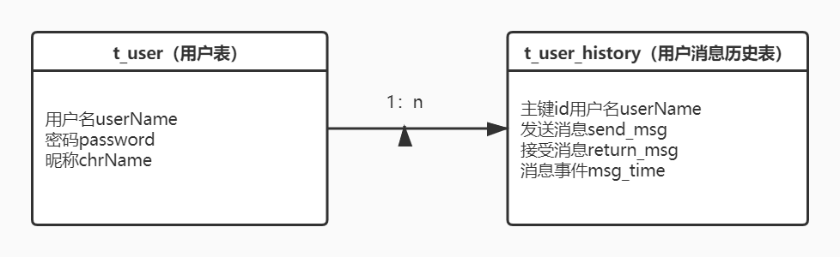

图3-1 数据库ER图

## 2.4 UML时序图（Sequence Diagram）

### 2.4.1 系统登录时序图

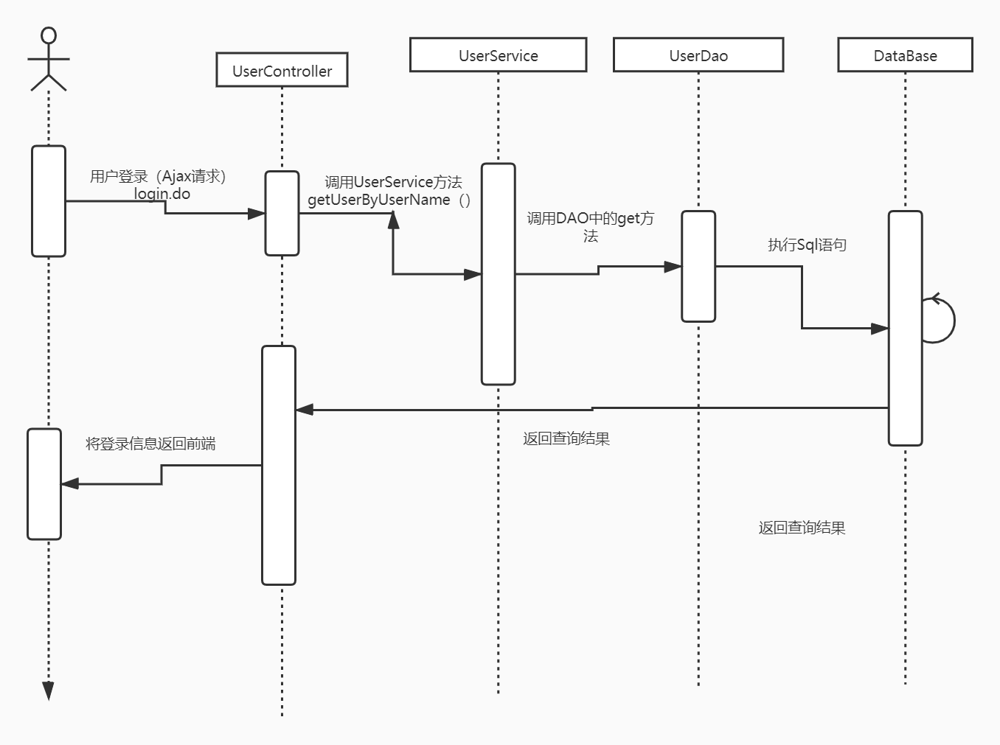

## 2.5 UML活动图（Activity Diagram）

### 2.5.1 登陆

登录操作需要验证用户名，密码，只有当用户名和密码同时存在即用户存在的情况下才能成功登录系统，否则会提示错误信息，具体流程如图2-6所示。

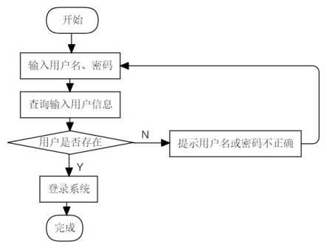

# **3 系统实现**

## 3.1 项目结构-后端服务器部分

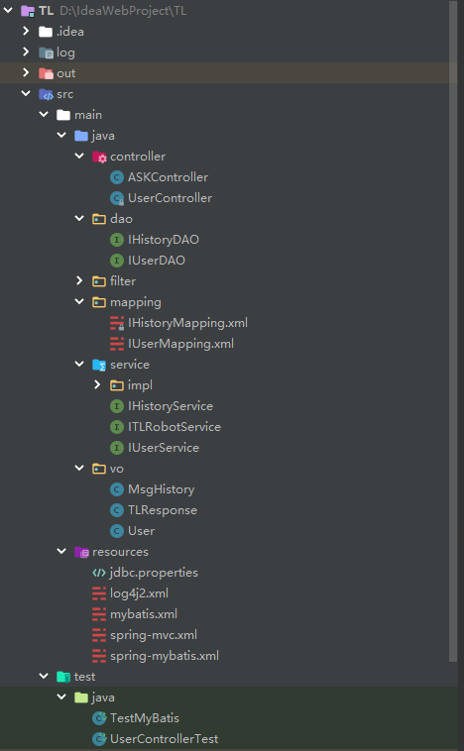

## 3.2 项目结构-前端页面部分

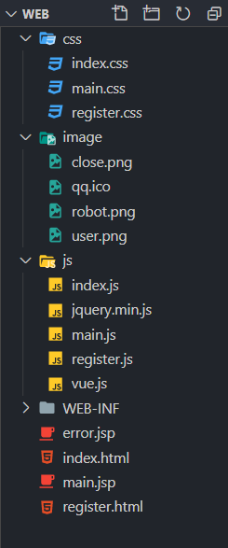

## 3.2 配置文件

在项目下新建Source Folder，名为resources

### 3.2.1 jdbc.properties文件

该配置文件主要是以文件形式保存数据库的驱动类名称，连接数据库的URL地址，访问数据库的用户名及对应的密码，数据路连接池配置信息，程序运行时会读取该文件相关信息，避免硬编码，当相关信息发生变化时，只需修改配置文件而不用修改源代码，增加程序的可扩展型。

### 

### 3.2.2 log4j2.xml文件

描述该文件作用，并对里面的配置进行解释

### 3.2.3 mybatis.xml文件

描述该文件作用，并对里面的配置进行解释

## 

## 3.2.4 sping-mvc.xml文件

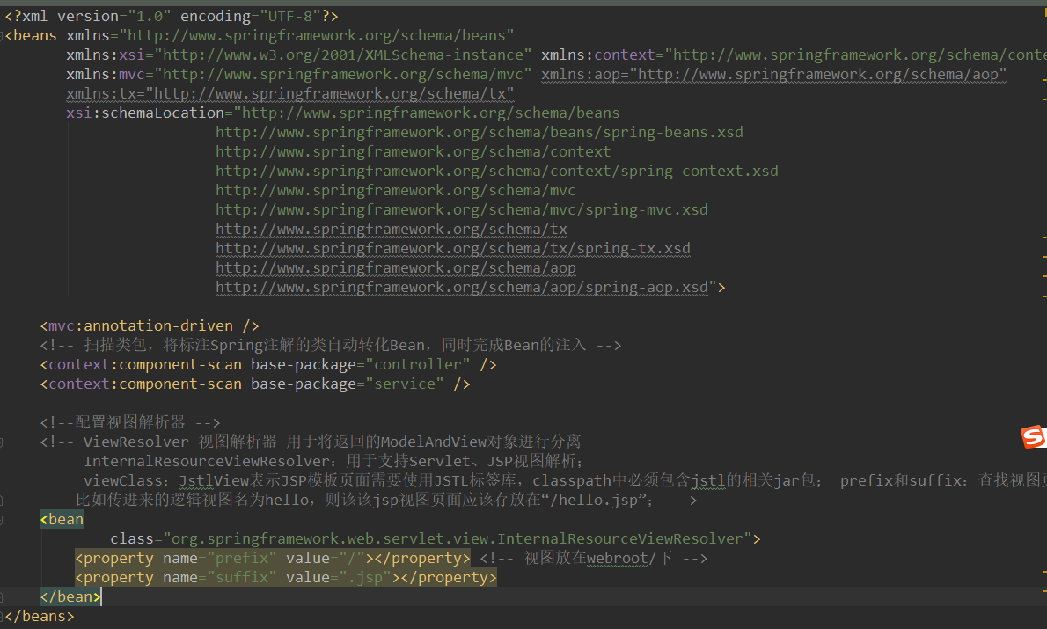

## 3.2.4 spring-mybatis.xml文件

该配置文件是描述spring和mybatis整合部分的配置其中包括jdbc配置问价的引入，数据库连接池的配置

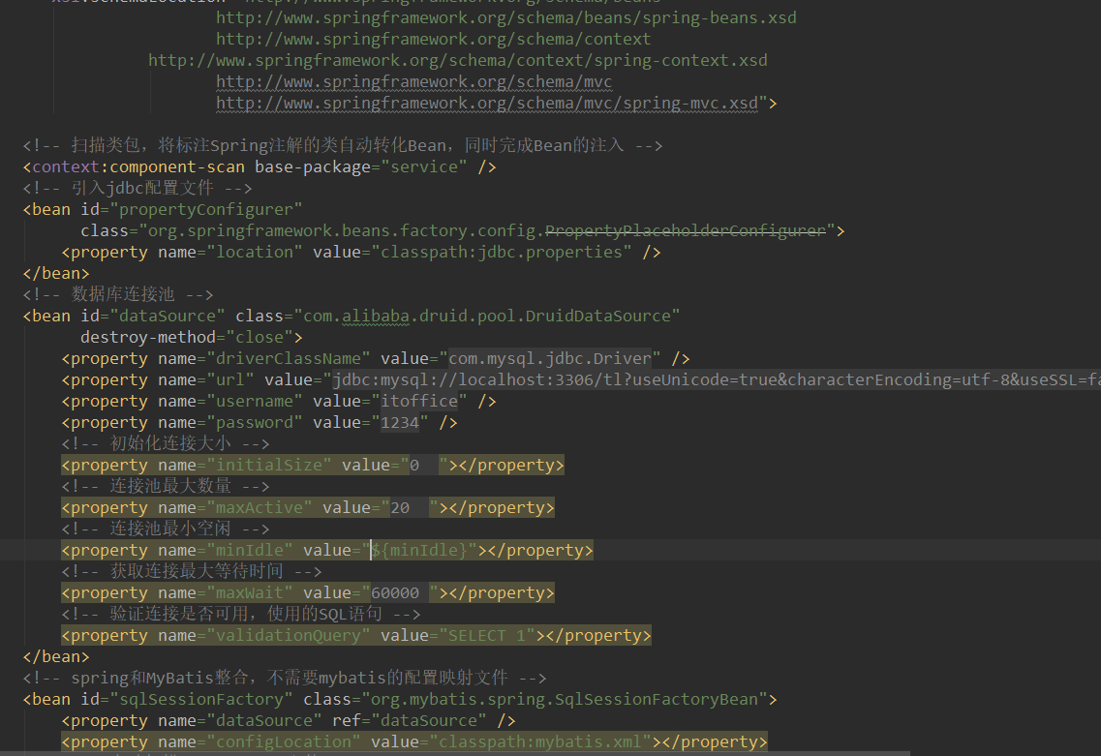

## 3.3 VO类User.java

package vo;  
  
public class User {  
 private String userName;  
 private String password;  
 private String chrName;  
  
 public User() {  
 }  
  
 public User(String userName,String password){  
 this.userName = userName;  
 this.password = password;  
 }  
  
 public User(String userName, String password, String chrName) {  
 this.userName = userName;  
 this.password = password;  
 this.chrName = chrName;  
 }  
  
 public String getUserName() {  
 return userName;  
 }  
  
 public void setUserName(String userName) {  
 this.userName = userName;  
 }  
  
 public String getPassword() {  
 return password;  
 }  
  
 public void setPassword(String password) {  
 this.password = password;  
 }  
  
 public String getChrName() {  
 return chrName;  
 }  
  
 public void setChrName(String chrName) {  
 this.chrName = chrName;  
 }  
  
 @Override  
 public String toString() {  
 return "User{" +  
 "userName='" + userName + '\'' +  
 ", password='" + password + '\'' +  
 ", chrName='" + chrName + '\'' +  
 '}';  
 }  
}

## 3.4 DAO接口类IUserDAO.java

package dao;  
  
import org.apache.ibatis.annotations.Param;  
import vo.User;  
  
import java.util.Date;  
  
public interface IUserDAO {  
 User get(@Param("userName") String userName);  
  
 void add(@Param("userName") String userName,@Param("password") String password,@Param("chrName") String chrName);  
}

## 3.5 接口映射文件UserMapper.xml

描述该文件作用，并对里面的关键信息进行解释

<?xml version="1.0" encoding="UTF-8"?>  
<!DOCTYPE mapper  
 PUBLIC "-//mybatis.org//DTD Mapper 3.0//EN"  
 "http://mybatis.org/dtd/mybatis-3-mapper.dtd">  
<mapper namespace="dao.IUserDAO">  
 <insert id="add">  
 insert into t_user (userName, password, chrName) values (#{userName}, #{password},#{chrName})  
 </insert>  
 <select id="get" parameterType="String" resultType="vo.User">  
 select * from t_user where userName = #{userName}  
 </select>  
  
</mapper>

## 3.6 工具包Util

### 3.6.1 TestMyBatis.java

import org.apache.logging.log4j.LogManager;  
import org.apache.logging.log4j.Logger;  
import org.junit.Test;  
import org.junit.runner.RunWith;  
import org.springframework.beans.factory.annotation.Autowired;  
import org.springframework.test.context.ContextConfiguration;  
import org.springframework.test.context.junit4.SpringJUnit4ClassRunner;  
import service.IHistoryService;  
import service.IUserService;  
import vo.User;  
  
import java.util.Date;  
  
@RunWith(SpringJUnit4ClassRunner.class)  
@ContextConfiguration(locations = {"classpath:spring-mybatis.xml"})  
public class TestMyBatis {  
 private static Logger *log* = LogManager.*getLogger*(Test.class.getName());  
  
 @Autowired  
 private IUserService userService;  
 @Autowired  
 private IHistoryService historyService;  
  
 @Test  
 public void test01(){  
 System.*out*.println(*log*.getName());  
 *log*.info("查询结果："+userService.getUserByUserName("ccc"));  
 }  
  
 @Test  
 public void test02(){  
 User user = new User("ccc","ccc");  
// userService.saveHistory(user,"asdasdasd","asdasdasdasd",new Date());  
 }  
  
 @Test  
 public void test03(){  
 User user = new User("ccc","ccc");  
 historyService.saveHistory(user,"你是谁","我是小傻子",new Date().toString());  
 }  
  
  
 @Test  
 public void test04(){  
  
 User user = new User("ccc","ccc");  
 System.*out*.println(historyService.getHistory(user));  
 }  
  
 @Test  
 public void test05(){  
 User user = new User("ccc","ccc","Ccc");  
 boolean success = userService.register(user);  
 System.*out*.println(success);  
 }  
  
  
  
}

## 3.7 服务层UserService.java

描述该文件作用，并对里面的关键代码进行解释

package service;  
  
import vo.User;  
  
import java.util.Date;  
  
public interface IUserService {  
 User getUserByUserName(String userName);  
  
 User checkLogin(User user);  
  
 boolean register(User user);  
  
}

## 3.8 服务层MsgHistory.java

package vo;  
  
import java.util.Date;  
  
public class MsgHistory {  
 private String userName;  
 private String send_msg;  
 private String return_msg;  
 private String msg_time;  
  
 public MsgHistory(String userName, String send_msg, String return_msg, String msg_time) {  
 this.userName = userName;  
 this.send_msg = send_msg;  
 this.return_msg = return_msg;  
 this.msg_time = msg_time;  
 }  
  
 public String getMsg_time() {  
 return msg_time;  
 }  
  
 public void setMsg_time(String msg_time) {  
 this.msg_time = msg_time;  
 }  
  
 public MsgHistory() {  
 }  
  
 public String getUserName() {  
 return userName;  
 }  
  
 public void setUserName(String userName) {  
 this.userName = userName;  
 }  
  
 public String getSend_msg() {  
 return send_msg;  
 }  
  
 public void setSend_msg(String send_msg) {  
 this.send_msg = send_msg;  
 }  
  
 public String getReturn_msg() {  
 return return_msg;  
 }  
  
 public void setReturn_msg(String return_msg) {  
 this.return_msg = return_msg;  
 }  
  
 @Override  
 public String toString() {  
 return "MsgHistory{" +  
 "userName='" + userName + '\'' +  
 ", send_msg='" + send_msg + '\'' +  
 ", return_msg='" + return_msg + '\'' +  
 ", msg_time=" + msg_time +  
 '}';  
 }  
}

## 3.9 服务层IHistoryDao.java

package dao;  
  
import org.apache.ibatis.annotations.Param;  
import vo.MsgHistory;  
  
import java.util.ArrayList;  
import java.util.Date;  
  
public interface IHistoryDAO {  
 void save_history(@Param("userName") String userName,  
 @Param("send_msg") String send_msg,  
 @Param("return_msg") String return_msg,  
 @Param("msg_time") String msg_time);  
  
  
 ArrayList<MsgHistory> get_history(@Param("userName") String userName);  
  
}

## 3.10 服务层HistoryMapping.java

<?xml version="1.0" encoding="UTF-8" ?>  
<!DOCTYPE mapper PUBLIC "-//mybatis.org//DTD Mapper 3.0//EN" "http://mybatis.org/dtd/mybatis-3-mapper.dtd" >  
<mapper namespace="dao.IHistoryDAO">  
 <insert id="save_history">  
 insert into t_user_history (userName, send_msg, return_msg, msg_time) VALUES (#{userName},#{send_msg},#{return_msg},#{msg_time})  
 </insert>  
 <select id="get_history" resultType="vo.MsgHistory">  
 select * from t_user_history where userName = #{userName}  
 </select>  
</mapper>

## 3.11 服务层IHistoryService.java

package service;  
  
import vo.MsgHistory;  
import vo.User;  
  
import java.util.ArrayList;  
import java.util.Date;  
  
public interface IHistoryService {  
  
 void saveHistory(User user, String sendMsg, String returnMsg, String date);  
  
 ArrayList<MsgHistory> getHistory(User user);  
}

## 3.12 服务层AskController.java

package controller;  
  
import org.springframework.beans.factory.annotation.Autowired;  
import org.springframework.stereotype.Controller;  
import org.springframework.web.bind.annotation.RequestMapping;  
import org.springframework.web.bind.annotation.RequestMethod;  
import org.springframework.web.bind.annotation.ResponseBody;  
import service.IHistoryService;  
import service.ITLRobotService;  
import service.IUserService;  
import vo.MsgHistory;  
import vo.TLResponse;  
import vo.User;  
  
import javax.servlet.http.HttpSession;  
import java.io.IOException;  
import java.util.ArrayList;  
import java.util.Date;  
import java.util.HashMap;  
import java.util.Map;  
  
@Controller  
public class ASKController {  
  
 @Autowired  
 private ITLRobotService itlRobotService;  
 @Autowired  
 private IHistoryService iHistoryService;  
 @Autowired  
 private IUserService userService;  
  
 @RequestMapping(value = "/ask.do",method = RequestMethod.*POST*)  
 @ResponseBody  
 public Map<String,Object> askQuestion(String question, HttpSession session){  
 Map<String,Object> map = new HashMap<String, Object>();  
 String answer = null;  
 try {  
 answer = itlRobotService.askQuestion(question);  
 } catch (IOException e) {  
 e.printStackTrace();  
 }  
 TLResponse tlResponse = new TLResponse(answer);  
 String answerText = tlResponse.getText();  
  
 if(answer != null){  
 //将记录保存  
 User user = (User) session.getAttribute("User");  
 iHistoryService.saveHistory(user,question,answerText,new Date().toString());  
 map.put("code",0);  
 map.put("msg","请求成功");  
 map.put("answer",answerText);  
 }else{  
 map.put("code",-1);  
 map.put("msg","请求失败");  
 }  
 return map;  
 }  
  
 @RequestMapping(value = "/getHistory.do",method = RequestMethod.*POST*)  
 @ResponseBody  
 public ArrayList<MsgHistory> getHistory(HttpSession session){  
 User user = (User) session.getAttribute("User");  
 return iHistoryService.getHistory(user);  
 }  
  
}

# **4 系统测试**

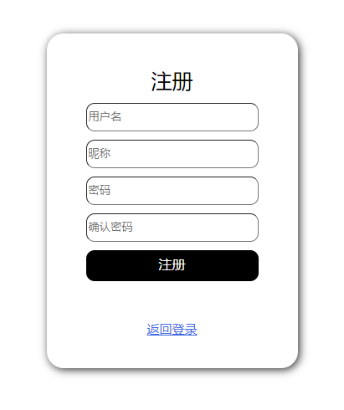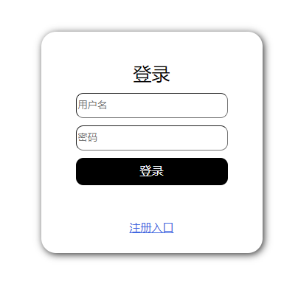

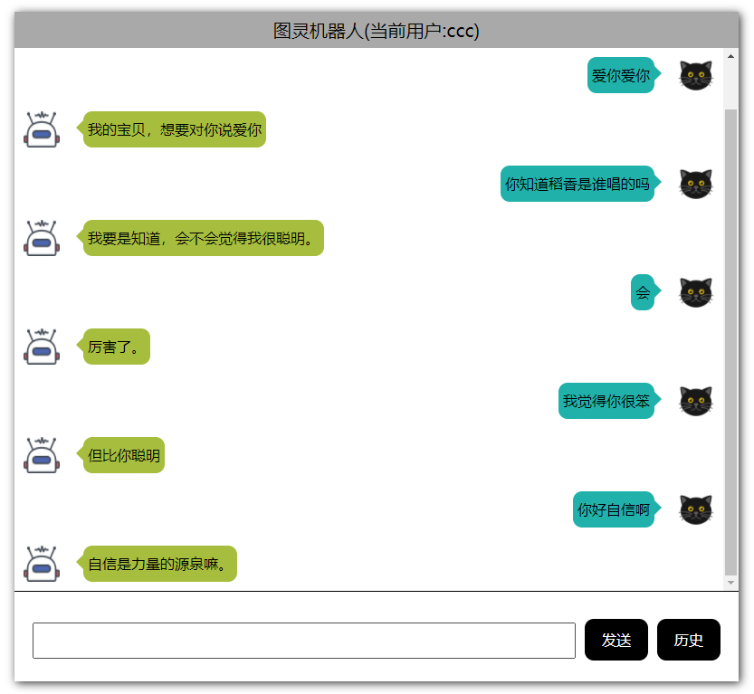

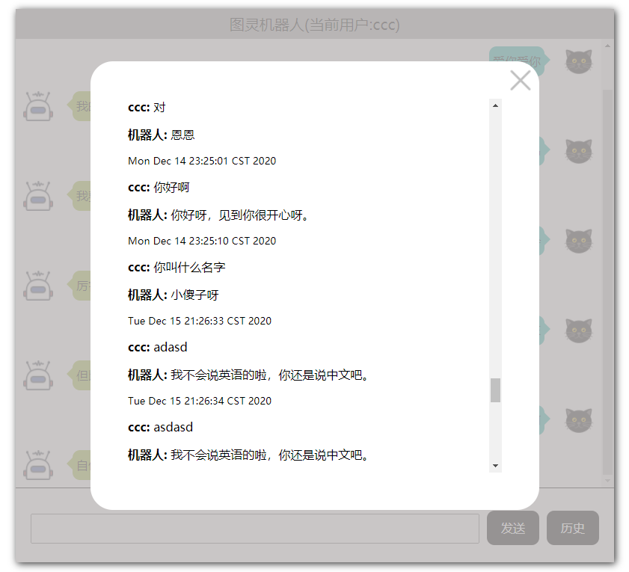

# **5 系统总结**

**开发中遇到的问题和解决方法：**

本程序主要需要解决的问题是前端聊天信息页面的显示，后端图灵机器人的调用方法。在显示聊天信息的页面中，我通过设置float来显示区分用户和机器人头像和消息的显示方向，并动态的设置每条消息所存在的div的高度来适应每条消息的长度，若一条消息的长度超过一定的限额，程序会将div的高度翻倍来适应此消息。另外，当用户点击查看历史消息的时候，展示出来的窗口中显示的历史信息是通过Vue的数据绑定和循环遍历来实现的，通过这种使用，我更加熟悉自己对前端的一些框架的使用，比如jQuery，Vue之类的框架。

在后端服务器中通过图灵机器人官网给出的请求连接加上userid和apikey这样一种get方式来请求图灵机器人服务器，将图灵机器人返回的信息用缓冲流来读取保存到StringBuffer中，然后通过提前写好的vo类TLResponse来解析图灵机器人返回的数据，从而取出我们需要的信息，然后发送给前端。

**本门课程的收获：**

本门课程让我学到的知识很多，在学本门课程之前，我仅仅只会简单的Java语言开发,比如写一个控制台程序，通过本门课程，我已经可以完整的做一个简单的网页应用程序，我认为这是一个学习维度的扩大，让自己慢慢去靠近一个企业级开发程序员所必须具备的能力。具体学习到的知识包括但不限于Web前端HTML，CSS，JavaScript，JQuery，Vue,，Bootstrap,Web后端学习到的包括Tomcat服务器的使用，Servlet，Filter，Listener，以及一些后盾框架，比如Mybatis，SpringMVC,SSM以及一些开发工具的使用，比如Maven仓库，JUnit单元测试等等。

**课程的建议：**

我认为这个课程没有存在问题，老师的教学方法和内容都是精心挑选，并认真的做出学习文档供学生学习，对于我这样课上学习能力较弱的学生也能将本门课程学习的相对较好。这也是为什么在学习了聂老师的Java语言课程之后还愿意选聂老师的JavaWeb的很大一部分的原因。

**以后的发展方向：**

会继续学习Java后端，学习使用一些新的框架，比如Spring Boot，Spring Cloud之类的框架，并多做一些实践程序，才提高自己的实战开发能力和整体设计程序的能力。

**自评成绩：**100