武汉纺织大学

Java应用开发课程设计

**简单在线考试系统**

**学 院： 数学与计算机学院**

**班 级： 软件11802班**

**姓 名： 陈为**

**学 号： 1802220130**

**指导老师： 聂刚**

**成 绩：**

**完成日期： 2020年6月19日**

目 录

[1 需求分析 1](#_Toc2965)

[1.1用户登陆 1](#_Toc6465)

[1.2主菜单 1](#_Toc27274)

[1.3各项功能 1](#_Toc17655)

[1.3.1 增加题目 1](#_Toc21322)

[1.3.2 修改题目 1](#_Toc30258)

[1.3.3 删除题目 2](#_Toc28610)

[1.3.4 修改题目 2](#_Toc14439)

[1.3.5 数据导出 3](#_Toc27115)

[1.3.6 退出 3](#_Toc28851)

[2 系统设计 3](#_Toc15323)

[2.1用户用例图 3](#_Toc21899)

[2.2 ER图 4](#_Toc16671)

[2.3 UML类图（Class Diagram） 4](#_Toc1640)

[2.4 UML时序图（Sequence Diagram） 6](#_Toc18606)

[2.4.1 系统登录 6](#_Toc3306)

[2.4.2 功能选择模块 6](#_Toc6852)

[2.4.3 答题模块 6](#_Toc11897)

[2.5 UML活动图（Activity Diagram） 6](#_Toc5309)

[2.5.1 登陆 6](#_Toc12858)

[2.5.1 功能选择 7](#_Toc2967)

[2.5.3 考试模块 8](#_Toc16882)

[2.5.4 信息查询模块 8](#_Toc4032)

[3 系统实现 9](#_Toc27433)

[3.1 项目结构 9](#_Toc1061)

[3.2 配置文件 9](#_Toc2679)

[3.2.1 jdbc.properties文件 9](#_Toc19162)

[3.2.2 log4j.properties文件 9](#_Toc31259)

[3.2.3 mybatis-config.xml文件 10](#_Toc7117)

[3.3 VO类User.java 10](#_Toc26179)

[3.4 DAO接口类IUserDAO.java 11](#_Toc32366)

[3.5 接口映射文件UserMapper.xml 11](#_Toc31927)

[3.6 工具包Util 11](#_Toc25901)

[3.6.1 MybatisUtils.java 11](#_Toc6856)

[3.6.2 MD5Util.java 12](#_Toc8757)

[3.7 服务层UserService.java 13](#_Toc29606)

[3.8 用户界面Login.java 14](#_Toc26330)

[4 系统测试 14](#_Toc19341)

[5 系统总结 14](#_Toc30615)

# 1 需求分析

设计一个简单考试系统，实现“登陆”、“答题”等功能，具体要求如下：

## 1.1用户登陆

当程序运行时，显示“欢迎进入考试系统，请输入用户名”，提示用户依次输入用户名及其密码，当用户名及密码不正确时，显示提示信息“用户名或密码不正确，请重新输入”.

## 1.2主菜单

当用户名及密码正确时，识别该用户身份，若是老师则界面如下：

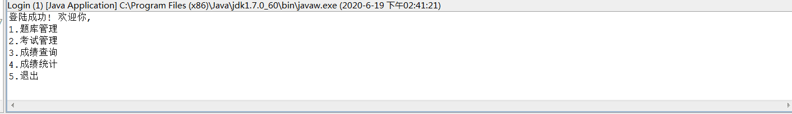

学生身份如下:



## 1.3各项功能

### 1.3.1 题库管理

当选择1时，显示如下子菜单。

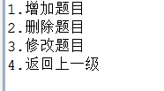

当选择1时，系统将提示你依次输入题目,选项,正确答案等数据,之后通过jdbc将新增加的题目写入题库表里.

当选择2时,系统将提示你输入要删除的题目号,然后系统删除数据库中该题号的题目.

当选择3时,系统将提示你输入需要修改的题目的题号,然后修改数据库中该题号的题目信息.

### 1.3.2 试卷管理

当选择2时,系统会提示你输入考试开始的时间,以及一份考卷的题目数量.

### 1.3.3 成绩查询

当选择3时，系统会将数据库中所有学生的成绩打印出来,以供查询.

### 1.3.4 成绩统计

当选择4时，系统将对数据库中的学生成绩进行统计,然后打印出最高分,最低分的学生成绩,以及平均分给老师参考.

### 1.3.5 退出

当选择5时，显示欢迎下次使用,并退出程序.

### 1.3.6 答题

当登陆身份是学生时,系统会提示考试时间,题目数量,并提醒你开始答题,当学生答完题时,系统会自动提交,并给出成绩,然后储存到后台数据库里.

# **2 系统设计**

## 2.1用户用例图

系统分为收银员，管理员两个角色，各角色的用户用例如下图2-1所示：

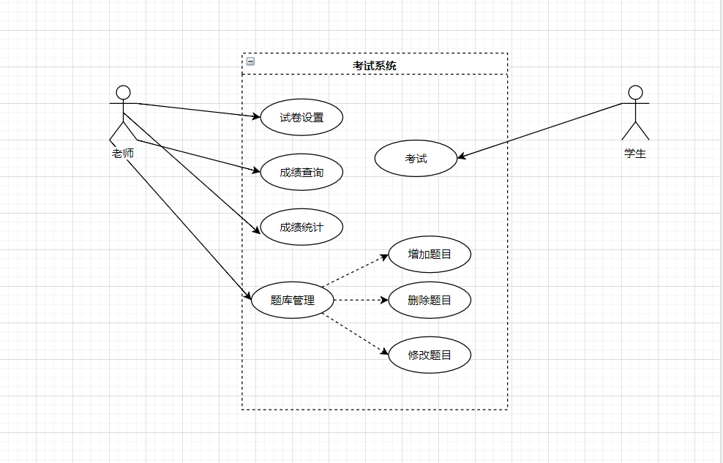

图2-1 用户用例图

## 2.2 ER图

数据库设计3张表，用户表，商品表，销售记录表，对应的ER图如图3-1所示。

%3CmxGraphModel%3E%3Croot%3E%3CmxCell%20id%3D%220%22%2F%3E%3CmxCell%20id%3D%221%22%20parent%3D%220%22%2F%3E%3Cmysql.table%20entity.table.tableName%3D%22uses%22%20label%3D%22uses%22%20id%3D%222%22%3E%3CmxCell%20style%3D%22swimlane%3BfontStyle%3D0%3BchildLayout%3DstackLayout%3Bhorizontal%3D1%3Bhtml%3D1%3BstartSize%3D26%3BfillColor%3D%23b0e3e6%3BhorizontalStack%3D0%3BresizeParent%3D1%3BresizeParentMax%3D0%3BresizeLast%3D0%3Bcollapsible%3D1%3BmarginBottom%3D0%3BswimlaneFillColor%3D%23ffffff%3Balign%3Dcenter%3BfontSize%3D13%3BstrokeColor%3D%230e8088%3Brounded%3D0%3Bshadow%3D1%3Bcomic%3D0%3Bglass%3D0%3BgradientDirection%3Dsouth%3BgradientColor%3D%23ffffff%3B%22%20vertex%3D%221%22%20connectable%3D%220%22%20parent%3D%221%22%3E%3CmxGeometry%20x%3D%2260%22%20y%3D%2250%22%20width%3D%22310%22%20height%3D%22130%22%20as%3D%22geometry%22%2F%3E%3C%2FmxCell%3E%3C%2Fmysql.table%3E%3Cmysql.column%20entity.column.tableName%3D%22uses%22%20entity.column.name%3D%22userName%22%20entity.column.dataType%3D%22VARCHAR%22%20entity.column.PK%3D%22true%22%20label%3D%22%26lt%3Bimg%20title%3D%26quot%3BPrimary%20Key%26quot%3B%20src%3D%26quot%3Bimg%2Fdb%2Fkey1.png%26quot%3B%20width%3D%26quot%3B16%26quot%3B%20height%3D%26quot%3B16%26quot%3B%20align%3D%26quot%3Btop%26quot%3B%26gt%3B%26amp%3Bnbsp%3B%26lt%3Bfont%20size%3D%26quot%3B1%26quot%3B%20face%3D%26quot%3BTahoma%26quot%3B%26gt%3B%26lt%3Bspan%20style%3D%26quot%3Bfont-size%3A%2013px%26quot%3B%26gt%3B%26lt%3Bb%26gt%3Bid%20int%20primary%20key%26lt%3B%2Fb%26gt%3B%26lt%3B%2Fspan%26gt%3B%26lt%3B%2Ffont%26gt%3B%22%20entity.column.oldName%3D%22id%22%20entity.column.datalen%3D%2220%22%20entity.column.decimals%3D%22%22%20entity.column.autoIncreament%3D%22%22%20entity.column.unsigned%3D%22%22%20entity.column.bin%3D%22%22%20entity.column.ascii%3D%22%22%20entity.column.unicode%3D%22%22%20entity.column.unique%3D%22%22%20entity.column.isNotNull%3D%22NOT%20NULL%22%20entity.column.defaultValue%3D%22%22%20entity.column.comment%3D%22%22%20entity.column.enum%3D%22%22%20entity.column.set%3D%22%22%20entity.column.enumSetValue%3D%22%22%20id%3D%223%22%3E%3CmxCell%20style%3D%22text%3Bhtml%3D1%3BstrokeColor%3Dnone%3BfillColor%3Dnone%3BspacingLeft%3D4%3BspacingRight%3D4%3Boverflow%3Dhidden%3Brotatable%3D0%3BportConstraint%3Deastwest%3BfontSize%3D12%3BverticalAlign%3Dmiddle%3B%22%20vertex%3D%221%22%20parent%3D%222%22%3E%3CmxGeometry%20y%3D%2226%22%20width%3D%22310%22%20height%3D%2226%22%20as%3D%22geometry%22%2F%3E%3C%2FmxCell%3E%3C%2Fmysql.column%3E%3Cmysql.column%20entity.column.tableName%3D%22uses%22%20entity.column.name%3D%22chrName%22%20entity.column.datalen%3D%2220%22%20entity.column.dataType%3D%22VARCHAR%22%20label%3D%22%26lt%3Bimg%20title%3D%26quot%3BPrimary%20Key%26quot%3B%20src%3D%26quot%3Bimages%2Fspacer.gif%26quot%3B%20width%3D%26quot%3B16%26quot%3B%20height%3D%26quot%3B16%26quot%3B%20align%3D%26quot%3Btop%26quot%3B%26gt%3B%26amp%3Bnbsp%3B%26lt%3Bfont%20size%3D%26quot%3B1%26quot%3B%20face%3D%26quot%3BTahoma%26quot%3B%26gt%3B%26lt%3Bspan%20style%3D%26quot%3Bfont-size%3A%2013px%26quot%3B%26gt%3B%26lt%3Bb%26gt%3Bname%20varchar(10)%26lt%3B%2Fb%26gt%3B%26lt%3B%2Fspan%26gt%3B%26lt%3B%2Ffont%26gt%3B%22%20entity.column.oldName%3D%22name%22%20entity.column.decimals%3D%22%22%20entity.column.autoIncreament%3D%22%22%20entity.column.unsigned%3D%22%22%20entity.column.bin%3D%22%22%20entity.column.ascii%3D%22%22%20entity.column.unicode%3D%22%22%20entity.column.PK%3D%22false%22%20entity.column.unique%3D%22%22%20entity.column.isNotNull%3D%22%22%20entity.column.defaultValue%3D%22%22%20entity.column.comment%3D%22%22%20entity.column.enum%3D%22%22%20entity.column.set%3D%22%22%20entity.column.enumSetValue%3D%22%22%20id%3D%224%22%3E%3CmxCell%20style%3D%22text%3Bhtml%3D1%3BstrokeColor%3Dnone%3BfillColor%3Dnone%3BspacingLeft%3D4%3BspacingRight%3D4%3Boverflow%3Dhidden%3Brotatable%3D0%3BportConstraint%3Deastwest%3BfontSize%3D12%3BverticalAlign%3Dmiddle%3B%22%20vertex%3D%221%22%20parent%3D%222%22%3E%3CmxGeometry%20y%3D%2252%22%20width%3D%22310%22%20height%3D%2226%22%20as%3D%22geometry%22%2F%3E%3C%2FmxCell%3E%3C%2Fmysql.column%3E%3Cmysql.column%20entity.column.tableName%3D%22uses%22%20entity.column.name%3D%22password%22%20entity.column.datalen%3D%2250%22%20entity.column.dataType%3D%22VARCHAR%22%20label%3D%22%26lt%3Bimg%20title%3D%26quot%3BPrimary%20Key%26quot%3B%20src%3D%26quot%3Bimages%2Fspacer.gif%26quot%3B%20width%3D%26quot%3B16%26quot%3B%20height%3D%26quot%3B16%26quot%3B%20align%3D%26quot%3Btop%26quot%3B%26gt%3B%26amp%3Bnbsp%3B%26lt%3Bfont%20size%3D%26quot%3B1%26quot%3B%20face%3D%26quot%3BTahoma%26quot%3B%26gt%3B%26lt%3Bspan%20style%3D%26quot%3Bfont-size%3A%2013px%26quot%3B%26gt%3B%26lt%3Bb%26gt%3Bname%20varchar(10)%26lt%3B%2Fb%26gt%3B%26lt%3B%2Fspan%26gt%3B%26lt%3B%2Ffont%26gt%3B%22%20entity.column.oldName%3D%22chrName%22%20entity.column.decimals%3D%22%22%20entity.column.autoIncreament%3D%22%22%20entity.column.unsigned%3D%22%22%20entity.column.bin%3D%22%22%20entity.column.ascii%3D%22%22%20entity.column.unicode%3D%22%22%20entity.column.PK%3D%22false%22%20entity.column.unique%3D%22%22%20entity.column.isNotNull%3D%22%22%20entity.column.defaultValue%3D%22%22%20entity.column.comment%3D%22%E5%AF%86%E7%A0%81%22%20entity.column.enum%3D%22%22%20entity.column.set%3D%22%22%20entity.column.enumSetValue%3D%22%22%20id%3D%225%22%3E%3CmxCell%20style%3D%22text%3Bhtml%3D1%3BstrokeColor%3Dnone%3BfillColor%3Dnone%3BspacingLeft%3D4%3BspacingRight%3D4%3Boverflow%3Dhidden%3Brotatable%3D0%3BportConstraint%3Deastwest%3BfontSize%3D12%3BverticalAlign%3Dmiddle%3B%22%20vertex%3D%221%22%20parent%3D%222%22%3E%3CmxGeometry%20y%3D%2278%22%20width%3D%22310%22%20height%3D%2226%22%20as%3D%22geometry%22%2F%3E%3C%2FmxCell%3E%3C%2Fmysql.column%3E%3Cmysql.column%20entity.column.tableName%3D%22uses%22%20entity.column.name%3D%22role%22%20entity.column.datalen%3D%2220%22%20entity.column.dataType%3D%22VARCHAR%22%20label%3D%22%26lt%3Bimg%20title%3D%26quot%3BPrimary%20Key%26quot%3B%20src%3D%26quot%3Bimages%2Fspacer.gif%26quot%3B%20width%3D%26quot%3B16%26quot%3B%20height%3D%26quot%3B16%26quot%3B%20align%3D%26quot%3Btop%26quot%3B%26gt%3B%26amp%3Bnbsp%3B%26lt%3Bfont%20size%3D%26quot%3B1%26quot%3B%20face%3D%26quot%3BTahoma%26quot%3B%26gt%3B%26lt%3Bspan%20style%3D%26quot%3Bfont-size%3A%2013px%26quot%3B%26gt%3B%26lt%3Bb%26gt%3Bname%20varchar(10)%26lt%3B%2Fb%26gt%3B%26lt%3B%2Fspan%26gt%3B%26lt%3B%2Ffont%26gt%3B%22%20entity.column.oldName%3D%22chrName%22%20entity.column.decimals%3D%22%22%20entity.column.autoIncreament%3D%22%22%20entity.column.unsigned%3D%22%22%20entity.column.bin%3D%22%22%20entity.column.ascii%3D%22%22%20entity.column.unicode%3D%22%22%20entity.column.PK%3D%22false%22%20entity.column.unique%3D%22%22%20entity.column.isNotNull%3D%22%22%20entity.column.defaultValue%3D%22%22%20entity.column.comment%3D%22%E8%A7%92%E8%89%B2%22%20entity.column.enum%3D%22%22%20entity.column.set%3D%22%22%20entity.column.enumSetValue%3D%22%22%20id%3D%226%22%3E%3CmxCell%20style%3D%22text%3Bhtml%3D1%3BstrokeColor%3Dnone%3BfillColor%3Dnone%3BspacingLeft%3D4%3BspacingRight%3D4%3Boverflow%3Dhidden%3Brotatable%3D0%3BportConstraint%3Deastwest%3BfontSize%3D12%3BverticalAlign%3Dmiddle%3B%22%20vertex%3D%221%22%20parent%3D%222%22%3E%3CmxGeometry%20y%3D%22104%22%20width%3D%22310%22%20height%3D%2226%22%20as%3D%22geometry%22%2F%3E%3C%2FmxCell%3E%3C%2Fmysql.column%3E%3Cmysql.table%20entity.table.tableName%3D%22product%22%20label%3D%22product%22%20id%3D%227%22%3E%3CmxCell%20style%3D%22swimlane%3BfontStyle%3D0%3BchildLayout%3DstackLayout%3Bhorizontal%3D1%3Bhtml%3D1%3BstartSize%3D26%3BfillColor%3D%23b0e3e6%3BhorizontalStack%3D0%3BresizeParent%3D1%3BresizeParentMax%3D0%3BresizeLast%3D0%3Bcollapsible%3D1%3BmarginBottom%3D0%3BswimlaneFillColor%3D%23ffffff%3Balign%3Dcenter%3BfontSize%3D13%3BstrokeColor%3D%230e8088%3Brounded%3D0%3Bshadow%3D1%3Bcomic%3D0%3Bglass%3D0%3BgradientDirection%3Dsouth%3BgradientColor%3D%23ffffff%3B%22%20vertex%3D%221%22%20connectable%3D%220%22%20parent%3D%221%22%3E%3CmxGeometry%20x%3D%2260%22%20y%3D%22210%22%20width%3D%22310%22%20height%3D%22130%22%20as%3D%22geometry%22%2F%3E%3C%2FmxCell%3E%3C%2Fmysql.table%3E%3Cmysql.column%20entity.column.tableName%3D%22product%22%20entity.column.name%3D%22barcode%22%20entity.column.dataType%3D%22VARCHAR%22%20entity.column.PK%3D%22true%22%20label%3D%22%26lt%3Bimg%20title%3D%26quot%3BPrimary%20Key%26quot%3B%20src%3D%26quot%3Bimg%2Fdb%2Fkey1.png%26quot%3B%20width%3D%26quot%3B16%26quot%3B%20height%3D%26quot%3B16%26quot%3B%20align%3D%26quot%3Btop%26quot%3B%26gt%3B%26amp%3Bnbsp%3B%26lt%3Bfont%20size%3D%26quot%3B1%26quot%3B%20face%3D%26quot%3BTahoma%26quot%3B%26gt%3B%26lt%3Bspan%20style%3D%26quot%3Bfont-size%3A%2013px%26quot%3B%26gt%3B%26lt%3Bb%26gt%3Bid%20int%20primary%20key%26lt%3B%2Fb%26gt%3B%26lt%3B%2Fspan%26gt%3B%26lt%3B%2Ffont%26gt%3B%22%20entity.column.oldName%3D%22id%22%20entity.column.datalen%3D%2210%22%20entity.column.decimals%3D%22%22%20entity.column.autoIncreament%3D%22%22%20entity.column.unsigned%3D%22%22%20entity.column.bin%3D%22%22%20entity.column.ascii%3D%22%22%20entity.column.unicode%3D%22%22%20entity.column.unique%3D%22%22%20entity.column.isNotNull%3D%22NOT%20NULL%22%20entity.column.defaultValue%3D%22%22%20entity.column.comment%3D%22%22%20entity.column.enum%3D%22%22%20entity.column.set%3D%22%22%20entity.column.enumSetValue%3D%22%22%20id%3D%228%22%3E%3CmxCell%20style%3D%22text%3Bhtml%3D1%3BstrokeColor%3Dnone%3BfillColor%3Dnone%3BspacingLeft%3D4%3BspacingRight%3D4%3Boverflow%3Dhidden%3Brotatable%3D0%3BportConstraint%3Deastwest%3BfontSize%3D12%3BverticalAlign%3Dmiddle%3B%22%20vertex%3D%221%22%20parent%3D%227%22%3E%3CmxGeometry%20y%3D%2226%22%20width%3D%22310%22%20height%3D%2226%22%20as%3D%22geometry%22%2F%3E%3C%2FmxCell%3E%3C%2Fmysql.column%3E%3Cmysql.column%20entity.column.tableName%3D%22product%22%20entity.column.name%3D%22productName%22%20entity.column.datalen%3D%2250%22%20entity.column.dataType%3D%22VARCHAR%22%20label%3D%22%26lt%3Bimg%20title%3D%26quot%3BPrimary%20Key%26quot%3B%20src%3D%26quot%3Bimages%2Fspacer.gif%26quot%3B%20width%3D%26quot%3B16%26quot%3B%20height%3D%26quot%3B16%26quot%3B%20align%3D%26quot%3Btop%26quot%3B%26gt%3B%26amp%3Bnbsp%3B%26lt%3Bfont%20size%3D%26quot%3B1%26quot%3B%20face%3D%26quot%3BTahoma%26quot%3B%26gt%3B%26lt%3Bspan%20style%3D%26quot%3Bfont-size%3A%2013px%26quot%3B%26gt%3B%26lt%3Bb%26gt%3Bname%20varchar(10)%26lt%3B%2Fb%26gt%3B%26lt%3B%2Fspan%26gt%3B%26lt%3B%2Ffont%26gt%3B%22%20entity.column.oldName%3D%22name%22%20entity.column.decimals%3D%22%22%20entity.column.autoIncreament%3D%22%22%20entity.column.unsigned%3D%22%22%20entity.column.bin%3D%22%22%20entity.column.ascii%3D%22%22%20entity.column.unicode%3D%22%22%20entity.column.PK%3D%22false%22%20entity.column.unique%3D%22%22%20entity.column.isNotNull%3D%22%22%20entity.column.defaultValue%3D%22%22%20entity.column.comment%3D%22%22%20entity.column.enum%3D%22%22%20entity.column.set%3D%22%22%20entity.column.enumSetValue%3D%22%22%20id%3D%229%22%3E%3CmxCell%20style%3D%22text%3Bhtml%3D1%3BstrokeColor%3Dnone%3BfillColor%3Dnone%3BspacingLeft%3D4%3BspacingRight%3D4%3Boverflow%3Dhidden%3Brotatable%3D0%3BportConstraint%3Deastwest%3BfontSize%3D12%3BverticalAlign%3Dmiddle%3B%22%20vertex%3D%221%22%20parent%3D%227%22%3E%3CmxGeometry%20y%3D%2252%22%20width%3D%22310%22%20height%3D%2226%22%20as%3D%22geometry%22%2F%3E%3C%2FmxCell%3E%3C%2Fmysql.column%3E%3Cmysql.column%20entity.column.tableName%3D%22product%22%20entity.column.name%3D%22price%22%20entity.column.datalen%3D%229%22%20entity.column.dataType%3D%22DECIMAL%22%20label%3D%22%26lt%3Bimg%20title%3D%26quot%3BPrimary%20Key%26quot%3B%20src%3D%26quot%3Bimages%2Fspacer.gif%26quot%3B%20width%3D%26quot%3B16%26quot%3B%20height%3D%26quot%3B16%26quot%3B%20align%3D%26quot%3Btop%26quot%3B%26gt%3B%26amp%3Bnbsp%3B%26lt%3Bfont%20size%3D%26quot%3B1%26quot%3B%20face%3D%26quot%3BTahoma%26quot%3B%26gt%3B%26lt%3Bspan%20style%3D%26quot%3Bfont-size%3A%2013px%26quot%3B%26gt%3B%26lt%3Bb%26gt%3Bname%20varchar(10)%26lt%3B%2Fb%26gt%3B%26lt%3B%2Fspan%26gt%3B%26lt%3B%2Ffont%26gt%3B%22%20entity.column.oldName%3D%22price%22%20entity.column.decimals%3D%222%22%20entity.column.autoIncreament%3D%22%22%20entity.column.unsigned%3D%22%22%20entity.column.bin%3D%22%22%20entity.column.ascii%3D%22%22%20entity.column.unicode%3D%22%22%20entity.column.PK%3D%22false%22%20entity.column.unique%3D%22%22%20entity.column.isNotNull%3D%22%22%20entity.column.defaultValue%3D%22%22%20entity.column.comment%3D%22%22%20entity.column.enum%3D%22%22%20entity.column.set%3D%22%22%20entity.column.enumSetValue%3D%22%22%20id%3D%2210%22%3E%3CmxCell%20style%3D%22text%3Bhtml%3D1%3BstrokeColor%3Dnone%3BfillColor%3Dnone%3BspacingLeft%3D4%3BspacingRight%3D4%3Boverflow%3Dhidden%3Brotatable%3D0%3BportConstraint%3Deastwest%3BfontSize%3D12%3BverticalAlign%3Dmiddle%3B%22%20vertex%3D%221%22%20parent%3D%227%22%3E%3CmxGeometry%20y%3D%2278%22%20width%3D%22310%22%20height%3D%2226%22%20as%3D%22geometry%22%2F%3E%3C%2FmxCell%3E%3C%2Fmysql.column%3E%3Cmysql.column%20entity.column.tableName%3D%22product%22%20entity.column.name%3D%22supply%22%20entity.column.datalen%3D%2220%22%20entity.column.dataType%3D%22VARCHAR%22%20label%3D%22%26lt%3Bimg%20title%3D%26quot%3BPrimary%20Key%26quot%3B%20src%3D%26quot%3Bimages%2Fspacer.gif%26quot%3B%20width%3D%26quot%3B16%26quot%3B%20height%3D%26quot%3B16%26quot%3B%20align%3D%26quot%3Btop%26quot%3B%26gt%3B%26amp%3Bnbsp%3B%26lt%3Bfont%20size%3D%26quot%3B1%26quot%3B%20face%3D%26quot%3BTahoma%26quot%3B%26gt%3B%26lt%3Bspan%20style%3D%26quot%3Bfont-size%3A%2013px%26quot%3B%26gt%3B%26lt%3Bb%26gt%3Bname%20varchar(10)%26lt%3B%2Fb%26gt%3B%26lt%3B%2Fspan%26gt%3B%26lt%3B%2Ffont%26gt%3B%22%20entity.column.oldName%3D%22price%22%20entity.column.decimals%3D%22%22%20entity.column.autoIncreament%3D%22%22%20entity.column.unsigned%3D%22%22%20entity.column.bin%3D%22%22%20entity.column.ascii%3D%22%22%20entity.column.unicode%3D%22%22%20entity.column.PK%3D%22false%22%20entity.column.unique%3D%22%22%20entity.column.isNotNull%3D%22%22%20entity.column.defaultValue%3D%22%22%20entity.column.comment%3D%22%22%20entity.column.enum%3D%22%22%20entity.column.set%3D%22%22%20entity.column.enumSetValue%3D%22%22%20id%3D%2211%22%3E%3CmxCell%20style%3D%22text%3Bhtml%3D1%3BstrokeColor%3Dnone%3BfillColor%3Dnone%3BspacingLeft%3D4%3BspacingRight%3D4%3Boverflow%3Dhidden%3Brotatable%3D0%3BportConstraint%3Deastwest%3BfontSize%3D12%3BverticalAlign%3Dmiddle%3B%22%20vertex%3D%221%22%20parent%3D%227%22%3E%3CmxGeometry%20y%3D%22104%22%20width%3D%22310%22%20height%3D%2226%22%20as%3D%22geometry%22%2F%3E%3C%2FmxCell%3E%3C%2Fmysql.column%3E%3Cmysql.table%20entity.table.tableName%3D%22saleDetail%22%20label%3D%22saleDetail%22%20id%3D%2212%22%3E%3CmxCell%20style%3D%22swimlane%3BfontStyle%3D0%3BchildLayout%3DstackLayout%3Bhorizontal%3D1%3Bhtml%3D1%3BstartSize%3D26%3BfillColor%3D%23b0e3e6%3BhorizontalStack%3D0%3BresizeParent%3D1%3BresizeParentMax%3D0%3BresizeLast%3D0%3Bcollapsible%3D1%3BmarginBottom%3D0%3BswimlaneFillColor%3D%23ffffff%3Balign%3Dcenter%3BfontSize%3D13%3BstrokeColor%3D%230e8088%3Brounded%3D0%3Bshadow%3D1%3Bcomic%3D0%3Bglass%3D0%3BgradientDirection%3Dsouth%3BgradientColor%3D%23ffffff%3B%22%20vertex%3D%221%22%20connectable%3D%220%22%20parent%3D%221%22%3E%3CmxGeometry%20x%3D%22480%22%20y%3D%2280%22%20width%3D%22280%22%20height%3D%22208%22%20as%3D%22geometry%22%2F%3E%3C%2FmxCell%3E%3C%2Fmysql.table%3E%3Cmysql.column%20entity.column.tableName%3D%22saleDetail%22%20entity.column.name%3D%22lsh%22%20entity.column.dataType%3D%22VARCHAR%22%20entity.column.PK%3D%22true%22%20label%3D%22%26lt%3Bimg%20title%3D%26quot%3BPrimary%20Key%26quot%3B%20src%3D%26quot%3Bimg%2Fdb%2Fkey1.png%26quot%3B%20width%3D%26quot%3B16%26quot%3B%20height%3D%26quot%3B16%26quot%3B%20align%3D%26quot%3Btop%26quot%3B%26gt%3B%26amp%3Bnbsp%3B%26lt%3Bfont%20size%3D%26quot%3B1%26quot%3B%20face%3D%26quot%3BTahoma%26quot%3B%26gt%3B%26lt%3Bspan%20style%3D%26quot%3Bfont-size%3A%2013px%26quot%3B%26gt%3B%26lt%3Bb%26gt%3Bid%20int%20primary%20key%26lt%3B%2Fb%26gt%3B%26lt%3B%2Fspan%26gt%3B%26lt%3B%2Ffont%26gt%3B%22%20entity.column.oldName%3D%22id%22%20entity.column.datalen%3D%2220%22%20entity.column.decimals%3D%22%22%20entity.column.autoIncreament%3D%22%22%20entity.column.unsigned%3D%22%22%20entity.column.bin%3D%22%22%20entity.column.ascii%3D%22%22%20entity.column.unicode%3D%22%22%20entity.column.unique%3D%22%22%20entity.column.isNotNull%3D%22NOT%20NULL%22%20entity.column.defaultValue%3D%22%22%20entity.column.comment%3D%22%22%20entity.column.enum%3D%22%22%20entity.column.set%3D%22%22%20entity.column.enumSetValue%3D%22%22%20id%3D%2213%22%3E%3CmxCell%20style%3D%22text%3Bhtml%3D1%3BstrokeColor%3Dnone%3BfillColor%3Dnone%3BspacingLeft%3D4%3BspacingRight%3D4%3Boverflow%3Dhidden%3Brotatable%3D0%3BportConstraint%3Deastwest%3BfontSize%3D12%3BverticalAlign%3Dmiddle%3B%22%20vertex%3D%221%22%20parent%3D%2212%22%3E%3CmxGeometry%20y%3D%2226%22%20width%3D%22280%22%20height%3D%2226%22%20as%3D%22geometry%22%2F%3E%3C%2FmxCell%3E%3C%2Fmysql.column%3E%3Cmysql.column%20entity.column.tableName%3D%22saleDetail%22%20entity.column.name%3D%22barcode%22%20entity.column.datalen%3D%2210%22%20entity.column.dataType%3D%22VARCHAR%22%20label%3D%22%26lt%3Bimg%20title%3D%26quot%3BPrimary%20Key%26quot%3B%20src%3D%26quot%3Bimages%2Fspacer.gif%26quot%3B%20width%3D%26quot%3B16%26quot%3B%20height%3D%26quot%3B16%26quot%3B%20align%3D%26quot%3Btop%26quot%3B%26gt%3B%26amp%3Bnbsp%3B%26lt%3Bfont%20size%3D%26quot%3B1%26quot%3B%20face%3D%26quot%3BTahoma%26quot%3B%26gt%3B%26lt%3Bspan%20style%3D%26quot%3Bfont-size%3A%2013px%26quot%3B%26gt%3B%26lt%3Bb%26gt%3Bname%20varchar(10)%26lt%3B%2Fb%26gt%3B%26lt%3B%2Fspan%26gt%3B%26lt%3B%2Ffont%26gt%3B%22%20entity.column.oldName%3D%22barcode%22%20entity.column.decimals%3D%22%22%20entity.column.autoIncreament%3D%22%22%20entity.column.unsigned%3D%22%22%20entity.column.bin%3D%22%22%20entity.column.ascii%3D%22%22%20entity.column.unicode%3D%22%22%20entity.column.PK%3D%22false%22%20entity.column.unique%3D%22%22%20entity.column.isNotNull%3D%22%22%20entity.column.defaultValue%3D%22%22%20entity.column.comment%3D%22%22%20entity.column.enum%3D%22%22%20entity.column.set%3D%22%22%20entity.column.enumSetValue%3D%22%22%20id%3D%2214%22%3E%3CmxCell%20style%3D%22text%3Bhtml%3D1%3BstrokeColor%3Dnone%3BfillColor%3Dnone%3BspacingLeft%3D4%3BspacingRight%3D4%3Boverflow%3Dhidden%3Brotatable%3D0%3BportConstraint%3Deastwest%3BfontSize%3D12%3BverticalAlign%3Dmiddle%3B%22%20vertex%3D%221%22%20parent%3D%2212%22%3E%3CmxGeometry%20y%3D%2252%22%20width%3D%22280%22%20height%3D%2226%22%20as%3D%22geometry%22%2F%3E%3C%2FmxCell%3E%3C%2Fmysql.column%3E%3Cmysql.column%20entity.column.tableName%3D%22saleDetail%22%20entity.column.name%3D%22productName%22%20entity.column.datalen%3D%2250%22%20entity.column.dataType%3D%22VARCHAR%22%20label%3D%22%26lt%3Bimg%20title%3D%26quot%3BPrimary%20Key%26quot%3B%20src%3D%26quot%3Bimages%2Fspacer.gif%26quot%3B%20width%3D%26quot%3B16%26quot%3B%20height%3D%26quot%3B16%26quot%3B%20align%3D%26quot%3Btop%26quot%3B%26gt%3B%26amp%3Bnbsp%3B%26lt%3Bfont%20size%3D%26quot%3B1%26quot%3B%20face%3D%26quot%3BTahoma%26quot%3B%26gt%3B%26lt%3Bspan%20style%3D%26quot%3Bfont-size%3A%2013px%26quot%3B%26gt%3B%26lt%3Bb%26gt%3Bname%20varchar(10)%26lt%3B%2Fb%26gt%3B%26lt%3B%2Fspan%26gt%3B%26lt%3B%2Ffont%26gt%3B%22%20entity.column.oldName%3D%22productName%22%20entity.column.decimals%3D%22%22%20entity.column.autoIncreament%3D%22%22%20entity.column.unsigned%3D%22%22%20entity.column.bin%3D%22%22%20entity.column.ascii%3D%22%22%20entity.column.unicode%3D%22%22%20entity.column.PK%3D%22false%22%20entity.column.unique%3D%22%22%20entity.column.isNotNull%3D%22%22%20entity.column.defaultValue%3D%22%22%20entity.column.comment%3D%22%22%20entity.column.enum%3D%22%22%20entity.column.set%3D%22%22%20entity.column.enumSetValue%3D%22%22%20id%3D%2215%22%3E%3CmxCell%20style%3D%22text%3Bhtml%3D1%3BstrokeColor%3Dnone%3BfillColor%3Dnone%3BspacingLeft%3D4%3BspacingRight%3D4%3Boverflow%3Dhidden%3Brotatable%3D0%3BportConstraint%3Deastwest%3BfontSize%3D12%3BverticalAlign%3Dmiddle%3B%22%20vertex%3D%221%22%20parent%3D%2212%22%3E%3CmxGeometry%20y%3D%2278%22%20width%3D%22280%22%20height%3D%2226%22%20as%3D%22geometry%22%2F%3E%3C%2FmxCell%3E%3C%2Fmysql.column%3E%3Cmysql.column%20entity.column.tableName%3D%22saleDetail%22%20entity.column.name%3D%22price%22%20entity.column.datalen%3D%229%22%20entity.column.dataType%3D%22DECIMAL%22%20label%3D%22%26lt%3Bimg%20title%3D%26quot%3BPrimary%20Key%26quot%3B%20src%3D%26quot%3Bimages%2Fspacer.gif%26quot%3B%20width%3D%26quot%3B16%26quot%3B%20height%3D%26quot%3B16%26quot%3B%20align%3D%26quot%3Btop%26quot%3B%26gt%3B%26amp%3Bnbsp%3B%26lt%3Bfont%20size%3D%26quot%3B1%26quot%3B%20face%3D%26quot%3BTahoma%26quot%3B%26gt%3B%26lt%3Bspan%20style%3D%26quot%3Bfont-size%3A%2013px%26quot%3B%26gt%3B%26lt%3Bb%26gt%3Bname%20varchar(10)%26lt%3B%2Fb%26gt%3B%26lt%3B%2Fspan%26gt%3B%26lt%3B%2Ffont%26gt%3B%22%20entity.column.oldName%3D%22productName%22%20entity.column.decimals%3D%222%22%20entity.column.autoIncreament%3D%22%22%20entity.column.unsigned%3D%22%22%20entity.column.bin%3D%22%22%20entity.column.ascii%3D%22%22%20entity.column.unicode%3D%22%22%20entity.column.PK%3D%22false%22%20entity.column.unique%3D%22%22%20entity.column.isNotNull%3D%22%22%20entity.column.defaultValue%3D%22%22%20entity.column.comment%3D%22%22%20entity.column.enum%3D%22%22%20entity.column.set%3D%22%22%20entity.column.enumSetValue%3D%22%22%20id%3D%2216%22%3E%3CmxCell%20style%3D%22text%3Bhtml%3D1%3BstrokeColor%3Dnone%3BfillColor%3Dnone%3BspacingLeft%3D4%3BspacingRight%3D4%3Boverflow%3Dhidden%3Brotatable%3D0%3BportConstraint%3Deastwest%3BfontSize%3D12%3BverticalAlign%3Dmiddle%3B%22%20vertex%3D%221%22%20parent%3D%2212%22%3E%3CmxGeometry%20y%3D%22104%22%20width%3D%22280%22%20height%3D%2226%22%20as%3D%22geometry%22%2F%3E%3C%2FmxCell%3E%3C%2Fmysql.column%3E%3Cmysql.column%20entity.column.tableName%3D%22saleDetail%22%20entity.column.name%3D%22count%22%20entity.column.datalen%3D%229%22%20entity.column.dataType%3D%22INT%22%20label%3D%22%26lt%3Bimg%20title%3D%26quot%3BPrimary%20Key%26quot%3B%20src%3D%26quot%3Bimages%2Fspacer.gif%26quot%3B%20width%3D%26quot%3B16%26quot%3B%20height%3D%26quot%3B16%26quot%3B%20align%3D%26quot%3Btop%26quot%3B%26gt%3B%26amp%3Bnbsp%3B%26lt%3Bfont%20size%3D%26quot%3B1%26quot%3B%20face%3D%26quot%3BTahoma%26quot%3B%26gt%3B%26lt%3Bspan%20style%3D%26quot%3Bfont-size%3A%2013px%26quot%3B%26gt%3B%26lt%3Bb%26gt%3Bname%20varchar(10)%26lt%3B%2Fb%26gt%3B%26lt%3B%2Fspan%26gt%3B%26lt%3B%2Ffont%26gt%3B%22%20entity.column.oldName%3D%22price%22%20entity.column.decimals%3D%22%22%20entity.column.autoIncreament%3D%22%22%20entity.column.unsigned%3D%22%22%20entity.column.bin%3D%22%22%20entity.column.ascii%3D%22%22%20entity.column.unicode%3D%22%22%20entity.column.PK%3D%22false%22%20entity.column.unique%3D%22%22%20entity.column.isNotNull%3D%22%22%20entity.column.defaultValue%3D%22%22%20entity.column.comment%3D%22%22%20entity.column.enum%3D%22%22%20entity.column.set%3D%22%22%20entity.column.enumSetValue%3D%22%22%20id%3D%2217%22%3E%3CmxCell%20style%3D%22text%3Bhtml%3D1%3BstrokeColor%3Dnone%3BfillColor%3Dnone%3BspacingLeft%3D4%3BspacingRight%3D4%3Boverflow%3Dhidden%3Brotatable%3D0%3BportConstraint%3Deastwest%3BfontSize%3D12%3BverticalAlign%3Dmiddle%3B%22%20vertex%3D%221%22%20parent%3D%2212%22%3E%3CmxGeometry%20y%3D%22130%22%20width%3D%22280%22%20height%3D%2226%22%20as%3D%22geometry%22%2F%3E%3C%2FmxCell%3E%3C%2Fmysql.column%3E%3Cmysql.column%20entity.column.tableName%3D%22saleDetail%22%20entity.column.name%3D%22operator%22%20entity.column.datalen%3D%2220%22%20entity.column.dataType%3D%22VARCHAR%22%20label%3D%22%26lt%3Bimg%20title%3D%26quot%3BPrimary%20Key%26quot%3B%20src%3D%26quot%3Bimages%2Fspacer.gif%26quot%3B%20width%3D%26quot%3B16%26quot%3B%20height%3D%26quot%3B16%26quot%3B%20align%3D%26quot%3Btop%26quot%3B%26gt%3B%26amp%3Bnbsp%3B%26lt%3Bfont%20size%3D%26quot%3B1%26quot%3B%20face%3D%26quot%3BTahoma%26quot%3B%26gt%3B%26lt%3Bspan%20style%3D%26quot%3Bfont-size%3A%2013px%26quot%3B%26gt%3B%26lt%3Bb%26gt%3Bname%20varchar(10)%26lt%3B%2Fb%26gt%3B%26lt%3B%2Fspan%26gt%3B%26lt%3B%2Ffont%26gt%3B%22%20entity.column.oldName%3D%22count%22%20entity.column.decimals%3D%22%22%20entity.column.autoIncreament%3D%22%22%20entity.column.unsigned%3D%22%22%20entity.column.bin%3D%22%22%20entity.column.ascii%3D%22%22%20entity.column.unicode%3D%22%22%20entity.column.PK%3D%22false%22%20entity.column.unique%3D%22%22%20entity.column.isNotNull%3D%22%22%20entity.column.defaultValue%3D%22%22%20entity.column.comment%3D%22%22%20entity.column.enum%3D%22%22%20entity.column.set%3D%22%22%20entity.column.enumSetValue%3D%22%22%20id%3D%2218%22%3E%3CmxCell%20style%3D%22text%3Bhtml%3D1%3BstrokeColor%3Dnone%3BfillColor%3Dnone%3BspacingLeft%3D4%3BspacingRight%3D4%3Boverflow%3Dhidden%3Brotatable%3D0%3BportConstraint%3Deastwest%3BfontSize%3D12%3BverticalAlign%3Dmiddle%3B%22%20vertex%3D%221%22%20parent%3D%2212%22%3E%3CmxGeometry%20y%3D%22156%22%20width%3D%22280%22%20height%3D%2226%22%20as%3D%22geometry%22%2F%3E%3C%2FmxCell%3E%3C%2Fmysql.column%3E%3Cmysql.column%20entity.column.tableName%3D%22saleDetail%22%20entity.column.name%3D%22saleTime%22%20entity.column.datalen%3D%22%22%20entity.column.dataType%3D%22DATETIME%22%20label%3D%22%26lt%3Bimg%20title%3D%26quot%3BPrimary%20Key%26quot%3B%20src%3D%26quot%3Bimages%2Fspacer.gif%26quot%3B%20width%3D%26quot%3B16%26quot%3B%20height%3D%26quot%3B16%26quot%3B%20align%3D%26quot%3Btop%26quot%3B%26gt%3B%26amp%3Bnbsp%3B%26lt%3Bfont%20size%3D%26quot%3B1%26quot%3B%20face%3D%26quot%3BTahoma%26quot%3B%26gt%3B%26lt%3Bspan%20style%3D%26quot%3Bfont-size%3A%2013px%26quot%3B%26gt%3B%26lt%3Bb%26gt%3Bname%20varchar(10)%26lt%3B%2Fb%26gt%3B%26lt%3B%2Fspan%26gt%3B%26lt%3B%2Ffont%26gt%3B%22%20entity.column.oldName%3D%22count%22%20entity.column.decimals%3D%22%22%20entity.column.autoIncreament%3D%22%22%20entity.column.unsigned%3D%22%22%20entity.column.bin%3D%22%22%20entity.column.ascii%3D%22%22%20entity.column.unicode%3D%22%22%20entity.column.PK%3D%22false%22%20entity.column.unique%3D%22%22%20entity.column.isNotNull%3D%22%22%20entity.column.defaultValue%3D%22%22%20entity.column.comment%3D%22%22%20entity.column.enum%3D%22%22%20entity.column.set%3D%22%22%20entity.column.enumSetValue%3D%22%22%20id%3D%2219%22%3E%3CmxCell%20style%3D%22text%3Bhtml%3D1%3BstrokeColor%3Dnone%3BfillColor%3Dnone%3BspacingLeft%3D4%3BspacingRight%3D4%3Boverflow%3Dhidden%3Brotatable%3D0%3BportConstraint%3Deastwest%3BfontSize%3D12%3BverticalAlign%3Dmiddle%3B%22%20vertex%3D%221%22%20parent%3D%2212%22%3E%3CmxGeometry%20y%3D%22182%22%20width%3D%22280%22%20height%3D%2226%22%20as%3D%22geometry%22%2F%3E%3C%2FmxCell%3E%3C%2Fmysql.column%3E%3CmxCell%20id%3D%2220%22%20value%3D%221..n%22%20style%3D%22edgeStyle%3DentityRelationEdgeStyle%3BfontSize%3D12%3Bhtml%3D1%3BendArrow%3DERoneToMany%3BstrokeWidth%3D2%3BstrokeColor%3D%236c8ebf%3BexitX%3D1%3BexitY%3D0.25%3BentryX%3D0%3BentryY%3D0.5%3B%22%20edge%3D%221%22%20source%3D%224%22%20target%3D%2214%22%20parent%3D%221%22%3E%3CmxGeometry%20relative%3D%221%22%20as%3D%22geometry%22%2F%3E%3C%2FmxCell%3E%3CmxCell%20id%3D%2221%22%20value%3D%221..n%22%20style%3D%22edgeStyle%3DentityRelationEdgeStyle%3BfontSize%3D12%3Bhtml%3D1%3BendArrow%3DERoneToMany%3BstrokeWidth%3D2%3BstrokeColor%3D%236c8ebf%3BexitX%3D1%3BexitY%3D0.5%3BentryX%3D0%3BentryY%3D0.5%3B%22%20edge%3D%221%22%20source%3D%228%22%20target%3D%2216%22%20parent%3D%221%22%3E%3CmxGeometry%20relative%3D%221%22%20as%3D%22geometry%22%2F%3E%3C%2FmxCell%3E%3C%2Froot%3E%3C%2FmxGraphModel%3E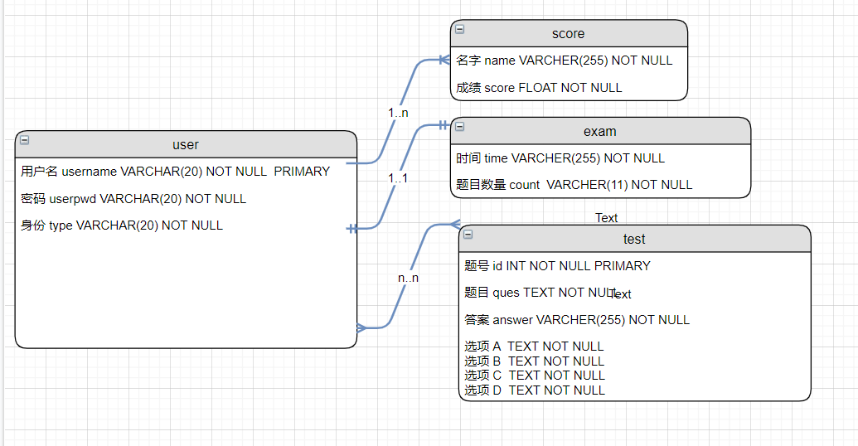

图3-1 数据库ER图

# **3 系统实现**

## 3.1 项目结构

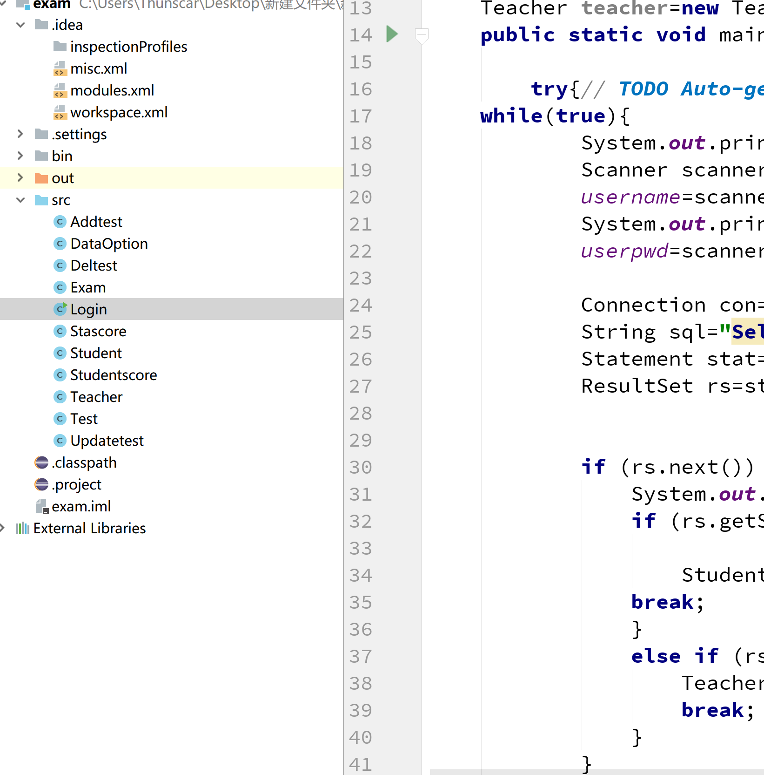

## 3.2 DataOption.java文件

连接数据库的URL地址，访问数据库的用户名及对应的密码，程序运行时会读取该文件相关信息，避免硬编码，当相关信息发生变化时，只需修改DataOption类，增加程序的可扩展型。

public class DataOption {

public static Connection getConnection()

{

Connection con=null;

try {

Class.forName("com.mysql.jdbc.Driver");//1驱动类名称

con=(Connection) DriverManager.getConnection("jdbc:mysql://localhost/examination", "root", "admin");//2url地址

} catch (ClassNotFoundException e) {

e.printStackTrace();

return null;

} catch (SQLException e) {

e.printStackTrace();

return null;

}

return con;

}

}

## 3.3 登陆界面Login.java

登陆界面,输入正确的账号密码,并验证身份进入对应的界面

**public** **class** Login {

**static** String *username*;

**static** String *userpwd*;

Teacher teacher=**new** Teacher();

**public** **static** **void** main(String[] args)**throws** Exception {

**try**{// **TODO** Auto-generated method stub

**while**(**true**){

System.***out***.println("欢迎进入考试系统,请输入用户名:");

Scanner scanner=**new** Scanner(System.***in***);

*username*=scanner.nextLine();

System.***out***.println("请输入密码:");

*userpwd*=scanner.nextLine();

Connection con=DataOption.*getConnection*();

String sql="Select \* from user where username ='"+*username*+"' and userpwd ='"+*userpwd*+"'";

Statement stat=con.createStatement();

ResultSet rs=stat.executeQuery(sql);

**if** (rs.next()) //验证账号密码是否正确{

**if** (rs.getString("type").equals("学生")) {

Student.*student*();//若身份是学生进入学生菜单

**break**;

}

**else** **if** (rs.getString("type").equals("老师")) {

Teacher.*teacher*();//若身份是老师进如教师菜单

**break**;

}

}

**else** {

System.***out***.println("账号或密码错误，请重新输入！");

}

rs.close();

stat.close();

con.close();

}

} **catch** (Exception e) {

// **TODO**: handle exception

}

}

## 3.4学生考试Student.java

生成考卷,并将学生的答案批阅,给出成绩

**public** **class** Student {

**static** **int** *count*;

**static** **int** *i*=1;

**static** **int** *j*=0;

**static** String *ans*;

**static** **double** *score*;

**public** **static** **void** student()**throws** Exception {

**try** {

Connection con=DataOption.*getConnection*();

String sql="Select \* from exam ";

Statement stat=con.createStatement();

ResultSet rs=stat.executeQuery(sql);

**if** (rs.next()) {

*count*=rs.getInt("count");

}

System.***out***.println("登陆成功!"+Login.*username*+",考试将于"+rs.getString("time")+"开始.请答题:");

String sql1="Select \* from test order by rand() limit "+*count*;//随机生成考卷的sql语句

ResultSet rs1=stat.executeQuery(sql1);

**while** (rs1.next()) {

System.***out***.println(*i*+"."+rs1.getString("ques"));

System.***out***.println("A."+rs1.getString("A"));

System.***out***.println("B."+rs1.getString("B"));

System.***out***.println("C."+rs1.getString("C"));

System.***out***.println("D."+rs1.getString("D"));

Scanner scanner=**new** Scanner(System.***in***);

*ans*=scanner.nextLine();

**if** (*ans*.equalsIgnoreCase(rs1.getString("answer"))) {

*j*++;//答对题目数量

}

*i*++;

}

System.***out***.println(*j*);

*score*=100.00/*count*\**j*;//计算成绩

PreparedStatement pStatement=con.prepareStatement("insert into score (name,score) values(?,?)");//把成绩写入数据库

pStatement.setString(1, Login.*username*);

pStatement.setDouble(2, *score*);

pStatement.executeUpdate();

rs.close();

rs1.close();

stat.close();

con.close();//关闭连接

System.***out***.println("考试完成，你的成绩为："+*score*);

}

**catch** (Exception e) {

// **TODO**: handle exception

}

}

}

## 3.5教师主菜单界面Teacher.java

教师菜单,方便操作

**public** **class** Teacher {

**static** **int** *i*;

**public** **static** **void** teacher()**throws** Exception {

// **TODO** Auto-generated method stub

System.***out***.println("登陆成功! 欢迎你,"+Login.*username*+"老师！");

System.***out***.println("1.题库管理");

System.***out***.println("2.考试管理");

System.***out***.println("3.成绩查询");

System.***out***.println("4.成绩统计");

System.***out***.println("5.退出");

Scanner scanner=**new** Scanner(System.***in***);

*i*=scanner.nextInt();

**switch** (*i*) {

**case** 1:

Test.*test*();

**break**;

**case** 2:

Exam.*exam*();

**break**;

**case** 3:

Studentscore.*studentscore*();

**break**;

**case** 4:

Stascore.*stascore*();

**break**;

**case** 5:

System.***out***.println("欢迎下次使用！！");

**break**;

**default**:

**break**;

}

}

}

# **4 系统测试**

学生:张三 密码:111

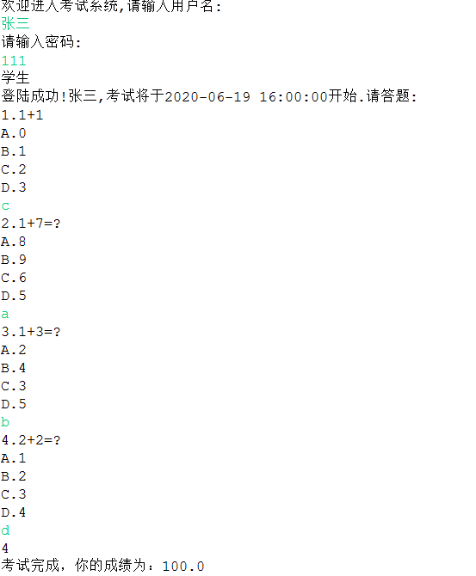

教师



# IMG_256

# IMG_256

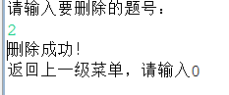

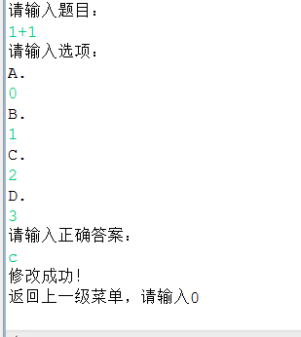

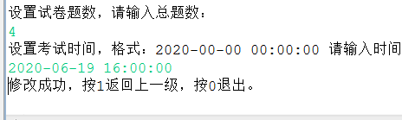

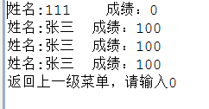

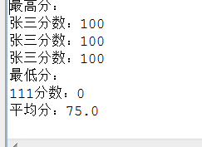

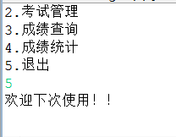

# **5 系统总结**

在随机生成考卷和平均分这两个方面遇到难题,后面通过上网大量的查阅资料,以及和同学讨论解决掉了这两个问题,系统还缺少的密码修改,成绩统计确少了图例的统计来更直观的反应成绩情况以及还存在一些小bug,通过这学期的课程学习,学到很多关于编程的新知识,并会自己弄一下有趣的小编程很有趣的一门课程,希望老师能够扩展更多的知识面,学到更多的东西,成绩的话感觉做的不是很好,给自己评个良好吧.