**HÌNH ẢNH THỰC TẾ**

**Designing a production monitoring system**: Raspberry MQTT broker (Python) – C#

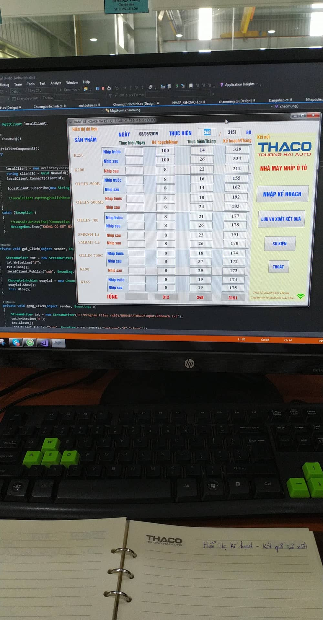 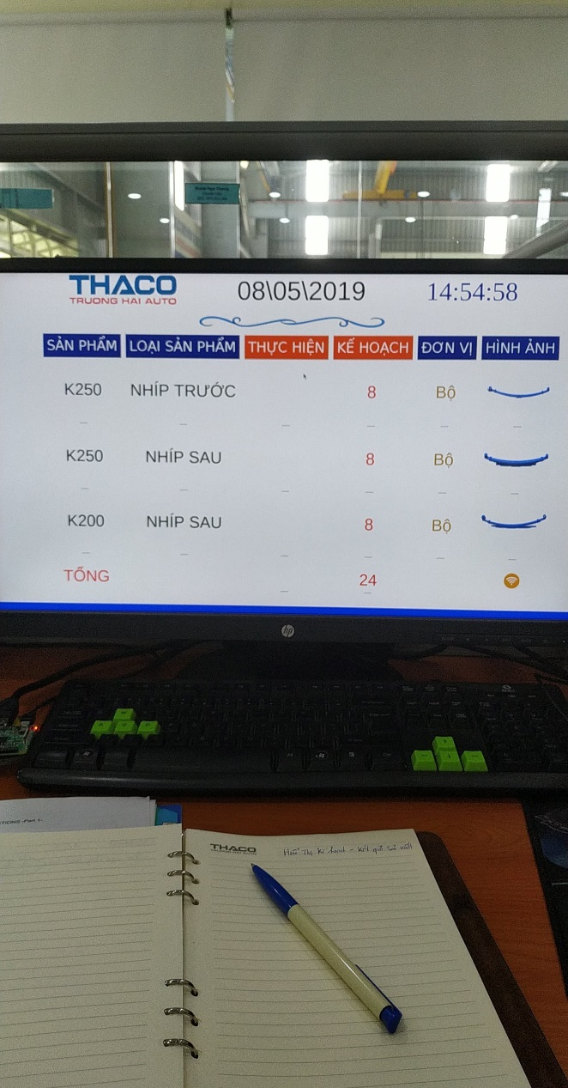

**Design remote control system for factory lights**: Raspberry MQTT broker (Python) – Android MQTT

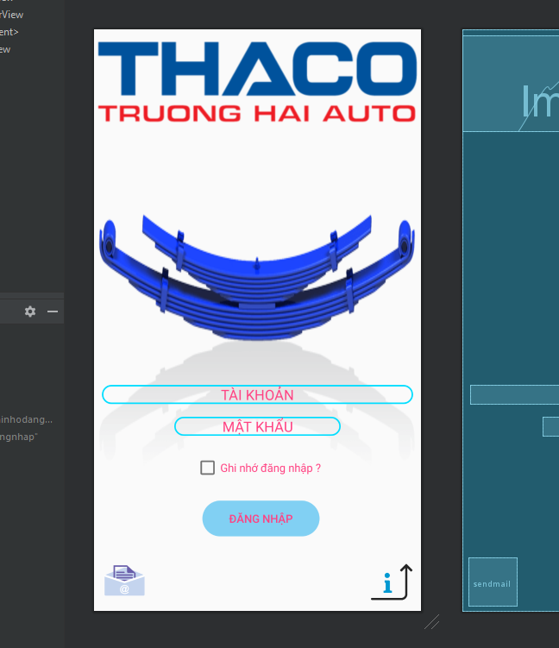 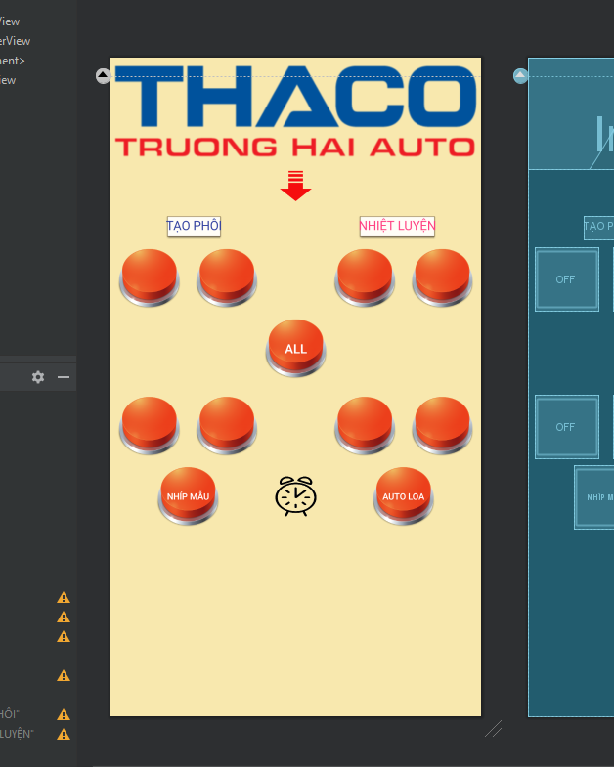

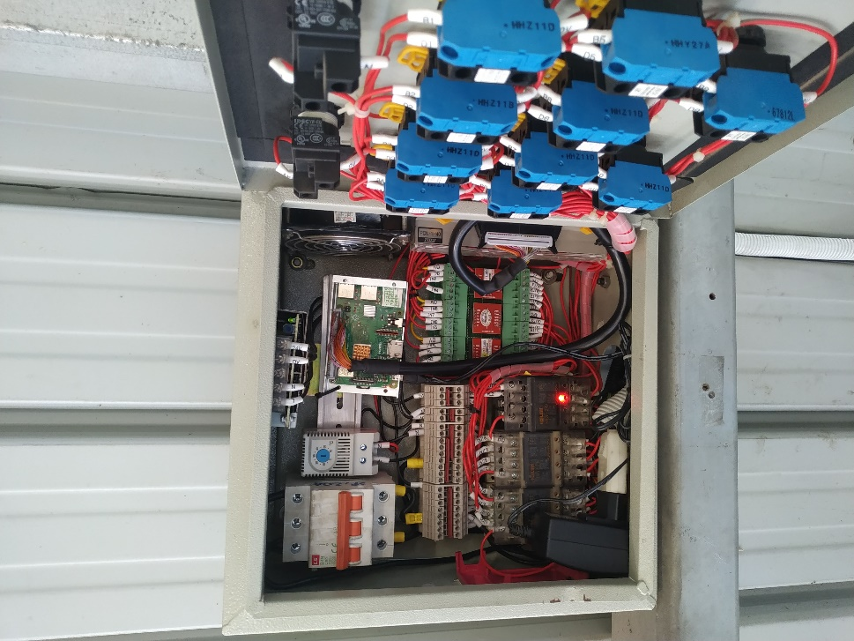 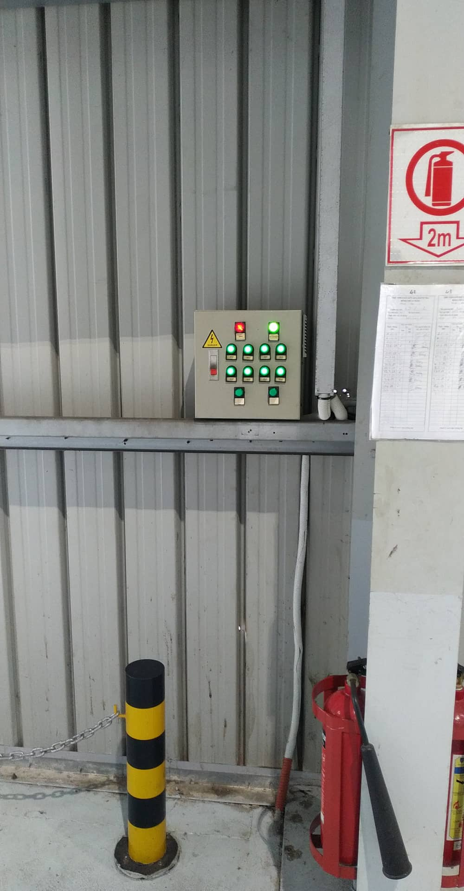

**SmartMirror**: Use Qtcreater, display and weather forecast, show news from Vnexpress.net

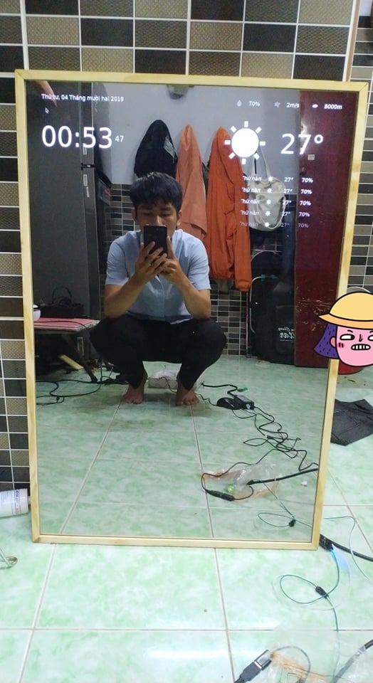

**EMOJI PLAY:**

- NRF51822, PTR5528 Nordic : BLE sleep mode (energy saving) use battery CR2032

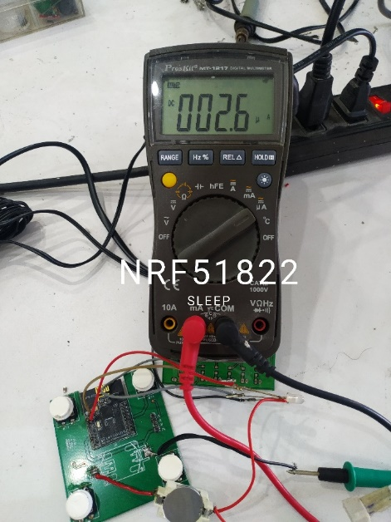 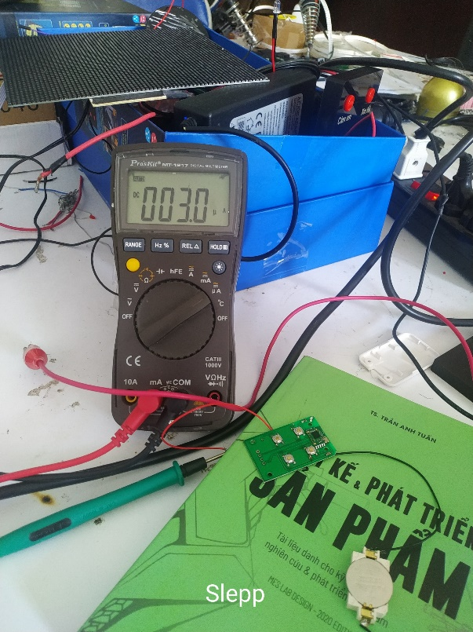

- App Android: Design with Kotlin use FastBLE library connect to ESP32 BLE

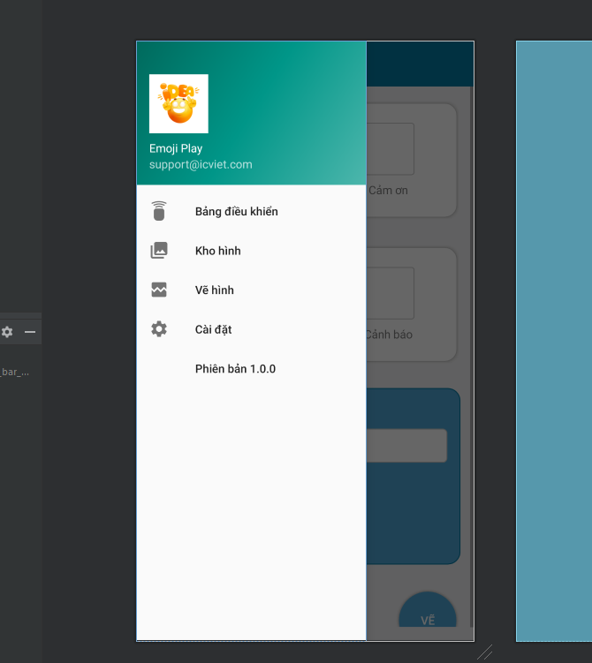 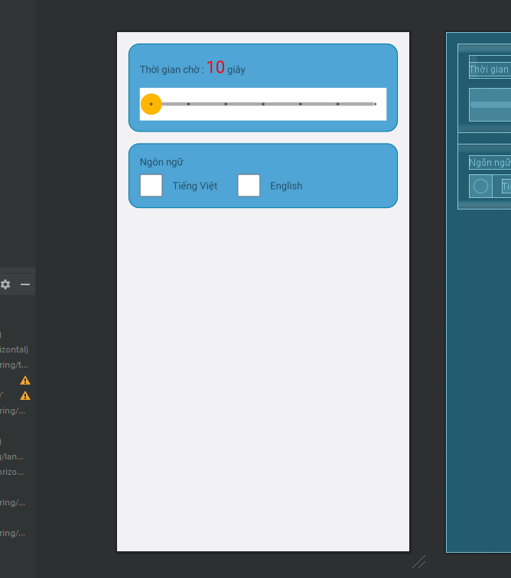 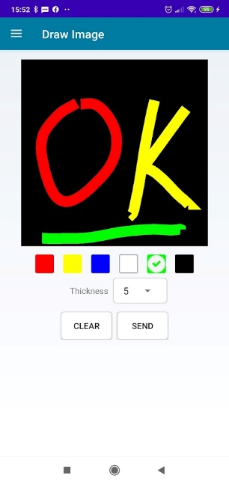

- App IOS: Design with SwiftUI use Corebluetooth library connect to ESP32 BLE

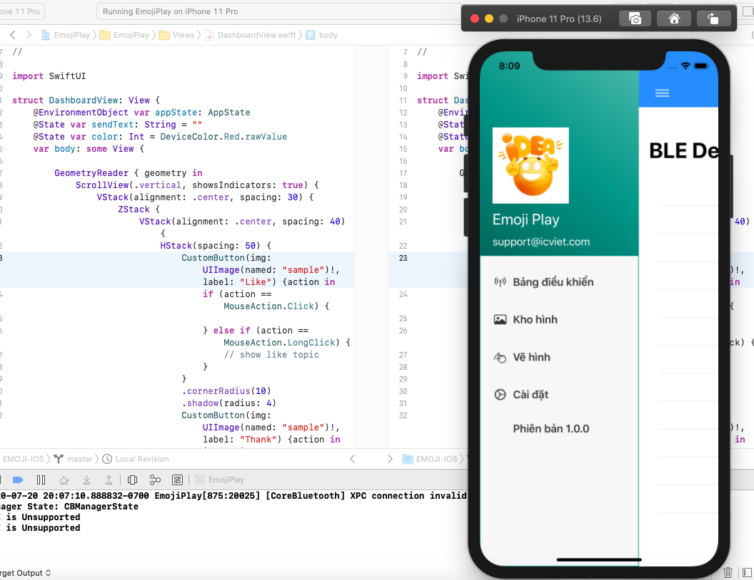 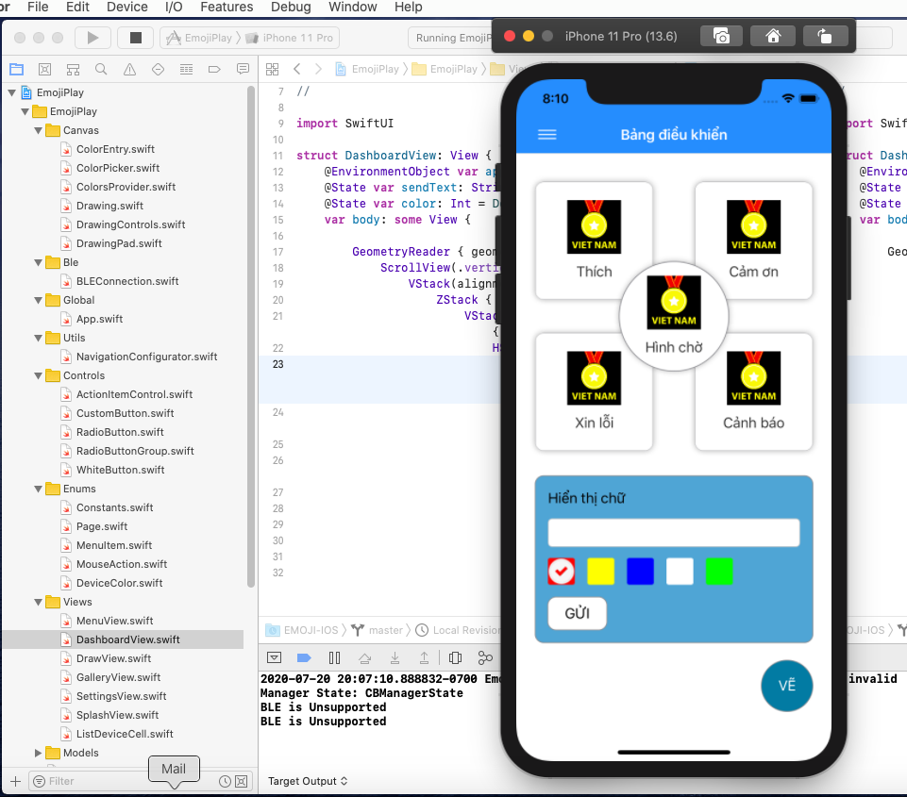

**Parking management software**: C# MQTT and ESP32 - NFC

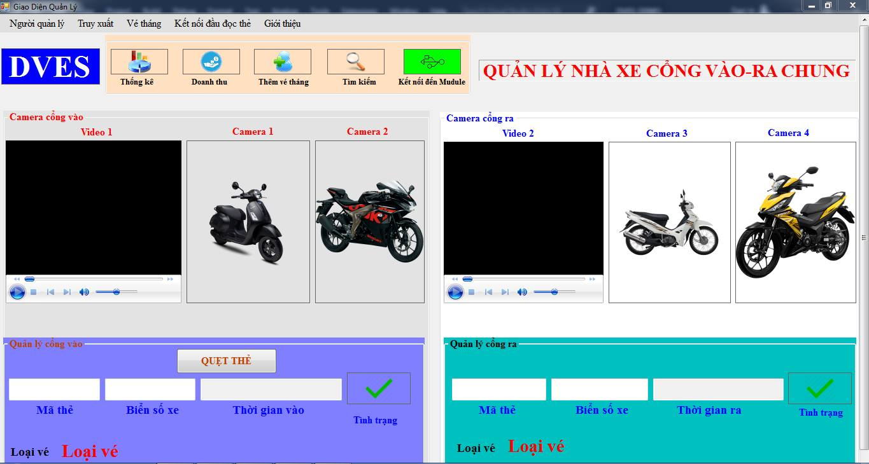

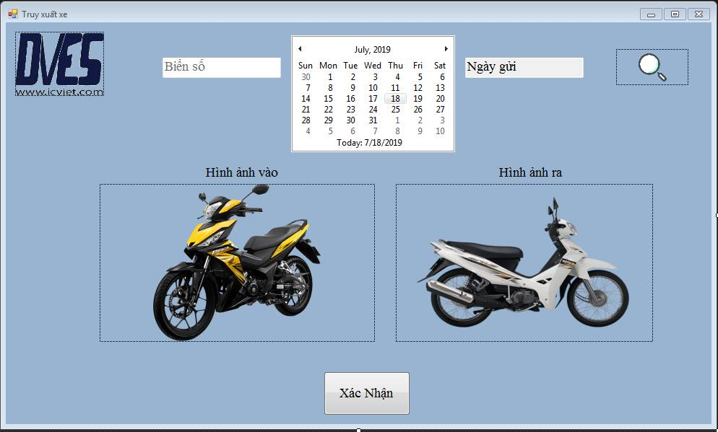

**Bus control**: Raspberry – Qtcreater – Python

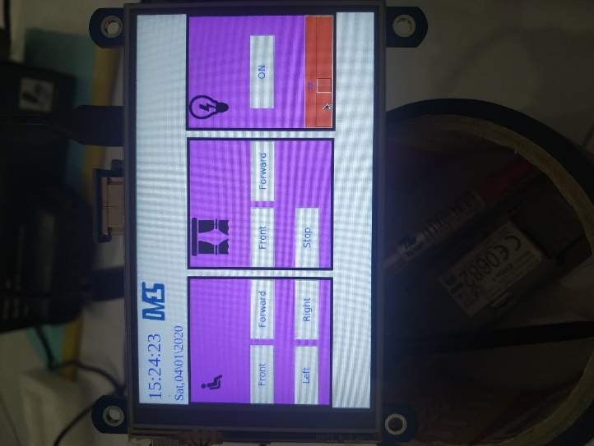

**Production management software**: C# - TCP/IP connect ESP32, windows service save database

