## Challenge Name: Reassign Google Docs Owners

Challenge Details

<http://www.cloudspokes.com/challenge_detail.html?contestID=215>

Solution Submitter Name

Romin Irani

Solution Submitter ID

romin

Solution Submitted Profile URL

<http://www.cloudspokes.com/profile.html?username=romin>

Solution File Attached

**reassigngoogledocs.zip**

Solution Details

**reassigngoogledocs.zip** contains the Eclipse GAE Project. I have removed the Google App Engine JAR files and also the Google Docs API / Google Data JAR files, so you will need to add those files to compile and run your project.

The web application is available at: <http://reassigndocs.appspot.com>

High Level features of the application are:

* Login with your Google Account. No username/password to be given to this application.
* Authorize access to your Google Docs via OAuth2.
* Provide a list of Google Doc IDs that you want to reassign to a new owner along with the new user name.
* Get a JSON list of Old Doc Ids and New Doc Ids as a result of the ownership transfer.
* View a log of all reassigns operations that you have done.
* Only those documents of which you are the owner will be transferred, the rest of them will ignored during the transfer ownership operation.

**Limitation**

* Google Docs currently does not allow copying of PDF documents. As a result of that, if you plan to transfer ownership of a PDF document, then it will result in operation not supported message. This is a standard message from Google Docs API.

**How to Use the Application?**

1. Visit the url: <http://reassigndocs.appspot.com> . You will see the following url:

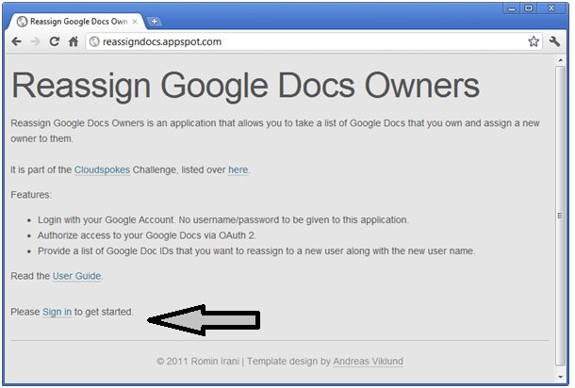

1. Click on the **Sign In** link to login to the application using your Google Account. You will see the standard Google Login screen where you can enter your credentials and click on Sign In. An example run is shown below:

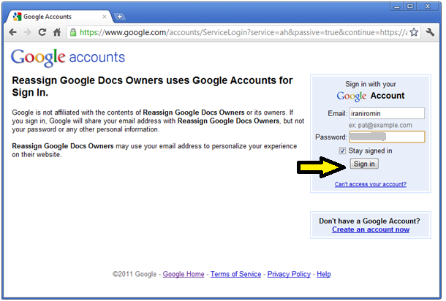

1. On successful Sign In, you will be let back to the main page and the application will ask you to authorize it to access Google Docs on your behalf. This is done via OAuth2. Simply click the **Authorize** link to get going.

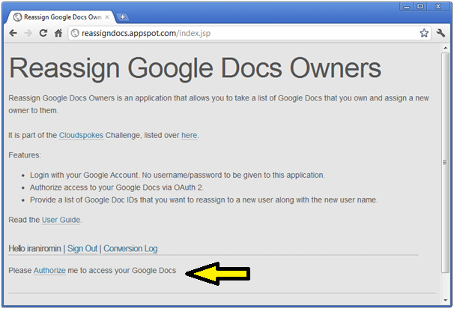

1. This will lead to an Authorization page where you will need to Allow Access to your Google Docs as shown below. Click on **Allow Access** to move forward:

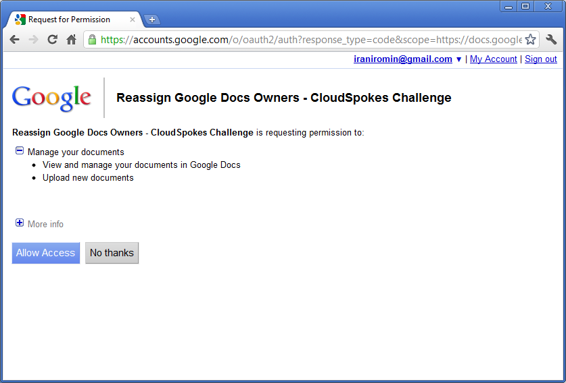

1. This will lead us to a form where you can enter the following:
   1. The **New Owner**
   2. The **List of Doc Ids** that you want to transfer ownership of to the **New Owner**.

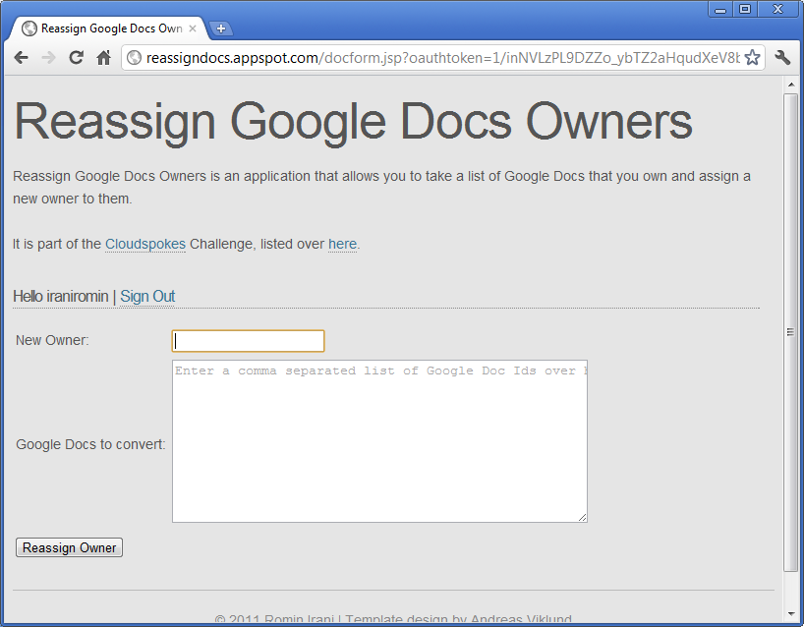

1. In the sample run below, I have entered the new user to which I want to transfer the ownership. I have also given a list of Doc Ids that I want to transfer to this new owner:

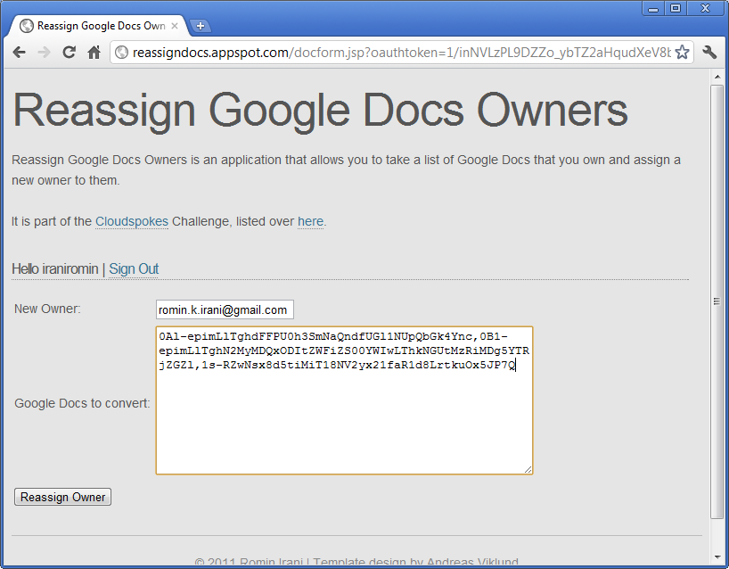

Note that the Doc Ids that I am transferring are for the following documents that I currently own:

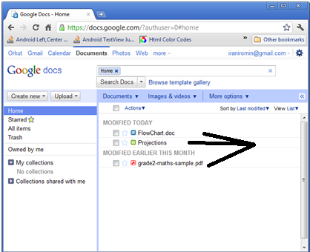

1. Simple click on the **Reassign Owner** button to **make a copy of the document and transfer the ownership to the new user.** The result is shown below:

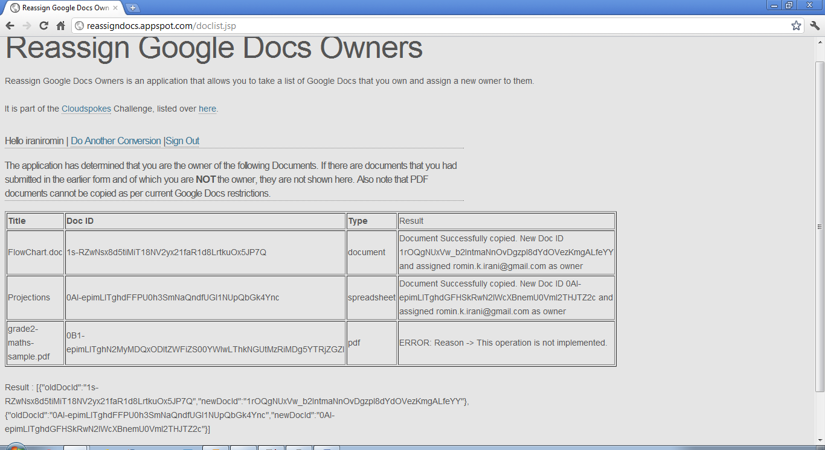

You will notice that out of the 3 documents, it was able to copy and transfer ownership of the Document and Spreadsheet type but failed for the PDF one, since copy of PDF documents is not supported by Google Docs. Additionally, note that you are not an owner of the document, then they will be silently ignored in the transfer ownership process.

1. You will also see the JSON result of the Old Doc Id and New Doc Id for all the documents that were successfully transferred as shown at the bottom of the above screen and reproduced here for you:

[{"oldDocId":"1s-RZwNsx8d5tiMiT18NV2yx21faR1d8LrtkuOx5JP7Q","newDocId":"1rOQgNUxVw_b2IntmaNnOvDgzpl8dYdOVezKmgALfeYY"},{"oldDocId":"0Al-epimLlTghdFFPU0h3SmNaQndfUGl1NUpQbGk4Ync","newDocId":"0Al-epimLlTghdGFHSkRwN2lWcXBnemU0Vml2THJTZ2c"}]

1. You also receive emails for successful ownership transfer. Each transfer results in an email and in the above case, we get two emails as shown below:

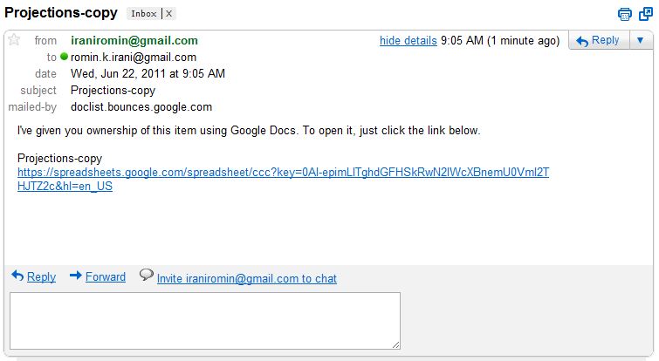

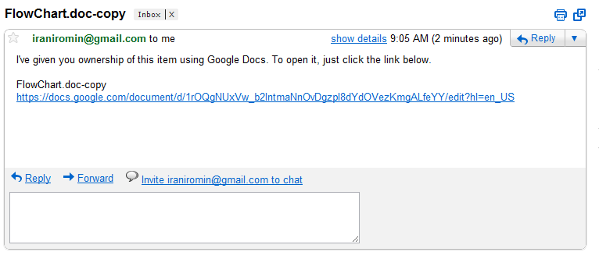

1. All conversion tasks are saved in the Datastore. You can get a list of all your tasks, via the Conversion Log link as shown below:

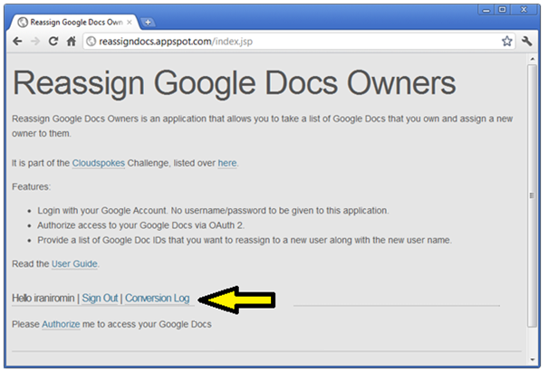

This will show you the Tasks that you have done so far with the JSON result, etc.

