
FPT UNIVERSITY- CAMPUS CAN THO
«««««
PROJECT PROPOSAL
“Smart Anti-Theft Camera”

IoT102 – SE1912 – Group: 3
Instructor: Nguyễn Hồng Hạnh

Name of group members | Contribution
Nguyễn Tiến Thương CE191329 | 20%
La Tấn Khanh CE191640 | 20%
Phan Ánh Ngọc CE191049 | 20%
Hồ Chí Nghĩa CE190960 | 20%
Lê Thị Kiều Trinh CE190422 | 20%

SUMMARY
This project focuses on the design and implementation of a smart home anti-theft surveillance system using Internet of Things (IoT) technology. The system is developed based on the ESP32-CAM microcontroller integrated with a PIR motion sensor to detect human movement. When motion is detected, the ESP32-CAM activates a camera to capture images, triggers an alarm using a buzzer and LED indicator, and sends real-time notifications along with captured images to the user via a Telegram Bot application.
The system allows users to remotely monitor the area, receive instant alerts, and view intrusion evidence through the Internet. Communication is implemented using Wi-Fi connectivity, ensuring fast and reliable data transmission. Experimental results show that the system operates stably, detects intrusions accurately, and provides timely notifications. This solution offers a low-cost, effective, and practical approach to enhancing home security and smart surveillance systems.

TABLE OF CONTENTS
SUMMARY ........................................................................................................................2
TABLE OF CONTENTS .....................................................................................................3

PART 1: INTRODUCTION ...........................................................5
1.1. Research Motivation ......................................................................................................5
1.2. Research Objectives .......................................................................................................5
1.3. Research Scope ...............................................................................................................6
1.4. Research Methodology ...................................................................................................6

PART 2:THEORETICAL AND TECHNOLOGICAL BACKGROUND .............................................................................7
2.1. Concept of IoT .................................................................................................................7
2.2. Main Technologies ..........................................................................................................7

PART 3:SYSTEM ANALYSIS AND DESIGN .............................8
3.1 System Requirements .....................................................................................................8
3.2 System Architecture .......................................................................................................8
3.3 List of Components ........................................................................................................8
3.4 System Block Diagram ...................................................................................................9
3.5 Circuit Diagram ..............................................................................................................12
3.6 Flowchart ........................................................................................................................13

PART 4: IMPLEMENTATION AND EXPERIMENTS ............13
4.1. Hardware .........................................................................................................................13
4.2. Software ...........................................................................................................................14
4.3. System Operation Process ...............................................................................................15

PART 5: RESULTS AND EVALUATION ......................................16
5.1. Achieved Results ..............................................................................................................16
5.2. Evaluation .......................................................................................................................17

PART 6: CONCLUSION AND FUTURE DEVELOPMENT.....17
6.1. Conclusion .....................................................................................................................17
6.2. Future Development ......................................................................................................18
REFERENCES ...................................................................................................................19
APPENDICES ....................................................................................................................19

PART 1: INTRODUCTION

1.1 Research Motivation
In the context of rapid technological development and increasing security concerns, home and property protection has become a critical issue. Conventional security solutions such as mechanical locks or simple alarm systems are limited in effectiveness, as they cannot provide real-time monitoring or remote supervision. These limitations create a demand for smarter and more flexible security systems.
With the advancement of Internet of Things (IoT) technology, devices can be interconnected and monitored remotely through the Internet, enabling real-time surveillance and instant alerts. Camera-based security systems, in particular, play an important role in detecting intrusions and providing visual evidence. Therefore, our group selected the topic “Research and Development of an IoT-Based Smart Anti-Theft Camera System” to apply IoT technology in a practical and cost-effective manner, aiming to enhance home security and support smart home applications.

1.2 Research Objectives
The main objectives of this research are as follows:
- To design and implement a smart anti-theft security system using the ESP32-CAM microcontroller for real-time image capture and monitoring.
- To detect unauthorized access through motion detection and automatically capture images when an intrusion occurs.
- To integrate alert mechanisms such as LED indicators and buzzer alarms to provide immediate local warnings.
- To connect the system with a Telegram Bot in order to send instant image notifications to the user via the Internet.
- To ensure the system is low-cost, easy to assemble, energy-efficient, and scalable, making it suitable for smart home applications.

1.3 Research Scope
The research scope of this study is defined as follows:
- The system is designed for households, small offices, and small retail stores, which require continuous and reliable security monitoring.
- This research focuses on the development of a Smart Anti-Theft Camera system based on the ESP32-CAM, featuring motion detection and real-time image capture when suspicious activities are detected.
- Captured images and alert notifications are transmitted to users via the Telegram application through an Internet connection.
- The system is intended to operate in small to medium-scale environments and is primarily designed for indoor deployment.
- The study emphasizes low-cost implementation, ease of installation, and expandability for smart home applications.

1.4 Research Methodology
The research methodology of this study includes the following steps:
- Reviewing and analyzing related documents and studies on IoT systems, surveillance cameras, sensors, and microcontroller-based security solutions.
- Designing the system architecture and circuit diagram, followed by assembling the hardware model using the ESP32-CAM and peripheral components.
- Developing, programming, and testing the system using the Arduino IDE, including motion detection, image capture, and Telegram notification functions.
- Conducting experiments to evaluate system performance, such as detection accuracy, response time, and notification reliability.

PART 2: THEORETICAL AND TECHNOLOGICAL BACKGROUND

2.1 Concept of IoT
The Internet of Things (IoT) refers to a network of interconnected devices that are capable of collecting, processing, and exchanging data through the Internet. These devices typically include sensors, microcontrollers, and communication modules, enabling them to operate intelligently and autonomously.
In the context of smart home applications, IoT technology allows users to monitor and control devices remotely via mobile applications or web platforms. By integrating IoT with security systems, such as smart anti-theft cameras, users can receive real-time alerts, access surveillance data, and enhance overall safety and convenience.

2.2 Main Technologies
The main technologies used in this project are described as follows:
- ESP32-CAM: Serves as the central microcontroller of the system, integrating Wi-Fi connectivity and a built-in camera module. It is responsible for image capture, data processing, and communication with Internet-based services.
- PIR Motion Sensor: Detects human movement by sensing changes in infrared radiation. When motion is detected, the sensor triggers the system to capture images and activate alert mechanisms.
- LED Light: Provides visual indication and additional illumination to support image capture during nighttime or low-light conditions.
- Buzzer: Generates local audible alerts to warn of potential intrusions.
- Telegram Bot: Enables real-time communication between the system and the user by sending alert notifications and captured images via the Internet, allowing remote monitoring and response.
- Infrared Remote Control and Telegram App Control: The system supports remote operation through an infrared remote control as well as direct commands via the Telegram application. Users can remotely enable or disable the system, control the LED light, and capture images instantly.

PART 3: SYSTEM ANALYSIS AND DESIGN

3.1 System Requirements
- Main Functions:
The system must be capable of detecting intrusions, providing local alerts through sound and light, and sending remote notifications to the user.
- Stability:
The system should operate continuously with stable performance and accurately detect intrusion events in real time.
- Security:
Only authorized users are allowed to control and monitor the system via the Telegram Bot to ensure system safety.
- Expandability:
The system should be designed in a modular manner, allowing easy integration of additional sensors or modules such as temperature sensors, cameras, or relays.
- Cost-effectiveness:
The system should utilize common and low-cost components while still maintaining reliability and practical usability.

3.2 System Architecture
The system architecture is divided into three main layers:
- Sensor Layer:
This layer includes the PIR motion sensor, which detects human movement by sensing changes in infrared radiation. When motion is detected, the sensor sends a signal to the control layer.
- Control Layer:
The ESP32-CAM acts as the central controller of the system. It processes signals from the PIR sensor, controls the camera module to capture images, and manages the operation of the buzzer and LED. The ESP32-CAM also handles Wi-Fi communication for data transmission.
- Alert and Remote Monitoring Layer:
This layer consists of local alert devices such as the buzzer and LED, which provide immediate audible and visual warnings. In addition, the system sends captured images and alert notifications to the user through the Telegram Bot, enabling remote monitoring and control via the Internet.

3.3 List of Components
No. | Component Name | Description | Quantity
1 | ESP32-CAM | Main microcontroller with integrated Wi-Fi and camera. Also includes onboard LED used for night illumination. | 1
2 | PIR Motion Sensor | Detects human movement based on infrared radiation changes and triggers the system. | 1
3 | Camera Module (Integrated) | Built-in camera on ESP32-CAM used to capture images when motion is detected. | 1
4 | Buzzer | Provides local audible alarm upon intrusion detection. | 1
5 | Onboard LED (ESP32-CAM) | Used to support image capture in low-light or nighttime conditions. | 1
6 | IR Remote Control | Allows the user to control the system remotely (turn on/off, trigger capture). | 1
7 | IR Receiver Module | Receives signals from the IR remote and sends commands to the ESP32-CAM. | 1
8 | Jumper Wires | Used for electrical connections between components. | ~15
9 | Breadboard | Prototype board for assembling and testing the circuit. | 1
10 | USB Cable / Power Supply | Used to power the ESP32-CAM and upload the program. | 1

3.4 System Block Diagram
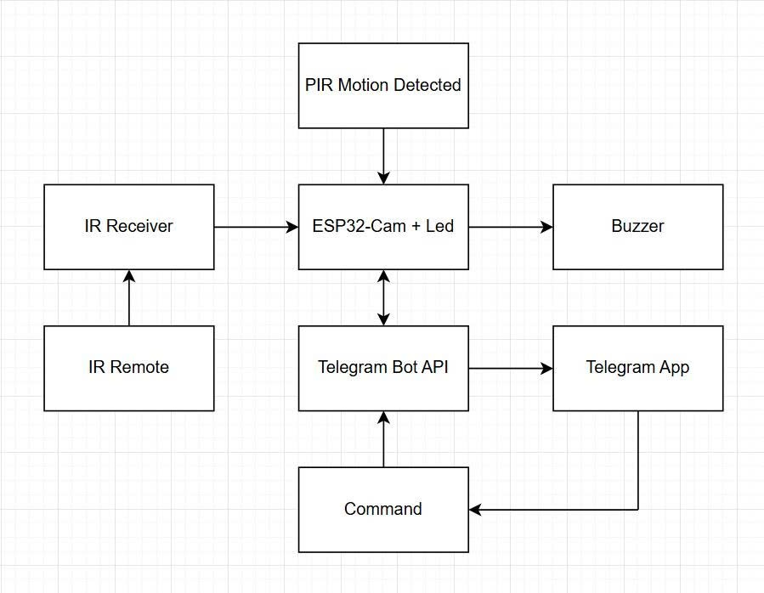

3.5 Circuit
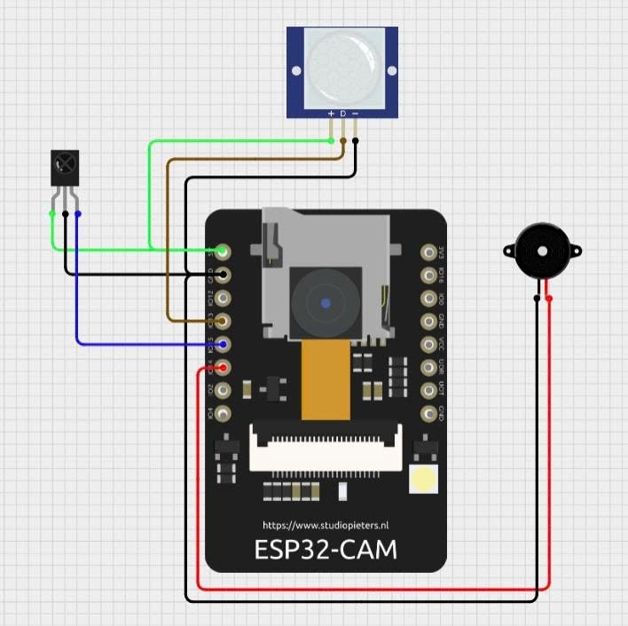

3.6 Flow Chart
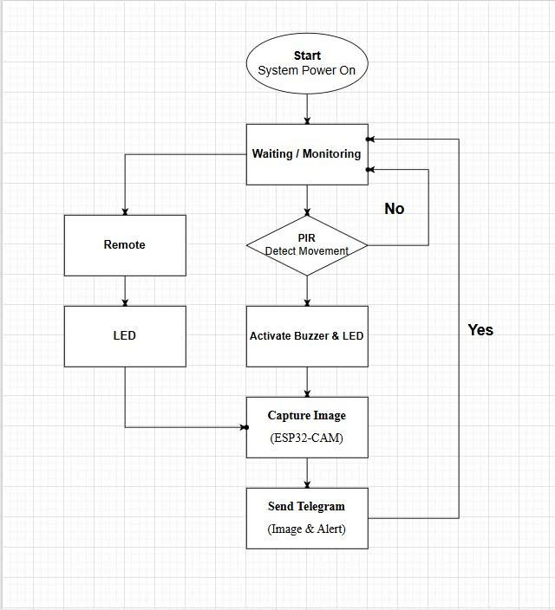

PART 4: IMPLEMENTATION AND EXPERIMENTS

4.1 Hardware
The system is implemented using low-cost, compact, and efficient hardware components suitable for small-scale smart security applications. The main components include:
- ESP32-CAM: Acts as the central controller of the system. It integrates Wi-Fi connectivity and an onboard camera module, enabling image capture, data processing, and communication with Internet-based services such as Telegram.
- PIR Motion Sensor: Used to detect human movement based on changes in infrared radiation. When motion is detected, the sensor triggers the ESP32-CAM to activate the alarm and capture images.
- Onboard LED (ESP32-CAM): Utilized to provide additional illumination during low-light or nighttime conditions to improve image quality. No external resistor is required since the LED is integrated into the board.
- Buzzer: Generates a local audible alarm to warn of potential intrusion.
- IR Remote Control and IR Receiver Module: Allow manual control of the system, such as enabling/disabling the alarm or triggering image capture remotely.
- Jumper wires and breadboard: Used to connect and assemble the components during prototyping and testing.
All components are assembled on a breadboard, with the ESP32-CAM serving as the core control unit that manages sensor inputs, alarm outputs, image capture, and wireless communication.

4.2 Software
The system software is developed using Arduino IDE with the C/C++ programming language. The program controls the operation of the ESP32-CAM and manages communication between sensors, actuators, and cloud services. The main software functions are described as follows:
- System Initialization:
Initialize GPIO pins for the PIR sensor, buzzer, and onboard LED; configure the camera module; establish a Wi-Fi connection; and set up the Telegram Bot for remote communication.
- Motion Detection:
Continuously monitor the PIR sensor to detect human movement. When motion is detected, the system considers it a potential intrusion event.
- Intrusion Handling:
Upon detecting motion, the system activates the buzzer for audible warning, turns on the onboard LED to provide illumination, and captures an image using the ESP32-CAM.
- Telegram Notification:
The captured image and an alert message are sent to the user via the Telegram Bot using Internet connectivity, enabling real-time remote monitoring.
- Remote Control Functions:
The system supports remote commands sent from the Telegram application, such as enabling or disabling the alarm system, manually turning the LED on or off, and triggering immediate image capture.
- Alarm State Management:
Once an intrusion is detected, the alarm state remains active for a predefined duration or until a specific command is received from the user, ensuring reliable alert behavior and preventing repeated false notifications.

4.3 System Operation Process
- Initially, the system is powered on and connected to the Wi-Fi network. The ESP32-CAM remains in standby mode while continuously monitoring the PIR motion sensor.
- When a human movement is detected, the PIR sensor sends a signal to the ESP32-CAM, indicating a potential intrusion.
- The ESP32-CAM immediately activates the local alarm, including the buzzer for audible warning and the onboard LED to provide additional lighting for image capture.
- At the same time, the camera captures an image of the monitored area.
- The captured image, along with an alert message, is sent to the user via the Telegram Bot in real time.
- The system then enters a cooldown period to prevent repeated alerts from the same motion event.
- The user can remotely control the system through Telegram commands, such as turning the system on or off, manually activating the LED, or requesting an instant photo capture.

PART 5: RESULTS AND EVALUATION

5.1 Achieved Results
After completing the hardware assembly and software implementation, the Smart Anti-Theft Camera system was tested in real indoor conditions. The achieved results are summarized as follows:
- The PIR motion sensor accurately detects human movement within the monitored area.
- When motion is detected, the system immediately activates local alerts, including the buzzer and onboard LED.
- The ESP32-CAM successfully captures images of the intrusion area with acceptable clarity, even in low-light conditions thanks to LED support.
- Alert messages and captured images are sent instantly to the user via the Telegram Bot.
- Remote control commands through Telegram, such as system activation, deactivation, LED control, and manual photo capture, work reliably.
- The system operates stably over extended periods with minimal delay and no significant communication errors.

5.2 Evaluation

Advantages
- Low cost: The system uses common, inexpensive, and easily available components such as the ESP32-CAM, PIR motion sensor, buzzer, and LED.
- Stable operation: Motion detection and image capturing functions operate reliably with fast response time.
- Real-time monitoring: Captured images are immediately sent to the user via the Telegram application, providing visual evidence in case of intrusion.
- High interactivity: Users can remotely control the system, receive alerts, and request images through Telegram commands.
- Scalability: The system can be easily expanded by integrating additional sensors or cloud-based services.

Limitations
- Dependence on Wi-Fi/Internet: The system cannot send notifications or images when the Internet connection is unavailable.
- Limited detection area: The detection range of the PIR sensor is limited and can be affected by environmental factors.
- No continuous video streaming: The system only captures images when motion is detected and does not support real-time video streaming.
- Limited recognition capability: Since the system relies on a PIR infrared sensor and does not integrate human/object recognition algorithms, false alarms may occur due to animal movement.

PART 6: CONCLUSION AND FUTURE DEVELOPMENT

6.1 Conclusion
- This project successfully developed a Smart Anti-Theft Camera System based on the ESP32-CAM platform. The system integrates a PIR motion sensor, built-in camera module, buzzer, and LED to detect intrusions and provide both visual and audible alerts.
- Experimental results show that the system is capable of detecting motion quickly and accurately, capturing images in real time, and immediately notifying users via the Telegram Bot application. Remote monitoring and control through Telegram enhance system convenience and user interaction.
- Overall, the proposed system operates stably, is cost-effective, and is suitable for small- to medium-scale applications such as households, small offices, and indoor surveillance environments.

6.2 Future Development
In future work, the proposed Smart Anti-Theft Camera System can be further improved and expanded in several aspects:
- Hardware improvements:
The system can be enhanced by integrating additional PIR sensors or multiple cameras to increase detection coverage and improve reliability. A backup power supply such as a rechargeable battery or solar energy system can also be added to ensure continuous operation during power outages.
- Software enhancements:
Artificial Intelligence (AI) techniques can be applied to analyze camera images, enabling human detection, object classification, and reduction of false alarms caused by pets or environmental factors. Moreover, the system can be extended to support additional notification channels such as email or SMS, or be integrated with popular IoT platforms like Blynk, Firebase, or Home Assistant for centralized management.
- Security upgrades:
To improve data security, encryption methods can be implemented for Internet communication. User authentication mechanisms such as one-time passwords (OTP) or biometric recognition (e.g., face recognition) can be added to enhance access control and system safety.
- Practical applications:
The system can be deployed in various real-world environments, including residential houses, offices, warehouses, and retail stores. In the long term, it can be expanded into a comprehensive Smart Home Security System, integrated with other smart devices to provide a fully automated and intelligent home protection solution.

REFERENCES
[1] https://github.com/LucaTomei/Esp32-Cam-PIR-Telegram?utm_source=chatgpt.com
[2] https://github.com/make2explore/Home-Security-System-using-ESP32CAM-and-Telegram?utm_source=chatgpt.com
[3] https://www.youtube.com/watch?v=D0mCmRcsd7w
APPENDIX

Appendix A: System Block Diagram
https://drive.google.com/file/d/1__tAAGlWrXJMr0ntsjNUFES3sSAVlxoV/view?usp=sharingAppendix B: System Flowchart
https://drive.google.com/file/d/1acOeKzf9qMByz16G-erntNfSfpW0cNVL/view?usp=sharingAppendix C: Circuit
https://app.cirkitdesigner.com/project/5e94724d-4b43-47cc-8751-4914fec5c02a
Appendix D: Source Code Link
https://drive.google.com/drive/folders/1x-5Q1lwMtyaKwiBAzDIcapZwX5-3mXSpAppendix E: Demo Video Link
Demo Video: https://drive.google.com/drive/folders/1xWWjPgqnMlk7wSHBefq4t83yAGc1cR--?usp=sharing

