Invasive species modelling in New Zealand forests

Anthony Davidson

2019-07-03

# Prerequisites

This is a *sample* book written in **Markdown**. You can use anything that Pandoc’s Markdown supports, e.g., a math equation $a^{2}+b^{2}=c^{2}$.

The **bookdown** package can be installed from CRAN or Github:

install.packages("bookdown")  
# or the development version  
# devtools::install_github("rstudio/bookdown")

Remember each Rmd file contains one and only one chapter, and a chapter is defined by the first-level heading #.

To compile this example to PDF, you need XeLaTeX. You are recommended to install TinyTeX (which includes XeLaTeX): <https://yihui.name/tinytex/>.

## This template

For this template I have divided the “chapters” into key sections needed to build and troubleshoot bookdown for graduate research projects. The aim of this bookdown is to provide a working archive of code for the bookdown package use with the statistics network.

You can reference chapters like so:

* Chapter 3
* Chapter ??
* Chapter 4

## Additional notes

… check out the website for more resources [here](https://www.ssnhub.com)

# Status

All other data and resources to render project from raw data (copied from my private GIT repository) can be found on [dropbox](https://www.dropbox.com/home/phd-drafts-anthony) and online [here](https://www.ssnhub.com/beech-forest-dynamics/) and are currently at a draft quality as I build my phd thesis.

|  |  |  |
| --- | --- | --- |
| GIThub Document | Overview | Status |
| *Pre-registration* | not needed | NA |
| [Current draft] | As I am developing this approach to reproducible research this draft will look better and better. | Online [here](https://www.ssnhub.com/beech-forest-dynamics/) |
| Online [link here](https://github.com/davan690/beech-fororest-dynamics/) | Dropbox is currently the backup for this as I get better at build gitbooks using RStudio and bookdown. This is currently only accessible if you have the private link that I will have sent through email. | Dropbox [link here](https://www.dropbox.com/home/phd-drafts-anthony/beech-forest-dynamics/drafts/Davidson_2019_BeechForest.html) |
| [Abstract] | Always last..ish a overview is online [here](https://www.ssnhub.com/beech-forest-dynamics/) | [*additional resources for collaborators here*](https://www.dropbox.com/home/phd-drafts-anthony) |
| [Style sheet] | A way of recording semantic choices for this research project. | Dropbox [Link here](https://www.dropbox.com/home/phd-drafts-anthony/beech-forest-dynamics/Styles_manual_sheet.md/) |
| Introduction | Currently within the draft manuscript | Dropbox [Link here](https://www.dropbox.com/sh/5h4mp67p7u6t1lj/AAAQVKS4qnvu2oQLu53JQUofa?dl=0); Online [link here](https://www.ssnhub.com/beech-forest-dynamics/intro.html) |
| Methods | manuscript methods can be found here and other extensions below | Online [link here](https://www.ssnhub.com/beech-forest-dynamics/method.html) |
|  | This report takes the raw CR data and generates simple average plots of beech seed, mice and rat abundances | [Model wrangling](https://www.ssnhub.com/Beech-forest-publication/) |
|  | To estimate the differences between Prediction A and B | [Simple ANOVAs](https://www.ssnhub.com/simple/) |
|  | To estimate the differences between Prediction C, D, and E | [Model outputs](https://www.ssnhub.com/outputs/) |
|  | Simulation model | Full simulation document [here](https://www.ssnhub.com/simulation/) |
| Results | The figures can be found here | Online [link here](https://www.ssnhub.com/beech-forest-dynamics/results.html) |
| Discussion |  | Online [link here](https://www.ssnhub.com/beech-forest-dynamics/discussion.html) |
| Bayesian methods |  | [Dropbox](https://www.dropbox.com/home/phd-drafts-anthony/beech-forest-dynamics/A1_full_bayesian_model.pdf) |
| Figures |  | [Dropbox](https://www.dropbox.com/home/phd-drafts-anthony/beech-forest-dynamics/figs) |
| Functional response |  | [Dropbox](https://www.dropbox.com/home/phd-drafts-anthony/beech-forest-dynamics/Davidson_2019_BeechForest_Appendix.pdf) |
| Mapping | coming online soon | [Dropbox](https://www.dropbox.com/home/phd-drafts-anthony/beech-forest-dynamics/figs) |
| [References] |  | [Dropbox](https://www.dropbox.com/home/phd-drafts-anthony/beech-forest-dynamics/figs) |
| [Appendix] |  | [Dropbox](https://www.dropbox.com/home/phd-drafts-anthony/beech-forest-dynamics/figs) |
| Extra resources |  | [Dropbox](https://www.dropbox.com/home/phd-drafts-anthony/beech-forest-dynamics/figs) |
|  |  |  |
|  |  |  |

<div class="project-card">  
 {%- assign gh-user = "davan690" -%}  
 {%- assign gh-project = "davan690/beech-forest-dynamics" -%}  
 <a target="_blank" href="https://github.com/{{- gh-user -}}/{{- gh-project -}}" class="project-link" title="Go to Github Poject Page">  
 <span class="fa-stack fa-4x">  
 <i class="fa fa-circle fa-stack-2x stack-color"></i>  
 <i class="fa fa-user-secret fa-stack-1x fa-inverse"></i>  
 </span>  
 <h4>{{- gh-project -}}</h4>  
 <hr class="seperator">  
 <p class="text-muted">The beginnings of a interactive PhD thesis using Markdown. </p>  
 <hr class="seperator">  
 <img src="https://img.shields.io/github/forks/{{- gh-user -}}/{{- gh-project -}}.svg?style=social&label=Fork" alt="Github" title="Github Forks">  
 <img src="https://img.shields.io/github/stars/{{- gh-user -}}/{{- gh-project -}}.svg?style=social&label=Stars" alt="Github" title="Github Stars">  
 </a>  
</div>

## My notes

And posts so far to help with development below:

{% for post in site.tags[“beech”] %} {{ post.title }} ({{ post.date | date_to_string }}) {{ post.description }} {% endfor %}

# Introduction

Worldwide, but particularly on islands, introduced mammalian predators can have significant impacts on native species (Towns, Atkinson, and Daugherty 2006). New Zealand’s (NZ) remaining native forests commonly contain four introduced mammalian predators; stoats (*Mustela erminea*; Veale (2015)), brushtail possums (*Trichosurus vulpecula Kerr*; Clout and Gaze (1984)), ship rats (*Rattus rattus*; Innes (2005) referred to as rats), and house mice (*Mus mus musculus*; Allen and Lee (2006)). In NZ forests, stoats are the top predator following their deliberate introduction in the late nineteenth century (King 2017). Stoat control is now commonly undertaken to protect native birds that are vulnerable to predation (White and King 2006), in particular, hole-nesting species like mohua (*Mohoua ochrocephala* ODonnell and Phillipson (1996)). However, the primary food source for stoats in NZ forests are rats and mice (White and King 2006) and there is a concern that reducing stoat populations to protect native birds may allow rodent populations to increase (e.g Rayner et al. (2007)). An increase in the number of rats and mice could offset the benefits of stoat control because rodents are known to consume the eggs and chicks of native birds (Allen and Lee 2006), directly compete with native species for food resources such as flowers and seeds (McQueen and Lawrence 2008) and predate on invertebrates (Ruscoe et al. 2012). In this paper we address the question: "does stoat control lead to increased abundance of rodents, particularly mice, in NZ beech forests?

Studies elsewhere in the world have shown that removing or reducing the abundance of a top predator often leads to an increase in the numbers of predators at lower trophic levels (termed mesopredator release), which in turn, can lead to unintended and often negative outcomes for native species (for a review see Prugh et al. (2009) and for examples see Rayner et al. (2007); Robles and Desharnais (2002)). While mesopredator release has been widely documented elsewhere, it is unclear if stoat control in NZ forests will cause rodent populations to increase. Rodent populations in NZ forests are known to respond strongly to variation in food supply (Choquenot and Ruscoe 2000; Ruscoe, Goldsmith, and Choquenot 2001; Blackwell, Potter, and Minot 2001; Blackwell et al. 2003; Ruscoe et al. 2005; Tompkins and Veltman 2006; Tompkins, Byrom, and Pech 2013; Holland et al. 2015; Latham et al. 2017), primarily seed availability (Figure 1).

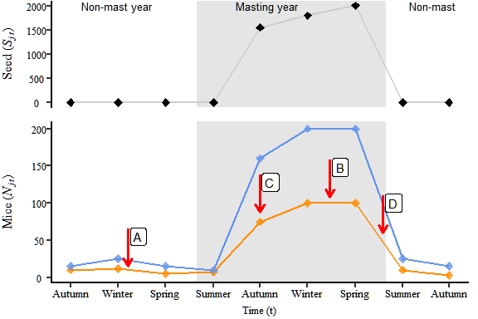

Figure 1: Expected changes in mouse populations over time in New Zealand forests (bottom panel) in response to changes in seed availability (top panel) during mast and non-mast years. In the bottom panel, arrows labelled A-D show the four predicted outcomes of stoat removal that we have tested in this paper. A) during non-mast years when little seed is available, B) at the peak of mouse abundance (during winter and spring in mast years), C) mouse populations should increase in size more rapidly in response to increased seed availability in mast years with stoat control than without; D) mouse populations should decline from peak abundance more slowly in mast years with stoat control than without.

This is particularly pronounced in beech forests where between years, beech seed production is highly variable with little seed produced in most years (Figure 1: non-mast years) and occasional years of high seed production (Figure 1: mast years). Mouse populations are low in non-mast years, due to low food availability (( Choquenot and Ruscoe 2000; King 1983). In mast years, when seed becomes abundant, mouse populations can increase rapidly following a predictable seasonal cycle. Seed begins to fall and accumulate on the forest floor in late summer allowing mouse populations to increase, with mouse populations typically remaining high through winter and into the following spring. Beech seed that is not consumed by mice and other seed predators germinates in spring to early summer, meaning this food resource disappears and mouse populations begin to decline. If the following year is a non-mast year with little seed available, mouse populations fall to low levels. It is unclear whether stoat populations can increase rapidly enough to exert sufficiently strong predation pressure to alter these food-driven population eruptions.

Previous studies have investigated the likely response of mouse populations to stoat control by modelling the outcome of interactions between stoats, mice and seed availability. Blackwell, Potter, and Minot (2001) made four predictions regarding the likely effects of stoat predation on mouse dynamics (see Figure 1) with a subsequent field study concluding that stoat predation should have minimal effects on the population dynamics of mice, identifying three different phases in the eruption cycle where stoats could have an effect (Figure 1). The subsequent study (Blackwell et al. 2003) specifically examined how stoat control could influence mouse populations at the peak (**Prediction B**), decline (**Prediction C**) or low (**Prediction A**) phases of the beech eruption cycle.

Subsequent modelling work reached similar conclusions (Tompkins and Veltman 2006; Tompkins, Byrom, and Pech 2013) but identified that the response of mice to stoat control should depend on interactions with rats. Specifically, (Tompkins, Byrom, and Pech 2013) concluded that, where rats were present, stoat control alone should allow rats to increase, which would have a suppressive effect on mouse populations through either predation or competition. In contrast, when both stoats and rats were controlled, mouse populations would increase to higher levels than in the absence of control (see *Figure 1*).

Our aim was to test the predictions outlined in both Blackwell et al. (2003) and Tompkins and Veltman (2006) using data from a large-scale field study. Specifically, we measured the abundance of mice and rats on trapping grids over six years in beech forest in two adjacent valleys, one with intensive stoat trapping and one without. In each valley we also manipulated rat densities by including trapping grids where rats were removed and compared these to grids without rat removal. This allowed us to examine if the response of mouse populations to stoat control (see *Figure 1*) was influenced by interactions with rats.

# Literature

Here is a review of existing methods.

# Methods

We carried out our study in beech forests in the South Island of New Zealand where stoats are the main predator and mice are the most abundant rodent species (King 1983). Ship rats (*Rattus rattus*; Innes (2005)) and kiore (*Rattus exulans*; Roberts (1991)) are also present but at much lower numbers (Jones et al. 2011). We tested whether reducing stoat populations by predator control influenced mouse population dynamics as shown in Figure 1, and whether the outcomes were affected by interactions between mice and rats. Specifically, we tested the following five predictions (Blackwell, Potter, and Minot (2001); Blackwell et al. (2003); Tompkins and Veltman (2006); and Tompkins, Byrom, and Pech (2013); Figure 1: **Prediction A to D**). Relative to sites without stoat control, mouse populations at sites with stoat control should exhibit (direction of red arrow; *Figure 1*):

1. Lower abundance in non-mast years;
2. Higher peak abundance in mast years;
3. A faster rate of increase in response to high seed availability in late summer during mast years;
4. A slower rate decline from peak abundance during mast years;
5. Predictions A-D should hold only when both stoat and rats are controlled.

## Data collection

Our study was carried out in two adjacent valleys: the Hollyford Valley (GPS *co-ord*, $44 \space 1 \space S$, $168 \space 1 \space E$) which has had intensive stoat control since 1983 to protect a vulnerable population of mohua (ODonnell and Phillipson 1996) and the Eglinton Valley ( GPS *co-ord*: $44 \space 2 \space S, \space$ $168 \space 5 \space E$ ) which had no stoat control conducted prior to and during the first part of our study (*pers comms*). To test **Predictions A-E**, we set up four trapping grids, in each valley, with each grid located at least **xx** kms apart. On each grid, we monitored the abundance of rodent species (mice, rats and kiore) using Elliot traps (**permit numbers?**. Each grid comprised $81$ traps with each trap located $20$ metres apart in a $9×9$ grid covering a total area of $2.56 \space ha \space (25600 \space m^2)$.

We estimated the abundance of rodents on each grid using capture-mark-recapture (CR), assuming a closed population during each trip, which typically lasted 5 nights. Traps were set prior to each night and all rodents captured were marked with ear tags so that individuals could be uniquely identified. Mice had single unique ear-tag, rats were ear tagged, and each individual was ear notched with a notch position that identified the night of first capture so we could identify animals that had been captured but had lost ear tags. We sexed and weighed each captured animal. We aimed to trap for five nights on each trip but due to unfavourable weather fewer nights were trapped on some trips.

We experimentally reduced rat (kiore and ship rats collectively) densities on two randomly selected grids in each valley by removing and humanely killing all captured rats on those grids **ref ethics?**). On the remaining two grids in each valley, we marked and released rats, as we did for mice on all grids.

To measure food availability we recorded the amount of seed reaching the forest floorby placing four standard circular seed-traps at **random** locations on each grid. Each trap had a radius of $tray_{i}=0.125m=0.0491m^{2}$ metres which over each trip equates to an overall sampled area on each grid of $Seed_{j,t}=Seed_{j,t}×0.1964m^{2}$. These seed traps were in place for the duration of the study, with each trap elevated $1.2$ metres above the ground and covered by wire netting to preclude seed predators. The contents of each seed-trap were collected once during each trip ($Seed_{j,t}$) and the contents were sorted to remove unwanted plant matter (e.g. leaf litter). We counted beech seeds, recording only those with a kernal because rodents are known to only consume the kernel of beech seeds [*cite*].

We undertook a total of *20* trips to the two valleys, with each trip spaced 3 months apart from May 1999 to February 2004. The timing of trips during the year corresponded to each of the four seasons (May = Autumn, August = Winter, November = Spring and February = Summer).

We aimed to test our predictions about the effects of stoat control by comparing mouse population dynamics in the two valleys. However, because we lacked replication at the valley-level, we could not be certain that differences in mouse population dynamics between valleys was due only to the presence or absence of stoat control. To overcome this, we undertook stoat control in the Hollyford Valley commencing in May 2002, allowing us to examine mouse dynamics in the presence or absence of stoat control in the same valley in addition to the between-valley comparison. Stoats were removed in the Hollyford Valley using 13 using Fenn Traps (are they following the road wendy? On map? data wendy?). The original treatments applied to the eight grids (two valleys; one with stoat control, one without, and; four grids in each valley, two with rat control and two without) were maintained from May 1999 to August 2002. From $November2002$**CHECK** onwards, we stopped collecting data from one rat control grid in each valley (Figure 2).

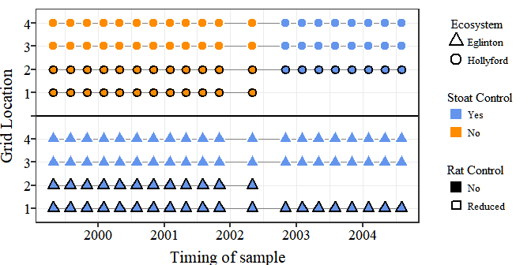

Figure 2: Schematic of the sampling design for this study showing the four grids in each valley labelled on the y axis. Each symbol represents a trip where mouse abundance, rat abundance and seed availability were measured on each grid, with circles for grids in the Hollyford valley and triangles for grids in the Eglinton valley. The colour and border of each symbol indicates whether each grid was subject to stoat and/or rat control. From May 2002 onward, stoat control commenced in the Hollyford valley and monitoring ceased on one grid without rat control in each valley.

## Statistical modelling

### Mouse abundance

We used the capture-recapture (CR) data to estimate the number of mice ($N_{j,t}$) on each grid ($j$) during each trip ($t$), assuming the numbers of mice on each grid were independent of each other and that the populations on each grid were closed for the duration of each trip. We had data on the number of times each mouse $i$ was captured on each grid, during each trip ($y_{i,j,t}$). We used the method described in Royle, Dorazio, and Link (2007) to estimate the number of mice from the CR data using data augumentation (Royle 2009, @royle2012a).

This involved augmenting data for the individual mice captured on each grid during each trip with pseudo-individuals that represented mice potentially present on the grid that were not captured. For the pseudo-individuals, the number of captures $y_{i,j,t}$ was set to zero. Each individual mouse, including the pseudo-individuals, was assigned an indicator variable $z_{i,j,t}$ taking the value 1 if the individual was present on the grid and 0 otherwise. For mice that were captured, $z_{i,j,t}$ is known and takes the value 1. For the pseudo-individuals, the value of $z_{i,j,t}$ is unknown and was estimated by modelling it as drawn from a Bernoulli distribution with overall probability of presence on a grid during a trip, $psi_{j,t}$:

$$z_{i,j,t}∼bernoulli(psi_{j,t})$$

The probability a individual mouse (including psuedo individuals) was captured $y_{i,j,t}$ times was drawn from a binomial distribution with probability, $μ_{i,j,t}$, conditional on the number of nights trapping on each grid during each trip $J_{j,t}$.

$$y_{i,j,t}∼bin\left(μ_{i,j,t},J_{j,t}\right)$$

$μ_{i,j,t}$ is the probabilty an individual was captured during one night of trapping on a grid. This depends on whether the individual was present on the grid or not ($z_{i,j,t}$) and the probability of capture conditional on presence ($p_{i,j,t}$).

$$μ_{i,j,t}=z_{i,j,t}×p_{i,j,t}$$

We specified the number of pseudo-individuals ($m_{j,t}$) to be $4×$ the total number of mice captured on each grid during each trip ($n_{j,t}$), which should be sufficient to ensure a non-informative prior (Royle, Converse, and Link 2012; Ruscoe et al. 2011).

We expected heterogeneity in the capture probabilities between grids and trips, and there is often heterogeneity among individuals in capture probability for small mammals (Krebs et al. 2011). We modelled variation in individual capture probability on the logit scale, allowing for heterogeneity by assuming values were drawn from a normal distribution with a different mean for each trip and grid ($μ.ind_{i,j,t}$). and a variance estimated from the data, which reflected unobserved among-individual heterogeneity. The mean capture probabilities for each trip and grid ($μ.ind_{j,t}$) were modelled hierarchically, treating them as draws from a normal distribution with overall mean and variance estimated from the data.

$$logit(p_{i,j,t})=lp_{i,j,t}$$

$$lp_{i,j,t}∼Normal(μ.ind_{j,t},τ.ind)$$

$$μ.ind_{j,t}∼Normal(μ_{p},τ_{p})$$

We estimated the number of mice on each grid during each trip $N_{j,t}$ by assuming the $z_{j,t}$.

$$N_{j,t}=∑z_{i,j,t}$$

We captured rats (ship rats and kiore combined) less often on grids than mice. Rather than a full capture-recapture analysis, we used the number of individual rats captured on each grid during each trip (the minimum number present) as an index of rat abundance. For each trip and grid we estimated seed availability as the number of seeds per $m^{2}$, averaged over all seed traps on a grid.

We tested our predictions as follows. To test if *stoat control resulted in more mice in seasons when mouse abundance was low* (Prediction A), we compared mouse abundance ($N_{j,t}$) on grids with and without stoat control during low periods of seed availability using two-way analysis of variance.

# You have a before-after design   
# how did your analysis account for this.   
# And what about rats?

To test if stoat control results in higher peak mouse abundance was high (**Prediction B**) we needed to account for the fact that peak abundance on gridsd would be partly driven by food avaliability (King 1983). We therefore compared the number of mice per seed ($N_{j,t+1}/N_{j,t}$) amoung grids with and without stoat control using the same ANOVA test as **Prediction A**.

To test **Prediction C** and **D** we modelled the **rate of increase of mice** ($r_{j,t}$) during the relevent seasons (Figure 1) with rate of increase as:

$$r_{j,t}=log\left(\frac{N_{j,t+1}}{N_{j,t}}\right)$$

To estimate ($r_{j,t}$) and propagate the uncertainty in our abundance estimates we used the complete data likelihood approach defined by Schofield and Barker (2014) (for details see Appendix 1.1).

To test predictions C and D we compared rates of increase with and without stoat control. To do this, we needed to account for other factors known to affect rates of increase in mouse populations, including seed availability, density dependence, and potential interactions with rats.

### Functional response

The relationship between seed availability and rate of increase will depend on the relationship between the number of seeds available to an individual mouse ($Seed_{j,t}$), how much is consumed and how this effects $r_{j,t}$ (Ruscoe et al. 2005).

# This needs a clearer explanation to step the reader through what you did.

In our population model we estimate the relationship between the intake rate (functional response output) and the population growth of the population rate ($r_{j,t}$) as linearity related the the “intake rate” ($S_{j,t}$). We estimate the consumption rate we fitted three theoretical models. A simple Type I (linear; $g(F^{1})=Seed_{j,t}$) functional response, a Type II functional response proposed by Holling (1959) ($g(F^{2})=log\left(Seed_{j,t}\right)$) and the fitted functional response estimated from data in NZ beech forests ((Choquenot and Ruscoe 2000); $g(F^{3})=1042.1\left(1−e^{−(Seed_{j,t}×0.00139)}\right)$. The third functional response was the best fitting functional response to data from the Eglinton Valley (Type II (IR); Ruscoe et al. (2005)). To test these three models for this “intake rate”, we fitted the different functional response models ($g(F^{i})$) to our data (Appendix 2).

Each function ($g(F^{i})$) was fitted to the cumulative beech seed falls data ($Seed_{j,t}$) where at each data point represents the average seed fall* (**data section**) *at each grid ($j$) and trip ($t$) compared to the rate of population growth ($r_{j,t}$) over the subsequent period ($r_{j,t+1}$). Models were assessed using two measures of model fit (r-squared and AIC; Appendix 2)). We found that the best fitting functional response was $S_{j,t}=log\left(Seed_{j,t}\right)$. For the population model we used the type II functional response to account for the “intake rate” $S_{j,t}$ of mice in relation to the rate of increase in mouse populations in relation to other community dynamics.

### Community dynamics

The model we fitted having identified the most appropriate functional response was:

$$r_{j,t}=β_{0,s,v,c}+β_{1,s,v,c}(S_{j,t})+β_{2,s,v,c}(N_{j,t−1})+β_{3,s,v,c}(R_{j,t−1})$$

# Explain what the beta terms represent in the model as part of describing each component

After accounting for the relationship between the *intake rate* ($S_{j,t}$) and the rate of increase in mouse populations we also know that mouse populations are regulated by other unidentified density dependent processes as well ($N_{j,t}$; Choquenot and Ruscoe (2000); Holland et al. (2015); Ruscoe et al. (2005)). It is still not clear what these density dependent processes are but it is still regarded that they are an important component of mice dynamics in NZ forests(Holland et al. 2015). In our model we include the abundance at time $t−1$ as a measure of density dependance ($N_{j,t−1}$).

Rats may also influence mouse populations via competition, because rats and mice have overlapping diets (King 2005; McQueen and Lawrence 2008), or possibly through direct predation (Bridgman et al. 2013). We were interested in whether there was a difference between areas with and without rats in relation to the outcome of mice dynamics. To do this we using the minimum number of rats in the season before ($R_{j,t−1}$).

# I see you do that here, but could be combined with the paragraph above.

To test **Prediction C** and **D** respectively (*does stoat control increase the rate at which mouse populations initially increasing/decreasing in response to beech seed intake*) we compared the population model intercept ($β_{i}$) between grids, with and without stoat control. Where $β_{0,s,v,c}$ (model intercept) is equivalent to $r_{j,t}$ when all other parameters are set to **zero** or **mean**; $β_{1,s,v,c}$ is the adjusted[1] effect of a intake rate ( $S_{j,t}$) on $r_{j,t}$; $β_{2,s,v,c}$ is the adjusted effect of a single unit change in mouse density at the beginning of the previous season $N_{j,t−1}$ and $β_{3,s,v,c}$ is the adjusted effect of a single unit change of the minimum number of rats alive ( $R_{j,t}$) at the beginning of the previous season $R_{j,t}$. If mesopredator release occurs in the increasing seasons; the intercept ($β_{0}$) for the areas with stoat control will be greater than the uncontrolled areas.

We tested if mes predator release only occurs when *rat populations are reduced to low densities.* (**Prediction E**) by comparing differences between population model coefficient for rats ($β_{3}$) grouped into the grids where we reduced rat densities and the others that where not. If rat interactions are sufficiently high to impact mice populations but only when stoats are at low levels would result in differences between these parameter estimates with replicates showing differing population dynamics.

[1] Refers to the model parameters being estimated after accounting for all other parameters in the population model (Model 1).

## Overall priors

# IS this the right place for priors?

Non-informative prior distributions were selected to allow the data to drive parameter estimation (Gelman and Pardoe 2006). The prior distributions of capture histories were assigned binomial distributions and variance terms were assigned broad uniform prior (0-100) as suggested by Gelman and Pardoe (2006). The remaining parameters were assigned normally distributed prior with mean 0 and variance 0.00001. Each model was run for 100 000 iterations with a burn-in of 50 000 iterations, which was sufficient to achieve convergence as judged by visual inspection of the chain histories.

## Software

Models were fitted in a Bayesian framework using Markov Chain Monte Carlo (MCMC) methods and implemented in JAGS (Plummer 2011), called from R v.4.3.4 using the jagsUI package (Kellner 2018). Each coefficient was modelled with uninformative priors for each season and valley. We specified non-informative priors to allow the data to drive parameter estimation (Gelman and Pardoe 2006). Each model was run for 100000 iterations with a burn-in of 50000 iterations, which was sufficient to achieve convergence as judged by visual inspection of the chain histories (Bronder, n.d.). For a full model description see Appendix 1.

# Results

We captured at total of ** individual mice, ** ship rats, and ** kiore during ** trips. The stoat control operation in the Eglinton Valley removed a total of $751$ individual stoats (**where did this come from?**) between May 1999 and June 2001 (**data missing for rest of study**). During this operation, low numbers of rats were also removed as by-catch in stoat traps but no other independent predator control was conducted (**pers comms?**).

Incidental stoat captures during our routine rodent trapping sessions were uncommon (proportion of total captures that were stoats = ), much lower in the Eglinton Valley ($N_{stoats}=8$) where the long-term predator control program was undertaken than the Hollyford Valley ($N_{stoats}=20$).

## Seeds

Our study captured three years of high seedfall ($1999$, $2000$ and $2003$). During all other years ($2001$, $2002$ and $2004$) we observed low seedfall in all grid (Figure. As expected, we observed high variability both between and within each trip. For example, in $2000$, the difference in seedfall between grids varied from the highest largest estimate of available seed ($Seed_{j,t} = 3387 \space m ^2$; Eglinton Valley) and another grid recording only ($Seed_{j,t} = 87 \space m ^2$; Hollyford Valley) on the same trip.

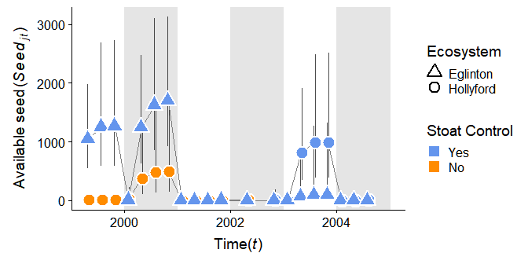

Figure 3: The average avaliable beech seed ($S_{j,t}$; point estimates) collected each season during the study period (Autumn 1999 to Winter 2004). The shape distinguishes the two valleys apart (triangle = Eglinton Valley, circle = Hollyford Valley) and solid symbols represent cases where stoats are uncontrolled and hollow in valleys with stoat removal.

## Mice

We estimated mouse abundance ($N_{j,t}$), where $j$ represents each unique grid and $t$ for each trip from the overall community dynamics model. Mouse found that mouse abundance was greatest in the Eglinton Valley in grids and trips where seed availability was also high. In any given year mouse abundance was on average greater in the Eglinton Valley (Figure 3.2; triangles) than the Hollyford Valley.

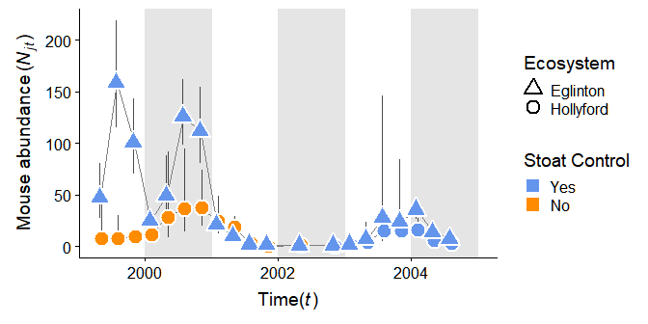

Figure 4: The abundance of mice ($N_{j,t}$; point estimates) collected each trip during the study period (Autumn 1999 to Winter 2004). The shape distinguishes the two valleys apart (triangle = Eglinton Valley, circle = Hollyford Valley) and solid symbols represent cases where stoats are uncontrolled and hollow in valleys with stoat removal.

## Rats

Rats and mice displayed a similar response to beech seed (Figure 3.3 and 3.2 respectively). Overall rat numbers ($R_{j,t}$) remained relatively low in both valleys throughout the six-year study except for a single trip in Spring 1999. The highest rat abundance was recorded where no stoat control was undertaken (Hollyford Valley).

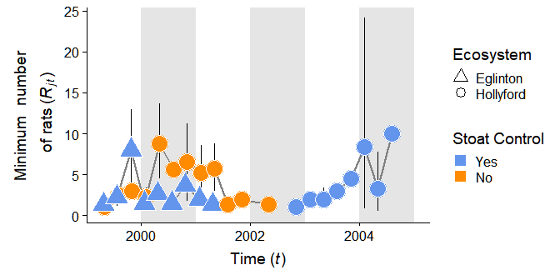

Figure 5: The estimates of rate captures ($R_{j,t}$; point estimates) collected each trip during the study period (Autumn 1999 to Winter 2004). The shape of each point distinguishes the two valleys (triangle = Eglinton Valley, circle = Hollyford Valley) and solid symbols represent cases where stoats are uncontrolled and hollow in valleys with stoat removal.

All other trips with high rat records were in areas with stoat control. In the Hollyford Valley during both mast-years, rats increased irrespective of stoat control (Figure 3.3; solid vs. open symbols). No rats were captured after May 2002.

## Community dynamics

We found that the *intake rate* ($S_{j,t}$) always had the greatest impact on $r_{j,k}$. Greater than both mouse density ($N_{j,t}$) and rat presence ($Rat_{j,t}$). We accounted for the confounding effects of community processes such as density and food avaliability using our bayesian model and then tested for evidence of mesopredator release of mice during our study. We used the fitted model estimates to assess the differences between the key predictions proposed for areas with and without control after accounting for both the observation error (data collection and population estimates) and process error (population dynamics; Ahrestani, Hebblewhite, and Post (2013)).

### Prediction A

*Stoat control does not increase mouse populations at times of low abundance.*

We compared the abundance of mice during trips when both mouse abundance and food availability were low and found no observable or significant differences in the estimates between areas with and without stoat control (f-stat = , CI = , p-value = *0.416489*) during any of the trips during our study. We did find that the variability in mouse abundance between the valley systems was different during these low mouse abundance phases (p-value = *0.0455377*).

We compared the abundance of mice during tripswhen both mouse abundance was low and food availability were low. We grouped the replicates between control areas (stoats present/absent), valleys( Eglinton and Hollyford Valleys) and rat conditions (rats reduced/not) and tested the differences between each group (Table 1).

We did not find any significant difference between areas with and without stoat control (p-value = 0.9299453). We found that the variation in mouse abundance was similar between our valley systems during these low mouse abundance times(p-value = 0.6835235). For Prediction A we did not need to account for varying seed input because seed fall was biological equivalent to zero for all grids and trips during low abundance seasons (Choquenot and Ruscoe 2000).

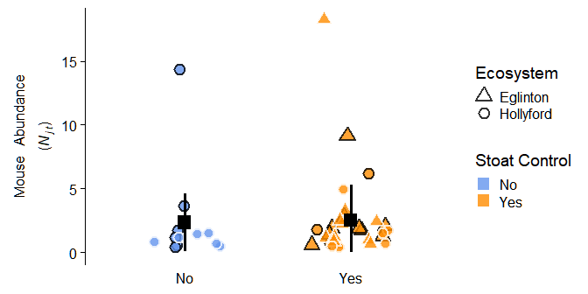

Figure 6: The unmodified abundance of mice in non-mast years (2001, 2003, 2004). The shape difference distinguishes the two valleys (triangle = Eglinton Valley, circle = Hollyford Valley), the yellow symbols represent cases where stoats are present and absent at points with black symbols and the solid symbols represent cases where rats are present and removed at points with hollow symbols.

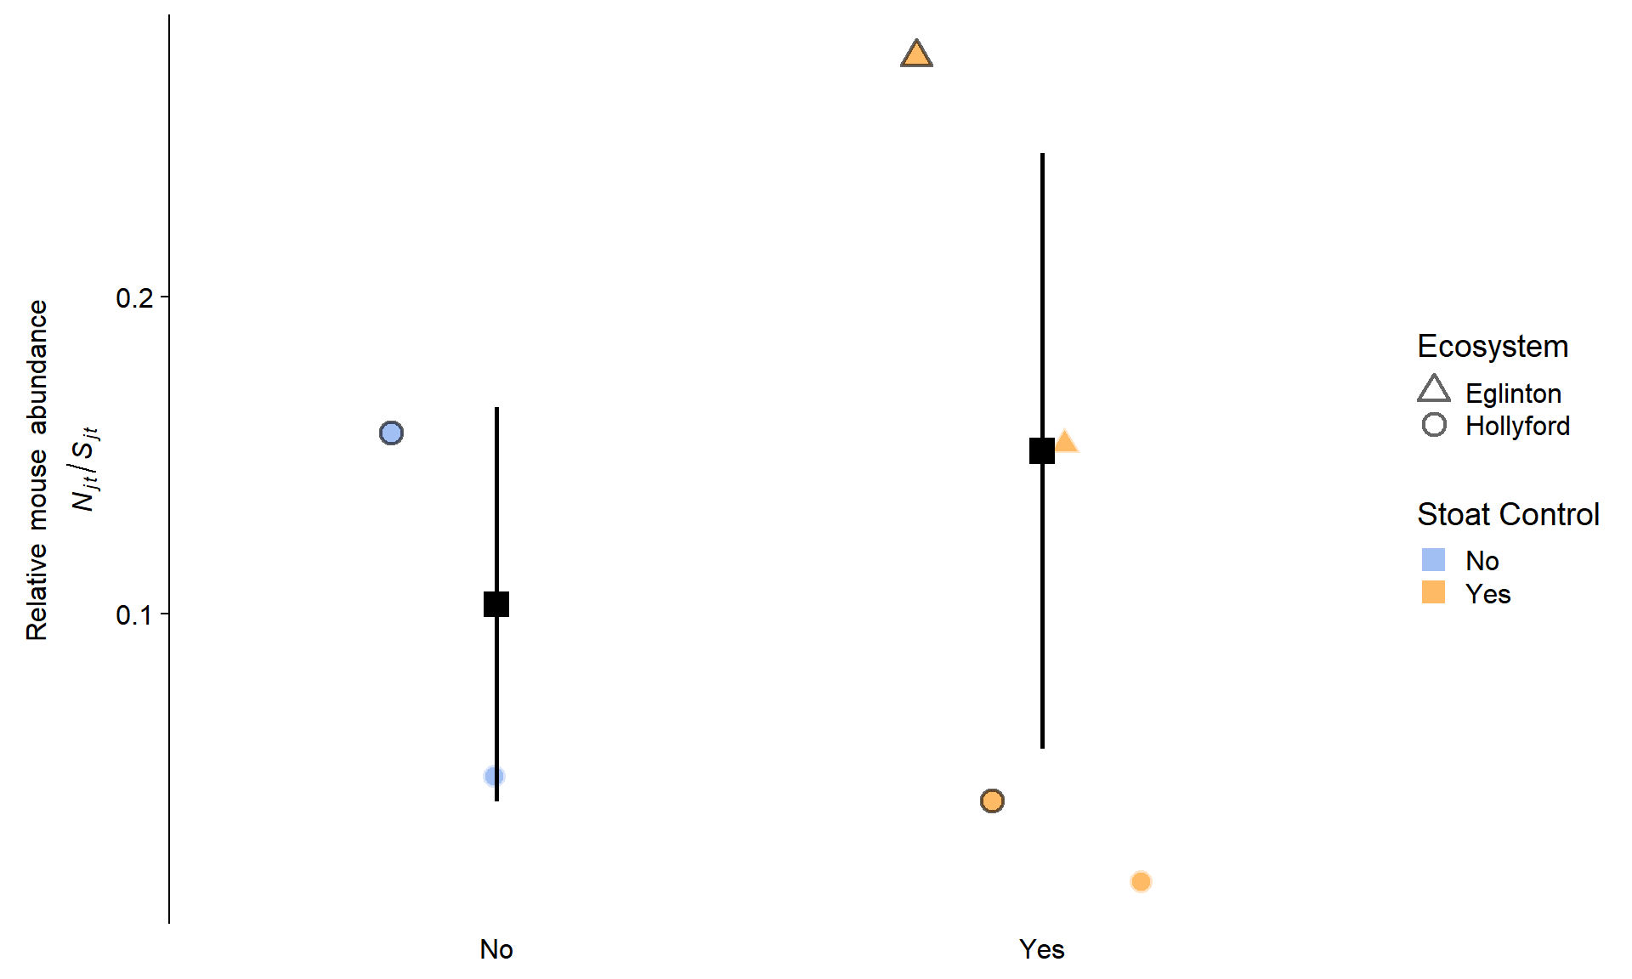

The unmodified abundance of mice in non-mast years (2001, 2003, 2004). The shape difference distinguishes the two valleys (triangle = Eglinton Valley, circle = Hollyford Valley), the yellow symbols represent cases where stoats are present and absent at points with black symbols and the solid symbols represent cases where rats are present and removed at points with hollow symbols.

For **Prediction A** we did not need to account for varying seed input because seed fall was biological equivalent to zero for all grids and trips during low abundance seasons (Choquenot and Ruscoe 2000).

### Prediction B

*Stoat control does not result in higher peak abundance of mice*

We manually accounting for the effect of seed during the high phases of mouse and seed abundance by dividing the total estimate of mouse abundance and dividing this by the intake rate ($\left(\frac{N_{j,t}}{S_{j,t}}\right)$) as a crude measure to account for the effects of food on mice populations. Our simple ANOVA model ([see here for analysis](www.ssnhub.com/beech-forest-publication/)) accounted for the differences in sample size between the areas with and without stoat control and un-equal variances within groups and found no significant difference between the stoat controlled and uncontrolled areas (**What is best here and I can repeat for all?**).

During the years of peak abundance in our study we did observe lower mouse abundance in the Hollyford Valley compared to the Eglinton Valley (**??**). Although this is not below the $0.05$ threshold. It should be noted that when the rat removal treatment was removed the p-value did drop below 0.05 (**??**).

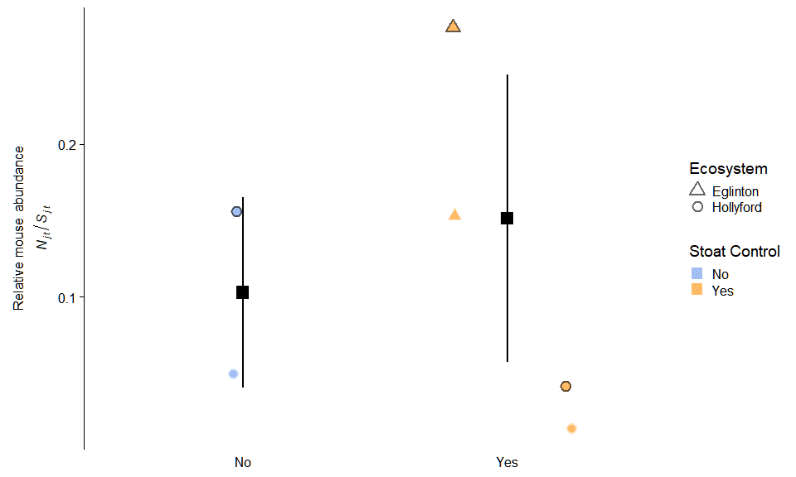

Figure 7: Difference between areas with and without stoat control at peak mouse abundance. The shape distinguishes the two valleys (triangle = Eglinton Valley, circle = Hollyford Valley). The yellow symbols represent cases where stoats are present and absent at points with black symbols and the solid symbols represent cases where rats are present and removed at points with hollow symbols.

### Prediction C

*Stoat control did not increase mouse populations as food becomes avaliable.*

We tested the differences in the rate of increase of mouse populations between the four seasons, two valleys and stoat control areas (excluding the rat treatment) during seasons when mouse population were increasing (August; Autumn - Winter). We found was no significant differences between mice populations ($r_{j,t}$) during the increasing seasons of mouse dynamics. All 95% credible intervals for the differences between these trips included zero (Figure 10).

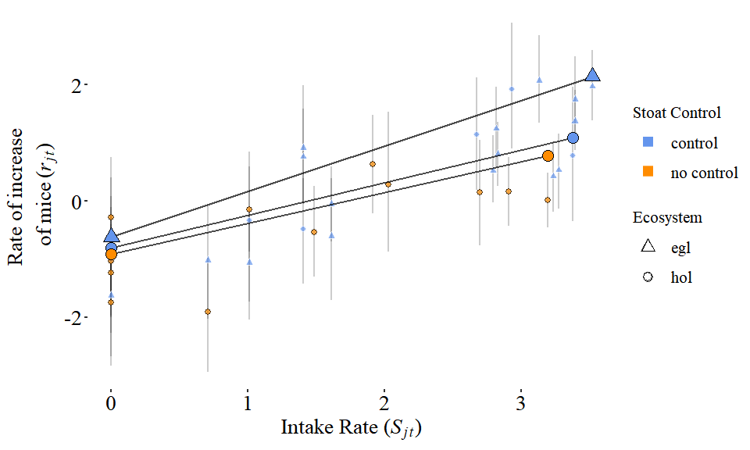

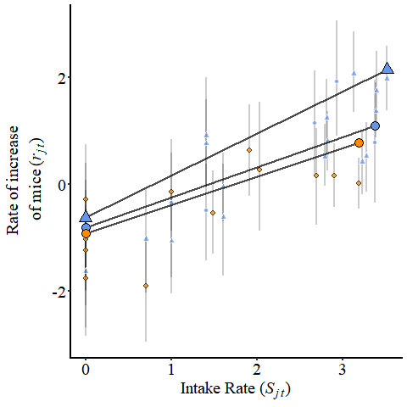

Figure 8: Visual representation of the effect of stoat control on the rate of increase in mice during the increasing seedfall (Autumn to Winter; **Prediction C**). The left column represents the untransformed estimates of seed $Seed_{t}$ (a), mouse density $N_{t−1}$ (b) and MNA of rats $R_{t}$ (c) in relation to rate of increase (). The right-hand column is the corresponding parameter estimate from the population model. The shape difference distinguishes the two valleys (triangle = Eglinton Valley, circle = Hollyford Valley) and the solid symbols represent cases where stoats are present and absent at points with hollow symbols.

### Prediction D

*Stoat control did not hasten the decline from peak abundance.*

This prediction specifically focused on the Spring and Summer seasons, when rodent populations are crashing (Figure 3.1 vs. Figure 3.2). Overall density had a weak negative effect on mice dynamics under all conditions (Figure 3.2) but was greatest during the declining seasons of mice dynamics. After accounting for seed and density in the population model there was a faster rate of decline in the Hollyford Valley (dashed lines) compared to the Eglinton Valley but this was not statistically significant.

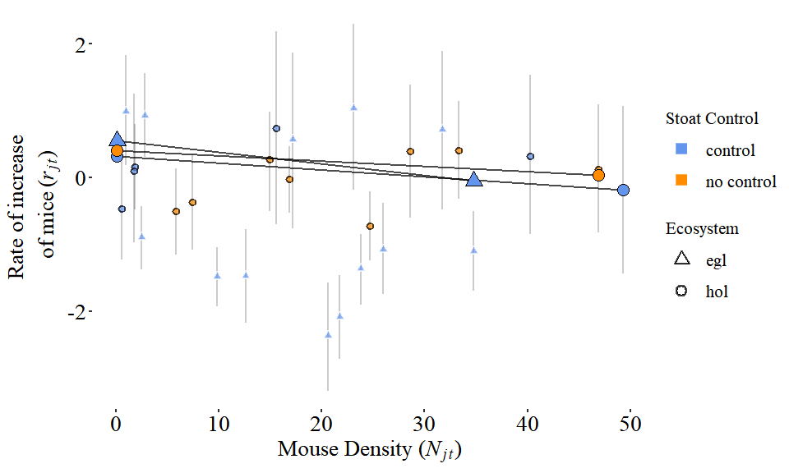

(#fig:decreasing_seed_and_r_plot)Results for the effect of stoat control during the decreasing seasons (Spring to Summer; prediction three). The left column represents the untransformed estimates of seed $S_{j,t}$ (a), mouse density $N_{t−1}$ (b) and MNA of rats $R_{t−1}$ (c) in relation to rate of increase (). The right-hand column is the corresponding parameter estimate from the population model. The shape difference distinguishes the two valleys (triangle = Eglinton Valley (E), circle = Hollyford Valley) and the solid symbols represent cases where stoats are present and absent at points with hollow symbols. Parameter estimates (d,e,f) represent the differences in stoat control between valleys (left; hollow triangle) and within valley (right; hollow circle).

### Prediction E

*Does the presence of rats impact the population dynamics of mice at each of the seasons tested in Predictions A-D.*

We found that rat numbers $R_{j,t}$ had the smallest overall effect on mice dynamics ($\mu(\beta_3 | All \space Seasons)= 0.007$) and was the most variable parameter in our community model ($CV_{rats}=5.74$). We recorded the highest number of rats in February and May, at the same times of high mouse abundance (Figure 3.3).

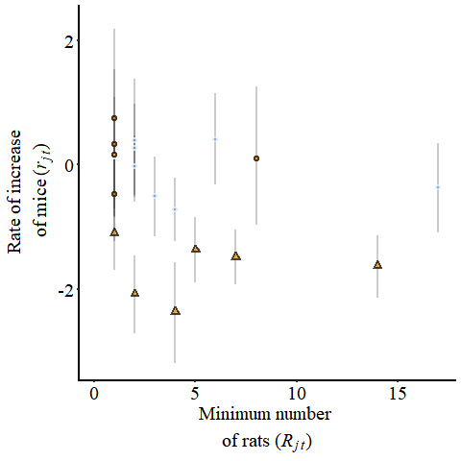

The unmodified abundance of mice in non-mast years. The shape difference distinguishes the two valleys, the yellow symbols represent cases where stoats are present and absent at points with black symbols and the solid symbols represent cases where rats are present and removed at points with hollow symbols.

The relationship between rats and mice was examined by comparing the estimated differences between treatments (Figure 8; lines represent mean relationships in the three treatment groups). We also statistically testing the difference between each different treatment and found no differences across all parameters (Figure 9).

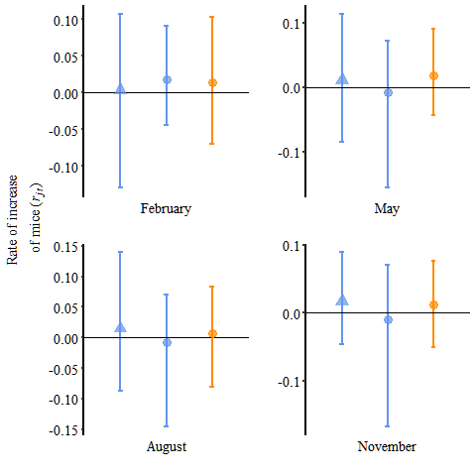

The unmodified abundance of mice in non-mast years. The shape difference distinguishes the two valleys, the yellow symbols represent cases where stoats are present and absent at points with black symbols and the solid symbols represent cases where rats are present and removed at points with hollow symbols.

We did not have enough data to estimate a statistical interaction between rats and mice (non-linear relationship) or other more complex non-linear models for rat dynamics.

## Conclusion

#### One

*Mouse populations* ***were not*** *affected by stoat control during any of the four seasonal seasons of New Zealand beech forests.*

#### Two

*Outcomes from predictions A-D did* ***not change*** *when rat populations were manually reduced to lower densities.*

# Discussion

Overall our study found no evidence of mesopredator release in the mouse populations we monitored. We used a Bayesian Hierarchical Model (BHM) to test our five predictions by experimentally manipulating ecosystem scale predator control to compare differences between areas with or without stoat control and a rat removal treatment on half our replicates. Our model replicated the mouse dynamics in our data and produced similar results to other NZ mammals community models (Choquenot and Ruscoe (2000); Ruscoe, Goldsmith, and Choquenot (2001); Ruscoe et al. (2005); Tompkins and Veltman (2006); Tompkins, Byrom, and Pech (2013); Holland et al. (2015); summarised in Figure 1). High food availability resulting in high mouse abundance is commonly observed in a range of NZ forest types (Innes et al., n.d.; Sweetapple, n.d.; Ruscoe et al. 2011, 2012). Modelling has incorporated these parameter estimates to represent invasive species dynamics in NZ forests (Tompkins and Veltman 2006; Tompkins, Byrom, and Pech 2013; Holland et al. 2015) A naive investigation of our summarised data (Figure 3.1, 3.2, and 3.3) might have falsely lead to similarly low powered conclusions, that rats may have an effect on mice dynamics as well as many generally accepted relationships. By using a BHM framework we were able to test the theoretical relationships proposed using experimental data.

#### Seed avaliablilty

When we fit our community model to the replicated CR data we found that beech seed and the subsequent *intake rate* had the greatest impact on mice populations in all seasons. We found that $r_{j,t}$ was strongest on grid and trips when beech seed was increasing. After comparing a selection of functional responses to our data (Appendix 1.3) we found the best type II response and converted our estimated $Seed_{j,k}$ per $m^{2}$ to the “*intake rate*” $S_{j,t}$. We found that the effect of mouse density ($N_{j,t}$) and rats ($R_{j,t}$) was lower than the “*intake rate*” ($S_{j,t}$). We observed that the effects of density were greatest during the declining seasons. These differences in effect sizes are similar to other studies.

#### Mouse density

The effect of mouse density and rats on was much lower and were also similar to other published results (Choquenot and Ruscoe 2000). We and many other studies observed high heterogeneity in abundance estimates. This type of data can be difficult to model correctly in many frequentest frameworks. To account for this heterogeneity in the biological data we used experimental manipulation and bayesian modelling framework to account for the confounding effects of food availability, mouse density, and rats to simultaneously assess the overall effect of stoat control on mice dynamics. Importantly, our model captured both the observational and process variability within NZ beech forests. We also conclude that the underlying heterogeneity in small mammal populations was sufficiently large to make estimating true response of mice to rats difficult in biological experiments (Figures 4-9).

#### Rat presence

Our results suggest that it is unlikely that rats have strong impacts on the rate of increase of mice in our large scale study system. Contrary to this, previous laboratory experiments suggested that interactions between mice and rats were negatively related to predation or competition effects and limited evidence of competition release has been observed in mixed podocarp-tawa forests in NZ. We found that rats had the smallest impact on mice dynamics (Figure 8). In part, this is due to the high variability in the number of rats and kiore between grids and sampling trips in our study (**??**), which is often the case in non-laboratory studies. Instead of rats/kiore being present but at low numbers in all grids (low effect size and low uncertainty), there were only a few grids that had comparability high numbers. This result suggests that refugee areas may exist and can support larger rodents in beech forests that current averages suggest. Overall, it is likely that beech forests do not have enough resources to support larger spatially uniform populations of rats.

## Bayesian modelling

The application of BHM’s in ecology has been increasing over the past decade (King 2012). BHM modelling can provide challenges when selecting models and assessing model fit (Auger-Méthé et al. 2016). To account for this, we used the general associations above as well as AIC and r-squared. We then used these parameters to fit the proposed theoretical population model. We investigated the patterns in our model to insure we adequately encapsulated the patterns in the data with our model to assess the effects of our parametrisation above. Large-scale ecological experiments are very informative but often need to be interpreted with caution due to often unique problems. We address these below and add additional direction to address these uncertainties in the results we found.

Our population model representation is relatively simplistic compared to some of the previous models that incorporated more interacting species and subsequently complex interactions. Our experimental design was just a big taking advantage of the situation to built a simple population model from CR data. A benefit to a simple BHM model is the ability to use bayes theorem to re-assess additional data in context of the proposed predictions. In the context of the data we have used in this experiment and uninformative priors. We choose to focus on high quality data collection methods and the key dynamics already identified with invasive species dynamics in NZ beech forests. There are however several key aspects that may be confounding our results, to the observational and population model choices.

## Stoat control

An alternative explanation for the lack of any observed effects of stoat control on mouse abundance was that the removal of animals was potentially limited by the effectiveness of a particular stoat control program, management or experimental design.

If trapping did not remove a sufficient number of individual stoats to reduce predation pressure we will not observe the theoretical responses proposed by Tompkins, Byrom, and Pech (2013) and others.

High individual heterogeneity in the capture rates of stoats at both high and low mouse densities makes reductions to zero individuals virtually impossible targets. This was the case in our study where by-catch of stoats in controlled areas was observed. As an indication of removal, $4.75$ times more stoats were removed from the stoat control program (Hollyford Valley 2001-2004) than caught in by-catch in areas already being controlled prior to the experiment. Our before/after treatment tested this and verified that we did not find differences within the grid when experimental treatments were changed. We may also be missing the impact of by-catch of other pests in stoat traps. We believe that any effect this may have on mice dynamics would be limited due to the limited impacts of rat removal in our data. Biologically, the differences in home range size of rodent species (10’s ha; (Bramley 2014; Innes and Skipworth 1983; Pryde, Dilks, and Fraser 2005)) relative to the home range of stoats and the scale of trap line (100’s ha; (Miller, Elliot, and Alterio 2001; Murphy and Dowding 1995)) which suggests that population level impacts from these removals is unlikely due to the limited number of animals removed and the re-invasion biology of rodents (Bramley 2014).

**<- is this too critical given ?… ->**

(Blackwell, Potter, and Minot 2001; Blackwell et al. 2003): However, the limited geographical scale of the study, low statistical power and replication between different forest types makes it difficult to compare the effect of different treatment types during the four different seasons.

Repleccate and extend on larger scale. **<- is this too critical given ?… ->**

## Resource pulse systems

During our study we found stoat control had minimal impact on mice populations compared to beech seed. Beech forests have previously defined as *resource pulse systems* (Wardle, n.d.). Strong resource pulses cause strong effects throughout an ecosystem (Yang et al. 2008). The process behind for this phenomenon is that even in the absence of control, stoats cannot attain high enough densities to limit mouse populations under conditions of high food availability (King 1983). Furthermore, the intrinsic differences in the reproductive and growth rates (life history traits) of each species reduces the ability of stoats to regulate mouse populations at the beginning of a masting event(King and Powell 2011). By taking the proposed processes that effect mice dynamics and applying a hierarchical model framework allows us to test and estimate effect sizes that further reduce uncertainty in the outcomes of predator control in NZ beech forests.

The effects of climate change and other human lead impacts will have lasting impacts on on future rodent dynamics (Holland et al. 2015). Population models of climate change indicate a shift to prolonged but lower overall mast events where it may be possible to observe mesopredator release of mice with the removal of predators (Tompkins, Byrom, and Pech 2013). Mice populations monitored in more complex forest ecosystems suggest complex interactions between top-down and bottom-up effects (Ruscoe et al. 2011, 2012). These studies suggest that rodent populations would increase in other NZ forest ecosystems after the removal of stoats (Ruscoe et al. 2011) or other invasive predators (Rayner et al. 2007).

## Challanges

Population level responses such as abundance and rate of increase are often measured using indices (e.g. MNA). This can lead to difficulty in estimating population level parameters such as density. We aimed to avoid this bias as we estimated mice abundance using capture-recapture (CR) data and an integrated population model to correctly account for uncertainty in abundance estimation when fitting the population model of mice dynamics. However due to limited population numbers and data, only indices could be used to represent rat interactions. Independent research in beech forests has shown a high correlation between indices of rats in this valley and CR data. Nevertheless, increasing the quality of the rat/kiore data would most likely reduce uncertainty on the estimates of these parameter estimates. By calculating the maximum increase from the fitted population model we were able to compare the maximum population growth rate to other studies ($R.max_{mice}=actualnumberhere$; Hone, Duncan, and Forsyth (2010)), however, analogous models are not directly comparable because they do not include a resource component (e.g. beech seed production) or use indices (e.g. $R_{j,t}$ ). Field studies are also difficult to directly compare because may studies incorporate structurally different ecosystems (e.g Ruscoe et al. (2011)), species indices instead of true abundance estimation using CR models or did not report effect sizes. Although this limitations exist our comparisons to general trends were all comparable to our model estimates and our estimates are all biologically viable.

## Management implications

Our model has subtle but important differences compared previous research when in comes to management application. We have incorporated a reproducible workflow(British Ecological Society 2018) for the future development of model testing for different and new datasets (Wickham 2014). In doing this we have incorporated leading reproducible science techniques to help address any aspects of our study may need for further support. Often studies of such large scale can address key population-level questions however these studies struggle to find replication because of the scale at which they are conducted (Oksanen 2001). Many issues that many confront a PFNZ2050 will be reduced by using simple but well fitted BHMs for predicting and allocation management resources.

#### Predator-free NZ

Our integrated population modelling approach and the large, high-quality CR data used to parametrise the model allowed us to predict and report the biologically relevant effect sizes. We used this to address the direct question of stoat control in NZ Beech Forests. Future studies can now test and assess the beech forest ecosystem compared to the data they collect. By using the unified modelling framework presented in this paper (Appendix 3; [Davidson (2019)), reproducible research practises and “tidy-data” (Wickham 2014). Many of the processes we have verified were previously hypothesized using indices of mice abundance (Blackwell, Potter, and Minot 2001; Blackwell et al. 2003), laboratory experiments (Bridgman et al. 2013), novel systems such as remote islands (Mulder et al. 2009) and small patches of mainland forest (Blackwell, Potter, and Minot 2001; Blackwell et al. 2003). We have integrated these results into a framework that can now test these results in other systems that are hypothesized to be different. It will be important for future work to continue monitoring this system for anomalies and unexpected patterns such as increases in other invasive predators, particularly rats.

# Prerequisites

This is a *sample* book written in **Markdown**. You can use anything that Pandoc’s Markdown supports, e.g., a math equation $a^{2}+b^{2}=c^{2}$.

The **bookdown** package can be installed from CRAN or Github:

Remember each Rmd file contains one and only one chapter, and a chapter is defined by the first-level heading #.

To compile this example to PDF, you need XeLaTeX. You are recommended to install TinyTeX (which includes XeLaTeX): <https://yihui.name/tinytex/>.

Ahrestani, Farshid S., Mark Hebblewhite, and Eric Post. 2013. “The Importance of Observation Versus Process Error in Analyses of Global Ungulate Populations.” *Scientific Reports* 3 (1). <https://doi.org/10.1038/srep03125>.

Allen, Robert B, and W G Lee. 2006. *Biological Invasions in New Zealand*.

Auger-Méthé, Marie, Chris Field, Christoffer M. Albertsen, Andrew E. Derocher, Mark A. Lewis, Ian D. Jonsen, and Joanna Mills Flemming. 2016. “State-Space Models’ Dirty Little Secrets: Even Simple Linear Gaussian Models Can Have Estimation Problems.” *Scientific Reports* 6 (1). <https://doi.org/10.1038/srep26677>.

Blackwell, G L, M A Potter, J A McLennan, and E O Minot. 2003. “The Role of Predators in Ship Rat and House Mouse Population Eruptions: Drivers or Passangers?” *Oikos* 100 (3): 601–13.

Blackwell, G. L., M. A. Potter, and E. O. Minot. 2001. “Rodent and Predator Population Dynamics in an Eruptive System.” *Ecological Modelling* 142 (3): 227–45. <https://doi.org/10.1016/S0304-3800(01)00327-1>.

Bramley, Gary N. 2014. “Home Ranges and Interactions of Kiore (Rattus Exulans) and Norway Rats (R. Norvegicus) on Kapiti Island, New Zealand.” *New Zealand Journal of Ecology* 38 (2): 7.

Bridgman, L. J., J. Innes, C. Gillies, N. B. Fitzgerald, S. Miller, and C. M. King. 2013. “Do Ship Rats Display Predatory Behaviour Towards House Mice?” *Animal Behaviour* 86 (2): 257–68. <https://doi.org/10.1016/j.anbehav.2013.05.013>.

British Ecological Society. 2018. “The British Ecological Society’s Guide to Reproducible Science.” <https://blog.revolutionanalytics.com/2017/12/bes-reproducible-science.html>.

Bronder, Steve. n.d. “Bayesian Hierarchical Models,” 19.

Choquenot, David, and Wendy A Ruscoe. 2000. “Mouse Population Eruptions in New Zealand Forests: The Role of Population Density and Seedfall.” *Journal of Animal Ecology* 69: 1058–70.

Clout, M. N., and P. D. Gaze. 1984. “Brushtail Possums (Trichosurus Vulpecula Kerr) in a New Zealand Beech (Nothofagus) Forest.” *New Zealand Journal of Ecology*, 147–55.

Davidson, Anthony R. 2019. *Anthony Davidson - Overview*. <https://github.com/davan690>.

Gelman, Andrew, and Iain Pardoe. 2006. “Bayesian Measures of Explained Variance and Pooling in Multilevel (Hierarchical) Models.” *Technometrics* 48 (2): 241–51. <https://doi.org/10.1198/004017005000000517>.

Holland, E Penelope, Alex James, Wendy A Ruscoe, Roger P Pech, Andrea E Byrom, and E Byrom. 2015. “Climate-Based Models for Pulsed Resources Improve Predictability of Consumer Population Dynamics: Outbreaks of House Mice in Forest Ecosystems.” *PloS One*, 1–16. <https://doi.org/10.1371/journal.pone.0119139>.

Holling, C. S. 1959. “The Components of Predation as Revealed by a Study of Small-Mammal Predation of the European Pine Sawfly1.” *The Canadian Entomologist* 91 (5): 293–320. <https://doi.org/10.4039/Ent91293-5>.

Hone, Jim, Richard P. Duncan, and David M. Forsyth. 2010. “Estimates of Maximum Annual Population Growth Rates (Rm) of Mammals and Their Application in Wildlife Management: Estimating Maximum Population Growth Rate.” *Journal of Applied Ecology* 47 (3): 507–14. <https://doi.org/10.1111/j.1365-2664.2010.01812.x>.

Innes, J. G., and J. P. Skipworth. 1983. “Home Ranges of Ship Rats in a Small New Zealand Forest as Revealed by Trapping and Tracking.” *New Zealand Journal of Zoology* 10 (1): 99–110. <https://doi.org/10.1080/03014223.1983.10423895>.

Innes, John G. 2005. “Ship Rat.” In *The Handbook of New Zealand Mammals*, edited by Carolyn M King, 2nd ed., 187–203. Melbourne: Oxford University Press.

Innes, John, Dave Kelly, Jacob McC Overton, and Craig Gillies. n.d. “Predation and Other Factors Currently Limiting New Zealand Forest Birds,” 1.

Jones, Christopher, Roger Pech, Guy Forrester, Carolyn M. King, and Elaine C. Murphy. 2011. “Functional Responses of an Invasive Top Predator Mustela Erminea to Invasive Meso-Predators Rattus Rattus and Mus Musculus, in New Zealand Forests.” *Wildlife Research* 38 (2): 131–40. <https://doi.org/10.1071/WR10137>.

Kellner, Ken. 2018. *jagsUI: A Wrapper Around ’Rjags’ to Streamline ’JAGS’ Analyses*. <https://CRAN.R-project.org/package=jagsUI>.

King, Carolyn M. 2017. “Pandora’s Box down-Under: Origins and Numbers of Mustelids Transported to New Zealand for Biological Control of Rabbits.” *Biological Invasions* 19 (6): 1811–23. <https://doi.org/10.1007/s10530-017-1392-6>.

King, Carolyn M. 1983. “The Relationships Between Beech (Nothofagus Sp.) Seedfall and Populations of Mice (Mus Musculus), and the Demographic and Dietary Responses of Stoats (Mustela Erminea), in Three New Zealand Forests.” *Journal of Animal Ecology* 52 (1): 141–66.

King, Carolyn M., and Roger A. Powell. 2011. “Managing an Invasive Predator Pre-Adapted to a Pulsed Resource: A Model of Stoat (Mustela Erminea) Irruptions in New Zealand Beech Forests.” *Biological Invasions* 13 (12): 3039–55. <https://doi.org/10.1007/s10530-011-9993-y>.

King, C M. 2005. *The Handbook of New Zealand Mammals*. Oxford University Press.

King, R. 2012. “A Review of Bayesian State-Space Modelling of Capture-Recapture-Recovery Data.” *Interface Focus* 2 (2): 190–204. <https://doi.org/10.1098/rsfs.2011.0078>.

Krebs, Charles J., Rudy Boonstra, Scott Gilbert, Donald Reid, Alice J. Kenney, and Elizabeth J. Hofer. 2011. “Density Estimation for Small Mammals from Livetrapping Grids: Rodents in Northern Canada.” *Journal of Mammalogy* 92 (5): 974–81. <https://doi.org/10.1644/10-MAMM-A-313.1>.

Latham, A. David M., Bruce Warburton, Andrea E. Byrom, and Roger P. Pech. 2017. “The Ecology and Management of Mammal Invasions in Forests.” *Biological Invasions* 19 (11): 3121–39. <https://doi.org/10.1007/s10530-017-1421-5>.

McQueen, Shirley, and Barry Lawrence. 2008. “Diet of Ship Rats Following a Mast Event in Beech (Nothofagus Spp.) Forest.” *New Zealand Journal of Ecology* 32 (8): 214–18.

Miller, Craig, Mike Elliot, and Nic Alterio. 2001. “Home Range of Stoats (Mustela Erminea) in Podocarp Forest, South Westland, New Zealand: Implications for a Control Strategy.” *Wildlife Research* 28 (2): 165. <https://doi.org/10.1071/WR00001>.

Mulder, Christa P. H., M. Nicole Grant-Hoffman, David R. Towns, Peter J. Bellingham, David A. Wardle, Melody S. Durrett, Tadashi Fukami, and Karen I. Bonner. 2009. “Direct and Indirect Effects of Rats: Does Rat Eradication Restore Ecosystem Functioning of New Zealand Seabird Islands?” *Biological Invasions* 11 (7): 1671–88. <https://doi.org/10.1007/s10530-008-9396-x>.

Murphy, Elaine C, and John E Dowding. 1995. “Ecology of the Stoat in Nothofagus Forest: Home Range, Habitat Use and Diet at Different Stages of the Beech Mast Cycle.” *New Zealand Journal of Ecology* 19 (2): 13.

ODonnell, C F J, and S M Phillipson. 1996. “Predicting the Incidence of Mohua Predation from the Seedfall, Mouse, and Predator Fluctuations in Beech Forests.” *New Zealand Journal of Zoology* 23 (3): 287–93. <https://doi.org/10.1080/03014223.1996.9518087>.

Oksanen, Lauri. 2001. “Logic of Experiments in Ecology: Is Pseudoreplication a Pseudoissue?” *Oikos* 94 (1): 27–38.

Plummer, Martyn. 2011. “JAGS Developers Manual.” <https://sourceforge.net/projects/mcmc-jags/files/Manuals/3.x/jags_user_manual.pdf/download>.

Prugh, Laura R., Chantal J. Stoner, Clinton W. Epps, William T. Bean, William J. Ripple, Andrea S. Laliberte, and Justin S. Brashares. 2009. “The Rise of the Mesopredator.” *BioScience* 59 (9): 779–91. <https://doi.org/10.1525/bio.2009.59.9.9>.

Pryde, Moira, Peter Dilks, and Ian Fraser. 2005. “The Home Range of Ship Rats (Rattus Rattus) in Beech Forest in the Eglinton Valley, Fiordland, New Zealand: A Pilot Study.” *New Zealand Journal of Zoology* 32 (3): 139–42.

Rayner, Matt J, Mark E Hauber, Michael J Imber, Rosalie K Stamp, and Mick N Clout. 2007. “Spatial Heterogeneity of Mesopredator Release Within an Oceanic Island System.” *Proceedings of the National Academy of Sciences of the United States of America* 104 (52): 20862–5. <https://doi.org/10.1073/pnas.0707414105>.

Roberts, Mere. 1991. “Origin, Dispersal Routes, and Geographic Distribution of Rattus Exulans, with Special Reference to New Zealand!” *PACIFIC SCIENCE* 45: 8.

Robles, Carlos D, and Robert Desharnais. 2002. “History and Current Development of a Paradigm of Predation in Rocky Intertidal Communities.” *Ecology* 83 (6): 1521–36. [https://doi.org/10.1890/0012-9658(2002)083[1521:HACDOA]2.0.CO;2](https://doi.org/10.1890/0012-9658(2002)083%5B1521:HACDOA%5D2.0.CO;2).

Royle, J. Andrew. 2009. “Analysis of Capture-Recapture Models with Individual Covariates Using Data Augmentation.” *Biometrics* 65 (1): 267–74. <https://doi.org/10.1111/j.1541-0420.2008.01038.x>.

Royle, J. Andrew, Sarah J. Converse, and William A. Link. 2012. “Data Augmentation for Hierarchical Capture-Recapture Models,” November. <http://arxiv.org/abs/1211.5706>.

Royle, J. Andrew, Robert M Dorazio, and William A Link. 2007. “Analysis of Multinomial Models with Unknown Index Using Data Augmentation.” *Journal of Computational and Graphical Statistics* 16 (1): 67–85. <https://doi.org/10.1198/106186007X181425>.

Ruscoe, Wendy A, Joseph S Elkinton, David Choquenot, and Robert B Allen. 2005. “Predation of Beech Seed by Mice: Effects of Numerical and Functional Responses.” *Journal of Animal Ecology* 74: 1005–19. <https://doi.org/10.1111/j.1365-2656.2005.00998.x>.

Ruscoe, Wendy A, Ruth Goldsmith, and David Choquenot. 2001. “A Comparison of Population Estimates and Abundance Indices for House Mice Inhabiting Beech Forests in New Zealand.” *Wildlife Research* 28: 173–78.

Ruscoe, Wendy A, David S. L. Ramsey, Roger P. Pech, Peter J. Sweetapple, Ivor Yockney, Mandy C. Barron, Mike Perry, et al. 2011. “Unexpected Consequences of Control: Competitive Vs . Predator Release in a Four-Species Assemblage of Invasive Mammals.” *Ecological Letters* 14: 1035–42. <https://doi.org/10.1111/j.1461-0248.2011.01673.x>.

Ruscoe, Wendy A., Peter J. Sweetapple, Mike Perry, and Richard P. Duncan. 2012. “Effects of Spatially Extensive Control of Invasive Rats on Abundance of Native Invertebrates in Mainland New Zealand Forests: Effects of Invasive Rat Control.” *Conservation Biology* 27 (1): 74–82. <https://doi.org/10.1111/j.1523-1739.2012.01932.x>.

Schofield, Matthew R., and Richard J. Barker. 2014. “Hierarchical Modeling of Abundance in Closed Population Capture–Recapture Models Under Heterogeneity.” *Environmental and Ecological Statistics* 21 (3): 435–51. <https://doi.org/10.1007/s10651-013-0262-3>.

Sweetapple, P J. n.d. “Effect of Reduced Possum Density on Rodent and Stoat Abundance in Podocarp-Hardwood Forests,” 25.

Tompkins, Daniel M., Andrea E. Byrom, and Roger P. Pech. 2013. “Predicted Responses of Invasive Mammal Communities to Climate-Related Changes in Mast Frequency in Forest Ecosystems.” *Ecological Applications* 23 (5): 1075–85. <https://doi.org/10.1890/12-0915.1>.

Tompkins, Daniel M, and Clare J Veltman. 2006. “Unexpected Consequences of Vertebrate Pest Control: Predictions from a Four-Species Community Model.” *Ecological Applications* 16 (3): 1050–61.

Towns, David R., Ian A. E. Atkinson, and Charles H. Daugherty. 2006. “Have the Harmful Effects of Introduced Rats on Islands Been Exaggerated?” *Biological Invasions* 8 (4): 863–91. <https://doi.org/10.1007/s10530-005-0421-z>.

Veale, Andrew J. 2015. “The Invasion Ecology and Molecular Ecology of Stoats (Mustela Erminea) on New Zealand’s Islands.” Waitako University.

Wardle, Peter. n.d. “Beech Forest in New Zealand – Southern Beech Forest.” In *Te Ara Encyclopedia of New Zealand*.

White, Piran C L, and Carolyn M. King. 2006. “Predation on Native Birds in New Zealand Beech Forests: The Role of Functional Relationships Between Stoats Mustela Erminea and Rodents.” *Ibis* 148 (4): 765–71. <https://doi.org/10.1111/j.1474-919X.2006.00579.x>.

Wickham, Hadley. 2014. “Tidy Data.” *Journal of Statistical Software* 59 (1): 1–23. <https://doi.org/10.18637/jss.v059.i10>.

Yang, Louie H., Justin L. Bastow, Kenneth O. Spence, and Amber N. Wright. 2008. “WHAT CAN WE LEARN FROM RESOURCE PULSES.” *Ecology* 89 (3): 621–34. <https://doi.org/10.1890/07-0175.1>.

1. 1