Fitting rates of change

Prediction C and D

Anthony Davidson

2019-05-16

# Overview

This report investigates the estimation of the rates of change between seasons. The data is in a similar structure as historically used for estimation of numerical and functional responses.

# Introduction

*Generally look at thesis drafts* [*here*](%22https://www.ssnhub.com/%22)*.*

These files are the supporting documetation to the data-wrangling code in the Beech forest manuscript [here](%22https://www.ssnhub.com/invasive-species-research.html/%22).

But there is also many other supporting resources and less formal tutorials on my [website](https://www.ssnhub.com).

# Methods

This report breaks down the parameter estimates from the bayesian hierarical model in the context of our predictions and the data we collected.

## Data

First the data for each parameter needs to be extracted and plotted. It can be hard to extract the information needed from a Bayesian output so I have left this for another vignette. For now I have just extracted the needed inforamtion for this paper.

*I Have used the following two datasets generated from the Davidson_2019_Data_warngling.RMD file*

# A tibble: 144 x 31  
 N se.N lcl.N ucl.N var grid trip grid.n trip.no valley control  
 <dbl> <dbl> <dbl> <dbl> <chr> <chr> <dbl> <dbl> <dbl> <chr> <chr>   
 1 85.2 17.3 53 114 N[1,~ egl ~ 1 1 1 egl control  
 2 141. 24.8 103 200 N[2,~ egl ~ 2 1 2 egl control  
 3 126. 15.7 100 162 N[3,~ egl ~ 3 1 3 egl control  
 4 23.8 1.66 22 28 N[4,~ egl ~ 4 1 4 egl control  
 5 89.5 18.5 57 125 N[5,~ egl ~ 5 1 5 egl control  
 6 133. 24.6 88 179 N[6,~ egl ~ 6 1 6 egl control  
 7 122. 18.1 93 164 N[7,~ egl ~ 7 1 7 egl control  
 8 31.7 4.55 25 43 N[8,~ egl ~ 8 1 8 egl control  
 9 17.8 3.50 13 26 N[9,~ egl ~ 9 1 9 egl control  
10 1.73 1.48 0 5 N[10~ egl ~ 10 1 10 egl control  
# ... with 134 more rows, and 20 more variables: Valley <fct>, year <dbl>,  
# month <chr>, cum.seed <dbl>, seed.account.N <dbl>, log.seed <dbl>,  
# valley.rep <chr>, grid.rats <chr>, Conditions <chr>, grouping.1 <chr>,  
# grouping.2 <chr>, grouping.3 <chr>, grouping.4 <chr>,  
# true.date <date>, treat.six <chr>, Rats <chr>, Control <chr>,  
# Date <date>, Treatments <chr>, Prediction <chr>

### Style points

* valley = egl and hol
* Valley = eglinton and hollyford
* Control =
* Control =
* trip = trip.no
* true.date = Date
* var = raw data parameter

### Reduce dataset

# A tibble: 144 x 9  
 N lcl.N ucl.N var grid Control Valley trip grid.n  
 <dbl> <dbl> <dbl> <chr> <chr> <chr> <fct> <dbl> <dbl>  
 1 85.2 53 114 N[1,1] egl M1 Yes Eglinton 1 1  
 2 141. 103 200 N[2,1] egl M1 Yes Eglinton 2 1  
 3 126. 100 162 N[3,1] egl M1 Yes Eglinton 3 1  
 4 23.8 22 28 N[4,1] egl M1 Yes Eglinton 4 1  
 5 89.5 57 125 N[5,1] egl M1 Yes Eglinton 5 1  
 6 133. 88 179 N[6,1] egl M1 Yes Eglinton 6 1  
 7 122. 93 164 N[7,1] egl M1 Yes Eglinton 7 1  
 8 31.7 25 43 N[8,1] egl M1 Yes Eglinton 8 1  
 9 17.8 13 26 N[9,1] egl M1 Yes Eglinton 9 1  
10 1.73 0 5 N[10,1] egl M1 Yes Eglinton 10 1  
# ... with 134 more rows

### Wrangling

# A tibble: 144 x 34  
 N se.N lcl.N ucl.N var grid trip grid.n trip.no valley control  
 <dbl> <dbl> <dbl> <dbl> <chr> <chr> <dbl> <dbl> <dbl> <chr> <chr>   
 1 85.2 17.3 53 114 N[1,~ egl ~ 1 1 1 egl control  
 2 141. 24.8 103 200 N[2,~ egl ~ 2 1 2 egl control  
 3 126. 15.7 100 162 N[3,~ egl ~ 3 1 3 egl control  
 4 23.8 1.66 22 28 N[4,~ egl ~ 4 1 4 egl control  
 5 89.5 18.5 57 125 N[5,~ egl ~ 5 1 5 egl control  
 6 133. 24.6 88 179 N[6,~ egl ~ 6 1 6 egl control  
 7 122. 18.1 93 164 N[7,~ egl ~ 7 1 7 egl control  
 8 31.7 4.55 25 43 N[8,~ egl ~ 8 1 8 egl control  
 9 17.8 3.50 13 26 N[9,~ egl ~ 9 1 9 egl control  
10 1.73 1.48 0 5 N[10~ egl ~ 10 1 10 egl control  
# ... with 134 more rows, and 23 more variables: Valley <fct>, year <dbl>,  
# month <chr>, cum.seed <dbl>, seed.account.N <dbl>, log.seed <dbl>,  
# valley.rep <chr>, grid.rats <chr>, Conditions <chr>, grouping.1 <chr>,  
# grouping.2 <chr>, grouping.3 <chr>, grouping.4 <chr>,  
# true.date <date>, treat.six <chr>, Rats <chr>, Control <chr>,  
# Date <date>, Treatments <chr>, Prediction <chr>, n <dbl>,  
# rat.mna <dbl>, lag.rat.mna <dbl>

#### Extracting rates from model outputs

# A tibble: 144 x 38  
 N se.N lcl.N ucl.N var grid trip grid.n trip.no valley control  
 <dbl> <dbl> <dbl> <dbl> <chr> <chr> <dbl> <dbl> <dbl> <chr> <chr>   
 1 85.2 17.3 53 114 N[1,~ egl ~ 1 1 1 egl control  
 2 141. 24.8 103 200 N[2,~ egl ~ 2 1 2 egl control  
 3 126. 15.7 100 162 N[3,~ egl ~ 3 1 3 egl control  
 4 23.8 1.66 22 28 N[4,~ egl ~ 4 1 4 egl control  
 5 89.5 18.5 57 125 N[5,~ egl ~ 5 1 5 egl control  
 6 133. 24.6 88 179 N[6,~ egl ~ 6 1 6 egl control  
 7 122. 18.1 93 164 N[7,~ egl ~ 7 1 7 egl control  
 8 31.7 4.55 25 43 N[8,~ egl ~ 8 1 8 egl control  
 9 17.8 3.50 13 26 N[9,~ egl ~ 9 1 9 egl control  
10 1.73 1.48 0 5 N[10~ egl ~ 10 1 10 egl control  
# ... with 134 more rows, and 27 more variables: Valley <fct>, year <dbl>,  
# month <chr>, cum.seed <dbl>, seed.account.N <dbl>, log.seed <dbl>,  
# valley.rep <chr>, grid.rats <chr>, Conditions <chr>, grouping.1 <chr>,  
# grouping.2 <chr>, grouping.3 <chr>, grouping.4 <chr>,  
# true.date <date>, treat.six <chr>, Rats <chr>, Control <chr>,  
# Date <date>, Treatments <chr>, Prediction <chr>, n <dbl>,  
# rat.mna <dbl>, lag.rat.mna <dbl>, mean.r <dbl>, se.r <dbl>,  
# lcl.r <dbl>, ucl.r <dbl>

#### Parameter dataset

# A tibble: 12 x 11  
 Valley Control month dat.seed.mean dat.rat.mean dat.mice.min  
 <fct> <chr> <chr> <dbl> <dbl> <dbl>  
 1 Eglin~ Yes Aug 2.01 1.75 1.43   
 2 Eglin~ Yes Feb 0.473 5.5 0.967  
 3 Eglin~ Yes May 1.57 2.88 0.598  
 4 Eglin~ Yes Nov 2.01 2 0.560  
 5 Holly~ No Aug 1.33 5.38 1.20   
 6 Holly~ No Feb 0.707 4.62 5.83   
 7 Holly~ No May 1.12 3.77 0.429  
 8 Holly~ No Nov 1.45 4.5 0.481  
 9 Holly~ Yes Aug 1.90 3.67 2.32   
10 Holly~ Yes Feb 0.338 2.4 0.528  
11 Holly~ Yes May 1.62 5 1.51   
12 Holly~ Yes Nov 2.05 3.33 0.414  
# ... with 5 more variables: dat.seed.min <dbl>, dat.rat.min <dbl>,  
# dat.mice.max <dbl>, dat.seed.max <dbl>, dat.rat.max <dbl>

##### Reconstructing parameter dataset

Observations: 48  
Variables: 6  
$ mean.b <dbl> 0.46081204, -0.25878996, -0.16741136, -0.51423246, -0...  
$ Control <chr> "control", "no control", "control", "control", "no co...  
$ Valley <chr> "egl", "hol", "hol", "egl", "hol", "hol", "egl", "hol...  
$ month <chr> "Feb", "Feb", "Feb", "May", "May", "May", "Aug", "Aug...  
$ para <fct> Intercept, Intercept, Intercept, Intercept, Intercept...  
$ Estimate <dbl> 0.46081204, -0.25878996, -0.16741136, -0.51423246, -0...

### Output datasets for modelling

* Parameter estimates: *n =* **48**
* Rate of change: *n =* **136**
* Abundance *n =* **144**

# Plots

Overall there are many combinations of plots that can be produced from a bayesian hierarichal model.

## Seed by month

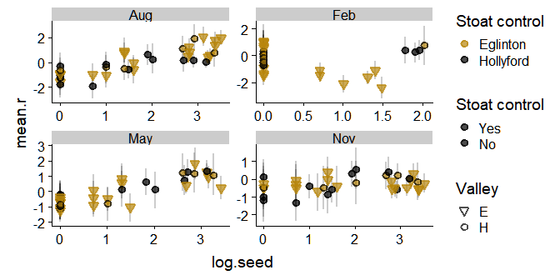

## All May data

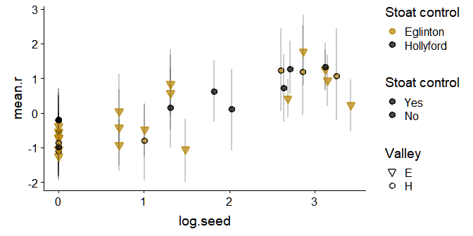

## All August data

### Autumn and Winter trends

* Rate of increase between Autumn and Winter
* (May and August rate of change)
* May mice abundace, seed and rat data

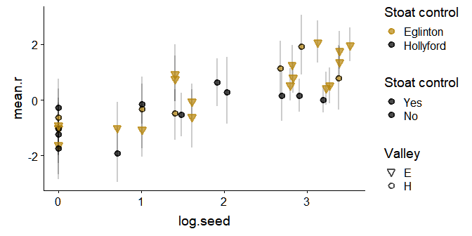

## All November data

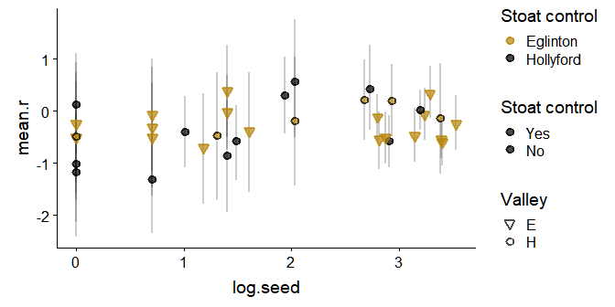

# Estimating lines

This is where it gets really tricky. I have done this in a way that works. I am sure there are better ways to code this but that is for a later date.

My steps are:

1. out.final1 and filter out only month of interest
2. Find max values

* background points

1. spread data across the different parameter estimates
2. reduce the out.full.136 to only feb
3. Merge with parameter dataset (steps1-2)
4. Plot away using ggplot2

## Seed

### All months

This is ok becuase the average estimates of line will all use the same average to estimate the trend line for each parameter and variable.

It comes difficult to combine plots when we want to compare differences between varaibles and rate of increase for a fixed time (month = ``).

#### Fitted plot

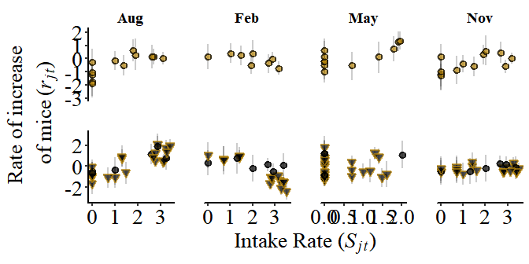

### August trend

This phase (Autumn to winter) has the strongest effect of intake rate on the population growth rates ($r_{jt}$).

#### Fitted plot

## Density

### All months

#### Fitted plot

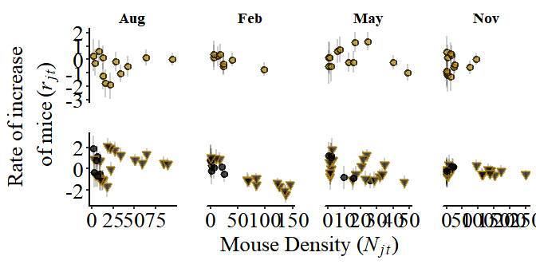

### February

#### Fitted plot

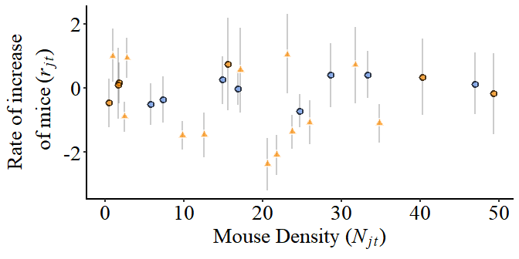

### May

#### Fitted plot

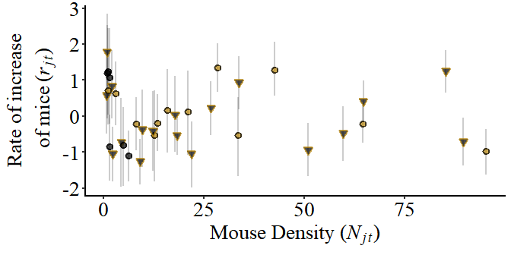

### Aug

#### Fitted plot

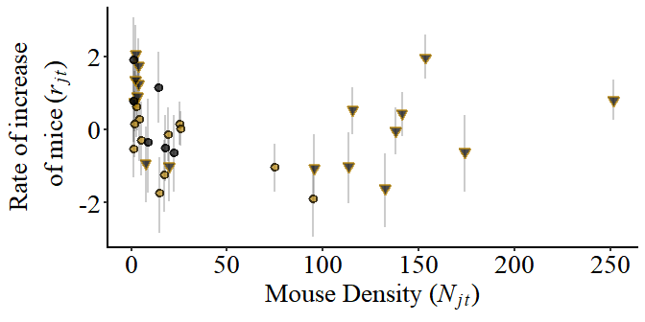

### Nov

#### Fitted plot

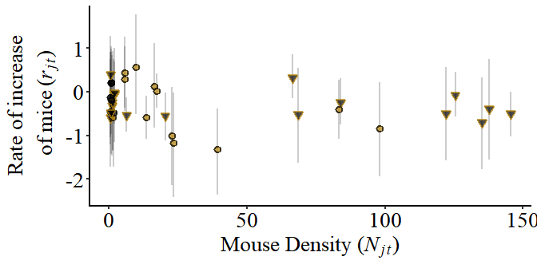

## Rats

### All months

#### Fitted plot

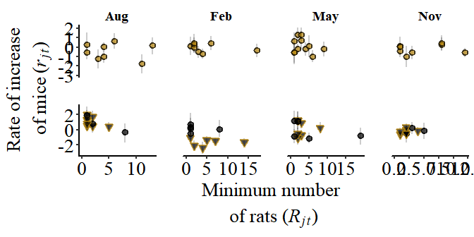

### February

### Fitted plot

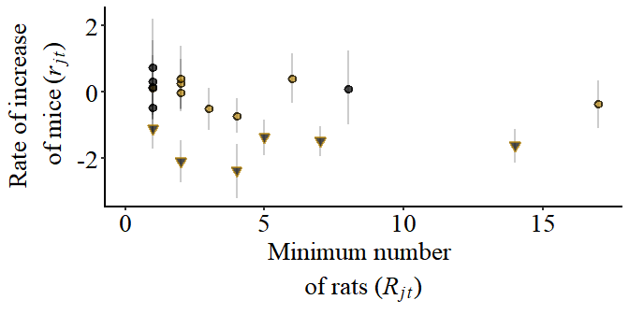

### Co-effiecents

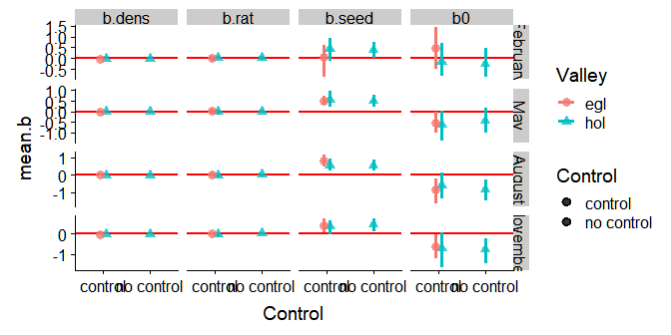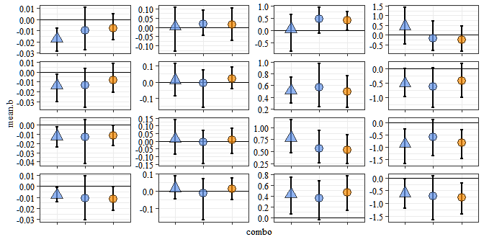

# Results

## Prediction C: Autumn and Winter trends

* Rate of increase between Autumn and Winter
* (May and August rate of change)
* May mice abundace, seed and rat data

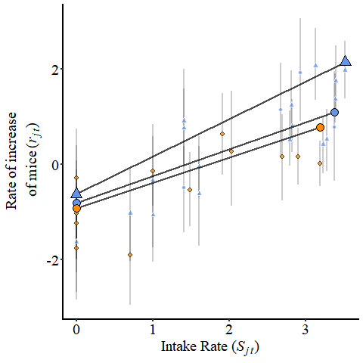

## Prediction D: Spring and Summer trends

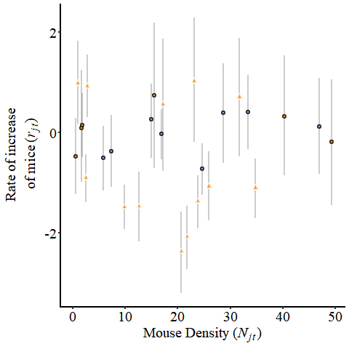

## Prediction E: Effect of rats

### Co-effiecents

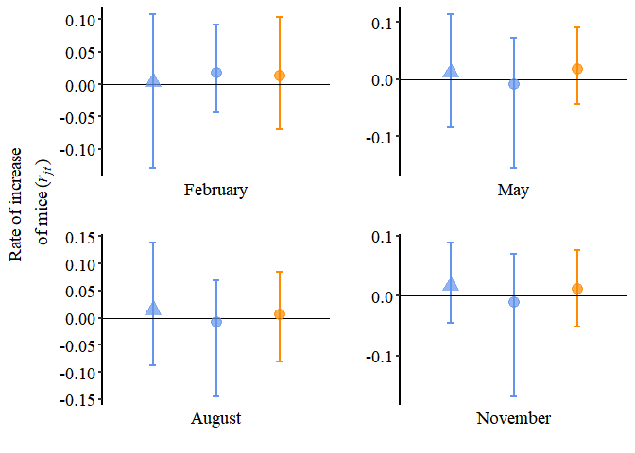

### Plot

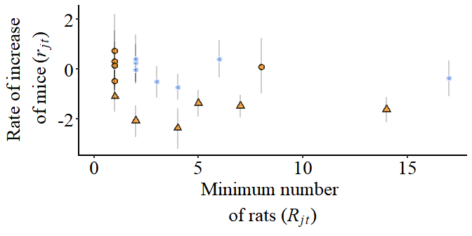

png   
 2

png   
 2

# Discussion

# Saving

## Saving

Must be png

# Appendix

# References