Beech forest dynamics

A simulation

Anthony Davidson

2019-05-16

#render this file as follows  
# render(rmarkdown::word_document("./Davidson_2019_Simulation.Rmd"))

This simple simulation model generates Figure 1 of this publication. This figure explains how I expect population dynamics to ’deterministically work’play-out" given our current understanding of Beech forest dynamics (Choquenot and Ruscoe 2000; Ruscoe, Goldsmith, and Choquenot 2001; Blackwell, Potter, and Minot 2001; Blackwell et al. 2003; Ruscoe et al. 2005; Tompkins and Veltman 2006 @ tompkins2013; Holland et al. 2015; Latham et al. 2017), primarily seed availability (Figure 1).

## Setup

knitr::opts_chunk$set(comment=NA,  
 fig.path = "../figs/",  
 echo=FALSE,  
 message=FALSE,   
 warning=FALSE)  
  
# how do I do this??  
# ,eval = FALSE,include = FALSE  
  
library(citr)  
# citr::md_cite("Beech-forest.bib")  
# bib(file = "Beech-forests.bib")

# Overview

New Zealand beech forests exhibit boom-bust dynamics orginally (after many edits looks like this vignette and Figure 1 below.

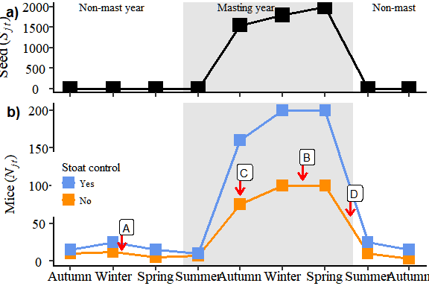

Figure 1: Each arrow and label represents a prediction we tested (Prediction B to D). Each prediction represents a collection of previous studies that have suggested how mouse populations may respond to seed availability in the presence or absence of stoats. A) during the years when no seed is available (non-mast years; Panel A); B) at the peak of mouse abundance (winter or spring); C) the season when mice populations are responding rapidly to increasing seed abundance (summer to winter in mast years; Panel B); D) when mouse abundance declines (spring to summer; Panel B). The top panel represents the average seed availability cycle in New Zealand Native Beech Forests between non-mast (no shading) and mast years (shaded grey). The bottom panel represents the expected response of mouse abundance ($N_{j,t}$) to the variation in seed availability ($Seed_{j,t}) above where solid yellow symbols represent locations where stoats are un-controlled

Where, beech trees mast in spatial synchronised but annually variable years dependant (Wardle 1991). Mice populations have invaded these systems and studies have shown that populations response numerically to changes in resources (beech seed) and mice have been modelled under a range of both functional and numerical responses (King 1983).

# Introduction

I have made a very simple simulation of the expected relationships from the literature. *For more detail see thesis drafts* [*here*](https://www.ssnhub.com/phd-thesis/)*.*

## Season

season

Freq

Autumn

3

Spring

3

Summer

3

Winter

3

## Mouse Abundance

#Abundance  
no.stoats <- c(25,15,25,15,10,160,200,200,25,15,25,20)  
stoats <- c(12,10,12,5,7,75,100,100,10,3,5,4)

## Beech Seed

#seed  
beech.seed <- c(0,0,0,0,0,rnorm(1,1550,1),rnorm(1,1800,1),rnorm(1,2000,1),0,0,0,0)  
lcl.seed <- c(0,0,0,0,rnorm(1,10,2),rnorm(1,1000,50),rnorm(1,3000,100),0,0,0,0,0)  
ucl.seed <- c(0,0,0,0,rnorm(1,190,10),rnorm(1,3000,50),rnorm(1,5000,100),0,0,0,0,0)  
stata <- seq(1,12,1)

## Stoat control

#control <- as.factor(c(rep(c("no.stoats"),4),rep(c("stoats"),4)))  
control <- factor(rep(1,12))  
kable(table(control))

control

Freq

1

12

## Date

#date  
date <- as.Date(as.character(c("1999-02-01","1999-05-01","1999-08-01","1999-11-01",  
 "2000-02-01","2000-05-01","2000-08-01","2000-11-01",  
 "2001-02-01","2001-05-01","2001-08-01","2001-11-01")))

### Labelling

#date  
date <- as.Date(as.character(c("1999-02-01","1999-05-01","1999-08-01","1999-11-01",  
 "2000-02-01","2000-05-01","2000-08-01","2000-11-01",  
 "2001-02-01","2001-05-01","2001-08-01","2001-11-01")))

## Create dataset

It is always nice to export csv data with meaningful labels.

### Labelling

labels1 <- c("Summer", "Autumn", "Winter", "Spring", "Summer", "Autumn", "Winter", "Spring")  
  
labels2 <- c("", "", "Non-mast year", "", "", "", "Mast year", "")

## Build dataset

season

date

stata

beech.seed

control

value

Autumn

1999-05-01

2

0.000

stoats

10

Winter

1999-08-01

3

0.000

stoats

12

Spring

1999-11-01

4

0.000

stoats

5

Summer

2000-02-01

5

0.000

stoats

7

Autumn

2000-05-01

6

1550.177

stoats

75

Winter

2000-08-01

7

1800.296

stoats

100

### Save data

# Results

### Plot data

season

date

stata

beech.seed

control

value

Autumn

1999-05-01

2

0.000

stoats

10

Winter

1999-08-01

3

0.000

stoats

12

Spring

1999-11-01

4

0.000

stoats

5

Summer

2000-02-01

5

0.000

stoats

7

Autumn

2000-05-01

6

1550.177

stoats

75

Winter

2000-08-01

7

1800.296

stoats

100

### Plot symbols/labels

# build points data  
# tibble my life  
arrow.length <- 10  
touchoff.distance <- 10 # distance between data and start of arrow  
arrowhead.size <- 3 # in millimeters  
time.loc <- as.character()  
  
# "1999-09-31", "2000-05-31", "2000-07-31", "2000-12-31"  
  
points.dat <- tibble(  
 prediction = as.factor(c("A", "C", "B", "D")),  
 value = as.numeric(c(15, 88, 108, 60)),  
 date = as.Date(c("1999-08-20", "2000-05-01", "2000-09-13", "2000-12-25")))  
  
# c("1999-02-01","1999-05-01","1999-08-01","1999-11-01","2000-02-01","2000-05-01","2000-08-01","2000-11-01", "2001-02-01","2001-05-01","2001-08-01","2001-11-01")

### Seed plot

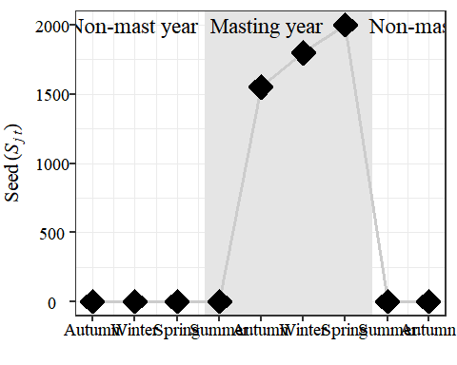

### Mouse plot

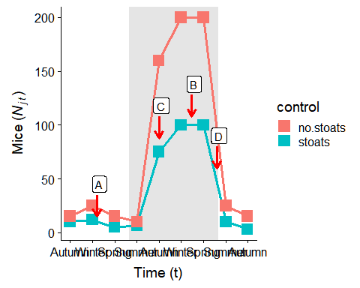

### Joint plot

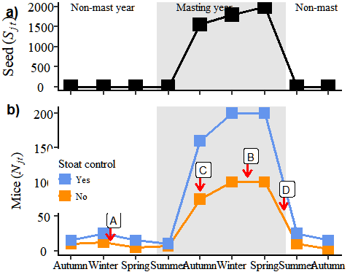

png   
 2



png   
 2

# Discussion

### Saving

png   
 2

# Appendix 1

## Old code

# References

Blackwell, G L, M A Potter, J A McLennan, and E O Minot. 2003. “The Role of Predators in Ship Rat and House Mouse Population Eruptions: Drivers or Passangers?” *Oikos* 100 (3): 601–13.

Blackwell, G. L., M. A. Potter, and E. O. Minot. 2001. “Rodent and Predator Population Dynamics in an Eruptive System.” *Ecological Modelling* 142 (3): 227–45. <https://doi.org/10.1016/S0304-3800(01)00327-1>.

Choquenot, David, and Wendy A Ruscoe. 2000. “Mouse Population Eruptions in New Zealand Forests: The Role of Population Density and Seedfall.” *Journal of Animal Ecology* 69: 1058–70.

Holland, E Penelope, Alex James, Wendy A Ruscoe, Roger P Pech, Andrea E Byrom, and E Byrom. 2015. “Climate-Based Models for Pulsed Resources Improve Predictability of Consumer Population Dynamics: Outbreaks of House Mice in Forest Ecosystems.” *PloS One*, 1–16. <https://doi.org/10.1371/journal.pone.0119139>.

King, Carolyn M. 1983. “The Relationships Between Beech (Nothofagus Sp.) Seedfall and Populations of Mice (Mus Musculus), and the Demographic and Dietary Responses of Stoats (Mustela Erminea), in Three New Zealand Forests.” *Journal of Animal Ecology* 52 (1): 141–66.

Latham, A. David M., Bruce Warburton, Andrea E. Byrom, and Roger P. Pech. 2017. “The Ecology and Management of Mammal Invasions in Forests.” *Biological Invasions* 19 (11): 3121–39. <https://doi.org/10.1007/s10530-017-1421-5>.

Ruscoe, Wendy A, Joseph S Elkinton, David Choquenot, and Robert B Allen. 2005. “Predation of Beech Seed by Mice: Effects of Numerical and Functional Responses.” *Journal of Animal Ecology* 74: 1005–19. <https://doi.org/10.1111/j.1365-2656.2005.00998.x>.

Ruscoe, Wendy A, Ruth Goldsmith, and David Choquenot. 2001. “A Comparison of Population Estimates and Abundance Indices for House Mice Inhabiting Beech Forests in New Zealand.” *Wildlife Research* 28: 173–78.

Tompkins, Daniel M, and Clare J Veltman. 2006. “Unexpected Consequences of Vertebrate Pest Control: Predictions from a Four-Species Community Model.” *Ecological Applications* 16 (3): 1050–61.

Wardle, P. 1991. *Vegetation of New Zealand*. Cambridge University Press.