Simple models for beech forests

Prediction A and B

Anthony Davidson

2019-05-16

|  |  |
| --- | --- |
| Prediction A | Prediction B |
| At times of low abundance | At times of high abundance |
| low abundance times | high abundance times |

# Introduction

At times of high and low abundance there is evidence that mice populations are likely to be under different population pressures. It has been shown that population level processes such as density dependance (competition between individuals for space or resources) when populations are at high abundance (Ruscoe et al. 2005). But at low abundance the demographic processes limiting populations are different, namely resource avaliability rather than competition (Choquenot and Ruscoe 2000). Because these two demographic processes are fundementally different we need to test these times independant of each other. We can then be sure that one phase/season is not obscurring the processes of the other.

# Methods

Using simple ANOVA methods for mixed models making the following assumptions:

1. Unequal variances
2. Unequal sample sizes
3. Non-independence removed
   * by partitioning groups by phase.
4. Seasons vary - phases don’t

## Low abundance

### Data selection

How to choose what groups to compare?

We have chosen to select trips 10 -> 15 as times of low abundance.

### Data manipulation

This dataset is generated from the from the Bayesian model but does not use any of the model coefficients. Therefore we use the overall abundance dataset including all $144$ replicates.

We can summarise the data over valleys, control areas and/or treatments to compare the means and variances.

These comparisons would be fine but there are un-equal replicates and other issues that we need to account for using a ANOVA or mixed model.

### Statistical models

#### Control only

Analysis of Deviance Table  
  
Model: gaussian, link: identity  
  
Response: N  
  
Terms added sequentially (first to last)  
  
 Df Deviance Resid. Df Resid. Dev F Pr(>F)  
NULL 41 522.00   
Control 1 0.32116 40 521.68 0.0246 0.8761

#### Control and valley

Analysis of Deviance Table  
  
Model: gaussian, link: identity  
  
Response: N  
  
Terms added sequentially (first to last)  
  
 Df Deviance Resid. Df Resid. Dev F Pr(>F)  
NULL 41 522.00   
Control 1 0.32116 40 521.68 0.0241 0.8773  
valley 1 2.93070 39 518.75 0.2203 0.6414

#### Control, valley and conditions

Analysis of Deviance Table  
  
Model: gaussian, link: identity  
  
Response: N  
  
Terms added sequentially (first to last)  
  
 Df Deviance Resid. Df Resid. Dev F Pr(>F)  
NULL 41 522.00   
Control 1 0.3212 40 521.68 0.0239 0.8781  
Valley 1 2.9307 39 518.75 0.2177 0.6435  
Conditions 1 7.1231 38 511.62 0.5291 0.4715

##### Log(N) for interest

Analysis of Deviance Table  
  
Model: gaussian, link: identity  
  
Response: log(N)  
  
Terms added sequentially (first to last)  
  
 Df Deviance Resid. Df Resid. Dev F Pr(>F)  
NULL 41 32.993   
Control 1 0.43485 40 32.558 0.5381 0.4677  
Valley 1 0.34157 39 32.216 0.4227 0.5195  
Conditions 1 1.50827 38 30.708 1.8664 0.1799

#### Full model

Analysis of Deviance Table  
  
Model: gaussian, link: identity  
  
Response: N  
  
Terms added sequentially (first to last)  
  
 Df Deviance Resid. Df Resid. Dev F Pr(>F)  
NULL 41 522.00   
Control 1 0.3212 40 521.68 0.0239 0.8781  
Valley 1 2.9307 39 518.75 0.2178 0.6435  
Conditions 1 7.1231 38 511.62 0.5293 0.4715  
Control:Conditions 1 13.7221 37 497.90 1.0197 0.3191

#### Model selection

## High abundance

### Data selection

### Data manipulation

##### Structuring levels

### Statistical models

Analysis of Deviance Table  
  
Model: gaussian, link: identity  
  
Response: n.seed.c  
  
Terms added sequentially (first to last)  
  
 Df Deviance Resid. Df Resid. Dev F Pr(>F)  
NULL 27 0.94151   
Control 1 0.013399 26 0.92811 0.3753 0.5454

Analysis of Deviance Table  
  
Model: gaussian, link: identity  
  
Response: n.seed.c  
  
Terms added sequentially (first to last)  
  
 Df Deviance Resid. Df Resid. Dev F Pr(>F)   
NULL 27 0.94151   
Control 1 0.013399 26 0.92811 0.4249 0.52047   
Valley 1 0.139698 25 0.78841 4.4297 0.04554 *  
---  
Signif. codes: 0 '***' 0.001 '**' 0.01 '*' 0.05 '.' 0.1 ' ' 1

Analysis of Deviance Table  
  
Model: gaussian, link: identity  
  
Response: n.seed.c  
  
Terms added sequentially (first to last)  
  
 Df Deviance Resid. Df Resid. Dev F Pr(>F)   
NULL 27 0.94151   
Control 1 0.013399 26 0.92811 0.4461 0.51055   
Valley 1 0.139698 25 0.78841 4.6515 0.04126 *  
Conditions 1 0.067617 24 0.72079 2.2514 0.14653   
---  
Signif. codes: 0 '***' 0.001 '**' 0.01 '*' 0.05 '.' 0.1 ' ' 1

Analysis of Deviance Table  
  
Model: gaussian, link: identity  
  
Response: n.seed.c  
  
Terms added sequentially (first to last)  
  
 Df Deviance Resid. Df Resid. Dev F Pr(>F)   
NULL 27 0.94151   
Control 1 0.013399 26 0.92811 0.4276 0.5196   
Valley 1 0.139698 25 0.78841 4.4587 0.0458 *  
Conditions 1 0.067617 24 0.72079 2.1581 0.1554   
Conditions:control 1 0.000176 23 0.72062 0.0056 0.9409   
---  
Signif. codes: 0 '***' 0.001 '**' 0.01 '*' 0.05 '.' 0.1 ' ' 1

[1] -9.930135 -12.497761 -13.008412

[1] 0.9281092 0.7884112 0.7207942

| co.effs | Estimate | Std..Error | t.value | Pr...t.. |
| --- | --- | --- | --- | --- |
| (Intercept) | 0.226 | 0.112 | 2.021 | 0.055 |
| ControlYes | -0.063 | 0.094 | -0.664 | 0.513 |
| ValleyHollyford | -0.173 | 0.085 | -2.038 | 0.053 |
| Conditionsrats.removed | 0.100 | 0.067 | 1.500 | 0.147 |

### Model selection

model.aic

mods.name

mod.dev

-9.930135

high.mod1

0.9281092

-12.497761

high.mod2

0.7884112

-13.008412

high.mod3

0.7207942

# Results

## Low abundance

### Summary

Observations

42

Dependent variable

N

Type

Linear regression

χ²(3)

10.37

Pseudo-R² (Cragg-Uhler)

0.02

Pseudo-R² (McFadden)

0.00

AIC

234.19

BIC

242.88

Est.

S.E.

t val.

p

(Intercept)

2.53

1.93

1.31

0.20

ControlYes

-0.14

1.63

-0.09

0.93

ValleyHollyford

-0.60

1.47

-0.41

0.68

Conditionsrats.removed

0.84

1.15

0.73

0.47

Standard errors: MLE

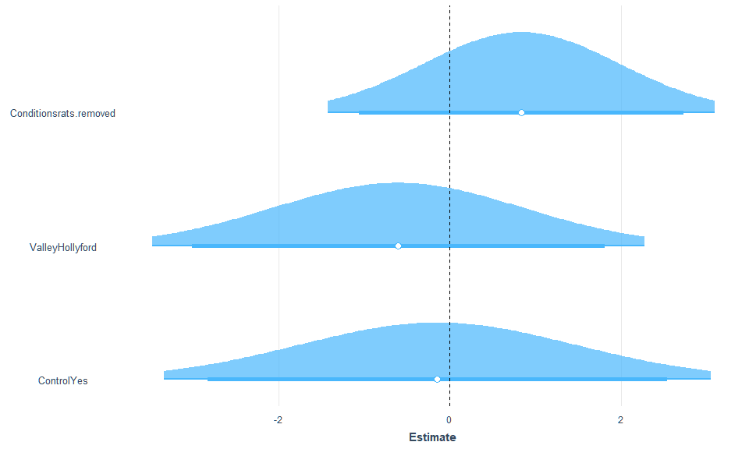

### Plots

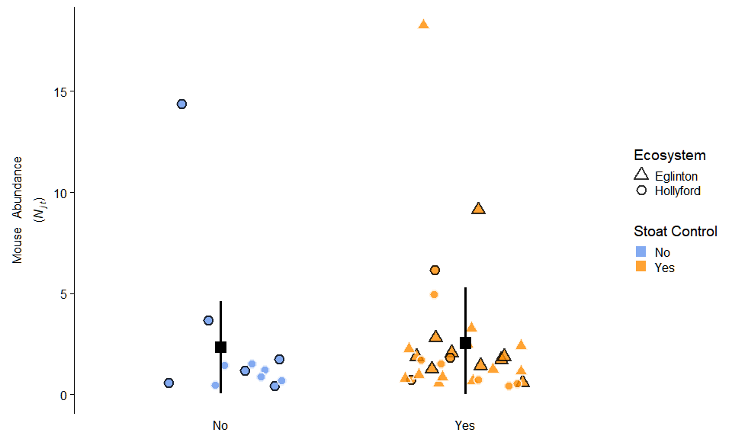

## High abundance

### Summary

Analysis of Deviance Table  
  
Model: gaussian, link: identity  
  
Response: n.seed.c  
  
Terms added sequentially (first to last)  
  
 Df Deviance Resid. Df Resid. Dev F Pr(>F)   
NULL 27 0.94151   
Control 1 0.013399 26 0.92811 0.4249 0.52047   
Valley 1 0.139698 25 0.78841 4.4297 0.04554 *  
---  
Signif. codes: 0 '***' 0.001 '**' 0.01 '*' 0.05 '.' 0.1 ' ' 1

Observations

28

Dependent variable

n.seed.c

Type

Linear regression

χ²(3)

0.22

Pseudo-R² (Cragg-Uhler)

-0.32

Pseudo-R² (McFadden)

-0.48

AIC

-13.01

BIC

-6.35

Est.

S.E.

t val.

p

(Intercept)

0.16

0.05

3.00

0.01

valleyhol

-0.17

0.08

-2.04

0.05

controlno control

0.06

0.09

0.66

0.51

Conditionsrats.removed

0.10

0.07

1.50

0.15

Standard errors: MLE

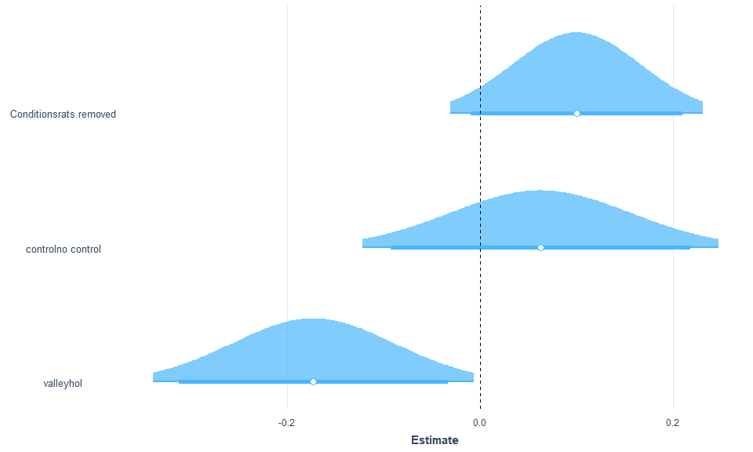

### Plots

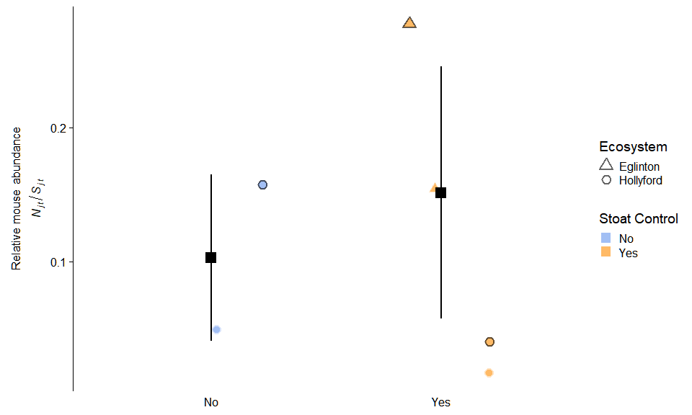

## Save plots

Must be png

png   
 2

png   
 2

# Discussion

This is an interest set of analysis because it is somewhat post-hoc but ….

# References

Choquenot, David, and Wendy A Ruscoe. 2000. “Mouse Population Eruptions in New Zealand Forests: The Role of Population Density and Seedfall.” *Journal of Animal Ecology* 69: 1058–70.

Ruscoe, Wendy A, Joseph S Elkinton, David Choquenot, and Robert B Allen. 2005. “Predation of Beech Seed by Mice: Effects of Numerical and Functional Responses.” *Journal of Animal Ecology* 74: 1005–19. <https://doi.org/10.1111/j.1365-2656.2005.00998.x>.