LIVEBOOT SENTINEL
External OS Intrusion Detection System
Technical Reference & Operations Manual
Version | 1.0.0
Platform | Windows / Linux
Stack | Python · FastAPI · SQLAlchemy · WebSocket
Classification | CONFIDENTIAL

1. Overview
LiveBoot Sentinel is a production-quality, multi-device security monitoring system designed to detect when any machine on a network boots from an external live operating system — such as Kali Linux, Tails, Parrot OS, or any other forensic or penetration testing environment. It operates continuously, collects forensic telemetry from endpoint agents, and streams real-time alerts to a central SOC dashboard.
The system is designed around a three-tier architecture: an endpoint agent running on monitored machines, a central FastAPI alert server, and a real-time SOC dashboard. All communications use HTTPS/TLS with API key authentication, and all logs are tamper-evident using SHA256 hash chaining.

1.1 Key Capabilities
- Detects USB and removable media boot sources using lsblk (Linux) and WMI (Windows)
- Identifies live OS kernel signatures: Kali, Tails, Parrot, BlackArch, Whonix, and 11 others
- Detects squashfs, overlayfs, aufs mounts characteristic of live OS environments
- Compares boot fingerprints against a stored baseline — flags any deviation
- Analyzes UEFI boot entries via efibootmgr (Linux) and bcdedit (Windows)
- Computes weighted risk scores across all indicators with NORMAL / WARNING / CRITICAL classification
- Sends cryptographically authenticated HTTPS alerts to a central server
- Broadcasts real-time events to connected dashboards via WebSocket
- Maintains tamper-evident append-only logs with SHA256 hash chaining
- Supports multiple simultaneous endpoint agents reporting to one server

2. System Architecture
The system follows a three-tier pipeline: endpoint agents collect telemetry and compute risk scores, the central FastAPI server ingests and stores alerts with full input validation, and the SOC dashboard presents live data via REST polling and WebSocket streaming.
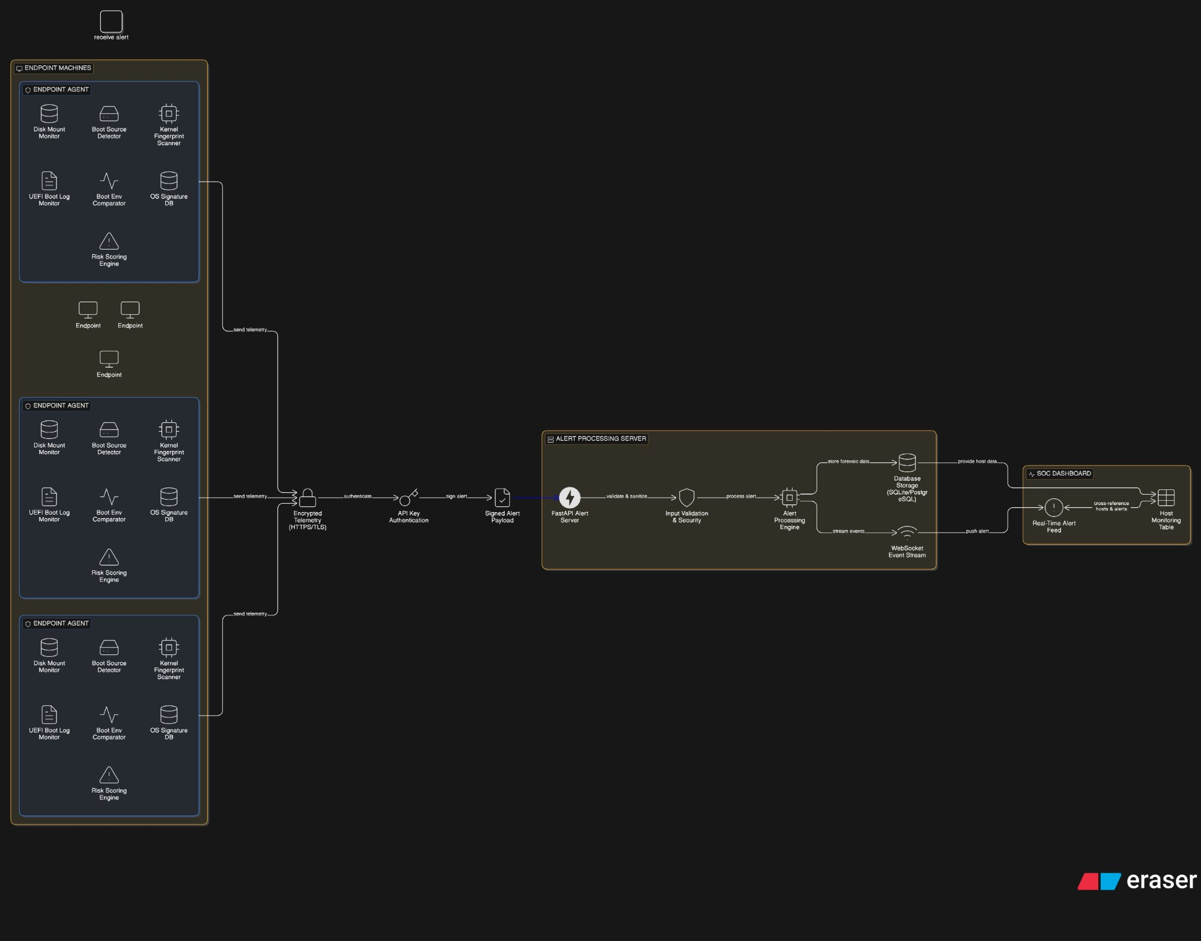
Figure 1 — LiveBoot Sentinel system architecture

2.1 Data Flow
- Endpoint agent runs all detection modules every 10 seconds
- Risk engine aggregates indicators and computes a weighted score
- If score exceeds threshold (50), agent POSTs alert to server via HTTPS
- Server validates input with Pydantic, persists to SQLite/PostgreSQL via SQLAlchemy ORM
- Server broadcasts alert event to all connected WebSocket clients immediately
- Dashboard receives the push event and updates the feed without page refresh

2.2 Three-Device Deployment
Device | Role | What runs
Device 1 | Alert API Server | uvicorn api:app --port 8443
Device 2 | SOC Dashboard (Antigravity) | localhost:5173 (browser)
Device 3 | Target / Monitored Machine | python main.py (agent)

3. Endpoint Agent Modules
The agent is a pure Python application with zero third-party dependencies. All detection uses Python stdlib on both Windows and Linux. It runs a detection cycle every 10 seconds and sends alerts only when the risk score exceeds the configured threshold.
Module | Function
boot_detector.py | Detects USB/removable boot using lsblk (Linux) or WMI Win32_DiskDrive (Windows). Emits USB_BOOT_DETECTED.
kernel_fingerprint.py | Reads uname -a (Linux) or platform module (Windows). Scans for 11 live OS keywords in kernel string, os-release, and /proc/cmdline.
disk_monitor.py | Scans /proc/mounts (Linux) or Win32_LogicalDisk (Windows) for squashfs, overlayfs, tmpfs-as-root, and suspicious mount points.
boot_fingerprint.py | Collects 5-field fingerprint (boot device, kernel, secure boot, root FS, disk UUID) and diffs against stored baseline.
uefi_monitor.py | Parses efibootmgr (Linux) or bcdedit (Windows) for USB boot entries and boot order changes.
signature_db.py | OS fingerprint database with 15 entries across penetration testing, anonymity, forensics, and live environment categories.
risk_engine.py | Weighted scoring across all indicators. Caps at 200. Returns NORMAL (0-29), WARNING (30-49), or CRITICAL (50+).
tamper_evident_logger.py | Append-only log at /var/log/liveboot_sentinel.log. Each entry: SHA256(prev_hash + entry_json). Chain breakage is detected by verify_log_integrity().
alert_client.py | HTTPS-only sender with TLS 1.2 minimum, hmac-safe API key, input sanitization, and exponential retry backoff.
baseline_generator.py | Run once on clean system. Stores boot fingerprint to /etc/liveboot_sentinel/baseline.json (Linux) or %USERPROFILE%\liveboot_sentinel (Windows).
main.py | Main loop. Runs all modules every 10 seconds. Aggregates indicators, computes score, triggers alert if score > 50.

4. Risk Scoring Engine
Every detection cycle produces a set of indicator strings. The risk engine applies a weighted score to each indicator, sums them, and caps the total at 200. The final score maps to one of three risk levels.

4.1 Risk Levels
Score Range | Level | Action
0 – 29 | NORMAL | Log only
30 – 49 | WARNING | Log only
50+ | CRITICAL | Send alert

4.2 Indicator Weights
Indicator | Score
USB_BOOT_DETECTED | +40
SQUASHFS_MOUNT_DETECTED | +30
TMPFS_ROOT_DETECTED | +35
LIVE_OS_KERNEL:* (any live OS match) | +28
FINGERPRINT_MISMATCH:DISK_UUID | +30
FINGERPRINT_MISMATCH:BOOT_DEVICE | +30
USB_UEFI_BOOT_ENTRY | +35
USB_FIRST_IN_BOOT_ORDER | +35
SECURE_BOOT_DISABLED | +20
LOG_TAMPERING_DETECTED | +50
LIVE_CMDLINE:BOOT=LIVE | +25
OVERLAY_FS_DETECTED | +20

5. Alert Server API
The FastAPI server exposes REST endpoints and a WebSocket endpoint. All REST endpoints require API key authentication via the X-API-Key header. Rate limiting is applied per IP (60 requests/minute by default).

5.1 Endpoints
Endpoint | Method | Description
/health | GET | Health check — no auth required
/alert | POST | Ingest alert from endpoint agent
/alerts | GET | List all alerts, newest first (paginated)
/alerts/critical | GET | List alerts with risk_score > 50
/alerts/{id} | GET | Fetch single alert by ID
/hosts | GET | List all monitored hosts
/stats | GET | Aggregate dashboard statistics
/ws/alerts | WebSocket | Real-time alert event stream

5.2 WebSocket Event Types
// Alert event — fires on every new alert ingested
{ "type": "alert", "data": { "id": 1, "hostname": "...", "risk_score": 95, ... } }

// Stats update — fires after every alert ingestion
{ "type": "stats", "data": { "total_alerts": 5, "critical_alerts": 2, ... } }

// Connection confirmation — fires on WebSocket connect
{ "type": "connected", "data": { "message": "...", "connections": 1 } }

// Keepalive — send "ping", receive:
{ "type": "pong" }

5.3 Alert Payload Schema
{
"hostname": "DESKTOP-F5NUAQ7",
"timestamp": "2026-03-16T10:30:00+00:00",
"boot_source": "usb",
"kernel": "6.1.0-kali9-amd64",
"detected_os": "Kali Linux",
"risk_score": 95,
"risk_level": "CRITICAL",
"indicators": ["USB_BOOT_DETECTED", "LIVE_OS_KERNEL:KALI_LINUX", ...]
}

6. OS Signature Database
The agent maintains a local signature database of 15 known live/security operating systems. Each entry carries a threat level from 1 (benign) to 5 (high-risk offensive tool) used to boost the risk score.
OS | Category | Threat Level
Kali Linux | Penetration Testing | 5 / 5
BlackArch | Penetration Testing | 5 / 5
BackTrack | Penetration Testing | 5 / 5
Parrot OS | Penetration Testing | 4 / 5
Pentoo | Penetration Testing | 4 / 5
Tails OS | Anonymity / Privacy | 4 / 5
Whonix | Anonymity / Privacy | 3 / 5
DEFT Linux | Digital Forensics | 3 / 5
REMnux | Malware Analysis | 3 / 5
CAINE | Digital Forensics | 3 / 5
Ubuntu Live | Live Environment | 2 / 5
Debian Live | Live Environment | 2 / 5
Fedora Live | Live Environment | 2 / 5

7. Security Design

7.1 Secure Coding Practices
- No shell=True anywhere — all subprocess calls use argument lists to prevent command injection
- Input validation via Pydantic v2 schemas with field-level validators and cross-field consistency checks
- SQL injection prevention via SQLAlchemy ORM — no raw SQL queries
- API key authentication using hmac.compare_digest for timing-attack-safe comparison
- Per-IP sliding window rate limiting (60 req/min) to prevent API abuse
- HTTPS-only enforcement — agent refuses to transmit over plain HTTP
- TLS 1.2 minimum on all connections
- Error sanitization — internal details never exposed in API error responses
- Secrets only via environment variables — never hardcoded
- Server runs as non-root user in Docker

7.2 Tamper-Evident Logging
Every log entry is SHA256 hash-chained to the previous entry. Modifying any historical entry breaks the chain and is immediately detected.
current_hash = SHA256(previous_hash + entry_json)

Entry format:
{
"timestamp": "2026-03-16T10:30:00+00:00",
"event": "Detection cycle 5: level=CRITICAL score=95",
"risk_score": 95,
"previous_hash": "a3f1...",
"current_hash": "9b2c..."
}

8. Deployment Reference

8.1 Environment Variables — Server
LIVEBOOT_API_KEYS | Comma-separated valid API keys (required)

LIVEBOOT_DB_URL | SQLAlchemy async DB URL (default: SQLite)

LIVEBOOT_CORS_ORIGINS | Comma-separated allowed dashboard origins

LIVEBOOT_RATE_LIMIT_MAX | Max requests per window (default: 60)

LIVEBOOT_ENABLE_DOCS | Set 'true' to enable /docs Swagger UI

8.2 Environment Variables — Agent
LIVEBOOT_ALERT_URL | HTTPS URL of server /alert endpoint (required)

LIVEBOOT_API_KEY | API key matching one in server LIVEBOOT_API_KEYS

LIVEBOOT_VERIFY_SSL | Set 'false' for self-signed certs (dev only)

LIVEBOOT_CA_BUNDLE | Path to custom CA cert bundle (optional)

8.3 Quick Start Commands

Server (Device 1)
cd liveboot_sentinel/server
$env:LIVEBOOT_API_KEYS = 'sentinel-dev-key-2026'
$env:LIVEBOOT_CORS_ORIGINS = '*'
$env:LIVEBOOT_DB_DIR = '$HOME\liveboot_data'
uvicorn api:app --host 0.0.0.0 --port 8443 \
--ssl-keyfile ..\certs\server.key \
--ssl-certfile ..\certs\server.crt

Agent (Device 3)
cd agent
$env:LIVEBOOT_ALERT_URL = 'https://10.119.80.246:8443/alert'
$env:LIVEBOOT_API_KEY = 'sentinel-dev-key-2026'
$env:LIVEBOOT_VERIFY_SSL = 'false'
python baseline_generator.py # run once on clean boot
python main.py

9. Project Structure
liveboot_sentinel/
├── agent/
│ ├── boot_detector.py # USB/removable boot detection
│ ├── kernel_fingerprint.py # Live OS kernel indicators
│ ├── disk_monitor.py # Abnormal mount detection
│ ├── boot_fingerprint.py # Baseline comparison
│ ├── uefi_monitor.py # UEFI boot entry analysis
│ ├── signature_db.py # OS fingerprint database
│ ├── risk_engine.py # Weighted risk score
│ ├── alert_client.py # Secure HTTPS sender
│ ├── tamper_evident_logger.py # SHA256 hash-chained log
│ ├── baseline_generator.py # One-time baseline creator
│ └── main.py # Main detection loop
├── server/
│ ├── api.py # FastAPI endpoints + WebSocket
│ ├── database.py # Async SQLAlchemy engine
│ ├── models.py # ORM models + Pydantic schemas
│ ├── alert_handler.py # Alert processing logic
│ ├── websocket.py # WebSocket connection manager
│ ├── requirements.txt
│ └── Dockerfile
├── certs/ # TLS certificates
├── docker-compose.yml
├── liveboot-sentinel.service # systemd unit
└── gen_certs.sh # Certificate generator

