Question 1 (8 pts)

1.1 (4 points) Equivalence:
Let 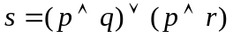
Let 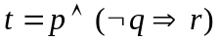
Requirements:
Prove that 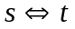
Hint: Student can use truth table or equivalence rules for the above proving.

1.2 (4 points) Simple reasoning:
Assume that we the following sentences:
(a) Macus was a Pompeian.
(b) All Pompians were Romans.
(c) Macus was a Romans.
Requirements:
(i) Translate the above sentences to Predicate Logic
(ii) Using Natural Deduction to infer the sentence given (c) from the sentences (a) and (b).

Question 2 (6 pts)
Assume that we the following sentences:
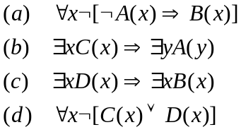
Requirements:
(i) (3 points) Using “Natural Deduction“ to infer the sentence in (d) from the sentences in (a) to (c).
(ii) (3 points) Using “Resolution Method“ to infer the sentence in (d) from the sentences in (a) to (c).

Question 3 (6 pts)
Assume that we have the following sentences in English:
(a) There is no student who is very good in Mathematical Logic but he/she is not good in Programming.
(b) All students who are very good in Programming then they will be able to find a job easily.
(c) All students of Class IU-AI are very good in Mathematical Logic
(d) Hoa is a student of IU-AI.
(e) Hoa will be able to find a job easily.
Requirements:
(i) (2 points) Translate the all the above sentences to Predicate Logic
(ii) (2points) Use "Natural Deduction" to infer the sentence given in (e) from the sentence (a) to (d)
(iii) (2 points) Use "Resolution Method" to infer the sentence given in (e) from the sentence (a) to (d)
--- The End ---

