APPENDIX B

DEVELOPING AN ULTIMATE CONSTRAINT SOLVER FOR M-QUEENS PROBLEM AND DEMONSTRATING WITH SIMULATION


Appendix B-1: Main frame of N-Queens Simulator

1 Solving N-Queens Problem by Backtracking Algorithm

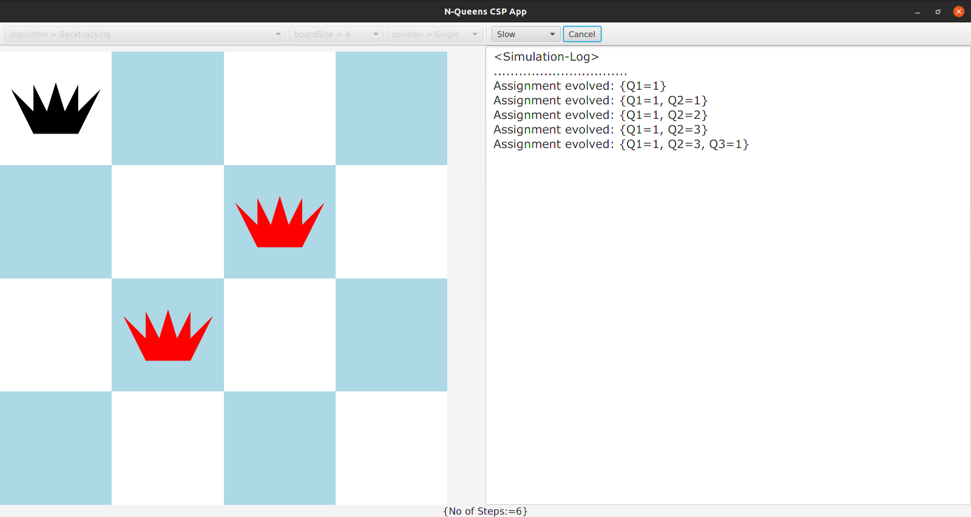

Appendix B-2(a) Running Step by Step of BT Algorithm

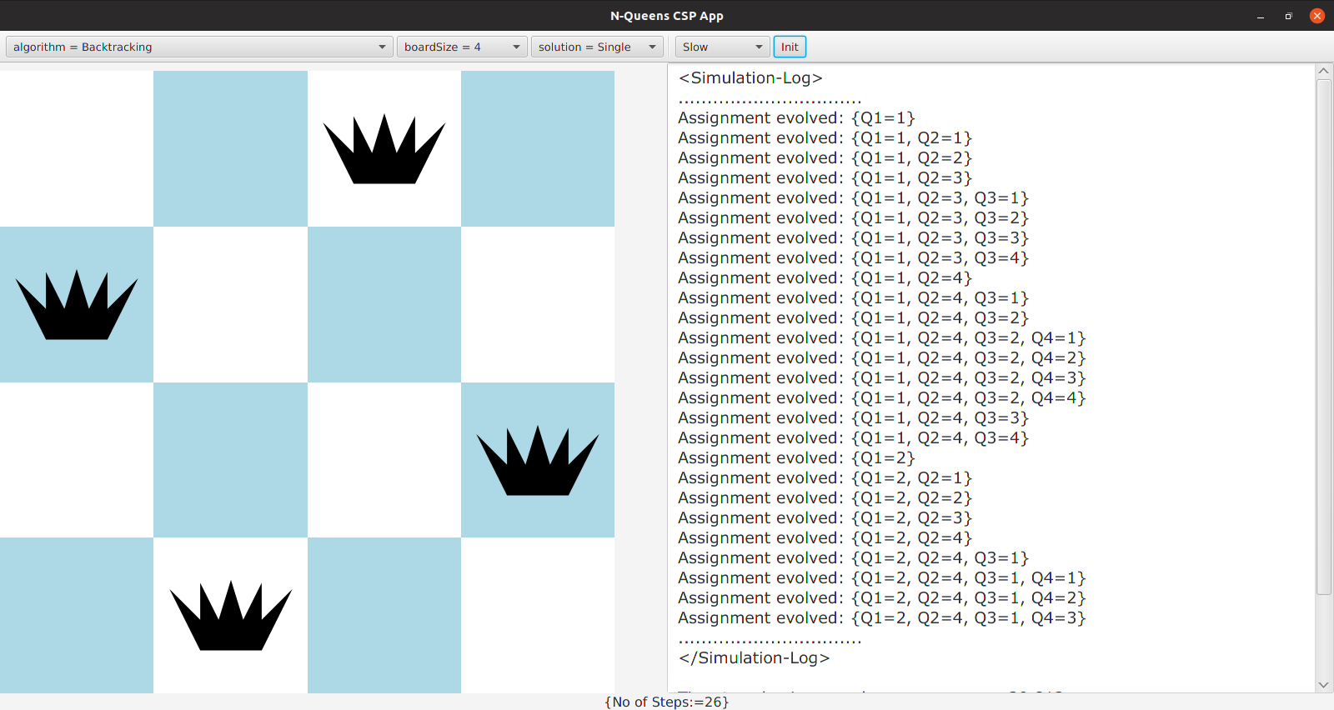
Appendix B-2(b) The end result of BT Algorithm

2 Solving N-Queens Problem by Forward Checking Algorithm

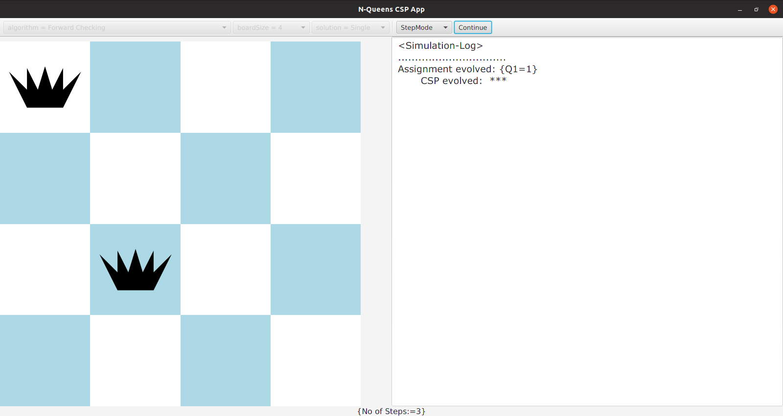
Appendix B-3(a) Running Step by Step of FC Algorithm

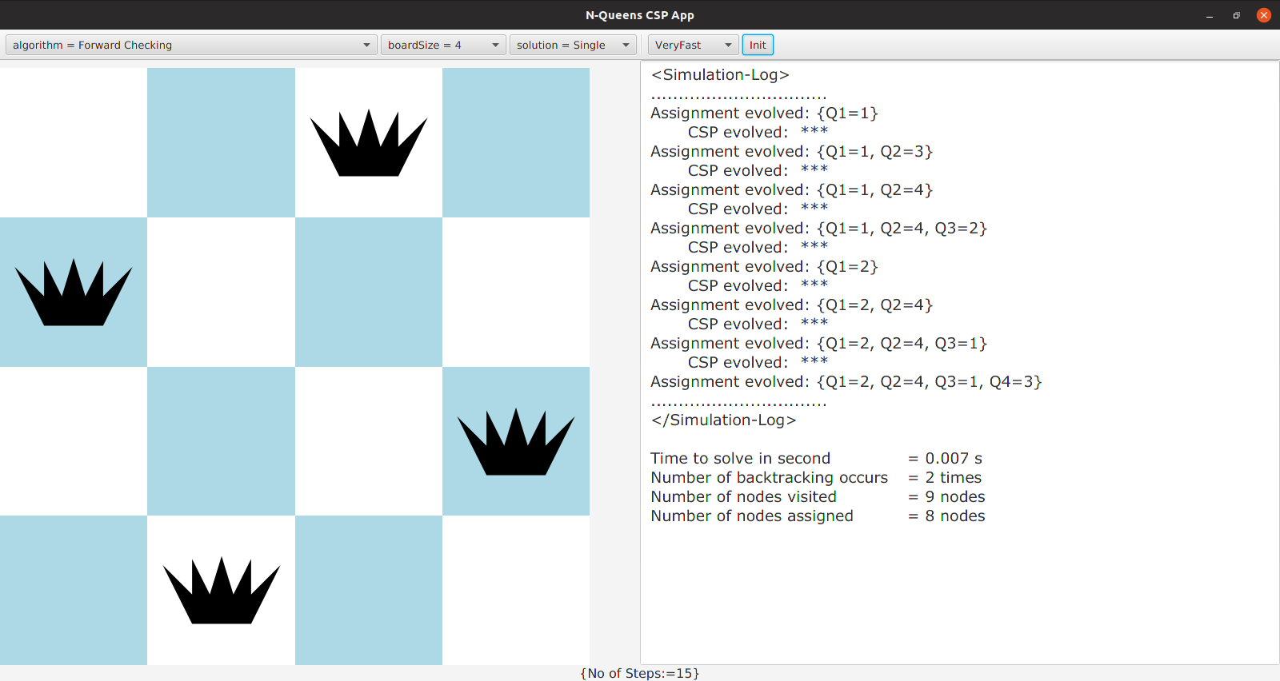
Appendix B-3(b) The end result of FC Algorithm

3 Solving N-Queens Problem by AC-3 with Forward Checking Algorithm

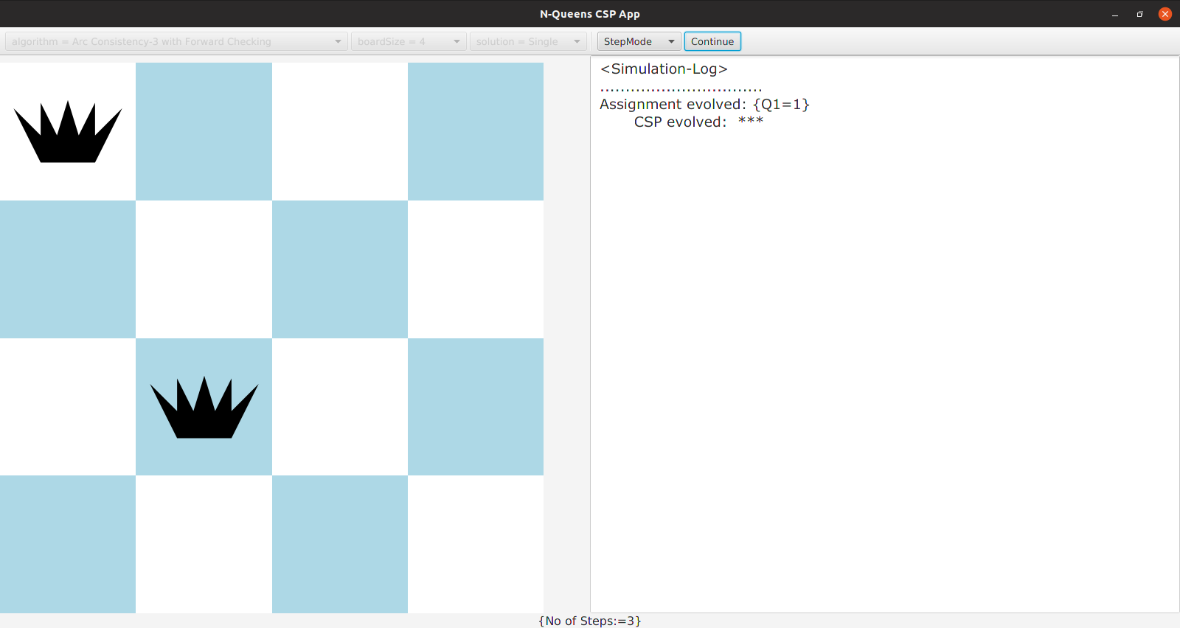
Appendix B-4(a) Running Step by Step of AC-3 with FC Algorithm

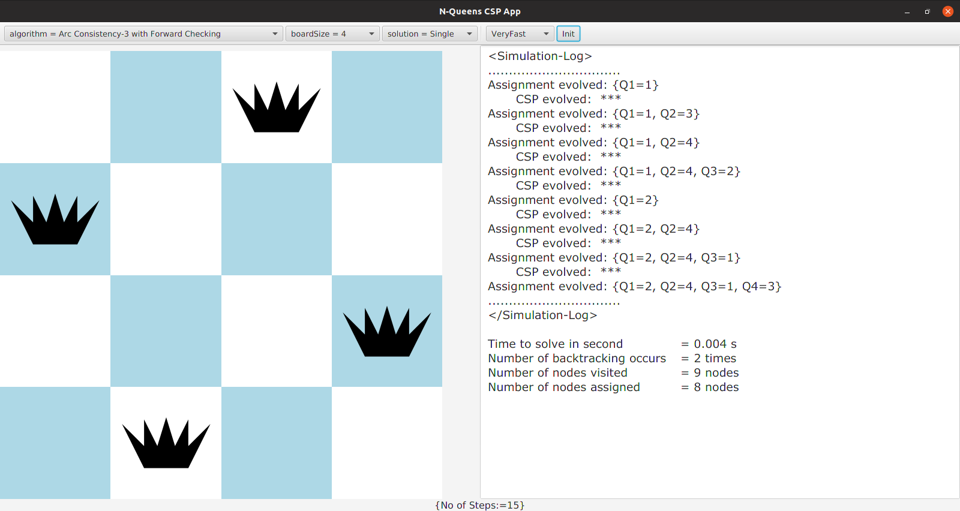
Appendix B-4(b) The end result of AC-3 with FC Algorithm

4 Solving N-Queens Problem by MAC-3 Algorithm

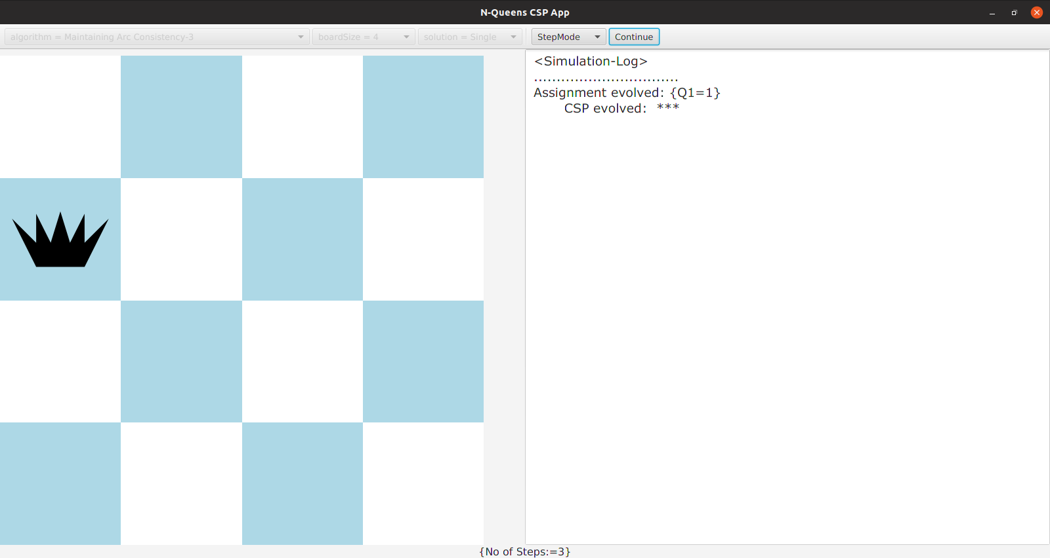
Appendix B-5(a) Running Step by Step of MAC-3 algorithm

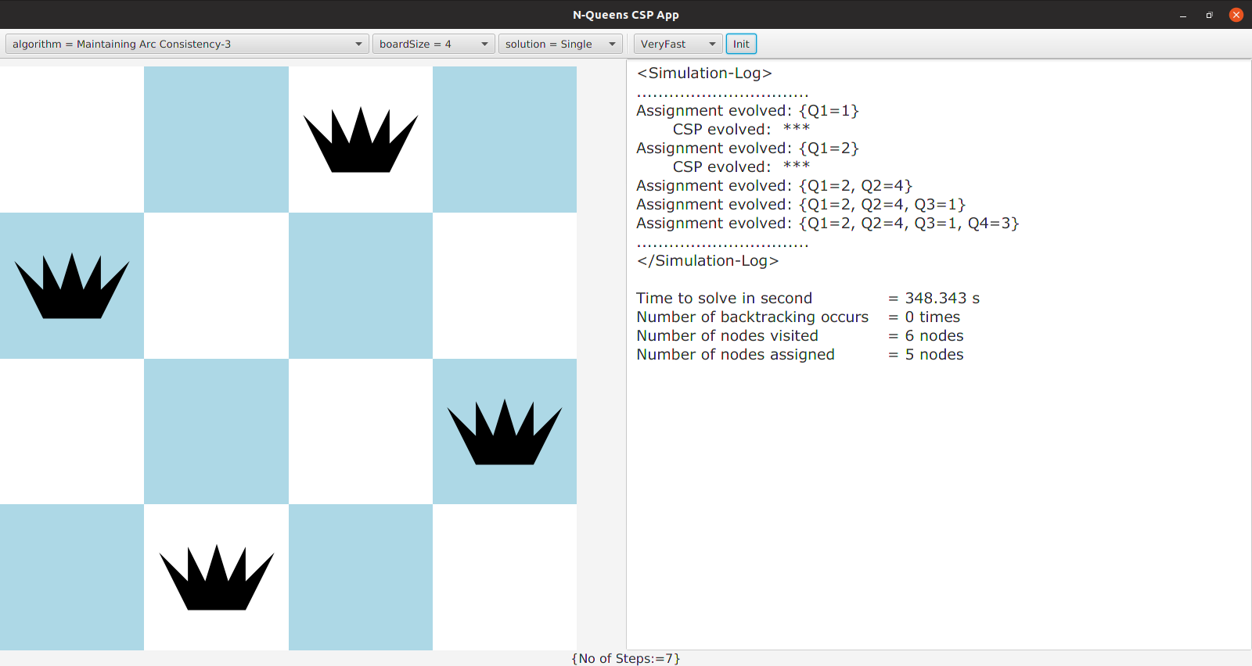

Appendix B-5(b) The end result of MAC-3 Algorithm

5 Solving N-Queens Problem by FC-MRV algorithm

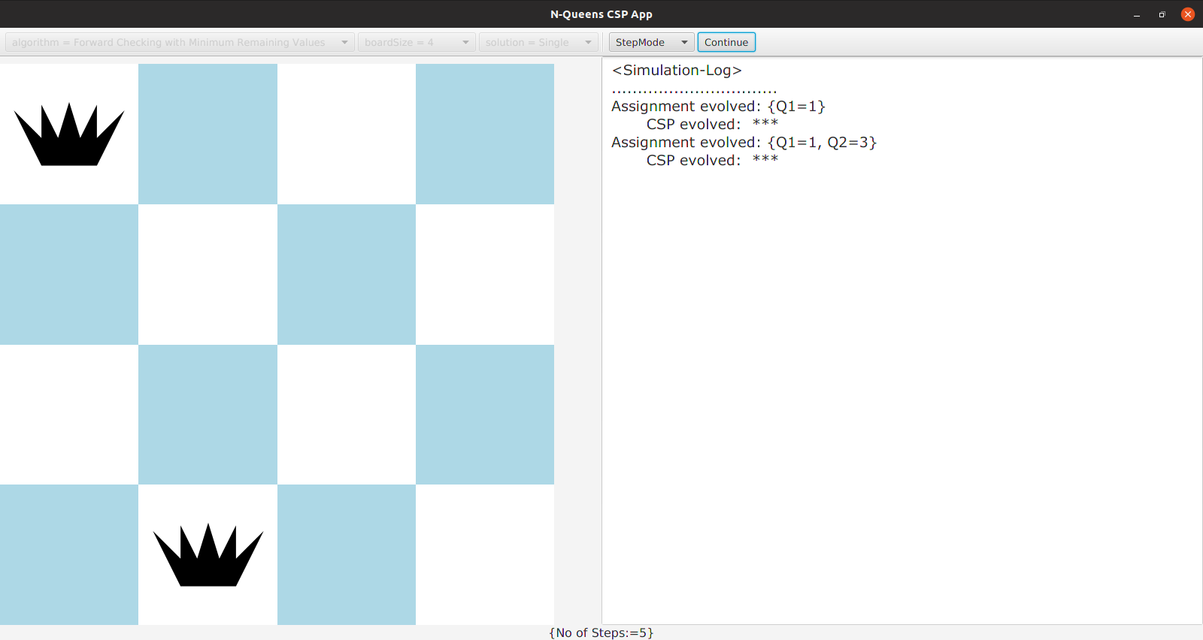
Appendix B-6(a) Running Step by Step of FC-MRV algorithm

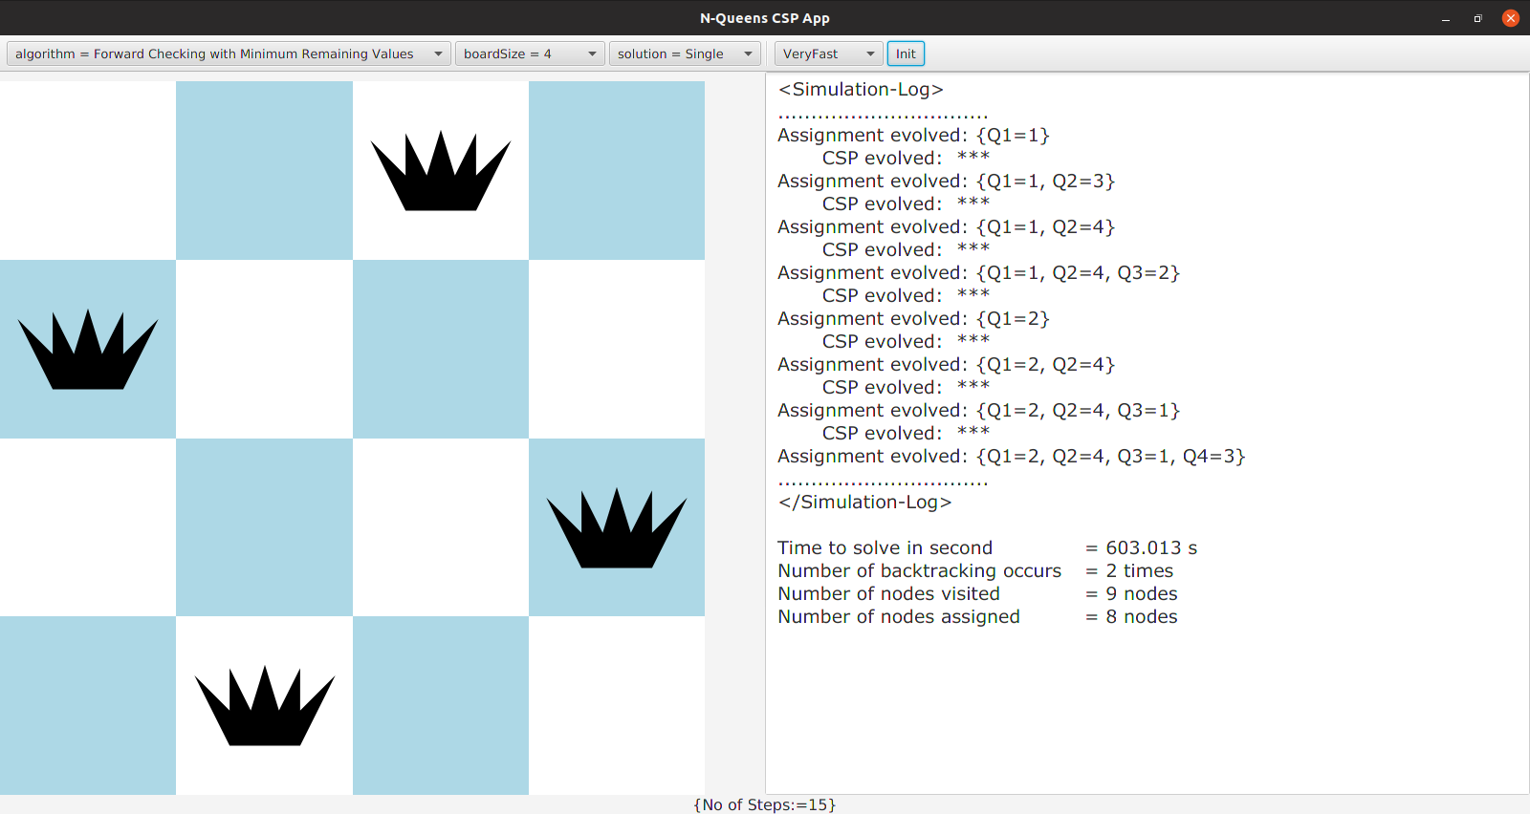
Appendix B-6(b) The end result of FC-MRV algorithm

6 Solving N-Queens Problem by FC-LCV algorithm

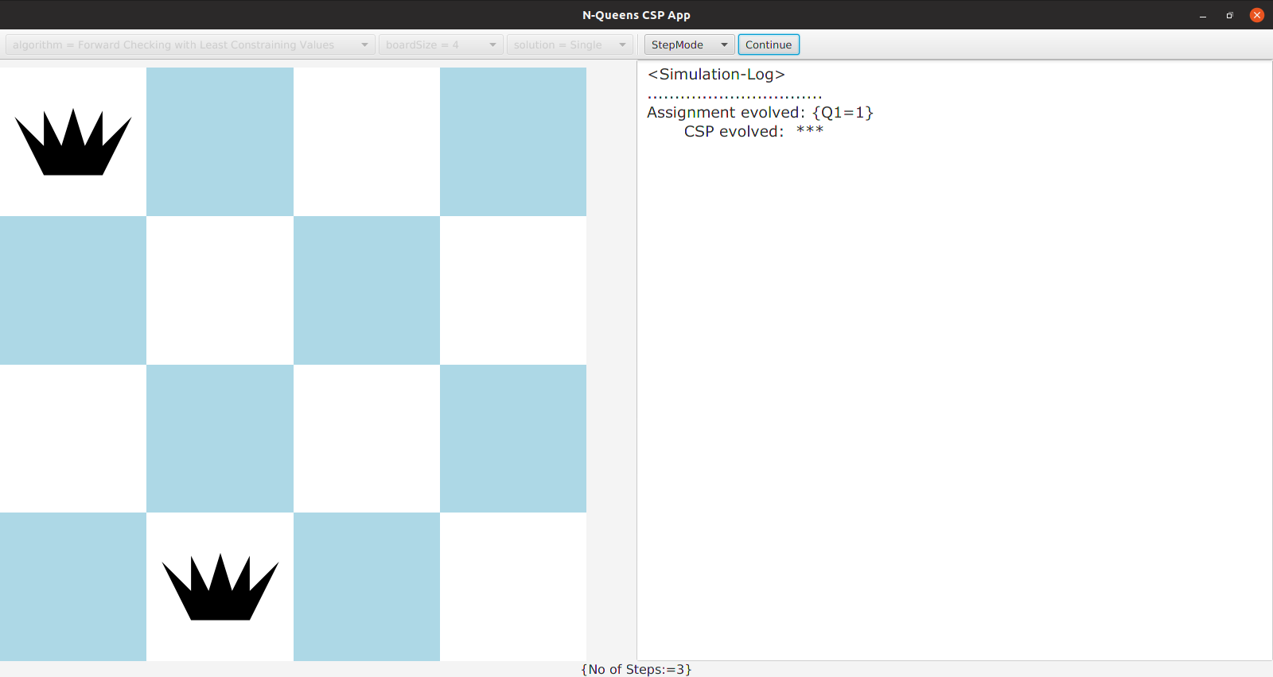
Appendix B-8(a) Running Step by Step of FC-LCV algorithm

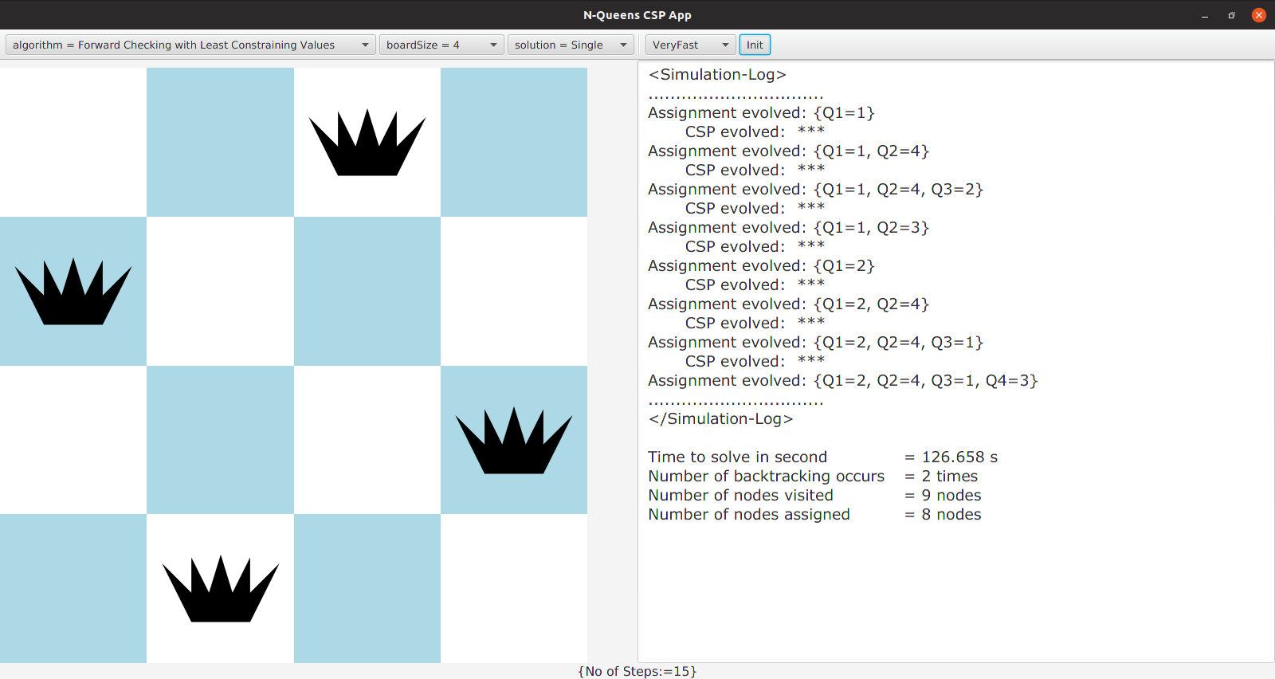
Appendix B-8(b) The end result of FC-LCV algorithm

