CONSTRAINT PROCESSING
FINAL PAPER

Distributed Stochastic Algorithm (DSA & DBA)

Delivered by:
Elad Levi 052673191
Miriam Kreisler 012640074

Table of Contents
1. General Comments 2
1.1. About the DSA implementation 2
1.2. More 2
1.3. Definitions 2
2. The algorithms 2
2.1. DBA from (2) 2
2.2. DSA from (4) 3
2.3. DBA and DSA comments 3
2.4. Data Structures 4
DBAAgent Class 5
DSAAgent 6
AnyTime implementation 6
Graph drawing 6
Privacy 7
Results 8
2.5. What we run 8
2.6. Problems with varying constraint density/count 9
Conclusions 14
External Software 14
References 14

General Comments

About the DSA implementation
The DSA algorithm that we implemented is based on (4) (Any time) and not on (3) e.g. our DSA Algorithm is completely synchronous (only when comparing our results to the ones in the article we noticed that there is a difference) . In on (3) DSA Agent will not send it’s value if it doesn’t change this is expected to significantly lower the number of ncccs and messages. This has the following implications
- Due to the fact that our Algorithm is synchronous counting and passing nccces in not requires – the number of ncccs will simply be the number of constraint checks done by the agents with most neighbors if all run the same number of cycles – or in the case we have islands of run and where the agents on each island run for a different number of cycles it will be related also to the number of cycles the agent run - in any case we can simply pick the ncccs from the agent with the largest value.
- Message count & ncccs is not really a measure that provides valuable information – since all the algorithms run for the same number of cycles
- We didn’t expect any computational impact of message delays.

More
ncccs – we don’t count calls to problem.has_conflicts since this is done at the beginning a small amount of times that is equal for all algorithms and doesn’t have impact on complexity of run. (in any case ncccs is not that significant as explained above)
Accessing weight table is also counted for ncccs

Definitions
d – The size of domain we are currently handling
n – The number of agents we are handling
Islands – we can view the agents as a graph where agents are connected to each other if they are constrained it is possible that all agents are connected but it is also possible that there are several groups of agents that are not connected – we call these groups Islands – since in the algorithms that we implemented agents are not aware of graph topology and each Island may operate on it’s own

The algorithms

DBA from (2)
set the local weights of constraints to one (for privacy the table is input to the agent in our implementation)
value = ChooseRandomValue()
while (no termination condition met) do
exchange value with neighbors
WR←BestPossibleWeightReduction()
send WR to neighbors and collect their WRs
if (WR > 0) then
if (it has the biggest improvement among neighbors) then
value←the value that gives WR
end if
else
if (no neighbor can improve) then
Increase violated constraints’ weights by one
end if
end if
end while
In addition a termination counter was added to DBA according to (2) – since DBA agents are not expected to change their value when reaching a result termination counter is set to 0 when a value is changed it is passed between neighbors and the lowest value is picked, therefore when termination counter reaches n we are sure that our current program may terminate. There is no need to send message to all Agents that end has come since they too will reach the termination counter and can end. (Sending this message is actually an error since it is possible that only one Island has reached a solution and there are other Islands that should not yet terminate)

DSA from (4)
value = ChooseRandomValue()
while (no termination condition is met)
send value to neighbors
collect neighbors’ values
if (ReplacementDecision())
select and assign the next value (we implemented both lines in select_next_value)

there are 5 different variants of DSA the different is in the decision to select a new value it is made according to the following table
Algorithm | Δ>0 | Conflict, Δ = 0 | No conflict, Δ = 0
DSA-A | v with p | – | –
DSA-B | v with p | v with p | –
DSA-C | v with p | v with p | v with p
DSA-D | v | v with p | –
DSA-E | v | v with p | v with p

DBA and DSA comments
- Since for DBA there are two kinds of messages and the flow is as flowing:
send_ok();
wait_ok();
send_improve();
wait_improve();
it is enough to have 2 message boxs for each agent one for improve and the other for ok. it is clrear that each agent will not go on to sending the message of the other kind till he received info from all neighbors. This is not the case in DSA where the flow is as following
send_ok();
wait_ok();

Since in this case it is possible that one neighbor will send it’s next message before another sent it’s current message we must have a separate mail box for each communication between 2 agents

Data Structures

Flows (Class)
The class contains the main program and some flows for running the tests it is responsible for
- Creating problem instances
- Setting up experiments and dispatching agent threads
- Collecting experiment data and creating a report
The main functions of interest are:

make_samples(int samples_count);
create problems in the dir input for runs with varying p1/p2
run_tests(int samples_count, int cycle_count, double p)
runs the tests using the different algorithms and produces a report
make_hard_samples(int no_of_samples);
creates problems with p1=0.7 and p2=0.375 the files are created in directory hard_input
run_hard_tests(int no_of_samples, int cycle_count);
runs the hard tests and collect data
make_random_samples(int no_of_random_samples);
makes a large amount of random tests
run_random_tests(int samples, int cycles);
runs the hard tests and collect data (almost the same code as in run_hard tests)

run_gui_test(String AgentAlgorith, int queens_count, int cycle_count, boolean any_time)
runs AgentAlgorith for queens_count queens and displays the graph (if anytime is true also BFS graph is presented)
String AgentAlgorith,int queens_count, int cycle_count)
runs AgentAlgorith for queens_count queens and displays the graph (if anytime is true also BFS graph is presented)

Messages:
All code related to messages is fount under package messages.
MessageBox<T> is a templated generic class for sending/receiving messages of type T among threads. Both send_messag and read_message methods are synchronizes in the current implementation a thread trying to read a message will wait till the message arrives (if we would implement the other DSA Algorithm we would have to setup another function that doesn’t wait (or have this as a parameter to function)
The message classes are very simple and their name describes their role – an interesting point to note is the fact that when using anytime we use different ok messages then when we don’t event to neighbors that are not paren/children on BFS tree

Package general

Problem (Class)
This is the same class we used in previous assignments

ValSet (Class)
This is used by FC-CBJ

Definitions (interface)
Contains the sataus of FC-CBJ

Agents
All agents implementaions are under the packages agents
In order to enable general control over super class AbrstractAgent was created it contains the common variables and methods it contains in some cases parmaers needed only none one type of agenst since we create the agents in AgentSolver class accordint to name using Java reflection.

AbrstractAgent (Class)
- Implements run from Runnable interface in order to allow running it in it’s own thread (each agent implements do_alg method where it does the actual work.
- Contains the following data (and more)
- agent_view – for each neighbor its id and current value id – the id of agent
- value – the current value of agent
- messeages_sent – number of messages sent
- NCCCs
- cycle_no
- problem – reference to the problem that is being solved
- weight_table – this is used for checking the conflicts between the neighbors in DSA the values are 0 or 1 and in DBA the values can change according to the algorithms
- Is responsible for sending ok messages between the different agents (for DSA all message handling is here DBA manages only improve message

DBAAgent Class
This implements DBA as described in (2) .

DSAAgent
This is an abstract class responsible to DSA parts that don’t involve sending messages. the implementation classes DSA_A_Agent through DSA_E_Agent are the real classes but they only implement select_next_value as described in the table above.

AnyTime implementation
The main Idea of AnyTime is to be able to keep the best results of the run that we have reached so far and provide it as the result any time required.
In order to do this without changing the number of messages significantly a BFS graph is created (we used Jung BFSDistanceLabeler in order to create this graph.)
The algorithm continues sending mesagges to all neighbors as before but in addition
- sends to it parent info what was the total cost of it’s sub tree is cycle#highet
- sends to it’s child the best_index found till now
Any time is managed for each island severalty.
We noticed also that in the case of anytime the root can realize that a solution was found (if one was found) and terminate the algorithm (we added this too to the different measures we took.

Graph drawing
We added the possibility to view the problem’s graphs, this current implementation is a static implementation and it is possible to view the graph before or after the test (but not dynamically try it out) this is demonstrated in the class Flows in the method run_gui_test currently run_gui_test runs the problem on n queens however it is very simple to provide any problem required to it as input. The solver panel will display the constraint graph and if any_time is set to true also BFS graph will be set.

Privacy
We reviewed Distributed constraint satisfaction with partially known constraints and setup our algorithm to keep privacy of constraints between agents (each agent gets only a weight table. We are not able to implement the measure that is suggested in the article since it is based on nogood messages that we don’t have in our algorithms. Due to the fact that the problem topology is not known to the Agents we believe that the algorithms keep privacy quite well – a smart agent my be able to conclude from it neighbors response to changes if it is a conflict or not however this is very difficult since
- In DSA if the neighbor has a large amount of neighbors he may not be sensitive to a single neighbor - therefore the fact that he didn’t change a value when current agent changed a value doesn’t mean that both values have the same impact on it.
- After a long time it is possible to randomly change the value to a new value(or at least cheat the neighbor into thinking the value changes and see its response
- If the neighbor changes value each we move to a certain new value then there is a high probability that the new value is in conflict while the old one is not
- If the neighbor doesn’t change it’s value then we don’t know if both variables are in conflict or both are not in conflict but we can assume they are the same.
- We must do this for a large amount of times and only in a very low portion of the messages (other wise we will never reach a stable area)

TODO

Results

What we run
- We run the problems with 15 variables and domain size of 10
- We run tests on 3 kinds of problems
      - Problems with varying constraint density/count such as we run in previous assignments we run the tests for p1=0.3 and p1=0.7 with p2 varying between 0.1 and 0.9. This we run only with anytime (since we clearly found anytime to be better)
For these problems we hoped to find a critical point in the following values of p1/p2
    - p1=0.3 p2 ~ 0.66
    - p1=0.7 p2 ~ 0.375
We run 60 samples for each p1/p2 (max cycle was set to 500)
We run these tests with p=0.3
- Random problems – we randomly selected p1 and p2 and run this on 1500 different problems (max cycles was set to 500) this was both with and without anytime
- Hard problems – we run 60 problems with p1=0.7 and p2=0.375 (max cycles was set to 700)
The number of cycles we choose was based on previous trials with higer numbers that showed us average anytime index in most cases doesn’t exceed 200
- Measures:
- Number of conflicts at the end – this number is expected to express how close the algorithm is to the optimal solution (the lower it’s value is the better the algorithm preformed
- Failures – In addition to running our algorithms which are all known to be incomplete we also run FC-CB this measure shows how many times we found a solution how many times was relevant DSA able to find it too? The lower this number is the better – we also kept the amount of solvable cases in order to get an Idea of how good our algorithm is
- Average Any Time index (Only for the any time Algorithms)
    - In cases where we run with anytime we kept the best index of any_time this shows how fast the best solution was found - this is the measure where we expect we may be able to find a phase transition since we expect that the harder the problem becomes it will take more time to reach a stable solution.
- Number of messages sent (expected to be identical for all runs that don’t have a termination mechanism other then max_cycles)
- Number of Ncccs (expected to be identical for all runs that don’t have a termination mechanism other then max_cycles)

Problems with varying constraint density/count

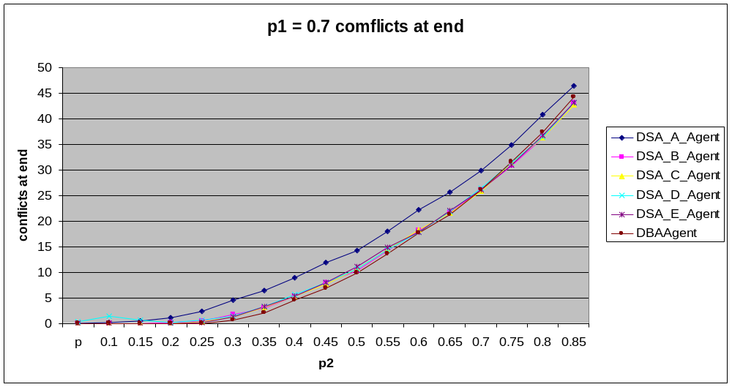
From the above graph we see that all algorithms find are further away from the expected result as the problem becomes harder. For p1=0.3 we saw similar results in addition to the fact that DBA was better then DSA till p2=0.8 (Here it is better only till p2=0.6)
Looking at the failure charts we see:
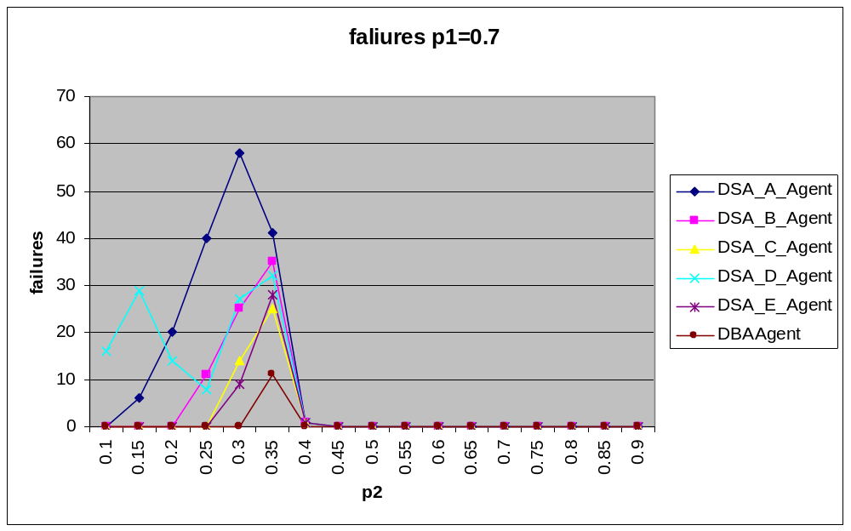
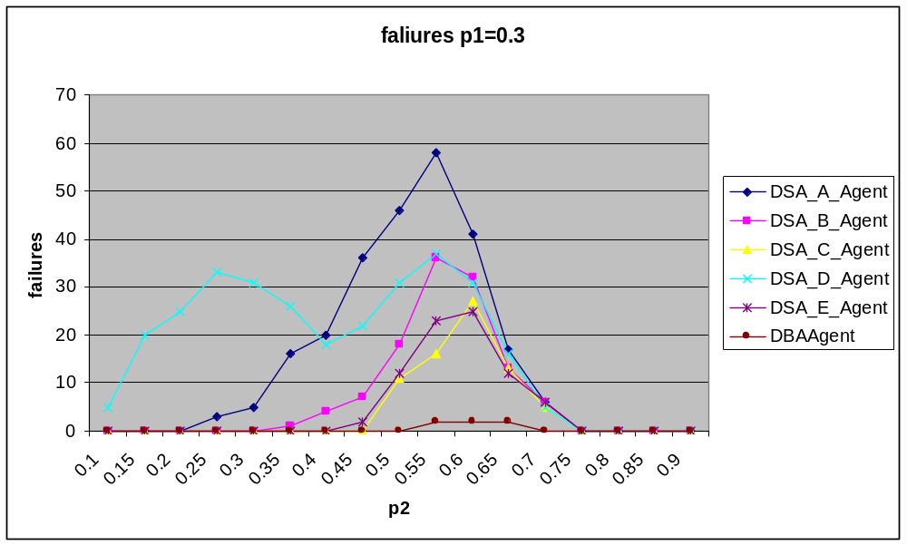
Most of the algorithms have one peek a little before expected phase transition and after phase transition point they drop to 0 – this can be explained by the fact that after the phase transition point there is no solution therefore there is no failure another two interesting observations here are:
- DBA in all cases is much more accurate then the other algorithms and only fails near the expected phase transition point
- All algorithms have only one peek but DSA D has two – on in the regular place where problems become hard and another much earlier – this can be explained by the fact that till a certain density changing of values happens by a few agents in parallel therefore disrupting the results as the problems get harder the chance for two neighbors changing values in the same round decreases and with it the number of failures. Hench the first maximum is due to the change in balance between the difficulty of the problem and the coupling between neighbors while the second peak it due to the fact that the problems are becoming harder to solve. In order to check this out we run these tests again with with p=0.7 and with p=0.05 we expect that with p1=0.7 this result will be more significant and continue for a longer period while for p=0.05 we expect this peak to disappear

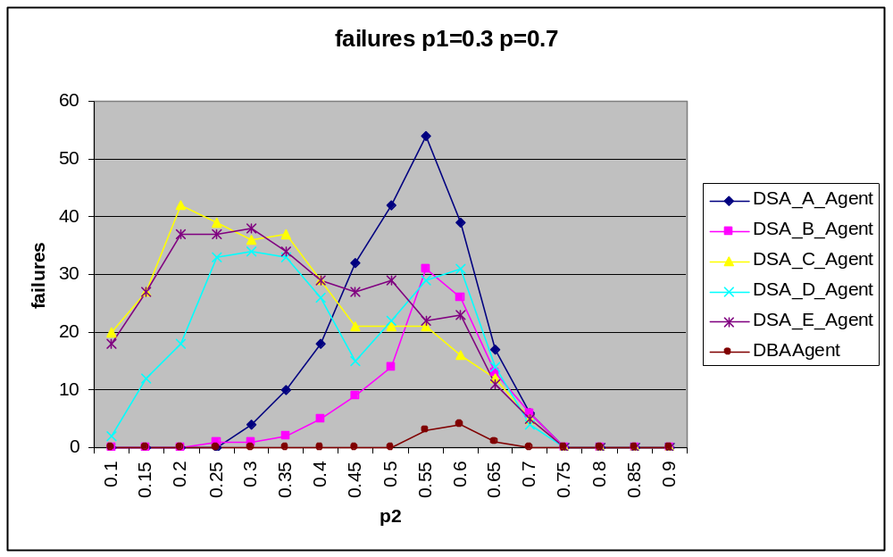

We see in general the for DSA-D there is a second peak around p2=0.3 for p1 = 0.3 and in p2=0.15 for p1=0.7. IN the case when p=0.7 DSA-C and DSA-E tend to have an early peek too.

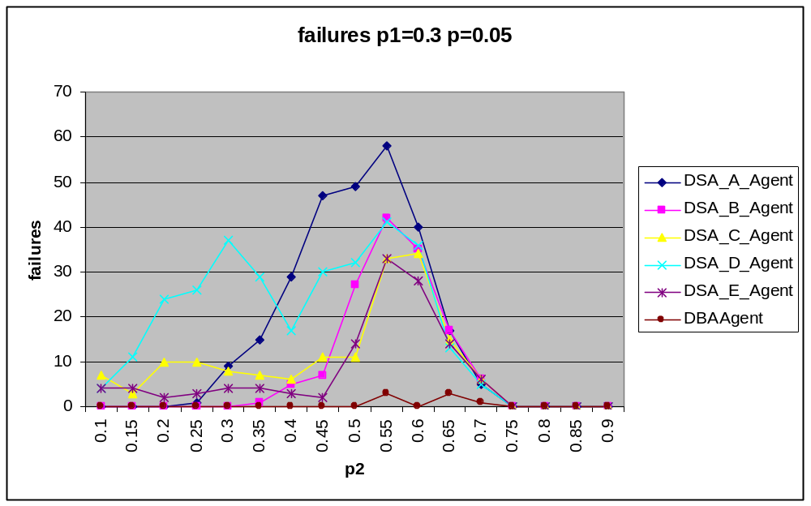
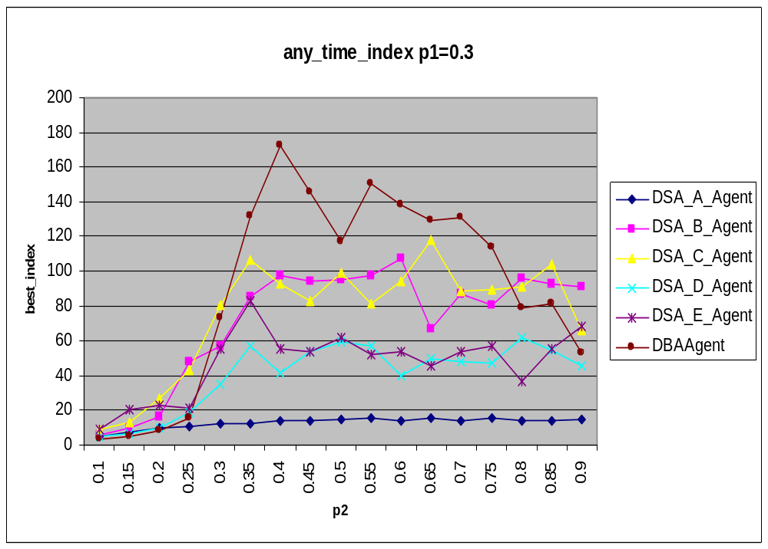
Looking at the chart we clearly see that DBA demonstrates a phase transition in the expected area for DSA B-E we see that anytime index does increase as we get closer to the point where phase transition is expected however after the phase transition any_time_index doesn’t decrease the reason for this is attributed to the fact that our algorithms are not complete and are not able to determinate that there is no solution.
Messages: we didn’t expect messages and ncccs to provide any valuable information with the regular algorithms since it is expected to be a constant therefore we added a termination condition using any time – when ever full solution is found run is terminated.
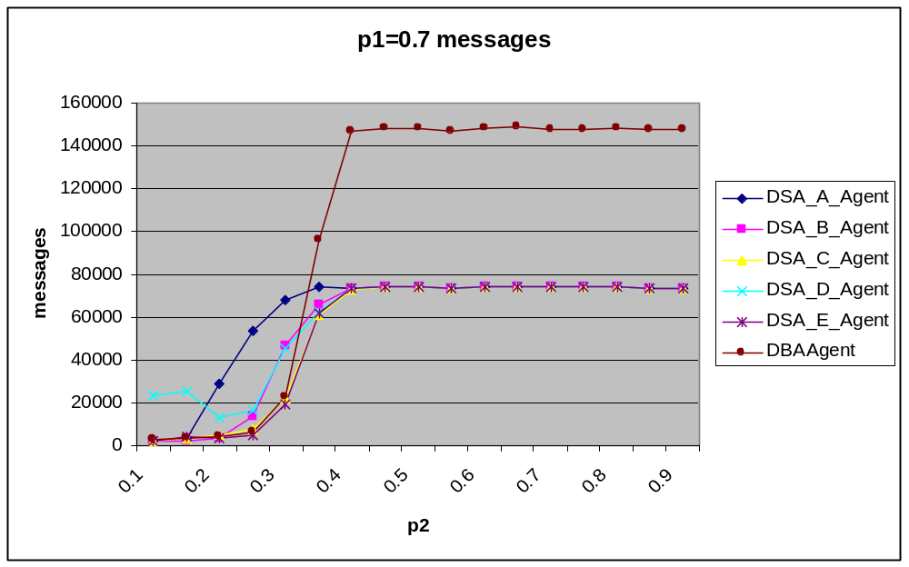
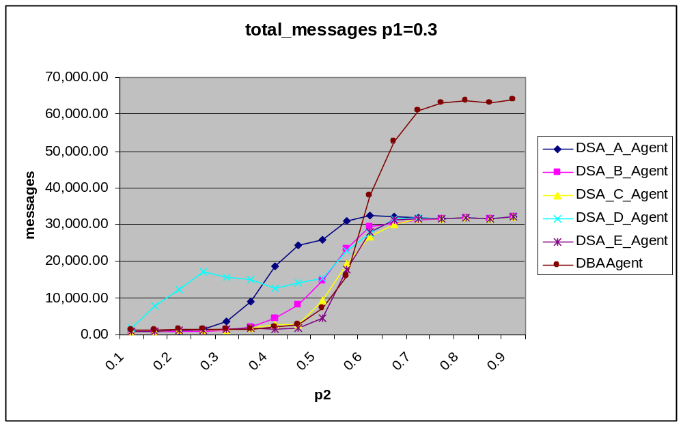
We see hear again that DSA-D has a second pear and that DSA-A is wasteful with messages. DBA is preferable with messages as long as a solution exist but when the problems get harder it runs more and sends more messages.

Hard problems
The chart below shows that DBA agent has many conflicts at the end but any time reduces it dramatically –since in the

Random Problems
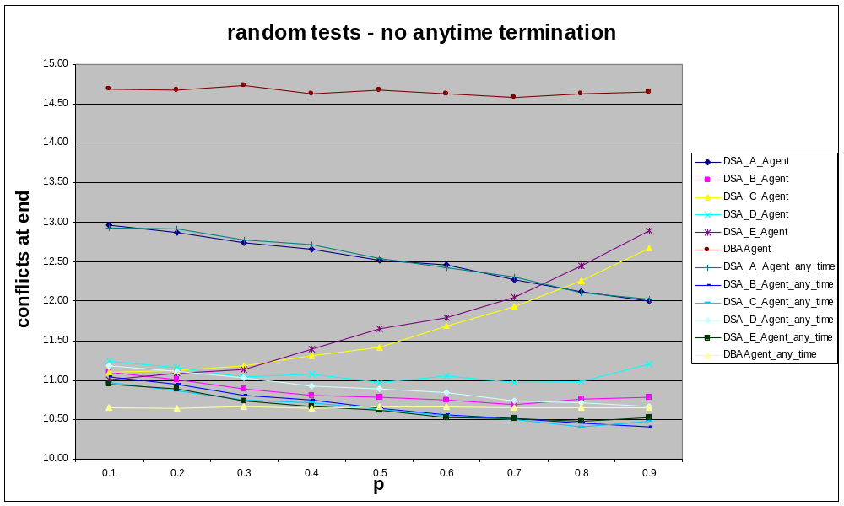
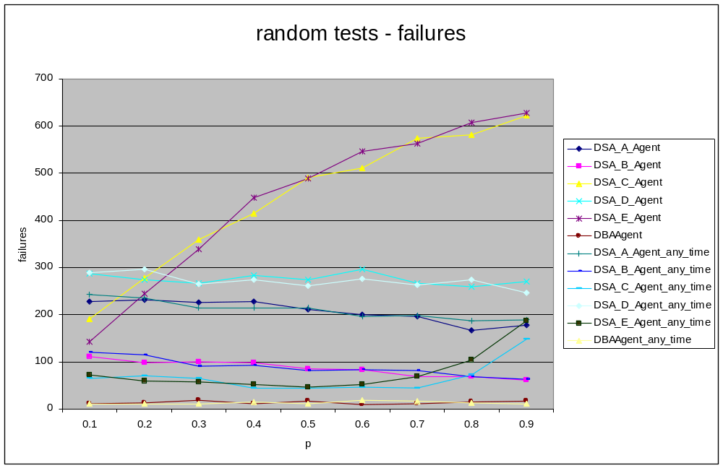
In the random tests we see that for DSA-C and DSA-E get very bad results as p grows hover adding anytime feature “fixes” this up and significantly reduces both the failures and the distance from end. The cause for this can be attributed to the fact that when p is large there are a lot of jumps (due to the high chance of changing a value) using any time allows us to capture the good results.
In the above picture we see that DBA is significantly more accurate then the other algorithms with very few failures – this is contradicts the fact that DBA is very far from 0 when looking at conflicts at end and can be attributed – We conclude here that when there is a solution DBA is most likely to find it (The chance is higher then 0.97 according to our results) but when there is no solution DBA will highly fluctuate trying to find a solution that doesn’t exist.

Conclusions
- Anytime is very useful when our goal is to minimize the conflicts – using it can significantly improve the results of the tests
- When we would like to reach the most accurate results DBA is the better algorithm choice however we must use anytime otherwise in cases where there is no solution DBA will highly fluctuate and will not give good results.
- For fast results DSA-A can be used however this will result in low accuracy
- More investigation is required with DSA variant that doesn’t send messages if value didn’t change

External Software
We used the following libraries in our implementation
- Jung - Java Universal Network/Graph Framework this was used in order to generate BFS tree and to visualize the graph the agents are not “aware” of this usage
- JXL – Java Excel API for creating the reports

References
- Brito and A. Meisels and P. Meseguer and R. Zivan. Distributed Constraint satisfaction with Partially Known Constraints. Constraints. Springer Science + Business Media, LLC 200
- M. Yokoo and K. Hirayama. Distributed breakout algorithm for solving distributed constraint satisfaction problems. Second International Conference on Multi-Agent Systems 1996.
- W. Zhang, Z. Xing, G. Wang, and L. Wittenburg. Distributed stochastic search and distributed breakout: properties, comparison and applications to constraints optimization problems in sensor networks. Artificial Intelligence, 161:1-2:55–88, January 2005.
- R. Zivan Anytime local search for distributed constraint optimization

- CSP Course guide

