Artificial Intelligence
LAB 2: Using the library to solve AI problems
LE Thanh Sach, Ph.D.

Introduction to Some AI Problems

River Crossing Problem:
A farmer wishes to carry a tiger, a buffalo and bundle of grass across a river, from the west to the east shore. The farmer is the proud owner of a small rowing boat called Bounty which he feels is easily up to the job. Unfortunately the boat is only large enough to carry at most the farmer and one other item. Tiger again, if left unattended the tiger will eat the buffalo and the buffalo will eat the grass.
Question: How can the farmer move all of the three objects from the west to the east shore by using Bounty?

Farmer, Tiger,
Buffalo and Grass
boat
River
boat
River
Farmer, Tiger,
Buffalo and Grass

8-puzzle:
2
1
3
4
7
6
5
8
1
2
3
4
5
6
7
8

Water Jugs Problem
“You are given two jugs, a 4-litre one and a 3-litre one. Neither has any measuring marker on it. There is a pump that can be used to fill the jugs with water. How can you get exactly 2 litres of water into 4-litre jug.”

Missionaries and cannibals
Three missionaries and three cannibals are on the left bank of a river. There is one canoe which can hold one or two people. Find a way to get everyone to the right bank, without ever leaving a group of missionaries in one place outnumbered by cannibals in that place.

N-Queens Problem
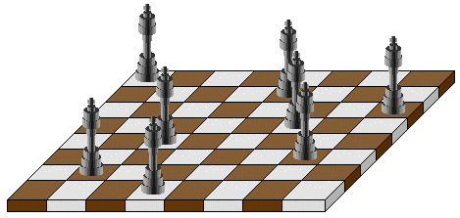

3*3*3 Rubik’s Cube Problem
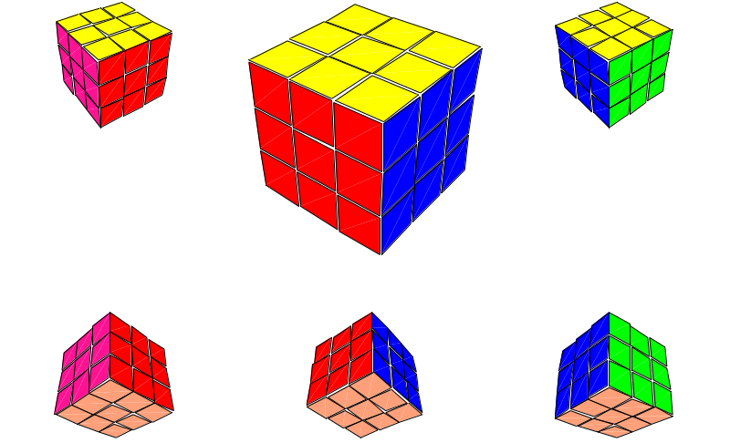

Map searching (navigation)
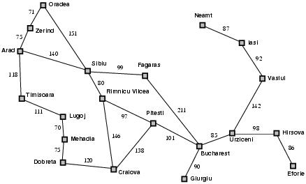

Solving the River Crossing Problem.
Assuming that students have created the following two projects, in previous LAB sessions.

1. Project AIMA: contains AIMA library for the courses. Almost algorithms in AIMA book are implemented inside this project.
2. Project AIDEMO: contains students’ application, for solving classical AI problems.

Students should refer to the instructions in previous LABs if you don’t have the two project mentioned above.
Step 1: Create package “search.farmer” in project “AIDEMO”.
Step 2: Create four classes given below for describing your problem – River Crossing.
- Class “FarmerState”:
  - An instance of this class represents a state in searching algorithm.
  - Please notice that state and node in AIMA are different. A node contains a state and other information for using with node.
- Class “GoalEvaluator”.
  - This class implement interface “GoalTest”, so it implements function “isGoalState”.
- Class “ActionFactory”.
  - This class implement interface “ActionsFunction”, so it implements function “actions”.
- Class “ResultFactory”.
  - This class implement interface “ResultFunction”, so it implements functions “result”.

Again, In order to describe your problem by using AIMA library, you have to specify four objects as follows:
1. An object for representing the initial state.
2. An object for representing the goal state.
3. An object for producing actions to be performed from a given state.
4. An object for producing result state if a given action is applied to a given state.
These objects are instanced from the four classes mentioned above respectively.
Step 3: Edit class “FarmerState”

package search.farmer;

public class FarmerState {
/*
I. value in m_state:
= 0: on the west side of the river
= 1: on the east side of the river
II. The order in array:
[Location of Farmer (LoFarmer), LoTiger, LoBuffalo, LoGrass]
*/
public static final int WEST = 0;
public static final int EAST = 1;
public int m_state[] = {WEST, WEST, WEST, WEST};

FarmerState(int state[]){
System.arraycopy(state, 0, m_state, 0, state.length);
}
boolean isValidState(int[] state){
boolean case1, case2, case3;
//1. Farmer, Tiger, Buffalo: on the same side
case1 = (state[0] == state[1]) && (state[0] == state[2]);
//2. Farmer, Buffalo, Grass: on the same side
case2 = (state[0] == state[2]) && (state[0] == state[3]);
//3. Dont care LoFarmer: LoTiger <> LoBuffalo, and LoBuffalo <> LoGrass
case3 = (state[1] != state[2]) && (state[2] != state[3]);
return case1 || case2 || case3;
}
int move(int side){
if (side == WEST) return EAST;
else return WEST;
}

public boolean canFamerMoveAlone(){
int newState[] = {move(m_state[0]), m_state[1], m_state[2], m_state[3]};
boolean cond1 = isValidState(newState);

if(cond1)return true;
else return false;
}
public boolean canFamerMoveWithTiger(){
int newState[] = {move(m_state[0]), move(m_state[1]), m_state[2], m_state[3]};
boolean cond1 = (m_state[0] == m_state[1]);
boolean cond2 = isValidState(newState);

if(cond1 && cond2)return true;
else return false;
}
public boolean canFamerMoveWithBuffalo(){
int newState[] = {move(m_state[0]), m_state[1], move(m_state[2]), m_state[3]};
boolean cond1 = (m_state[0] == m_state[2]);
boolean cond2 = isValidState(newState);

if(cond1 && cond2)return true;
else return false;
}
public boolean canFamerMoveWithGrass(){
int newState[] = {move(m_state[0]), m_state[1], m_state[2], move(m_state[3])};
boolean cond1 = (m_state[0] == m_state[3]);
boolean cond2 = isValidState(newState);

if(cond1 && cond2)return true;
else return false;
}
FarmerState moveAlone(){
int newState[] = {move(m_state[0]), m_state[1], m_state[2], m_state[3]};
return new FarmerState(newState);
}
FarmerState moveWithTiger(){
int newState[] = {move(m_state[0]), move(m_state[1]), m_state[2], m_state[3]};
return new FarmerState(newState);
}
FarmerState moveWithBuffalo(){
int newState[] = {move(m_state[0]), m_state[1], move(m_state[2]), m_state[3]};
return new FarmerState(newState);
}
FarmerState moveWithGrass(){
int newState[] = {move(m_state[0]), m_state[1], m_state[2], move(m_state[3])};
return new FarmerState(newState);
}
//---------------------------------
private String num2String(int side){
if (side == WEST) return "WEST";
else return "EAST";
}
public String toString(){
String result = "";
result = "[ FAMER=" + num2String(m_state[0]) + "," +
"TIGER=" + num2String(m_state[1]) + "," +
"BUFFALO=" + num2String(m_state[2]) + "," +
"GRASS=" + num2String(m_state[3]) + " ]";
return result;
}
}
Step 4: Edit class “GoalEvaluator”

package search.farmer;

import aima.core.search.framework.GoalTest;

public class GoalEvaluator implements GoalTest{
public boolean isGoalState(Object state) {
FarmerState s = (FarmerState)state;
int goalState[] = {1, 1, 1, 1};
//Verify whether s.m_state == goalState:
boolean flag = true;
for(int i=0; i< 4; i++){
if(s.m_state[i] != goalState[i]){
flag = false;
break;
}
}
return flag;
}
}
Step 5: Edit class “ActionFactory”
package search.farmer;

import java.util.LinkedHashSet;
import java.util.Set;

import aima.core.agent.Action;
import aima.core.agent.impl.DynamicAction;
import aima.core.search.framework.ActionsFunction;

public class ActionFactory implements ActionsFunction{

public static Action FARMER_MOVE_ALONE = new DynamicAction("FARMER_MOVE_ALONE");
public static Action FARMER_MOVE_TIGER = new DynamicAction("FARMER_MOVE_TIGER");
public static Action FARMER_MOVE_BUFFALO = new DynamicAction("FARMER_MOVE_BUFFALO");
public static Action FARMER_MOVE_GRASS = new DynamicAction("FARMER_MOVE_GRASS");

public Set<Action> actions(Object s) {
FarmerState state = (FarmerState)s;
Set<Action> actionList = new LinkedHashSet<Action>();

if(state.canFamerMoveAlone()) actionList.add(FARMER_MOVE_ALONE);
if(state.canFamerMoveWithTiger()) actionList.add(FARMER_MOVE_TIGER);
if(state.canFamerMoveWithBuffalo()) actionList.add(FARMER_MOVE_BUFFALO);
if(state.canFamerMoveWithGrass()) actionList.add(FARMER_MOVE_GRASS);

return actionList;
}

}
Step 6: Edit class “ResultFactory”
package search.farmer;

import aima.core.agent.Action;
import aima.core.search.framework.ResultFunction;

public class ResultFactory implements ResultFunction{
@Override
public Object result(Object s, Action a) {
FarmerState state = (FarmerState)s;
FarmerState resultState = null;

if(a.equals(ActionFactory.FARMER_MOVE_ALONE)){
resultState = state.moveAlone();
}

if(a.equals(ActionFactory.FARMER_MOVE_TIGER)){
resultState = state.moveWithTiger();
}
if(a.equals(ActionFactory.FARMER_MOVE_BUFFALO)){
resultState = state.moveWithBuffalo();
}
if(a.equals(ActionFactory.FARMER_MOVE_GRASS)){
resultState = state.moveWithGrass();
}
return resultState;
}
}
Step 7: Create your search application. This application uses the four classes created above to solve the search problem, in combination with search algorithm developed in AIMA library. Create class “FarmerApp” and then edit it as follows:
package search.farmer;

import java.util.List;

import aima.core.agent.Action;
import aima.core.search.framework.Problem;
import aima.core.search.framework.Search;
import aima.core.search.framework.SearchAgent;
import aima.core.search.framework.TreeSearch;
import aima.core.search.framework.GraphSearch;
import aima.core.search.uninformed.BidirectionalSearch;
import aima.core.search.uninformed.BreadthFirstSearch;
import aima.core.search.uninformed.DepthFirstSearch;
import aima.core.search.uninformed.DepthLimitedSearch;
import aima.core.search.uninformed.IterativeDeepeningSearch;
import aima.core.search.uninformed.UniformCostSearch;

public class FarmerApp {
public static void main(String args[]) {
try{
int position[] = {
FarmerState.WEST,
FarmerState.WEST,
FarmerState.WEST,
FarmerState.WEST};
FarmerState intialState = new FarmerState(position);
GoalEvaluator goalState = new GoalEvaluator();
ActionFactory actionLister = new ActionFactory();
ResultFactory resultLister = new ResultFactory();

Problem problem = new Problem(
intialState,
actionLister,
resultLister,
goalState);

Search search = new BreadthFirstSearch(
new GraphSearch());

//Search search = new UniformCostSearch();
//Search search = new DepthFirstSearch(new GraphSearch());
//Search search = new DepthLimitedSearch(8);
//Search search = new IterativeDeepeningSearch();

SearchAgent agent = new SearchAgent(problem, search);
List<Action> actions = agent.getActions();

System.out.println("List of Actions should be performed to reach the goal state:");
for(Action a: actions){
System.out.println(a.toString());
}
}
catch(Exception e){
System.out.println(e.toString());
}
}

}
Step 8: Compile and run.
Step 9: Explain the output
Step 10: Change FarmerApp to use the following search algorithms:
- Breadth First Search (BFS)
- Uniform Cost Search (UCS)
- Depth First Search (DFS)
- Depth Limited Search (DLS)
- Iterative Deepening Search (IDS)
Step 11: Go to source code of the algorithms mentioned above to read and understand them with help from your lecturer.

Exercises.
Solve all of the problems given above

