Artificial Intelligence
LAB 5: Constraint Satisfaction Problem
LE Thanh Sach, Ph.D.

Typical Problem
- Coloring map.
Requirement:
- Use N colors, for example N=3: Red, Green, and Blue
- Color map such that different states receive different colors.

1. Australian Map:
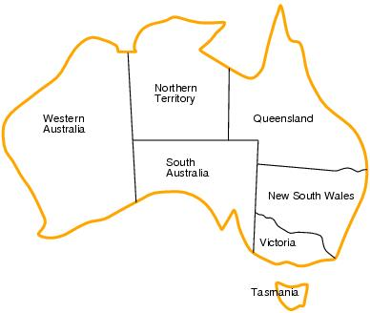
2. A Part of Vietnamese Map 1:
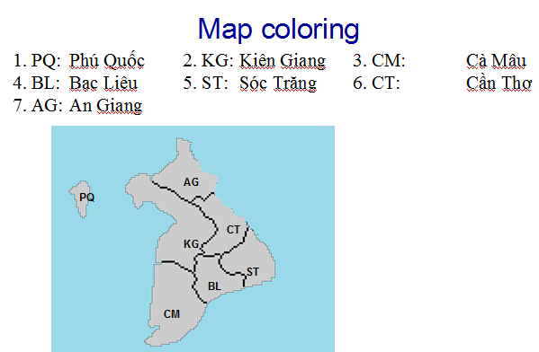

3. A Part of Vietnamese Map 2:
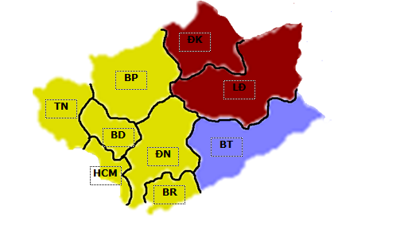
1. TN: Tây Ninh 2. HCM: Hồ Chí Minh 3. BR: Bà Rịa
4. ĐN: Đồng Nai 5. BD: Bình Dương 6. BP: Bình Phước
7. BT: Bình Thuận 8. LĐ: Lâm Đồng 9. ĐK: Đak Nông
- N-Queens
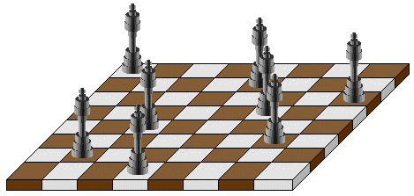

- Sudoku:
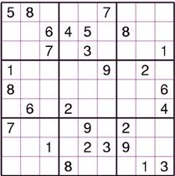

Algorithm:

Step 1: Declare your map.
- Create a class named “AustralianMap” in package “csp”
- Edit the class as follows

package csp;

import java.util.ArrayList;
import java.util.List;

import aima.core.search.csp.CSP;
import aima.core.search.csp.Domain;
import aima.core.search.csp.NotEqualConstraint;
import aima.core.search.csp.Variable;

public class AustralianMap extends CSP {
public static final Variable NSW = new Variable("NSW");
public static final Variable NT = new Variable("NT");
public static final Variable Q = new Variable("Q");
public static final Variable SA = new Variable("SA");
public static final Variable T = new Variable("T");
public static final Variable V = new Variable("V");
public static final Variable WA = new Variable("WA");
public static final String RED = "RED";
public static final String GREEN = "GREEN";
public static final String BLUE = "BLUE";

private static List<Variable> collectVariables() {
List<Variable> variables = new ArrayList<Variable>();
variables.add(NSW);
variables.add(WA);
variables.add(NT);
variables.add(Q);
variables.add(SA);
variables.add(V);
variables.add(T);
return variables;
}

public AustralianMap () {
super(collectVariables());

Domain colors = new Domain(new Object[] { RED, GREEN, BLUE });

for (Variable var : getVariables())
setDomain(var, colors);

addConstraint(new NotEqualConstraint(WA, NT));
addConstraint(new NotEqualConstraint(WA, SA));
addConstraint(new NotEqualConstraint(NT, SA));
addConstraint(new NotEqualConstraint(NT, Q));
addConstraint(new NotEqualConstraint(SA, Q));
addConstraint(new NotEqualConstraint(SA, NSW));
addConstraint(new NotEqualConstraint(SA, V));
addConstraint(new NotEqualConstraint(Q, NSW));
addConstraint(new NotEqualConstraint(NSW, V));
}
}

You can use one of the two algorithms:
- Standard Backtracking
- Improved Backtracking

Step 2.1: Use Standard Backtracking Algorithm
- Create class named “CSPSolver”
- Edit the class as follows

package csp;

import org.junit.Assert;
import aima.core.search.csp.Assignment;
import aima.core.search.csp.BacktrackingStrategy;
import aima.core.search.csp.ImprovedBacktrackingStrategy;
import aima.core.search.csp.CSP;
import aima.core.search.csp.ImprovedBacktrackingStrategy.Inference;
import aima.core.search.csp.ImprovedBacktrackingStrategy.Selection;

public class CSPSolver{
public static void main(String[] args) {
//Create a CSP Problem
CSP csp = new AustralianMap();

//Create a solver using Standard Backtracking Solver
BacktrackingStrategy solver = new
BacktrackingStrategy();

//Solve the Problem, and Get the result
Assignment results = solver.solve(csp);

//Print the output
System.out.println(results.toString());
}
}

Step 2.2: Use Improved Backtracking Algorithm
- Create class named “CSPSolver”
- Edit the class as follows

package csp;

import org.junit.Assert;
import aima.core.search.csp.Assignment;
import aima.core.search.csp.BacktrackingStrategy;
import aima.core.search.csp.ImprovedBacktrackingStrategy;
import aima.core.search.csp.CSP;
import aima.core.search.csp.ImprovedBacktrackingStrategy.Inference;
import aima.core.search.csp.ImprovedBacktrackingStrategy.Selection;

public class CSPSolver{
public static void main(String[] args) {
//Create a CSP Problem
CSP csp = new AustralianMap();

//Create a solver using Standard Backtracking Solver
ImprovedBacktrackingStrategy solver = new
ImprovedBacktrackingStrategy();

//Configure to use:
//1. Minimum Remaining Value
//2. Forward Checking
solver.setVariableSelection(Selection.MRV);
solver.setInference(Inference.FORWARD_CHECKING);

//Solve the Problem, and Get the result
Assignment results = solver.solve(csp);

//Print the output
System.out.println(results.toString());
}
}

Excercises:
- Color Part of Vietnamese map as shown in Section I.
- * Color the whole Vietnamese map by using 5 colors.

