APPENDIX A


Appendix A-1: Main frame of N-Queens Simulator

1 Solving N-Queens Problem by Backtracking Algorithm

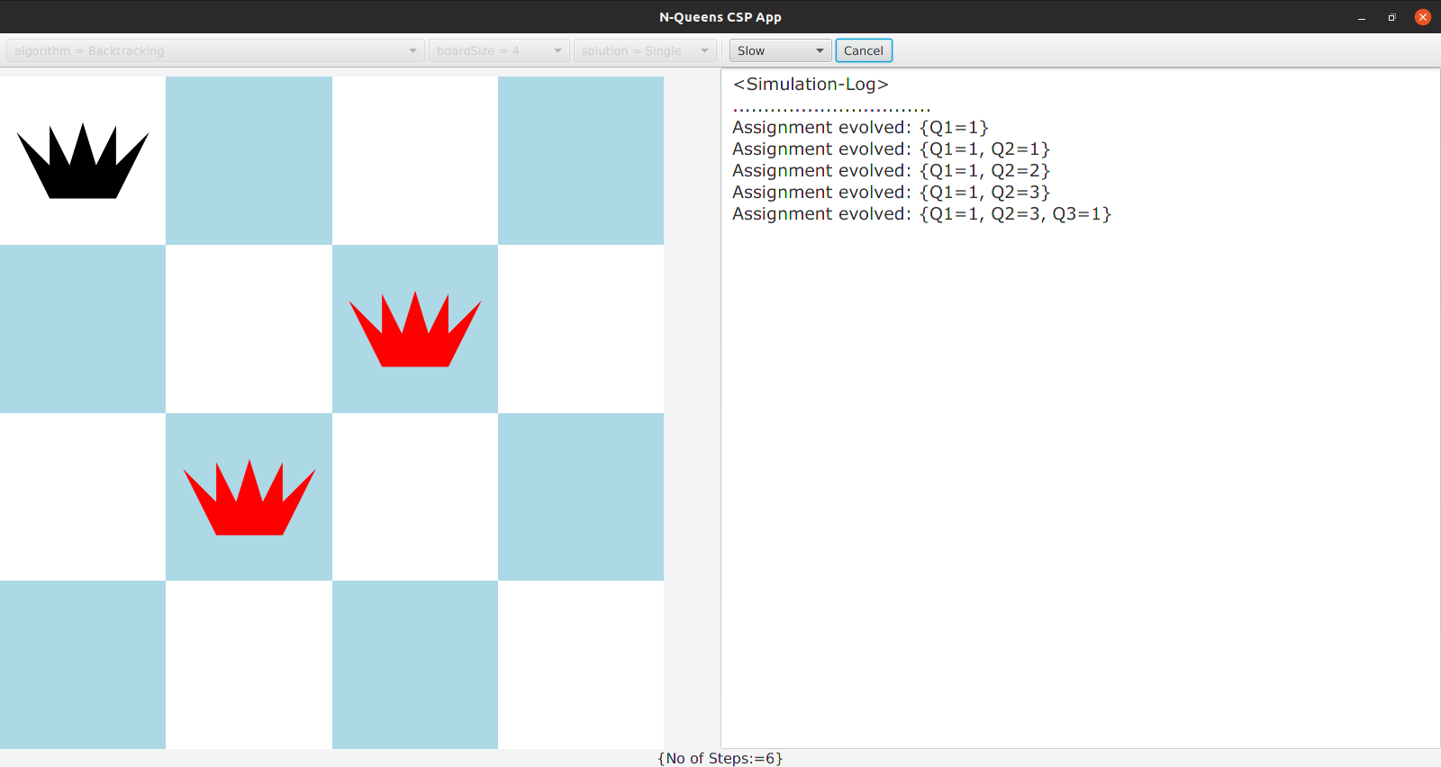

Appendix A-2(a) Running Step by Step of BT Algorithm

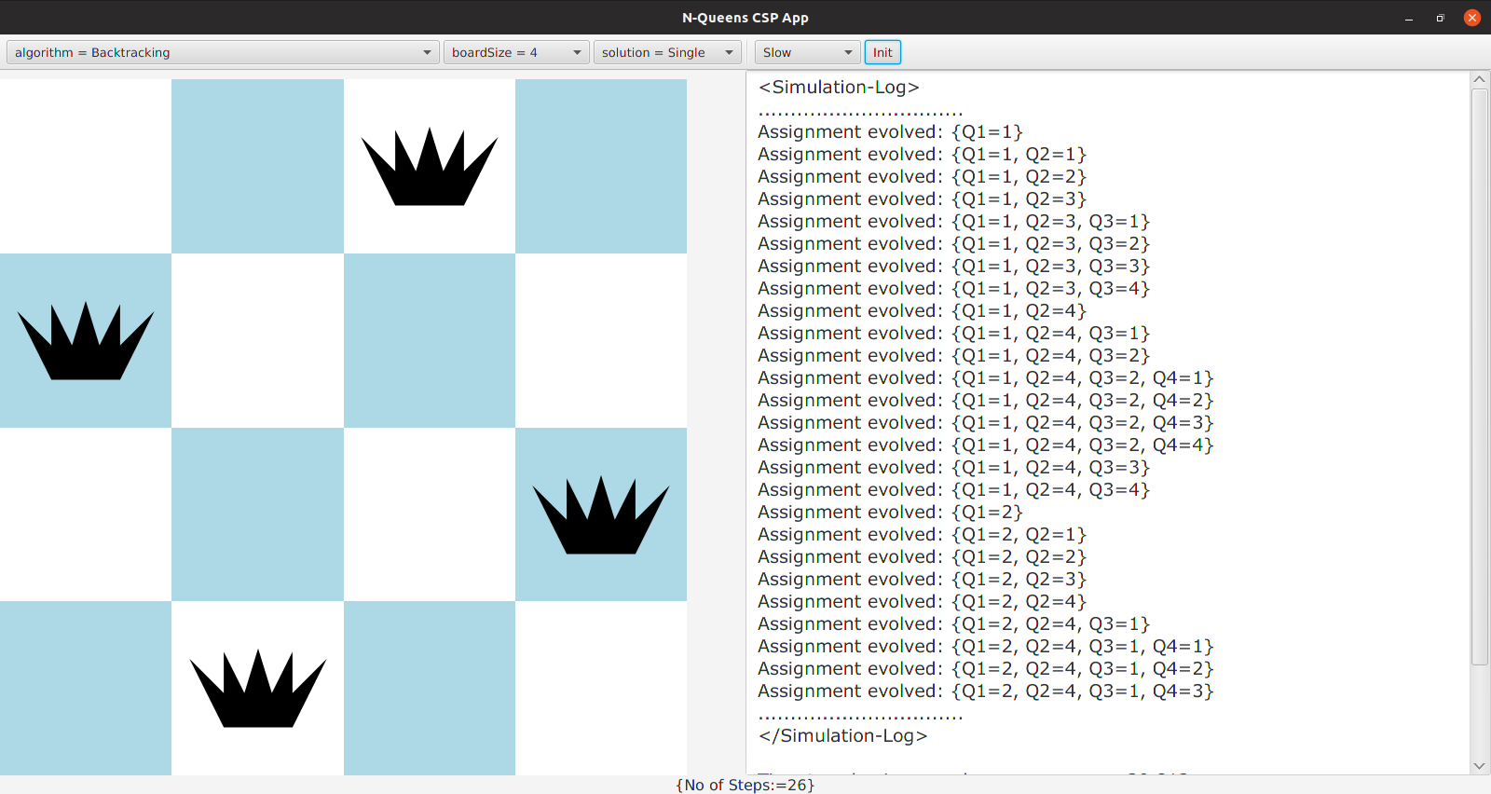
Appendix A-2(b) The end result of BT Algorithm

2 Solving N-Queens Problem by Forward Checking Algorithm

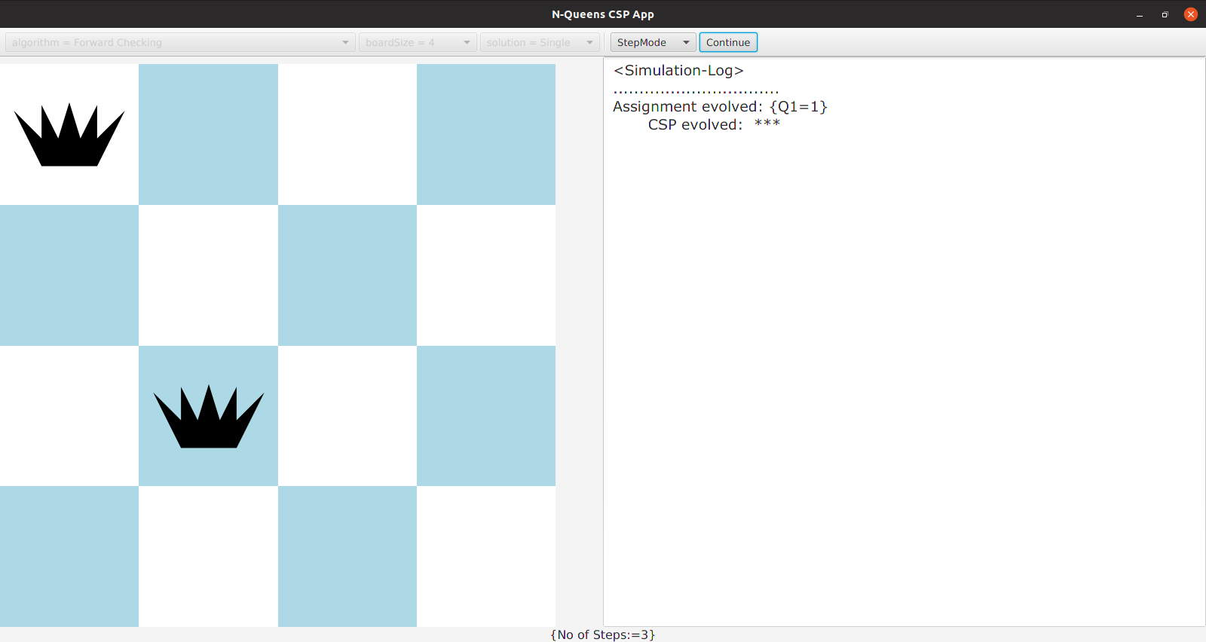
Appendix A-3(a) Running Step by Step of FC Algorithm

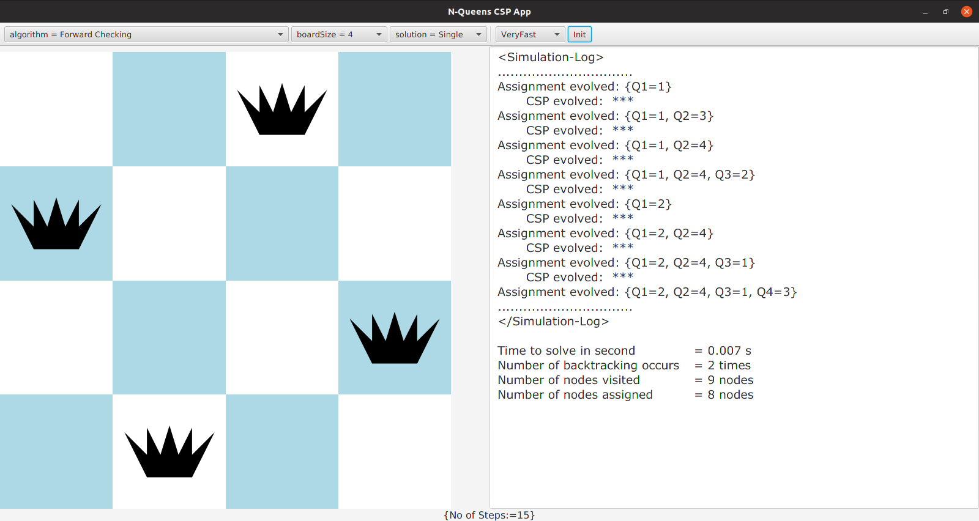
Appendix A-3(b) The end result of FC Algorithm

3 Solving N-Queens Problem by AC-3 with Forward Checking Algorithm

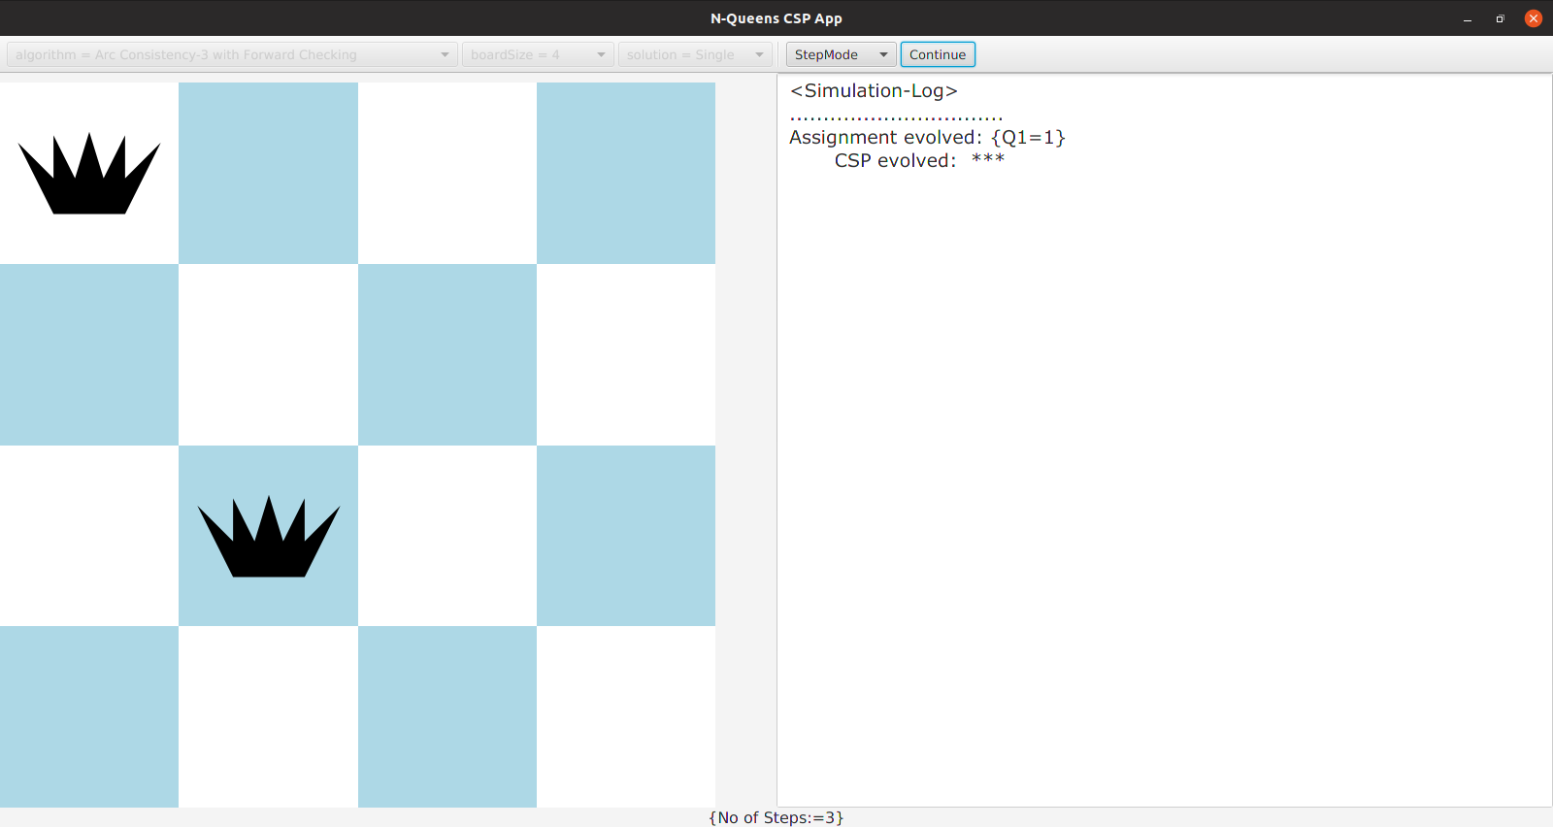
Appendix A-4(a) Running Step by Step of AC-3 with FC Algorithm

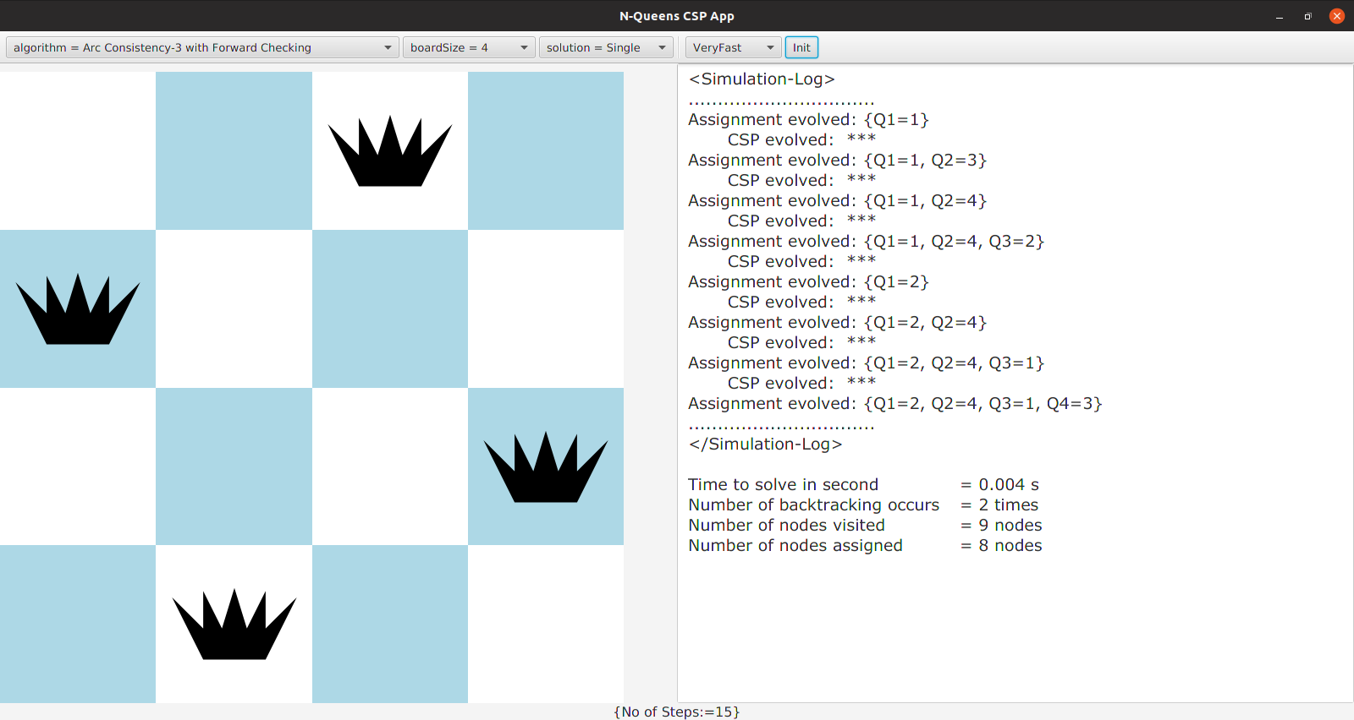
Appendix A-4(b) The end result of AC-3 with FC Algorithm

4 Solving N-Queens Problem by MAC-3 Algorithm

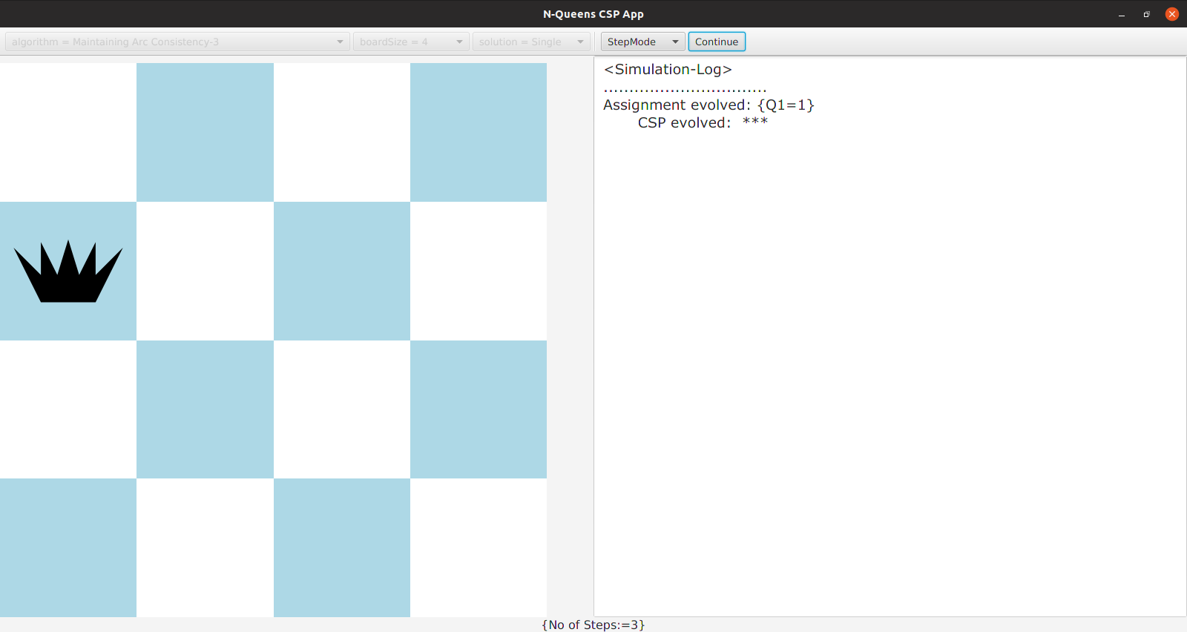
Appendix A-5(a) Running Step by Step of MAC-3 algorithm

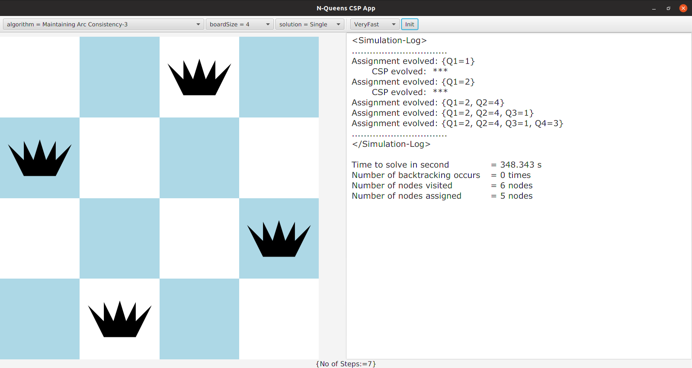

Appendix A-5(b) The end result of MAC-3 Algorithm

5 Solving N-Queens Problem by FC-MRV algorithm

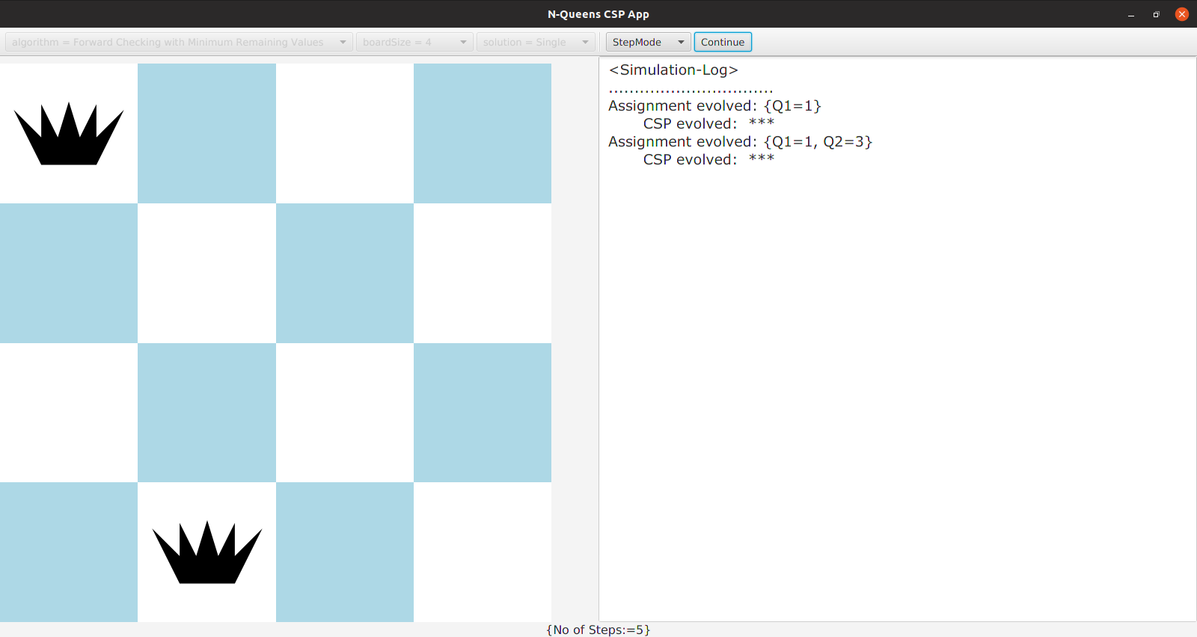
Appendix A-6(a) Running Step by Step of FC-MRV algorithm

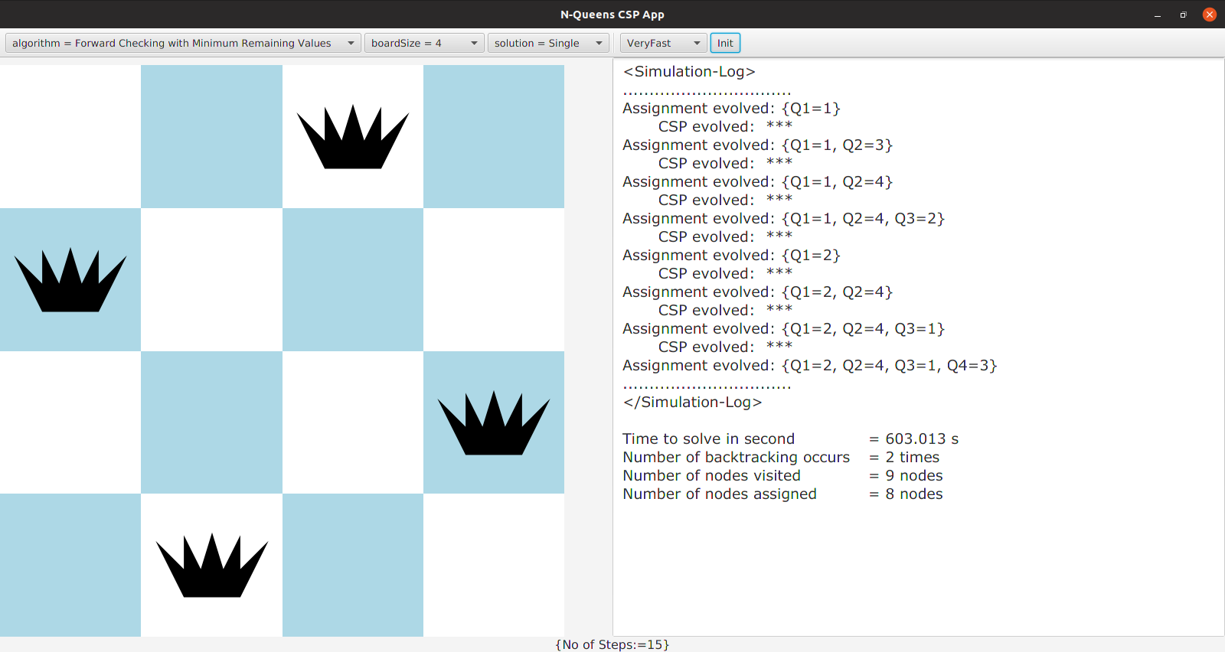
Appendix A-6(b) The end result of FC-MRV algorithm

6 Solving N-Queens Problem by FC-LCV algorithm

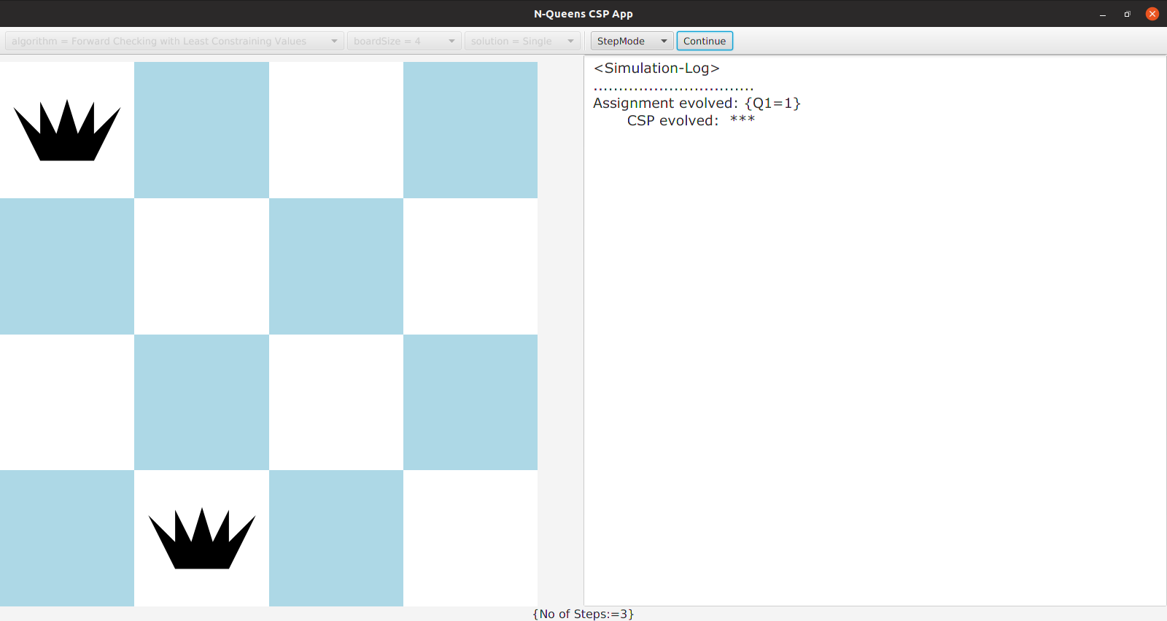
Appendix A-8(a) Running Step by Step of FC-LCV algorithm

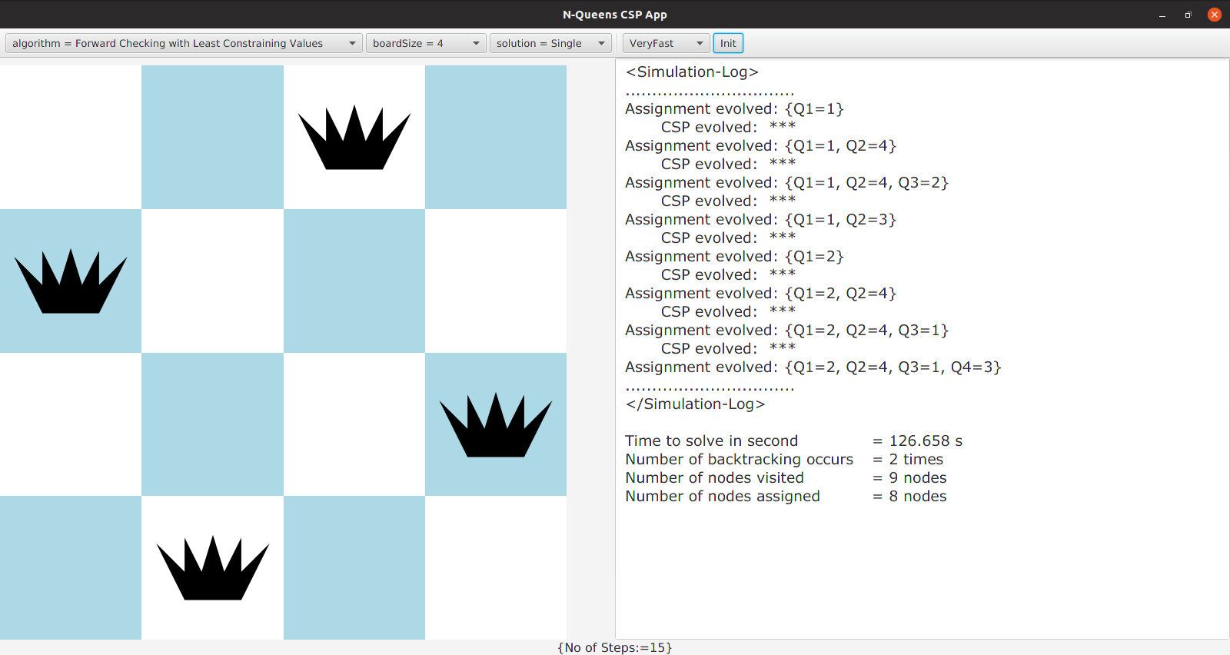
Appendix A-8(b) The end result of FC-LCV algorithm

