APPENDIX C
SAMPLE CALCULATION

1. N-Queens Problem Calculation

Calculation of N-Queens problem is based on the assumption that N=4. All of the seven algorithms are traced with N=4. Before tracing these algorithms, how the 4-queens problem has been modeled with CSP has been provided.

1.1 4-Queens Problem as CSP

Place 4 Queens on a chess board of 4 x4 such that no two queens reside in the same row, column or diagonal.

Variables: each column is a variable.

Domains: D_{i} ={1,2,3,4}

Constraints: There are = 6 constraints involved:

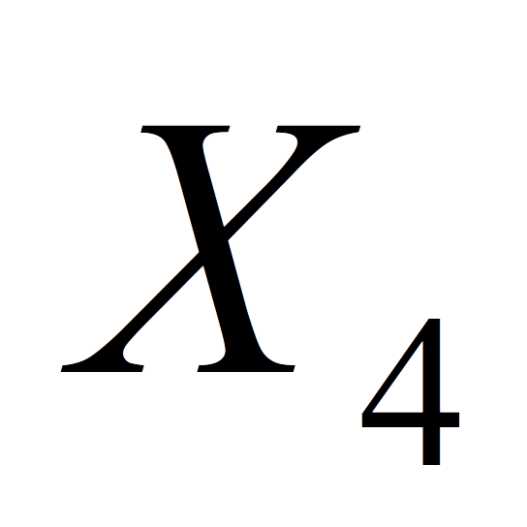

Figure C-1. Constraint graph for 4-queens

The number of constraints C in 4-Queens is 6.

The maximum possible number of constraints on N variables is= = 6

So, each variable is constrained with all other variables and the constraint graph is a complete graph.

Constraint Density of N-Queens = C / = 1

1.2 Numbers of nodes in CSP

The number of nodes in the search tree is:

whereis the domain of variableandis the size of this domain.

With this formula, it is not difficult to see that if the variables were ordered by their domain sizes in descending order, then the number of nodes in the search space would be maximal.

If the variables were ordered by their domain sizes in ascending order, then the number of nodes in the search space would be minimal.

2. Backtracking Algorithm

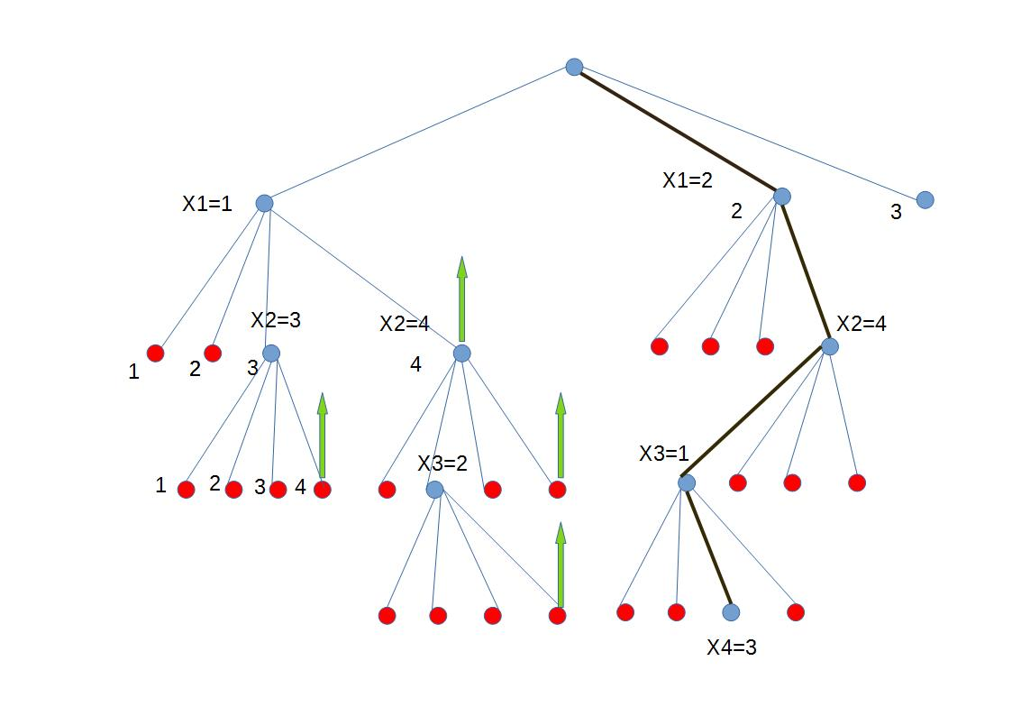

Figure C-2. A pictorial Illustration of Backtracking tree for 4-queens

The number of nodes in the search tree is at most

s=d⁰+d¹+d²+d³+……… +d^{n}
s=1+d¹+d²+d³+……… +d^{n}(equation 1)

multiplying d to left and right
ds=d¹+d²+d³+……… +d^{n}+d^{n+1} (equation 2)

By subtracting (equation 1) - (equation 2)
s-ds=1- d^{n+1}

s=

So, the worst case time complexity is O(d^{n}).

3. Forward Checking Algorithm

Figure C-3. The progress of a 4-Queens search with Forward Checking

3.1 Forward Checking Algorithm Evaluation

Time Complexity: O(ed²) where d is the largest domain size and e is the number of constraints involved with future variables.

The maximum number of possible edges for a given graph with n variables is e=n(n-1)/2. Thus O(ed²) can be written as O(n²d²).

But, forward checking is only an inference method and it is submerged in backtracking algorithm, thus the overall time complexity is O(d^{n} + n²d²).

4. AC-3 Algorithm

Iteration | Queue | Di(Reduction) | Di(Restore) | Revise(i,j)
1 | (1,2) | False |  | True
2 | (1,3) | True |  | True
3 | (1,4) | True |  | True
4 | (2,3) |  |  | inconsistent
4 | (2,3) | True |  | True
5 | (2,4) |  |  | inconsistent
 |  |  | True
6 | (1,2) | True |  | True
7 | (1,3) | True |  | True
8 | (1,4) | True |  | True
9 | (2,3) | True |  | True
10 | (2,4) | True |  | True
11 | (3,4) | True |  | True

Figure C-4. The progress of a 4-Queens search with AC-3

Time Complexity: O(n²d³) where n is the number of variables and d the maximum number of domain values.
- A binary CSP has at most O(n²) arcs. Because, if every node(variable) is connected to the rest of the variables, then it has n*(n-1) arcs (constraints).
- REVISE() takes O(d²) time. REVISE means checking the consistency of an arc.
- Each variable is inserted into Queue up to d times.

Thus, the total complexity of AC-3 is O(n²+d²+d)=O(n²d³).

In the worst case scenario, every value in the domain of X_{i} will have to be tested against every value in X_{j}.

5. MAC-3 algorithm

Figure C-5. The progress of a 4-Queens search with MAC-3

MAC-3 is formed by embedding AC-3 algorithm during search. The MAC algorithm aims at solving a CSP instance and performs a depth first search with backtracking while maintaining arc consistency. It is important to remark that all known AC algorithms are incremental.

An arc-consistency algorithm is incremental if its worst case time complexity is the same when it is applied up to nd times on P where between two consecutive executions at least one value has been deleted. For any branch, due to incrementally, the worst case complexity of MAC-3 is O(n²d³).

6. FC-MRV algorithm

Figure C-6. The partial progress of a 6-Queens search with FC-MRV algorithm

7. FC-LCV algorithm

Q
Q
Q
Q
X
X
X
X
X
X
X
X
X
X
X
X
X
X
X
X
X
X
X
X
X
X
X
X
X
X
X
Q
Q

2
2
2
4
3
3
3
3
3

X
X
X
X
X
X
X
X
X
X
X
Q
Q
Q
X
X
X
X
Q
Q
Q
X
X
Q
Q
Q
Q
X
X
X
X
X
X
X
X
X
Q
X
X
X
X
X
X
X
X

4

Q
Q
Q
Q
Q
Q
Q
Q
Q
Q
Q
Q
X
X
X
X
X
X
X
X
X
X
X
X
X
X
X
X
X
X
X
X
X
X
X
X
X
X
X
X
X
X
X
X
X
X
X
X
X
X
X
X
X
X
X
X

3
2
1
3
2
3

Figure C-7. The progress of a 6-Queens search with FC-lCV algorithm
8. Backjumping Algorithm Calculation

Q
1
2
3
4
Q
1
2
3
4
Q
1
1
Q

Step 1: Step 2: Q2 conflict set={1}

1
2
3
4
Q
Q
1
2
1
2
Q
Q
1
2
3
4
Q

Step 3: Leaf dead-end occurs at X3. Step 4: Leaf dead-end occurs at X4.

Q3 Conflict set={1,2}.
1
2
3
4
Q
1
1
1
Q
1
2
3
4
Q
Q

Step 5: Step 6: Q2 Conflict set={1}.

1
2
3
4
Q
Q
Q
1
2
3
4
Q
Q
Q
2
3
Q

Step 7: Step 8: Q3 Conflict set={3,2} and solution found.

Figure C-8. The progress of a 4-Queens search with BJ algorithm

