CHAPTER 2
THEORETICAL BACKGROUND
This chapter presents background theories and approaches related to the study of constraint satisfaction problems. Some standard or well-known CSPs and related concepts for solving CSPs are reviewed. Moreover, how a problem can be modeled as CSP in AI has been described.

2.1 Problem Solving in AI
Problem solving is fundamental to many AI-based applications. There are two types of problems. Firstly, problem likes computation of the square root of a value. These can be solved through the use of deterministic procedure and the success is guaranteed. Second, in the real world, very few problems lend themselves to straightforward solutions. Most real world problems can be solved only by searching for a solution. Artificial Intelligent (AI) is concerned with these types of problem solving.
Problem solving is a process of generating solutions from observed data. A problem is characterized by a set of goals, a set of objects, and a set of operation. These could be ill-defined and may evolve during problem solving. Problem space is an abstract space. It encompasses all valid states that can be generated by the application of any combination of operators on any combination of objects. The problem space may contain one or more solutions. Solution is a combination of operation and objects that achieve the goals.

2.2 General Problem Solving
Problem solving has been the key areas of concern for Artificial Intelligence. Problem solving is a process of generating solutions from observed or given data. It is however not always possible to use direct method (i.e. go directly from data to solution). Instead, problem solving often need to use indirect or model-based methods. General problem solver (GPS) was a computer program created in 1957 by Simon and Newell to build a universal problem solver machine. GPS was based on Simon and Newell’s theoretical work on logic machines. GPS in principle can solve any formalized symbolic problem, like: theorems proof and geometric problem and chess playing. GPS solved many problems such as the Towers of Hanoi, that could be sufficiently formalized, but GPS could not solve any real-world problems.
To build a system to solve a particular problem, there are needed to define the problem precisely- find input situations as well as final situations for acceptable solution to the problem, to analyze the problem – find few important features that may have impact on the appropriateness of various possible techniques for solving the problem, to isolate and represent task knowledge necessary to solve the problem, and choose the best problem solving techniques and apply to the particular problem[22].

2.3 Problem Definitions
A problem is defined by its elements and their relations. To provide a formal description of a problem, there are needed to do following:
- Define a state space that contains all the possible configurations of the relevant objects, including some impossible ones.
- Specify one or more states that describe possible situations, from which the problem solving process may start. These states are called initial states.
- Specify one or more states that would be acceptable solution to the problem. These states are called goal states.
- Specify a set of rules that describe the actions (operators) available.
The problem can then be solved by using the rules, in combination with an appropriate control strategy, to move through the problem space until a path from an initial state to a goal state is found. The process is known as search. Search is fundamental to the problem solving process. Search is a general mechanism that can be used when more direct method is known. Search provides the framework into which more direct methods for solving sub parts of a problem can be embedded. A very large number of AI problems are formulated as search problems[22].

2.3.1 Problem Space
A problem space is represented by directed graph, where nodes represent search states and paths represent the operators applied to change the state. To simplify search algorithms, it is often convenient to logically and systematically represent a problem space as a tree. A tree usually decreases the complexity of a search at a cost. Here, the cost is due to duplicating some nodes on the tree that were linked numerous times in the graph. A tree is a graph in which any two vertices are connected by exactly one path. Alternatively, any connected graph with no cycles is a tree.

2.3.2 Problem Solving Methods
Problem-solving methods are categorized as special purpose and general purpose[5].
- Special-purpose method is tailor-made for a particular problem, often exploits very specific features of the situation in which the problem is embedded.
- General-purpose method is applicable to a wide variety of problems. One general-purpose technique used in AI is “means-end analysis”. It is a step-by-step, or incremental, reduction of the difference between current state and final goal.

2.3.3 State
A state is representation of elements at a given moment. A problem is defined by its elements and their relations. At each instant of a problem, the elements have specific descriptors and relations; the descriptors tell – how to select elements? Among all possible states, there are two special states called: initial state and final state.

2.3.4 State Change
A successor function is needed for state change. The successor function moves one state to another state. It is a description of possible actions; a set of operators. It is a transformation function on state representation, which converts that state into another state. Successor function defines a relation of accessibility among states. It represents the conditions of applicability of a state and corresponding transformation function.

2.3.5 State Space
A state space is the set of all states reachable from the initial state. It forms a graph in which the nodes are states and the arcs between nodes are actions. In state space, a path is a sequence of states connected by a sequence of actions. The solution of a problem is part of the map formed by the state space.
The structures of state space are trees and graphs. Tree is a hierarchical structure in a graphical form; and graph is a non-hierarchical structure. Search process explores the state space. In the worst case, the search explores all possible paths between the initial state and the goal state.

2.3.6 Problem Solution
In the state space, a solution is a path from the initial state to a goal state. A solution cost function assigns a numeric cost to each path. It also gives the cost of applying the operators to the states. A solution quality is measured by the path cost function; and an optimal solution has the lowest path cost among all solutions. The solution may be any or optimal or all. The importance of cost depends on the problem and the type of solution asked.

2.3.7 Searching for Solutions
A solution is an action sequence, so search algorithm works by considering various possible action sequences. The possible action sequences starting at the initial state from a search tree with the initial state at the root; the branches are actions and the nodes correspond to states in the state space of the problem. Search algorithms require a data structure to keep track of the search tree that is being constructed[22]. An algorithm’s performance can be evaluated in four ways:
- Completeness : Is the algorithm guaranteed to find a solution when there is one?
- Optimality : Does the strategy find the optimal solution?
- Time complexity : How long does it take to find a solution?
- Space complexity : How much memory is needed to perform the search?

2.4 Constraint Satisfaction Problems
A problem is solved when each variable has a value that satisfies all the constraints on the variable. A problem described this way is called a constraint satisfaction problem, or CSP. CSP search algorithms take advantage of the structure of states and user general-purpose rather than problem-specific heuristics to enable the solution of complex problems. The main idea is to eliminate large portions of the search space all at once by identifying variable /value combinations that violate the constraints[25].
A model of constraint satisfaction problem consists of: a set of variables, a domain of values for which the variables can take and a set of constraints. A constraint is just a logical relation among several variables that restricts the possible values that variables can take. A constraint can be unary, binary or n-ary. In this thesis, binary constraint or the constraints that involve only two variables are only concerned and the variables domains are finite sets. A solution to a constraint satisfaction problem is, in its mathematical form, involves finding values assignment for the set of variables in the problem such that all constraints are satisfied.

2.4.1 Standard Search Problem
It is fairly to see that a CSP can be given an incremental formulation as a standard search problem as follows[25]:
Initial state : the empty assignment {}, in which all variables are unassigned.
Successor function : a value can be assigned to any unassigned variable, provided that it does not conflict with previously assigned variables.
Goal test : the current assignment is complete.
Path cost : a constant cost for every step.

All search problems
CSPs
The space of all search problems
-states and actions are atomic
-goals are arbitrary sets of states

The space of all CSPs
-states are defined in terms of variables.
-goals are defined in terms of constraints

Figure 2.1 CSP is a type of Search Problem
2.4.2 General Characteristics of CSP’s Search Space
Since the search space has a natural tree structure, instantiations will sometimes be also called nodes. There are properties of CSPs which differentiate them from general search problems[4]. It is the presence of these properties that makes problem reduction possible in CSPs. Besides, specialized search techniques can be, and have been, developed to exploit these properties so as to solve CSPs more efficiently. The properties of CSPs are:
(1) The size of the search space is finite
The number of leaves of the search tree is, whereis the domain of variable x_{i}, andis the size of this domain. Notice that L is not affected by the ordering in which one decide to label the variables. However, this ordering does affect the number of internal nodes in the search space. In general, if the variables are ordered as x₁,x₂,...., x_{n} , the number of nodes in the search tree is:
(2.1)
With this formula, it is not difficult to see that if the variables were ordered by their domain sizes in descending order, then the number of nodes in the search space would be maximal. That should also be the upper bound of the size of the search space. If the variables were ordered by their domain sizes in ascending order, then the number of nodes in the search space would be minimal. However, the size of the problem is dominated by the last and most significant term,
.

(2) The depth of the tree is fixed
When the variables are ordered, the depth of the search tree is always equal to the number of variables in the problem regardless of the ordering. When the ordering of the variables is not fixed, the depth of the tree is exactly 2n, where n is the number of variables.

(3) Subtrees are similar
If the ordering of the variables is fixed, then the subtrees under each branch of the same level are identical in their topology. The same choices are available in all sibling subtrees.The fact that the subtrees are similar means that experiences in searching one subtree may be useful in subsequently searching its siblings.

2.4.3 Reduction Techniques of CSP
Problem reduction techniques transform CSPs to equivalent but hopefully easier problems by reducing the size of the domains and constraints in the problems. Problem reduction is possible in CSP solving because the domains and constraints are specified in the problems, and that constraints can be propagated.
Problem reduction involves two possible tasks: (1) removing redundant values from the domains of the variables; and (2) tightening the constraints so that fewer compound labels satisfy them; if constraints are seen as sets, then this means removing redundant compound labels from the constraints. If the domain of any variable or any constraint is reduced to an empty set, then one can conclude that the problem is insoluble. Reduced problems are possibly, though not necessarily, easier to solve for the following reasons. Firstly, the domains of the variables in the reduced problem are no larger than the domains in the original problem. This leaves us with fewer labels to consider. Secondly, the constraints of the reduced problem are at least as tight as those in the original problem. This means that fewer compound labels need to be considered in the reduced problem.
Problem reduction requires one to be able to recognize redundant values and redundant compound labels. Such information can be deduced from the constraints. For example, if x and y are variables, and a constraint requires x to be greater than y in value, then one can remove from the domain of x all the values which are smaller than the smallest value in the domain of y. Similarly, the domain of y all the values which are greater than the greatest value of x can be removed.
Problem reduction is often referred to as consistency maintenance in the literature. Maintaining consistency of a problem means reducing a problem to one which has certain properties. Maintaining a different consistency means maintaining different properties in the problem.
The use of the term consistency in the CSP literature may need some clarification. In logical systems, a system is called inconsistent if absurdity can be derived from it; for example, if x<0 and x>4 must both hold. In the CSP literature, a problem is called inconsistent with regard to a property when that property does not hold in the problem. Therefore, being inconsistent does not prevent a problem from being solvable. The use of the term inconsistency in these two different contexts should not be confused.

2.4.4 Characteristics of Individual CSPs
CSPs are NP-hard in general, but every CSP is unique, and it is quite possible to develop specialized techniques to exploit the specific features of individual CSPs. Indeed, some such techniques have been developed[4].

A. Number of solutions required
Some applications require a single solution and some require all solutions to be found. Examples of problems which require single solutions are scene labelling in vision, scheduling jobs to meet deadlines, and constructive proof of the consistency of a temporal constraints network. Examples of problems where all solutions are required are logic programming where all variable bindings are to be returned, and scheduling where all possible schedules are to be returned for comparison.
Problems which require a single solution favour techniques which have a better chance of finding solutions at an earlier stage. The ordering of the variables and the values in searching is especially significant in solving such problems. Consequently, heuristics for ordering variables and values could play an important role in solving them. Solution synthesis techniques are normally used to generate all solutions.

B. Problem size
The size of a problem could be measured by the number of variables, the domain sizes, the number of constraints, or a combination of all three.The number of variables determines the depth of the search tree. The domain sizes determine the branching factors (number of branches) at the nodes. The number of leaves in the search tree, (2.2) dominates the size of the search tree. This is probably the most commonly used criteria for measuring the size of a problem, but the number of constraints in a problem should not be overlooked. The more constraints there are in a problem, the more compatibility checks one is likely to require in solving it. On the other hand, constraints could help one to prune off the search space, and therefore reduce the total number of consistency checks.
Small problems are only difficult when compatibility checks are computationally expensive. For such problems, techniques which minimize the number of compatibility checks necessary should be favoured.

C. Types of variables and constraints
The type of variable affects the techniques that one can apply. If all the variables in a problem are numbers and all the constraints are conjunctive linear inequalities, then integer programming or linear programming, both studied extensively in operations research, are appropriate tools for handling it.
A number of CSP solving techniques have been developed for binary CSPs. Normally, constraints can be propagated more effectively through binary constraints rather than through general constraints. For example, if X + Y < 10 is a constraint, then the values of X and Y determine one another. If one commits to X=2, then one can immediately remove from the domain of Y all the values which are greater than 7. But if the constraint is A + B + C <10, then committing to A=2 leaves us with B + C < 8, which will not allow us to reduce the domains of B and C until either B or C is fixed.

D. Quality of solutions
In applications such as industrial scheduling, the objective is often to find single solutions. However, not all solution tuples are as good as one another. For example, assigning different machines (value) to the same job (variables) could incur different costs. It might also affect the production line. Given an optimization function, the requirement is to find the optimal or near-optimal solution tuple(s), rather than finding any solution tuple. If the variables are numbers, and the constraints are inequalities, then linear programming or integer programming may be useful for finding optimal solutions.

Table 2.1 Relating difficulty of problems, tightness and number of solutions
Solutions required | Tightness of the problem
Solutions required | Loosely constrained | Tightly constrained
Single solution required | Solutions can easily be found by simple backtracking, hence such problems are easy. | Simple backtracking may require a lot of backtracking, hence harder compared with loose problems
All solutions required | More space needs to be searched, hence such problems could be harder than tightly constrained problems | Less space needs to be searched, hence, given the right tools, could be easier than loosely concerned problems

A CSP in which the optimal solution is required is akin to a problem in which all solutions are required. A naive approach is to look at all solutions in order to choose the best. However, in some applications one may be able to find heuristics to help pruning off search space which has no hope of containing solutions that are better than the best solution found so far.
In industrial scheduling, the environment changes dynamically. Under such situations, near-optimal solutions are often sufficient because optimal solutions at the point when it is generated may become suboptimal very soon. For such applications, stochastic search techniques are often used.

E. Partial solutions
Not every CSP is solvable. In many applications, problems are mostly over-constrained. When no solution exists, there are basically two things that one can do. One is to relax the constraints, and the other is to satisfy as many of the requirements as possible. The latter solution could take different meanings. It could mean assigning as many variables as possible without violating any constraints. It could also mean assigning all the variables in such a way that as few constraints are violated as possible. Such compound assignments are actually useful for constraint relaxation because they indicate the minimum set of constraints which need to be violated. Furthermore, weights could be added to the assigning of each variable or each constraint violation. In other words, the problems are:
(1) to maximize the number of variables assigned, where the variables are possibly weighted by their importance;
(2) to minimize the number of constraints violated, where the constraints are possibly weighted by their costs.

2.5 N-Queens Problem
A queen is the strongest piece on a chessboard able to move any number of squares vertically, horizontally or diagonally. For n x n board, there can be number of n-queens that do not attack each other. This is a generalization of the problem of putting eight non attacking queens on a chessboard. A chess player named Max Bezzel originally proposed this 8-queens problem in 1848 [6].
The N-Queens problem is a well-known problem among computer scientists. Although the N-Queens problem has very specific features which can be exploited in solving it, it has been used extensively for illustrating CSP solving algorithms. It is also a combinatorial problem in artificial intelligence or operations research.
The N-Queens problem become intractable for large values of ‘n’ and thus placed in NP-hard (non-deterministic polynomial time hard) which is a class of problems that are at least as hard as the hardest problems in NP.
Given any integer N, the problem is to place N queens on N distinct squares in an N x N chess board, satisfying the constraint that no two queens should threaten each other. The rule is such that a queen cannot threaten any other pieces on the same row, column or diagonal.

2.6 Applications Related with N-Queens Problem
The n-queens problem is often studied as a “mathematical recreation”, but Erabs, Tanik and Aliyazicioglu note several applications: parallel memory storage schemes, VLSI testing, traffic control and deadlock prevention. Erbas and Tanik, and Nair introduces a memory storage scheme for conflict free access for parallel memory systems using n-queens solutions. Kunde and Gurtzig use modular n-queens solutions to study reconfigurable meshes with buses (RMB). The modular n-queens problem is equivalent to finding “valid” periodic skewing schemes for parallel memories.
For deadlock prevention, Tanik shows that given a solution to the n-queens problem, one can find a set of deadlock free paths. As well, Erbas, Sarkeshik and Tanik note that the n-queens problem has applications in neural networks and constraint satisfaction problems. Another example of an application of the n-queens problem is in image processing, discussed by Yang, Wang, Liu. Chiang considers applications of n-queens solutions to motion estimation. Dean and Parisi develop a statistical mechanical model of “glassy” phase transitions and note that modular n-queens solutions are the zero-energy points in their Hamiltonian.
Yamamoto, Kitamura and Yoshikura give a computer analysis of the statistical secondary structure of nucleic acids, and remark that this computation is related to searching for n-queens solutions. Erdem and Lifschitz note that n-queens problems are examples of finite normal, absolutely tight logic problems and of interest to the study of theories of negation. Colbourn and Sagols define two rather than O(n³); triple systems, themselves, have many applications.
Taylor also observes that a weaker variant of the n-queens problem is equivalent to the problem of finding the “Florentine rows” on n symbols. Heden uses partial n-queens solutions to construct maximal partial spreads of many sizes in PG(3,q),the three-dimensional projective space over the finite field F_{q}. Finally, Hsiang, Shieh and Chen note that complete mapping problems, a variant of the n-queens problem, are ideal to test propositional solvers. Thus the n-queens problem is also of interest in physics and computer science and has some industrial applications[10].

2.7 Modelling N-Queens problem as CSP
In the case of 4-queens, the problem can be encoded as a CSP as follows:
- X={q₁,q₂,q₃,q₄},each variable qi corresponds to the queen placed in the i^{th} column.
- D={D(q₁), D(q₂), D(q₃), D(q₄)}, where D(qi)={1,2,3,4}.The value corresponds to the row where the queen representing the i^{th} column can be placed.
- (2.3). A constraint between each pair of queens that forbids the involved queens to be placed in the same row or diagonal line.

Q
Q
Q
Q
q1
q2
q3
q4
3
1
2
4

Figure 2.2 A solution to the four queen problem

2.8 Caution with modeling N-Queens problem
N-Queens problem has very specific features:
- Firstly, it is a binary constraint satisfaction problem.
- Secondly, every variable is constrained by every other variable which need not be the case in every other problems.
- Thirdly, N-Queens problem has more than one solution.
- More importantly, assignment for every variable conflicts with at most three values of each other variable, regardless of the number of variables in the problem.

2.9 Map Coloring Problem
Map coloring is the act of assigning different colors to different features on a map. There are two very different uses of this term. The first is in cartography, choosing the colors to be used when producing a map. The second is in mathematics, where the problem is to determine the minimum number of colors needed to color a map so that no two adjacent features have the same color [15].
The goal of a map coloring problem is to color a map so that regions sharing a common border have different colors. Regions that meet only in a point may share a common color. A map coloring problem can be solved by first converting the map into a graph where each region is a vertex and an edge connects two vertices if and only if the corresponding regions share a border. Once a map is converted into a graph, a process called vertex coloring can be used to decide how the map should be colored. To color the graph, vertex coloring rules are used. Vertex coloring rules are:
- Vertices connected by an edge must be different colors.
- Use the fewest possible number of colors.
Map coloring algorithms are obviously useful for coloring maps but they have less obvious uses as well. For example, suppose the job is to assign frequencies to radio stations so that no stations near each other have the same frequency. It can be treated this as a map coloring problem by making a node for each radio station, making links between those that are near other, and then coloring the resulting graph[15].
Similarly, in a class scheduling problem the goal is to schedule classes, ensuring instructors aren’t scheduled to teach two classes at the same time. This problem can be modelled by making a node for each class and connecting those that are taught by the same instructor. It can also be added in links representing classes that must be taken by the same group of students. The resulting graph coloring can tell the minimum number of time slots needed. Other less intuitive map-coloring problems involve circuit board and feature testing, and register allocation[26].

2.9.1 Modelling as CSP
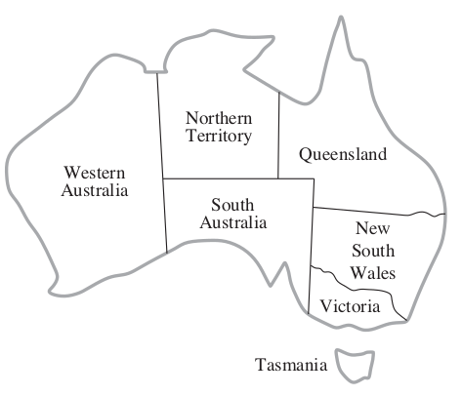
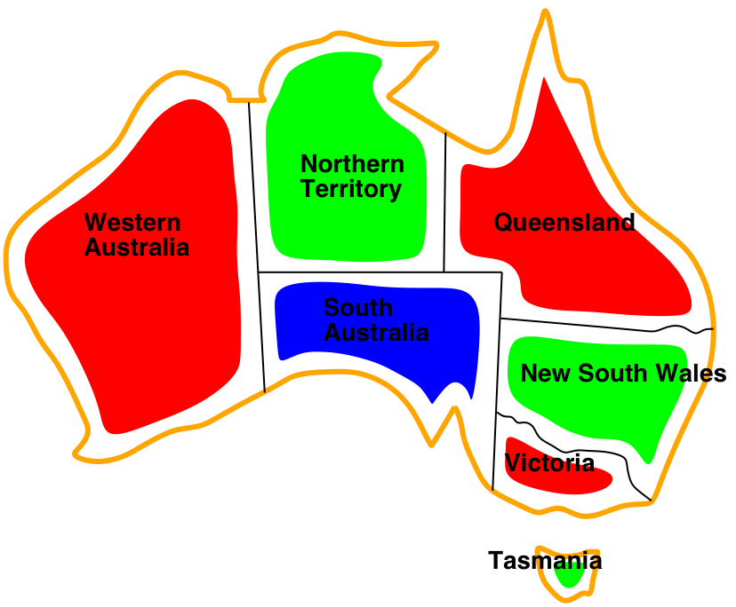Figure 2.3(a) Map of Australia Figure 2.3(b) Map of Australia after before coloring coloring

Variables : WA, NT, Q, NSW, V, SA, T
Domains : Di={red, green, blue}
Constraints : adjacent regions must have different colors

2.10 Sudoku Problem
Sudoku is a logic-based, combinatorial, number-placement puzzle. The objective is to fill a 9 x 9 grid with digits so that each column, each row, and each of the nine 3 x 3 sub-grids that compose the gird contain all of the digits from 1 to 9. The puzzle setter provides a partially completed grid, which for a well-posed puzzle has a single solution[25].
Completed games are always a type of Latin square with an additional constraint on the contents of individual regions. Sudoku puzzle is well popular around the world now. It can be found in daily newspaper, journal, magazine and so on. It has been widely used as an IQ test in job-interview, entrance-exam and many qualification tests. Sudoku puzzles are used in data hiding techniques like Steganography[23]. It is used like a key to hide data behind images.

2.10.1 Modelling as CSP

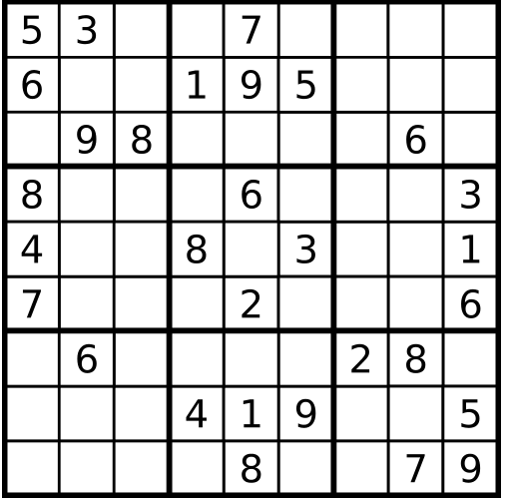
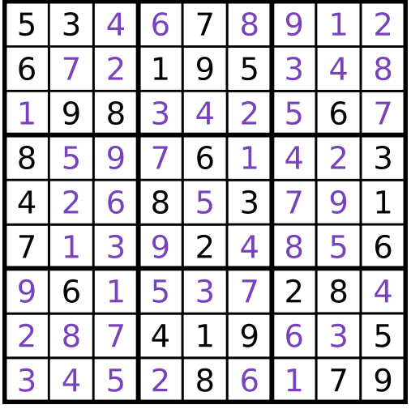

Figure 2.4(a) Sudoku before solved. Figure 2.4 (b) Sudoku after solved.

Variables : The variables will be each cell on the grid.
Domains : The domains will be any digit from 1 to 9.
Constraints : Same digit can’t appear twice in the same row.
Same digit can’t appear twice in the same column.
Same digit can’t appear twice in the same region.

2.11 Langford Pairing Problem
A Langford pairing, also called a Langford sequence, is a permutation of the sequence of 2n numbers 1,1,2,2,…….,n, n in which the two 1s are one unit apart, the two 2s are two units apart, and more generally the two copies of each number k are k units apart. It is a combinatorial mathematics.
Langford pairings are named after C. Dudley Langford, who posed the problem of constructing them in 1958 [16]. This problem is also a benchmark problem of CSP from [3].Skolem (1957) used Skolem sequences to construct Steiner triple systems. In the 1960s, E. J. Groth used Langford pairings to construct circuits for integer multiplication[16].
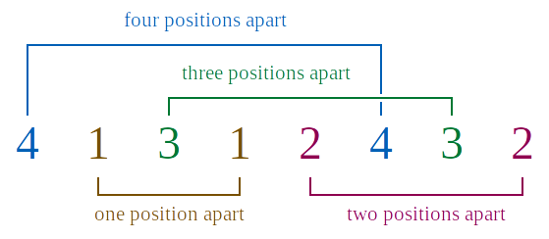

Figure 2.5. A Langford pairing for n = 4.

2.11.1 Modeling as CSP


Figure 2.6 L(2,4), with black=1, red=2, blue=3 and yellow=4

Variables :The variables will be numbers from 1 to 8.
Domains :The domains will be 4 sequence.
Constraints :To arrange the eight numbers in the two sets into a single sequence in which the two 1’s appear one number apart, the two 2’s appear two numbers apart, the two 3’s appear three numbers apart, and the two 4’s appear four numbers apart.

2.12 Magic Square Problem
In recreational mathematics and combinatorial design, a magic square is an n x n square grid filled with distinct positive integers in the range 1,2,…., n² such that each cell contains a different integer and the sum of the integers in each row, column and diagonal is equal.
The sum is called the magic constant or magic sum of the square. A square grid with n cells on each side is said to have order n. The magic constant of a normal magic square depends only on n and has the following value:
M = n(n^2+1)/2 (2.4)
This problem is taken as a benchmark problem of CSP from [3]. Magic Square can be found in pixel based image encryption[26]. It can also be found in data hiding technique. It is also applied in producing Antenna[28].
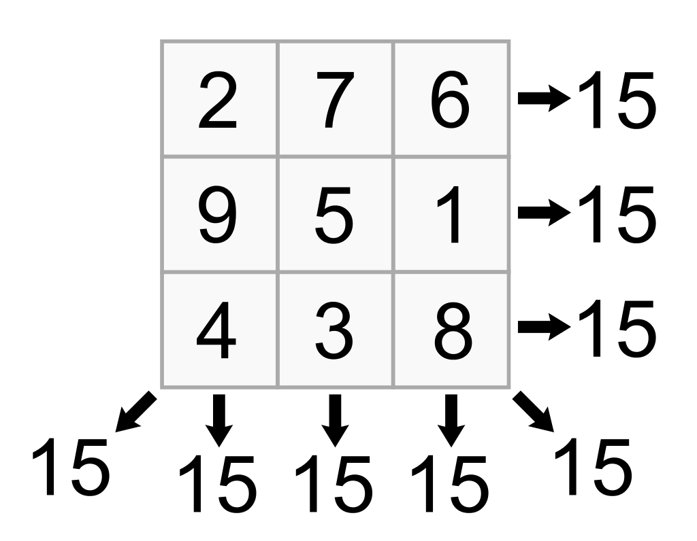

Figure 2.7 A graphical representation of Magic Square with size=3

2.12.1 Modeling as CSP
Variables : The variables will be each cell on the grid.
Domains : The domains will be any digit from 1 to n².
Constraints : The sum of all digits in the row, column and diagonal must be equal.

2.13 Wedding Seating Arrangement CSP
Arranging and assigning people in wedding party is a difficult problem. The organizer has to arrange the seating according to the list of attendees. He must take into account that couples must sit together in the same table. He must avoid that no all male or female sit together in the same table.

Variables : The variables will be chairs in one set of table. Tables can more than one.
Domains : Persons of Male and Female.
Constraints : No male or female will sit together in one table and couples must sit together in one table.

2.14 Reminder System CSP
This reminder system assigns a person to remind another person. Every person gives a list of people whom they want to remind to this system. The system assigns a suitable list of people according to the constraints.
The problem is that students sometimes miss assignment since they do not frequently check assignments on noticeboard. So, if one student finds an assignment, he or she reminds others that he or she is responsible for.

Variables, Domain : A person is part of variable (as reminder) and also part of domain. (as remindee).
Constraint : Every person must remind one person and also reminded by one person. Reminder and Remindee should not be the same.

2.15 Summary
In this chapter, the detail explanation of theoretical background is described. Problem-solving in artificial intelligence has been described and explained that searching is the most commonly used technique of problem solving in artificial intelligence. Next, how problem has been defined by its elements and their relations has been shown. And then, an overview of Constraint Satisfaction Problem solving approaches have been given. Specialized search techniques can be developed to take advantage of properties that are special to CSPs. Such properties include the fact that choice points are known in advance. Some of the most studied problem-specific characteristics of CSPs have been listed.
The proposed N-Queens problem has been discussed in detail. Standard CSPs such as Map Colouring, Sudoku, LangFord Pairing, Magic Square, Wedding Seating arrangement and Reminder CSP have been described. And then, it describes how to model such problem with CSP. All of these problems can be solved by algorithms described in next chapter.

