Coursework Cover Sheet
Students should complete the input fields contained in this form and attach it in front of your formal assessment submission. All fields within this form are required. Please ensure that check boxes and radio buttons are appropriately selected. The last three questions are just for you to personally consider.
Department and assessment information:
School Name: Engineering and Computing
Assessment title: Assignment 1: Killer Quebes
Course Title: Computer Games Development / Software Engineering / Computer Science
Module Title: Games Concepts
Module Code: CO1301
Year of Study: 2025-2026
Academic Misconduct / Plagiarism Declaration
By attaching this front cover sheet to my assessment I confirm and declare that I am the sole author of this work, except where otherwise acknowledged by appropriate referencing and citation, and that I have taken all reasonable skill and care to ensure that no other person has been able, or allowed, to copy this work in either paper or electronic form, and that prior to submission I have read, understood and followed the University regulations as outlined in the Academic Integrity Policy and Procedure for Academic Misconduct
Have you checked the following? This will help your assessment achievement.
I have applied the learning outcomes for this module ☐
I have checked for Academic Integrity via Turn-it-in ☐
I have followed the guidance in the Assessment Brief and have not used AI to boost my grade unfairly. ☐
I have used references in accordance with instructions in the Assessment Brief ☐
I have proofread my work for spelling, grammar and punctuation. ☐
I have checked that the word count/size of this submissions accords with the guidance provided in the Assessment Brief.☐
Well-being
We wish to support any student who is experiencing mitigating circumstances which prevents students from performing to the best of their ability when completing or submitting assignments. If you are experiencing such circumstances, then you may apply for Mitigating Circumstances. Wherever possible this must be done prior to handing in your assignment.

Do you need to apply for mitigating circumstances for this assignment Please select Yes / No

Please refer to the Mitigating Circumstances Policy

Questions you may wish to consider:
- Have I allowed sufficient time to prepare this assessment?

- Have I reflected on previous feedback and made improvements in accordance with advice?

- What grade am I expecting?

Title Page

Name – Thusara Dinusith Gunawardhana
No – 21383911
Module Name – Gaming Concepts
Module Number – CO1301
Game Name -Killer Quebes

Game Description
- This game is called Killer Quebes. The first thing a player will see is a start page that asks them to press enter to start the game. After starting the game, players can see blocks coming towards the arrow, so the goal of the game is to destroy all the blocks before they reach the arrow.

Conditions
- This game contains two main conditions,
- Victory condition - Destroy all blocks to win.
- Defeat condition - Lose if a block reaches the arrow before the player destroys it.
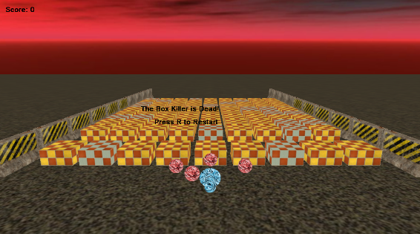

Defeat Condition – Marble turns red
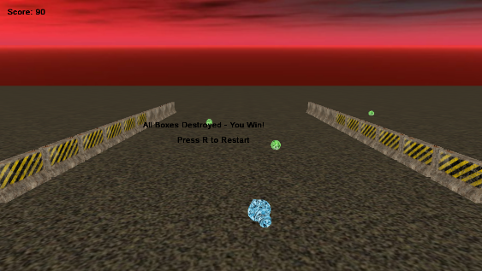

Victory Condition – Marble turns green

Screens
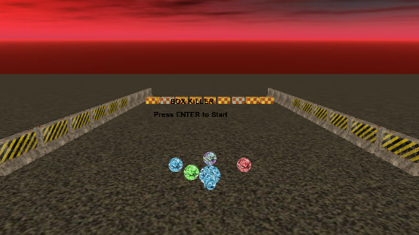
1 Screen – Start Screen

2 Screen
- Blocks are coming
- Arrow can turn left and right
- Player can shoot marbles
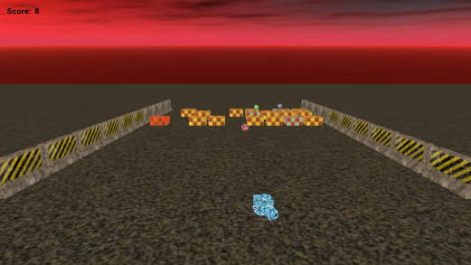
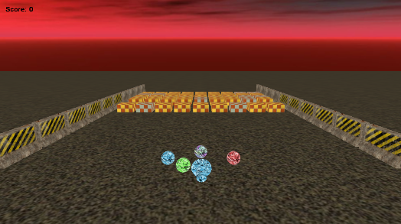

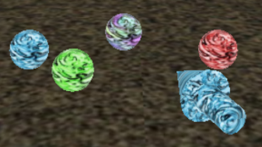
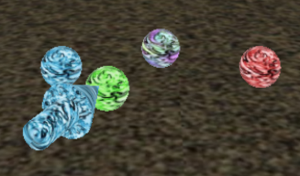

3 screen – End screen

Game STD diagram,
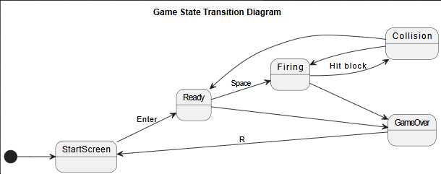

Block STD Diagram,
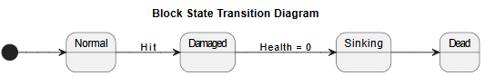

Marble STD Diagram,
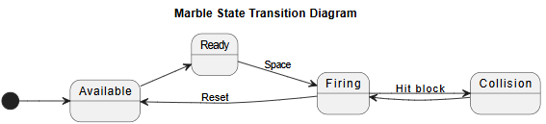

Testing
Test | Expected Result | Actual Result
Click Space to shoot marbles | Marbles move forward, hit, and return | Correct
Hit block | Block health decreases (turns red and destroy) | Correct
Destroy block | Block sinks | Correct
Hard blocks | Two hard blocks per row | Correct
Click Z to aim left | Arrow turns left | Correct
Click Z to aim left | Arrow turns right | Correct

Evaluation

- Improve game logic by adding more future.
- Improve Collision detection between marbles and barriers.
- Improve the game by adding sound effects.

