Project Development Log
Project Title:
Does the use of deep learning models that are trained on normal chest X-rays and a small set of common thoracic diseases effectively detect previously unknown thoracic diseases as abnormal?
Student: Thushan Pamoditha
Supervisor: Dr Adrian Bishop
Progress covered: Steps 1-10 (Dataset preparation through model comparison)

Contents
- 1. Project Overview
- 2. Development Progress Summary
- 3. Steps 1-3: Dataset Preparation and Validation
- 4. Step 4: Unseen Disease Simulation
- 5. Steps 5-6: Model Setup and Training Pipeline
- 6. Step 7: Baseline Model Training
- 7. Step 8: Unseen Disease Training
- 8. Step 9: Experimental Testing
- 9. Step 10: Binary vs Disease-Specific Model Comparison
- 10. Key Findings So Far
- 11. Project Status and Next Step
- 12. GitHub Repository and Evidence

1. Project Overview
This research investigates whether deep learning models can recognise chest X-rays containing thoracic diseases that were deliberately excluded from model training. The NIH ChestX-ray14 dataset is used to simulate this situation. Two architectures, DenseNet121 and ResNet50, are evaluated. The project first develops a direct binary classifier that predicts Normal or Abnormal. It then develops disease-specific multi-label models and collapses their outputs to a binary decision: if any known disease is predicted, the image is treated as Abnormal; otherwise it is treated as Normal.
The current implementation uses 14,999 locally available chest X-ray images from the first two NIH image archives. Four diseases were selected for unseen-disease experiments: Atelectasis, Effusion, Pneumonia and Pneumothorax. The workflow has now progressed through model comparison (Step 10).

2. Development Progress Summary
Step | Stage | Status
1 | Dataset Selection & Understanding | Completed
2 | Data Cleaning & Preprocessing | Completed
3 | Data Splitting Strategy | Completed
4 | Unseen Disease Simulation | Completed
5 | Model Setup | Completed
6 | Training Pipeline | Completed
7 | Baseline Model Training | Completed
8 | Unseen Disease Training | Completed
9 | Experimental Testing | Completed
10 | Model Comparison | Completed
11 | Performance Evaluation | Next
12 | Explainability Analysis | Not started
13 | Result Analysis | Not started
14 | Final Solution | Not started

3. Steps 1-3: Dataset Preparation and Validation

3.1 Step 1 - Dataset Selection and Understanding
The NIH ChestX-ray14 dataset was selected because it contains frontal chest X-ray images with 14 thoracic disease labels and a No Finding category. The locally available subset contained 14,999 PNG images. Metadata records were examined to understand the label structure and to identify suitable diseases for the unseen-disease experiments.
- Total locally available images: 14,999.
- Binary definition: 0 = Normal / No Finding; 1 = Abnormal / one or more thoracic disease labels.
- Four selected unseen-disease candidates: Atelectasis, Effusion, Pneumonia and Pneumothorax.
- Pneumonia has a comparatively small unseen test sample and will therefore require cautious interpretation.

3.2 Step 2 - Data Cleaning and Preprocessing
Metadata was matched with the locally available image files. Binary labels and 14 disease-specific indicator columns were retained, and the processed data was saved as available_data.csv. The final processed subset contained 8,753 normal images and 6,246 abnormal images.
Class | Images | Percentage
Normal (0) | 8,753 | 58.36%
Abnormal (1) | 6,246 | 41.64%

3.3 Step 3 - Patient-Level Data Splitting and Validation
The processed data was split at patient level so that images belonging to the same patient could not appear across training, validation and test sets. This prevents patient leakage and provides a more reliable evaluation of model generalisation.
Split | Images | Patients | Normal | Abnormal
Training | 10,699 | 2,746 | 6,236 | 4,463
Validation | 2,179 | 588 | 1,257 | 922
Testing | 2,121 | 589 | 1,260 | 861

- Train/validation patient overlap: 0.
- Train/test patient overlap: 0.
- Validation/test patient overlap: 0.
- Missing images: 0.
- Duplicate image records: 0.
- All 14 diseases were represented in training, validation and test splits.
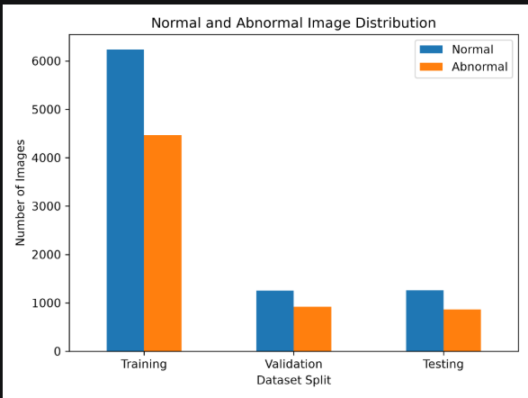
Figure 1. Normal and abnormal image distribution across the training, validation and testing splits.
The class distribution remains reasonably consistent across all three patient-level splits. Normal images are more common than abnormal images, but both classes remain well represented in every split.
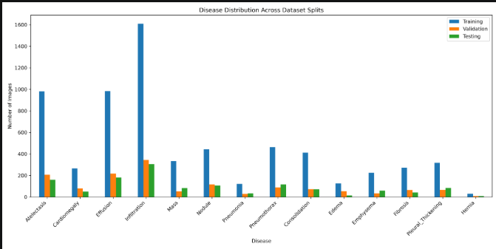
Figure 2. Distribution of the 14 thoracic disease labels across the dataset splits.
The figure shows the expected class imbalance in the NIH ChestX-ray14 subset. Infiltration is the most frequent disease label, while labels such as Hernia, Pneumonia and Edema are comparatively rare. All 14 disease labels are represented across the training, validation and testing datasets.
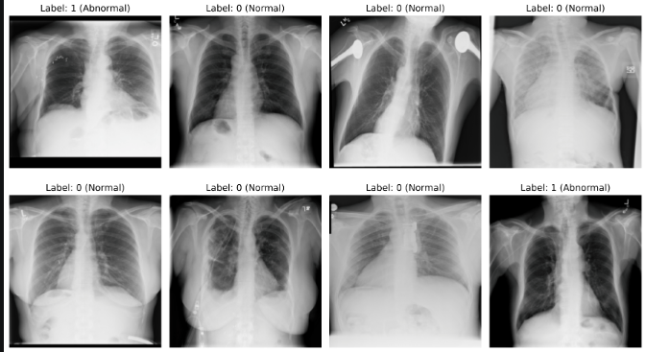
Figure 3. Example chest X-rays loaded through the training pipeline with binary labels.
This visual check confirms that the PyTorch data pipeline correctly loads the chest X-rays and associates each image with its binary Normal or Abnormal label.

4. Step 4: Unseen Disease Simulation
To simulate a genuinely unseen disease, every training and validation image containing the selected held-out disease was removed, including multi-disease images. This is important because retaining an image such as Pneumonia + Effusion during training would still expose the model to Pneumonia. The original test images containing the held-out disease were retained as the unseen test set.
Held-out disease | Training images | Validation images | Unseen test images
Atelectasis | 9,717 | 1,971 | 160
Effusion | 9,715 | 1,962 | 181
Pneumonia | 10,577 | 2,150 | 33
Pneumothorax | 10,235 | 2,090 | 117

Validation checks confirmed that the held-out disease count was zero in each corresponding filtered training and validation dataset.

5. Steps 5-6: Model Setup and Training Pipeline

5.1 Step 5 - Model Setup
ImageNet-pretrained DenseNet121 and ResNet50 models were configured for binary classification. The DenseNet121 classifier was replaced with a two-output linear layer using 1,024 input features, while the ResNet50 final fully connected layer was replaced with a two-output layer using 2,048 input features. Both models successfully produced an output tensor of shape [1, 2] during the architecture test.
- Framework: PyTorch 2.8.0 + CUDA 12.9 build.
- GPU: NVIDIA GeForce RTX 3050 6GB Laptop GPU.
- DenseNet121 final output: 2 classes.
- ResNet50 final output: 2 classes.

5.2 Step 6 - Training Pipeline
A PyTorch Dataset class, image transforms and DataLoaders were implemented. Images are loaded as RGB, resized to 224 x 224 pixels and normalised using ImageNet mean and standard deviation values. Random horizontal flipping is applied only to training images. Validation and test images are not augmented.
- Batch size: 8.
- Training DataLoader: shuffle enabled.
- Validation/test DataLoaders: shuffle disabled.
- Training batch shape verified as [8, 3, 224, 224].
- A sample training visualisation confirmed that images and binary labels were being loaded correctly.

6. Step 7: Baseline Model Training
DenseNet121 and ResNet50 were trained as baseline binary classifiers using the original training and validation datasets, where all available diseases remained represented. Both models used the same settings for a fair comparison: 3 epochs, batch size 8, Adam optimiser, learning rate 0.0001 and CrossEntropyLoss. The best model checkpoint was selected using the lowest validation loss.
Model | Epoch 1 Val. Acc. | Epoch 2 Val. Acc. | Epoch 3 Val. Acc. | Best observed Val. Acc.
DenseNet121 | 66.36% | 64.80% | 69.44% | 69.44%
ResNet50 | 68.70% | 67.92% | 67.92% | 68.70%

DenseNet121 reached the higher observed validation accuracy, while ResNet50 reached a higher final training accuracy. These baseline models provide the reference models trained with all diseases available.
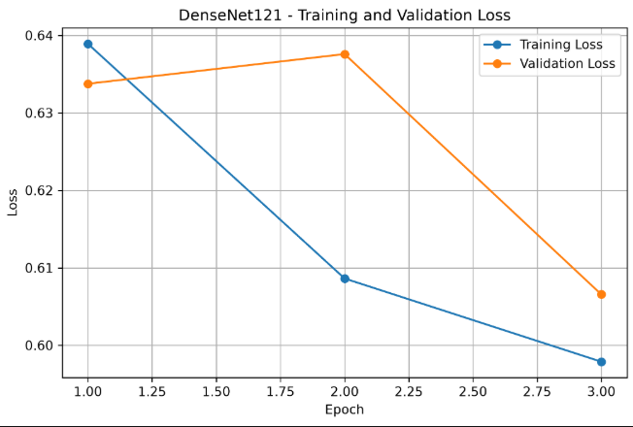
Figure 4. DenseNet121 baseline training and validation loss over three epochs.
DenseNet121 training loss decreased across the three epochs. Validation loss increased slightly in epoch 2 before decreasing to its lowest value in epoch 3, which was retained as the best checkpoint.
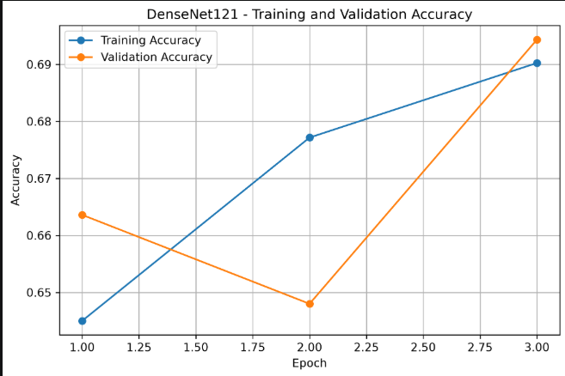
Figure 5. DenseNet121 baseline training and validation accuracy over three epochs.
DenseNet121 training accuracy improved across all three epochs. Validation accuracy varied during training and reached its highest value in epoch 3 at approximately 69.44%.
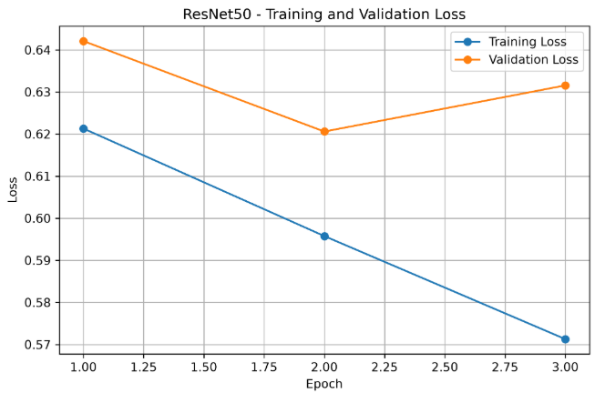
Figure 6. ResNet50 baseline training and validation loss over three epochs.
ResNet50 training loss decreased consistently. Validation loss reached its lowest value in epoch 2 and then increased slightly in epoch 3, so the epoch 2 checkpoint was retained according to the validation-loss selection rule.
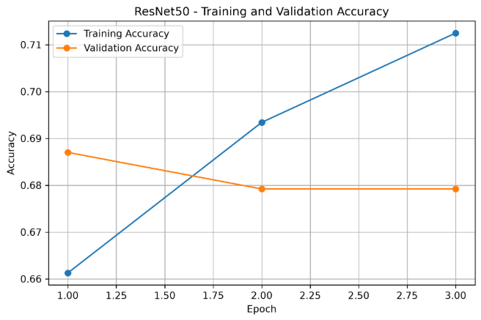
Figure 7. ResNet50 baseline training and validation accuracy over three epochs.
ResNet50 training accuracy increased steadily, while validation accuracy was highest in epoch 1 and remained close to 68% in epochs 2 and 3. Checkpoint selection was based on validation loss rather than validation accuracy.

7. Step 8: Unseen Disease Training
For each selected held-out disease, DenseNet121 and ResNet50 were retrained using the corresponding filtered training and validation datasets created in Step 4. The same training settings used for the baseline models were retained to keep the experiments comparable.
Held-out disease | DenseNet121 best observed Val. Acc. | ResNet50 best observed Val. Acc.
Atelectasis | 69.51% | 71.44%
Effusion | 67.79% | 67.69%
Pneumonia | 67.67% | 68.47%
Pneumothorax | 68.33% | 68.90%

Eight unseen-disease binary models were therefore produced: two architectures for each of the four held-out diseases.

8. Step 9: Experimental Testing
Each Step 8 binary model was tested on the corresponding unseen_test.csv. Every image in these test sets contains the held-out disease and is therefore considered abnormal for this experiment. The main Step 9 measure was the unseen disease detection rate: the percentage of unseen-disease images predicted as Abnormal.
Disease | Model | Test images | Predicted abnormal | Predicted normal | Detection rate
Atelectasis | DenseNet121 | 160 | 68 | 92 | 42.50%
Atelectasis | ResNet50 | 160 | 50 | 110 | 31.25%
Effusion | DenseNet121 | 181 | 93 | 88 | 51.38%
Effusion | ResNet50 | 181 | 76 | 105 | 41.99%
Pneumonia | DenseNet121 | 33 | 24 | 9 | 72.73%
Pneumonia | ResNet50 | 33 | 25 | 8 | 75.76%
Pneumothorax | DenseNet121 | 117 | 65 | 52 | 55.56%
Pneumothorax | ResNet50 | 117 | 38 | 79 | 32.48%

Pneumonia produced the highest binary unseen-disease detection rates for both architectures. However, its test set contains only 33 images, so this result should not be interpreted with the same confidence as diseases with larger test samples.

9. Step 10: Binary vs Disease-Specific Model Comparison

9.1 Disease-Specific Model Setup
A second modelling approach was implemented to compare direct binary classification with disease-specific classification. For each experiment, the held-out disease was removed as both a training exposure and an output class. The disease-specific model therefore contained 13 outputs representing the remaining known diseases.
Because chest X-rays can contain multiple disease labels, the disease-specific models used BCEWithLogitsLoss. Positive class weighting was applied to reduce the effect of strong label imbalance. DenseNet121 and ResNet50 were each trained for 3 epochs for all four held-out-disease experiments.

9.2 Collapsing Disease-Specific Predictions to Binary
For comparison with the direct binary models, sigmoid probabilities were generated for all 13 known disease outputs. Using a threshold of 0.5, an image was classified as Abnormal if at least one known disease output reached or exceeded the threshold. If all 13 outputs were below 0.5, the image was classified as Normal. The model did not need to identify the held-out disease by name; the experiment tested whether it recognised the image as abnormal through any known disease response.

9.3 Comparison Results
Disease | Model | Binary detection | Disease-specific detection | Difference (pp) | Higher detection
Atelectasis | DenseNet121 | 42.50% | 96.88% | +54.38 | Disease-specific
Atelectasis | ResNet50 | 31.25% | 85.62% | +54.38 | Disease-specific
Effusion | DenseNet121 | 51.38% | 100.00% | +48.62 | Disease-specific
Effusion | ResNet50 | 41.99% | 90.61% | +48.62 | Disease-specific
Pneumonia | DenseNet121 | 72.73% | 96.97% | +24.24 | Disease-specific
Pneumonia | ResNet50 | 75.76% | 96.97% | +21.21 | Disease-specific
Pneumothorax | DenseNet121 | 55.56% | 98.29% | +42.74 | Disease-specific
Pneumothorax | ResNet50 | 32.48% | 99.15% | +66.67 | Disease-specific

Architecture | Average binary detection | Average disease-specific detection
DenseNet121 | 55.54% | 98.03%
ResNet50 | 45.37% | 93.09%

Note: These Step 10 results show detection of abnormality on unseen-disease images only. They do not yet demonstrate that the disease-specific approach is a better overall classifier. Because the collapsed multi-label rule has 13 opportunities to exceed the 0.5 threshold, its very high detection rates may also be associated with false-positive predictions on normal images. This must be investigated in Step 11 using specificity, confusion matrices, ROC/AUC and the other planned evaluation metrics.

10. Key Findings So Far
- A complete patient-level data pipeline has been implemented with no patient leakage across train, validation and test sets.
- Strict unseen-disease datasets were created by removing every training and validation image containing the held-out disease, including multi-disease cases.
- DenseNet121 and ResNet50 can detect some previously unseen disease images as abnormal using direct binary classification, but the detection rate varies substantially by disease.
- In the current binary experiments, Pneumonia had the strongest unseen detection, while Atelectasis and some Pneumothorax results were considerably weaker.
- Under the predefined 0.5 threshold and 'any known disease = abnormal' rule, the disease-specific models produced much higher unseen-disease detection rates than the direct binary models.
- The high disease-specific detection rates require further evaluation against normal images before any conclusion is made about overall superiority.
- Pneumonia has only 33 unseen test images in the current subset, which is an important limitation.

11. Project Status and Next Step
Steps 1 through 10 of the research implementation plan are complete. The next stage is Step 11 - Performance Evaluation. This stage will calculate Accuracy, Precision, Recall/Sensitivity, F1-score, Specificity and AUC, and will generate ROC curves and confusion matrices. This evaluation is particularly important for determining whether the high disease-specific unseen-detection rates are accompanied by a high false-positive rate.

12. GitHub Repository and Evidence
Repository Name: Deep_Learning_for_ChestXray_Generalisation
Repository: github.com/Thushan14/Deep_Learning_for_ChestXray_Generalisation
The repository is used for version control and to maintain the implementation history. Terminal transcripts, CSV result files, training histories, graphs and saved model checkpoints are also maintained locally as project evidence.
- Data-processing summaries and distribution graphs.
- Unseen-disease candidate analysis and simulated unseen datasets.
- Step 5 model setup terminal output.
- Step 6 training pipeline output and sample visualisation.
- Step 7 baseline training histories and graphs.
- Step 8 unseen-disease training histories and graphs.
- Step 9 unseen-disease testing results.
- Step 10 disease-specific training histories and binary-vs-disease-specific comparison CSV.

