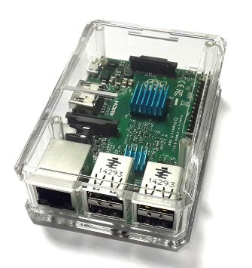

distance between set pin and beginning of rpi pin

distance between rpi pins

distance between 2 set pins

Raspberry pi distance between 2 set pins